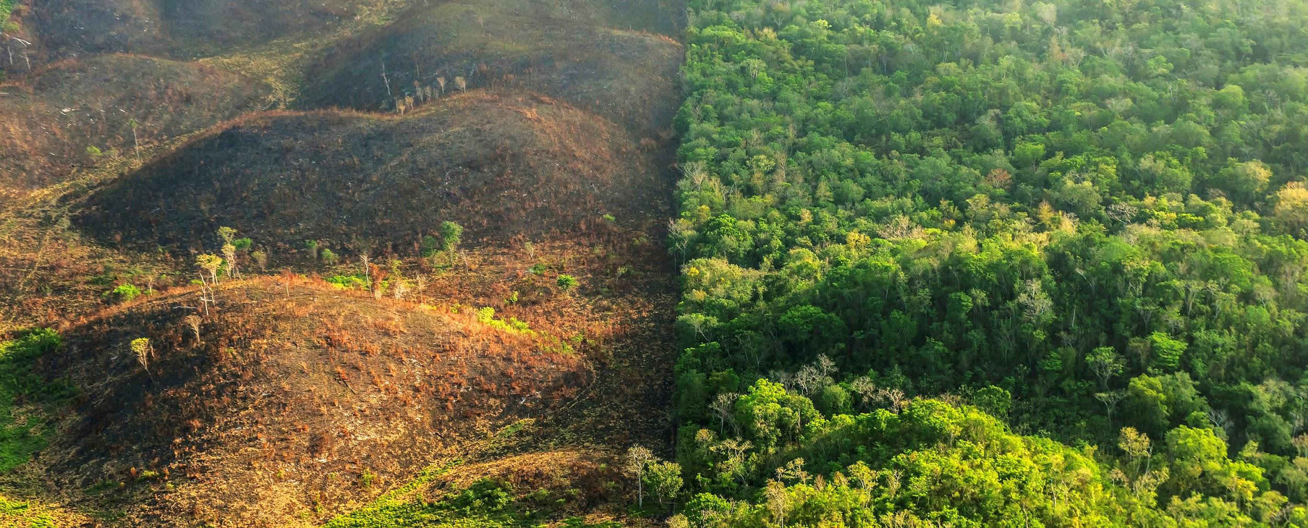
Course Title: Pandemics & the Environment
Course Number: ENV490
Term: Spring 2021
Course Credits: 3
Class Meeting Time: Tues & Thur 13:00-14:20
Class Location: Henry Hall 207 & zoom (link in Canvas)

Instructor Name: Dr. Lupita Ruiz-Jones
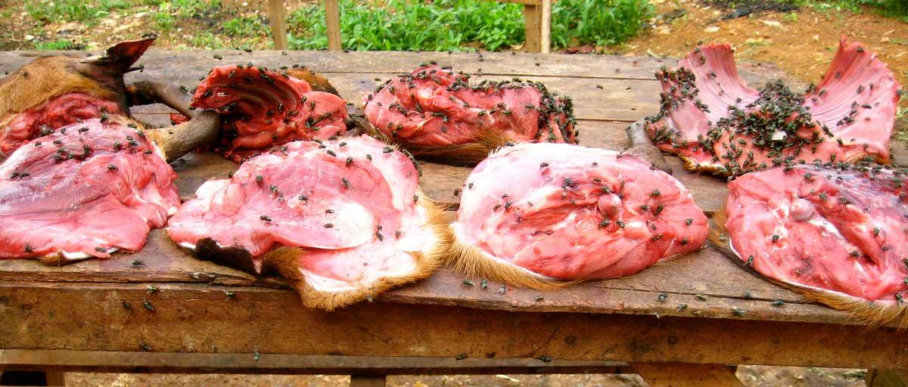
Email: guadalupe.ruiz-jones@chaminade.edu
Office Location: Wesselkamper 104
Cell Phone (welcome to text): 505.603.1985
Office Hours: Tues 2:30-4:00 / Wed 12:30-1:30 / Thur 2:30-4:00 (via Zoom for now - text me to lmk you want to join zoom -- zoom link in Canvas)

We will start the semester with Tues class being in zoom and Thur class in-person.

Service learning activity on Saturday Feb 20 = Kaimuki Cleanup hosted by Sustainable Coastlines. You will participate for a minimum of 2 hours that day -- this is part of your grade.

In-person class: wear your mask and socially distance; no eating or drinking in the classroom.

Zoom class: set yourself up for learning by being in a place you can focus (i.e., not in a car driving or somewhere you will be continuously distracted -- if this is the case, I will ask you to leave class and you will not get credit for the day).

Understatement of our time...we are living in a challenging pandemic.
I recognize that all of us are disappointed that this college experience is not what we signed up for. These times are frustrating (sometimes I feel like having a temper tantrum). But it is imperative that we step up and bring our best self forward--our future selves will look back at how we responded. Approach this situation with compassion, empathy, and respect. We will get on the other side of this pandemic and feel different.

Course overview
Why did COVID-19, Zika, and Ebola happen? Are such epidemics, and pandemic in the case of COVID-19, just random stochastic events or are there more proximate cause and effect dynamics at play? In this graduate style seminar course, we will look at aspects of conservation science to address questions of how, why, where, when, etc. such viruses "spill-over" from nature to humans. We will explore how deforestation, forest fragmentation, encroachment into wilderness, international wildlife trade, bush meat and wildlife markets, etc. all serve as mechanisms and vectors for viral spillover and transmission into human populations.

As this 400-level course will be run as a seminar, the success of the course and the depth of your learning will be the fruits of your active participation in class discussions and your critical thinking in individual, pair, and team projects. We will start the course by reading Spillover: Animal Infections and the Next Human Pandemic by David Quammen. There will also be supplemental material in the form of short articles, podcasts, and videos.

I will facilitate the class discussions the first four weeks of the semester, then you will take the lead. Starting week four you will work in pairs to select the discussion topics from Spillover and you will decide on the supplemental material (e.g., scientific articles, popular science articles, op-eds, videos, podcasts). There are so many interesting topics to explore under the theme of “Pandemics and the Environment” and you will have a voice in the material you want to focus your learning on so be curious.

In the last third of the course you will work in small teams on final projects where you will develop solutions to the challenges you have learned about. During week 13 of the semester (second to last week) you will present your solutions.

Classroom etiquette (in the time of the COVID-19 pandemic)

When we are together in the same physical classroom, our primary goal will be to keep each other safe. Wear your masks in the classroom. Drink water before coming into the room. No eating or drinking during class. Keep physical space between you, your peers and me. And if you have any COVID symptoms, be responsible and stay home, and let me know your situation.

Course Learning Outcomes

- To gain confidence as a critical reader and discussant, independent researcher, and collaborative team member.
- Understand the dynamics of viral spillover from nature into human populations.
- Analyze the underlying causes of viral spillover.
- Evaluate the role of different stakeholders involved in aiding and undermining conservation efforts.

Course requirements & grading breakdown

- 22% = Participation In Discussions: This class will be run like a graduate seminar course, hence we will mostly have class discussions and I will do pretty much zero lecturing. Your active and engaged participation in class discussion is essential for the success of the course and your learning -- come prepared!
- 20% = Online Discussion Posts: Prior to most discussions you will post discussion questions and/or responses to prompts on Canvas. Engaging in these online discussions will help prepare you for class discussions.
- 30% = Leading Discussions: You will collaborate with a partner on leading class discussion by selecting the main topic to focus on from the reading and selecting supplemental material. Early on I can give you some ideas to select from, but I expect as you learn more you will develop your own ideas based on your curiosity. You will lead 2-3 class discussions.
- 25% = Team Solution Project: In the last third of the semester you will work in small teams on a project focused on developing a solution to present to a key stakeholder.
- 3% = Service learning activity on Feb 20: Contribute a minimum of 2 hours to the Kaimuki Cleanup hosted by Sustainable Coastlines -- this is your campus neighborhood.

See Canvas Modules for the tentative schedule.

A = Outstanding scholarship and an unusual degree of intellectual initiative
B = Superior work done in a consistent and intellectual manner
C = Average grade indicating a competent grasp of subject matter
D = Inferior work of the lowest passing grade
F = Failed to grasp the minimum subject matter; no credit given

Extra credit opportunities
Throughout the course I will notify you of opportunities to engage with ideas and scholars outside of Chaminade. Due to the pandemic, most of these opportunities will be webinars. You are also welcome to attend any other webinar you find on your own that is related to course material. I will give you up 3 extra credit points (depends on the quality of your reflection) for each webinar you participate in. There are specific criteria for your reflection on Canvas in the Extra Credit Discussion Assignment.

Attendance and your grade
As an enrolled student in the course, I expect that you will attend every class unless you are sick or have a COVID-related situation. If you have more than two unexcused absences your grade will be negatively impacted. An important aspect of learning is active engagement. There is no substitute for being in class when it comes to understanding and thinking critically about the material. Due to the COVID-19 pandemic, it is essential that you stay home if you have any symptoms -- your absence will be excused. Unexcused absences occur when playing hooky to go surfing, to sleep, to cram for an exam in another class, etc.

Course website
We will use Canvas and google drive.

Required course textbook
Quammen, D. Spillover: Animal Infections and the Next Human Pandemic. 2012. [ISBN:9780393346619]
* This book is available in the bookstore and as an e-book on Amazon.

Classroom atmosphere

Expectations of students in class
You have the responsibility to commit yourself to your academic work in ways that will increase your learning. In this course, following the guidelines below will give you the best chance of growing as a critical thinking learner:

Arrive to every class on time, which means settled in your seat by the start time. If it is a zoom class, this means being in a place where you can focus, take notes, and engage (i.e., not driving, etc.)

Approach the work of the course with the habits of mind critical for success at the university level: intellectual curiosity, critical engagement, and creativity.

Prepare by doing all the required reading and assignments before class.

Listen actively and with respect to your peers. We listen to each other with dignity by thoughtfully grappling with the ideas of others and using non-verbal cues to show we are paying attention to them. Active listening is essential to engaged participation.

Speak up and challenge yourself to share your thoughts and ideas with your classmates in skillful and respectful ways. Being critical of your peers is essential for proper academic discourse, but we strive to do so respectfully. Since you are thinking on your feet, you are not expected to speak with perfect clarity. Class discussion is a cooperative enterprise, not a competition. A quality contribution is one that helps stimulate our learning. A thoughtful response to another student’s comment leads to a much richer learning experience than a long and well-researched but disconnected comment.

Inquire by asking questions—this is a key aspect of learning. Ask yourself questions as you engage with the course material. Engage with your peers by asking questions. Often there is not a single “right” answer.

Expectations you can have of me
I will continually strive to be an engaging, thoughtful, and critical teacher. One of my primary goals is to create a learning environment where everyone feels included. You can expect me to make space for you to share your thoughts and questions. You can also expect me to listen to your feedback on how the class is going -- please share your observations and ideas with me.

Technical Assistance for Canvas
- Search for help on specific topics or get tips in Canvas Students
- Live chat with Canvas Support for students
- Canvas Support Hotline for students: +1-833-209-6111
- Watch this video to get you started
- Online tutorials: click on “Students” role to access tutorials
- Contact the Chaminade IT Helpdesk for technical issues: helpdesk@chaminade.edu or call (808) 735-4855

Tutoring and Writing Services

Chaminade is proud to offer free, one-on-one tutoring and writing assistance to all students. Tutoring and writing help is available on campus at Kōkua ʻIke: Center for Student Learning in a variety of subjects (including, but are not limited to: biology, chemistry, math, nursing, English, etc.) from trained Peer and Professional Tutors. Please check Kōkua ʻIke’s website (https://chaminade.edu/advising/kokua-ike/) for the latest times, list of drop-in hours, and information on scheduling an appointment. Free online tutoring is also available via Smarthinking. Smarthinking can be accessed 24/7 from your Canvas account. Simply click Account – Notifications – Smarthinking. For more information, please contact Kōkua ʻIke at tutoring@chaminade.edu or 808-739-8305.

Course Policies

Communication with me
I’m always happy to address your questions. I generally answer emails within 24 hours on weekdays and by the following weekday if sent on a weekend or holiday. Please do not wait until the last minute to ask questions. I expect you to communicate with me about any issues related to the course. Clear and timely communication can anticipate many standard problems that arise during a course. I am also super happy to just chat with you about topics you find interesting or you are curious about.

Late work policy
If something happens and you know you need an extension on an assignment, contact me. If we do not make a prior arrangement, 10% of the assignment points will be deducted for each day after the assignment due date.

Grades of "Incomplete"
You may negotiate an incomplete grade with me when there are specific justifying circumstances, but it is necessary that you have at least completed 70% of the required assignments. When submitting a grade the “I” will be accompanied by the alternative grade that will automatically be assigned after 90 days. These include IB, IC, ID, and IF. If only an “I” is submitted the default grade is F. The completion of the work, evaluation, and reporting of the final grade is due within 90 days after the end of the semester or term; this may not be extended.

Cell phones, tablets, and laptops
Out of consideration for your classmates, please set your cell phone to silent mode during class. Students are encouraged to bring laptops or tablets to class as I will at times assign online activities and readings that will require the use of a laptop or tablet. It is well known that these devices can be extremely distracting to your learning as well as the learning experience of your peers. When you are in class I expect that you are focused on the material and not multitasking by checking email, social media, or unrelated material on your device.

Disability Access
If you need individual accommodations to meet course outcomes because of a documented disability, please speak with me to discuss your needs as soon as possible so that we can ensure your full participation in class and fair assessment of your work. Students with special needs who meet criteria for the Americans with Disabilities Act (ADA) provisions must provide written documentation of the need for accommodations from the Counseling Center by the end of week three of the class, in order for instructors to plan accordingly. If a student would like to determine if they meet the criteria for accommodations, they should contact the Kōkua ʻIke Coordinator at (808) 739-8305 for further information (ada@chaminade.edu).

The Counseling Center website is updated with current resource information. Inquiries and questions can always be referred to counselingcenter@chaminade.edu.

Title IX Compliance
Chaminade University of Honolulu recognizes the inherent dignity of all individuals and promotes respect for all people. Sexual misconduct, physical and/or psychological abuse will NOT be tolerated at CUH. If you have been the victim of sexual misconduct, physical and/or psychological abuse, we encourage you to report this matter promptly. As a faculty member, I am interested in promoting a safe and healthy environment, and should I learn of any sexual misconduct, physical and/or psychological abuse, I must report the matter to the Title IX Coordinator. If you or someone you know has been harassed or assaulted, you can find the appropriate resources by visiting Campus Ministry, the Dean of Students Office, the Counseling Center, or the Office for Compliance and Personnel Services.

Attendance Policy
For the University wide attendance policies please the 2020-2021 Academic Catalog.

You are expected to regularly attend all courses for which you are registered. You should notify me when illness or other extenuating circumstances prevent you from attending class and make arrangements to complete missed assignments. Notification may be done by emailing me. It is my prerogative to modify deadlines of course requirements accordingly. Any student who stops attending a course without officially withdrawing may receive a failing grade.

Unexcused absences equivalent to more than a week of classes may lead to a grade reduction for the course. Any unexcused absence of two consecutive weeks or more may result in being withdrawn from the course, although I am not required to withdraw students in that scenario. Repeated absences put students at risk of failing grades.

Students with disabilities who have obtained accommodations from the Chaminade University of Honolulu ADA Coordinator may be considered for an exception when the accommodation does not materially alter the attainment of the learning outcomes.

Federal regulations require continued attendance for continuing payment of financial aid. When illness or personal reasons necessitate continued absence, you should communicate first with me to review the options. Anyone who stops attending a course without official withdrawal may receive a failing grade or be withdrawn at my discretion.

Academic Conduct Policy
Students should conduct themselves in a manner that reflects the ideals of the University. This includes knowing and respecting the intent of rules, regulations, and/or policies presented in the Student Handbook, and realizing that students are subject to the University’s jurisdiction from the time of their admission until their enrollment has been formally terminated. Please refer to the Student Handbook for more details. A copy of the Student Handbook is available on the Chaminade website.

This syllabus and course schedule are living documents: they are free to change. I try to adhere as closely as possible, but there will be times in which we will take longer on a particular topic or add or delete a topic to enhance the course. I like to be able to react to you as the course proceeds and go with the flow a bit in order to make the course experience sort of custom fit to you!

You are responsible for all of the information in this document: not reading it does not make you exempt from knowing what’s in it!

Use this syllabus to keep you organized and how your grade is determined.

