CHAMINADE UNIVERSITY OF HONOLULU
FALL EVENING SESSION
October 2 - December 11, 2007
PEARL HARBOR NAVAL BASE CAMPUS

COURSE: RE/ENV 331: Environmental Ethics
INSTRUCTOR: Dr. Malia Dominica Wong, O.P. TIME: Tuesdays, 5:30-9:40PM
PHONE: 676-1452 E-MAIL: mwong2@chaminade.edu

REQUIRED TEXTS: *Kinsley, David: Ecology and Religion, Prentice-Hall, 1995.
*Easton, Thomas and Theodore Goldfarb: Taking Sides: Clashing Views
On Controversial Environmental Issues, McGraw-Hill, 2007.

DESCRIPTION
Examines religious perspectives on ethical issues within the context of an ecumenical and inter-religious dialogue in the field environmental studies, with particular attention paid to contemporary Catholic and Asian ethicists. The goals are to assist students in their study and understanding of the personal and social dimensions of these ethical perspectives and learn effective methods for dealing with relevant ethical issues within environmental studies. Fulfills interdisciplinary capstone course requirement.

STUDENT LEARNING OUTCOMES LINKED TO PROGRAM LEARNING OUTCOMES {PLO}

Upon successful completion of this course students will demonstrate:
- an understanding of Catholic environmental theology, its historical development and views on ecology, environmental ethics and ecological spirituality, referencing broader Christian and human traditions; (PLO 1.b)
- an understanding of the application of values found in the religious traditions under study with regard to real world situations of environmental need and service to the planetary life systems; (PLO 2.b)
- an awareness of the uniqueness of Hawaii and the Pacific Rim as a meeting place for various religious traditions as they try to live responsibly within this region’s fragile ecological systems. (PLO 3.a; Service Learning Objective);
- how religions and cultures interact with each other, affecting values, beliefs and creative responses to the contemporary ecological crises. (PLO 3.b)
- an understanding of the distinctive role of the gospel and Catholic Social Thought in both affirming and challenging cultural ecological values and assumptions. (PLO 3.c; Service Learning Objective)
- a critical understanding of and appreciation for the varied positions of Christianity and other major world religions on environmental ethics and spirituality. (PLO 1.a)
- an understanding of the application of Christian faith and imagination to the ecological spirituality. (PLO 1.c)
- a reflective engagement with course content so as to encourage personal growth and adaptation in creating new environmentally responsible lifestyles. (PLO 2.a; Service Learning Objective)
- an understanding of the Marianist tradition of education for service and responsible participation in the public sphere, particularly in the advocacy of environmental justice and peace. (PLO 2.c; Service Learning Objective)
- a capacity to articulate the fundamental questions of ultimate meaning as seen from the perspectives of ecology and environmental spirituality that will intellectually and spiritually engage them throughout their lives. (PLO 2.d; Service Learning Objective)
- an understanding of morality and ethics, the methods of moral decision making, and the specific applications of environmental ethics and spirituality. (PLO 2.e)

Students will also be able to:
- demonstrate an understanding of morality and ethics and how they impact ecology and environmental issues;
- develop and apply a model for moral decision-making;
- compare and contrast ways that the world’s religions are engaging the environmental crisis and how that engagement is changing them and their practitioners;
- demonstrate an understanding of the potentials for religious traditions to contribute to the solutions for the moral dilemmas created by the contemporary environmental crisis;
- demonstrate a personal commitment to life-enhancing action.

ORGANIZATIONAL THEMES: MARIANIST EDUCATIONAL PHILOSOPHY AND DIVERSITY
Organizational themes refer to underlying structural links that contribute to the choice of content, the pedagogy selected for participation of the teacher/learner and student/teacher in bringing the content to life, and fulfillment of the course objectives within a broader frame of education and building community.

- The first set of organizational themes around which the course is constructed is drawn from the “Characteristics of Marianist Universities.”
- Educate for formation in faith;
- Provide an integral quality education;
- Educate for family spirit;
- Educate for service, justice and peace; and
- Educate for adaptation and change.

These characteristics are important in the way we will teach the course, in our expectation of your participation in the realization of the course goals and objectives, and in the selection of materials we will ask you to read. As the semester progresses, the specific character of your education in a Marianist University will impact on your discipline in ways that emphasize the reflective dialogue between faith and reason in the issues and values we study. Marianist education seeks graduates who, having been schooled with a concern for the whole person, approach their professions from this same wholistic perspective as they seek to build communities that serve the needs of justice and peace, while seeking creative ways to adapt to changing environments and needs.

- The second major organizational theme is diversity and the complex issues that are associated with theory and practice of criminology and criminal justice within diverse, multi-ethnic and multi-religious communities.

Two explicit objectives arise from these organizational themes:
- The students will incorporate into their presentations and final project an awareness of the Marianist educational characteristics and how they impact on their reading of the sources and themes for the course and their personal philosophy and practice within the field of environmental studies and ethics. See the Characteristics of Marianist Universities at http://intra.chaminade.edu/admin/CMU.pdf

- The Final exam contains one question on the Marianist educational characteristics and one question on the meaning and effects of diversity in the theory and practice of environmental stewardship.

REQUIREMENTS
Students are to come to each class prepared by having read the assigned readings, completed any other homework assignments and being ready for in-class activities. If you arrive late to class, or leave early without informing the instructor on the reasons, you will lose attendance points.

GRADING
Grading will be based upon regular class attendance, class work, homework, projects, quizzes, participation, and effort. Papers must be typed, double-spaced, 10 or 12 point font only. 1-1/2 inch margins. Extra credit-- events and topics to be discussed as the occasion arises. Note: communication with the teacher is essential if you have any concerns, are called away on duty, etc.

*CATEGORIES: WEIGHTING:
Attendance: 20%
Class Participation: 10%
Reflection Papers: 15%
Homework: 10%
Quizzes: 10%
Midterm 15%
Final: 20%
100
90-100: A 80-89: B 70-79: C 60-69: D 59 and below: ☹

ASSIGNMENTS
*Homework:
Each week you are requested to submit over the readings, a paragraph of your own stance or opinions on the subject matter. Note: even though subject-content field trips may change and not match up with the readings on occasion, continue reading as scheduled.
*Reflection Papers:
1 1/2 page typed papers. Content: reflections and reactions over the field trip-- observations, comparisons, feelings, learnings, etc. Not a synoptic report.
*Quizzes:
Short review quizzes over vocabulary and content.

LEARNING OUTCOME ASSESSMENT

All student's work will be evaluated for:
*knowledge of the subject matter from textbooks, class presentations, discussions,
videos, research, outside class activities
*ability to apply the knowledge to understand current issues in society
*understanding of the subject matter from different viewpoints

MIDTERM
“Fake food -- I mean those patented substances chemically flavored and mechanically bulked out to kill the appetite and deceive the gut -- is unnatural, almost immoral, a bane to good eating and good cooking.” Julia Child (1912-2004)
“Many scientists now feel that these “plastic” unnatural foods have created a form of chemically aided neurophysiological degeneration and may be directly responsible for the increase in crime, obesity, asthma, hyperactivity and learning disabilities in children.” -Frankenfoods
I. Bring in a healthy food/dish to share
*Note: You can check list of GMO/non-GMO foods at: True Food Now!:
http://www.truefoodnow.org/shoppersguide/guide_printable.html
II. Choose one of the topics (or another area of your interest), to research upon and present your findings in a 3-5 minute speech in relation to the food you bring in.
a. Methods and Mechanisms for Genetic Manipulation of Plants
b. Unintended Effects from Breeding
c. Adverse Impacts of Food on Human Health: toxicity, nutritional deficiency, and allergenicity
d. Dangers of “Farm Raised”
e. Methods and Mechanisms of Genetic Manipulation and Cloning of Animals
f. Raw vs. Cooked or Processed
g. Natural or Unnatural: The Economical Choice
h. Ethics of Natural and Unnatural Foods
i. Religious Influence and Food Choices

WEEKLY OVERVIEW:

Oct. 2 Introduction
Hmwk: Readings/Summary
1.. ER: Chap. 10: Superiority of Humans
ER: Chap. 13: Animal Rights
2. TS: Issue 14: Genetic Engineering

Oct. 9 Genetic Engineering
Hmwk: Readings/Summary
1. ER: Chapt. 5: Hinduism
2. TS: Issue 6: Pollution Rights Trading

Oct. 16 Ahimsa: Nonviolence
ISKCON Center, 6PM
51 Coelho Way
Hmwk: Readings/Summary
1. ER: Chap. 4: Native American Religion
2. TS: Issue 3: Price on Ecosystems Goods and Services

Oct. 23 Board of Water Supply, Recycled Water
Hmwk: Prepare for Midterm

Oct. 30 Midterm
Hmwk: Readings/Summary
1. ER: 6: Chinese Religions
2. TS: 8: Arctic Drilling

Nov. 6 Ecological Spirituality
Greendrinks Environmental Network
E&O Trading Company
1200 Ala Moana Blvd.
Hmwk: Project Report

Nov. 13 Green Building and Eco-Environments
The ARTS at Marks Garage
1159 Nuuanu Ave., Honolulu, 96817
Hmwk: Readings/Summary
Choose an ER and a TS of personal interest.

Nov. 20 Buddhist Religions and DDT
Hmwk: Readings/Summary
1. ER: Select a reading from Christianity and Eco. Themes
2. TS: Issue 13, p. 234ff

Nov. 27 Christianity and Population Growth
Hmwk: Prepare for Final Exam

Dec. 4 Final Exam

*Note: Syllabus subject to change.

EXTRA-CREDIT:
Free Presentation: Chef Leslie Ashburn presents "Healthy Whole Foods in a Flash"
Sat., Oct. 20, 2007, 7 p.m., McCoy Pavillion, Ala Moana Park

Olelo.
The Vegetarian Society of Hawaii presents "Vegetarian," a weekly Public Access TV program. All programs air on Olelo, Cable Channel 52, Thursdays at 6-7 p.m.

10/25/07-11/22/07
"Lifestyle Medicine in the Marshalls"
John Kelly, M.D. 57:50
8/14/07 Castle Memorial Hospital Auditorium
10/04/07-11/01/07-11/29/07
"Vitamins and Minerals Demystified"
Steve Blake, Sc.D. 58:07
9/11/07 Ala Wai Golf Course Clubhouse
10/11/07-11/08/07-12/06/07
"What's New in Plant-based Nutrition?"
John Kelly, M.D. 57:50
8/14/07 Ala Wai Golf Course Clubhouse
10/18/07-11/15/07-12/13/07
"The Raw Food Diet"
William Harris, M.D. 57:46
7/10/07 Ala Wai Golf Course Clubhouse
75 of our previous speakers and presentations are now online in Flash format at:
http://www.vsh.org/videos.htm (high speed internet connection advisable).
You can also watch "Vegetarian" on line at 6:00 PM on Thursdays by going to: http://olelo.org/ and clicking on "Oahu_Channel 52."

UHM Sierra Club

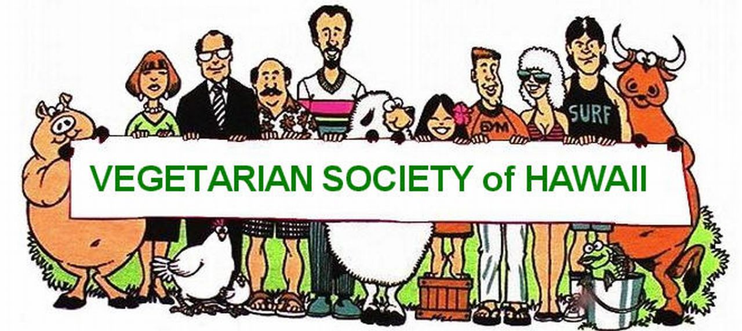
The UHM Sierra club meets every Thursday at 5:30 PM at the Awesome Energy House. Often we have hiking or other activities before our meetings and movie nights to follow. We are a small, diverse group of people passionate about sustainability and the environment and always love new company. There is no admission, no commitment, and we have fun. (We love fun!) Feel free to join us this or any Thursday!

