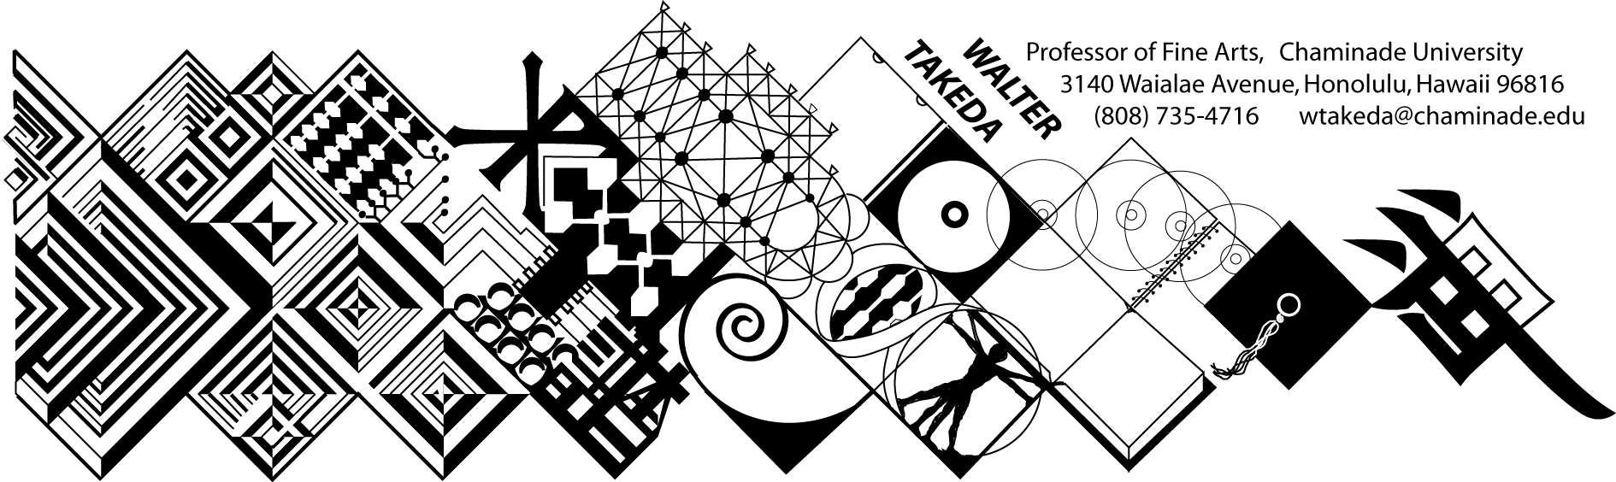
ID 310 History of Furnishings & Interiors Spr 07
MWF 10-10:50 am

Office Hrs: afternoons
or appointment

ID 310 is a requirement for all Interior Design majors. It covers the history of interior design, furnishings and architecture as it relates to ID. Knowledge of the past is important to the ID student, even though the field is ever-changing. Reinterpretations of past styles resound through history, i.e. Post-Modernism.
This class presents material in chronological order; you are expected to do parallel reading in your text. At the beginning of each class, a pool of slides will be shown of previous critical material. As much as possible, these works will be from the text. After each class, keep a list of this pool of slides. Use this "mini-review" to good advantage; cramming for THIS class is a poor idea.
Before each exam there is a thorough review of the material. Audio taping this review helps many students.
Examinations are the main criteria for grade. All students must take the exams; the following comparative analysis paper opportunity will only be offered students who have taken the exams. Your ability to recognize artists and/or styles not in the review pool will take the test beyond mere rote memory; this will be an assessment tool to gauge an important goal of this course. As such, additional quizzes (which may not count to the grade) may be administered.

Comparative Analysis Papers may be offered as an alternative to poor examination performance; your paper’s grade will substitute for the exam grade only if higher. This will be written in a strict format, which will be clearly stated in a student handout. These are due at the beginning of class of the stated deadline; anything later has a letter grade deduction.
MAKEUP EXAMS are a serious matter. Students will notify the instructor BEFORE the exam, then bring in a verifiable excuse, such as a service station invoice, doctor's slip, etc. It is the student's responsibility to abide by these two conditions and the instructor's prerogative to refuse a makeup. The makeup will be scheduled by the instructor, and if the student is again absent, he or she will be given a zero. In fairness to other students, a harder makeup exam will be administered, i.e. instead of multiple choice, you will be required to write in the answers. If it is at all possible to take the test on time, make every effort to do so rather than risk a more difficult exam. THERE IS ABSOLUTELY NO EXTRA CREDIT IN THIS COURSE!
The student is obligated to abide by the conditions of this syllabus, the Chaminade catalog, and the Chaminade student handbook, and cannot claim ignorance of these conditions as an excuse.
GRADING SCALE: A:100-90, B: 89-80, C: 79-70, D: 69-60. Please note that this scale may be different from other instructors. Each exam, including the final, will be equally weighted.

The instructor reserves the right to adjust the schedule and contents of this syllabus, such as exam times or grading criteria or any other changes. Any announced change made in class is the student's responsibility.

COURSE SCHEDULE:

Jan
17 Introduction; general remarks on furniture
19 Paleolithic; neolithic

22 Egyptian culture; interior design
24 Aegean domiciles
26 Greek culture and values; architectural motifs

29 Greek homes & furnishings; moldings
31 Review for First Exam
Feb 2 FIRST EXAM

5 Roman culture; the arch and derivatives
7 Roman homes & furniture
9 Pompeii

12 Roman wall painting styles
14 Medieval period
16 Medieval period continued

19 No class – Presidents’ Day
21 Italian Renaissance; palazzi
23 Villas; High Renaissance; Mannerism

26 Review for Second Exam
28 SECOND EXAM
Mar 2 Baroque

5 French Renaissance to Louis XIV
7 Versailles
9 Versailles

12 Rococo
14 Neoclassicism
16 Late German Baroque

19 Review for Third Exam
21 THIRD EXAM
23 English Renaissance

Apr 2 Palladianism (last day to withdraw or go cr/nc)
4 Robert Adam
6 Good Friday – no class

9 Islamic design
11 Chinese design
13 Japanese design

16 Japanese design
18 Japanese interiors
20 Japanese interiors

23 The 19th Century styles
25 Early 20th Century: Art Nouveau, Art Deco
27 The Sixties

30 Post Modernism
May 2 Post Modernism
May 4 Final Review

Final: Check regular exam schedule

