COURSE: | ED 471 Language Arts: Curriculum and Methods  Winter 2007  3 credits
Instructor: | Dr. Vickie Iwamoto  Email: vickie.iwamoto@adjunct.chaminade.edu or viwamoto@yahoo.com
CATALOGUE DESCRIPTION: | This course includes philosophy and rationale for the teaching of Language Arts to young children. Focus is on the developing language skills with young children. These include how to develop a language rich environment at the early childhood level. Topics include oral language, pre-reading activities and writing activities. Prerequisites: ED 215, ED 217 & ED 233
COURSE OBJECTIVES: | - Increase understanding of Language arts curriculum.  - Gain greater understanding of the developmental nature of language arts acquisition.  - Increase awareness and understanding of language arts observation and assessment.  - Acquire a range of teaching strategies to create and implement a quality language arts environment and curriculum.  - Reflect on experience and knowledge of their ECE experiences.
TEXT: | Early Childhood Language Arts 3rd ed. 2003, by M. Jalongo  The course being run from my personal website : www.geocities.com/dr_iwamoto
 | ACADEMIC REQUIREMENTS:
Participation | Each student is expected to assume a shared responsibility for the content and process of the class. Your active participation is essential in making the class a good experience for everyone. Specific expectations are that you:  - Attend all class sessions and arrive on time.  - Do the assigned reading before each class session.  - Participate in class discussions.  - Submit assignments on time.  - Handle concerns with the instructor.  - Work cooperatively as appropriate.
Grading | Assignments and Projects:  All submitted assignments are expected to be word-processed and of the quality appropriate for undergraduate study. At least ten percent (10%) of the possible points will be deducted for sloppy, or careless, work. Take the time to proofread your assignments to make sure they are free of typographical and/or grammatical errors. Do not combine several assignments into one. Each assignment is to be submitted as an independent assignment and will be assessed as such. The instructor reserves to right to return, not graded, all work that does not meet this standard.
Criteria | The following criteria are used for evaluating course work:  - Completeness (all parts of the assignment must be done)  - Quality of Content  - Quality of Classroom Participation  - Thoughtfulness and reflection of coursework & classroom experience
Policy | Unless otherwise stated at the time of the assignment, assignment are due when noted in the course schedule. Late assignments will be accepted one week after the original due date with 50% of the points will be deducted from the grade. Student’s grade will be based on the content and clarity of assignments and understanding of the course matter.
Assignments | Points  - Weekly Online Written Assignments (10 total) Examples include: 100  - Creating a language arts and literary environment  - Use of Technology  - Parent Letter  - Observation and Participation Field Work Write-Up 10  - Language Arts Integrated Curriculum 20  - Journal Article Review – to be shared with the class 5  - Portfolio Self Review 10  - Final 10  Total = 155  Note: Specifics guidelines for assignments/projects will be provided.
Grading Scale | Based on a total of 155 points, letter grades are as follows:  155-140 = A, 124-139 = B, 108-123 = C, 82-107= D, 81 and below = F  (90-100%=A; 80-89%=B; 70-79%=C; 60-69%=D; below 60%=F)
UNIVERSITY POLICIES | Plagiarism - “Plagiarism is the offering of work of another as one's own. Plagiarism is a serious offense and may include, but is not limited to, the following:  1. Complete or partial copying directly from a published or unpublished source without proper acknowledgment to the author. Minor changes in wording or syntax are not sufficient to avoid charges of plagiarism. Proper acknowledgment of the source of a text is always mandatory.  2. Paraphrasing the work of another without proper author acknowledgment.  3. Submitting as one's own original work (however freely given or purchased) the original exam, research paper, manuscript, report, computer file, or other assignment that has been prepared by another individual.  In the cases of alleged academic dishonesty (such as plagiarism, cheating, claiming work not done by the student, or lying) where a faculty member observes or discovers the dishonesty, the faculty members may choose to confront the student and handle the matter between the faculty member and the student, or the faculty member may choose to refer the incident to the Chair or Graduate Program Director. (If the Chair or the Director is the instructor in question, the concern should be directed to the Associate Provost; if the Associate Provost is the instructor in question, the concern should be directed to the Executive Vice President and Provost.) If the faculty member chooses to confront the situation and it is not satisfactorily resolved between the faculty member and the student, the matter may then be referred or appealed to the Chair or Director.  In either case, the Chair or Graduate Program Director may choose to 1) resolve the matter through a meeting with both the student and the faculty member, or 2) refer the matter to the Executive Vice President and Provost. The findings, in either case, are final.” (Taken from Chaminade University General Catalog, p. 48.)  Incomplete - An incomplete (I) may be given to a student who did not complete a small portion of the work or final examination due to circumstances beyond the student's control. The incomplete contract must be signed by the student and the instructor. The work must be completed in 90 days or the incomplete will revert to the grade that the student would have earned. This grade and the date the work is due will be specified on the incomplete contract.  Please refer to your Student Handbook, General Catalog, and the Education Division Policy Manual for other important institutional and academic policies including Classroom department, Freedom of Expression, Add/Drop, Disabilities, and others.

Learning Experiences:
- Online Weekly Assignments – Assignments will be explained in each week’s module. The assignments are designed to help you internalize concepts and create products that will be of use to you in your classroom.

- Observation and Participate Field Work Write Up: Choose One
- Collect five drawing/writing/spelling samples from a child between 2 and 8 years of age. Spend time with the child having a conversation about the drawings, what they mean, what story they tell. Use only plain white paper, no worksheets or pre made materials. Offer dark colors for markers or crayons, not orange, yellow, or pink. You will be sharing these drawings and your assessment. Turn in a folder with the drawings, writing/spelling samples from the child (no names please). Write the child’s chronological age in months and the child’s stage in drawing, writing, and/or spelling on the back of each artifact.
- Work with a child in Kindergarten or Grade 1 culminating in a typed paper of 6-8 pages. You will observe and interact with a child. You will make a number of visits. You will administer a Phonological Awareness Literacy screening; obtain a sample of writing, oral language sample, and a story retelling. No names should be used in your paper.
- Language Arts Integrated Curriculum
- Set up a superior language arts and literacy environment for the early childhood classroom. Be sure to include the following;
  - A map of your classroom with specific areas set aside for literacy learning.
  - Give examples of materials you will make available to enhance literacy skills. For example, specific books, toys, art materials, types of dramatic play materials, blocks, puppets, mailboxes.
  - Outline the library area, with furniture and special touches to make it attractive and inviting.
  - A daily schedule including times during the day you will focus on literacy activities, (small group time, large group time, independent choice reading time)
  - Within this daily schedule create lessons that demonstrate integrated curriculum. Create a mini unit that justifies this.
  - Strategies you will use to involve parents in literacy.
  - Ways you will authentically assess the progress children make in language development as they interact with materials, with you and with peers. Be sure this occurs during the natural routines of the day, using techniques like tape recording, anecdotal records, language sampling, and parent reports. No worksheets or tests.

- Journal Article Review – to be shared with the class
- Review journals in the field of education that publish articles on children’s literature or on literacy. Choose an article that you feel is significant for early childhood. Prepare a paper giving bibliographical information, an abstract and an explanation as to your choice of the article.
- Portfolio Self Review
- You are to develop a literacy portfolio or notebook that will contain information, lesson plans, time schedules, newsletters/letters, etc. related to the teaching of literacy components in the Guided/ Interactive classroom. You will be gathering all the information from the online assignments you create and what you see in each week’s module. For each section, include an extended, well supported rationale and explanation for your plans/choices. Also clearly organize and label your notebook so that each section is separate and easy to locate. You should address the following at a minimum and may extend to other areas that would be relevant to your developing growth and thinking about reading, writing, and word study. After the creation of this portfolio you will self evaluate it. Your section rationales will also be included in your evaluation to show evidence of them.

- Final Exam - Reflection piece- Must be proctored – (See Chaminade Website)- More information to follow.
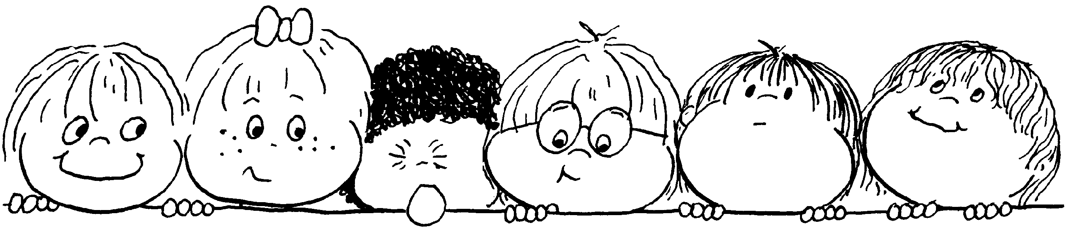
Class Schedule
Week 1  Week of January 8 | Overview  Review Syllabus and Website (both Chaminade’s and Dr. Iwamoto’s)  Assignments:  - Complete introduction (online assignment)  - Read Chapters 1,2 and 3  - Have you signed up for your O & P (Observation and Participation fieldwork)?
Week 2  Week of January 14 | What is Language Development?  Family Literacy  Assignments:  - Complete Online Assignment  - Read Chapter 4  - Work on projects
Week 3  Week of January 21 | Effective Listening  Assignments:  - Complete Online Assignment  - Read Chapter 5 and 6  - Work on projects
Week 4  Week of January 28 | Effective Speaking  Assignments:  - Complete Online Assignment  - Read Chapter 7  - Work on projects
Week 5  Week of February 4 | Emergent Literacy  Assignments:  - Complete Online Assignment  - Read Chapter 8 and 9  - Work on projects
Week 6  Week of February 11 | Promoting Independent Reading  Children’s Literature  Assignments:  - Complete Online Assignment  - Due: Journal Article Review – Post on website- Instructions to follow  - Read Chapter 10  - Work on projects
Week 7  Week of February 18 | Teaching Reading and Writing  Assignments:  - Complete Online Assignment  - Read Chapter 11  - Work on projects

Week 8  Week of February 25 | Technology and Literacy in the Early Childhood Classroom  Assignments:  - Complete Online Assignment  - Read Chapter 12 and 13  - Work on projects

Week 9  Week of March 4 | Designing and Managing an Effective Program  Assessment  Assignments:  - Complete Online Assignment  - Work on Projects
Week 10  Week of March 11 | Assessment  Pulling the course together  Assignments:  - Complete Final – Details to come  - Complete Final Online Assignment  - Due: Observation and Participation Field Work Write-Up  - Due: Language Arts Integrated Curriculum  - Due: Portfolio Self Review
All online assignments will be posted on Sundays. The online assignment is due that week on or before the next Sunday by 11:59 p.m. For example, if I post an assignment on January 14, the assignment is due no later than January 21 by 11:59 p.m. On your email message sent to me the time stamp sent must be posted before 11:59 p.m. or your assignment will be late.
The instructor will take off points for late assignments.

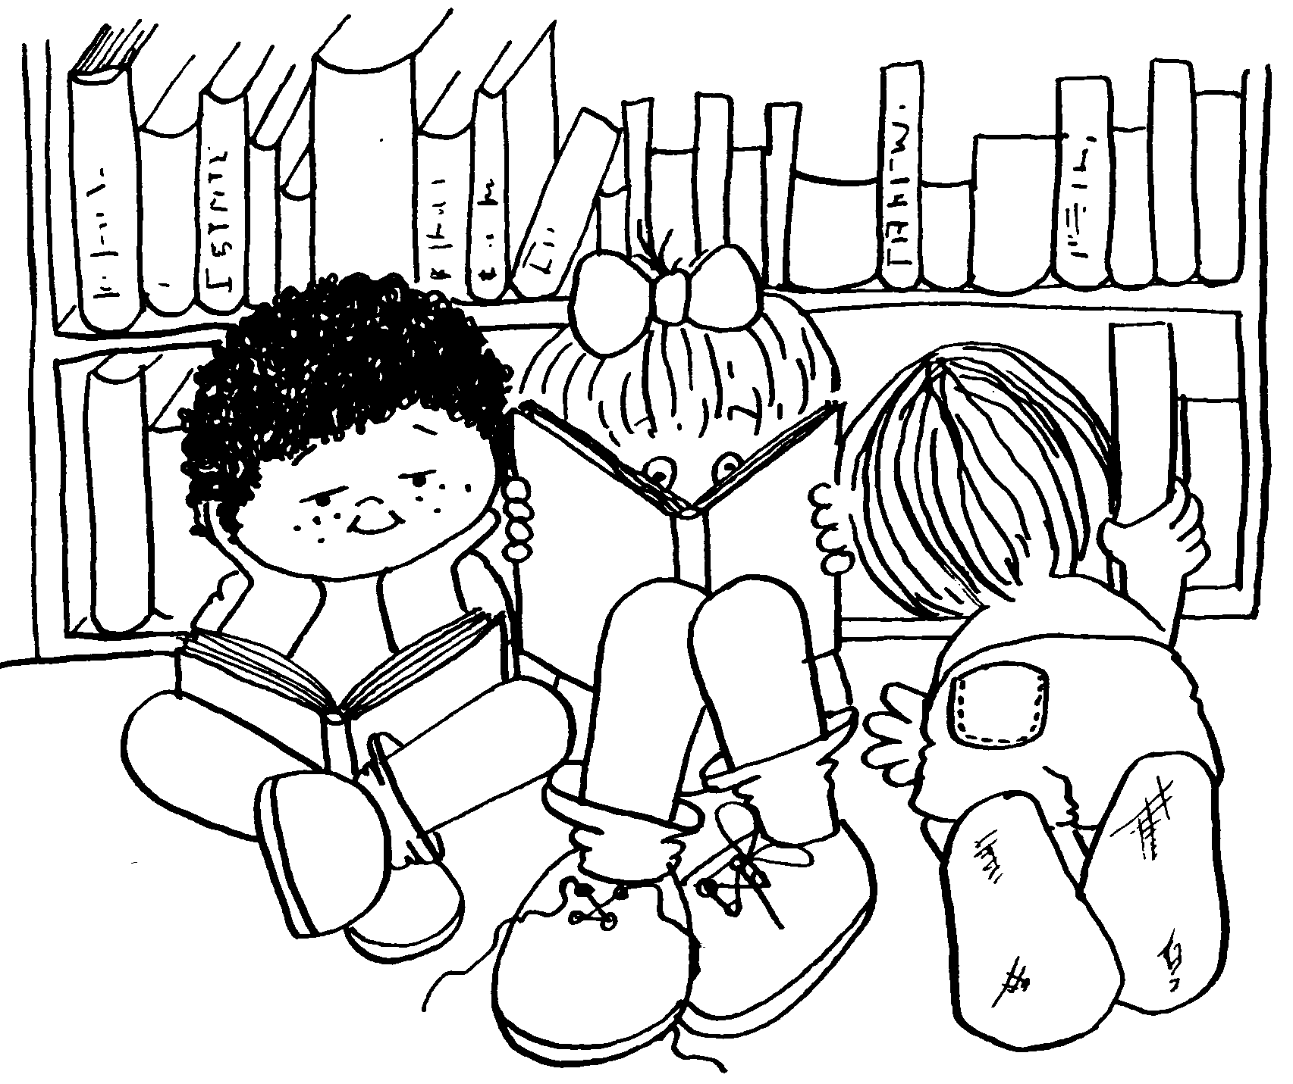
All assignments are due no later than
Sunday, March 18, 2006 by midnight. That includes mailed in assignments. Sorry no exceptions.

