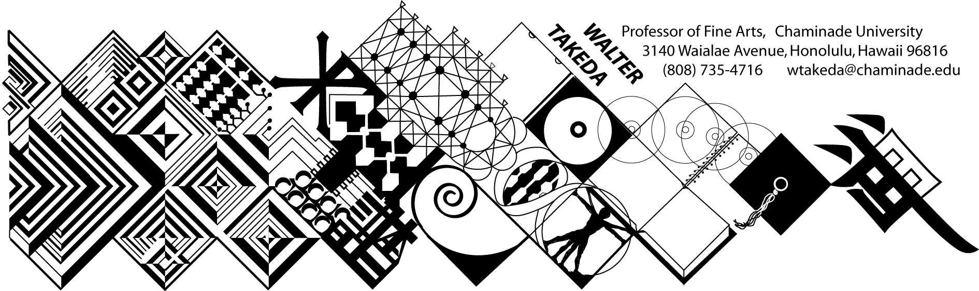
ART 202 Spr 2006
Survey of Art II
Tues/Thurs 8-9:20 am
Text: Art thru the Ages
Office Hrs: afternoons
or appointment: E205

Art 202 is a general survey course, with no prerequisites, that may be used to fulfill CUH's general education fine arts requirement or used as a liberal arts elective.
The material covers a survey of Western art, sculpture, and architecture from the Renaissance to present. In this age of frequent travel, you will undoubtedly have opportunity to visit many of the areas covered. Study of these cultures will result in a deeper understanding of this rich human legacy.
This class presents material in chronological order; you are expected to do parallel reading in your text. At the beginning of each class, a pool of slides will be shown of previous critical material. As much as possible, these works will be from the text. After each class, keep a list of this pool of slides, correctly spelled as to artist, title of work and school or style. Use this "mini-review" to good advantage; cramming for THIS class is a poor idea.
Before each exam is a thorough review of the material. Audiotaping this review helps many students.
Examinations will include objective questions (multiple choice, true/false), slide identification (artist, title, school), and a written comparative analysis (paper) between two works. Your ability to recognize artists and/or styles not in the review pool will take the test beyond mere rote memory.
MAKEUP EXAMS are a serious matter. Students will notify the instructor BEFORE the exam, then bring in a verifiable excuse, such as a service station invoice, doctor's slip, etc. It is the student's responsibility to abide by these two conditions and the instructor's prerogative to refuse a makeup. The makeup will be scheduled by the instructor, and if the student is again absent, he or she will be given a zero. In fairness to other students, a harder makeup exam will be administered; if it is at all possible to take the test on time, make every effort to do so rather than risk a more difficult exam. THERE IS ABSOLUTELY NO EXTRA CREDIT IN THIS COURSE! The instructor may extend to the entire class an alternative paper in lieu of a bad grade.
The student is obligated to abide by the conditions of this syllabus, the Chaminade catalog, and the Chaminade student handbook, and cannot claim ignorance of these conditions as an excuse.
GRADING SCALE: A:100-90, B: 89-80, C: 79-70, D: 69-60. Please note that this scale may be different from other instructors. Each exam, including the final, will be equally weighted.

The instructor reserves the right to adjust the schedule and contents of this syllabus, such as exam times or grading criteria or any other changes. Any announced change made in class is the student's responsibility.

TUESDAY | THURSDAY
Jan 10 Intro; Proto-Renaissance | 12 Italian Renaissance
17 Italian Renaissance; Int Gothic | 19 Early Flemish
24 High Renaiss: Leonardo, Raphael | 26 Michelangelo
31 16thC Mann, Ven; PAPER DUE | Feb 2 16thC German, Flemish
7 REVIEW: Italian Baroque | 9 FIRST EXAM
14 17thC Spanish; REWRITE DUE | 16 Dutch Realism
21 Dutch Realism | 23 French 17thC; Versailles
28 Rococo | Mar 2 Neoclassicism
7 Romanticism | 9 Romanticism; Realism
14 Impressionism; PAPER DUE | 16 Impressionism
28 Impressionism; REVIEW | 30 SECOND EXAM
Apr4 Post-Impress; REWRITE DUE | 6 Post-Impressionism
11 Picasso & Cubism | 13 Cubism & consequences
18 Dada & Surrealism | 20 European Expressionism, Action, Pop
25 Modern, Post-Modern architecture | 27 Post-Modern Review
FINAL EXAM – check schedule of courses

