Chaminade University
Fall Evening, 2005 (Oct. 3 – Dec. 16)
EN 315 BRITISH LITERATURE
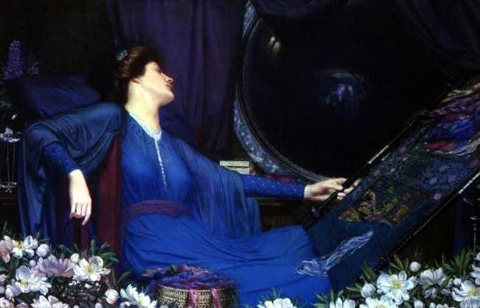 | S  Y  L  L  A  B  U  S
INSTRUCTOR: Christine Hansen ("virtual office." My virtual office is not as casual as the one for the lady above, though). I’m available anytime by e-mail at chansen@chaminade.edu or through the Web CT e-mail; available by phone at 262-2281).
TEXT: The Norton Anthology of English Literature: The Major Authors, Abrams et al, Norton, 7th ed., ISBN 0-393-96150-8.

I strongly suggest that you purchase the text, but if you can’t afford it, there are other options. For example, most of the primary texts are available online. In some cases, I’ve tried to provide suitable links for you, under the heading “electronic texts” for the relevant week. In some cases, you may need to find the links yourself.
WARNING: Do not accidentally purchase the regular Norton anthology. Be sure to get the “Major Authors” version.

COURSE DESCRIPTION:

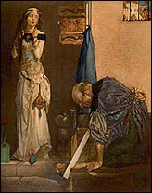English 315, Backgrounds in British Literature, provides students with a survey of British literature from its beginnings to the late 20th Century. The course centers on examining major works, including European backgrounds, spanning from Anglo-Saxon writing to Modernism and the 20th Century. The course also provides an introduction to critical theory and its application to literary study. The course is one of two "literary backgrounds" courses required of all English majors, yet open to English minors and non-majors as well. As is the case with all English courses, this one places a strong emphasis on the continuing development of research and writing skills. Students engage in online discussions and prepare essays for presentation to their instructor and to their classmates. The course features a discussion forum that enables an online learning community focused on course readings and the critical analysis of literature. By the end of the semester, students should feel that they have a clearer and deeper sense of the disparate origins of British literature and have substantially refined their analytical, research and writing skills.

COURSE GOALS:
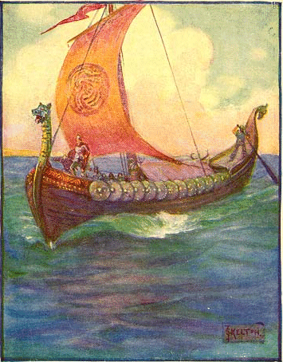By the end of the term, students who have been actively and consistently engaged in the course readings, discussions and other assignments, who have consistently developed and refined their insights via regular journal writing, and who have completed the required essays and research projects, should be able to: Understand and articulate the contexts in which British literature is studied; Evaluate and explain ethical and religious ideas that emerge in the study and discussion of British literature; Distinguish the major literary/intellectual movements, styles and authors that have evolved within and about the broad context referred to as "British" by outlining its chronological development from its beginning to the present; Identify and categorize various critical strategies used in the analysis of British literature; Apply insights about British literature to the preparation and delivery of interpretative statements to diverse readers (different ages, cultural backgrounds, etc.); Formulate questions grounded in concepts related to the study of British literature and direct them to instructor, classmates and diverse others; Summarize, critique and extend class discussions and related ideas about the concepts "Britain,"
"British" and "literature" ; Make qualitative distinctions among the wide variety of British literature research sources available via the Internet and libraries; Propose, execute and prepare research projects in British literature; Appropriately self-assess one's own insights and skills related to the study of British literature; Understand how language change affected British literature, and be able to pinpoint the various important junctures in the changing language and literature.

Grading
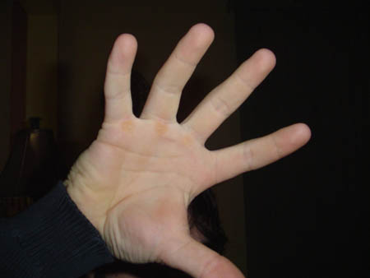
It’s really not so bad…☺

Discussion Board Participation: 20%
Essays: 2 @ 25% each = 50%
Final exam: 30%

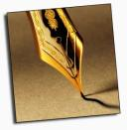 MORE ABOUT ESSAYS:
There are two required essays, worth 30 points each (60 points total). Criteria for grading will be based on student explanations that are clear, concise, and thorough and that begin with a thesis sentence articulating the main point of the essay, present arguments and relevant quotes from the text(s), and offer a suitable conclusion. Essays should employ the thesis/body/conclusion format and should display good critical thinking skills. This means that the writer not only needs to read the relevant texts and know the content, but to discuss them intelligently and offer opinions. The essay should not be a summary of the material, but a critical analysis of the material. Many students wonder how to choose a topic. The answer is to choose a topic that interests you. However, one paper must deal with a topic from Anglo-Saxon or Medieval literature, including Chaucer; the second paper must deal with one of our later readings (post-Chaucer). If you’re having trouble deciding on a topic, some suggestions might be to write about symbolism in some piece of literature; to examine the psychology of a character or group of characters; to consider feminist or multicultural themes in one of the readings; to compare and contrast heroic ideals in two works; what a piece of literature can reveal about a historical setting, or vice versa; to consider how biography can illuminate a piece of literature; and so on.

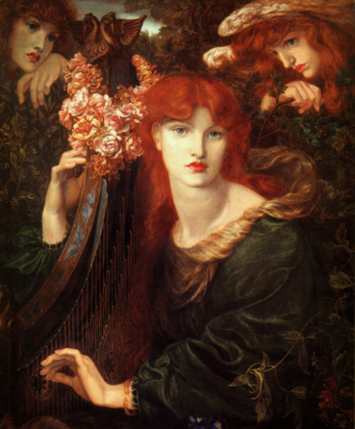 MORE ABOUT WEB CT DISCUSSION POSTINGS: Each week, students are required to submit a response on the Web CT Discussion Board to a weekly discussion question (see the syllabus for the question), and also to address some of the other students' postings. In general, students will post a minimum of 20 topical messages during the course. Web CT discussion postings are typically at least 50 words in length. The aggregate of your postings will count 20% of your final grade. Late postings will be marked down.

MORE ABOUT THE FINAL EXAM:
The final exam will consist of a multiple choice section, and an essay section. Yes, the multiple choice section will entail some work of review, since it covers all the material we have read for the term. The best way to prepare is simply by reviewing the readings and discussion board postings. The exam will be closed book.

EXTRA WEB SITE NAVIGATIONS:
Some units require you to navigate extra Websites. These sites will be listed under the appropriate unit in the “Schedule” section of this syllabus.

FINAL EXAM LOCATIONS:

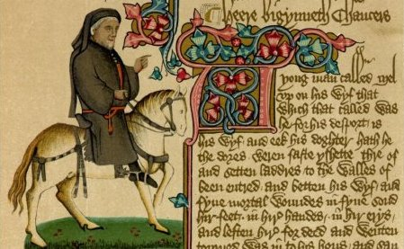

Students have the opportunity to take the final exam at different locations, including the main campus, satellite locations on Oahu, and off-island approved sites. You will have to make arrangements well in advance.
for off-island exams: CONTACT DONNA YOSHIMURA AT DYOSHI@CHAMINADE.EDU. THIS MUST BE DONE EARLY, TO ARRANGE FOR AN APPROVED TESTING LOCATION.
FOR satellite location EXAMS, RESERVE A SEAT AT THE SATELLITE LOCATION. YOU CAN CONTACT JON NAKASONE OR YOUR BASE COORDINATOR FOR FURTHER INFORMATION.
Please be advised that whether you need a satellite reservation or an approved off-island test arrangement, I am unable to make such arrangements. DO NOT CONTACT ME FOR SATELLITE TESTING ARRANGEMENTS OR FOR OFF-ISLAND TESTING ARRANGMENTS.

FINAL GRADES FOR OFF-CAMPUS STUDENTS:
Some students who take the final exam off-island or at a satellite campus will be issued a provisional grade. The reason for this is that the final exams do not always reach me before the grades deadline. Most instructors handle this by issuing all the off-campus students an “incomplete” grade, which is then removed after grading the exam. However, your student record permanently reflects both the Incomplete and the removal. For this reason, I prefer to issue a provisional grade, based on the student's work to date. Please be warned that if your exam is substantially different in quality from the rest of your work, this provisional grade may well have to be changed after I grade your final exam (if so, this will be done by issuing a Change of Grade form). Please let me know if you have any questions about this policy.

LOG-ON PROBLEMS / TECHNICAL DIFFICULTIES:


The technical advisor for our Web CT system is Jon Nakasone. If you experience log-on or other difficulties with the Web CT system, you should contact Jon immediately, at jnakason@netserver05.chaminade.edu

DISCUSSION BOARD ETIQUETTE:

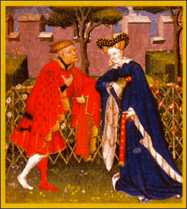 Please put your name in the title of every discussion board post. Never post new material under another post ("posting under" is only used to respond to someone else's original post).

SCHEDULE:

WEEK ONE (Oct. 3 – Oct. 9): Anglo-Saxon and Early Medieval Lit.

English is a Germanic language, and once had gender and inflection similar to that found in modern German today. Prior to the arrival of Christianity in Britain, Britain was pagan, and was settled by Celtic peoples. These peoples were displaced by Germanic tribes from the continent, such as the Angles and the Saxons (the word "England" is derived, in fact, from the term "Angleland.") During this time, Britain was characterized by great regional variability in language and culture, and many dialects. Anglo-Saxon poetry is the earliest literature in English. The first great poems of this period were recited orally, but poetry was later written down (in much the same way that Homer began to write down the oral epic poetry in Greece). These poems have a lovely cadence, and were recited orally (written literature was preceded by a long tradition of oral literature, and the surviving Anglo-Saxon works are the closest thing that remains of these oral achievements. As the Anglo-Saxon period merged into the early Medieval period, great changes occurred in the language and culture. Today, "Old English," the language of the Anglo-Saxons, can only be read today with special training or in translation (we will be reading it in translation). Also, the heroic, pagan culture of the Anglo-Saxons gradually transformed into the Catholicism of the Middle Ages. Some of these transformations, such as the waning of the pagan worldview and the ascendancy of Christianity, can actually be seen by a careful reading of the poems. Can you look for clues in the assigned readings?

Textbook reading: pp. xli-118 (NAEL -- Norton Anthology of English Literature)

Web CT Discussion Board Reading: See the additional poems under “Week One Lectures” on the Discussion Board.

This week’s discussion question: What are some of the inferences we can draw about Anglo-Saxon life and culture, based on readings of the poems, "The Wanderer," "The Seafarer," "The Dream of the Rood" and "Beowulf"? Post your answer by midnight on Sunday, Oct. 9.

Websites for this week:

1) Audio readings from Beowulf:
http://www.engl.virginia.edu/OE/Beowulf.Readings/Beowulf.Readings.html

2) The Wanderer audio reading:
http://www.engl.virginia.edu/OE/OEA/wanderer.html

3) It is worth navigating this entire site: http://www.regia.org/village.htm

4) An Anglo-Saxon village:
http://loki.stockton.edu/~ken/wharram/anglo.htm

Electronic texts:

1) Beowulf hypertext
http://www.humanities.mcmaster.ca/%7Ebeowulf/

WEEK TWO (Oct. 10 – Oct. 16): The World of Chaucer

Chaucer's world was dominated by the power of the Catholic Church, and permeated by themes like chivalry, courtly love, and pilgrimages. Canterbury Cathedral would have dwarfed a pilgrim. Here, a pot-bellied friar might have loped along; a jester would have felt at home; or a knight, or a pardoner selling false indulgences. Chaucer dealt with many such stock figures, using his literary skills to satirize their hypocrisy. The result is a combination of entertainment, scathing wit, and probing psychological insight, as he satirizes the personages of his time.

Textbook reading: pp. 119-259 (NAEL)

This week’s discussion question: What sort of character is the Wife of Bath? Post your answer by midnight on Sunday, Oct. 16.

Websites for this week:

1) A recitation of Chaucerian English (click on item #9 on the page, “The Wife of Bath’s Prologue” lines 1-29 read by Marie Borroff of Yale University. Other recordings of Chaucerian English are also available on the page, if you want to try them too):
http://www.wwnorton.com/nael/noa/audio.htm

2) Biography and essays on Chaucer: http://www.luminarium.org/medlit/chaucer.htm

3) Pilgrims Passing to and fro: The Lives & Times of the Canterbury Tales Pilgrims
http://www.godecookery.com/pilgrims/pilgrims.htm

Optional Web resources for this week:

1) Chaucer "metapage": http://www.unc.edu/depts/chaucer

2) Harvard Chaucer page by Larry Benson
http://www.courses.fas.harvard.edu/~chaucer/

3) Medieval clothing (part of an interesting Medieval site):
http://www.learner.org/exhibits/middleages/clothing.html

4) Medieval English towns
http://www.trytel.com/~tristan/towns/towns.html

5) Anthology of Middle English Literature: http://www.luminarium.org/medlit/

Electronic texts:

1) The General Prologue – An Electronic Edition
Middle English with popup translations by Edwin Duncan
http://www.towson.edu/~duncan/chaucer/index.htm

2) The Canterbury Tales in Middle English
Frames version with glossary by Librarius
http://www.librarius.com/

3) The Canterbury Tales in Modern Translation
http://www.litrix.com/canterby/cante001.htm

WEEK THREE (Oct. 17 – Oct. 23): Spenser and Marlowe

There was more to the Renaissance than just Shakespeare! Edmund Spenser is generally considered a Renaissance poet, despite the fact that he took many of his themes from the Medieval world (such as chivalry and romance), and despite the fact that even in his own day, his use of English was considered archaic. However, he is one of the great masters of English poetry. Marlowe, a playwright who died in his twenties, depicted a world of violence and action. He was one of several writers to deal with the Faust legend, concerning a man who sold his soul to the devil.

Textbook reading: pp. 315-338 (NAEL); Spenser, pp. 357-442; Marlowe, The Tragical History of Doctor Faustus pp. 456-491.

Web CT Discussion Board Reading: See the additional item under “Week Three Lectures” on the Discussion Board.

This week’s discussion question: Go to the Discussion Board to read the Discussion Question for the week, since it involves reading an excerpt from The Faerie Queene. Post your answer by midnight on Sunday, Oct. 23.

Websites for this week:

No required sites this week

Optional Web resources for this week:

1) Biography and essays on Edmund Spenser:
http://www.luminarium.org/renlit/spenser.htm

2) The University of Cambridge Spenser Page: http://www.english.cam.ac.uk/spenser/main.htm

3) An overview of Spenser and his work: http://www.oldarcadia.com/spenser_a.html

4) Biography and Essays on Christopher Marlowe:
http://www.luminarium.org/renlit/marlowe.htm

5) Biography of Marlowe:
http://www.marlowe-society.org/life.htm

Electronic texts:

1) The Tragical History of Doctor Faustus (Project Gutenberg)
http://www.gutenberg.org/etext/779

2) The Faerie Queene (Renascence)
http://darkwing.uoregon.edu/~rbear/fqintro.html

WEEK FOUR (Oct. 24 – Oct. 30): Shakespeare, Renaissance Women

Among our greatest thinkers is William Shakespeare, a man who apparently did not attend university and who died without world acclaim, as an actor and part-owner of a theater during an age when acting was considered a lowly profession. The range of Shakespeare’s plays cuts across dramatic genres, from histories to comedies to tragedies. In general, he is known for his psychological acumen and the universality of his observations about life, as well as for his remarkable innovation with the English language. As for Elizabethan drama, although it flourished under the patronage of one of the most remarkable and brilliant women in history, Elizabeth I, it is paradoxical that women were not allowed to appear on the Elizabethan stage. Even the most tender moments in Shakespearean drama, such as the famous balcony scene in Romeo & Juliet, were played by a male actor.

Textbook reading: pp. 350-357 (NAEL); Shakespeare pp. 492-575; Mary Wroth pp. 650-659.

This week’s discussion question: Why was Shakespeare so fascinated by themes of mortality, time, and the finite nature of human mortal existence? Consider the role that outbreaks of plague may have played in his worldview; Shakespeare’s only son, Hamnet, died during an outbreak of plague. Post your answer by midnight on Sunday, Oct. 30.

Essay #1 due by Sunday, Oct. 30. (See the “More on Essays” section of this syllabus)

Websites for this week:

1) Virtual tour of the Globe Theater:
http://search.eb.com/shakespeare/ind_globe.html

2) Shakespeare Timeline:
http://shakespeare.palomar.edu/timeline/summarychart.htm

3) Site on Elizabeth I: http://www.luminarium.org/renlit/eliza.htm

4) Picture and Biography of Lady Mary Wroth: http://darkwing.uoregon.edu/~rbear/mary.html

5) “The Plague”: http://ise.uvic.ca/Library/SLT/society/plague.html

6) “Bubonic Plague and Shakespeare”: http://www.william-shakespeare.org.uk/bubonic-plague-shakespeare.htm

Optional Web resources for this week:

1) Life in Elizabethan England: http://renaissance.dm.net/compendium/index.html

2) Shakespeare: Life and Times
http://shakespeare.palomar.edu/life.htm

3) 16th Century Renaissance English Literature: http://www.luminarium.org/renlit/

4) “How Catholic was Shakespeare”?
http://www.catholiceducation.org/articles/arts/al0147.html

Electronic texts:

1) All of Shakespeare’s plays are available online at http://the-tech.mit.edu/shakespeare/

WEEK FIVE (Oct. 31 – Nov. 6): The Metaphysical Poets, Milton

Milton is perhaps the most contradictory English poet; branded as overly-intellectual, he was both a Christian and a revolutionary. His epic work Paradise Lost is considered one of the great works in the English language.

Textbook reading: pp. 672-853 (NAEL)

This week’s discussion question: Describe the character of Satan in Paradise Lost. Post your answer by midnight on Sunday, Nov. 6.

Websites for this week:

No required Websites this week

Optional Web resources for this week:

1) Early 17th Century English Literature (Luminarium)
http://www.luminarium.org/sevenlit/index.html

2) John Milton (Luminarium)
http://www.luminarium.org/sevenlit/milton/

3) John Milton (Michael Bryson)
http://www.brysons.net/miltonweb/index.html

4) The Milton Reading Room
http://www.dartmouth.edu/%7Emilton/

Electronic texts:

1) Paradise Lost
http://darkwing.uoregon.edu/~rbear/lost/lost.html

WEEK SIX (Nov. 7 – Nov. 13): The Restoration and the 18th Century
Jonathan Swift was the Orson Wells of his day; just as Wells stirred up the nation with his dramatizations—causing some more naïve listeners to believe that Martians were invading the Earth—so some of Swift’s readers failed to appreciate his devastating wit for what it was. Probably the greatest satirist in English, Swift was also a passionate social activist, who cared deeply about the problems of his day, and felt no hesitation in pointing out political folly. Swift is just one of the interesting characters you will meet on this sojourn into Restoration literature.

Textbook reading: pp. 855-878 (NAEL); Dryden 904-915; Swift pp.
966-967 and 1113-1119; Pope 1119-1161; Samuel Johnson pp. 1196-1207 and 1259-1265; Boswell pp. 1273-1281.

This week’s discussion question: What do you think of Swift's techniques to move social conscience? Post your answer by midnight on Sunday, Nov. 13.

Websites for this week:

No required Websites this week.

Optional Web resources for this week:

1) Restoration Drama:
http://www.theatrehistory.com/british/restoration_drama_001.html

2) Jonathan Swift
http://www.heureka.clara.net/art/swift.htm

2) Biography of Pope:
http://encarta.msn.com/encnet/refpages/RefArticle.aspx?refid=761556104

3) Samuel Johnson site: http://www.lichfield.gov.uk/sjmuseum/

4) John Dryden site:
http://www.imagi-nation.com/moonstruck/clsc76.html

Electronic texts:

1) Jonathan Swift online http://onlinebooks.library.upenn.edu/webbin/book/search?amode=start&author=Swift%2c%20Jonathan

2) “A Modest Proposal” by Jonathan Swift
http://www.gutenberg.org/etext/1080

WEEK SEVEN (Nov. 14 – Nov. 20): The Romantic Period

Usually regarded as one of the most fascinating and enigmatic periods in literary history, the Romantic Period saw the ascendance of British poets to the vanguard of revolutionary artistic change. In general, the Romantic poets were iconoclasts. They saw that the new industrialism sweeping Britain was the leading edge of an unprecedented dehumanization; and they were committed to opposing it. The Romantic poets focused on recording and illuminating the beauty of the natural world, and argued that our deepest human potential is in tune with nature. They believed in the power and dignity of the emotions. They overthrew old structures, including rigid rhyme schemes; yet paradoxically, a few of the greatest Romantic poets (like Wordsworth and Percy Shelley) also wrote some sonnets.

Textbook reading: pp. 1313-1335, pp. 1359-1360, 1388-1449,
1490-1491 (through "The world is too much with us"), pp.1499-1513, 1573-1598 (through the end of "Kubla Khan") pp. 1623-1635, 1636-1639, 1640-1645 (beginning with "She walks in beauty"), pp. 1710-1712,1714-1720 (through the end of "Ozymandius") pp. 1768-1796, 1814-1816 ("La Belle Dame sans Merci"), pp. 1819-1822 ("Ode on a Grecian Urn"). (NAEL)

This week’s discussion question: Why do you think the Romantic poets were so interested in nature, and treated natural surroundings with an almost religious sense of awe? Post your answer by midnight on Sunday, Nov. 20.

Websites for this week:

1) This single site is very comprehensive, and should provide everything you need:
http://andromeda.rutgers.edu/~jlynch/Lit/romantic.html

WEEK EIGHT (Nov. 21 – Nov. 27): The Victorian Period

Textbook reading: pp. 1859-188 Tennyson 1916-1933 (through "The
Eagle") Arnold 2073-2091 (through the end of "Dover Beach") Rossetti
2134-2152 (through the end of "Goblin Market") Hopkins 2155-2163 (through the end of "Spring and Fall") Hardy/Conrad pp. 2271-2363.

This week’s discussion question: Analyze Christina Rossetti's "Goblin Market." What is about? Post your answer by midnight on Sunday, Nov. 27.

Websites for this week:

No required Websites this week.

Optional Web resources for this week:

1) Comprehensive site on the Victorian Period:
http://65.107.211.206/victorian/

2) Search individual Victorian authors at:
http://www.humanitiesweb.org/cgi-bin/human.cgi?s=l

3) What is the Heart of Darkness? Site at: http://www.stfrancis.edu/en/student/kurtzweb/darkness.htm

4) Site on Hopkins: http://kildare.ie/community/Hopkins/

Electronic texts:

1) Heart of Darkness
http://www.gutenberg.org/etext/526

WEEK NINE (Nov. 28 – Dec. 4): Recent British Literature

Textbook reading: W.B. Yeats pp. 2363-240 Joyce pp. 2496-2524 T.S. Eliot pp. 2604-2644 Dylan Thomas pp. 2697-2703 and Salman Rushdie pp.
2737-2748.

This week’s discussion question: What is Yeats' poem "The Second Coming" about? What kind of society does it depict? Post your answer by midnight on Sunday, Dec. 4.

Essay #2 due by Sunday, Dec. 4. (See the “More on Essays” section of this syllabus)

Websites for this week:

No required Websites this week.

Optional Web resources for this week:

1) Dylan Thomas site:
http://encarta.msn.com/encnet/refpages/refarticle.aspx?refid=761564383

2) William Butler Yeats site:
http://www.theatlantic.com/unbound/poetry/yeats/bogan.htm

3) James Joyce site:
http://www.facstaff.bucknell.edu/rickard/Joyce.html

4) T.S. Eliot site:
http://www.poets.org/poets/poets.cfm?prmID=18&CFID=14069146&CFTOKEN=30817950

5) Salman Rushdie site: http://www.subir.com/rushdie.html

WEEK TEN (Dec. 5 – Dec. 16): Review

Textbook reading: There is a lot of reading in this course. You should use this week to review thoroughly for the final exam. In addition to testing your comprehension of some material, the final will also contain questions to ensure that you have completed all of the assigned readings.

This week’s discussion question: What was your favorite reading this term, and why? Post your answer by midnight on Sunday, Dec. 11.

CHAMINADE’S DIVERSITY STATEMENT:
Chaminade's "Core Beliefs Statement" says, "Students, both traditional and non-traditional, bring a variety of talents, traditions, cultures and abilities. This diversity brings a special opportunity to the Chaminade community, which can then nurture and guide each student to the fullest realization of potential." Consequently, this course encompasses readings that both reflect and examine the diversity of our literary heritage. Additionally, the course puts special attention on the problems faced by authors seeking to write from unique personal or cultural perspectives to readers who may not share the same perspectives or cultural background.

ACADEMIC HONESTY AND PLAGIARISM:
All material submitted in fulfillment of course requirements must be written by the registered student. While students are strongly encouraged to consult sources outside the required reading of the course, they are also responsible for clearly stating the nature of their sources. Statements of "common knowledge" are generally exempt from this scholarly requirement.
Plagiarism is defined as the presentation of someone else's ideas as your own. Plagiarism in this course will result in a grade of "0" for the assignment and possible failure for the course. If the instructor suspects plagiarism, the burden of proof of the originality of the writing lies with the student. Evidence of originality would include copies of early drafts of the writing, research and interview notes, as well as the ability to discuss the themes of the writing with the instructor. Students should consider their instructor's vigilance in such matters a normal part of the academic process and should be prepared to present evidence of originality if requested. Students are strongly advised to save files of early drafts of essays, along with outlines, research notes and other supporting documentation, as the instructor may at any time require that they be presented.

