Chaminade University Ed 413 Children’s Literature
Instructor: Dr. Vickie V. Iwamoto Fall 2005 - Online

Email: viwamoto@yahoo.com
Course Outline

Goal

The goal of this course is to present an introduction to children’s literature. Content includes an overview of the history of children’s literature and will focus on contemporary works and authors and illustrators of books for children. ED 413 is designed to help the classroom teacher understand children’s books in all genres, and examine criteria for evaluation children’s literature. The development of ideas to promote/ use children’s literature both in the classroom and for recreation reading will also be discussed.

Course Objectives

- Students will develop and apply criteria for selecting and evaluating quality books to share with children.

- Students will read, respond and evaluate children’s books as they relate to the developmental needs, reading preferences and interests of children at different ages (from birth through grade eight).

- Students will develop an understanding of the value of children’s literature and its importance in the elementary school curriculum.

- Students will be able to explain the issues and trends in children’s literature through class discussion and sharing of picture books, poetry, novels, information books and biographies. Multicultural stories and issues will be included in each genre.

- Students will synthesize educational journals, resources book, educational technology and other professional materials relating to children’s literature.

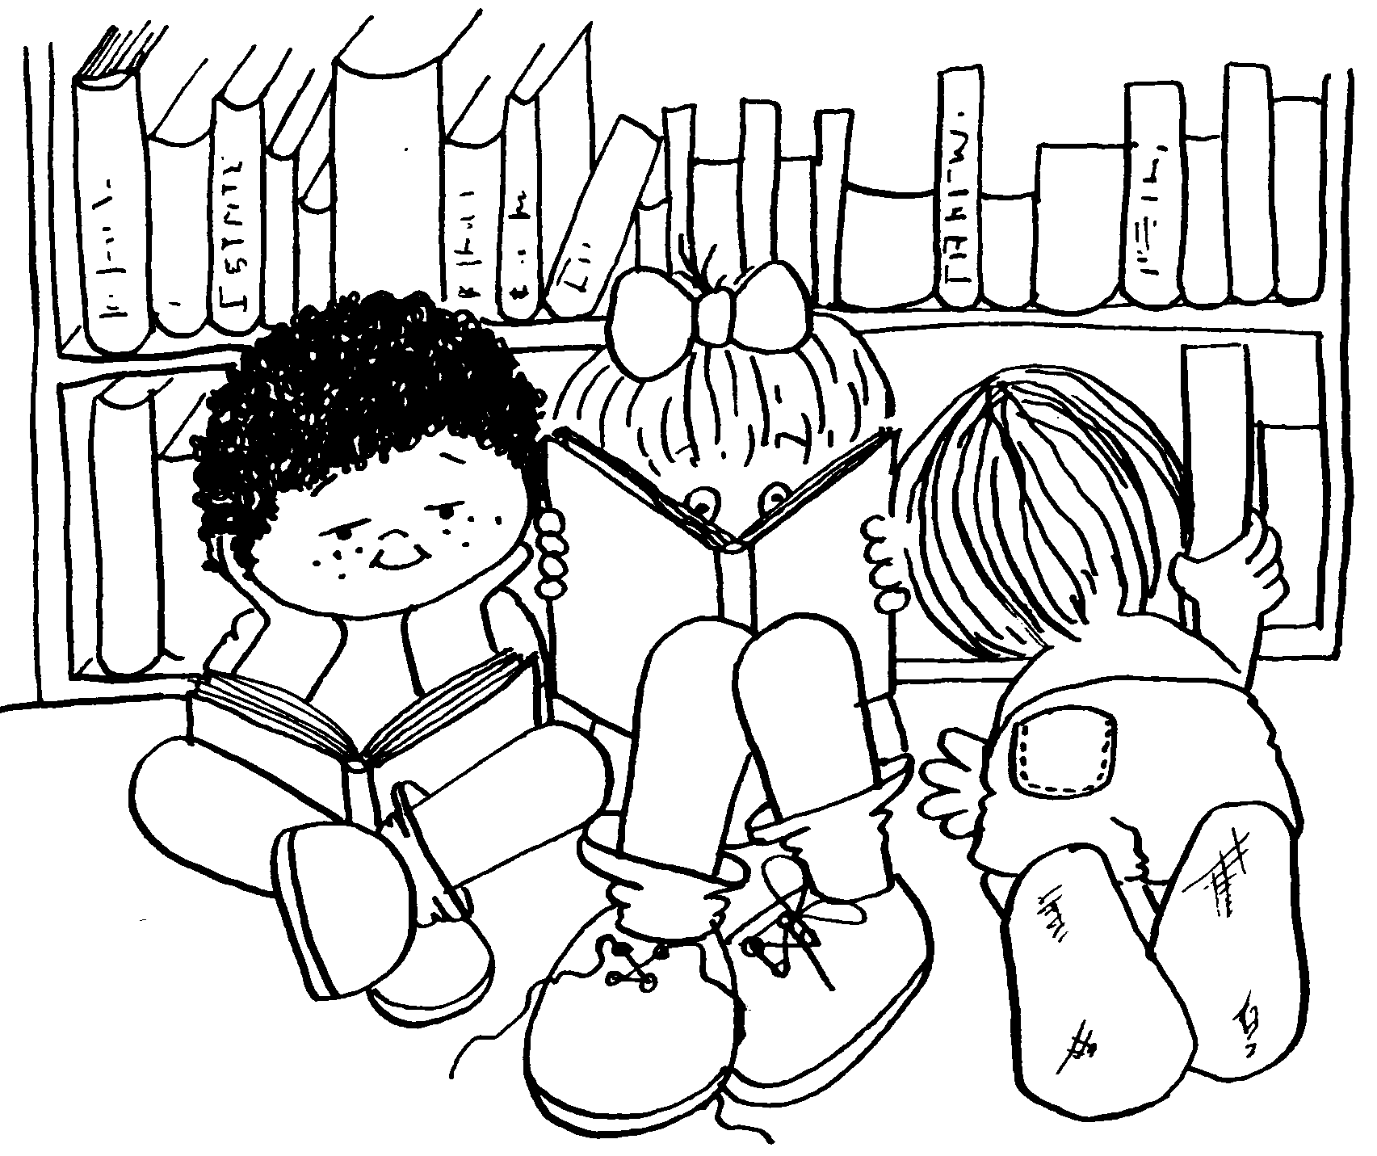
Course Requirements
Materials:
- Text: Children’s Literature Briefly, Tunnell, Michael, James S. Jacobs. (1997) Prentice-Hall Publishers. ISBN 0-13-096214-7

Requirements
Learning Experiences
Book Card File/Author Information Collection 20
Online Weekly Assignments (10 assignments at 10 points each) 100
Independent project (APA format) 25
Final Exam (Reflection piece) 10

Grading System: Based on a total of 155 points, letter grades are as follows:
155-140 = A, 124-139 = B, 108-123 = C, 82-107= D, 81 and below = F

Assignments and Projects:
All submitted assignments are expected to be word-processed and of the quality appropriate for undergraduate study. At least ten percent (10%) of the possible points will be deducted for sloppy, or careless, work. Take the time to proofread your assignments to make sure they are free of typographical and/or grammatical errors. Do not combine several assignments into one. Each assignment is to be submitted as an independent assignment and will be assessed as such. The instructor reserves to right to return, not graded, all work that does not meet this standard.

Late Policy:
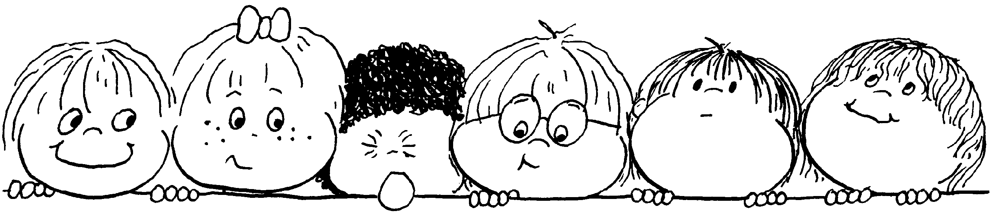
Assignments submitted late will be penalized at least 20% of the total possible points. A late project is defined as one that was not submitted by the established deadline.

Learning Experiences

Book Card File/ Author Information Collection
Read a minimum of 40 books from lists in your text. Each book should be for children from birth to age fourteen. The books do not have to be listed in your textbook. For example, you can add books from Hawaii’s authors. At least five of the books should be for the more mature reader (i.e. Newberry award winners and Honor Books-- see textbook for a list). All books should be saved on disk and should be in a logical order so that you can find them at a later time. Points will be given for details and for organization. The disk will be mailed to me and you will also keep a copy. This project may be too large to email to me. Please do not add any graphics. Your text includes a CD Rom, which has a large database. This also can be of help to you. All should use the following format:
Title Genre
Author/Illustrator Approximate Age Span
Publisher Number of Pages

Copyright Date
ISBN #
Summary of Plot
Personal Notation
Evaluation

Information should include:
a. Author and title
b. Genre/ type of book
c. Bibliographic information (also include the original publication date)
d. Assessed and/or recommended age/grade range of the book
e. Interest level and reading level
f. A short (3-4 sentences) plot summary--should be specific enough to call the book to mind.
g. Personal notes for using a book, such as an example of strong use of a literary element, protagonist/antagonist, curriculum possibility, whether it is good for, reading aloud, individual reading or teaching concepts, list any possible problems.
- Evaluation

Independent Projects
Develop your own project concerning children’s literature. Look through your textbook. Which areas are you draw to? The appendix sections also may help. Prepare a written description of your project and present it to the instructor for approval and suggestions by the third week of class. The purpose of the independent project is to provide an opportunity to delve into something of interest to you. Choose something you can have fun with and enjoy doing. Remember that the independent project assignment should be typed and double-spaced, references should be cited (in APA format) and it is expected that written assignments will be organized and grammatically correct.

Here are a few examples:
Author / Illustrator Research
Review literature (including professional journals) on an author/ illustrator of children’s literature books. For this assignment you will prepare your research for an oral presentation to your class. Though you do not have to video tape it, you may wish to. Give biographical information, books published (both in and out of print), current publisher and unique anecdotes that characterize the individual.

Book Talk
Choose a book for you Book Talk (chapter book for the more mature reader). Review resource materials on book talks for effective strategies and hints (see text p. 233). Include title, author, publisher, and grade level. Use materials that you feel would make your presentation powerful. Remember that the purpose is to make your audience want to read the book (a tickler). Bring something to show (the book, item from the story, etc.) You will have a short written report along with videotaping yourself presenting the Book Talk. You do not have to have an audience.

Journal Article Abstract
Review journals in the field of education that publish articles on children’s literature. Choose four articles that you feel are significant. Prepare a paper giving bibliographical information, an abstract and an explanation as to your choice of each of the articles.

Syllabus: ED 413
Children’s Literature

Week 1 Introduction
Week of October 2 Preview course requirements, syllabus and textbook
Chapter 1
Assignments:
- Read Chapter 1, 2 and 3
- Complete Online Assignment

Week 2
Week of October 9 Chapter 2
Chapter 3
Assignments:
- Read Chapter 4, 5 and 13
- Description of Independent Project
- Complete Online Assignment

Week 3
Week of October 16 Chapter 4
Chapter 5
Chapter 13

Due: Description of Independent Project
Assignment:
- Read Chapter 6, 7, 15 and 16
- Complete Online Assignment

Week 4
Week of October 23 Chapter 6
Chapter 7
Chapter 15 and 16
Assignment:
- Read Chapter 8 and 14
- Complete Online Assignment

Week 5
Week of October 30 Chapter 8
Chapter 14
Assignment:
- Read Chapter 9
- Complete Online Assignment
Week 6
Week of November 6 Chapter 9
Assignment:
- Read Chapter 10 and 11
- Complete Online Assignment

Week 7
Week of November 13 Chapter 10 & 11
Assignment:
- Read Chapter 12
- Complete Online Assignment

Week 8
Week of November 20 Chapter 12
Literature Circles
Assignment:
- Read Chapter 17, 18 and 19
- Complete Online Assignment

Week 9
Week of November 27 Chapter 17, Chapter 18 and Chapter 19
Reader’s Theater
Assignment:
- Work on Independent Project
- Finish Book Card File
- Complete Online Assignment
- Read Chapter 20 and 21

Week 10
Week of December 4 Course evaluation
Due: Complete Book Card File and
Independent Project
Assignment:
- Complete Final Online Assignment
- Complete Online Assignment 10

All online assignments will be posted on Sundays. The online assignment is due that week on or before the next Sunday by 11:59 p.m. For example, if I post an assignment on October 9, the assignment is due no later than October 16 by 11:59 p.m. On your email message sent to me the time stamp sent must be posted before 11:59 p.m. or your assignment will be late. The instructor will take off points for late assignments.

All assignments are due no later than
Sunday, December 11, 2005. That includes mailed in assignments. Sorry no exceptions.

