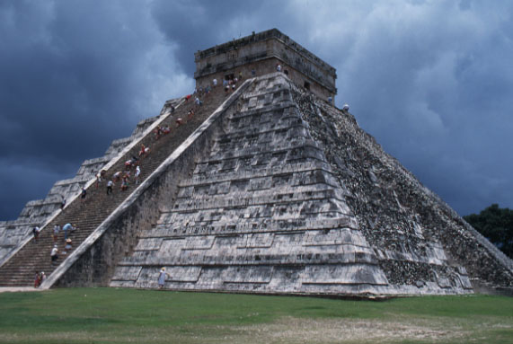

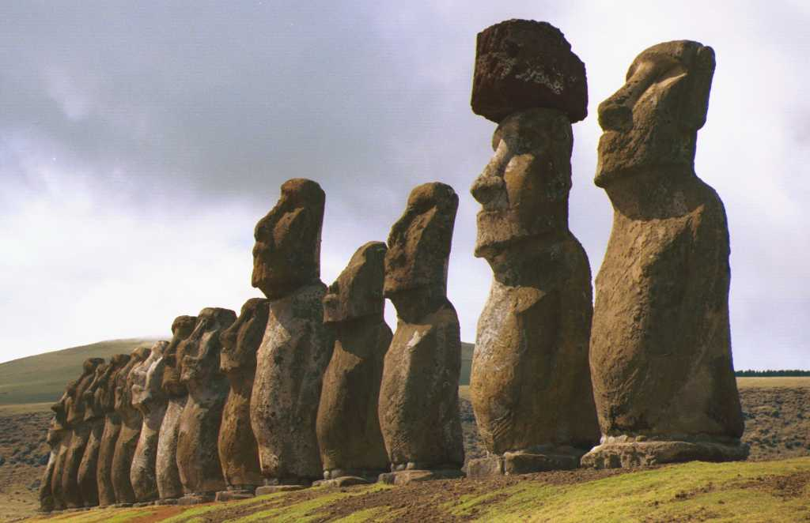
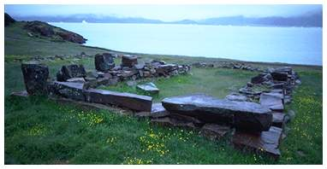

Lost Civilizations and the Role of Environmental Degradation
Fall 2005
Dr. Gail Grabowsky

A thing is right when it tends to preserve the integrity, stability and beauty of the biotic community. It is wrong if it tends otherwise.
Aldo Leopold

The material substances of our bodied live on in the plants and animals, just as our bodies are composed from minute to minute of substances that once were parts of other animals and plants, stretching back through time to prehistoric ferns and reptiles, to ancient biota that floated in the primal seas of earth. Our kinship with all earth creatures is global, linking us to the whole living Gaia today. It also spans the ages, linking our material substance with all the beings that have gone before us on earth even to the dust of exploding stars.
Rosemary Radford Ruether

Everything the Power of the World does is done in a circle. The Sky is round and I have heard that the earth is round like a ball and so are all the stars. The Wind, in its greatest power, whirls. Birds make their nests in circles, for theirs is the same religion as ours. The sun comes forth and goes down again in a circle. The moon does the same, and both are round.
Even the seasons form a great circle in their changing, and always come back again to where they were. The life of a man is a circle from childhood to childhood and so it is in everything where power moves.
Black Elk.
ENV 380: Lost Civilizations and the Role of Environmental Degradation

Fall 2005

Course Introduction

Instructor: Dr. Gail Grabowsky

Address: Behavioral Sciences Building, room 107
Environmental Studies
Chaminade University
3140 Waialae Ave
Honolulu, HI 96816

Phone: 735-4834 (ext. 834 if calling from on campus)

E-mail address: ggrabows@chaminade.edu

Office hours: T: 2:00 – 4:30; Th: 2:00 – 4:30; F: 1:00 – 4:30; or by appointment

Environmental Studies Program Student Learning Outcomes:
This course is not one of those that is required for a major, minor or certificate in Environmental Studies at Chaminade University. It is being offered out of the Environmental Studies Program on a one-time only basis because a wonderful new book, Collapse, was just published by Pulitzer Prize winning author and scientist Dr. Jared Diamond, and because the topic of the book, and therefore the course, is timely and intriguing. Because the course is offered by the Environmental Studies Program, it will nevertheless complement in many instances a number of the Environmental Studies Program Learning Outcomes. These are the following:

The Environmental Studies student will demonstrate an understanding of:

- The central importance of spirituality and worldviews in the “environmental movement”
- Problem-solving skills from diverse disciplines for diverse populations
- Scientific reasoning and methodology
- The roles and importance of laws, politics and economics in environmental issues
- Relevant written and oral communication skills
- Computer literacy
- The major environmental issues and their potential solutions
- The importance of the environment in our own health and well being
- Career opportunities in the environment

Course description:
This one-time only course is intended to inspire its participants to consider whether modern western civilizations are conducting themselves in ways that could lead to their demise due to environmental degradation. The discussion of this issue will be guided by Pulitzer Prize winning author Jared Diamond’s new book: Collapse which discusses this issue and looks into past societies that have collapse for clues to their demise. Diamond concludes that a number of these collapsed civilizations failed because they had developed unsustainable long-term relationships with their environment.

Introduction:
I am oersonally very excited to teach this course because this book has received rave reviews. One reviewed from the top scientific journal: Science concluded his review of Collapse by saying this may be the most important book you read in lifetime [emphasis mine]. That is a pretty amazing statement from a regular book reviewer. I have read most of Diamond’s prior Pulitzer Prize winning book: Guns, Germs and Steel which explains why western civilization dominates today (and his answer is not that western civilization was better than any other!). We are going to watch a video series summarizing this former book because I feel it is a good introduction to reading Diamond’s latest book: Collapse.
I think most of you will really enjoy this book and this course as Diamond is, in my opinion, one of our most amazing living minds. He sysnthesizes amazing amounts of information in very creative ways.
I would like to encourage you all to do a number of behavioral things in order to be successful in this course grade-wise and in order to enjoy this course maximally. These are:

- KEEP UP WITH THE READING!!! This paramount to your success and enjoyment. To motivate you I will give you unannounced pop quizzes! ☺ You simply must keep up with the reading. I have assigned only about 5.4 pages a day of reading…that’s 38 pages a week or 20 pages prior to each class. You can do it! It’s not much!
- Attend class…missing discussions in a discussion class is a VERY bad idea as there are few notes taken, so there is little record of what you missed.
- Share your thoughts. Tell us what you think. Think. Try and discover and learn all you can from Diamond’s thoughts. Try and draw your own conclusions and form your own opinions. Share all these with the class.
- Keep up with the three major assignments in the course … I will explain these as they come up.

Course Learning Outcomes:
When a you complete this course you should:
- Know some past civilizations that have failed
- Understand some of the hypothesized reasons why some failed civilizations may have failed
- Understand the general importance of environmental health to the stability of all civilizations
- Be familiar with how modern western civilization may be making potentially lethal environmental mistakes that could lead to the failure of this civilization
- Know some of the proposed solutions for avoiding the failure of modern western civilization due to environmental degradation
- Come up with some solutions to the environmental degradation Diamond points out is currently occurring
- Demonstrate “Passion Power” for the environment and Marianist values through service learning
- Demonstrate writing competency
- Demonstrate competency in preparing and giving a Power Point presentation
- Demonstrate the ability to put together a portfolio expose using written, visual and other media in a creative way

Course Requirements:
Your grade will be based on the following assignments. Each of the items/activities listed below will be described to you in writing or orally in class. The dates of each activity (or its parts) are indicated on the Schedule portion of this syllabus with the exception of the service learning activities and dates which are presented to you in a separate Service Calendar.

Lecture Grade:
- Pop Quizzes on the reading
- Lost Civilizations Presentation
- Our Own Bad Practices Essay
- A Single Solution Portfolio
- Service Learning/Term Paper
- Final Exam

The proportion that each contributes to your grade in this course is as follows:

Pop Quizzes 15%
Lost Civilization Presentation 15%
Our Own Bad Practices Essay 15%
A Single Solution Portfolio 15%
Service Learning/ Term Paper 15%
Final Exam 25%
100%
Grading:
Pop quizzes and the final exam will be graded on a curve with the mean being a B-/C+. The Presentation, Essay and Portfolio will be graded based on: (1) Effort, (2) Thoroughness, (3) Correctness, (4) Organization, and (5) Creativity. Service learning is graded based on how many service outings you completed; four service activities earns you an A for that portion of the course, three service outings earns you a B, two a C, one a D, zero and F.

Required texts:
Diamond, Jared. 2005. Collapse: How Societies Choose to Fail or Succeed. Viking Press.

Other readings and exercises may come from outside sources. These will be provided to you as the course proceeds.

Some Course Specifics:
Service Learning Option:
In this course you will have the opportunity to work in the community and/or in the field and do a variety of environmentally-related activities. These activities may involve teaching others about environmental issues, helping out at environmentally-related events, designing an environmental research project or helping out “in the field” as we try to restore native ecosystems, document the state of particular ecosystems, etc. These activities are all “Service Learning” opportunities. They are all fun – experience has taught me this, my students always get a lot out of them, and they are all educational in a way that pertains to the course. If you do four service outings (20 hours) then you do not have to do the term paper and you receive an automatic A for that 20% of your lecture grade.
Service learning activities occur in conjunction with one of a number of environmental groups or “NGO’s”: non-governmental organizations. The groups I use for service learning have been carefully chosen by myself because (1) I believe they have a worthy and justifiable environmental mission, (2) they do things that provide opportunities for education for you.

Term Paper:
The term paper is a 15 – 20 page double-spaced, word-processed paper about an issue that we discussed in class related to our reading of Collapse. Your term paper topic must be approved by Dr. Gail. If you neglect to have it approved it will not receive a passing grade. The paper is due on the day of the final exam. It must have three hardcopy references and one of these must be original scientific research from a peer-reviewed scientific journal. Do not plagiarize your term paper. I am very good at discovering plagiarism. If you plagiarize any part of your paper you will not receive a passing grade for this course.

Extra Credit Options:
Periodically throughout the course there will be talks you may attend that pertain to the course material. I will let you know when these opportunities arise. If you choose to attend you will earn +1.5 extra credit points towards a lecture exam. If you do more than the four required service activities then you’ll receive extra credit for those outings you do after your fourth (+3 per trip). You may not do the term paper as extra credit, if you do a term paper it is for the grade (for that 20% of the course). You may do a term paper and count any service activities you do as extra credit.

Attendance:
While I dearly hope that you can make every class…, since you are adults now, you are free to miss any lecture class you choose… but KNOW that there may be some consequences should you choose to exercise this option: your grade could (and most likely WILL) suffer. I believe that students who have missed a lot of classes ALWAYS would have done better if they had not missed classes. There simply is no substitute for being in class when it comes to understanding the material. I can give you a fishing pole, but I cannot make you fish.
If you miss a lecture exam or lab your absence must be excused if it is not to formally effect your grade. Excused absences occur when you bring in a doctor’s note, a funeral announcement for a family member, notice of participation in athletic events, etc. Unexcused absences occur when you were working, surfing, sleeping, cramming for an exam in another class, etc.

If you are handicapped under the Americans with Disabilities Act:
Chaminade will provide assistance for any student with documented disabilities. You must contact Dr. Don Kopf ph# 735-4845 or Dr. June Yasuhara ph# 739-4603 at the counseling center (office is next to security) in order to determine if you meet the requirements for documentation as being disabled under ADA.

Classroom Atmosphere:
Guys, I value a very open, yet courteous class atmosphere. Express your ideas! Ask your questions! (The only dumb question is the one in which you ask yourself if you should ask your question.) Respect the thoughts and ideas and opinions of others – really think about what others say. Let them fully express their thoughts and ideas and then you do the same. The thing I value most from my college days are all the wonderful, valuable, diverse ways of looking at and understanding the world that I was exposed to. Be an open vessel – take ideas in! You will learn as much from each other as you do from me.

This syllabus and course schedule are living documents: they are free to change. I try to adhere as closely as possible to them for your convenience, but there will be times in which we will take longer on a particular topic or add or delete a topic to enhance the course. I like to be able to react to you as the course proceeds and go with the flow a bit in order to make the course experience sort of custom fit to you!

You are responsible for all of the information in this document: losing it or not reading it are NOT excuses for not knowing what’s in it! USE IT to keep you organized!!!


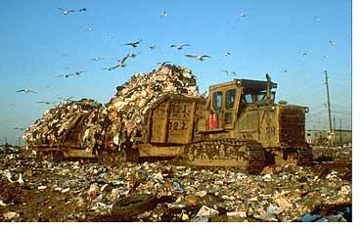

ENV 380: Lost Civilizations and the Role of Environmental Degradation

Course Schedule

Week of: Readings & Activities

8/22 – 8/26 Course Introduction; Pre-Book Readings (copy provided); Video:
Guns, Germs, and Steel

8/29 – 9/2 Prologue; Chapter 1

9/5 – 9/9 Chapter 2; Introduce Lost Civilizations Presentations

9/12 – 9/16 Chapters 3 & 4

9/19 – 9/23 Chapters 5 & 6; Deliver Lost Civilizations Presentations

9/26 – 9/30 Chapter 7

10/3 – 10/7 Chapters 7 & 8

10/10 – 10/14 Chapter 9; Assign Our Own Bad Practices Essay

10/17 – 10/21 Chapter 10 & 11

10/24 – 10/28 Chapter 12; Our Own Bad Practices Essay Due

10/31 – 11/4 Chapter 13

11/7 – 11/11 Chapter 14; Assign A Single Solution Portfolio

11/14 – 11/18 Chapter 15 & 16

11/21 – 11/23 Chapter 16; A Single Solution Portfolio Due

11/28 – 12/2 Conclusions and Synthesis

The Final Exam for this class is on Tuesday, December 6 from 12:45 – 2:45 in our classroom.

