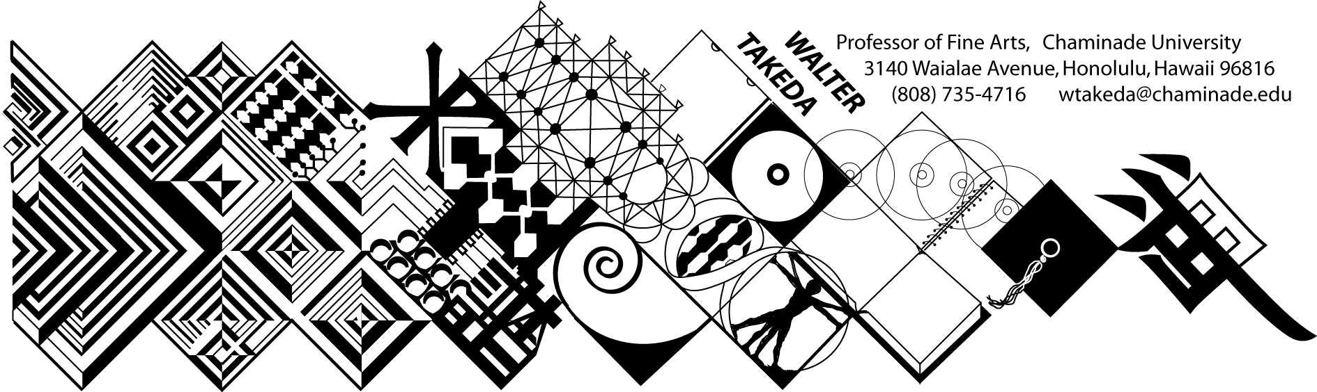
ART 201 – Fall 2005
Survey of Art I
Tues/Thurs 8-9:20 am
Henry 104
Text: Art thru the Ages
Office Hrs: afternoons
or appointment: E205

COURSE DESCRIPTION: Art 201 is a general survey course that may be used to fulfill Chaminade's fine arts requirement of the general education core; it is also a requirement for the BFA major. There is no prerequisite for this course.
The material covered in this course includes a survey of Western art from Paleolithic to the Gothic period, as well as Asian art. Art 202, for which this course is not a prerequisite, continues from the Renaissance to contemporary art.
In this age of frequent travel, you will undoubtedly have some opportunity to visit areas where there are considerable works of art. It is hoped that this course would make these trips more meaningful and life-enhancing. Involvement in the rich endowment of human artistic endeavors is a vital part of one's college and life experience.

ATTENDANCE will be taken for administrative purposes but will not affect your grade, which is based solely on your test performance. Attendance is ABSOLUTELY MANDATORY on scheduled exam days. Attendance is particularly crucial in this class; it is categorically impossible to do well just be relying on the text.

HOW TO STUDY FOR THIS COURSE: Each day material will be presented with slides. At the beginning of each class, the instructor will show accumulating slides from previous lectures for which you will be responsible. Whenever possible, these mandatory slides will come from the textbook. Hence, be on time and take meaningful advantage of these "mini-reviews" at the beginning of class. Keep an ongoing list of these works. Do parallel reading in the text. Note how the instructor wants the periods broken down. Familiarize yourself with the general characteristics of each style or sub-style; part of the exam will test this knowledge with slides other than from the mandatory pool. If you have difficulty taking notes, bring a tape recorder to class; it is particularly helpful to tape the thorough, full-period review before examinations.

EXAMINATIONS, as stated above, will not be based exclusively on the obligatory pool of slides, but will also test your ability to recognize styles from other examples. In addition to slide questions, there will be other objective questions of a multiple choice, true/false nature. There will also be a comparative analysis written on differences between two given works of art. Handouts may be given describing the strict format with which this analysis is to be written. In keeping with Chaminade's writing standards, the analysis will be written in proper grammar, spelling and clarity of thought. The following grading criteria will apply to all exams: A = 100-90%, B = 89-80%, C = 79-70%, D = 69-60%, F = 59% or lower.

A most significant goal if for you to be able to distinguish the different expressions and styles presented in this course. In order to assess this, the exams will include slides which are not from the aforementioned obligatory pool of slides. It will be an opportunity for you to apply your knowledge beyond rote memory. It is hoped that there will be significant improvement from test to test.

MAKEUP EXAMS will necessarily be more difficult in fairness to other students. Questions may be restructured in a more difficult way, and there will be additional questions increasing the points that could be deducted. Students will notify the instructor BEFORE the scheduled exam if they are to miss a scheduled exam for reasons beyond their control, e.g. flat tire, illness, etc. Leave a message at the instructor's office number above. Subsequently, present evidence to this effect, i.e. service station invoice, doctor's slip, etc., to be eligible for a makeup. The time of the makeup exam will be at the instructor's convenience, not the student's. Failure to appear a second time will result in a zero. There is no other extra credit opportunity in this class. Vacations extending into regularly scheduled exam days will not be considered an excuse for makeups or early exams.

By enrolling in this class, the student understands and agrees to the conditions of this syllabus, and cannot claim ignorance of it as an excuse for noncompliance.

COURSE SCHEDULE: The instructor reserves the right to make adjustments to the following schedule verbally in class, for which the student is responsible.

The instructor reserves the right to adjust the schedule and contents of this syllabus, such as exam times or grading criteria or any other changes. Any announced change made in class is the student's responsibility.

TUESDAY | THURSDAY
Aug 23 Intro; Paleolithic art | Aug 25 Some art theories; Neolithic Art (+Chinese)
Aug 30 Mesopotamia | Sep 1 Egypt – Old Kingdom
Sep 6 Egypt – New Kingdom REVIEW | Sep 8 FIRST EXAM
Sep 13 India | Sep 15 China: Shang to Qin
Sep 20 China: Han to Tang | Sep 22 China: Northern and Southern Song
Sep 27 Ming and Qing; REVIEW | Sep 29 SECOND EXAM
Oct 4 Japan: Jomon to the Horyuji | Oct 7 Japanese Buddhist temples
Oct 11 Japan: Muromachi | Oct 13 Edo & castles ; REVIEW
Oct 18 THIRD EXAM | Oct 20 Aegean and early Greek art
Oct 25 Greek art | Oct 27 Late Greek; Rome
Nov 1 Roman | Nov 3 Roman; REVIEW
Nov 9 FOURTH EXAM | Nov 10 Late Antique/Early Christian; Byzantine
Nov 15 Islam | Nov 17 Islam; Romanesque
Nov 22 Gothic | Nov 24 Thanksgiving
Nov 29 Gothic | Dec 2 FINAL REVIEW
FINAL EXAM – check course schedule

All exams are equally weighted. However, a good Final Exam performance will be of greater importance favorable to you in borderline cases.

