Table of Contents

Topic page numbers
Lab syllabus 2 – 11

Lab #1: Microscopy 12

Lab #2: Diversity 13 – 16

Lab #3: Honolulu Zoo & Waikiki Aquarium 17-20

Lab #4: Kingdom Plantae: Foster Botanical Gardens 21-24

Lab #5: Kingdom Animalia: Phyla Mollusca and Echinodermata: Clam &
Starfish dissection 25-34

Lab #6: Physical and dietary assessment 35 – 46

Lab #7: Digestive system 47-53

Lab #8: Oxygen consumption lab 55-60

Lab #9: Plant & animal respiration & circulation 61

Lab #10: Volume regulation and excretory system 63-68

Lab #11: Plant & animal reproduction
Animal embryology 69-85

Lab #12: Nervous & musculoskeletal systems 87-92

Lab #13: Ecology - Kaloko Cove Estuary Field Trip 93-96

Appendix
Appendix #1: Plant anatomy and reproduction
Appendix #2: Keys for anatomical models
IMPORTANT INFORMATION FOR BIOLOGY 204 LAB

Student Name:

Lab section:

Meeting times:

Lab Instructor:
Office hours:
Office location: Henry Hall room 16
Phone number:
E-mail address:

If you have to miss a lab, you should make an arrangement with your lab instructor to attend another lab that week. Due to the nature of our labs, you may or may NOT be able to make up the lab.

Dear Students,

Welcome to biology 203 and 204. Biology 203 and 204 are challenging courses. If you do not have a strong science background, it is strongly recommended that you take biology 101 and 102. The biology faculty and staff are committed to providing you with the tools that you will need to succeed in your upper division courses as well as your post-graduate pursuits. The labs meet 3-hours per a week. To help you succeed, here are some following suggestions:

- Attend labs. “I was not here for lab” is not an excuse for not knowing what was covered in lab.
- Come to labs prepared. Expect to have a lab quiz every time you have lab.
- Prepare for the lab by reading the lab manual and lecture material.
- Ask questions. Don’t wait until the last minute to approach your instructor if you are having difficulties.
- Participate mentally and physically in lab. Don’t leave all the work to your lab partners.
- Keep a detailed lab notebook.
- Bring your lab manual and your two required lab texts to class.
- Know when things are due without having to be reminded.
- Follow directions provided to you for lab reports, exercises, etc.
- If you have a different instructor for lecture, please consult with your lab instructor weekly to see if you missed any announcements made during lecture that pertains to the lab. It is YOUR responsibility to pick up any lab handouts.
- Follow lab safety procedures (e.g. no eating, no drinking, wearing toe covered shoes, etc.).
Remember, the knowledge that you will take away from your courses is directly proportional to what you put into your courses so keep a positive attitude and work hard! We wish you a fun and exciting semester ahead!

Sincerely,
Biology faculty
COURSE SYLLABUS AND OUTLINE

“The beginning is the most important part of the work.” - Plato

Text:

- Wachtmeister, H.F. & Scott, L.J. (2001) 6th ed. Encounters with Life: General Biology Laboratory Manual. Englewood: Morton Publishing.
- Van De Graaff, K.M. & Crawley, J.L. (2001) 4th ed. A Photographic Atlas for Biology Laboratory. Englewood: Morton Publishing.

Course description

Biology 204L is a 1 semester credit introductory biological science laboratory for those students enrolled in biology 204 – cellular and organismic biology. This laboratory course is for students desiring advanced studies in the sciences, e.g. biology, forensic science, medicine, dentistry, environmental health, and other areas.

Goals of the course: The course is designed to fullfill the following goals:

- To present principle methods and techniques coupled with appropriate instruments utilized in the study of cells and organisms;
- To allow investigation and problem solving by manipulative and experimental methodology including preparation of written laboratory reports;
- To examine applications of principles and concepts in lecture.
- To work collaboratively in order to accomplish a common goal, i.e., lab experiment; and
- To learn the structure and function of organs and systems by microscopic viewing and dissection.

Objectives for Students: At the completion of the course, the student will be able to do the following:

- identify and classify organisms from the major kingdoms and phyla.
- identify organs and their functions.
- identify and use specific biological equipment.
- identify parts of a scientific laboratory report.
- develop an appreciation of working collaboratively in groups.

Laboratory preparation, outline, and attendance

- Preparation of laboratory assignments listed on the lab outline and presented in lab handouts are essential in successful completion of the laboratory and safety of your fellow students.
- Handouts in the laboratory outline refer to assignments not in the lab manual. Lab handouts may be given to students prior to the laboratory exercise and include procedures and instructions for the laboratory.
- Attendance for the laboratory is mandatory. Laboratory absences must be documented by valid excuses, such as a physician’s excuse. Grade penalties will be imposed for unexcused absences by the instructor.

GRADING

In class assignments and homework

There will be two in class assignments (aquarium/zoo & physical/dietary assessment worksheet) and two homework assignments (East Oahu Coastline paper & dietary analysis).

Quizzes

Quizzes will be administered in the first 10 minutes of lab. Quizzes will be on the previous week’s material as well as the material that will be covered for that day. If you miss a lab (excused or unexcused) you will not be able to make up the quiz and you will receive a zero for that quiz.

Lab Exams

Lab exams usually run for about one hour. Due to the nature of the exams, early and late exams are not given.

The exam is a station exam composed of 30+ 5 stations totaling 100 – 110 points. One to 1.5 minutes is given for each station and at the end of the exam, the student may return to any station.

Each station may have part A and B.

- Microscope slides, preserved and fresh specimens, dissections, instruments and their use, and field trip objectives, observations and questions asked on lab handouts have been used in the past.

Lab notebooks will be due at the time of the exam.

Laboratory notebook

- All students will be required to maintain a bound laboratory notebook into which ALL laboratory information and data is to be entered. Lab notebooks will be checked twice a semester and graded.
- The notebooks must be bound with non-tear out pages. Spiral notebooks are unacceptable, as are three-hole folder paper.
- The format and grading of lab notebooks are provided for you. Please follow the format including a table of contents with dates, exercise title, and page numbers.
- Notebooks are due at the time of the lab exams. Notebooks that are one day late will be penalized by one grade level (15%) and no credit will be given for lateness beyond one day. This is the Biology Department policy on late notebooks and papers.

Format for lab notebook:

  - All observations, data, calculations, lab notes, and lab related materials must be entered DIRECTLY into the notebook. Neatness is not a prerequisite, but it must be legible and organized.
  - An index or table of contents is required and includes the following: a) date of exercise, b) topic, and c) page numbers in the lab book.
  - Number the pages in your lab book if it is unnumbered.
  - Drawings are mandatory with identification of structures and organisms. Specific characteristics differentiating the specimen from others should be noted for later use, i.e., studying for identification questions on exams.
  - Since recopying of notes is discouraged, notebooks should be presentable with information completed to the current lab period. Notebooks may be examined without previous notice to determine progress.
  - Grading of notebooks is based on 1) organization-inclusion of all assigned works, table of contents (page number, lab title, date), proper labeling and identification of structures and specimens in drawings (i.e. figure number, title, magnification, etc), and completeness of data collected and 2) interpretation observations in exercises, completeness/correct answers to questions asked, conclusions drawn, summary, and error analysis.

Hints:

- Record everything and anything in the beginning. With time and experience you will learn what, how, and why to record information with your own shorthand that will allow greater freedom in recording and interpreting.
- Immediately after obtaining data and completing observations, review and organize them. Remember that time is the ally of forgetfulness.
- Use writing materials that are waterproof and streak proof.
- Do not depend on the “other person” to take your notes, especially when working in group type experiments and exercises or field trips.
- Lab handouts, review articles, supplemental information and completed lab reports can be affixed to your notebook. References used should definitely included with name(s) of author(s), title, year, and volume/page numbers.
- When the instructor presents information, especially at the beginning of the lab period, write copious notes. Often lab exam questions and significant information for successful complete of lab exercises are contained in the beginning briefing.

Examples of lab notebook conclusions:

Conclusion: “It seems that our experiment worked. We got 4 different results in the end. Light blue, green, dark blue & turq.”

Better: “The TLC experiment appeared to be a success as indicated by the four pigments which appeared on the TLC plate, beta-carotene (orange), ….”

Conclusion: “I learned a lot from the lab.”

Better: “Part 2 of the lab showed the relationship between light and the first phase of photosynthesis. Without light and chloroplasts, the light phase of photosynthesis can not proceed. The DCIP dye was used as a substitute for NADP+. It carries out the same function of accepting hydrogen atoms and electrons and becomes clear as it becomes reduced…”

Lab report

Components:

1. Title: A title explains to the reader what the report contains. A title should not be so general that it does not specify what the experiment is, i.e., “oxygen consumption.” Neither should the title be so long that it tells everything, i.e., “Osmosis using dialysis bags containing 0.5 M sucrose solution placed in isotonic, hypertonic, and hypotonic solutions with iodine…” It should sound professional (versus “A day in the life of an enzyme”). Be creative and imaginative to attract the interest of the reader. Do not use the title on the laboratory handout or from the laboratory text.

2. Abstract: An abstract is a BRIEF, one-paragraph summary of the RESULTS of the experiment. Some investigators include short sentences on the purpose of objectives of the experiment. It precedes the introduction with single spacing and is indented. Identify your abstract by placing the word, abstract, before the paragraph.

3. Introduction: This portion includes a full discussion of the objectives of the experiment. A literature review becomes important here. It also includes the biological concepts or principles on which the experiment is based and what is expected in the experiment (i.e. hypothesis). Include a brief review of evidence from previous experiments or known information from previous testing whenever possible.

4. Methods and materials: Methods, techniques, equipment/supplies used are included in this portion. You may be brief by stating: “Please refer to the methods and materials as given in the lab handout or lab manual.” You must include a description of the control and why such a control was utilized and explanations of deviations from original procedures.

5. Experimental data: consolidate your data into tables and graphs. Use the following format: 1) Table 1. “title of table” and 2) Figure 1 “Title of figure.” Units must be included. Calculations may be included in this section which precedes the discussion section.

Example of a poorly written table:

Our data
Time | weight of bag
3 | 7.0
6 | 7.8
9 | 8.0
12 | 8.9
15 | 9.0

6. Discussion: This portion discusses and explains the results of the research. It includes:
- a thorough discussion of the results of the experiment. You will make reference to your figures and/or graphs.
- a comparison of the results to the theoretical principles and what was expected.
- error analysis or plausible reasons for deviations.
- concentrate on errors of experimental design and instrumentation. Do not rely solely on technique errors, i.e., “the investigator titrated the wrong volume or did not obtain the correct weight.” Answers to questions asked by experiment should be incorporated into this section, i.e., questions asked on handout sheets.

7. Conclusions: An optional portion in which the investigator assesses the experiment by listing in short sentences the results.

8. Literature cited or used: A part of the report comparable to a bibliography that cites the works of others used in the report. You must cite works of others even if direct quotes were not used or you are guilty of plagiarism. If direct quotes are used, follow standard English procedures. Use American Psychology Association format.

Procedures

1. Laboratory reports are separate reports that are not written into the laboratory notebook.

2. Typed or word processed reports are mandatory and hand written reports are unacceptable.

3. Papers are due on dates listed in the laboratory outline or dates provided by your instructor. Laboratories requiring lab reports are listed in the laboratory outline.

4. Late papers will be reduced by one grade (15%) for one day late and papers later than one day will be unacceptable with an F grade given. It is your responsibility to ensure that the paper is received by your instructor.

5. It is expected that correct English grammar and spelling are used in reports. Points will be deducted for incorrect usage of English grammar and spelling. For example, the general rule of thumb is that for every two spelling errors, one point is deducted.

6. Two references, other than the laboratory handout, text, and lab manual are required and are normally used in the introduction and discussion section.

7. Length of typed papers should be about 7 to 10 pages (including title page & reference page) and are double-spaced (except for the abstract). It should not exceed 15 pages. The font should be 12 points for the body of the report.

8. Grading of papers is based on use of proper format and procedures, organization, and interpretation.

9. Sometimes it is required that data from the entire laboratory section be pooled or used, it is the STUDENT’s responsibility to obtain the results from other students or groups. It is useful to obtain this information during the lab period and not wait till the following day.

Please refer to “Checklist for Grading Essays and Research Papers.”

Class standing, office hours, and extra help:

1. Students may obtain their grades at any time during the semester by consulting with the instructor. Please make an appointment with your instructor. Students receiving a D or F grades will receive deficiency notices. It is mandatory that students receiving deficiency notices make an appointment to see the instructor.

2. Office hours are listed on the instructor’s office door, Henry Hall 16. The instructors are also available by appointment.

3. Tutoring services are available through the Chaminade University Learning Center. The Biology Department provides upper class students majoring in biology as tutors. Please contact the instructor regarding availability of tutoring services.

Lab Rules:

1. No eating or drinking in the lab.
2. Wear toe covered shoes while in the lab.
3. Wear goggles and lab coat when instructed to do so.
4. Tie back long hair.
5. Do not throw anything down the sink unless instructed to do so by the instructor.
6. Wipe down your area after you complete the lab.

Lab manual authors:
Professor Ron Iwamoto
Professor Patti Lee-Robinson
Lisa Nagai Kwock, M.S.

Contributors:
Professor Henry Gomes
Professor Joan Kuh

Tentative Course Outline

Week | Date | Topics | Additional Readings besides lab manual | Assignments/Quizzes/  Exams
1 | 1/10-1/14 | Lab #1 - Introduction: syllabus, outline, microscopy | Encounters: Topic 2: pp. 11-17, 21  Atlas: pp. 2
2 | 1/17-1/21 | Lab #2 – diversity: the five kingdoms – plantae, animalia, monera, fungi, and protista | Encounters: pp. 18-20; 97-102  Atlas: Chs. 3 & 7 | Quiz #1 course syllabus and outline
3 | 1/24-1/28 | Lab #3 – Honolulu Zoo & Waikiki Aquarium | Wear walking shoes. | Aquarium assignment due.
4 | 1/31-2/4 | Lab #4 – Kingdom Plantae: Foster Botanical Gardens | Wear walking shoes & insect repellent.
5 | 2/7-2/11 | Lab #5 – Kingdom Animalia: Phyla Echinodermata & Mollusca – clam and starfish dissection
6 | 2/14-2/18 | Lab #6 - Physical & dietary assessments: computerized diet analysis homework explained; tests for pH and plant nutrients | Wear short and tee-shirt. | In class: Physical & dietary assessment sheet.
7 | 2/21-2/25 | Lab #7 - Digestive systems: Phylum chordata - fetal pig & Phylum Annelid - earthworm dissections;  Molluscan radula, baleen from whales, etc. | Encounters: pp. 237-245  Atlas: pp. 118-119, 128 | Homework due: computerized dietary analysis
8 | 2/28-3/4 | LAB EXAM #1 |  | Lab notebook due
9 | 3/7-3/11 | Lab #8 - Oxygen consumption experiment: Winkler oxygen titration method of determining oxygen consumption  Respiratory structures: gills, trachea, spiracles, stoma, etc. | Encounters: pp. 240-241  Atlas: pp. 125, 199-205
10 | 3/14-3/18 | Lab #9 – Plant respiration & circulation; Animal circulatory system; EKG | Encounters: pp. 243-247, 251-257  Atlas: pp. 9-10, 158-162, 199-205 | DUE: ROUGH DRAFT FOR OXYGEN CONSUMPTION LAB REPORT

Week | Date |  | Topic |  | Readings in addition to the lab manual | Assignments/Exams/Quizzes
12 | 3/21-3/25 |  | SPRING BREAK
13 |  | 3/28-4/1 | Lab #10 - Excretory and Reproductive systems: Sea hares, crabs, urine analysis | Encounters: pp. 166-168; 247-250; 331-333  Atlas: pp. 125, 199-205
14 | 4/4-4/8 |  | Lab #11 – Reproduction  Plant reproduction: cone, flowers, fruits and seeds;  Phylum Chordata: zebra fish  Human Reproduction |  | Handouts  Encounters: pp. 303-330  Atlas: pp. 22, 96-98, 169-171 | DUE: FINAL DRAFT FOR OXYGEN LAB REPORT
15 | 4/11-4/15 |  | Lab #12 - Nervous system: dissection of sheep brain, model of brain, ear, eye, and skeletal-muscular system |  | Encounters: pp. 259-280  Atlas: pp. 10, 11, 13, 15, 141-157
16 | 4/18-4/22 |  | Lab #13 Ecology – field trip to Kaloko Cove: Estuarine & tidepool ecology, adaptations of endemic & coastal plants, measurements (pH, temperature, salinity) |  | Wear shoes. | DUE: Final lab report for sea hare/osmoregulation experiment
17 | 4/25-4/29 |  | LAB EXAM #2 |  |  | Lab notebooks are due.

Biology Laboratory
Rules and Regulations

Shoes must be worn at ALL times when in the lab. Students will NOT be allowed in the laboratory without shoes. Sandals and open-toed shoes are prohibited in the lab.

Lab coats, goggles and safety glasses must be worn when performing work in the laboratory. This includes manipulation of chemicals (both hazardous and nonhazardous).

Eating, drinking, smoking, etc. is not permitted in any laboratory or any area where chemicals are being used or stored.

Wash work surfaces well before leaving the laboratory.

Clean up the work area on completion of an operation or at the end of each day.

No waste shall be disposed down the drain unless otherwise instructed to do so.

No guests or animals will be allowed in the lab.

Long hair must be secured back and off the shoulders, as appropriate.

Ties, carves, and other loose clothing must be secured.

Wash promptly whenever a chemical has contacted your skin.

Do not smell or taste chemicals.

I have read and agree to the above biology lab rules and regulations. I realize that failure to comply with the above rules may result in a reduction of points from my lab grade.

____________________________________ _________________
Student signature Date

CHECKLIST FOR GRADING ESSAYS AND RESEARCH PAPER

Student: Points/grade:

GOOD POINTS NEEDS IMPROVEMENT

Theme/focus is clearly stated _____ Needs clearer theme/focus _____

Theme is well-developed _____ Needs deeper analysis _____

Specific examples are given _____ Give more evidence based research _____

Attempted interpretations _____ Missing interpretation _____

Well-structured/organized _____ Rethink organization _____

Has a conclusion _____ Lacks a conclusion _____

Clearly written _____ Needs more synthesis _____

Well-documented (has at least two of the Needs more sources _____
required scientific references/texts) _____ (Encyclopedias & dictionaries do NOT count)

Good command of topic _____ Factual/concept errors _____

Good synthesis skills _____ Poor grammar _____

Good use of references _____ Multiple spelling errors _____

Good presentation of data (e.g. tables Poor subject/verb agreement _____
and graphs are labeled) _____
Report format not followed _____
APA format used _____
Poor presentation of data _____

Poor documentation _____

No data analysis _____
The following components are missing
or needs revision:

- title
- abstract
- introduction
- methods & materials

- data
- discussion
- conclusion
- references

______________________________ ________________
Instructor Date
Lab #1: Microscopy

Lab #2: Diversity

Prelab
1. Read this section.
2. Read and bring Encounters and Atlas textbooks to class.
3. Bring your Biology 6th ed. textbook to class.
4. For instructor, pick up planaria and moldy bread.

Procedure

1. You will view several specimens (i.e. slides, pictures, models, and live/preserved specimens) that are representative of the following kingdoms: Monera, Fungi, Protista, Plantae and Animalia.

2. You need to know the kingdom as well as phylum and class (when appropriate) of each organism.

3. Additional instructions:

Kingdom Monera

1. Characteristics
a. prokaryotic cells – cell wall
b. include bacteria and cyanobacteria (blue-green algae)
c. reproduce asexually by binary fission, but have genetic recombination process
d. beneficial
- decomposers
- fix nitrogen
- vitamin K and B-12

2. Bacteria
a. structure:
- nucleoid = chromosome in cytoplasm
- mesosome = membranous structure, may be mitochondria? Chloroplast?
- Cell wall = peptidoglycan polymers or murein = carbohydrate and protein chains
- Cell membrane
- Pili or flagella

3. Cyanobacteria
a. structure
- photosynthetic pigments and accessory pigments
- rod shaped, spherical, or in chains
b. characteristics
- found in soil, fresh water and salt water
- found in “Old Faithful” geyser at Yellowstone National Park, 73-100↓ C, found in polluted water (Oscillatoria), and causes “Swimmer’s Itch” in Hawaii in Kailua/Lanikai beaches during the summer season (Lyngbya)
- Bacteria slide: coccus, bacillus, spirillum
- Lyngbya – causes swimmers itch, cyanobacteria or blue-green algae

Kingdom Protista

- Euglenozoa – flagellates: slide of Euglena
- Pseudopod – rhizopoda: slide of Amoeba
- Alveolata – ciliophora (ciliates): slide of Paramecium
- Alveolata – apicomplexa: slide of Plasmodium (causes malaria)

algae
- Chlorophyta – slide of Volvox & Ulva (sea lettuce)
- Rhodophyta (red algae) – coralline algae, Gracilaria (ogo), Limu manue’a, Porphyra (nori)
- Phaeophyta (brown algae) – Sargassum, Nereocystis and Laminaria (kelp, algin)
- Chrysophyta (yellow brown algae) – slide of diatoms
- Pyrrophyta (dinoflagellates) - slide

Kingdom Fungi

- Phylum Zygomycota
  - Rhizopus stolonifer (black bread mold): view it under the dissecting microscope and note the black sporangia and hyphae. What is the function of the sporangia? What is one benefit of the position of the sporangia?

- Phylum Ascomycota
  - blue-green mold
  - Penicillium
  - Yeast

- Phylum Basidiomycota
  - Bracket fungus on log
  - Mushroom

- Lichen
  - Lichen is a good example of mutualism. It is actually a combination of algae and fungus (usually an ascomycete). The algae provide the fungus with nutrients via photosynthesis while the fungus provides the algae with a secure home (see page 627 in Campbell). This relationship enables the otherwise delicate algae to live in harsher, drier environments.

Kingdom Plantae

Bryophyta – nonvascular plants
- Phylum Hepatophyta – liverworts (Marchantia)
- Phylum Bryophyta - moss

Pteridophytes – seedless vascular plants
- Phylum Lycophyta – club moss ( Selaginella & Lycopodium)
- Phylum Pterophyta
  - whisk fern (Psilotum) FYI: used in haku leis
  - horsetails (Equisetum)
  - fern

Gymnosperms – “naked” seed plants
- Phylum Ginkgophyta - Ginkgo
- Phylum Cycadophyta – cycads
- Phylum Coniferophyta – conifers such as pines and spruces (most conifers are evergreens)

Angiosperms – flowering plants, vascular seed plants
- Phylum Anthophyta
  - Monocots
  - Dicots

Kingdom Animalia

- Phylum Porifera – dry sponges (preserved)

- Phylum Cnidaria
  - Class Anthozoans – coral animals & sea anemone
  - Class Scyphozoans – jellyfish: sea wasp & Portuguese Man-O-War – FYI: if you get stung by a jellyfish, use meat tenderizer and baking soda.

- Phylum Platyhelminthes
  - Class Turbellaria – genus Dugesia (planarian slide)
  - Class Trematoda – flukes
  - Class Cestoidea – tapeworms

- Phylum Nematoda – roundworm, hookworm?

- Phylum Mollusca
  - Class Gastropoda – cone shells (textile, marbled, and striated cones)
  - Class Polyplacophora – chitons
  - Class Bivalvia – clams, mussels, scallops, oysters
  - Class Cephalopoda – squids, octopuses, nautiluses

- Phylum Annelida – segmented worms
  - Class Oligochaeta – earthworm
  - Class Hirudinea – leech
  - Class Polychaeta – marine segmented worms

- Phylum Arthropoda – joint footed; What are the differences between the three classes?
  - Class Arachnida – spiders, ticks, mites, scorpions, and horseshoe crab
  - Class Crustacea – crabs and lobsters, slide of copepods = Cyclops
  - Class Insecta – flies, roaches, fleas

- Phylum Echinodermata – radial symmetry or pentamerous symmetry
  - Class Asteroidea – sea stars (aka starfish)
  - Class Ophiuroidea – brittle starfish
  - Class Echinoidea – sea urchins, sand dollars; FYI: remedy for spines, urine
  - Class Holothuroidea – sea cucumbers

- Phylum Chordata – notochord, hollow nerve cord, pharyngeal slits and postanal tail
  - Subphylum Cephalochordata – lancelets (bladelike shape)
  - Subphylum Urochordata – turnicates (aka sea squirt)
  - Class Cephalaspidomorphi – lamprey
  - Class Chondroichthyes (cartilaginous skeletons) – sharks and rays
  - Class Osteichthyes (bony fish) – scorpion fish, puffer fish, lion fish
  - Class Amphibia – mud puppy (Necturus) and newt
  - Class Reptilia – Hawaiian snake, green turtle, boa constrictor, cobra
  - Class Aves – frog eating owl, rufus hornbill
  - Class Mammalia – bat, whale (baleen)

Lab notebook:
1. draw slides (remember to properly label your figures)
2. notes on specimens
3. draw observations on the planaria experiment
4. optional: answers to questions posed throughout this section

A word on Viruses ….
Viruses are not considered living organisms, therefore, they have not been assigned a kingdom. Viruses lack the components (e.g. mitochondria, cell membrane) that a typical cell has.

1. Structure: Virus particle = virion
a. protein capsules = capsid with subunits called capsomeres
b. core = DNA or RNA (a virus with RNA is called a retrovirus)
c. capsid and core = nucleocapsid
d. envelope = protein and lipid material surrounds some viruses

2. Physiology

a. can adapt and mutate
b. require host cell to reproduce
c. have lysogenic (non-virulent, does not kill host cell) or lytic (virulent, does kill host cell) pathways

3. diseases caused by viruses
a. hepatitis A, B, C, etc.
b. measles & German measles or rubella
c. common cold & influenza
d. small pox
e. chickenpox
f. warts
g. mumps
h. Herpes simplex (HSV 1 = cold sore, HSV 2 = genital sores or lesions)
i. AIDS or acquired immune deficiency syndrome caused by human immunodeficiency virus (HIV)

Lab #3: Honolulu Zoo and/or Aquarium visits 

Objectives: The field trip is designed to fulfill the following:

1. To observe biodiversity of flora and fauna, such as coastal plants at Waikiki Aquarium and avian organisms at the zoo;
2. To observe organisms and habitats that are not accessible, such as the White Rhinoceros in the Savanna exhibit at the zoo;
3. To view and learn about endemic, endangered species such as the Hawaiian monk seal at the aquarium;
4. To learn about the flora and fauna, invertebrate and vertebrates, and representatives of kingdoms viewed in the laboratory in their natural environments or habitats.
5. To stimulate your interest in returning to view all of the exhibits and learn about living organisms at a leisurely pace.

Note: If you miss this field trip, you need to go to the aquarium and/or zoo on your own time. Please answer the questions below and staple your receipt(s) to your worksheet. Several points will be deducted if worksheets are turned in without a receipt(s).

Aquarium

Before the visit:

1. Review your class notes (if you have any) and Chapter 33 of your text. These include Cnideria, Arthropoda, Mollusca, Echinodermata, and Chordata.

2. Review this handout.

3. Make sure you have a clipboard or a hard surface to write on and bring it with you to the aquarium and zoo.

- The Waikiki Aquarium is the third oldest aquarium in the U.S. It is small but packed with a lot of information. Take your time as you go through the exhibits, don’t rush through. Remember, you’ll be tested on this information for upcoming quizzes and exams so make the most of your time here.

 Visit the “Corals are alive” exhibit near the entrance to answer the following questions:

Is coral a plant, animal or mineral? (4)

How do corals grow? (5)

What are some anthropogenic (human-generated) activities that threaten the health of a coral activity?

What phylum do the various coral species belong to? What other animals belong to this phylum? (9)

What is a polyp? What are there features? What are zooxanthallae? (9)

 Gallery 1: South Pacific Marine Communities

Reef relationships: Give an example of a symbiotic relationship, where two organisms mutually help each other. Hint: sea anemone and anemone fish (15)

Watch the video at station 15 for a couple of minutes. What is mimicry? How does mimicry help organisms?

Watch the video at station 17 on the development of jelly fish. What are the four stages of the jellyfish?

Name four recyclers of the reef (18).

 Nautilus display

The nautilus first appeared how many years ago?

Jet-set: Cephalopod molluscs – What anatomical and physical traits distinguish this phylum from other phyla?

 Gallery 2: Hawaiian Marine Communities

What is the range of the Nautilus? See “Where are they found” using the touch screen.

 Gallery 3: Diversity and Adaptation

What is unique about the shark skeleton?

Why are sharks biologically important?

Who is the most dangerous predator, sharks or humans?

 Gallery 4: Fisheries and Conservation

What are some positive and negative ways people in Hawaii interact with local aquatic environments?

 Outside: Main tank

What is the one endemic marine mammal on display at the aquarium? What is its distribution in nature (how many of left in the wild)?

What does this mammal eat?

What are the differences between seals and sea lions?

 Outside: Mahimahi tank

What is aquaculture? Why is done? What are two types of animals that are being aquacultured in Hawaii?

What is the scientific name for mahimahi?

Why is the tank for the mahimahi circular (versus rectangular)?

Zoo

a. Identify 3 endangered Hawaiian birds.

b. Identify the State of Hawaii bird, a derivative of the Canadian goose and note the reduced webbing on its feet, modified to walking on lava.

c. Observe the endangered Bird of Paradise from New Guinea viewed in the lab.

d. Identify for each class the following:

1. mammalian: ________________

2. reptilian: __________________

3. amphibian: __________________

e. Identify 2 specific habitats viewed at the Honolulu Zoo.
Map of Waikiki Aquarium

Lab #4: Foster Botanical Garden Field Trip – Plant Systematics

First a few safety notes:

- There are poisonous plants in the garden---some are labeled clearly and others are not. Do not put any plant or plant part in your mouth.

- Be alert as you walk under the trees and other foliage. Watch for falling fronds and fruits, particularly near the Royal Palms and cannonball trees.

- Be aware of thorny branches and exposed roots.

- Adhere to all warnings posted in the garden including those posted in the poisonous flora section.

- Wear insect repellant. (Will be provided.) Sunscreen will also be provided.

Introduction

Today we are going to visit a “plant zoo” or a botanical garden in downtown Honolulu. This garden was started approximately 150 years ago. Some of the specimens are over 130 years old. Most of the specimens are originally from subtropical and tropical regions of the world. Some of the concepts that we will be learning about from our visit are

- The difference between native, endemic and indigenous species in the Hawaiian Islands.
- Learn about members that belong to three different groups of the kingdom Plantae.
- Learn about some of the commercial, ethnical/cultural and medical purposes of some of the plants.

Plant Diversity

As you learned in lecture throughout the semester, living organisms have been sorted into kingdoms based on whether they consist of prokaryotic or eukaryotic cells, whether they are single-celled or multicellular and how they acquire their energy and essential nutrients in the form of food. The kingdom Plantae includes organisms that are multicellular eukaryotes and autotrophic. Most of the plants that we are familiar with are photosynthetic in that they convert solar energy into chemical energy (usually in the form of a carbohydrate such as glucose sugar). While plants use this chemical energy themselves, they also produce this energy for the rest of the food chain present in an ecosystem.
Plants are further classified as members of one of four major divisions (instead of phyla used for the other kingdoms) based on their anatomy, reproduction and life cycle:

Mosses which are nonvascular terrestrial plants that reproduce by spores. They absorb water and nutrients through pores located all over on the plant body. Subsequently, mosses grow close to the ground and are small in size. (There are probably numerous examples of mosses in the garden but we will not be focusing on them today.)

Ferns are nonflowering plants that reproduce by spores but have a vascular system to distribute water and nutrients to all portions of the plant body. Therefore, they can grow taller than mosses.

Gymnosperms are non-flowering, vascular plants that reproduce by seed. This group includes the conifers which are the most highly evolved gymnosperms as well as the more primitive gymnosperms Gingko biloba and cycads. The conifers produce their seeds in cones. Remember that a seed is a young plant embryo that also contains nutritive tissue and a protective outer coat called a seed coat.

Angiosperms or flowering plants are the most successful, diverse and widespread group of plants under the Earth’s current environmental conditions. Flowering plants come in a wide range of sizes from the aquatic duckweed (~ 5 mm in width) to Eucalyptus trees that can be more than 300 feet in height. Plants that have bright, symmetrical flowers easily belong to this group. However, grasses, palms and cacti are not so obvious members of this group since their flowers are either unusual, inconspicuous or are rarely seen (bloom one night a year for example).

Origins

Most plants at Foster Botanical Garden are introduced or non-native/alien/exotic species brought in by the founder and later the Fosters who took over the 5.5 acre plot of land when the founder returned to Germany. [See additional history on the Foster Botanical Garden guide—attached.] However there are native species of plants to view here as well. As we saw in the film on the natural history of Hawaii, plant seeds could have gotten here a number of ways including borne on wind or ocean currents, by “rafting” on floating debris or by hitching a ride on a migratory bird’s feathers or within its digestive tract.
Native is reserved for species that got to the island without assistance from humans; they either may be endemic or indigenous to Hawai’i. Endemic plants have evolved since their introduction to islands to the extent that they are new species and unique to Hawai’i. Some notable endemic plants include the silversword (‘ahinahina), some hibiscus species (including the red hibiscus koki’o ke’oke’o) and alula (found on the cliffs of northern Moloka’i). Indigenous species designate species that got to the Hawaiian Islands without human assistance but are still found in other parts of the world. One of these is the hala or Pandanas tree (also known as tourists’ pineapple). There are also a number of species present in the garden that were brought by the first humans to arrive in the Hawaiian Islands beginning sometime between 800 A.D. and 1300 A.D. Some of the species brought over by the Polynesians were bamboo, breadfruit (ulu), taro (kalo), sweet potato (‘uala) and candlenut (kukui nut). These plants did well given the similarity in climate and soil conditions between the islands and the homeland of the Polynesians.

From www.aloha.net about adaptive radiation of plant species in Hawaii:

When a species faces a variety of different habitats, adaptation can create several different species. These species are best pictured as "radiating" outward from the ancestral form into a variety of new adaptive forms. Scientists refer to this process as "adaptive radiation." For example, a plant, arriving on an island that offers both dry and wet habitats might give rise to two species: one adapted to the wetter habitats, and the other adapted to the dry. In the Hawaiian Islands, there are habitats from extremely dry to constantly saturated, from sea level to alpine elevations, and from flat terrain to vertical cliffs. The combinations of moisture, elevation and topographic factors are so numerous that the opportunities for adaptations are extremely abundant. As a result, some single ancestral species, arriving millions of years ago, have adaptively radiated into tens, or even hundreds of separate species.

Touring the garden

Follow the self-guided tour through the park. Near the gazebo, not marked on the map, is a number of plant species endemic to Hawaii as noted by the place of origin in the upper right hand corner of the green identification sign. Also on the sign is listed the common name, if available, and below the scientific name, always available. Remember that the scientific species designation includes the Genus and species in italics.

As you go through the park, answer/fill-in the following questions either directly into your lab notebook or on the worksheet below and place in your lab notebook.

- By the front gate is a collection of fruits and seeds from a number of plants in the garden. From examining some of these specimens, predict how some of these may be spread away from the parent plant. Write your predictions below.

- There are two ferns that you should pay particular attention too, they are the stag horn fern (an epiphyte-in the beginning of the tour) and the bird’s nest fern (at the end of the tour). Can you find the spores on these two ferns? Compare the structure of the spores between these two species of fern & draw their structures.

- Identify 3 plants that belong to the fern group. Provide the scientific name.
a.
b.
c.

- Palms belong to the angiosperm family Palmae. As you walk through the park note the diversity in this class with respect to size (Royal palms), leaf (or frond) shape, trunk surface and the location and structure of the fruit/seeds. With respect to leaf shape, there are two major forms. One form is called pinnate where all of the leaflets are arranged like the pinnae of a bird’s feather. The other shape is palmate where the leaflets radiate out from the same point and produce a fan-like frond.

Sketch a palmate-shaped palm leaf and a pinnate-shaped palm leaf and label each.

- What are five families of angiosperms that you see in the garden today (Palmae, bromiliadae, orchids, grasses, etc.)? Families are also noted on the green identification sign in the lower left hand corner (a word that ends in “ae” or “eae”).
a.

b.

c.

d.

e.

- What are the species endemic to the Hawaiian Islands that are found in the park? What is an endemic species of palm present in the park? Name at least one endemic species of fern present in the park.

- Visit the prehistoric glen that contains members of the division Cycadophyta of the group gymnosperms. These species have been around since the Mesozoic Age (~240 Mya) and predominated during the time of the dinosaurs along with conifers and ferns. What purpose do the fossil remains serve for the modern-day occupants of Earth?

- Plants are the most common producers in an ecosystem, e.g. are the source of nutrients and foods for the rest of the species. Also, as the result of photosynthesis, they are the source of all oxygen gas found in the atmosphere and dissolved in water which is essential for aerobic organisms to carry out the process of cellular respiration (making usable chemical energy from a non-usable chemical energy source). Plants also serve a wide array of medicinal, economic and cultural roles in addition to providing energy in the form of edible roots, fruits, seeds and herbaceous parts of the plant.

Identify plants (1-2 per purpose) in the garden that

- have medicinal purposes (products used in the treatment of disease)

- have commercial or economic purposes (wood, fuel, fiber)

- produce edible fruits or seeds

- have cultural or religious significance (used for burial, etc.)

- Identify 1 plant that is a conifer. _____________________________________

OPTIONAL ASSIGNMENT

Select a plant from garden that is not included on the self-guided tour which you find interesting and want to know more about. Write down its common name and scientific name. Then, using the internet as a resource, write a description similar in format to those found in the self-guided tour that includes its origin, what group of plants it belongs to, a description of its fruit or seed and any economic, religious/cultural and economic importance it may have. Also include any other facts that you find interesting (such as pollinators, folklore tidbits, etc.) I’ve had the best luck with the Google search engine using the common name or scientific name to search. An informative site maintained at the University of Hawaii is:

http://www.botany.hawaii.edu/faculty/carr/

Lab #5: Kingdom Mollusca and Echinodermata: Dissection of Clam and starfish

Prelab
Read this section

Objectives

1. To observe animal behavior using fighting fish and/or hermit crabs as a model.
2. To learn in depth about the physiology and anatomy of animal representatives from the following phyla: Mollusca, and Echinodermata.

The student is responsible for identification and functions of each of the following structures:

starfish: aboral and oral surfaces, central disk, arms or rays, ambulacral groove, tube feet, madreporite, gonads, hepatic caecum or digestive gland, stomach, spines, and pedicellariae slide; additional structures: __________________________

clam: umbo, adductor muscles, foot, mantle, heart, gills (ctenidia), gonads, digestive gland, intestine, siphon, labial palps; additional structures: ____________________________

Exercise #1: Dissection
Echinodermata: starfish

Instructions: As you study the starfish anatomy, read along to understand the function of various internal and external organs.

Introduction

Starfish (or sea stars) are from the Phylum Echinodermata (Gk. Echino, spiny; derma, skin), Class Asteroidea. The phylum has five other Classes: Echinoidea (urchins), Ophiuroidea (brittle stars), Holothuroidea (sea cucumbers), Crinoidea (sea lilies), and Concentricycloidea (sea daisies). Echinoderms are exclusively marine animals. They lack any excretory organs (which is a likely reason for their exclusive marine existence), heart or segmentation.
The most striking characteristic of the group in their pentaradiate symmetry; their body can usually be divided into five parts around a central axis. This unique symmetry,
however, is secondarily derived from a bilaterally symmetric ancestral form (all echinoderm larvae are bilaterally symmetric). Because of this symmetry, the surfaces of echinoderms are not divided into dorsal and ventral, but oral (bearing the mouth) and aboral (opposite the mouth).

A. Support and Movement
Support in the starfish is by an endoskeleton and movement is achieved mainly by action of the tube feet or podia, components of the water vascular system.

1. Skeleton

The starfish’s body is supported by a calcareous endoskeleton composed of adjacent articulating skeletal plates. Although the skeleton may appear to be outside the body of the organism, it is actually covered with a thin epidermal layer. While the skeleton’s primary function is protection and support, it also assists in locomotion. In the arms of starfish, the body wall muscles are arranges in bands between the plates, providing various degrees of arm motion.
In addition to short spines or turbercles, pincer-like pedicellarie (modified spines) cover the outer surface of the starfish. Pedicellaire functions to keep the starfish clean, protect the more delicate tube feet and capture small prey organisms.

2. The water vascular system

The starfish skeleton is perforated by pairs of pores through which the tube feet (podia) pass. The tube feet are just one of the several components that make up the water vascular system. Generally, the system is made up of a madreporite, stone canal, ring canal, radial vessels, ampullae, and podia. Filled with a fluid similar to seawater, the water vascular system serves in locomotion, respiration, feeding, and sensation.
The system opens to the exterior through a special skeletal plate, the madreporite, located off-center on the aboral surface. Apparently, some sea water is able to pass through the madreporite, but under normal circumstances the system is essentially closed. Internally, the madreporite connects to the stone canal, which leads to the ring canal. The ring canal extends around the central disc on a plane perpendicular to the oral-aboral axis. In addition to a radial canal extending into each arm, the ring canal gives rise to blind pouches called polian vesicles. These vesicles may help to regulate the internal pressure within the water vascular system.

Figure 5-1. Echinoderm water vascular system

In each arm, the radial canal gives rise to numerous lateral canals. Each lateral canal passes through a pore between the skeletal plates and terminates in a tube foot. Each tube foot consists of a bulbous ampulla and a hollow, muscular podium.

The tube feet, with their sucker-disk ends, are the means by which the starfish can “walk,” climb, and hold-fast to hard surfaces. The tube feet are extended hydrostatically by the contraction of the ampullae which forces fluid down into them. When the foot comes in contact with the substrate, the center of its terminal sucker is withdrawn, causing a vacuum and the foot “sticks.” The longitudinal muscles within the foot then contract, shortening the foot (and thus pulling the starfish forward) and forcing the fluid back into the ampulla.

B. Respiration and Circulation

Much of the gaseous exchange in starfish is conducted by the epidermis at the tube feet and special outpocketings of the body wall called papulae or dermal gills. The tissues of these gills are ciliated and act to produce currents in the overlying water.

Internal transport of gases in echinoderms is accomplished by the coeloms and the water vascular system. Fluids are moved through these systems mainly by ciliary action.

C. Feeding and Digestion

Most starfish are opportunistic predators and scavengers. They feed on dead animal matter and prey on a variety of invertebrates. Many starfish have an eversible stomach. They spread their stomach over the surface of the food source, secrete primary enzymes, and suck in the partially digested soup. Some starfish have stomachs so thin and flexible that they can slide it between the closed valves of mussels and clams. The prey’s body is liquefied inside its own shell.

The digestive system of the starfish extends from the mouth in the center of the oral surface to the anus in the center of the aboral surface. Internal to the mouth is a very short esophagus leading to the cardiac stomach, which is the portion this is everted during feeding. Aboral to the cardiac stomach is a flat pyloric stomach, from which arises a pair of pyloric ducts that extend into each arm. These ducts lead to large paired digestive glands or pyloric ceca in each arm. A short intestine leads from the pyloric stomach to the anus. The pyloric ceca and cardiac stomach are the main sites of enzyme production. Digested products are moved through the ducts into the ceca, where they are absorbed and stored.

E. Reproduction
Mature starfish and urchins are dioecious; they are either male or female. When the gametes are ripe they are shed through pores on the aboral surface with fertilization taking place externally in the open water.

Lab Exercises
Students should work in pairs. Wear gloves.

A. External Anatomy

Obtain one preserved starfish and place it on a dissecting tray. Id its aboral and oral surfaces. Place it oral surface up in a small culture dish filled with seawater.

Examine the starfish’s oral surface with your dissecting microscope. Identify the mouth region, ambulacral grooves, ambulacral spines and tube feet. Refer to figure 5-2.

When you have finished your observations of the oral surface, turn the starfish over to examine the aboral surface. Locate the central disk. With high power, examine the madreporite. What is the function of this structure. Examine the spines. Locate the pedicellariae around the base of the spines. Find the papulae (dermal gills). How do they aid in respiration?

B. Internal Anatomy

The first, and most difficult, step in the starfish dissection is the removal of the central disk. The goal is to make a circular cut and completely remove the disk, rather like cutting the lid off a soup can. Do not cut through the madreporite.

Start by pushing the tip of one of your scissors blades through the starfish skeleton immediately to the right of the madreporite. Cut away from the madreporite (counter clockwise) by slowly making small snips. Continue along the perimeter of the central disk. As you cut with one hand, try to hold the newly cut edge of the disk between your fingers of the other hand. Every few cuts, separate the disk from the internal organs by scraping your scissors gently along the underside of the disk. The internal organs are attached to the test by a mesentery (“skin like membrane”). Internal organs will be damaged if you are impatient; take your time. When the circular cut is nearly complete and you have reached the madreporite’s left side, cut around the madreporite to the inside and complete the circular cut. At this point the disk should come off easily.
Locate the two rectal glands which are above the pyloric stomach.

Next remove the aboral surface of an arm. Choose an arm opposite the madreporite and snip off the very tip. Insert the tip of your scissors blade and make a cut the length of the arm toward the central disk.

Figure 5-2. Oral view of typical starfish

Figure 5-3. The internal organs

When you reach the point where the arm meets the central disk, stop and make a similar cut the length of the same arm along the other side. Then, holding the skeleton, gently lift it up, being careful to separate it from the pyloric cecum as you go. Finally, cut away the last bit of skeleton near the central disk and completely remove the skeleton.

Locate the pyloric duct and examine the two large lobes of the digestive gland or pyloric cecum.

Using the procedure described above, remove the aboral surface of the test from two more arms. Do not remove the test from the arms adjacent to the madreporite.

When you are finished, remove the pyloric ceca from one arm. Be careful not to tear the pyloric stomach. Locate the gonads (may not be clearly visible, dependent on the maturity of the starfish specimen). In the third arm, remove the pyloric ceca and the gonads. Locate and examine the ambulacral plates, retracter muscles, and ampullae.

Figure 5-4. Cross-sectional of starfish arm

Return to the central disk and gently cut away the top of the pyloric stomach. The inside of the cardiac stomach is now visible. You should also be able to see the opening of the mouth. How does the starfish use the cardiac stomach to eat its prey?

Using your forceps, completely remove the cardiac stomach. The stone canal leading to the madreporite should now be visible. Locate the ring canal, Tiedemann’s bodies and polian vesicles. Notice how the spines in the mouth region differ from those of the external body surface.

Exercise #2: Dissection
Phylum Mollusca: Clam

Introduction

Clams (as well as snails, squids) are from the Phylum Mollusca , Class Bivalvia. The phylum has three other major Classes: Polyplacophora (chitons), Gastropoda (snails, slugs, and Cephalopda (squids, octopuses, chambered nautilus). Molluscs can be found in aquatic and terrestrial environments. Members of this group have a muscular foot, visceral mass, and mantle.

A. Support and Movement

Clams, like other bivalves, possess a hard exoskeleton, the shell. The two valves (shells) are attached together by a ligament located on the dorsal surface. The valves are kept together by anterior and posterior adductor muscles. The clam has a muscular foot that can be observed at the ventral side of the visceral mass. It uses its foot for digging and anchoring.

B. Respiration and Circulation

Clams have an incurrent siphon that brings in oxygen-rich water which passes over a pair of gills called ctenidium. Gas exchange is achieved by countercurrent exchange. As the water passes over the gills, oxygen diffuses into the blood vessels found in the gills while carbon dioxide diffuses from the blood vessels into the water. The oxygen-rich blood then travels throughout the body via an open circulatory system. Molluscs have a respiratory pigment called hemocyanin that contains copper (versus iron in hemoglobin) and binds to the oxygen. The oxygen-poor water exits the clam via the excurrent siphon.

C. Feeding and Digestion

When the water moves into the clam, the water is passed along the gill’s (aka ctenidium) of the clam which has mucus that traps food particles and cilia that draws the particles to the mouth of the clam. At the opening of the mouth, there are labial palps which aid in sorting out the food from the sand, etc. The sand is coated with mucus and released through the incurrent siphon.

From the mouth, the food passes through the esophagus and then released into a stomach. The stomach also acts like a digestive gland (analogous to the liver in mammals). The food eventually passes through the intestine where food is absorbed. The intestine becomes the rectum which passes through the pericardial cavity.

E. Reproduction

Fertilization is external; the gametes are released into the water and fertilized. The eggs hatch larvae that live as plankton.

Lab Exercises

Students should work in groups of two or three. Wear gloves.

Figure 5-5. Clam external anatomy

A. External Anatomy

Obtain one clam and place it on a dissecting tray. Examine the clam’s external skeleton, the shell. Locate the umbo , hinge ligament, and not the concentric lines of growth which radiate across the shell. Identify the dorsal, ventral, lateral, anterior and posterior surfaces. (Hint: The hinge is dorsal.)

B. Internal Anatomy

1. Using your scalpel, cut through the hinge ligament. Be sure to safely cut away from yourself and completely through the ligament. If you have done this properly you will discover an area posterior to the ligament where the scalpel enters the clam.

2. Use the blunt end of your large scissors to penetrate this area. When the scissors are imbedded approximately 2-3 cm pry the valves apart by very, very slowly twisting the scissors. This will require some force but it is important that this force be applied gradually so that the valves are separated and not cracked.

3. The dorsal portions of the mantle should now be visible through the gap you have created. With your probe locate the posterior adductor muscle. When you are sure you have located the muscle, carefully cut through it with your scalpel. Try to make the cut as near as possible to the muscle’s attachment on the left valve. This should release the closing force on the posterior margin of the shell.

4. You will now be able to peer into the mantle cavity. Continuing with your probe, locate the anterior adductor muscle. When you have located it, carefully cut through it will your scalpel near its attachment

Figure 5-6. Internal view of clam showing water and food flow. Solid arrows are water (black-oxygenated; white-deoxygenated), dashed arrows are food.

to the left valve. Be very careful that you only cut the muscle and not the mouth, labial palps or visceral mass which are located very near the muscle.

5. The left valve should now be only loosely connected to the mantle and some small muscles, e.g., foot retractors. Use your probe and small scissors to complete the valve removal. If you have done a good job your animal should look similar to that in figure 5-6.

6. Place the clam in a small culture dish and cover it with seawater. If you have a live clam and if you were careful with the dissection, the clam should still be relatively intact and the heart still functioning. Locate the pericardial cavity and the heart within and observe its contraction. Notice that the rectum passes directly through the heart.

Figure 5-7. Internal anatomy of the clam.

7. Locate and identify the foot, adductor muscles, and foot retractor.

8. Cut away the overlying mantle with your small scissors to completely expose the mantle cavity and ctenidia. Identify the incurrent and excurrent siphons, and with your probe trace the normal flow of water through the clam. What structures propel this flow? With your probe, lift up the foot and visceral mass to expose the right side of the clam. Notice that the animal is bilaterally symmetric with left and right ctenidia, labial palps, and mantle.

9. Place the culture dish under your dissecting microscope and focus on the ctenidia. (If your specimen is still alive, you may be able to observe the movement of the cilia on the ctenidia. Place a few drops of dye (carmine) suspension slightly above the ctenidia. The particles will settle on the ctenidia and become trapped in the mucus. Note the direction of their movement.)

10. Remove a small piece of the ctenidia with your small scissors and place it on a microscope slide with a small amount of seawater. Cover with a coverglass, and locate the free uncut edge under your compound microscope.

11. Return to your clam and locate the labial palps surrounding the mouth. What is their function? It may be difficult to identify the digestive tract of the clam. Cutting through the mouth and esophagus will expose the greenish pulpy digestive gland. See if you can identify the rectum and trace it through the heart, around the posterior adductor muscle till it exits as the anus near the excurrent siphon.

Table 1. Similarities and differences between molluscs and echinoderms.
 | Mollusca | Echinodermata
Body symmetry

Movement and support

Circulation & gas exchange

Digestion

Reproduction

Lab Notebook
1. Include your observations for this experiment.
2. Include a drawing (properly labeled) of the external anatomy of the starfish (include ambulacral groove, mouth, ambulacral spine).
3. Include a drawing (properly labeled) of the internal organs of the starfish.
4. Include a drawing (properly labeled) of the external anatomy of the clam.
5. Include a drawing (properly labeled) of the internal organs of the clam.
6. Table 1. Similarities and differences between molluscs and echinoderms. Use your lab manual and text to complete the table. Be concise.

Lab #6: PHYSICAL and DIETARY ASSESSMENT WORKSHEET

Prelab
1. Read this lab.
2. Wear shorts and tee-shirt.
3. Instructor – bring cotton balls and alcohol.

Objectives
1. To learn about the different ways to assess physical and dietary status.
2. To learn the normal anatomical and physiological ranges of humans.

Procedure
1. Work with a partner. (Its faster to work in pairs.)
2. Go to a station and follow the directions provided.
3. Fill in the answers/results on this worksheet and place in your lab notebook.

STATION:
#1. Height: _____ inches _____ centimeters
Weight: ______ pounds ______ kilograms

#2. THA Body Fat analyzer: _____% body fat

#3. TBF-611 Body fat scale: _____% body fat

#4. skin fold thickness measurements:

Anatomical sites:
1. Thigh skinfold – (males and females)
Vertical fold midway between the inguinal fold and the top of the patella on the anterior surface.
2. tricep skinfold – (females only)
Vertical fold midway between the tips of the acromion and olecranon processes.
3. suprailiac skinfold – (females only)
palpate the crest of the ilium. Lift an oblique fold over the highest point of its arch.
4. abdominal skinfold – (males only)
Vertical fold at the mid-clavicular line horizontal to the umbilicus.
5. chest skinfold – (males only)
Diagonal fold at the level of the xiphoid in the midaxillary line.
6. subscapular skinfold – (males and females)
Diagonal fold along the right inferior border.
males
skinfold trials | Right thigh | abdominal | chest | Right scapula
#1
#2
#3
mean
females
skinfold trials | Right thigh | Right tricep | Right suprailiac | Right scapula
#1
#2
#3
mean
skinfold equations:

college age females (Wilmore and Behnke)

LBW (kg) = 8.63 + ( 0.68 x B) – (0.16 x S) – ( 0.10 x T) – (0.05 x H)
FBW (kg) = B – LBW
% body fat = 100 (FBW/B) = ______%

college age males (Sloan and Weir)

D = 1.1043 – 0.00133 (H) - 0.00131 (S)

% body fat = 100 [(4.57/D) – 4.142] = _____%

where: A = right abdominal
B = body weight (kg)
H = right thigh
I = right suprailiac
S = right scapular
T = right tricep
D = density (gm/cc)
LBW = lean body weight (kg)
FBW = fat body weight

#5. Mid-upper arm circumference: _______ cm

#6. waist to hip ratio: ________

#7. Lymph nodes: comments – were any palpable? which one(s)? List.

#8. Inspection of skin and nails. List any abnormal findings.

VITAL SIGNS

#9. pulses: radial pulse - _______ beats/ minute

Grade of pulse: 4+ bounding, 3+ increased, 2+ normal, 1+ weak, 0 absent
pulse site | right side | left side
radial
brachial
popliteal pulse
dorsalis pedis
posterior tibial pulse

#10. blood pressure - ______ systolic _____ diastolic

#11. heart sounds : comments. Any abnormal sounds?

#12. Lung sounds: comments. Any abnormal sounds?

#13. Respirations - _____ respirations/minute

Vision Assessment

#14. Pupillary light reflex:

#15. Near vision: ___/____

#16. Snellen Eye chart: right eye - ____/_____ left eye - ____/_____

Neuro Assessment

#17. Reflexes:

Grade of Reflexes: 4+ very brisk, hyperactive, 3+ brisker than average, 2+ normal,
1+ diminished, low normal,0 no response
reflex | grade of reflex
biceps reflex
triceps reflex
brachioradialis reflex
quadriceps reflex ("knee jerk")
Achilles reflex ("ankle jerk")
Diet History Assessment

Your name: ______________________

Occupation: _______________________

Perception of health (e.g. rate health on a scale of 0-10, 0 being very ill to 10 being very healthy): ____________

Past health history : Illnesses, surg, hospitalizations, accidents and injuries.
________________________________________________________________________
_________________________________________________________________________

Family and personal history of: GENOGRAM
- stroke
- heart disease
- cancer
- diabetes
- Tuberculosis
- hypertension
- asthma
- seizures
- mental illness
- alcoholism or drug abuse
- Parkinsons or Alzheimers

Have you ever followed a special diet before? Yes No

Did you have trouble following the diet? Yes No

Do you have any food allergies or intolerances? Yes No

Which food(s)? _______________________________________________________________________________

Do you take any vitamin, mineral or herbal supplements? Yes No Sometimes
Explain:

Do you take any medications? Yes No Sometimes
Explain:

Daily food intake:

Do you live: alone _____ with family _____ other ______________________

Who plans meals? _________________________ Cooks? ___________________

Do you drink alcohol? Yes No

If yes, what kind of alcohol do you drink (e.g. beer, vodka) ________________________________________

How much and how often (e.g. 2 cans of beer every Saturday) ________________________________________

What is a typical day like for you? ________________________________________________________________
____________________________________________________________________________________________
____________________________________________________________________________________________

Any social activities? __________________________________________________________________________

Sleep/rest patterns (e.g. how many hours do you sleep)? _______________________________________________

What did you eat in the last 24-hours?

Time Food Amount eaten
e.g. 8:00 a.m. corn flakes cereal with whole milk 1 cup of cereal and 1 cup milk

What dietary and general recommendations were made to you by partner?

____________________________________________________________________________________________

____________________________________________________________________________________________

Answer the following questions.

1. What was the most difficult part of this lab experience?

2. What was the most enjoyable part of this lab experience?

3. Do you feel you need to change your lifestyle? What changes will you make to your lifestyle, if any?

Lab: Energy Expenditure and Intake Evaluation

Prior to lab:
- Read this handout.
- Bring a calculator.

Introduction

Obesity is an increasingly growing health concern amongst Americans. Numerous diets and weight loss regimes have been put forth by scientists, doctors, and dietitians with limited success. As stated in the first law of thermodynamics, “Energy cannot be created not destroyed…” If a person’s energy intake is equal to his/her energy output, then that person will maintain his/her weight. If a person takes in more energy than used, then the energy is stored as potential energy in adipose tissue. As a result, the person gains weight. If a person takes in less energy than use, then the energy stored in adipose tissue will be utilized. This results in weight loss.

The purpose of this lab is to teach you how to calculate a person’s energy expenditure and how to plan a person’s diet and exercise appropriately.

Here are a following terms that you need to know:

RMR or resting metabolic rate is the energy which one expends to maintain basic body functions such as breathing, heart pumping, glands functioning, and maintaining body temperature. Generally, those individual’s with the greatest amount of lean body mass (and therefore least amount of fat) have the highest RMR’s. In almost every case, this component of energy expenditure is the greatest.

BMR or basal metabolic rate.

TEE or thermic effect of exercise is the amount of energy expended during any physical activity- such as reading, walking, rowing, bicycling, running, hiking, etc. This is the only component of energy expenditure which you can control or alter.

TEF or thermic effect of food is the amount of energy needed to process your food through your gastrointestinal tract. This number is usually about 10% of the total energy expenditure.

RMR + TEE + TEF = Total energy expended (estimated)

ACTIVITY #1: Calculating your total energy expenditure

RMR

A. current body weight in pounds: _____
Convert to kilograms: _____
(note: 2.2 pounds = 1 kilogram)

Height: _____ ft _____ inches
Convert to centimeters: ____
(note: 2.54 cm = 1 inch)

BMI: _____ kg/m²

B. sex ____ M _____ F

Age: _____ years

C. RMR equations:

Females:

(9.56 x your weight in kg) + 655.1 + (1.85 x your height in centimeters) – (4.68 x your age in years) = resting metabolic rate (kilocalories)

Males:

(13.75 x your weight in kg) + 66.47 + (5 x your height in centimeters) – (6.76 x your age in years) = resting metabolic rate (kilocalories)

RMR: _____ kcalories/24 hours

TEE

Sedentary: Sometimes under the case of someone else. Minimal activities such as reading, watching TV, playing cards, etc.

Lightly active: Most students, office workers and professionals; lawyers, doctors, shop workers, teachers, drivers, lab workers, playing a musical instrument, housewives with mechanical appliances, unemployed persons. This includes eight hours sleep and 16 hours of sitting or standing. Three of the 16 hours must include light activity (walking, laundry, golf, ping pong) and one hour must be moderate activity (tennis, dancing, walking briskly, aerobics, etc.).

Moderately active: Most persons in light industry, electrical, carpentry and building trades (excluding heavy laborers), many farm workers, soldiers not in active service, commercial fishermen, housewives without mechanical appliances.

Very active: Full time athletes, unskilled laborers, some agricultural workers (especially farming), forestry workers, army recruits and soldiers in active service, mine workers, steel workers. This level requires moderate intensity activity for most of the work day or exercise comparable to running 9 to 13 miles/day.

Extremely active: Lumberjacks, blacksmiths, female construction workers, heavy manual digging, rickshaw pullers, and coal mining. Moderate to high level of physical activity for most of the work day or exercise comparable to running 14 to 17 miles/day.

Activity Factors
Level of activity Men Women

Sedentary 0.3 0.3
Lightly active 0.6 0.5
Moderately active 0.7 0.6
Very active 1.1 0.9
Extremely active 1.4 1.2

A. RMR (from above) ____ kcal

B. activity factor ____

C. TEE = RMR x activity factor ____ kcal

TEF (thermic effect of food)

TEF accounts for about 10% of a person’s total energy intake. We can estimate this by taking 10% of RMR + TEE.

TEF = 0.1 x (RMR + TEE)

TEF = 0.1 x (_____ + _____) = _____ kcal

TEF = _____ kcal

Total energy expenditure:

RMR + TEE + TEF = _____ kcalories/24 hrs

ACTIVITY #2: Calculating percent kcalories from fat

It is recommended that 30% of your kcalories should be derived from fats.

0.3 x total energy expenditure = ____ kcalories from fat

____ kcalories from fat  9 kcal/gram = ____ grams of fat/ 24 hours

Fat budget:
____ grams of fat/ 24 hours

Bio 204 LAB: NUTRITIONAL ANALYSIS

Instructions:

Keep a 24-hour dietary record of everything you ate and drank (see “Food servings sized to everyday items” on page 35 to get an idea of portion sizes). Use measuring utensils to ensure accuracy. Do not include water or supplements.

Step 1: log onto the website “http://147.208.9.133.” It will bring you to the Interactive Healthy Eating Index “Welcome…” screen.

Step 2: Go to the bottom of the screen and click on “Login New User.”

Step 3: Type in the required information (e.g. “Name”) and press “save.” You will see a “welcome, (your name)” confirmation. Click on “Proceed to Food Intake.”

Step 4: On the left side of your screen, you will see a section called “Enter Food Item.” Type in your first food item and click on “search” button.

Nearly half a million food items and serving sizes are listed. It is important to spell the word correctly. For example, if you ate a chocolate bar, type in the word “chocolate” and a list of choices will be made available to you. You have to use the down arrow key to search the list of possibilities. Click on the “add” button for the food item matching the closest description to your food item. The food item will appear to the right of your screen.

Continue to add all of your food items for one day.

Step 5: After you have listed all your food items, you now need to select the serving size and number of servings. Click on “select quantity.” You will see your foods listed to the left of the screen. Select a serving size for each food item you’ve listed. Then, scroll to the extreme right of your screen and enter the number of servings. For example, if you stated that you have “1 mug (8 oz)” of milk as your serving size but you drank 16 ounces, type in “2” as the number of servings.

Step 6: After you’ve finished step 5, click on the “save and analyze” button. This will bring you to the “Analyze Your Food Intake Screen.” Click on the “calculate…” command for the following:
- HEI Score (see example on page 36)
- Nutrient Intakes
- Food Guide Pyramid
Print each screen for that day.

Now that you have your print outs, analyze your eating habits for that day. Answer the following questions:

What nutrients are you low/deficient in? (less than 75% of the recommendation)
e.g. iron

What foods carry the nutrients that you are deficient in?
e.g. fish, beef, iron fortified cereal

Based on your nutritional analysis, what chronic diseases might you be at risk for? (e.g. heart disease, hypertension, diabetes, osteoporosis)
e.g. iron deficiency anemia

What was the hardest part about keeping a food record?

What did you discover about the way you eat?

Based on your two day record, what are some changes you can make regarding your eating habits and diet?
e.g. eat iron fortified cereal in the morning

ASSIGNMENT DUE:

- 3 print outs of 24- hour record
- answers to the questions provided

food servings sized
example: HEI

Lab # 7– Digestive Systems
Phylum Chordata: fetal pig & Phylum Annelida: Earthworm

Prelab
- Read this section.
- Bring the Biology Atlas and Encounters with Life.
- Read pages 241-243 (digestive system of the fetal pig) from Encounters with Life.

Objectives

1. Dissect a fetal pig to observe structures of the digestive systems of a vertebrate.
2. Dissect an earthworm to observe structures of the digestive systems of an invertebrate.
3. View microscopic and macroscopic digestive structures.
4. View laser disc slides and laser disc videos.

Procedures

1. Work in pairs on the fetal pig dissection. Refer to Topic 28 in lab manual and pp. 199-205 in the Biology Atlas.

2. Examine slides and specimens including the following:
- villi in human duodenum of the small intestine (Atlas, pp. 166)
- typhlosole of earthworm (Atlas, pp. 118)
- Aristotle’s lantern of sea urchins (Atlas, pp. 128)
- Baleen of whale and sperm whale tooth
- Boar tusks
- Shark teeth and jaws
- Spiral valve of shark (dissection)

3. Examine wall mount of human digestive tract.

4. Dissect earthworm to observe digestive structures: crop, gizzard, intestines, etc. Refer to Encounters pp. 186-190 and Atlas pp. 117-118.
Exercise 1.
Chordata: Fetal pig dissection

Introduction

The digestive system consists of the gastrointestinal tract (GI tract) and its accessory organs (i.e. pancreas, liver, and some glands). The primary function of the digestive system is to digest (breakdown) food through chemical and mechanical means. After the food is broken down into its macronutrient (i.e. fat, carbohydrates, and protein) and micronutrient (i.e. vitamins and minerals) components, the nutrients are then absorbed. Note: Water does not have to be digested. It is simply absorbed in the stomach and large intestine.

Fetal pig dissection.
Follow the directions provided on pages 240-243 from the Encounters with Life textbook. Identify all of the structures listed in bold print. You will quizzed at the end of lab.

Exercise 2.
Annelida: Earthworm Dissection

Introduction

Earthworms belong to the Phylum Annelida. Most earthworms are burrowers. Annelids have a one-way gut with a mouth where food enters and an anus where waste leaves.

A. Feeding and digestion

As the earthworm burrows it ingests decaying organic matter through its mouth, which is a simple opening. The food passes through the pharynx, a very muscular organ which functions to swallow the material and force it along. The pharynx gives way to a narrow esophagus which is covered by the five pairs of pseudohearts of the circulatory system. Posterior to the esophagus is the thin walled crop which serves as a temporary storage organ. Material then passes into the thick-walled gizzard. The gizzard which is filled with bits of gravel and sand, grinds up the food.

Finally, the food passes into the stomach-intestine where the uptake of nutrients actually occurs. This digestion is aided by enzymes secreted by the intestinal cells. (source: bio 172 lab manual, UH Manoa)

Other features of the earthworm include:

B. Support and Movement

Earthworms move with the aid of setae which are small bristles along the body of the worm. The body of an earthworm is partitioned into segments by many septa.

C. Respiration

Earthworms are skin-breathers. In other words, they rely on diffusion through the outer body wall to supply them with the oxygen needed for their metabolism. This diffusion, however, is enhanced by a well developed circulatory system which transports dissolved gases to and from the earthworm’s interior organs. (source: bio 172 lab manual, UH Manoa)

D. Circulation

The earthworm’s vascular system is a closed circulatory system (as opposed to open circulatory systems). The earthworm has several pairs of pseudohearts located around the esophagus. The earthworm’s circulatory system has hemoglobin. Unlike vertebrates such as humans, in the annelids hemoglobin is found directly in the blood and not bound to red blood cells. (Remember what hemoglobin does.)

E. Reproduction

Earthworms are hermaphroditic and mating is by mutual cross fertilization followed by encapsulation and deposition of the zygotes in a cocoon. During copulation, the mating worms align themselves side-by-side but facing in opposite directions. Mucous secretions from the clitellum hold the worms together. Sperm is deposited externally. Muscle action of external sperm grooves facilitates the movement of sperm along the body to the seminal receptacle. (source: bio 172 lab manual, UH Manoa)

A few days after copulation, the citellum produces a leathery cocoon that is transported, by muscle action, along the external body surface. As it moves along the body, the cocoon receives eggs and then sperm. Fertilization takes place within the cocoon as it is deposited into the soil. Development of zygotes is direct, with no larval stage. Usually after several weeks, one or a few hatchlings will emerge from the cocoon. (source: bio 172 lab manual, UH Manoa)

Lab Assignment: Worm Dissection
(taken from bio 172 lab manual, UH Manoa)

Obtain a preserved worm and place it in your dissection tray. Examine your worm under the dissecting microscope. With the animal immobile identify all the features as indicated below. How many setae are there per segment?

Begin your dissection by placing your earthworm dorsal surface up, and secure it by pinning through the prostomium and “tail” to the tray. Very carefully pull up on the earthworm’s skin with your forceps, and with your small scissors make an incision through the dorsal body wall about 4-5 cm posterior (below) to the clitellum. Begin cutting forward through the wall, being extremely careful to avoid damaging the organs beneath. Use your forceps, scissors, and sharp probe to open and cut away the body wall from the internal septa. Continue cutting forward all the way to the prostomium. The worm’s internal organs should now be in full view.

Figure 1-3 worms
Figure 4 – Internal Anatomy, Dorsal view
Use the squirt bottles of distilled water to keep your earthworm from drying out. The fluid will also tend to float up the earthworm’s internal organs, making them easier to see. You may wish to pin back the body wall in a few places to keep the organs exposed.

Identify the pharynx, esophagus, crop, and gizzard. What is the function of each of these organs? The calciferous glands are involved in ionic balance, ridding the body of excess calcium and maintaining a constant pH.

Clean Up

DO NOT dump the loose pieces, etc. into the sink! Be sure to clean your dissection tray and workplace, as well as your dissection instruments and hands.

Lab notebook:
1. Picture (in pencil) of your earthworm dissection. Label all of the major organs.
2. Any observations, insights on the earthworm dissection.
3. Picture of your fetal pig dissection. Label all of the major organs.

Structures from other organisms that aid in digestion

Radula of molluscs

Radula are food collection devices found in Gastropod Molluscs (snails, limpets like ‘opihi, and some cone shell gastropods). This device is a hard pharyngeal plate containing many small teeth. In herbivorous mollusks, like cowries, limpets, and chitons, it is used to scrape algae or seaweeds from rocks. In carnivorous molluscs, like some cone shells (Conus ebraeus, the Hebrew Cone, and Conus striatus, the toxic Striated Cone), the radula is modified to form piercing-like stylets with poison glands to capture other shells. What is remarkable is that Conus striatus feeds on fish by means of its radula.

Earthworm typhlosole

To increase the surface area for absorption, earthworms posses a large dorsal fold of the intestine, the typhlosole. This structure projects downward into the intestinal cavity increasing the surface area without making the digestive cavity prohibitively large. It is analogous to function to the villi of humans, gastric ceca of insects, spiral valve of sharks, and root hairs of plants.

Mosquito food collecting

The food collecting device of mosquitoes is a piercing-and-sucking structure. The proboscis has piercing-and-sucking structures with maxilla, mandibles, labium, epipharynx and hypopharynx. These are used to obtain the liquid food, along with anti-coagulants to prevent clotting of blood.

Often the mosquito is a vector (agent of transmission) of disease, such as malaria (protozoan, Plasmodium), which is injected into animals when the mosquito pierces flesh for its food.

Aristotle’s Lantern of Echinoderms

Aristotle’s lantern is a chewing organ of sea urchins. It consists of 40 calcareous ossicles, including five sharp-pointed teeth which converge toward the center of the mouth. These beak-like teeth are located on the oral surface are continuous growths from five dental sacs located in the interior of the urchin which are outgrowths of the pharynx. Muscles move the teeth and hard parts of the lantern apparatus.

Sea urchins are omnivorous and scavengers. The lantern is used to scrape algae from rocks or break through the armor of a dead lobster/crab. Some sea urchins use their lanterns to bore holes into rocks in which they reside. Often a sandy area, such as the bottom of Waimea Bay, are devoid of urchins in daylight hours, but since urchins are nocturnal (active at night), the sandy bottom is covered with urchins at night.

Baleen food collection structures

Whales are organized into two different groups based upon the method of obtaining food: 1) mysticeti that filter feed on plankton with rows of comblike plates, baleen; and 2) ondonticeti that capture prey with teeth. Some filter feeding whales include the blue whale, gray whale, and humpback whale. The food is primarily copepods and krill (shrimp – usually Euphausids and Mysids). The largest animal on earth, the blue whale uses baleen to obtain 120 million krill/day, gains 40 tons in one feeding season, and maintains its bulk of 200 tons. Baleen was used for ribbing for corsets, buggy whips, divining rods, mainsprings for clocks, suspenders and other uses.

Whales such as the sperm whale, pilot whale (actually a dolphin), killer whale, and porpoises, have teeth. Native Americans, the Eskimos and Aleuts, carve drawings on the teeth, called scrimshaw.

If available, examine the baleen and sperm whale tooth.

Tusks of boar

Tusks are not used as a primary means of food collection. It may be used to scrape bark, knock down trees and shrubs, and root in soil for tubers. Notice the two tusks are positioned to rub against each other to maintain sharpness.

Pathophysiology: Gallstones

Bile that aids in the emulsification (large droplets broken up into small droplets) and digestion of fats. Bile, a combination of cholesterol, bile pigments, and bile salts is produced by the liver and stored in the gallbladder. Sometimes the cholesterol and calcium/phosphate salts become concentrated and hard. These hard, calcified stones are gallstones. They may block the bile duct to the small intestine and are very painful. Treatment involves chemical solvents used to dissolve the gallstones or if necessary, surgical removal. Gallstones are like kidney stones in producing painful effects and in blocking structures. Gallstones and kidney stones are chemically different.
INTENTIONALLY LEFT BLANK
Lab #8: Oxygen Consumption Experiment

Prelab preparation
1. Read this section

Objectives:
1. Complete the Winkler Titration Method for determination of oxygen or biochemical oxygen demand.
2. Determine the oxygen consumption of nektonic and benthic organisms.
3. Learn laboratory skills of titration, pipetting, and using the balance.

Introduction:
Measurements of the concentration of dissolved oxygen are basic to studies in physiology, ecology, and oceanography. The quantity of oxygen in aquatic habitats may be used to indicate water pollution as bacteria, particularly coliform bacteria from the intestines of animals, use oxygen in the water. In addition, oxygen levels in water demonstrate the presence of organisms that photosynthesize. Oxygen may also be used as an indicator of an organism’s metabolism and compared to oxygen required by the organism in routine and strenuous activities. These are the situations in which oxygen concentration and measurement of the levels of oxygen are related.

Procedures:
1. The experiment should be conducted with four assigned students in each group. Each group will be assigned to work with Procambarus clarkii, the freshwater crayfish, or with Tilapia, a ubiquitous fish ranging from freshwater to seawater. Talamita, or the blue-pincher crab may also be used.

2. Each student in the group should obtain experience titrating and pipetting one complete set of measurements. Measurements from each group will be pooled at the end of the lab. You will need everyone’s data for the lab report.

3. Select 3 animals and gently transfer to quart jars. Do not antagonize nor unnecessarily disturb organisms. A fourth quart jar will be given to you to use as a control. Make your own control.

4. Place jars with animals into the aquarium provided. Fill each jar to the top without bubbling water, trapping air bubbles, and seal. At the same time, one of the members of your group should fill a Winkler or BOD bottle again without bubbling water, trapping air bubbles and bubbling the water from water in the aquarium. Record the time.

5. Jars with the organisms should be incubated for 1, 1.5, and 2 hour time periods. During the incubation, fix and titrate the initial Winkler BOD bottle. When a time period is reached, fill a BOD bottle with water from the jar that contains the organism. Fix and titrate each of the BOD bottles. At the tend of the experiment, your group will have fixed and titrated 5 BOD bottles: 1) the initial, 2) 1 hour, 3) 1.5 hours, 4) 2 hours, and 5) the control. The control should be done at the 2 hour time period.

6. Weigh each of the organisms in the jars and be sure to match with titration values of each water sample.

7. You are to assume the initial water sample will give the initial oxygen concentration. Over the incubation period, the organism in the jar should consume oxygen in the sealed jar. Hence, one can calculate oxygen consumed from the difference between the initial and final (end of incubation time) water sample.

Page 1- winkler tration technique

Page 2

Page 3

Page 4 - chart

Oxygen consumption lab report

1. Due dates: drafts are due __________& final reports are due _________.

2. Pool the results for the class. Obtain data for the crayfish, Procabarus clarkia (if conducted) and Tilapia, Tilapia.

3. Calculate mg O₂/liter for each organism. Multiply your average titer value by 4.

4. Using weights and time of incubation, calculate the following for each organism used.

a. Subtract the final oxygen value from the initial oxygen value.

b. Divide by weight, e.g. 25 grams.

c. Divide by time of incubation, e.g. 1 hr, 1.5 hr, or 2 hrs.

d. Your value should be oxygen consumption of the animal in mg O₂/liter/wet weight in gms/time of incubation in hours.

5. Plot your results neatly on graph paper (it is strongly encouraged that you use a computer generated graph):
a. Plot oxygen consumption (mg O2/liter/gm wet wt./hour) on the y-axis and wet weight on the x-axis. You should have one line for each genus (organism).

b. Plot oxygen consumption (mg O2/liter/gm wet wt./hour) on the y-axis and time on the x-axis. This is a semi-log plot and again you should have one line for each genus (organism).

c. other graphs: __________________________________________________________________

6. Questions and analysis:
a. Be sure to interpret your data and figures (graphs).
b. If your control demonstrates that oxygen was consumed over a 2 hour period and no visible animals were in the jar, what organisms could be consuming or producing oxygen? How could one correct your data for consumption or production of oxygen in the control?
c. What relationship is demonstrated between oxygen consumption and size of animals in theory? Was this demonstrated in your data? Explain the differences in consumption of species you used.
d. What is demonstrated by the figure of oxygen consumption over time?
e. Compare the different habitats of the species. Should a crawling and benthic (bottom) organism have a lower oxygen consumption than a nektonic (swimming) organism like Tilapia? Compare species and habitat differences.

7. References will be placed on closed reserve in the library including: Prosser and Brown, Comparative Animal Physiology, and Hoar, General and Comparative Physiology.

Record your observations in your lab manual.
Lab #9 – Respiratory and circulatory system: plant, sheep and fetal pig models

Prelab
- Read this section.
- Read Encounters pp. 240-241 and 243-247 on the respiratory and circulatory system of the fetal pig.

Objectives
1. Revisit the fetal pig to observe structures of the respiratory and circulatory system of a vertebrate.
2. View microscopic and macroscopic components of the plant circulatory system.
3. Learn the parts of the heart using the sheep heart as a model.

Procedures
1. Fetal pig. Encounters exercise 28: Dissection respiratory system, pp. 240-241 and dissection circulatory system, pp. 243-247, Atlas pp. 203-204. Identify the major structures of the respiratory and circulatory system.

2. Human. Atlas pp. 161-162. See model.
- Artery x.s., Atlas pp. 160
- Vein x.s., Atlas pp. 160
- Slide blood smear – Wrights stain for blood cells, pp. 251-254
- Models: learn the components or types of cells
  - Heart, pp. 247, 256, Atlas pp. 159
  - Blood cell types: erythrocytes, leukocytes, and thrombocytes, Atlas pp. 10
  - (See frog and bird erythrocytes)

3. Plants – angiosperms. Encounters exercise 20 and 29.
- Leaf types: xerophyte, mesophyte, hydrophyte (pp. 161, Atlas pp. 91)
- Ranunculus or Buttercup root x.s., pp. 156, Atlas pp. 86
- Ranunculus stem-dicot stem, pp. 159
- Allium or onion root l.s., pp. 155, Atlas pp. 85
- Zea or corn stem, x.s. – monocot stem, pp. 159, Atlas pp. 88
- Tilia or basswood stem, x.s.-woody dicot stem, pp. 160-161
- Models: learn the components or types of cells
  - Leaf, pp. 155

4. Slides on demonstration:
- Gill of fish or clam

5. Blood pressure and EKG components
- Take your blood pressure if you haven’t done so.
- Learn of EKG (Campbell text pp. 816-817) components, Atlas pp. 160

Additional activities: _________________________________________________________
INTENTIONALLY LEFT BLANK
Lab #10 –Volume Regulation and Excretory System

Prelab
1. Read this section.
2. Read your lab textbooks as instructed.

Objectives

1. To examine excretory structures and learn functions of the structures in diverse organisms, such as planaria (Phylum Platyhelminthes), earthworm (Phylum Annelida), grasshopper (Phylum Arthropoda), fetal pig (Phylum Chordata), and sheep (Phylum Chordata).

2. To prepare and complete an experiment examining the ability of organisms to regulate water balance or to volume regulate.

3. To experience and learn about human diagnostic urine tests for substances, such as sugar.

Procedures

1. Read carefully the instructions for the volume regulation experiment and begin the experiment immediately following the instructor’s directions since the experiment will occur over a 2 hour period.

2. While incubating specimens, complete Topic 10 in your lab manual, pp. 95-101 including the following:
- examine the slide of flame cells of planaria
- examine the slide of earthworm nephridia
- dissect a grasshopper to examine the Malpighian tubules
- dissect the excretory-reproductive system of the fetal pig
- examine the sheep kidney & try to identify the cortex, medulla and pelvis

3. Urine analysis activity: During the laboratory period, you may be asked to donate and test your own urine for specific substances. Or you may be provided with simulated urine. Please follow the instructions given by the instructor. Write your answers in the worksheet provided by the Carolina Biology Supply Company®.

Introduction

The success of any organism to inhabit a habitat is dependent upon the ability of that organism to adapt to the biological and physico-chemical characteristics of the environment. One of the limitations imposed on living systems by the environment is a concentration of salts and water which differ markedly from the concentration of body fluids. Thus, for the successful invasion of non-marine habitats, freshwater or terrestrial or estuarine, by marine organisms; adaptive mechanisms have evolved. The morphological adaptations, such as relatively impermeable skin, and physiological functions, like excretion of scant urine, provide the animals with a means to maintain their body fluid concentrations with cellular functions.

The following exercise will illustrate several of the physiological difficulties
faced by animals in a hypoosmotic environment and the concept of volume regulation. The body fluids of such animals are hyperosmotic to the surrounding medium. Water flows in due to differences in water concentration; the animal swells. If the animal behaved as a simple osmometer, swelling should continue for some time in direct relation to exposure. Decreased rates of swelling may mean that the animal is able to excrete some of the water or that it is able to prevent the swelling due to muscular resistance of the body wall. It may also indicate a loss of salt, perhaps by the active transport mechanism. Even though the body surfaces are relatively impermeable to salts, they are not likely to be absolutely so. Loss of salts may decrease the gradients. The failure of the organisms to establish their original volumes when returned to sea water should provide a basis for arguments concerning the loss of salts.

EXERCISE

1. Divide into teams of at least 3 to 4 students.

2. Obtain 4 sea hares (marine, opisthobranch molluscs) or 4 blue-pincher crabs (marine or estuarine, decapod crustaceans). The sea hares will be either Aplysia Juliana, Stylochilus, or Placobranchus that are stenohaline, reef flat or tidepool organisms. The crab will be either Thalamita crenata, the blue-pincher crab or Metopograpsus messor, a grapsid crab, that are common in estuarine areas and are euryhaline organisms.

3. Dry each organism on a paper towel and weigh each organism. After weighing each organism, place each organism into one of the following beakers. Record and keep track of the time including time of entry.

4. The organisms are to be immersed into one of the following beakers.

For sea hares:
a. 95% sea water
b. 85% sea water
c. 75% sea water
d. a control

For crabs:
a. 95% sea water
b. 85% sea water
c. 75% sea water
d. a control

5. At 30 minute intervals, dry and weigh each organism for a duration of 1.5 hours. After 1.5 hours, remove the organisms and place into 100% sea water. Weigh at 15 minute intervals for 30 minutes.

6. Record your data in tabular form.

Questions to be incorporated into the lab report:

1. Each group must obtain results for both the molluscs and arthropods. Your analysis is to include both groups of organisms.

2. Plot on a graph change in weight on the y-axis versus time (minutes) on the x-axis for both groups of organisms. You may use separate graphs or one for comparison purposes.

3. Differentiate between stenohaline and euryhaline organisms. Differentiate between conformer and regulator organisms. Compare the results in the graph and identify whether each group of organisms is a conformer or regulator. Explain why?

4. Does the organism recover when replaced in normal (100%) sea water? Why or why not?

5. What kind of habitats would one expect to find these organisms and why?

6. Explain some anatomical and functional adaptations of the following organisms to solve osmotic and ionic problems.

a. a freshwater fish
b. a saltwater fish
c. a shark
d. a marine bird

References

1. Hoar, W. S. (1983). General and Comparative Physiology. Prentice Hall, Englewood Cliffs, N.J.

2. Nicol, J.A. (1969). Biology of Marine Animals. John Wiley & Sons, New York, N.Y.

3. Prosser, C. L. (ed.) 1973 Comparative Animal Physiology. W.B. Saunders, Philadelphia, PA.

Record your observations from all experiments.

Urine kit

Urine kit
NOTES:
Lab #11- part 1: Plant reproduction: cone, flowers, fruits and seeds
Guest: Mr. Henry Gomes

Prelab

1. Read this section.

Introduction

Fruit can be classified into one of three categories. They are either simple, multiple, or aggregate. Below is a list of various fruits on demonstration, classified according to the categories just mentioned.

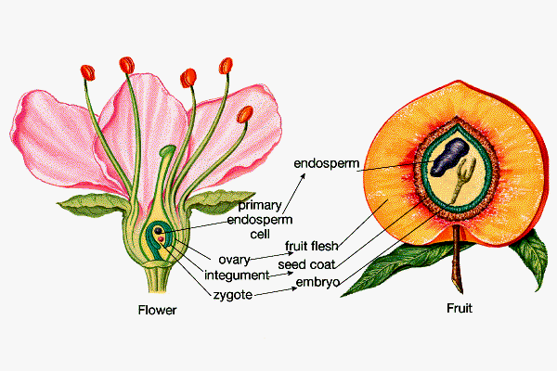
Figure 10-1. Origins of fruit anatomy.

SIMPLE FRUIT

A fruit that is derived from a single ovary (refer to figure10-1. These fruits are the most common and exhibit the greatest array of variation. Simple fruits are further broken down into a dehiscent fruit (one that splits when ripe) or an indehiscent fruit (one that does not split when ripe). Simple fruits can also be categorized as fleshy fruits.

Dehiscent fruits

- Legume – characteristic of the bean family. Pod splits on two sides.
- Follicle – splits only along one side (
- Capsule – splits along many different lines (see moringa).

Indehiscent fruits

- Akene – Thin-shelled, single seed enclosed in each fruit (see sunflower).
- Winged akene – Akene with hairs or a parachute-like structure for dispersal (see milkweed and oleander).
- Samara – akene with wings for dispersal purposes (see maple).
- Nuts – The pericarp is stony in a true nut. Almonds and hickory nuts are “commercial” not botanical nuts (see chestnuts).
- Caryopsis – Characteristic of the grass family. Like an akene (achene) but the entire periphery of the seed is attached to fruit, whereas, in the achene the attachment of seed to fruit is at one and only one point. Also known as a grain (see wheat).

Fleshy fruits

- Berry – Fruit that contains one or more seeds with a fleshy, succulent covering (derived from the mesocarp). The date is a single-seeded berry, grapes are several-seed berries and tomatoes are many-seeded berries. It is the second most common type of fruit (see grape, tomato, kiwi, avocado, banana –sterile).

- Pepo – Characteristic of the gourd family. The outer exocarp is converted into a hard rind (see cucumbers, watermelon, melons, pumpkin).

- Hesperidium – Citrus family characteristic. The rind is separable, leathery, parchment-like partitions separate the inner portions (see oranges and limes).

- Drupe – See is enclosed in a stony endocarp. Stony endocarp is sometimes called the pit (see peach, plum, olive, lychee, kukui). It is the most common.

- Pome – Characteristic of many members of the rose family. The majority of the fruit is a result of the enlargement of the receptacle and the calyx (see apples and pears).

MULTIPLE FRUITS

Fruits composed of a number of closely associated fruits derived from different flowers, these fruits forming one body at maturity (see pineapple and puhala).

AGGREGATE FRUITS

Fruits derived from a number of simple pistils, all from the same flower (see strawberry).

Procedures

1. Listen and take notes during Mr. Gomes’ lecture.
2. Study the model of the flower.
1 – simple fruits
2 – multiple fruit
seed dispersal mech
fruit types

Part 2: Anatomy of Male Reproductive System

Please read prior to lecture and lab. Know structures and terms that are in BOLD print.

Testis

A. Location – suspended below the pelvic floor in the scrotum which is divided into two compartments by a connect tissue septum. The skin of the scrotum contains smooth muscle fibers which contracts in response to cold temperatures to elevate the testes toward the body. This helps to maintain a constant temperature – essential for spermatogenesis.

B. Capsule – A tough sheath of connective tissue, surrounds the testis and sends septa into the testis to subdivide it into lobules, each of which contains a

C. Seminiferous tubule – a highly coiled tubule where spermatozoa are produced; spermatozoa flow toward the hilus of the testis and enter channels which leave the testis. The seminiferous tubules are lined by spermatongonia (stem cells which produce spermatozoa) and Sertoli cells which nuture the developing spermatozoa.

D. Leydig cells – are cells located outside the seminiferous tubules in the testis which secrete male sex hormone, testosterone. The function of these cells is regulated by lutenizing hormone (LH) from the anterior lobe of the pituitary gland.

Figure 1. Sagittal views of the male reproductive tract

Know: Optional:
1. Penile urethra 9. Membranous urethra
2. Vas deferens (ductus) 10. Root of penis
3. Bulbourethral gland 11. Corpus spongiosum
4. Prostatic urethra 12. Corpus cavernosum
5. Ejaculatory duct 13. Glans penis
6. Prostate
7. Epididymis
8. Testis
14. Seminal vesicle

Figure 2. Testis, efferent ductules & epididymis

1. Capsule
2. Septum
3. Seminiferous tubule
4. Efferent ductules
5-7. Epididymis
8. Vans deferens

9. Seminiferous tubule
10. Interstitial cells 16. Acrosome
11. Spermatogonia 17. Neck
12. Primary spermatocyte 18. Midpiece
13. Secondary spermatocyte 19. Body
14. Spermatid 20. Tail
15. Spermatozoan
Spermatic ducts

A. Efferent ductules – 10 – 12 small ductules leave the testis at its hilus and enter a single highly coiled tubule called the

B. Epididymis – a elaborately coiled tubule ( about 25’ long if stretched out) which is wrapped in connective tissue and fitted snugly over the superior and posterior borders of the testis. This is both a site for final maturation of the sperm and the storage site for spermatozoa prior to ejaculation. The epididymis is lined by pseudostratified columnar epithelium and is continuous with the

C. Vas deferens – which is also lined by pseudostratified columnar epithelium. The vans deferens undergoes peristaltic contractions to expel stored sperm during ejaculation. In the pelvis, the vans deferens passed behind the urinary bladder where it contributes to the

D. Ejaculatory duct – which passes through the substance of the prostate gland to empty into the prostatic urethra. The spermatozoa plus added fluids then are expelled from the body via the membranous and penile urethra.

Accessory glands

A. Seminal vesicles – a pair of glands located posterior to the urinary bladder. They secrete a sticky, slightly alkaline, yellowish substance rich in fructose – the primary energy source for spermatozoa. About 60% of the total ejaculate (semen) is produced by the seminal vesicles. The duct of the seminal vesicles joins the vans deferens to form the ejaculatory duct.

B. Prostate gland – a gland the size of an unshelled kukui nut which surrounds the proximal portion of the urethra below the bladder. This gland has many small ducts which open directly into the prostatic urethra secreting a thing, milky-looking alkaline fluid. Prostatic fluid promotes sperm motility and protects sperm from the acidic environment of the female vagina.

C. Bulbourethral (Cowper’s) glands – paired pea-size mucus-secreting glands located in the pelvic floor whose ducts open into the penile urethra. Prior to ejaculation, these glands secrete mucus to lubricate the urethra and protect the spermatozoa.

Penis

A. Structure – The copulatory organ of the male reproductive system is suspended anterior to the scrotum. The skin covering the shaft of the penis is hairless and contains melanin pigment. The glans is covered by loose-fitting, retractable skin called the prepuce (or foreskin) which is often removed during circumcision.

B. Erection and ejaculation – In response to nervous stimulation, penile veins constrict and arterioles dilate which engorges the erectile tissue of the penis with blood resulting in an erection. Ejaculation is the discharge of semen from the penis. Peristaltic contractions of the epididymis, vans deferns and ejaculatory duct initiate ejaculation. Peristaltic contractions of the urethra expel the semen from the penis. There are, on average, about 100 million spermatozoa/cc of ejaculate, and total ejaculate volume is about 2-4 cc. Following ejaculation, penile vessels return to normal diameter and the excess blood drains from the penis returning it to a flaccid state.
Figure 3. Spermatogenesis

Spermatogenesis

A. Spermatogonium – the stem cell that divides mitotically to form a replacement and a

B. Primary spermatocyte – these cells undergo 1st meiotic division to form

C. Secondary spermatocytes – which undergo 2nd meiotic division to form

D. Spermatids – small cells with a haploid number of chromosomes which, through structural changes become

E. Spermatozoa – structurally complete but functionally immature until they spend a critical amount of time in the epididymis where final maturation takes place.

Clinical considerations

Prostatic hypertrophy – swelling of the gland due to blockage of its ducts; relatively common in older men and usually benign.

Study questions

Trace the passage of spermatozoa from the seminiferous tubules to ejaculation listing the reproductive tubules through which they must pass.

Where does spermatogenesis occur?

Give the function(s) of the following structures:

Structure Function

1. Bulbourethral glands

2. Prostate gland

3. Seminal vesicle

4. Leydig cells

Female Reproductive System

Introduction
The female reproductive system includes both internal and external organs. The internal organs consist of the primary and secondary sex organs of the female. The external genitalia (mons pubis, labia majora and minora, clitoris and hymen) and the mammary glands form the superficial organs of the female reproductive system.

Figure 4. Sagittal section through female pelvis

(fallopian tube or uterine tube)
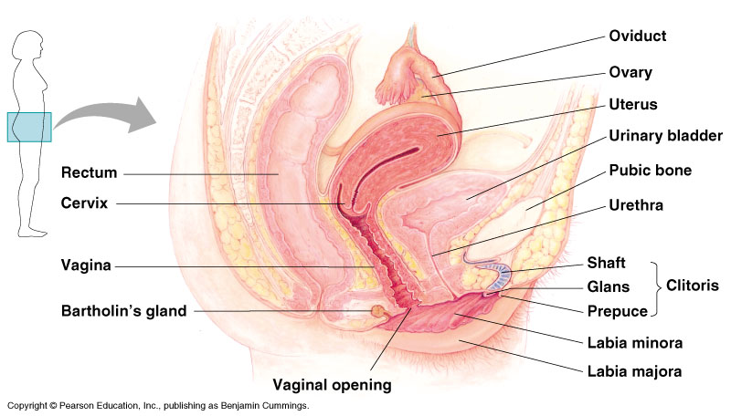
Mons pubis
Vaginal orifice
Symphysis pubis

Fundus of uterus
Figure 5. Anterior view of female reproductive organs

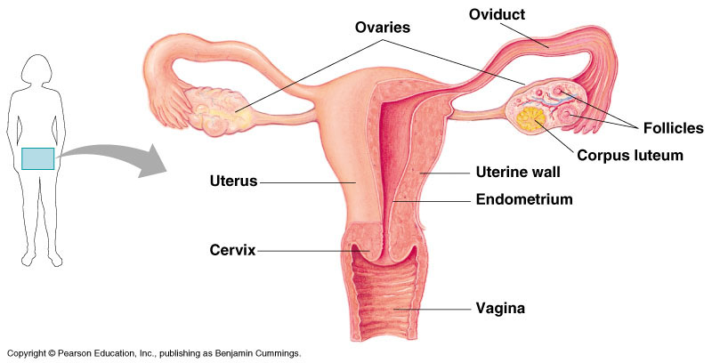
fimbriae
Myometrium and perimetrium
Body of uterus

Ovary

A. Location – suspended in the pelvis by a mesentery and two ovarian ligaments. The ovaries are small, oval bodies about the size of an almond which produces both gametes (ova) and female sex hormones (estrogen and progesterone).

B. Capsule – is a thin connective tissue.

C. Ovarian stroma – consists of an outer cortex and inner medulla:

Cortex – contains ovarian follicles in various stages of development and interstitial tissue between follicles. Ova are located and nourished within the follicles.

a. Pre-ovulatory follicles – grow (in response to hormones from the anterior pituitary gland) from primary to secondary to mature follicles. Each contains an ovum and increasing numbers of layers of surrounding cells.

b. Post-ovulatory follicles - change into an endocrine organ, the corpus luteum (yellow body), which secretes progesterone until it degenerates to become a corpus albicans (white body).

c. Interstitial tissue – consists of connective tissue, blood vessels, and remnants of the theca from old follicles.

Figure 6. Internal structure of the ovary

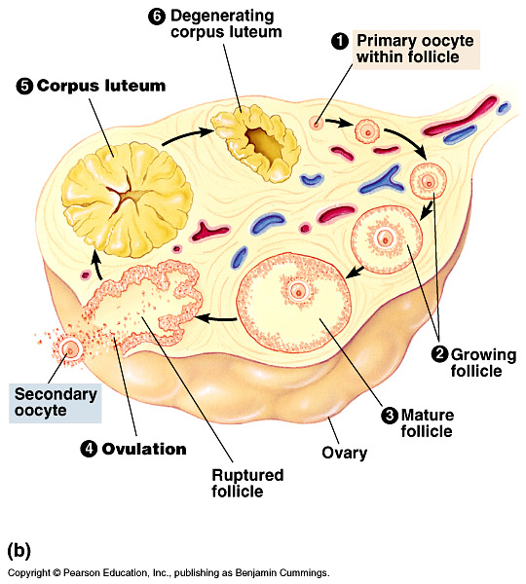

Uterine tubes, uterus and vagina

A. Uterine tubes (oviducts or fallopian tubes) – transport ova from the ovaries to the uterus. Each tube is about 10 cm long and lined with ciliated and secretory columnar epithelium. Finger-like processes (fimbria) spread over the surface of the ovary to help capture ova at ovulation. Fertilization usually occurs during an ovum’s passage through the uterine tube.

B. Uterus – a hollow, thick-walled, muscular organ shaped like an inverted pear.

1. Location – between the urinary bladder anteriorly and the rectum and sigmoid colon posteriorly. The uterus is suspended by the broad ligament. The largest part of the uterus is the body while the tapered lower part is the cervix. The uppermost part, above the entrance of the uterine tubes, is called the fundus.

2. Uterine wall – composed of perimetrium, myometrium, endometrium; The endometrium is the inner lining of the body and fundus. It contains blood vessels which persists through menstruation and pregnancy. Part of the endometrium sheds as menses and helps to form the maternal contribution to the placenta in pregnancy. During the menstrual cycle, it thickens in response to female sex hormones in preparation for implantation of an embryo.

C. Vagina – serves as 1) the receptive organ for the penis for sperm deposition during sexual intercourse, 2) the birth canal during parturition, and 3) provides for the passage of the menses. It is a muscular tube about 9.5 cm long which encircles the cervix and opens to the outside. The vagina is lined with stratified squamous epithelium supported by smooth muscle and connective tissue. The vagina is lubricated during sexual excitement by secretions from the vestibular (Bartholin’s)glands located immediately inside the vaginal orifice and by secretions from mucous glands within the cervix of the uterus.

External genitalia (or vulva)

A. Mons pubis – an elevated pad of adipose tissue anterior to the pubic symphysis which is covered by hair after puberty.

B. Labia majora – two longitudinal folds of skin containing loose connective tissue and covered with hair and sebaceous glands.

C. Labia minora – two smaller folds between the labia majora covered by hairless thin skin.

D. Clitoris – a small rounded erectile body. The clitoris corresponds both in structure and origin with the penis of the male, differing in size.

Mammary glands

A. Structure – The mammary glands, located within the breasts, are modified sweat glands and part of the integumentary system. Functionally, however, they are part of the reproductive system since they secrete milk for nourishment of the young. The size and shape of the breasts vary considerably due to genetic differences, age, or pregnancy.

Figure 7. Mammary gland

B. Histology – Each mammary gland is composed of 15-20 lobes, each having its own lactiferous duct that opens at the tip of the nipple. The nipple contains some erectile tissue and is surrounded by a circular pigmented areola that has a few sebaceous glands and hair follicles. The tubules of the mammary gland respond to hormones during pregnancy and develop secretory alveoli which secrete milk after parturition. Following termination of lactation, the mammary tissue regresses to an inactive state unless stimulated again by the appropriate hormones.

Ovulation and Menstruation

A. Ovulation – rupturing of the follicular wall to release an ovum into the uterine tube. Ovulation usually occurs every 28-30 days, generally alternate ovaries. If the ovum is not fertilized, menstruation will be initiated about 14 days after ovulation.

B. Phases of the menstrual cycle

1. Menstrual phase – characterized by a blood discharge of endometrial tissue during the first 3-6 days of the cycle.

2. Proliferative phase – begins after cessation of menses and continues to day 15 (approx). During this time, the functional layer of the endometrium is regrowing.

3. Secretory phase – from days 15-27 is characterized by growth of uterine glands and an increase in blood supply in preparation for implantation of the blastocyst (developing embryo).

4. Premenstrual phase – is initiated immediately prior to menstrual phase if implantation does not occur. It involves an initial breakdown of the functional layer of the endometrium and occasionally external spotting of blood.

Clinical terminology

A. Amenorrhea – suppression or absence of menstruation; may be a response to stress (e.g. anorexics) and not necessarily related to pregnancy.

B. Dysmenorrhea – difficult and painful menstruation commonly resulting from uterine contractions; persistent dysmenorrheal may indicate presence of disease.

C. Ectopic pregnancy – implantation of a blastocyst outside the uterus, usually in the uterine tube.

D. Hysterectomy – removal of the uterus (TOTAL hysterectomy = removal of ovaries, tubes and uterus).

E. Oophorectomy – removal of an ovary.

F. Tubal ligation – sterilization by tying and removing a segment of the uterine tubes; usually cannot be repaired successfully.

Study questions:

During a typical 28-day menstrual cycle, when would a female most likely be fertile?

A common complaint of pregnant women is constipation and frequency of urination. Explain these problems anatomically.

Lab #11- part 3: Embryology

Prelab

1. Read this section.

Objectives

1. To learn about the different stages of embryological development using the zebra fish and sea urchin as a model.
2. To identify gametes from different species.

Procedures

1. Embryology. Refer to Topic 35 in Encounters with Life pp. 317-330.

2. Examine slides and specimens including the following:
- Human sperm
- Human ovary
- Starfish or sea urchin blastula
- Gastrula stage
- Human egg
- Starfish sperm
- Bipinnaria and brachiolaria larvae
- Chick embryo slides: 33, 48, 72 and 96 hours – whole mounts

LAB MANUAL

- Notes on Mr. Gomes lecture (if given).
- Your drawings of the different stages of development in the zebra fish.
- Questions posed throughout this section.
NOTES:
Lab #12 – Nervous/Musculoskeletal systems

Prelab
1. Read this section
2. Read Ch. 30 in Encounters, pp. 259-265; Ch. 31 pp. 274-275; Atlas pp. 152-154; Ch. 32 pp. 281-288; Atlas pp. 141-147; Ch. 33 pp. 293-298; Atlas pp. 148.

Objectives

1. Review the nervous and musculoskeletal systems at the microscopic and macroscopic levels.
2. Learn the anatomy and physiology of the nervous, skeletal and muscular system.
3. Learn medical terms in describing bodily movements (see pages 67-70).

Procedures

1. Dissect sheep brain (see figures 11-1 and 11-2). Identify the anatomical parts of the brain.
2. Perform the human reflexes exercises: patellar reflex, Achilles reflex, and photo-pupil reflex.

3. Examine slides and specimens including the following:
- Human brain model
- Human eye model
- Human ear model
- Cow eye preserved specimen
- Human skeleton
- Cat, bird, frog, crab/lobster, insect skeleton
- Slides:
  - Tendon, teased
  - Hyaline cartilage
  - Elastic cartilage or fibers, teased
  - Smooth muscle, isolated
  - Skeletal muscle, isolated
  - Cardiac muscle with intercalated discs
  - Earthworm, c.s.

4. View laser disc material. Refer to listing below: NOT AVAILABLE FOR SPRING 2005
11755 thyroid gland 02728 gyri, brain
00138 goiter 01342 Alzheimer’s disease, senile plaques
34355 pituitary gland 12462 tissue, osseous cross section
16101 acromegaly 11759 cartilage, hyaline
12463 Islets of Langerhans (pancreas) 14636 elastic cartilage
01601 motor end plate 14614 skeletal muscle
12466 neuron 14617 skeletal muscle, c.s.
00619 node of Ranvier 26245 skeletal muscle, l.s.
02727 sulcus, brain 14620 smooth muscle
14625 cardiac muscle, intercalated discs

sheep brain picture
directional terms
1
2
3
4
Lab #13: Kaloko Cove Field Trip

Prelab

- See “g:” drive for pictures of plants.
- Dress accordingly. Wear shorts or swim suit, old sneakers or tabis (slippers have a bad habit of floating away). Hat is optional. Normally, it is very hot and windy so some of you may want to bring suntan lotion or sunscreen.
- Meet at the second restroom at Sandy Beach. This is the restroom that is away from the surfing area of Sandy Beach. Kite flying is the passion at this restroom.
- You are welcome to bring your own refreshments. There will be some that the lab provides but this will be minimal.
- Read the handout prior to coming to class.

Objectives
- Observation of estuaries and intertidal organisms and habitat.
- Observation of ecological succession by mangroves.
- Observation of coastal plants and adaptations to a halic environment.
- Examine the abiotic factors that influence life in a coastal environment.
- Examine and identify endemic, indigenous, and exotic plants commonly found in a halic environment.

Procedures:
Come to class with your lab notebook to take notes and pay attention!
Enjoy class!

Organisms

- Metopograpsis messor (grapsid crab)
- Polypus ornatus (night octopus)
- Eleotris sandvicensis (goby)
- Acanthurus triostegus (convict tang or manini)

The following organisms are representative of some of the tidepool organisms viewed at Kaloko Cove:

- Nerita picea (round, black snails or pipipi)
- Cypraea caputsepentis (snake head cowry)
- Enchinometra mathaei (rock boring sea urchin)
- Ophiocoma (brittle starfish)
- Holothuria (sea cucumber)
- Xanthid or rock crabs
- Graspus tenuicraustatus (grasped or a’ama crab)
- Sea anemones
- Calcinus (hermit crabs)
- Blenny or jumping jack fish
- Juvenile white sea perch and convict tang
- Squirrelfish – especially at night, bright red in tidepools
Plants
- Messerschmidia argentea (Tree Heliotrope): 8-10 feet tall
- Helitropium anomalum (aka hinahina or Beach Heliotrope )*
  - Hinahina means gray colored (Merlin, 1977)
  - Low lying, native, perennial beach plan that has tiny white hairs over the leaves giving it its characteristic silvery appearance
  - Indigenous to several Pacific Islands, it thrives in dry, sandy beach environments
  - Uses: flowers may be used in lei making, leaves have brewed to make tea
- Helitropium currassavicum*
- Scaevola taccada (aka Naupaka-kahakai or Beach Naupaka)
  - Grows close to the ground, but may form a bush of up to 8 to 10 feet (Merlin, 1977)
  - Whitish flowers which appear as if they had been torn in half
  - Indigenous plant that grows along many Hawaiian shores

Uses: in ancient Hawaii, white fruits were sometimes eaten, bark was used as medicinal material
*Sprawling herbs that are found clumped in various areas along the beach.

Notice the similarity of the flowers in all three. Notice the leaves resemble those of the naupaka. How do these plants survive? Give four different characteristics.

Other plants:
- Mesquite or kiawe
- Hawaiian cotton – may not see
- Nema
- Assorted grasses

Lab notebook:
1. Why are estuaries important?
2. What is ecological succession?
3. Why are mangrove trees important in succession?
4. What is the difference between intertidal and estuarine habitats?
5. What are some physical factors that are important in interdial habitats?
6. What are the two primary ways that seeds can reach an island from some distant shore? Name one organism that has reached the Hawaiian islands through one of the dispersal methods that you suggested in the first part of this question?
7. Could these plants survive successfully further inland? Would you expect to see modifications in the structure of the plant? Different growth habits? Different leaves?
8. Describe a hypothetical situation concerning mangrove succession on shorelines near stream or river mouths.
9. Notice that many of the coastal plants have bright or unusual flowers. Why?
10. Describe 5 adaptations of coastal plants.
References
1. Acker, S. (1972) “Mangrove Ecology.” Oceans 5(4): 34-43.
2. Lauff, G.H. (ed.), Estuaries.
3. Merlin, M.D. (1977). Hawaiian Coastal Plants and Scenic Shorelines. Honolulu: Oriental Pub.
4. Odum, E. Ecology
5. Water Resources Research Center, University of Hawaii 1969 “Estuarine Pollution in the State of Hawaii,” Tech. report 31.

Position Paper: Due ____________________

1. You are to write a 2 page maximum position paper on the question: “Should development be allowed in a coastal area (e.g. Kaloko cove)?”

2. There are articles in Sullivan Library on reserve including the following:

- “Ka Iwi Coast Plan Moves Ahead,” by Robbie Dingeman, Honolulu Advertiser, 1/10/01, B-1.

- “Vehicles, trash marring Ka Iwi Coast,” by Melissa Tanji, Honolulu Advertiser, 1/26/1999, B-3.

- “Bishop Estate loses Queen’s Beach Suit,” by Jeanne Mariani, Honolulu Star-Bulletin, April 1, 1991, A-1, A-8.

- “Support the Ka Iwi Park master plan!” Kaiwi Action Council, undated-after October 1995- pamphlet.

Procedural criteria:

1. Include a reference page and cite your references.

2. Support your statements using facts and data and use your references in the main body of your paper.

3. Find additional references for further support and excellence.

4. Follow standard English procedures. The reference text for English compositions that is currently in use for all English classes is The Scott, Foresman Handbook for Writers.
Map to Kaloko Cove

APPENDIX
Appendix #1

Plant Anatomy and Reproduction
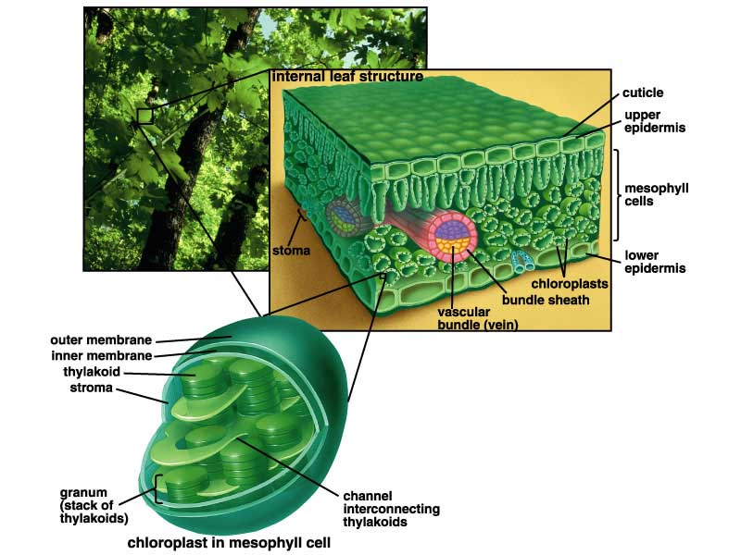
Dr. Joan Kuh

- General stuff

- Characteristics of organisms in the plant kingdom

- Photosynthesis
- What is it?
Chemical reaction for photosynthesis:

- Where it takes place in the plant.
- Chloroplasts
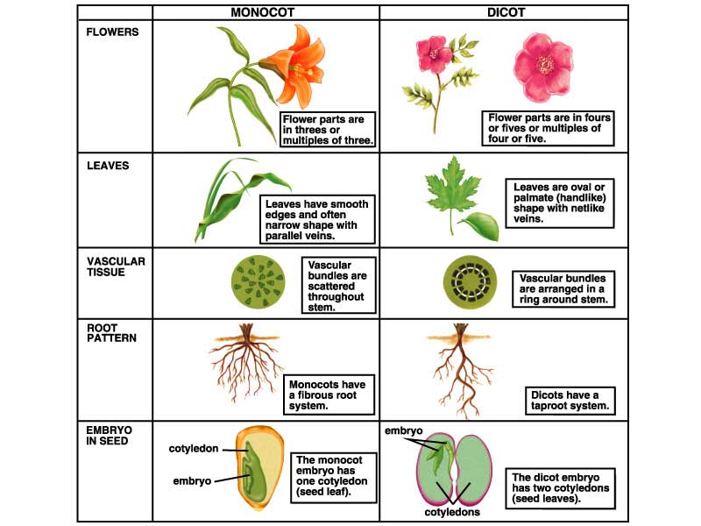
- Chlorophyll and accessory pigments

- Angiosperms
- Three adaptations found in this class:
a.
b.
c.
- Two major groups
- monocots
- dicots
- how these differ:

- Parts of a plant
- Overall body plan
- Roots
Functions:

- Shoots
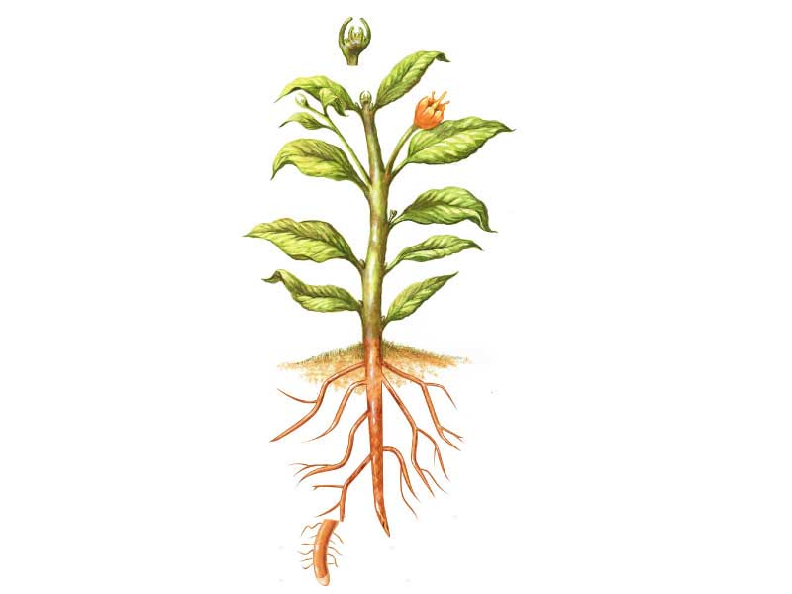
Functions:

- Tissue types
- Vascular tissue
- Xylem
Function:
- Phloem
Function:
- Leaves
Function:
- Roots
Function:
- Stems
Function:

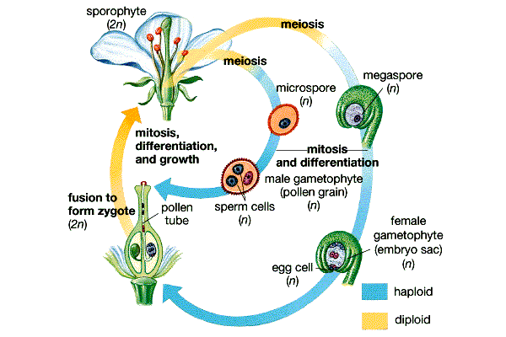
- Reproduction in angiosperms
- Overview
- Parts of a flower
- Meiosis and production of gametes
- Pollen
- Egg cells
- Pollination and Fertilization
- Seed development
- Fruits

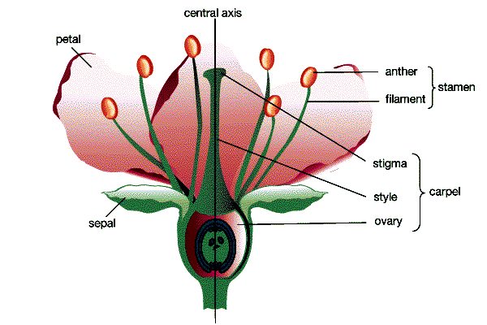
Pollination
& Fertilization

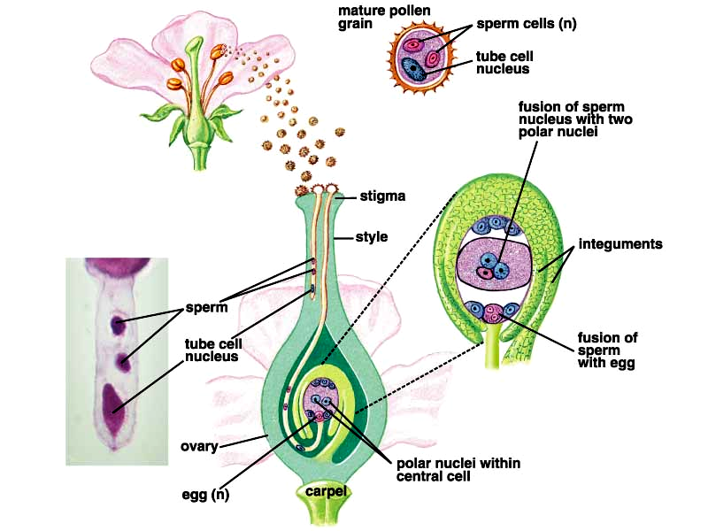
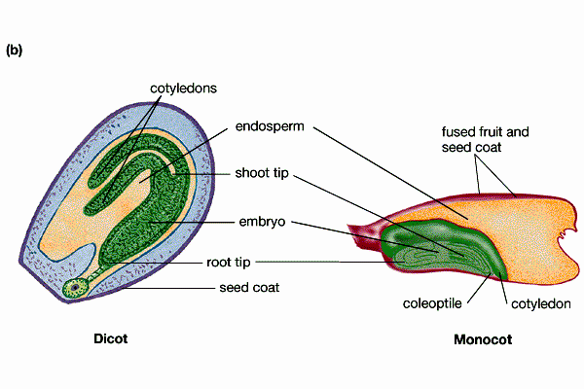
Appendix #2

Keys for anatomical models.

