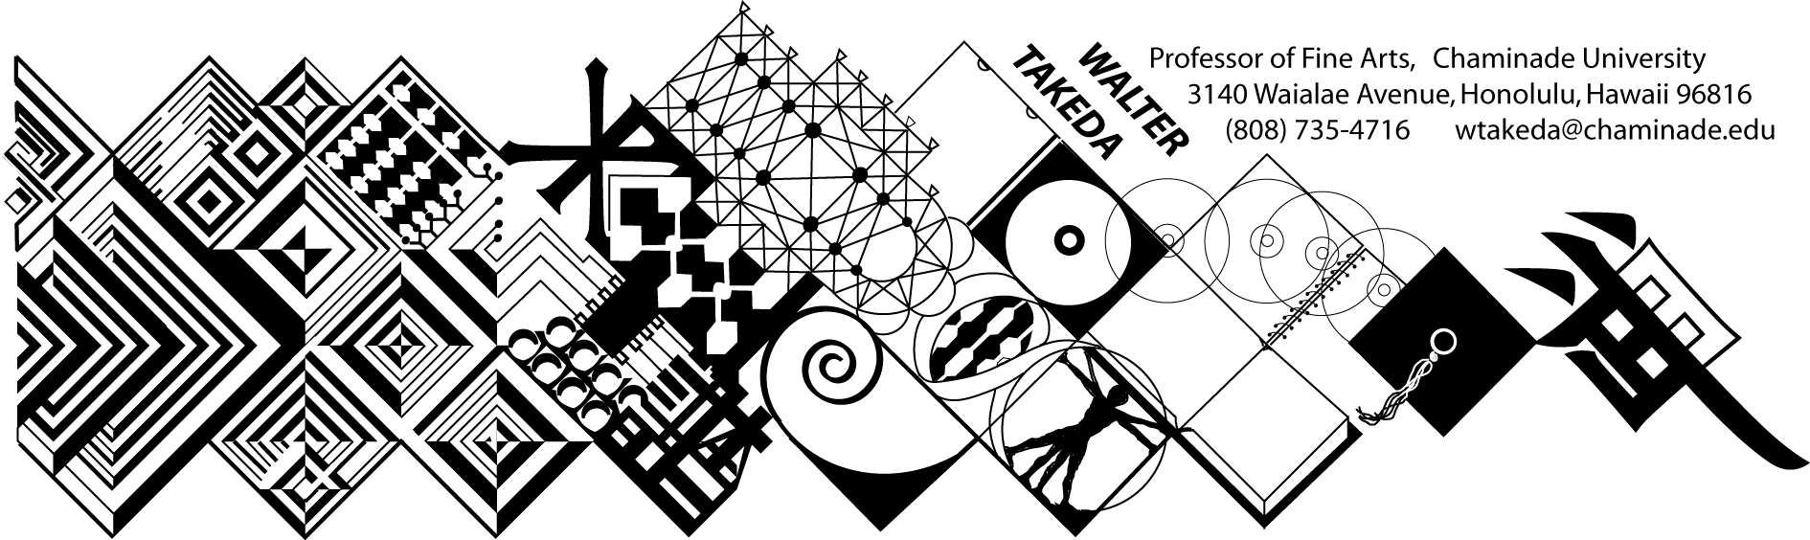
ART 202
Survey of Art II
Tues/Thurs 8-9:20 am
Eiben 207
Text: Art thru the Ages
Office Hrs: afternoons
or appointment: E205

Art 202 is a general survey course, with no prerequisites, that may be used to fulfill CUH's general education fine arts requirement or used as a liberal arts elective.
The material covers a survey of Western art, sculpture, and architecture from the Renaissance to present. In this age of frequent travel, you will undoubtedly have opportunity to visit many of the areas covered. Study of these cultures will result in a deeper understanding of this rich human legacy.
This class presents material in chronological order; you are expected to do parallel reading in your text. At the beginning of each class, a pool of slides will be shown of previous critical material. As much as possible, these works will be from the text. After each class, keep a list of this pool of slides, correctly spelled as to artist, title of work and school or style. Use this "mini-review" to good advantage; cramming for THIS class is a poor idea.
Before each exam is a thorough review of the material. Audiotaping this review helps many students.
Examinations will include objective questions (multiple choice, true/false), slide identification (artist, title, school), and a written comparative analysis (paper) between two works. Your ability to recognize artists and/or styles not in the review pool will take the test beyond mere rote memory. A comparative analysis paper may be assigned to substitute for a poor exam performance; deadlines will be announced in class. All students must take the exams to qualify for the paper.
MAKEUP EXAMS are a serious matter. Students will notify the instructor BEFORE the exam, then bring in a verifiable excuse, such as a service station invoice, doctor's slip, etc. It is the student's responsibility to abide by these two conditions and the instructor's prerogative to refuse a makeup. The makeup will be scheduled by the instructor, and if the student is again absent, he or she will be given a zero. In fairness to other students, a harder makeup exam will be administered; if it is at all possible to take the test on time, make every effort to do so rather than risk a more difficult exam. THERE IS ABSOLUTELY NO EXTRA CREDIT IN THIS COURSE!
The student is obligated to abide by the conditions of this syllabus, the Chaminade catalog, and the Chaminade student handbook, and cannot claim ignorance of these conditions as an excuse.
GRADING SCALE: A:100-90, B: 89-80, C: 79-70, D: 69-60. Please note that this scale may be different from other instructors. Each exam, including the final, will be equally weighted.

The instructor reserves the right to adjust the schedule and contents of this syllabus, such as exam times or grading criteria or any other changes. Any announced change made in class is the student's responsibility.

TUESDAY | THURSDAY
Jan 11 Intro; Proto-Renaissance | 13 Italian Renaissance
18 Italian Renaissance; Int Gothic | 20 Early Flemish
25 High Renaiss: Leonardo, Raphael | 27 Michelangelo
Feb 1 16thC Mann, Venetian | 3 16thC German, Flemish
8 REVIEW: Italian Baroque | 10 FIRST EXAM
15 17thC Spanish | 17 Dutch Realism
22 Dutch Realism | 24 French 17thC; Versailles
Mar 1 Rococo | 3 Neoclassicism
8 Romanticism | 10 Romanticism; Realism
15 Impressionism | 17 Impressionism
29 Impressionism; REVIEW | 31 SECOND EXAM
5 Post-Impressionism | 7 Post-Impressionism
12 Picasso & Cubism | 14 Cubism & consequences
19 Dada & Surrealism | 21 European Expressionism, Action, Pop
26 Modern, Post-Modern architecture | 28 Post-Modern Review
FINAL EXAM Tues, May 3, 8-10am

