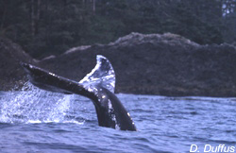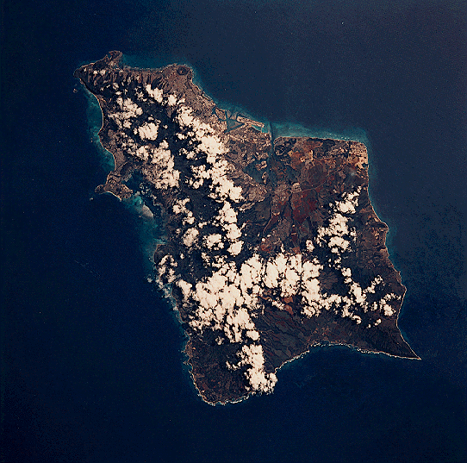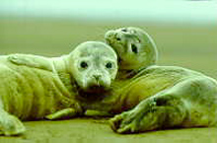
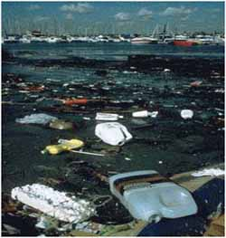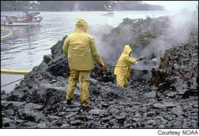

Marine Environmental Science Laboratory: ENV 115L (Laboratory)

Course Syllabus
Fall 2004

Human alteration of earth is substantial and growing.
Peter M. Vitousek et al.
Science 1997

Not unlike the lobster, we humans tend not to notice changes in our “water” so long as they happen gradually. For an American, dropping into the “hot pot” of Haiti or Burkina Faso creates a shock of realization: the entire planet is in the same pot, and while their are local spots hotter than others, our “pot” is warming worldwide.
Thom Hartmann
The Last Hours of Ancient Sunlight

Instructor: Dr. Gail Grabowsky

Address: Environmental Studies, Rm 107 Behavioral Sciences (high-on-the-hill!)
Chaminade University
3140 Waialae Ave
Honolulu, HI 96816

Phone: 735-4834 (ext. 834 if calling from on campus); home 922-5206 (please don’t call after 9:00 pm)

E-mail address: ggrabows@chaminade.edu

Office hours: Behavioral Sciences Building, room 107
T: 2:00 – 5:00; Th: 2:00 - 5:00; F: 1:00 – 5:00; Or by appointment

Course Description: This course introduces students to the scientific methodologies used to determining and studying the current major marine environmental issues. Issues studied include: global warming, marine pollution, marine debris, oil spills, fisheries exploitation, fisheries by-catch, marine alien species and coral reef degradation. Laboratory exercises are conducted in the field and on the Chaminade campus. Students taking this course will be engaged in field science activities.

Course Objectives: When you have completed this course you should:
Know what science is and how scientific research is conducted
Know the basic units used in making scientific measurements
Be able to devise a hypothesis and set up an experiment to test the hypothesis
Be able to competently collect, record, analyze, present and interpret scientific data
Be able to write up a scientific research report
Be comfortable conducting field measurements in a variety of types of marine habitats
Be able to document the physical effects of a number of the major marine environmental issues
Be able to document some of the detrimental effect(s) marine environmental issues have on marine ecosystems
Experience the role of environmental service in living in the Marianist tradition and in ameliorating marine environmental issues

Course Requirements: Your grade in this course will be based on the following. Each of the items/activities listed below will be described to you in writing or orally in class.

- One Formal Laboratory Write Up 20%
- Laboratory worksheets, homework, etc. 60%
- Laboratory notebook 20%

Course Grading: The proportion that each of the above contributes to your grade in this course is as follows:
Formal Laboratory Write Up 100 points (100 points each)

Lab worksheets, etc. 300

Laboratory Notebook 100
500 points total

Grading criteria will be explained in detail in class.

Texts:
Required: You should purchase these in the bookstore.

Sumich, J.L. & G.H. Dudley. Laboratory & Field Investigations in Marine Biology. 5th Edition. McGraw-Hill Science/Engineering/Math. 1992. [ISBN: 0697051072]

Supplemental Texts: We will do a number of laboratory activities that do not from a specific lab book per se. These have been put together by Dr. Gail and/or her colleagues. You will be given handouts for these labs. There will also be some quantitative “dry labs” which will come out of the book below. You will be given handouts for these as well.

McConnell, R.L. & D.C. Abel. Environmental Issues: Measuring Analyzing, and Evaluating. 2nd Edition. Prentice Hall, Upper saddle River, NJ. 2002.

Things You’ll Need for Class:
- Lab Notebook: Your lab grade will be partly dependant on your lab notebook which I will check twice during the semester. The lab notebook should contain ALL handouts, notes, data, Issue homeworks etc. items that pertain to lab. It should be neatly organized in chronological order. It should NOT contain anything from lecture (keep a separate notebook for lecture).
- Snorkel Gear: It is NOT a pre-requisite that you be able to snorkel/swim to take this class but you will have the opportunity to do so in lab if you are able. The University does own snorkel gear (mask, snorkel and fins) which each of you can check out from student services. If you want to check this equipment out you MUST do so a few days in advance. If you own your own gear that is great. If you check out the gear be sure and check that it is in working order – particularly that the snorkel valve is in place – on occasion students have checked out gear that is not in working order. Have me check it out if you’d like before you take it in the water to find out it isn’t working!
- Shoes that can get wet: Be sure you have something for your feet that you can cross wet basalt rocks in! These will get wet.
- Water Bottle: Bring this to all labs that occur in the field.
- A love of the field and getting dirty, wet or cold: Guys this is a marine course so will will have/get to go outside! Be ready to be hot/cold, dirty etc. and prepare accordingly. Bring sunscreen if you need it, a towel, a wetsuit, etc. if you’d like and have a mind to be IN nature!

Reminders of Important University-Wide Policies:
The following policies are summarized from the 2002-2003 Student Handbook. Please be sure that you have reviewed these and other policies that your Handbook contains.

Attendance:
Students are expected to attend all classes. The University assumes you are mature enough to be responsible for your behavior.

I must report any absence of two weeks or more to the Office of the Associate Provost and the Registrar.

You should notify me when illness prevents you from attending class and make arrangements to complete the missed assignments. Depending on your circumstances, I may modify deadlines of course requirements. Anyone who stops attending a course without officially withdrawing, may receive a failing grade.

Classroom Deportment:
- You are expected to be punctual; unexcused tardiness [being five or more minutes late to class] will be considered an absence
- Radios, tape decks, headsets, televisions, and other personal audiovisual equipment not pertinent to the class are prohibited during class.
- Beepers and cellular telephones are also prohibited during class except in extenuating circumstances for which you have received my approval in advance.
- And finally, I expect you to follow the University’s “dress code” requiring footwear and appropriate shirts to be worn during all classes (I want no unnecessary “distractions during class!”)

Academic Honesty:
Students are responsible for promoting academic honesty at Chaminade by not participating in or facilitating others’ participation in any act of academic dishonesty, and by reporting incidences of academic dishonesty (such as theft of tests, records, and other confidential materials, altering grades, and/or plagiarism) to their instructors.

Freedom of Expression:
Students are free to take reasoned exception to the views offered in a particular course of study. They may be required to know thoroughly the specific bodies of knowledge or interpretations or theories set forth by the professor, but are free to reserve judgment as to the truth or falsity of them.

Students are expected to maintain the standards of academic performance articulated in course syllabi, supplemental readings, assignments and Academic and Student Affairs policies. The instructor is considered the normal and competent judge of academic work. Students have an appeals process in the rare case of unjust grading and evaluation by the procedure detailed in the Academic Grievance section of the Student Handbook.

If you are handicapped under the Americans with Disabilities Act:
Chaminade will provide assistance for any student with documented disabilities. You must contact Dr. Don Kopf ph# 735-4845 or Dr. June Yasuhara ph# 739-4603 at the counseling center (office is next to security) in order to determine if you meet the requirements for documentation as being disabled under ADA.

You are responsible for all of the information in this document:
Losing it or not reading it, are not excuses for not knowing what’s in it!!!

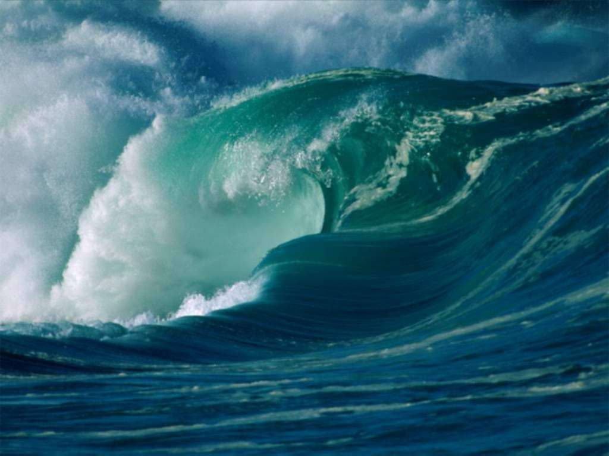

Marine Environmental Science Laboratory

Course Schedule
Fall 2004

DATE LAB TOPIC ACTIVITIES
8/23 No Lab – Will introduce lab in Lecture on 8/24
8/30 Marine Issues of Interest; Introductory Video Share a marine issue of concern to you
9/6 L A B O R D A Y N O C L A S S E S
9/13 Asking Questions; Metric System Lab; Video Chpt 1 in lab book; Lab handout
9/20 Taxonomic Classification & Identification Chpt 3 in lab book; Lab handout
9/27 Phytoplankton; Issue homework #1; Video Chapter 5 in lab book; Issue handout
10/4 Attached Marine Plants (Potential Formal Lab) Chapter 6 in lab book; Diamond Head
10/11 C O L U M B U S D A Y N O C L A S S E S
10/18 Marine Animals Lab Notebook Check!
Lab handouts; Waikiki Aquarium
10/25 Marine Debris Lab (Potential Formal Lab) Lab handout; Waimanalo
11/1 Coral Reef Health – A Less than Healthy Reef Lab handout; Ala Moana
11/8 Alien Species Lab; Issue homework #2 Issue handout; Waikiki
11/15 Coral Reef Transects (Potential Formal Lab) Handouts; Graph worksheet; Waikiki?
11/22 Formal Lab Write-Up Procedures Handouts
11/29 Real Issues in the Research Literature Lab Notebook Check!
Journal Article Critiques
Formal Lab Write-Up due

