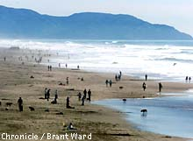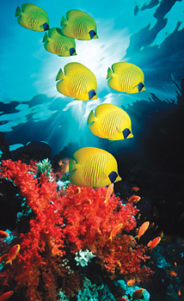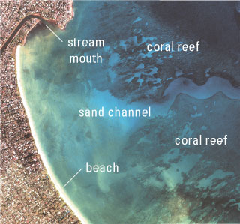

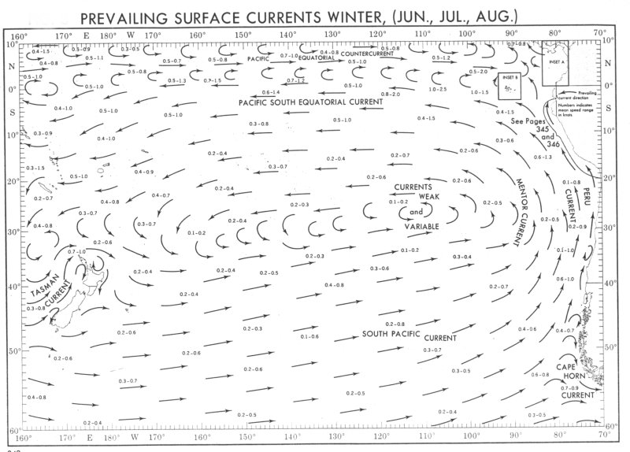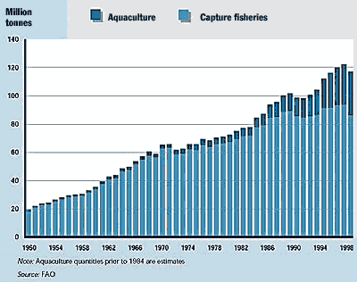

Marine Environmental Science: ENV 115 (Lecture)

Course Syllabus
Fall 2004

An Oceanographers Dream

I built my soul a stately treasure house
Beside the rolling ocean’s swell,
With cunning apparatus to disclose

The gems below that dwell, --

Those living gems ‘of purest ray serene,’
Oft frail, fantastic, strange and rare,
Whose lives sheer mysteries have ever been,
But need not be – with care.

‘Twas not in marbled luxury it grew,
With spacious courts and colonnades;
A boat and cooling tanks were most in view,
And tackle of all grades.

An isolated pinnacle I chose,
Five hundred miles from every shore:
Sheer from th’ Atlantic’s deep abyss it rose,
Three miles in depth or more.

Around it limpid dark blue waters flows
From distant equatorial seas:
It feels, above the pulse of melting snows,
The Gulf Stream’s vagrancies.

A sturdy, broad beamed, fishing boat I planned,
Equipped with motor, winch and screw,
For quick excursions out and back to land –
A man and boy for crew.

The zone of waters which concerns us most,
Where mighty currents change their beat,
Can here be sampled three miles off the coast
To full 3,000 feet.

Bermuda, watch-tower of the Sargasso Sea!
Its coral cap twelve miles across,
On this one spot my treasure-house would be, --
Its absence the world’s loss.

Walter Garstang, 1943

The scientific community is no private club. In principle, and in its best and broadest sense of the words, scientific inquiry can be undertaken by anyone on almost any subject matter.
W. Quine and J. Ullian

Instructor: Dr. Gail Grabowsky

Address: Environmental Studies, Rm 107 Behavioral Sciences (high-on-the-hill!)
Chaminade University
3140 Waialae Ave
Honolulu, HI 96816

Phone: 735-4834 (ext. 834 if calling from on campus); home 922-5206 (please don’t call after 9:00 pm)

E-mail address: ggrabows@chaminade.edu

Office hours: Behavioral Sciences Building, room 107
T: 2:00 – 5:00; Th: 2:00 - 5:00; F: 1:00 – 5:00; Or by appointment

Course Description: This course introduces students to the scientific causes and consequences of the current major marine environmental issues. Topics include: effects of global warming on ocean ecosystems, marine pollution, marine debris, oil spills, fisheries exploitation, fisheries by-catch, marine alien species and coral reef degradation. The course focuses on making students aware of the material causes and consequences of each issue as well as the role of science in devising solutions to each issue.

Course Objectives: When you have completed this course you should:
Know what science is and how scientific research is conducted
Be familiar with and experienced at reading the primary scientific literature
Know the physical causes of each of the major marine environmental issues
Know the actual and projected physical consequences of each of the major environmental issues
Understand the causal network of events that constitutes each issue
Understand the detrimental effect(s) of each issue on marine ecosystems
Understand the detrimental effect(s) of each issue to human welfare
Be familiar with some of the specific mechanisms diverse indigenous people of the Pacific employ(ed) in gathering ocean resources that may be considered sustainable practices
Understand how modern marine environmental laws may effect the traditional practices of indigenous peoples
Experience the role of environmental service in living in the Marianist tradition and in ameliorating marine environmental issues

Course Requirements: Your grade in this course will be based on the following. Each of the items/activities listed below will be described to you in writing or orally in class.

- Two lecture exams and the final (which is cumulative) 60% (20% each)
- Marine environmental issue journal article critique 20%
- Environmental service OR
Marine Environmental Issues & Opinion Paper 20%

Course Grading: The proportion that each of the above contributes to your grade in this course is as follows:
Exams 300 points (100 points each)

Journal Article Critique 100

Service Learning & Reflection 100
500 points total

Grades will be assigned to written exams using a curve with the mean score for the class being a B- and the score immediately below the mean being a C+. This will be explained in detail in class.

You may choose between service learning and the term paper. If you complete five service learning activities (usually occurring on Saturday mornings from about 8:30 to about 1:00) you will receive a letter grade of “A” for the service learning/term paper component of the course. Five service learning activities represent roughly 25 hours of volunteer work (five hours per activity). If you complete four service learning activities you will receive a letter grade of a “B’; three activities earns you a “C”; two activities earns you a “D” for that portion of the course.

There is no extra credit assignment available in this course, but (1) if you do more than 5 service activities you will receive 3 extra credit points for each additional activity. Also (2) if you choose to write the term paper, each service learning outing you participate in will earn you three extra credit points. You may not write a term paper for extra credit. There may also be occasional talks with a marine environmental theme that you may attend for two extra credit points each. I will let you know when all service learning and talk opportunities arise. You may of course find an environmental service opportunity on your own and do it for credit – be sure to check it out with me BEFORE you do you own activity however to be sure it will get you credit for service.

The Marine Environmental Issues & Opinion Paper must be 10 – 15 pages (double-spaced) and have three hard-copy references (on-line journals and books are okay) and one journal article reference from a peer-reviewed journal. It will be due on the day of the final exam.

Texts:
Required: You should purchase these in the bookstore.

Sheppard, C. Coral Reefs: Ecology, Threats and Conservation. World Life Library, Voyaguer press. 2002. [ISBN 0896582205]

Castro, P. & M. E. Huber. Marine Biology. 4th Edition. McGraw Hill. 2002. [ISBN 0072852909]

Supplemental Texts: A number of readings in this course will come from the following documents. Other readings may come from documents not on the list below which become known to me or relevant during the course. I will provide hard copies or e-copies of all non-textbook readings to you.

Boesch, D. F. et al. 2001. “Marine Pollution in the United States.” Pew Oceans Commission.

Carlton, J.T. 2001. “Introduced Species in U.S. Coastal Waters.” Pew Oceans Commission.

Dayton, P. K., S. Thrush and F.C. Coleman. 2002. “Ecological Effects of Fishing in Marine Ecosystems of the United States.” Pew Oceans Commission.

Poepoe, K.K., P.K. Bartram and A. M. Friedlander. 2003(?). “The use of traditional Hawaiian knowledge in the contemporary management of marine fisheries.” Putting Fishers’ Knowledge to Work: Conference Proceedings, pp. 328-339.

Staff. 2003. “Socioeconomic Perspectives on Marine Fisheries in the United States.” Pew Oceans Commission.

Stratton, J.A. et al. 1969. “Our Nation and the Sea: A Plan for Action.” Report of the Commission on Marine Science, Engineering and Resources. United States Govenrment printing office, Washington, D.C.

Szmant, A. M. 2002. “Nutrient enrichment on coral reefs: Is it a major cause of coral reef decline?” Estuaries 25: 743-766.

Watkins, J. D. et al. 2004. Preliminary Report of the U.S. Commission on Ocean Policy. Washington, D.C.

Reminders of Important University-Wide Policies:
The following policies are summarized from the 2002-2003 Student Handbook. Please be sure that you have reviewed these and other policies that your Handbook contains.

Attendance:
Students are expected to attend all classes. The University assumes you are mature enough to be responsible for your behavior.

I must report any absence of two weeks or more to the Office of the Associate Provost and the Registrar.

You should notify me when illness prevents you from attending class and make arrangements to complete the missed assignments. Depending on your circumstances, I may modify deadlines of course requirements. Anyone who stops attending a course without officially withdrawing, may receive a failing grade.

Classroom Deportment:
- You are expected to be punctual; unexcused tardiness [being five or more minutes late to class] will be considered an absence
- Radios, tape decks, headsets, televisions, and other personal audiovisual equipment not pertinent to the class are prohibited during class.
- Beepers and cellular telephones are also prohibited during class except in extenuating circumstances for which you have received my approval in advance.
- And finally, I expect you to follow the University’s “dress code” requiring footwear and appropriate shirts to be worn during all classes (I want no unnecessary “distractions” during class!)

Academic Honesty:
Students are responsible for promoting academic honesty at Chaminade by not participating in or facilitating others’ participation in any act of academic dishonesty, and by reporting incidences of academic dishonesty (such as theft of tests, records, and other confidential materials, altering grades, and/or plagiarism) to their instructors.

Freedom of Expression:
Students are free to take reasoned exception to the views offered in a particular course of study. They may be required to know thoroughly the specific bodies of knowledge or interpretations or theories set forth by the professor, but are free to reserve judgment as to the truth or falsity of them.

Students are expected to maintain the standards of academic performance articulated in course syllabi, supplemental readings, assignments and Academic and Student Affairs policies. The instructor is considered the normal and competent judge of academic work. Students have an appeals process in the rare case of unjust grading and evaluation by the procedure detailed in the Academic Grievance section of the Student Handbook.

Classroom Atmosphere:
I value a very open, yet courteous class atmosphere. Express your ideas! Ask your questions! (The only dumb question is the one in which you ask yourself if you should ask your question.) Respect the thoughts and ideas and opinions of others – really think about what others say. Let them fully express their thoughts and ideas and then you do the same. The thing I value most from my college days are all the wonderful, valuable, diverse ways of looking at and understanding the world that I was exposed to. Be an open vessel – take ideas in! You will learn as much from each other as you do from me.

If you are handicapped under the Americans with Disabilities Act:
Chaminade will provide assistance for any student with documented disabilities. You must contact Dr. Don Kopf ph# 735-4845 or Dr. June Yasuhara ph# 739-4603 at the counseling center (office is next to security) in order to determine if you meet the requirements for documentation as being disabled under ADA.

You are responsible for all of the information in this document:
losing it or not reading it, are not excuses for not knowing what’s in it!!!

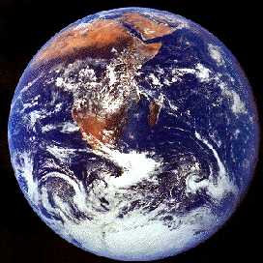

Marine Environmental Science Lecture

Course Schedule
Fall 2004

Part I

Ocean Inhabitants & Environments

WEEK TOPIC ACTIVITIES
8/23 – 8/27 Course Intro; Science; Seawater Chpts 1, 3 in textbook
8/30 – 9/3 Marine Biodiv: Microbes and Producers Explain Article Critiques; Chpts 5, 6
9/7 – 9/10 Marine Biodiv: Invertebrates, Fish, Foul & Mammals Chpts 8, 9 in textbook
9/13 – 9/17 Marine Ecosystems: Estuaries, Intertidal & Subtidal Chpts 11, 12 in textbook
9/20 – 9/24 Marine Ecosystems: Coral Reefs & Open Ocean Chpts 14, 15 in textbook

Part II

Threats to Our Oceans

WEEK TOPIC ACTIVITIES
9/27 – 10/1 EXAM I (9/27); Fisheries & Aquaculture Outside Readings (handed out to you)
10/4 – 10/8 Fisheries and Aquaculture (continued)
10/12 – 10/15 Alien Species Outside Readings (handed out to you)
10/18 – 10/22 Coral Reef Threats Coral Reefs book
10/25 – 10/29 Coral Reef Threats (continued) Outside Readings (handed out to you)
11/1 – 11/5 Marine Pollution Outside Readings (handed out to you)
11/8 – 11/12 Marine Pollution (continued)
11/15 – 11/19 EXAM II (11/15); Coastal Development Outside Readings (handed out to you)
11/22 – 11/24 Coastal Development

Part III

Solutions

WEEK TOPIC ACTIVITIES
11/29 – 12/3 Solutions to Marine Threats Outside Readings (handed out to you)

The Final Exam will be in our classroom on Tuesday, December 7, 2004 from 12:45 – 2:45 PM.

Service learning reflections are due on 12/7 BY midnight as are Marine Environmental Issues & Opinion Papers for those students who did not complete the service learning component of the course.

