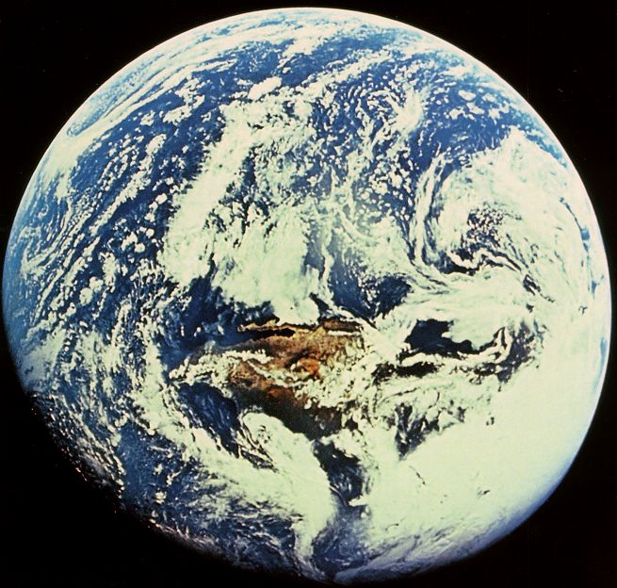

ENV 100: Introduction to Environmental Issues

Fall 2004
Dr. Gail

Syllabus

I find myself wrestling with such demons this early November morning, as my disconnected professional and personal roles clash with my desire for a more cohesive existence. Outside I hear the neighborhood stir with preparations for the new day, the busy pulse of work, school, and commerce projecting a hum of energy and purpose. What seems lacking in all this activity, though, is a sense of integrity – an integration of work and community, a harmony of place and environment.
Stephen R. Kellert
The Value of Life

With all beings and all things we shall be as relatives.
Black Elk

Wilderness remains because we allow it to exist.
Roderick Nash

The environment is too serious a business to be left to environmentalists.
J. William Futell

In the largest sense, humanity’s ultimate economic problem is to use Ultimate Means wisely in the service of the Ultimate End.
Herman E. Daly
Valuing the Earth:
Economics, Ecology, Ethics

The key idea is that we ought not to let the environmental organizations, business lobbyists or the media be alone in presenting truths and priorities. Rather, we should strive for a careful democratic check on the environmental debate, by knowing the real state of the world – having knowledge of the most important facts and connections in the essential areas of our world.
Bjorn Lomborg
The Skeptical Environmentalist

Instructor: Dr. Gail Grabowsky

Address: Environmental Studies, Rm 107 Behavioral Sciences (high-on-the-hill!)
Chaminade University
3140 Waialae Ave
Honolulu, HI 96816

Phone: 735-4834 (ext. 834 if calling from on campus); home 922-5206 (please don’t call after 9:00 pm)

E-mail address: ggrabows@chaminade.edu

Office hours: T: 2:00 – 5:00; R: 2:00-5:00, F: 1:00 – 5:00, Or by appointment

Texts:
Vital Signs 2003: The Trends that are Shaping Our Future. 2003. W.W. Norton & Company in cooperation with the United Nations Environment Programme.

Supplemental Texts: Texts in bold are those we will be reading from most often.

Betrayal of Science and Reason: How Anti-Environental Rhetoric Threatens Our Future. 1996. P.R. Ehrlich & A.H. Ehrlich.Island Press, Washington, D.C.

Earth Insights: A Multicultural Survey of Ecological Ethics from the Mediterranean Basin to the Australian Outback. 1994. J.B. Callicott, University of California Press, Berkeley, CA.

Environment 00/01 (17th edition). 2000. J. L. Allen editor, Dushkin/McGraw-Hill Publisher.

Environment 03/04 (22nd edition). 2003. J. L. Allen editor, Dushkin/McGraw-Hill Publisher.

Environment 04/05 (23rd edition). 2004. J. L. Allen editor, Dushkin/McGraw-Hill Publisher.

Environmental Ethics: An Introduction to Environmental Philosophy. (3rd Edition) 2001. J.R. Des Jardins. Wadsworth Publishing Company.

State of the World 2002. 2002. C. Flavin, H. French & G Gadener editors. W.W. Norton & Company, New York.

The Skeptical Environmentalist: Measuring the Real State of the World. 2001. B. Lomborg. Cambridge University Press.

Valuing the Earth: Economics, Ecology and Ethics. 1993. H.E. Daly & K.N. Townsend eds. The MIT Press, London, England.

Watersheds: Classic Cases in Environmental Ethics. 1994. L.H. Newton & C.K. Dillingham, Wadsworth Publishing Company, Belmont, CA.

Watersheds 2: Ten Cases in Environmental Ethics. 1997. L.H. Newton & C.K. Dillingham, Wadsworth Publishing Company, Belmont, CA.

Watersheds 3: Ten Cases in Environmental Ethics. 2002. L.H. Newton & C.K. Dillingham, Wadsworth Publishing Company, Belmont, CA.

Introduction to Environmental Issues:
This is the first course along the path to a degree (major or minor) in Environmental Studies at Chaminade. It is the most general, interdisciplinary and inclusive course that you’ll take as an Environmental Studies student. This course introduces you to a variety of careers in the environment and to real people with those careers. Through this course you will discover the complexity of environmental challenges and the diversity of environmental values, and you will begin to learn and use the tools and techniques required for successful environmental problem solving.
In this class you will be presented with real (International and Hawaiian) environmental issues which you will investigate, attempt to understand in entirety and devise a solution or solution-strategy for. Issues are organized into three "modules:” (1) WATER & AIR issues, (2) TERRESTRIAL ECOSYSTEM issues, and (3) HUMAN DEVELOPMENT issues. At the end of each module you will choose your own contemporary issue that pertains to the module and: gather information on that issue, pool information to gain a full understanding of the problem, network with one another and discuss the problem, devise possible solutions, negotiate, and finally reach a hypothetical solution which you will “advocate” in a presentation to the class. Solutions must be systems based: they must address the entire issue. Each subsequent module will be more complex than the previous one requiring you to draw upon the perspectives of a wider range of disciplines and manage more variables. This course is meant to introduce you to the sorts of multidisciplinary tasks you will be learning about in greater detail in later courses and performing in your future careers.
You will also have the opportunity throughout this course to participate in service learning activities aimed at ameliorating some of the environmental challenges discussed in the classroom. These hands-on, problem-solving approaches allow you to discover the many disciplines and techniques involved in ameliorating real environmental challenges.

Environmental Studies PROGRAM Competencies and Objectives:
The course goals or “competencies” for ENV 100 comprise a portion of the educational goals of the entire Environmental Studies major (or minor or certificate). Because this is the first course along your path to a degree in Environmental Studies, the competencies you gain from ENV 100 represent only the initial competencies in a much larger set which the Environmental Studies Program professors, Chaminade University and professionals working in the environment aim to have you possess by the time you graduate and complete your degree.
The competencies for Chaminade’s Environmental Studies degrees were not “pulled out of the sky.” In establishing the Environmental Studies Program at Chaminade, over forty professionals with diverse careers in the environment were asked via a survey: “What do you need to know on the job?” And: “Based on your experience, what do you think anyone graduating with a degree in the environment should know today?” Eighty-five different kinds of responses, all suggestions for what you need to know to successfully work in the “environmental industry” today, were received from the professionals. These comprise the majority of the Program competencies for a major in Environmental Studies. Dr. Gail will give you a listing of them; it is really important for you to know what these professionals believe you need to know!
A number of additional program competencies were added to those of the professionals by the faculty and administration of Chaminade University. Our competencies include very practical suggestions like: You need to know what kind of jobs there are in the environment. And some very deep, foundational goals which relate to what Chaminade’s educational mission is, like: You need to know how Catholic Marianist values support environmental efforts. You also need to know the spiritual importance of natural resources from a Catholic and diverse array of other spiritual traditions. With the addition of these competencies, the total list of competencies we want you to obtain from a major in Environmental Studies comes to 104.
All 104 of the competencies can be placed under one of nine general Environmental Studies Program Objectives. Because this is technically the first course along your path to an Environmental Studies degree, the nine objectives for the entire Program have been listed below so that you may become familiar with them:

Environmental Studies Program Objectives:
Students graduating with a major, minor or certificate in Environmental Studies will:
- Understand the central importance of spirituality and worldviews in the “environmental movement”
- Possess problem-solving skills from diverse disciplines for diverse populations
- Possess a solid scientific foundation
- Know the roles and importance of laws, politics and economics in environmental issues
- Possess good written and oral communication skills
- Demonstrate computer literacy
- Know the major environmental issues and their potential solutions
- Know the importance of the environment in our own health and well-being
- Be able to successfully land a career in the environment

Each one of these objectives will be accomplished by you as you acquire the competencies that fall under each objective (see separate handout listing objectives and competencies). If you are majoring in Environmental Studies you should be able to acquire all of the competencies and therefore all of the objectives once your education, and degree, are complete. If you are pursuing a minor or Certificate you will acquire a subset of the competencies under each Program objective by the time your minor or certificate are complete.

ENV 100 Course Outcomes:
This is the introductory course along your path to a major, minor or certificate in Environmental Studies at Chaminade. As such it is a really important course because it introduces you to almost all of the areas you will be learning more about as your education proceeds. This course lays a foundation and is intended to open your eyes to the complexity and components of environmental issues and successful environmental problem solving. This course should be enjoyable for each of you because, since you are taking it, you must already be interested in environmental issues and have your “favorite” issues or solution ideas.

The fifteen particular outcomes that this course should provide you with are:

- Knowledge of diverse environmental ethics and their implications for the treatment of nature.
- An understanding of the positive roles Judeo-Christian and Polynesian worldviews can play in environmental problem solving
- A demonstration of Marianist values and “Passion Power” for the environment through service.
- Knowledge of the importance of natural resources for the holistic health of diverse peoples.
- Knowledge of the diverse perspectives of stakeholders and the ability to take a balanced outlook to each problem.
- The ability to collaborate with others in developing a systems approach to creative environmental problem-solving
- Knowledge of the environmental issues surrounding food production using bio-engineered crops.
- An introduction to economic steady-state growth models.
- An awareness of the complexity of environmental issues and the important role of economics and politics in environmental problem solving.
- Knowledge of the major federal, state and non-governmental environmental agencies.
- The ability to use search engines, create Power Point presentations and advocate via speech and writing.
- A thorough understanding of some of the major historical environmental crises.
- Professional contacts in Hawaii.
- Familiarity with a variety of careers in the environment.
- Knowledge of how to look for a job in the environment

Course Modules:
These are the Modules, in order, for the course. We have indicated below the duration of each module:
Module 1: WATER and AIR ISSUES (8/23-9/24)
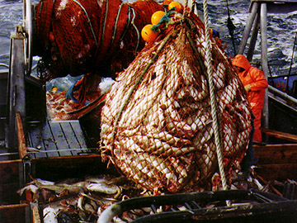
International water issues: The Exxon Valdez

Overfishing

International Air Issue: Global Warming

Hawaiian water issue: NWHI Coral Reef Ecosystem Reserve
Waiahole Ditch

Module 2: TERRESTRIAL ECOSYSTEM ISSUES (9/27-10/29)

International terrestrial eco issues: Old Growth Redwood Forests

Pesticide Use

Hawaiian terrestrial nature issues: Fire
Miconia

Module 3: HUMAN DEVELOPMENT ISSUES (11/1-12/3)


International development issues: Love Canal
Genetically Altered Crops

Hawaiian development issues: Traffic

Land fills on Oahu

Population Growth

Grading:
Your grade in this course will be based on your take-home exam, presentation and assignment scores. There will be 3 take-home exams: one after the completion of each module. Exams I and II will be handed out to you on the last Friday of each module and will be due on the following Friday. Exam III, covering the third module, will be due on the day scheduled for our final exam. Students successfully completing FIVE service-learning activities may substitute their service credits for Exam III and will receive a letter grade of “A” for the third exam. Students completing four service outings can substitute their service for the third exam and will receive a “B” for it; students completing three service credits will receive a “C” for the third exam if they wish to substitute service for it. Students completing two or fewer service activities must take Exam III. Exams will cover topics, ideas and concepts addressed in each module.
Presentations will be prepared by groups of 2/3 students and will be presented at the end of each module. Presentations will be based on a particular international or local environmental issue and will (1) demonstrate students’ understanding of the issue, (2) demonstrate the students’ awareness of each of the components or “players” involved in the issue, (3) demonstrate the students’ understanding of all of the ethical aspects of the issue and (4) demonstrate the students’ ability to attempt to devise a solution to the problem, which may incorporate a number of compromises in the eyes of each of the players. There will be three presentations. The specific topic of each will be decided within each module.
In addition to the take-home exams and presentations, there will be a few other assignments. These will include, but are not limited to, an expose on an environmental agency and an environmental career description essay.

Grading will be quantified as follows:

Exam I 20% (100 points)
Exam II 20% (100 points)
Exam III/Service Learning 20% (100 points)
Assignments 10% (50 points)
Presentations 30% (150 points: 50 each)

Environmental Ethics:
Because an important part of this course entails imparting on you students an awareness of the importance of ethics in environmental-problem solving, and because the professors in the Environmental Studies Program want you to be aware of the huge variety of kinds of environmental ethics in the real world, we will devote class time to discussions of the various environmental ethics of peoples from all over the world. We will use the books: Valuing the Earth and Earth Insights: A Multicultural Survey of Ecological Ethics and Environmental Ethics: An Introduction to Environmental Philosophy as sources of information about the specific ecological ethics of people from all over the world.

Course Materials:
I will provide many of the readings in the course to you. They will come from diverse sources. Bring your Vital Signs 2003 to class every day. You will need access to both a library and the worldwide web. You will also need to have computer discs/CD’s that can hold your Power Point presentations. It’s a good idea if you belong to Chaminade’s computer network so that you won’t have to put your presentations on a disk at all and so that you can communicate with each other via e-mail.

Classroom Atmosphere:
Guys, I value a very open, yet courteous class atmosphere. Express your ideas! Ask your questions. Propose solutions. (The only dumb question is the one in which you ask yourself if you should ask your question.) Respect the thoughts and ideas and opinions of others – really think about what others say. Let them fully express their thoughts and ideas and then you do the same. The thing I value most from my college days are all the wonderful, valuable, diverse ways of looking at and understanding the world that I was exposed to. Be an open vessel – take ideas in. You will learn as much from each other as you do from me.

Nothing is Certain but Change Itself Clause…
This syllabus and course schedule are living documents: they are free to change. I try to adhere as closely as possible to each, but there will be times in which we will take longer on a particular topic or add or delete a topic to enhance the course. I like to be able to react to you as the course proceeds and go with the flow a bit in order to make the course experience sort of custom fit to you!

You are responsible for all of the information in this document: losing it or not reading it are not excuses for not knowing what’s in it!
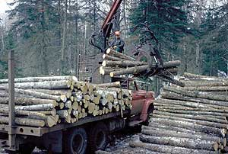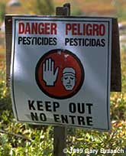
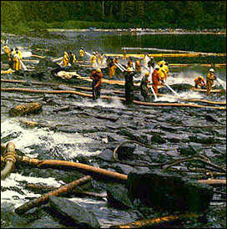

Introduction to Environmental Issues

Course Schedule

Week of: Readings & Activities

Module 1: WATER and AIR ISSUES

8/23 – 8/27 Course Introduction; Pre-Assessment
First Issue Reading (handed out to you)
Environmental Ethics: Chapter 1 [Sci, Ethics and the Enviro]

8/30 – 9/3 First Issue (continued); Enviro Agency Exposé; Ethics Video

9/6 – 9/10 Second Issue Reading (handed out to you)
Earth Insights: Chapter 2 [Western European enviro ethics]

9/13 – 9/17 Second Issue (continued); Third Issue Reading (handed out to you); Choose Presentation Topics & Groups

9/20 – 9/24 Third Issue (continued)
Take-Home Exam
Current Water/Air Issues Presentations

Module 2: TERRESTRIAL ECOSYSTEM ISSUES

9/27 – 10/1 First Issue Reading (handed out to you)
Earth Insights: Chapter 6 [Polynesian enviro ethics]

10/4 – 10/8 First Issue (continued); Enviro Careers Exposé; Ethics Video

10/11 – 10/15 Second Issue Reading (handed out to you); Reading on Steady-State Vs Growth Economies (handed out to you)

10/18 – 10/22 Second Issue (continued)
Take-Home Exam
Current Terrestrial Ecosystem Issues Presentations

Module 3: HUMAN DEVELOPMENT ISSUES

10/25 – 10/29 First Issue Reading (handed out to you)
Earth Insights: Chapter 4 [East Asian Deep Ecology enviro ethics]

11/1 – 11/5 First Issue (continued); Ethics Video

11/8 – 11/12 Second Issue Reading [Genetically Altered Crops] (handed out to you); Someone you know with a career in the environment exposé

11/15 – 11/19 Second Issue (continued)

11/22 – 11/24 Environmental Ethics: Chapter 4 [Responsibilities to Future Generations]

11/29 – 12/3 Earth Insights: Chapter 9 [Postmodern enviro ethics]; Post-Assessment
Take-Home Exam
Current Human Development Issues Presentations

The third take-home exam will be handed out on 11/29 and is due on Wednesday, 12/8 (by 12 NOON). This is the day our final is scheduled for.


