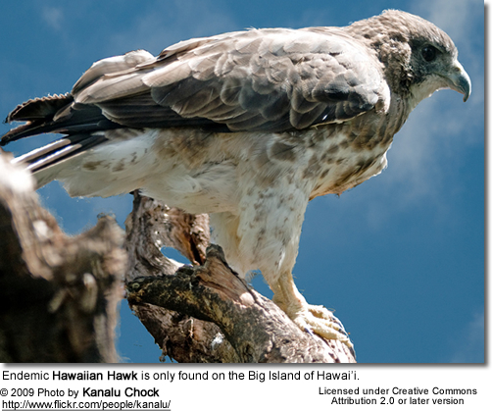
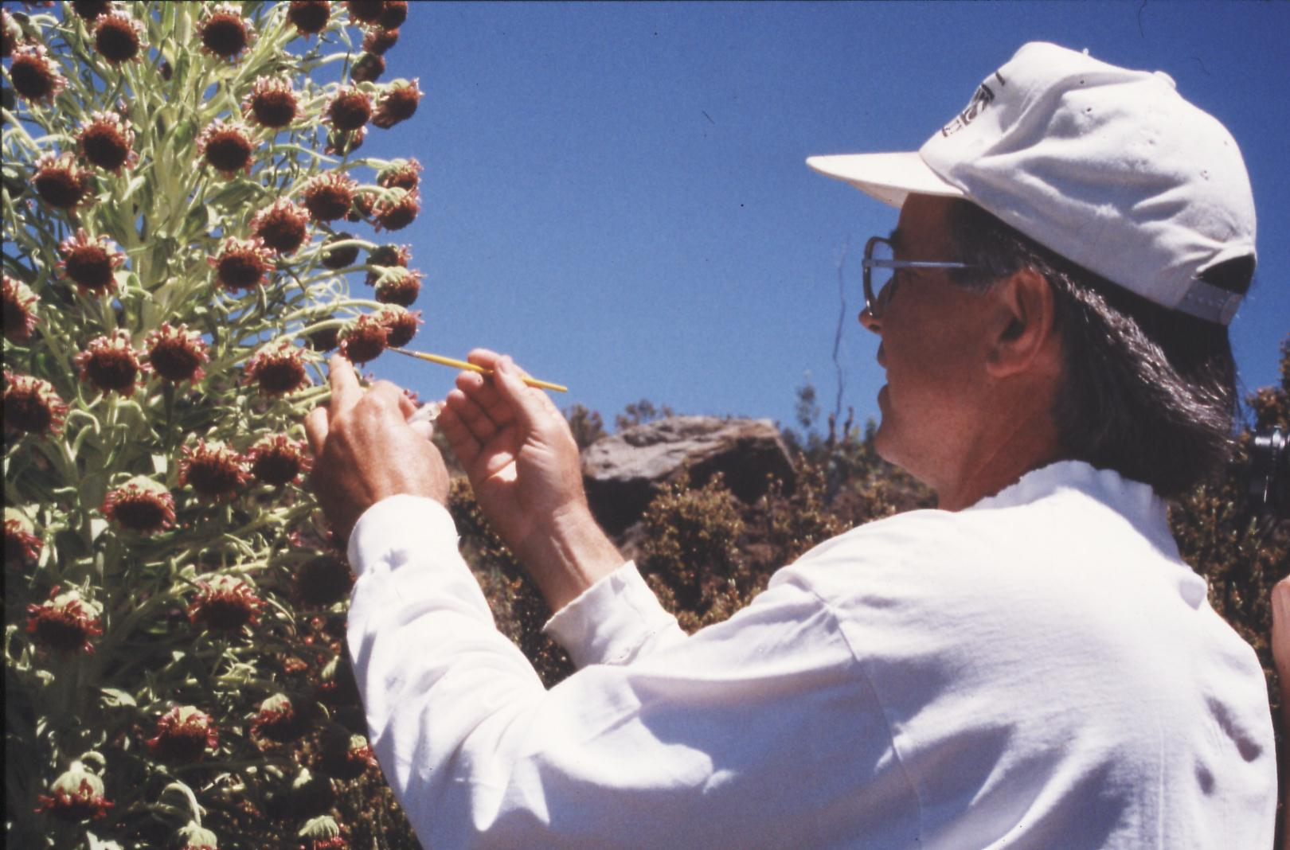
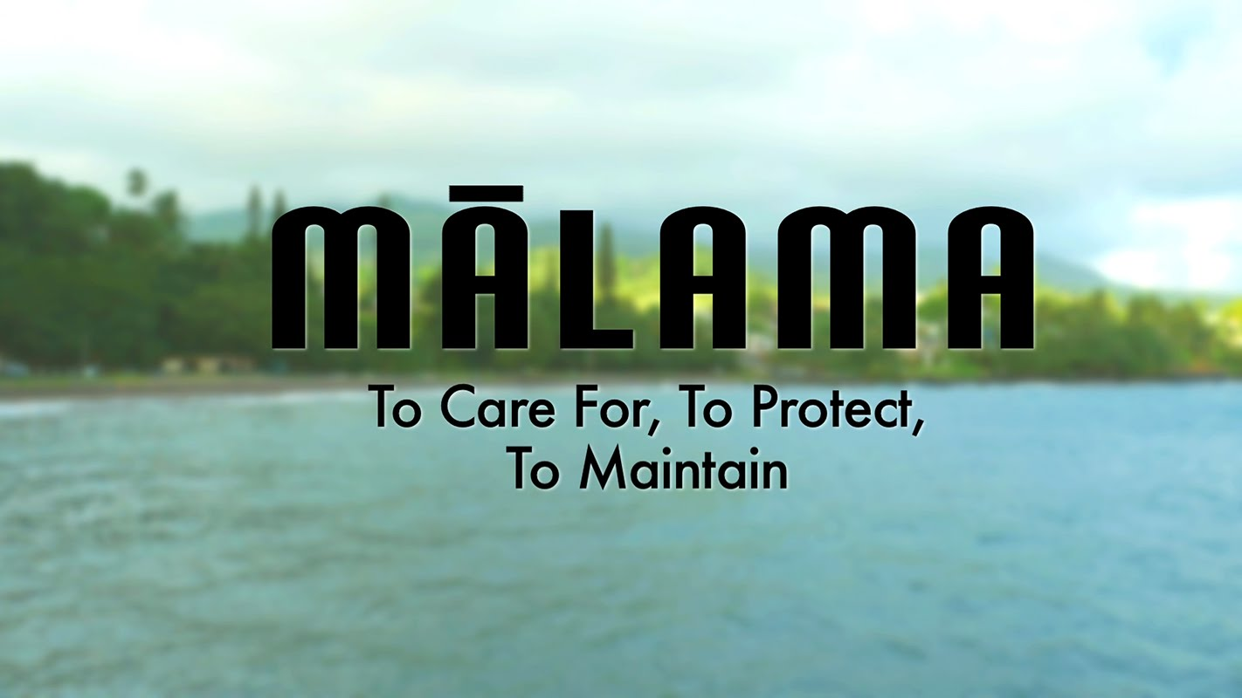

ENV 201 & 201L: Conservation Biology & Ecology Lecture and Laboratory
Fall 2026
Dr. Gail Grabowsky

Syllabus

The Earth’s resources are also being plundered because of short-sighted approaches to the economy, commerce and production. The loss of forests and woodlands entails the loss of species which may constitute extremely important resources in the future, not only for food but also for curing disease and other uses…. It is not enough, however, to think of different species merely as potential “resources” to be exploited, while overlooking the fact that they have value in themselves. Each year sees the disappearance of thousands of plant and animal species which we will never know, which our children will never see, because they have been lost forever.
Note: ALL of the links for the first MONTH are provided on the COURSE SCHEDULE on page 7 of this syllabus in Google Drive!

Pope Francis, Laudato Si 2015

A worldview does not dissolve overnight. Rather, like one of Hutton’s mountain ranges, it erodes through long centuries.
Lorien Eisley

Few will have the greatness to bend history itself; but each of us can work to change a small portion of events, and in the total of all those acts will be written the history of this generation.
Robert F. Kennedy
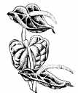

A thing s right if it tends to preserve the integrity, stability and beauty of the biotic community. It is wrong if it tends to do otherwise.
Aldo Leopold

Change your thoughts and you change the world.
Norman Vincent Peale

The scientific community is no private club. In principle, and in its best and broadest sense of the words, scientific inquiry can be undertaken by anyone on almost any subject matter.
W. Quine and J. Ullian
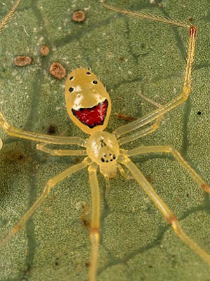

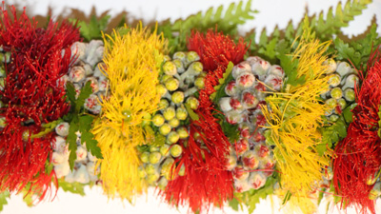
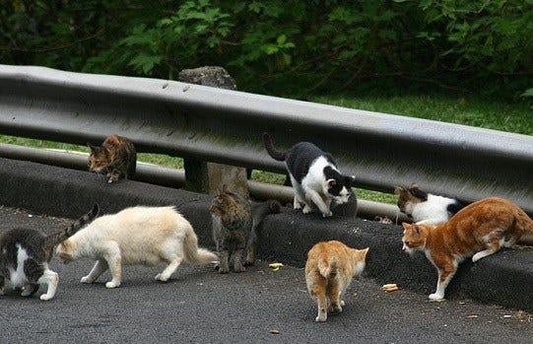
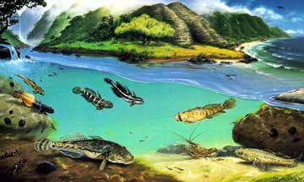
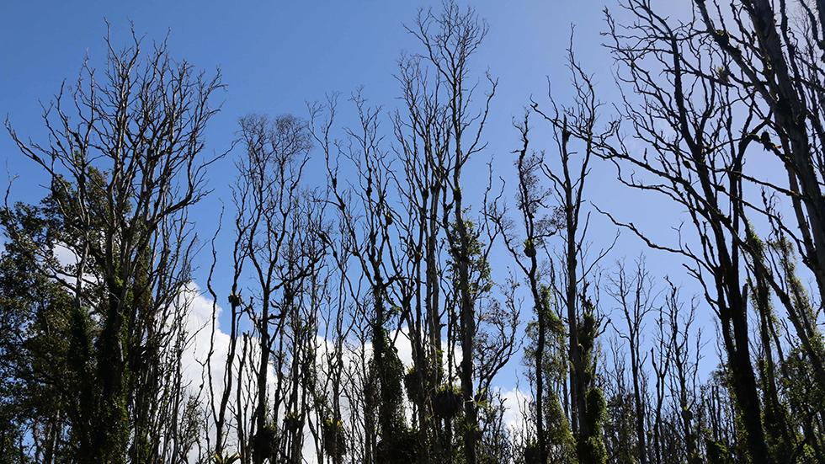

Department Name: Environmental Program
School Name: School of Natural Sciences and Mathematics
Course Credits: 3/1
Class Meeting Days: Lecture: TTh 1:00-2:20 Class Location: Sullivan 102
Class Meeting Days: Lab: M 2:30-5:20 Class Location: HL4 and OUTSIDE

Instructor: Dr. Gail Grabowsky
E-mail address: ggrabows@chaminade.edu
Phone: 735-4834 (ext. 834); cell 808-387-9319 (you may text anytime!)
Office Location: Wesselkamper Science Center, room 105
Office hours: T-F 3:00-6:00 PM; Or by appointment (Zoom or in person)
Dr Gail’s Zoom Link: https://chaminade.zoom.us/j/2916035174
Course Canvas Website: Lecture and Lab are in the same Canvas folder because they
compliment one another throughout the course.
Google Drive Folder: HERE!

University Course Catalog Descriptions:
ENV 201 Conservation Biology & Ecology
An introduction to conservation biology issues and goals and the principles of ecology. The course includes consideration of the impacts of human activity on ecosystems and our efforts to ameliorate destructive impacts and devise sustainable solutions. Major topics include the effects of industrialization, agriculture, pollution, species introduction and human population growth and development on the health and future sustainability of ecosystems and humans alike. Particular emphasis is placed on island ecosystems. Course must be taken concurrently with ENV 201L.

ENV 201L Conservation Biology & Ecology Laboratory
Students perform laboratory and field research techniques used in conducting conservation biology and ecological research and restoration. Analyses are conducted in the laboratory and in the field. Course must be taken concurrently with ENV 201.

Course Overview and Introduction:
Welcome to Conservation Biology & Ecology. I really enjoy teaching/facilitating this class because it comes from the heart (and the mind) as I am, like many of you, concerned for the current state and future of Earths ecosystems and al the life including us, that depend on them for so much. This course mainly focuses on the condition of earth’s ecosystems: what threatens them and their species and why and how to keep them healthy or return them to a healthier state once they are degraded. I feel this class is not simply a course you take in college, it changes the lives of most who take it, as it introduces you to and helps you understand the causes and consequences of the real-world environmental issues we confront every day (or every time we take a sip of water…). If you are an Environmental Studies or Environmental Science major OR a student with another major(s): WELCOME!
One thing I want all of us to realize through this course is that science is NOT a “sacred cow.” It is a very useful tool, but it is not in itself infallible or the only component of solutions to our environmental, ecological and sustainability challenges. We also must consider the people involved, their values and beliefs, their economics, politics, history, culture, needs, desires, etc in order to solve any environmental problem. Also while the science we do helps us gather information about a phenomenon or determine how to behave in order to change a situation, it does not tell us what is better or worse, right or wrong, what we should or should not do. Because of the complexity of conservation issues and the fact that science is only one of the players involved in learning about and solving them, we will have to touch on those other factors in this science course as well.

Marianist Values
This class represents one component of your education at Chaminade University of Honolulu. An education in the Marianist Tradition is marked by five principles and you should take every opportunity possible to reflect upon the role of these characteristics in your education and development:
- Education for formation in faith
- Provide an integral, quality education
- Educate in family spirit
- Educate for service, justice and peace
- Educate for adaptation and change

Native Hawaiian Values
Education is an integral value in both Marianist and Native Hawaiian culture. Both recognize the transformative effect of a well-rounded, value-centered education on society, particularly in seeking justice for the marginalized, the forgotten, and the oppressed, always with an eye toward God (Ke Akua). This is reflected in the ‘Olelo No’eau (Hawaiian proverbs) and Marianist core beliefs:
- Educate for Formation in Faith (Mana) E ola au i ke akua (ʻŌlelo Noʻeau 364) May I live by God
- Provide an Integral, Quality Education (Na’auao) Lawe i ka maʻalea a kūʻonoʻono (ʻŌlelo Noʻeau 1957) Acquire skill and make it deep
- Educate in Family Spirit (‘Ohana) ʻIke aku, ʻike mai, kōkua aku kōkua mai; pela iho la ka nohana ʻohana (‘Ōlelo Noʻeau 1200) Recognize others, be recognized, help others, be helped; such is a family relationship
- Educate for Service, Justice and Peace (Aloha) Ka lama kū o ka noʻeau (ʻŌlelo Noʻeau 1430) Education is the standing torch of wisdom
- Educate for Adaptation and Change (Aina) ʻAʻohe pau ka ‘ike i ka hālau hoʻokahi (ʻŌlelo Noʻeau 203) All knowledge is not taught in the same school

What this course counts for:
This course is required for Environmental Studies and Environmental Science majors and minors. It also counts for your Quantitative Reasoning requirement under our General Education Program. If you are an Environmental major the table below shows you how this course helps you achieve the Program Learning Outcomes for Environmental Studies and Environmental Science and at what level of proficiency. Some of the Learning Outcomes are shared between the two majors but not all. NOTE: If you are not an ENV major think about it! Environmental Studies is not a large major and it goes well with many other majors: BU + ENV, COM + ENV, ED + ENV, CJ = ENV, etc!!!!!

Upon completion of the undergraduate B.S. program in Environmental Studies, students will be able to:
Environmental Studies Program Learning Outcomes | ENV 201/L
Authenticate their commitment to service, justice and peace through experiential project-based
activities that enhance the condition of the integral ecology, care for creation and value all voices.
Apply analytical methods and skills from multiple disciplines to environmental problems.
Participate in, plan and execute environmental change-making strategies that employ scientific,
political, socio-cultural, artistic, educational and economic skills and knowledge.
Design and describe new futures and ideas that solve environmental problems and foster
sustainability.
Pursue throughout their education the ever-changing knowledge and skills that prepare them for
the adaptation and change essential to environmental problem solving.

Upon completion of the undergraduate B.S. program in Environmental Science, students will be able to:
Environmental Science Program Learning Outcomes | ENV 201/L
Authenticate their commitment to service, justice and peace through experiential project-based
activities that enhance the condition of the integral ecology, care for creation and value all voices.
Apply scientific reasoning and methodology to environmental problems.
Identify the major physical, chemical and biological components, interactions and cycles of earth
systems and ecosystems.
Propose, design and participate in scientific research projects that document, describe and/or
help solve environmental problems and foster sustainability.
Pursue throughout their education the ever-changing knowledge and skills that prepare them for
the adaptation and change essential to environmental problem solving.
Introduces to the concept or skill
Develops the concept or skill
Gains mastery of the concept or skill

The COURSE Learning outcomes for the lecture and lab are the following:
Lecture: When you complete this course you will be able to:
- Summarize what science is and how scientific research is conducted and shared with others
- Outline the role of science in enabling us to understand and problem-solve conservation issues
- Explain the role of ethics in allowing us to define conservation problems and solutions
- Describe the major causes of habitat/ecosystem degradation and destruction and species loss
- Relate a number of potential solutions for global and Pacific Island habitat/ecosystem degradation and destruction and species loss
- Give examples of the basic structure and types of fresh water and terrestrial ecosystems
- Categorize the generalized sorts of interactions between organisms and their environment
- Define what a healthy ecosystem is and what sustainability means in general
- Explain the historic reasons why human population growth occurred and what its future implications are for ourselves and other species
- Experience first-hand the connections between academic work and real-life situations

Lab: When you complete this course you will be able to:
- Articulate the scientific method and how to apply it to real environmental issues
- Recall what descriptive science is and how it is important in conservation biology
- Memorize the basic units used in making scientific measurements
- Recite the taxonomic hierarchy and describe the systematic biology methodology and the species concept
- Differentiate between species abundance and distribution
- List some of the measures used to determine ecological stress
- Interpret and create graphs, tables and maps
- Express the importance of, and know how to access and read, the primary scientific literature
- Formulate a hypothesis and design a scientific experiment to test it
- Prepare a formal laboratory write-up

Required Texts: An Introduction to Conservation Biology. 2018. [ISBN: 9781605354736]

Supplemental Texts: Many other articles, reports and exercises will come from other sources. All of them will be provided to you in Google Drive in the course folder.

Course Website: The majority of the content for this course is in our class Google Drive folder HERE!
The course Syllabus, Service Learning Sheets and Written Reflection, and other important documents can be found in our course Canvas folder.

Grading & Assessment:
Lecture grading will be quantified as follows:
Exam I and II and Final Exam (20% each) 60% 600 pts

Habitat Type Project - Group Presentation 15% 150 pts
15 hours of Service Learning + Survey, Photos & Discussion 15% 150 pts
Quizzes on outside readings (i.e. readings not in the textbook) 10% 100 pts
100% 1000 pts
Lab grading will be quantified as follows:
Lab assignments, worksheets, info shares 50% 500 pts
Conservation Journal Article Critique 20% 200 pts
Hypothetical Experiment Write-Up 20% 200 pts
Attendance 10% 100 pts
100% 1000 pts
Letter grades are interpreted as follows:
A = Outstanding scholarship and an unusual degree of intellectual initiative
B = Superior work done in a consistent and intellectual manner
C = Average grade indicating a competent grasp of subject matter
D = Inferior work of the lowest passing grade, not satisfactory for fulfillment of prerequisite course work
F = Failed to grasp the minimum subject matter; no credit given

Grading procedures and the components of your grade:
Lecture grades will be determined in part by written exams using a curve with the mean score for the class being a B- and the score immediately below the mean being a C+. This will be explained in detail in class. The lecture exams will cover the material from the start of class up until the first exam and the material after the first exam up until the second Exam. These exams will have a variety of types of questions on them. The final exam is cumulative, multiple choice and covers the lecture material for the entire semester. A review sheet will be handed out before every exam.
The details surrounding the lecture presentations, service learning assignment and quizzes will be explained in class and via handouts. The factors that determine your particular grade for the presentation, your service learning and the quizzes will also be explained in a grading explanation/rubric handout.
Lab grades for oral and written lab assignments and worksheets will be determined based on your effort, correctness (when there is a correct response etc.) and your thoughtfulness. Effort in general manifests itself as neatness, completeness, thoroughness, calories expended per unit time(!), timeliness, correct spelling, any extra creative things you do above-and-beyond what is expected, etc. Correctness means do your statements jive with corresponding scientific knowledge, do your conclusions follow from the evidence before you, did you calculate an equation correctly, interpret a graph accurately, make a table that illustrates your data properly, etc. Thoughtfulness can show up in many ways, perhaps you really think things through, trying to consider all the variables or you worked hard to tie pieces of evidence together, maybe you consider something that may be important that everyone else ignores. Have done some thinking, really reflected upon a topic, analyzed it, etc. thoroughly.

Service Learning Requirement:

You will need to participate in 15 hours of service-learning work throughout the semester that aims to help Hawaii and the Pacific islands achieve the United Nations Sustainable Development Goals (SDG) and is officially tied to Chaminade’s United Nations CIFAL Honolulu training center. This year you have five opportunities to choose from. You can commit to just one of them or participate in all of them! Sign up for which you want to do on this sheet HERE!

- Helping out with Chaminade’s Pono Popoki Project. Here is the link to the Project Google Drive folder! Contact person is Dr. Gail
- Helping out the World Institute for Society and the Environment (WISE) Here is the link – a non-profit organization (NGO) dedicated to “empowering society to fall in love with the earth”. Dr. Gail is on the board and will connect you with Dr. Dave Augeri the founder, and/or
- Helping out the GEMM Project (Gender Equity through Malama Ma`i) See Lizette Nolasco in WSC 115 or email her at Lizette.nolasco@chaminade.edu
- Helping to Count and Map the number of Manu-O-Ku on Campus (also called white terns or fairy terns) Here is the link. Mr. Rich Downs is our contact person.

Throughout the semester you will need to keep track of your service hours on a form Dr. Gail created that lives HERE in Google Drive. Also you MUST share photos of yourself (and your friends if you’d like) HERE in action, DOING your service work and contributing to making campus a more sustainable place! So, everyone will complete two essay exams and 15 hours of planet-aiding service projects. You get to decide which essay exam you will replace with your service project.
NOTE: I have changed the absence policy since handing out your hard copy of the syllabus. New policies highlighted in yellow.
Attendance and your grade:
If you miss a LECTURE or LAB your absence must be excused if it is not to formally effect your grade. Excused absences occur when you bring in a doctor’s note, a funeral announcement for a family member, notice of participation in athletic events, etc. Unexcused absences occur when you were working, surfing, sleeping, cramming for an exam in another class, etc. I am a scientist; I require hard evidence if an absence is to be excused. So if your car breaks down on the way to class take a picture of your smoking engine or flat tire right then and share it with me ASAP! Make SURE I can verify the date and time of the breakdown and it will be an excused absence, however, no evidence; no excused absence.
You are allowed zero unexcused absences for LAB and ONE unexcused absence from LECTURE. Use it wisely! After one unexcused absence in lecture you will receive 10 points off on your exams for each unexcused absence.

Extra Credit Options:
Periodically throughout the course there will also be presentations and webinars you may attend that pertain to the course material. You can earn +2 extra credit points towards your quiz grades for each talk you attend. In order for all talks/activities to count for extra credit you MUST have them approved by Dr. Gail PRIOR TO the event and you MUST document your presence with a photograph of yourself participating or some other kind of evidence. You may earn up to 10 extra credit points from attending talks/presentations and for each hour of service learning you participate in past the optimal 15 hours. ALSO NEW: 0.25 points/day every day you stowaway your phone (= 10 points overall if you stow it every day1)

Classroom Atmosphere:
Specific to Dr. Gail’s classes: Guys, I value a very open, yet courteous class atmosphere. Express your thoughts! Ask your questions! (The only dumb question is the one in which you ask yourself if you should ask your question.) Respect the thoughts and ideas and opinions of others – really think about what others say. Let them express themselves fully, then you do the same. The thing I value most from my college days are all the wonderful, valuable, diverse ways of looking at and understanding the world that I was exposed to by my fellow students and my professors. Be an open vessel – take ideas in! You will learn as much from each other as you do from me.

This syllabus and course schedule are living documents: they are free to change. I try to adhere as closely as possible to them for your convenience, but there will be times in which we will take longer on a particular topic or add or delete a topic to enhance the course. I like to be able to react to you as the course proceeds and go with the flow a bit in order to make the course experience sort of custom fit to you!

You are responsible for all of the information in this document: losing it or not reading it do not make you exempt from knowing what’s in it!

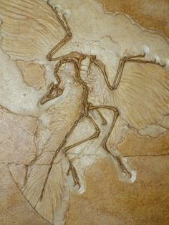
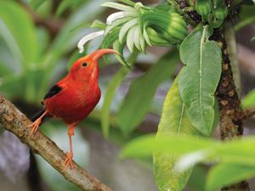
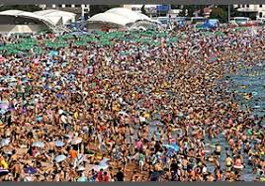
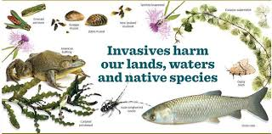

Class Schedule: ENV 202 & 201L
Fall 2026
Link to our Course Google Drive Folder

Part I
Knowledge, Ethics & the Environment in General

WEEK TOPIC ACTIVITIES
1 Course intro; Who we are; Course path; Questions? Review course syllabi; Assessment; Lab Safety
Lab 1: “A Life on Our Planet” (83 min); Watch the Trailer here & Discussion after
UPLOAD a photo of a favorite natural place; Upload a photo of nature you HERE due 8/24

Important terms & concepts; UN SDG’s Read: “Human Domination…”; QUIZ on 8/25 Review your photos – why you it!

2 Lab 2: Survey nature issues that concern us Share an enviro issue & your photos
General human effect on the environment: QUIZ on “Human Domination” on 8/25! Land Transformation; Oceans See the folder here for Modules 1-6

3 Lab 3: Indigenous Knowledge Lab (on your own!) Upload your worksheet by lab on 8/31 HERE!
Alteration of biogeochemical cycles Review IK labs…
Alteration of biogeochemical cycles (cont’d) Read: “Living Planet Report 2020” pp.6-50

4 NO CLASS MONDAY 9/7: Labor Day!
Biotic change and species loss QUIZ on “Living Planet Report 2020” on 9/8
“Human Domination” paper wrap-up Skim: “A Safe Operating Space for Humanity”
Boundaries we may have overstepped already… Read: “The Philosophy of Science”

5 Lab 4: Value Lab Bring something to value!
What is science? Underlying philosophy & methods QUIZ on “The Philosophy of Science”
Science, traditional knowledge and ecological ethics Read/Review: Textbook chapter 1
What is Conservation Biology (then and now)? Hypothetical Experiment Assignment explained!

Part II
Pristine Nature: Biodiversity and Ecology

WEEK TOPIC ACTIVITIES
6 Lab 5: Metric Measure & Gathering Data: Handouts and Worksheet, fun facts videos
The history of life on earth Read/Review: Textbook chapter 2
The characteristics and requirements of life History of Life Power Point by Dr. Gail
E X A M I scheduled for 9/25 E X A M I scheduled for 9/25

7 Lab 6: Eco Footprint Calculation (on your own!) Handout; Online, share on 10/5 (No lab meeting)
Life: Unity and diversity and their implications... Read/Review: Textbook chapter 3
Evolution: Evidence Evidence of Evolution Power Point by Dr. G.
Evolution: Patterns Hypotheses Due on 10/2!

8 Lab 7: Biological Diversity I & Classification Worksheet, Camanicules & Gallery Walk
Evolution: Mechanisms Read/Review: Textbook chapter 6
Evolution: Speciation & Extinction Habitat Type Presentation explained

WELLNESS WEEK! (10/13-10/16) No classes but lots of activities!

9 Lab 7: Biological Diversity II Fieldtrip to Zoo! Zoo Biodiv Photo Contest!
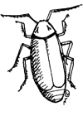
Human historical place in nature; World Pop Clock
Ecological principles; causal networks Revised Hypotheses due by 10/24!

10 Lab 8: Life Expectancy & Fertility Rate Lab (on your own!) Worksheet; Get your ohana’s data!


Abiotic & Biotic ecological interactions Read/Review: Textbook chapter 4
Ecological productivity; Ecosystems
Habitat Presentations Habitat Type Oral Presentations

11 Lab 9: IDing Hawaiian Birdsong Worksheet; Awards for those who ID first!
Soil; Earth’s habitats & systems STUDY FOR THE EXAM!!!
Ecology wrap-up!
E X A M II scheduled for 11/6 E X A M II scheduled for 11/6

Part III

Island Populations and Challenges

WEEK TOPIC ACTIVITIES
12 Lab 10: Species back from the brink! (on your own!) Worksheet & photo upload! (No lab meeting)
Islands: Why each is unique & things they all share… Read/Review: Textbook chapter 5
Islands: Geology, climate, dispersal, endemism Island Types & Adaptive Radiation Power Points
Islands: Adaptive radiation, invasives & extinctions

Part IV

Restoring Biodiversity & Living Sustainably on Island Earth

WEEK TOPIC ACTIVITIES

13 Lab 11: Native and invasive species St. Louis Hike; Worksheet
Dr. Gail explains sustainability’s role & the SDG’s!
Species level conservation Read/Review: Textbook chapter 7
MSY, MVP and PVA! Pop management measures

14 Lab 12: Conservation Structured Decision Making SDM Group Collaboration; Fieldtrip to Library
Protected areas; Predictors of success Read/Review: Textbook chapter 8 & 9
Ex Situ conservation; Zoos, aquariums, gene banks
Captive breeding; Ecological restoration Read/Review: Textbook chapter 10

15 Lab 13: Conservation Journal Article Critiques Short presentation: purpose and findings
Ecotourism; Conservation answers for Hawaii Read: “Mind in the Biosphere; Mind of…”
Decision-making algorithms QUIZ on “Mind in the Biosphere;…” on 12/3!
Your Conservation Fixes


Important Dates You Should Know:
- Our FINAL EXAM will be given DURING FINALS WEEK! Date and time TBA!
- Part II of the Hypothetical Experiment Project: Designing an Experiment and your service learning assignments (Excel sheet fill-in and photos) are all due by Friday December 11th^{th} at midnight! Late assignments will not be accepted!

Specific Credit Situations: The minimum 45 hours of engagement per credit hour can be satisfied in fully online, internship, or other specialized courses through several means, including (a) regular online instruction or interaction with the faculty member and fellow students and (b) academic engagement through extensive reading, research, online discussion, online quizzes or exams; instruction, collaborative group work, internships, laboratory work, practica, studio work, and preparation of papers, presentations, or other forms of assessment. This policy is in accordance with federal regulations and regional accrediting agencies.
How ENV 201 (lecture, 3 credits) Meets the Credit Hour Policy:
There are three components to the amount of time students will spend in a course:
- Seat time: = 35 hours
- Time spent on key assessments:
  - Four outside readings with quizzes = (2 hours reading x4 +(1 hour review x 4) = 8+4 = 12 hours
  - Ten textbook chapters to read = 4 hours each x 10 = 40 hours
  - 15 hours mandatory service project and reflections = 18 hours
  - Collaborative 10-15 minute Habitat Type Presentations = 10 hours research, slide prep, practice
  - Reviewing for Exam I, II and Final Exam = 8 + 8 + 10 = 26 hours
TOTAL: 141 Hours

How ENV 201 Laboratory (1 credit) Meets the Credit Hour Policy:
There are three components to the amount of time students will spend in a course:
- Seat time: = 30 hours
- Time spent on key assessments:
  - Fifteen worksheets, in class sharing preparation, online assignments = 15 hours
  - Formal Laboratory Write-Up = 10 hours
  - Hypothetical Experiment Project = 5 hours
TOTAL: 60 Hours
Classroom Atmosphere
Guys, I value a very open, yet courteous class atmosphere whether we are together in person or working together/discussing something online. Express your ideas! Respect the thoughts and ideas and opinions of others – really think about what others say. You will learn as much from each other as you do from me. Ask your questions. (The only dumb question is the one in which you ask yourself if you should ask your question.) Propose solutions. THINK, LEARN, WORK HARD, HAVE FUN.

Nothing is Certain but Change Itself Clause…
This syllabus and course schedule are living documents: they are free to change. I try to adhere as closely as possible to each, but there will be times in which we will take longer on a particular topic or add or delete a topic to enhance the course. I like to be able to react to you as the course proceeds and go with the flow a bit in order to make the course experience sort of custom fit to you!

You are responsible for all of the information in this document: losing it or not reading it are not excuses for not knowing what’s in it!
______________________________________________________________________________

Other important general notables not specific to this class…

Grades of "Incomplete”: Students and instructors may negotiate an incomplete grade when there are specific justifying circumstances. When submitting a grade the “I” will be accompanied by the alternative grade that will automatically be assigned after 30 days if the student does not complete the coursework. These include IB, IC, ID, and IF. If only an “I” is submitted the default grade is F. The completion of the work, evaluation, and reporting of the final grade is due within 30 days after the end of the semester or term. This limit may not be extended.

The rest of this syllabus listing information of general importance to every student and every class can be found in our course Google Drive folder HERE!

Academic Honesty
Academic honesty is an essential aspect of all learning, scholarship, and research. It is one of the values regarded most highly by academic communities throughout the world. Violations of the principle of academic honesty are extremely serious and will not be tolerated.
Students are responsible for promoting academic honesty at Chaminade by not participating in any act of dishonesty and by reporting any incidence of academic dishonesty to an instructor or to a University official. Academic dishonesty may include theft of records or examinations, alteration of grades, plagiarism, and unauthorized and/or undisclosed AI usage, in addition to more obvious dishonesty. See catalog section Student Use of Artificial Intelligence in Academic Work for further information.
Questions of academic dishonesty in a particular class are first reviewed by the instructor, who must make a report with recommendations to the Director of the Academic College. Punishment for academic dishonesty will be determined by the instructor, Director, and the Dean of Academic College and may include an “F” grade for the work in question, an “F” grade for the course, academic notice, or dismissal from the University.
AI (Artificial Intelligence) Statement
Chaminade University recognizes the increasing role of artificial intelligence (AI) technologies in academic and professional environments. AI encompasses, but is not limited to, generative AI platforms, automated writing or content generation software, coding assistants, and similar tools. Students must ensure all submitted work genuinely reflects their knowledge and effort. Using AI to produce or significantly complete graded assignments, exams or other academic tasks – defined as use that substitutes for or substantially replaces a student’s own analysis, reasoning or written expression – without explicit instructor approval is considered academic misconduct and will be dealt with according to the University’s Academic Honesty Policy.
If an instructor has reasonable grounds to question whether submitted work genuinely reflects a student's own knowledge, authorship, or mastery of course material — or whether it meets the course's expectations for AI use — the instructor may require the student to provide additional or alternative evidence of authorship and content mastery. Such evidence may include drafts, notes, revision history, source materials, process explanations, oral discussion, in class work, or completion of an alternative assessment. A student’s refusal or inability to provide such evidence may be considered, along with other available information, in evaluating whether the work meets course requirements and stated learning outcomes. Instructors will not rely solely on AI detection software or other automated tools in making grading or academic integrity determinations. Such determinations will be based on the totality of the available information and handled in accordance with applicable University policies and procedures. See the catalog section Student Use of Artificial Intelligence in Academic Work for further information.

Title IX and Nondiscrimination
Chaminade University of Honolulu is committed to providing a learning, working and living environment that promotes the dignity of all people, inclusivity and mutual respect and is free of all forms of sex discrimination and gender-based violence, including sexual assault, sexual harassment, gender-based harassment, domestic violence, dating violence, and stalking. As a member of the University faculty, I am required to immediately report any incident of sex discrimination or gender-based violence to the campus Title IX Coordinator. For pregnant and parenting students, I am also obligated to provide you with similar resources for support and protections available to you. My goal is to make sure that you are aware of the range of options available to you and have access to the resources and support you need.

Contact information and reporting options: chaminade.edu/titleix/nondiscrimination/. File a report via the Campus Incident Report Form.
Nondiscrimination Policy and Notice of Nondiscrimination
The university is committed to comply with all State and Federal statutes, rules, and regulations which prohibit discrimination. The university is committed to a policy of nondiscrimination on the basis of race, sex, gender identity and expression, age, religion, color, national origin (including shared ancestry and ethnic characteristics), ancestry, citizenship, disability, genetic information, marital status, breastfeeding, arrest and court record (except as permissible under State law), sexual orientation,or status as a covered veteran. Inquiries about Title IX or general Civil Rights concerns may be referred to the University’s Title IX Coordinator, the U.S. Department of Education’s Office for Civil Rights, or both and contact information may be found HERE. On-campus Confidential Resources may also be found here at CAMPUS CONFIDENTIAL RESOURCES.
The University’s Nondiscrimination Policy and Grievance Procedures can be located on the University webpage at: https://chaminade.edu/compliance/title-ix-nondiscrimination-policies-procedures/.
To report information about conduct that may constitute sex discrimination or make a complaint of sex discrimination under Title IX, please refer to the Campus Incident Report form. Chaminade University of Honolulu prohibits sex discrimination in any education program or activity that it operates.
The NOTICE of NONDISCRIMINATION can be found here: Notice of Nondiscrimination.

Student with Disabilities Statement- Kōkua ʻIke
Accessibility Services recognizes disability as a valued aspect of diversity and ensures equal access to the educational environment in accordance with Section 504 of the Rehabilitation Act; the Americans with Disabilities Act, as amended; and the principles and professional standards of the Association on Higher Education and Disability.Access is supported through reasonable accommodations and referrals to campus and community resources.
Appointments with the Accessibility Services Coordinator are available through Stellic at
https://chaminade.stellic.com and may be held virtually or in person. Drop-in
appointments are also welcome.
Students seeking support must meet with the Accessibility Services Coordinator as
early as possible, even if they are unsure whether they have appropriate documentation
of their disability or its impacts. The Accessibility Services Coordinator prioritizes
listening to students’s experiences and will discuss any documentation needs during the
initial intake meeting. Students may seek support at any time.
Learn more at https://chaminade.edu/ada-accommodations
Campus Resources & Support Services
The following resources are available to all Chaminade students. Reach out early — these services exist to support your success.

Resource | Description | Contact / Website
Accessibility Services  (Kōkua ʻIke) | Accommodations under Section 504 and ADA. Contact early — appointments via Stellic, virtual or in person. | ada@chaminade.edu  chaminade.edu/ada-accommodations
Tutoring & Academic  Coaching (Kōkua ʻIke) | Tutoring and Academic Coaching Services support students’ progression toward their  academic, personal, and professional goals with clarity and intention. Services include  individualized support in English, math, nursing, sciences, and social sciences, as well as guidance in developing goals and study strategies. | chaminade.edu/tutoring-academic-coaching-services
Career Services | Career Services supports students throughout their career journeys. Services include  individualized job search strategy coaching, resume reviews, job interview coaching,  and access to career-related resources and opportunities. | chaminade.edu/career-services
Basic Needs Resources | Support for food insecurity, housing instability, and other basic needs. | chaminade.edu/basic-needs/
Title IX /  Nondiscrimination | Reporting and support for sex discrimination and gender-based violence. Campus Incident Report Form available online. | chaminade.edu/titleix/resources-and-support/
Hazing Prevention | Confidential support, crisis intervention, and reporting for any type of abuse including hazing. | hazingpreventionnetwork.org/athlete-helpline/
Campus Safety /  SafeSwords | Security escort service for anyone who feels unsafe walking alone on campus at any time of day. Call security and a professional will escort you to your destination. | chaminade.edu/student-life/security/campus-safeswords-program/
CUH Alert Emergency  Notification | Emergency text system. Register your cell number via the Chaminade portal and confirm the text to complete enrollment. | chaminade.edu

PAU!!!
See you in class!

