

History
School of Humanities, Arts, and Design

HI-444-00-2 Modern Japan
Asynchronous Online Course
3 Credits

Instructor Information

Instructor: Dr. Michio “Mitch” Yamasaki
Email: myamasak@chaminade.edu
Phone: (808) 735-4824
Office Location: Henry 206H
Virtual Office Hours:

You can email me at myamasak@chaminade.edu any time you have a question or problem. I will respond within 48 hours. However, if you would like a synchronous meeting during office hours, I am happy to give you a call if you provide me with a phone number that I can reach you and your desired meeting day/time. I will be available for synchronous office hours on the days and times listed below:

Monday 10:00 AM - 12:00 Noon
Wednesday 02:00 PM - 04:00 PM
Friday 04:00 PM – 06:00 PM

School of Humanities, Arts, and Design

The discipline of History is part of the School of Humanities, Arts, and Design (SHAD). The Dean of SHAD is Cheryl Edelson, Ph.D. Her office is in Henry 206. Dr. Edelson’s email address is cedelson@chaminade.edu. Her phone number is (808) 735-4826.

Course Description

In four short decades, how was Japan transformed from a medieval society to a modern nation? Why did Japan become imperialistic? What brought on World War II? How did America’s occupation of Japan transform the nation? What brought on Japan’s “economic miracle” after World War II? How did the status of Japanese women evolve during the modern period? Why did Japan give birth to some of the world’s best manga (comics) and anime (cartoons)? These and other fascinating topics will be covered in this course. Prerequisites: EN 102 and COM 101. Cross-listed with POL-444.

Course Outline

Module 1: Overview and To Do List (0:30)
Course Completion Schedule (1:00)
Tokugawa Japan: Powerpoint Lecture & Note-Taking Guide (6:00)
Internal Problems: Powerpoint Lecture & Note-Taking Guide (6:00)

Module 2: Overview and To Do List (0:30)
External Pressures: Powerpoint Lecture & Note-Taking Guide (6:00)
Bakumatsu: Powerpoint Lecture & Note-Taking Guide (6:00)
Exam 1 (1:00)

Module 3: Overview and To Do List (0:30)
Fukuzawa Yukichi: Powerpoint Lecture & Note-Taking Guide (6:00)
Meiji Political Development: Powerpoint Lecture & Note-Taking Guide (7:00)

Module 4: Overview and To Do List (0:30)
Meiji Economics: Powerpoint Lecture & Note-Taking Guide (6:00)
Meiji Culture: Powerpoint Lecture & Note-Taking Guide (6:00)
Exam 2 (1:00)

Module 5: Overview and To Do List (0:30)
Meiji Foreign Affairs: Powerpoint Lecture & Note-Taking Guide (7:00)
Taisho Era: Powerpoint Lecture & Note-Taking Guide (6:00)

Module 6: Overview and To Do List (0:30)
Economic Crisis and Ultranationalism: Powerpoint Lecture & Note-Taking Guide (6:00)
Military Expansion: Powerpoint Lecture & Note-Taking Guide (6:00)
Exam 3 (1:00)

Module 7: Overview and To Do List (0:30)
World War II – Part 1: Powerpoint Lecture & Note-Taking Guide (6:00)
World War II – Part 2: Powerpoint Lecture & Note-Taking Guide (6:00)

Module 8: Overview and To Do List (0:30)
Occupation – Part 1: Powerpoint Lecture & Note-Taking Guide (6:00)
Occupation – Part 2: Powerpoint Lecture & Note-Taking Guide (6:00)
Exam 4 (1:00)

Module 9: Overview and To Do List (0:30)
Postwar Politics: Powerpoint Lecture & Note-Taking Guide (3:00)
Economic Miracle: Powerpoint Lecture & Note-Taking Guide (3:00)
Japanese Women: Powerpoint Lecture & Note-Taking Guide (3:00)
Education in Japan: Powerpoint Lecture & Note-Taking Guide (3:00)
Participate in Communities of Practice (1:00)

Module 10: Overview and To Do List (0:30)
1950s Film: Powerpoint Lecture & Note-Taking Guide (4:00)
Manga: Powerpoint Lecture & Note-Taking Guide (4:00)
Anime: Powerpoint Lecture & Note-Taking Guide (4:00)
Exam 5 (1:00)

Course Text

W. Scott Morton and J. Kenneth Olenik, Japan: Its History and Culture, McGraw-Hill, Fourth Edition (any edition is fine)

Course Activities

Take 5 examinations

Grading

Five (5) Examinations 500 points

Grades

450-500 points = A
400-449 points = B
350-399 points = C
300-349 points = D
Below 300 points = F

Retaking Examinations

You might encounter a technical problem while taking an examination. If this should happen, contact the instructor immediately (Dr. Yamasaki myamasak@chaminade.edu). You will be allowed to retake the exam at an appropriate time.

Late Discussion Posts

The quality of discussions plays an important role in the success of the course. Without time to read and respond to classmates, our shared classroom community will be diminished. Therefore, late discussion posts will receive a 50% deduction.

Grade of Incomplete

If students are unable to complete the course, the instructor may offer a grade of “incomplete.” This will provide a 30-day extension for the student to complete the course. In order for the students to receive a grade of “incomplete,” they must discuss the matter with the instructor before the end of the term.

Learning Outcomes

1. Change and Continuity

Foremost to the study of history is the understanding of change and continuity. Why do certain beliefs, ideas and institutions change over time while others remain the same? This course studies the political, social, economic, and cultural developments of Modern Japan. It will look at the rise and fall of the centralized feudalism or the Tokugawa Bakufu. It will analyze the rapid modernization of the country during the Meiji period. The course will review the steps that led Japan to a catastrophic war in the Pacific (World War II). It will examine Japan under military occupation of the United States. It will study the country’s miraculous economic growth after World War II. Finally, the course will examine the political, social, and cultural developments in contemporary Japan.

2. Adaptation & Change

This course will evaluate the ways in which adaptation and change are essential to understanding the past, analyzing the present, and meeting future challenges. If we want to know how and why Japan is the way it is today, we must first look to the past to find the answers. How did Japan adapt to a world that went through profound changes during the two and a half centuries the country isolated itself from the world during the Tokugawa Bakufu? How did Japan change rapidly during the Meiji period, modernizing itself within 40 years, something that took Europe centuries to accomplish? Those changes turned Japan into a predatory and imperialistic nation. It led Japan into World War II. How did Japan adapt to itself from a global empire to a country occupied by foreign soldiers? How then did it change from a militaristic nation to one focused on finances, creating a breath-taking economic miracle that made Japan the second richest nation in the world?

3. Global Awareness

This course will integrate the experience of students with global awareness in the context of this course – Modern Japan – and in the field of history with a diverse community of learners. HI/POL 444 introduces students to the unique history and culture of Modern Japan. It is a country with a unique religion that sees the divine in all aspects of nature. Shintoism recognizes mountains, streams, and even the wind as kami. The Japanese believed that divine winds or kamikaze drove Mongol invaders from its shores. They called their suicide airplanes that crashed into American warships during World War II kamikaze. During the Meiji period, the Japanese literally threw off their Asian culture and heritage to become a modernized and westernized nation. It became an imperialist nation with a derogatory attitude towards other Asians. It committed numerous crimes against military and civilian populations in China, Manchuria, and the Philippines. After World War II, its economy rebounded and its culture became on to emulate in Asia. It is still a leader in the production of anime and manga that is shared by people around the world.

Our students come from a diverse background, including Asia, Oceania, Europe, Africa, and the Americas. This course will introduce them to a unique East Asian civilization. It will enable them to see how Japan developed, adapted and changed to circumstances it encountered. In this way, Modern Japan will give students to a global awareness or better understanding of the origins and development of their own cultures.

General Education Learning Outcomes

Upon successfully completing this course, students will be able to…

- identify the ways in which adaptation and change are essential to understanding the past, analyzing the present, and meet future challenges and needs

- recognized their own experience with global awareness in the context of this Japanese history course and the field of history within a diverse community of learners

Course Learning Outcomes

Upon successfully completing this course, students will be able to…

- identify the key people, events, and developments in Japanese history

- exhibit an understanding of change, continuity, and causality (this is also a program learning outcome)

Program Learning Outcomes

Upon successfully completing this course within the Historical and Political Studies Program, students will be able to…

- explain the workings of politics and governance

- exhibit an understanding of change, continuity, and causality

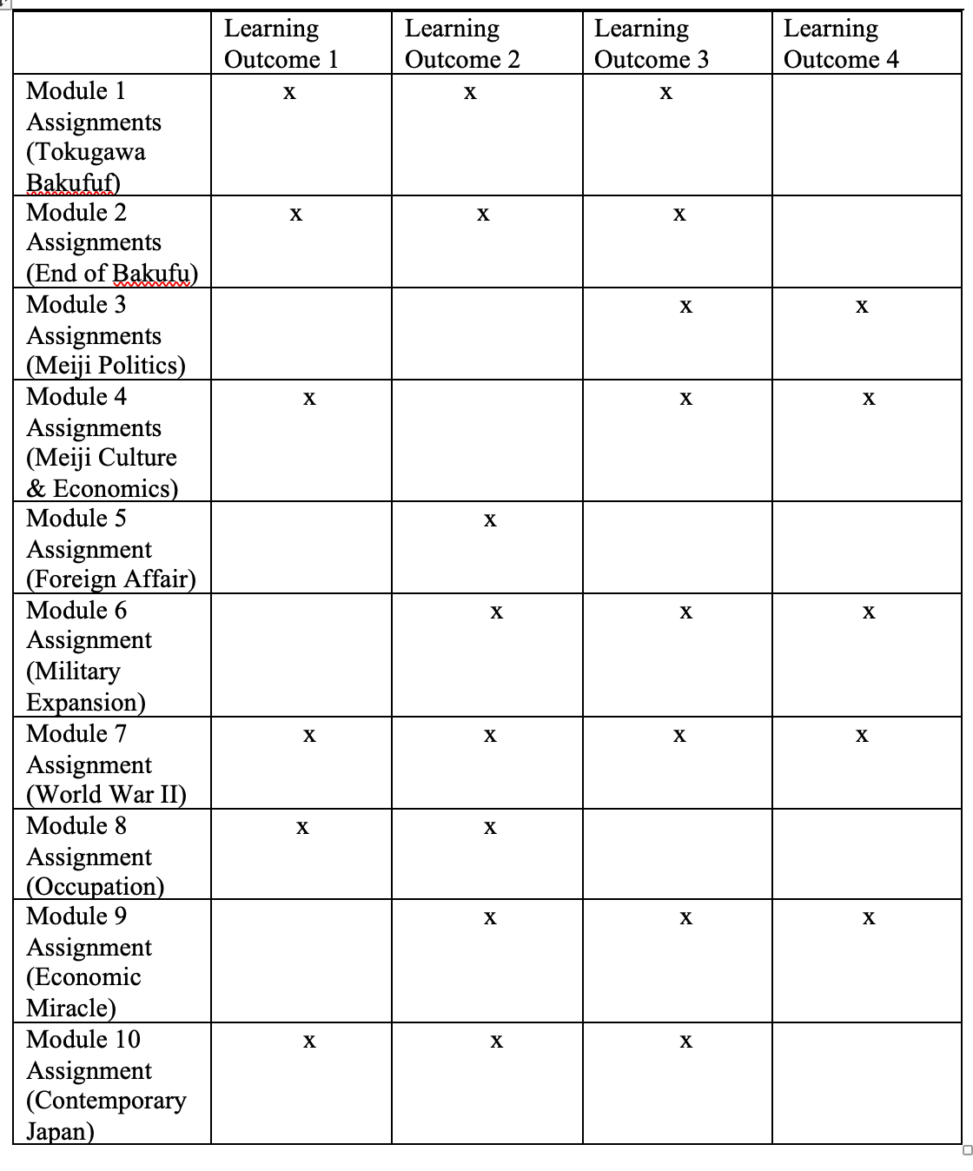

Marianist Values

This course embodies the “Characteristics of the Marianist Education,” central to the mission of Chaminade University of Honolulu, in the following ways…

Provide an Integral, Quality Education

In this course, the instructor and the students “collaborate together in attaining knowledge of the human condition within the larger community of all creation, applying both faith and reason in their quest of meaning.” They seek to “uncover and probe the deep questions of human meaning. It places this search for truth within a value-centered worldview that begins with the dignity of each person, living their life within an interconnected whole that we call creation.”

Educate for Service, Justice, Peace, and Integrity of Creation

Marianist higher education is “deeply committed to the common good.” This course is undertaken as “a form of service in the interest of justice and peace, and the university curriculum is designed to engage the classroom with the wider world.” It is part of our responsibilities as an institution built on the teachings of Christ “to promote the dignity of all human persons. To do so authentically, we must acknowledge, analyze, and deeply comprehend global disparities.”

Educate for Adaptation and Change

After the French Revolution, Father Chaminade, founder of the Society of Mary, stated, “new times call for new methods.” Adaptation and change, however, must begin with a firm understanding of the past. This course understands that “students need a substantive knowledge of the past, analytical tools for understanding the world around them and critical thinking skills to mindfully respond and shape the unknowable future.” It tries “to shape students’ understanding of the interconnectedness of human knowledge as a foundation for effective action in an increasingly interdependent world.”

Native Hawaiian Values

Education is an integral value in both Marianist and Native Hawaiian culture. Both recognize the transformative effect of a well-rounded, value-centered education on society, particularly in seeking justice for the marginalized, the forgotten, and the oppressed, always with an eye toward God (Ke Akua). This is reflected in the ‘Olelo No’eau (Hawaiian proverbs) and Marianist core beliefs:

Provide an Integral, Quality Education (Na’auao) Lawe i ka maʻalea a kūʻonoʻono (ʻŌlelo Noʻeau 1957) Acquire skill and make it deep.

Educate for Service, Justice and Peace (Aloha) Ka lama kū o ka noʻeau (ʻŌlelo Noʻeau 1430) Education is the standing torch of wisdom.

Educate for Adaptation and Change (Aina) ʻAʻohe pau ka ‘ike i ka hālau hoʻokahi (ʻŌlelo Noʻeau 203) All knowledge is not taught in the same school.

Important Information

Academic Honesty

Violations of the Honor Code are serious. They harm other students, your professor, and the integrity of the University. This includes signing in for someone else on attendance sheets. It also includes persons taking online examinations for someone else.

Alleged violations will be referred to the Office of Judicial Affairs.

For the most up to date information, please refer to the Academic Honesty Policy on the Chaminade University Catalog website.

Students with Disabilities

The University is committed to providing reasonable accommodations for all persons with disabilities. Students who need accommodations must be registered with Student Disabilities Services. Students with special needs who meet criteria for the Americans with Disabilities Act (ADS) provisions must provide written documentation of the need for accommodations from the Counseling Center by the end of week three of the class, in order for the instructor to plan accordingly. You may contact the staff in the Counseling Center at (808) 735-4845.

Title IX and Nondiscrimination Statement

Chaminade University of Honolulu is committed to providing a learning, working and living environment that promotes the dignity of all people, inclusivity and mutual respect and is free of all forms of sex discrimination and gender-based violence, including sexual assault, sexual harassment, gender-based harassment, domestic violence, dating violence, and stalking. As a member of the University faculty, I am required to immediately report any incident of sex discrimination or gender-based violence to the campus Title IX Coordinator.

Nondiscrimination Policy & Notice of Nondiscrimination

Chaminade University of Honolulu does not discriminate on the basis of sex and prohibits sex discrimination in any education program or activity that it operates, as required by Title IX and its regulations, including in admission and employment. Inquiries about Title IX may be referred to the University’s Title IX Coordinator, the U.S. Department of Education’s Office for Civil Rights, or both and contact information may be found at the Chaminade University Title IX Office Contact Information and Confidential Resources website. On-campus Confidential Resources may also be found here at CAMPUS CONFIDENTIAL RESOURCES.

The University’s Nondiscrimination Policy and Grievance Procedures can be located on the University webpage at: https://chaminade.edu/compliance/title-ix-nondiscrimination-policies-procedures/.
To report information about conduct that may constitute sex discrimination or make a complaint of sex discrimination under Title IX, please refer to the Campus Incident Report form. Chaminade University of Honolulu prohibits sex discrimination in any education program or activity that it operates. The NOTICE of NONDISCRIMINATION can be found here: Notice of Nondiscrimination.

CUH Alert Emergency Notification

To get the latest emergency communication from Chaminade University, students’ cell numbers will be connected to Chaminade’s emergency notification text system. When you log in to the Chaminade portal, you will be asked to provide some emergency contact information. If you provide a cellphone number, you will receive a text from our emergency notification system asking you to confirm your number. You must respond to that message to complete your registration and get emergency notifications on your phone.

Kokua ‘Ike: Tutoring & Learning Services

Chaminade is proud to offer free, one-on-one tutoring and writing assistance to all students. Tutoring and writing help is available on campus at Kōkua ʻIke: Center for Student Learning in a variety of subjects (including, but are not limited to biology, chemistry, math, nursing, English, etc.) from trained Peer and Professional Tutors. Please check Kōkua ʻIke’s website for the latest times, list of drop-in hours, and information on scheduling an appointment. Free online tutoring is also available via TutorMe. Tutor Me can be accessed 24/7 from your Canvas account. Simply click on Account > TutorMe. For more information, please contact Kōkua ʻIke at tutoring@chaminade.edu or 808-739-8305.

