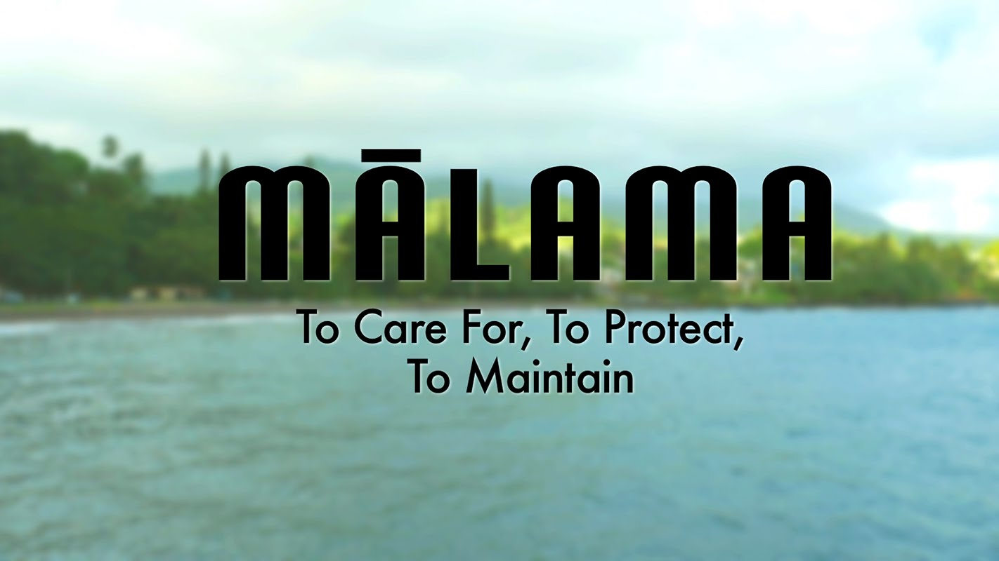
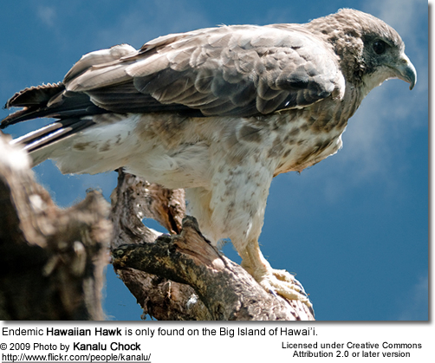
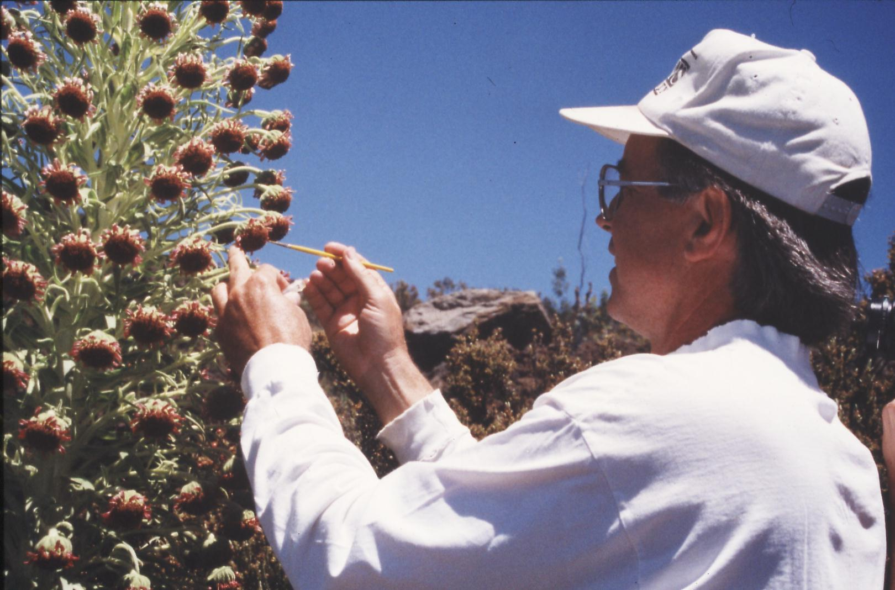

Note: ALL of the links for the first MONTH are provided on the COURSE SCHEDULE on page 7 of this syllabus in Google Drive!

ENV 201 & 201L: Conservation Biology & Ecology Lecture and Laboratory
Fall 2024
Dr. Gail Grabowsky

Syllabus

The Earth’s resources are also being plundered because of short-sighted approaches to the economy, commerce and production. The loss of forests and woodlands entails the loss of species which may constitute extremely important resources in the future, not only for food but also for curing disease and other uses…. It is not enough, however, to think of different species merely as potential “resources” to be exploited, while overlooking the fact that they have value in themselves. Each year sees the disappearance of thousands of plant and animal species which we will never know, which our children will never see, because they have been lost forever.
Pope Francis, Laudato Si 2015

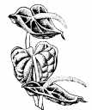
A worldview does not dissolve overnight. Rather, like one of Hutton’s mountain ranges, it erodes through long centuries.
Lorien Eisley

Few will have the greatness to bend history itself; but each of us can work to change a small portion of events, and in the total of all those acts will be written the history of this generation.
Robert F. Kennedy

A thing s right if it tends to preserve the integrity, stability and beauty of the biotic community. It is wrong if it tends to do otherwise.
Aldo Leopold

Change your thoughts and you change the world.
Norman Vincent Peale

The scientific community is no private club. In principle, and in its best and broadest sense of the words, scientific inquiry can be undertaken by anyone on almost any subject matter.
W. Quine and J. Ullian
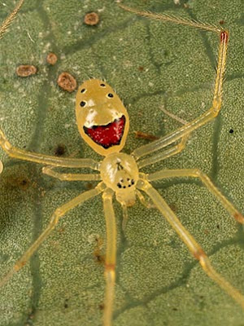

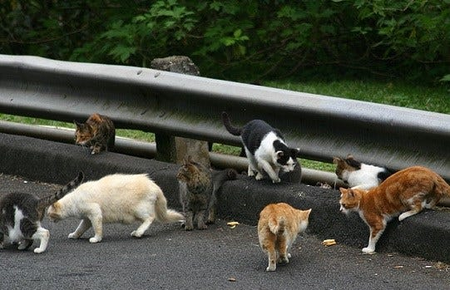
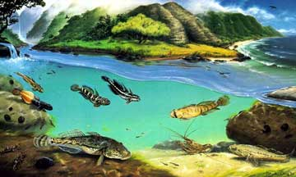
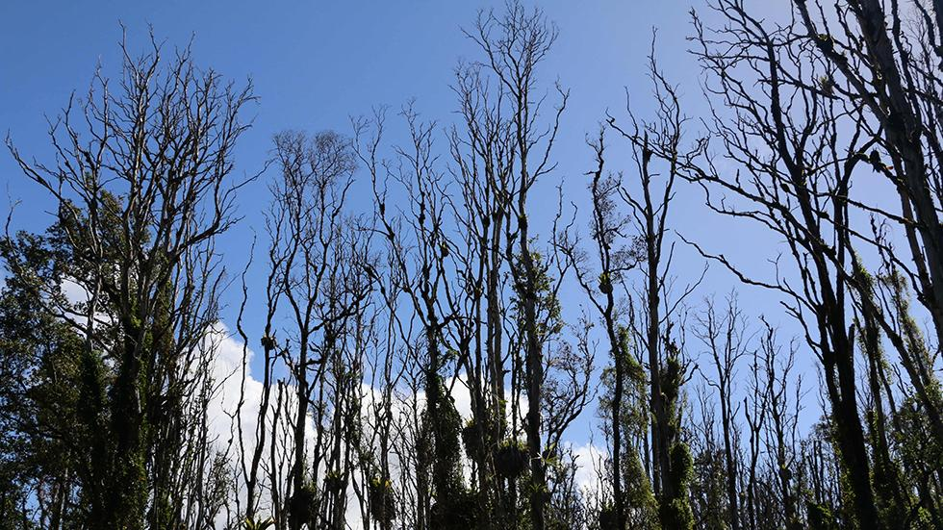
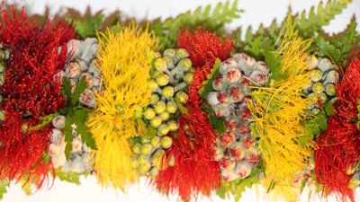

Department Name: Environmental Program
School Name: School of Natural Sciences and Mathematics
Course Credits: 3/1
Class Meeting Days: Lecture: TTh 1:00-2:20 Class Location: Henry Hall 107
Class Meeting Days: Lab: M 2:30-5:20 Class Location: HL4 and OUTSIDE

Instructor: Dr. Gail Grabowsky
E-mail address: ggrabows@chaminade.edu
Phone: 735-4834 (ext. 834); cell 808-387-9319 (you may text anytime!)
Office Location: Wesselkamper Science Center, room 105
Office hours: T-F 4:00-6:00 PM; Or by appointment (Zoom or in person)
Dr Gail’s Zoom Link: https://chaminade.zoom.us/j/2916035174
Course Canvas Website: Lecture and Lab are in the same Canvas folder because they
compliment one another throughout the course.
Google Drive Folder: HERE!
(https://drive.google.com/drive/folders/1KrsxWSiR2u3--jAWg0faggDslcxfgjDK?usp=drive_link)

University Course Catalog Descriptions:
ENV 201 Conservation Biology & Ecology
An introduction to conservation biology issues and goals and the principles of ecology. The course includes consideration of the impacts of human activity on ecosystems and our efforts to ameliorate destructive impacts and devise sustainable solutions. Major topics include the effects of industrialization, agriculture, pollution, species introduction and human population growth and development on the health and future sustainability of ecosystems and humans alike. Particular emphasis is placed on island ecosystems. Course must be taken concurrently with ENV 201L.

ENV 201L Conservation Biology & Ecology Laboratory
Students perform laboratory and field research techniques used in conducting conservation biology and ecological research and restoration. Analyses are conducted in the laboratory and in the field. Course must be taken concurrently with ENV 201.

Course Overview and Introduction:
Welcome to Conservation Biology & Ecology. I really enjoy teaching/facilitating this class because it comes from the heart (and the mind) as I am, like many of you, concerned for the current and future environment. This course mainly focuses on the condition of earth’s ecosystems: what threatens them and their species and why and how to keep them healthy or return them to a healthier state once they are degraded. I feel this class is not simply a course you take in college, it changes the lives of most who take it, as it introduces you to and helps you understand the causes and consequences of the real-world environmental issues we confront every day (or every time we take a sip of water…). If you are an Environmental Studies or Environmental Science major/minor OR a student with another major(s): WELCOME!
One thing I want all of us to realize through this course is that science is NOT a “sacred cow.” It is a very useful tool, but it is not in itself infallible or the only component of solutions to our environmental, ecological and sustainability challenges. We also must consider the people involved, their values and beliefs, their economics, politics, history, culture, needs, desires, etc in order to solve any environmental problem. Also while the science we do helps us gather information about a phenomenon or determine how to behave in order to change a situation, it does not tell us what is better or worse, right or wrong, what we should or should not do. Because of the complexity of conservation issues and the fact that science is only one of the players involved in learning about and solving them, we will have to touch on those other factors in this science course as well.

Marianist Values
This class represents one component of your education at Chaminade University of Honolulu. An education in the Marianist Tradition is marked by five principles and you should take every opportunity possible to reflect upon the role of these characteristics in your education and development:
- Education for formation in faith
- Provide an integral, quality education
- Educate in family spirit
- Educate for service, justice and peace
- Educate for adaptation and change

Native Hawaiian Values
Education is an integral value in both Marianist and Native Hawaiian culture. Both recognize the transformative effect of a well-rounded, value-centered education on society, particularly in seeking justice for the marginalized, the forgotten, and the oppressed, always with an eye toward God (Ke Akua). This is reflected in the ‘Olelo No’eau (Hawaiian proverbs) and Marianist core beliefs:
- Educate for Formation in Faith (Mana) E ola au i ke akua (ʻŌlelo Noʻeau 364) May I live by God
- Provide an Integral, Quality Education (Na’auao) Lawe i ka maʻalea a kūʻonoʻono (ʻŌlelo Noʻeau 1957) Acquire skill and make it deep
- Educate in Family Spirit (‘Ohana) ʻIke aku, ʻike mai, kōkua aku kōkua mai; pela iho la ka nohana ʻohana (‘Ōlelo Noʻeau 1200) Recognize others, be recognized, help others, be helped; such is a family relationship
- Educate for Service, Justice and Peace (Aloha) Ka lama kū o ka noʻeau (ʻŌlelo Noʻeau 1430) Education is the standing torch of wisdom
- Educate for Adaptation and Change (Aina) ʻAʻohe pau ka ‘ike i ka hālau hoʻokahi (ʻŌlelo Noʻeau 203) All knowledge is not taught in the same school

What this course counts for:
This course is required for Environmental Studies and Environmental Science majors and minors. It also counts for your Quantitative Reasoning requirement under our General Education Program. If you are an Environmental major the table below shows you how this course helps you achieve the Program Learning Outcomes for Environmental Studies and Environmental Science and at what level of proficiency. Some of the Learning Outcomes are shared between the two majors but not all. NOTE: If you are not an ENV major think about it! Environmental Studies is not a large major and it goes well with many other majors: BU + ENV, COM + ENV, ED + ENV, CJ = ENV, etc!!!!!

Upon completion of the undergraduate B.S. program in Environmental Studies, students will be able to:
Environmental Studies Program Learning Outcomes | ENV 201/L
Authenticate their commitment to service, justice and peace through experiential project-based
activities that enhance the condition of the integral ecology, care for creation and value all voices.
Apply analytical methods and skills from multiple disciplines to environmental problems.
Participate in, plan and execute environmental change-making strategies that employ scientific,
political, socio-cultural, artistic, educational and economic skills and knowledge.
Design and describe new futures and ideas that solve environmental problems and foster
sustainability.
Pursue throughout their education the ever-changing knowledge and skills that prepare them for
the adaptation and change essential to environmental problem solving.

Upon completion of the undergraduate B.S. program in Environmental Science, students will be able to:
Environmental Science Program Learning Outcomes | ENV 201/L
Authenticate their commitment to service, justice and peace through experiential project-based
activities that enhance the condition of the integral ecology, care for creation and value all voices.
Apply scientific reasoning and methodology to environmental problems.
Identify the major physical, chemical and biological components, interactions and cycles of earth
systems and ecosystems.
Propose, design and participate in scientific research projects that document, describe and/or
help solve environmental problems and foster sustainability.
Pursue throughout their education the ever-changing knowledge and skills that prepare them for
the adaptation and change essential to environmental problem solving.
Introduces to the concept or skill
Develops the concept or skill
Gains mastery of the concept or skill

The COURSE Learning outcomes for the lecture and lab are the following:
Lecture: When you complete this course you will be able to:
- Summarize what science is and how scientific research is conducted and shared with others
- Outline the role of science in enabling us to understand and problem-solve conservation issues
- Explain the role of ethics in allowing us to define conservation problems and solutions
- Describe the major causes of habitat/ecosystem degradation and destruction and species loss
- Relate a number of potential solutions for global and Pacific Island habitat/ecosystem degradation and destruction and species loss
- Give examples of the basic structure and types of fresh water and terrestrial ecosystems
- Categorize the generalized sorts of interactions between organisms and their environment
- Define what a healthy ecosystem is and what sustainability means in general
- Explain the historic reasons why human population growth occurred and what its future implications are for ourselves and other species
- Experience first-hand the connections between academic work and real-life situations

Lab: When you complete this course you will be able to:
- Articulate the scientific method and how to apply it to real environmental issues
- Recall what descriptive science is and how it is important in conservation biology
- Memorize the basic units used in making scientific measurements
- Recite the taxonomic hierarchy and describe the systematic biology methodology and the species concept
- Differentiate between species abundance and distribution
- List some of the measures used to determine ecological stress
- Interpret and create graphs, tables and maps
- Express the importance of, and know how to access and read, the primary scientific literature
- Formulate a hypothesis and design a scientific experiment to test it
- Prepare a formal laboratory write-up

Required Texts: An Introduction to Conservation Biology. 2018. [ISBN: 9781605354736]

Supplemental Texts: Many other articles, reports and exercises will come from other sources. All of them will be provided to you in Google Drive in the course folder.

Course Website: The majority of the content for this course is in our class Google Drive folder here: https://drive.google.com/drive/folders/1KrsxWSiR2u3--jAWg0faggDslcxfgjDK?usp=drive_link

The course Syllabus, Service Learning Written Reflection and other important documents as well as assignments better offered/handled in Canvas can be found in our course Canvas folder HERE.

Grading & Assessment:
Lecture grading will be quantified as follows:
Exam I and II and Final Exam (20% each) 60% 600 pts

Habitat Type Project - Group Presentation 15% 150 pts
15 hours of Service Learning + Survey, Photo & Discussion 15% 150 pts
Quizzes on outside readings (i.e. readings not in the textbook) 10% 100 pts
100% 1000 pts
Lab grading will be quantified as follows:
Lab assignments, worksheets, info shares 50% 500 pts
Formal Lab Write-Up 20% 200 pts
Hypothetical Experiment Write-Up 20% 200 pts
Attendance 10% 100 pts
100% 1000 pts
Letter grades are interpreted as follows:
A = Outstanding scholarship and an unusual degree of intellectual initiative
B = Superior work done in a consistent and intellectual manner
C = Average grade indicating a competent grasp of subject matter
D = Inferior work of the lowest passing grade, not satisfactory for fulfillment of prerequisite course work
F = Failed to grasp the minimum subject matter; no credit given

Grading procedures and the components of your grade:
Lecture grades will be determined in part by written exams using a curve with the mean score for the class being a B- and the score immediately below the mean being a C+. This will be explained in detail in class. The lecture exams will cover the material from the start of class up until the first exam and the material after the first exam up until the second Exam. These exams will have a variety of types of questions on them. The final exam is cumulative, multiple choice and covers the lecture material for the entire semester. A review sheet will be handed out before every exam.
The details surrounding the lecture presentations, service learning assignment and quizzes will be explained in class and via handouts. The factors that determine your particular grade for the presentation, your service learning and the quizzes will also be explained in a grading explanation/rubric handout.
Lab grades for oral and written lab assignments and worksheets will be determined based on your effort, correctness (when there is a correct response etc.) and your thoughtfulness. Effort in general manifests itself as neatness, completeness, thoroughness, calories expended per unit time(!), timeliness, correct spelling, any extra creative things you do above-and-beyond what is expected, etc. Correctness means do your statements jive with corresponding scientific knowledge, do your conclusions follow from the evidence before you, did you calculate an equation correctly, interpret a graph accurately, make a table that illustrates your data properly, etc. Thoughtfulness can show up in many ways, perhaps you really think things through, trying to consider all the variables or you worked hard to tie pieces of evidence together, maybe you consider something that may be important that everyone else ignores. By being “thoughtful” I don’t mean that you look out for other people (i.e. are kind) I mean that you have done some thinking, really reflected upon a topic, have given it some time, have analyzed it, etc. thoroughly.

Service Learning Requirement:

You will need to participate in 15 hours of service-learning work throughout the semester that aims to help Hawaii and the Pacific islands achieve the United Nations Sustainable Development Goals (SDG) and is officially tied to Chaminade’s United Nations CIFAL Honolulu training center. This year you have five opportunities to choose from. You can commit to just one of them or participate in all of them!

- Helping out with Chaminade’s Pono Popoki Project. Here is the link to the Project Google Drive folder! Contact person is Dr. Gail
- Helping out with our Sustainability Council – a campus club that Dr. Gail advises and Campus Mala Project = outdoor sustainability-related planting, gardening, composting, native plant outplanting, projects, and/or community projects. Contact person is Dr. Gail for Sustainability Council and Mitch Steffey for the Mala Project.
- Helping out the GEMM Project (Gender Equity through Malama Ma`i). Contact person is Rhea José.
- Helping out with a project of YOUR OWN DESIGN that must be APPROVED by Dr. Gail

Throughout the semester you will need to keep track of your service hours using the Apply for Service Points form that comes from Chaminade’s Service Learning & Community Engagement Office which is directed by Mitch Steffey. You must also document your service hours on a form Dr. Gail created that lives HERE in Google Drive. Also you MUST share pictures of yourself (and your friends if you’d like) HERE in action, DOING your service work and contributing to making campus and the world a more sustainable place! At the completion of your 15 hour project you will complete the assignments in the course Canvas module at the bottom of course Canvas page.

Attendance and your grade:
While I dearly hope that you can make every class…, since you are adults now, you are free to miss any lecture class you choose… but KNOW that there may be some consequences should you choose to exercise this option: your grade could (and most likely WILL) suffer. Students who have missed a lot of lecture periods ALWAYS would have done better if they had not missed classes. There simply is no substitute for being in class when it comes to understanding the material. I can give you a fishing pole, but I cannot make you fish.
If you miss a lab your absence must be excused if it is not to formally effect your grade. Excused absences occur when you bring in a doctor’s note, a funeral announcement for a family member, notice of participation in athletic events, etc. Unexcused absences occur when you were working, surfing, sleeping, cramming for an exam in another class, etc. I am a scientist; I require hard evidence if an absence is to be excused. So if your car breaks down on the way to class take a picture of your smoking engine or flat tire right then and share it with me ASAP! Make SURE I can verify the date and time of the breakdown and it will be an excused absence, however, no evidence; no excused absence.

Extra Credit Options:
Periodically throughout the course there will also be presentations and webinars you may attend that pertain to the course material. You can earn +2 extra credit points towards your quiz grades for each talk you attend. In order for all talks/activities to count for extra credit you MUST have them approved by Dr. Gail PRIOR TO the event and you MUST document your presence with a photograph of yourself participating or some other kind of evidence. You may earn up to 10 extra credit points from attending talks/presentations.

Classroom Atmosphere:
Specific to Dr. Gail’s classes: Guys, I value a very open, yet courteous class atmosphere. Express your thoughts! Ask your questions! (The only dumb question is the one in which you ask yourself if you should ask your question.) Respect the thoughts and ideas and opinions of others – really think about what others say. Let them express themselves fully, then you do the same. The thing I value most from my college days are all the wonderful, valuable, diverse ways of looking at and understanding the world that I was exposed to by my fellow students and my professors. Be an open vessel – take ideas in! You will learn as much from each other as you do from me.

This syllabus and course schedule are living documents: they are free to change. I try to adhere as closely as possible to them for your convenience, but there will be times in which we will take longer on a particular topic or add or delete a topic to enhance the course. I like to be able to react to you as the course proceeds and go with the flow a bit in order to make the course experience sort of custom fit to you!
You are responsible for all of the information in this document: losing it or not reading it do not make you exempt from knowing what’s in it!

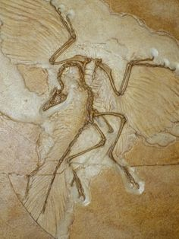
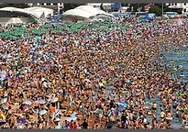
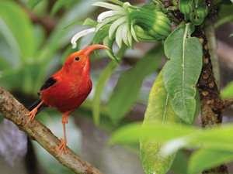
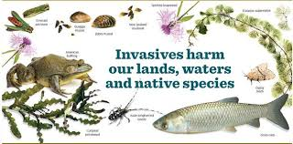

Class Schedule: ENV 202 & 201L

Fall 2024
Link to our Course Google Drive Folder

Part I
Knowledge, Ethics & the Environment in General

WEEK TOPIC ACTIVITIES
NOTE Monday-Friday of Week 1 Dr. Gail is at the World Sprint Outrigger Canoe Races BUT you have something to do for class each day this week!!! See below:

1 Lab 1: WATCH “Endangered Planet” (53 min); Watch (on your own); QUIZ on 8/26 in lab!
UPLOAD a photo of a favorite natural place; Upload a photo of nature you here due 8/26
Tuesday: Mr. Steffy leads class; Role taken! Read Course Syllabus HERE
FILL OUT the Course Opening Survey HERE Fill in the Course Opening Survey in class!
Thursday: No class meeting Read: “Human Domination…”; QUIZ on 8/29

2 Dr. Gail Returns; Course Intro, Who you are! Do you have questions about the course/syllabus?
Lab 2: Survey of issues that concern us (Verbally) Share an enviro issue; Review photos
General human effect on the environment: QUIZ on “Human Domination” on 8/29! Land Transformation; Oceans

3 NO CLASS MONDAY 9/2: Labor Day!
Lab 3: Indigenous Knowledge Lab (on your own!) Upload your worksheet by lab on 9/9 here!
Alteration of biogeochemical cycles Biosphere II’s failure video
Alteration of biogeochemical cycles (cont’d) Read: “Living Planet Report 2020” pp.6-50
4 Lab 4: Value Lab Bring something to value! Review IK labs…
Biotic change and species loss QUIZ on “Living Planet Report 2020”
“Human Domination” paper wrap-up Skim: “A Safe Operating Space for Humanity”
Boundaries we may have overstepped already… Read: “The Philosophy of Science”

5 Lab 5: Metric Measure & Gathering Data: Handouts, Worksheets, fun facts videos
What is science? Underlying philosophy & methods QUIZ on “The Philosophy of Science”
Science, traditional knowledge and ecological ethics Read/Review: Textbook chapter 1
What is Conservation Biology (then and now)? Hypothetical Experiment Assignment explained!

Part II
Pristine Nature: Biodiversity and Ecology

WEEK TOPIC ACTIVITIES
6 Lab 6: Eco Footprint Calculation (on your own!) Handout; Done online, share results on 9/30
The history of life on earth Read/Review: Textbook chapter 2
The characteristics and requirements of life History of Life Power Point by Dr. Gail
E X A M I scheduled for 9/26 E X A M I scheduled for 9/26

7 Lab 7: Biological Diversity I & Classification Worksheet, Camanicules & Gallery Walk
Life: Unity and diversity and their implications... Read/Review: Textbook chapter 3
Evolution: Evidence Evidence of Evolution Power Point by Dr. G.
Evolution: Patterns Hypotheses Due on 10/3!

8 Lab 8: Biological Diversity II Fieldtrip to Zoo! Zoo Biodiv Photo Contest!
Evolution: Mechanisms Read/Review: Textbook chapter 6
Evolution: Speciation & Extinction

9 NO CLASS MONDAY: Indigenous People Day!
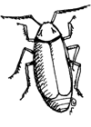
Lab 9: Life Expectancy & Fertility Rate Lab (on your own!) Worksheet; Get your ohana’s data!
Human historical place in nature; World Pop Clock Habitat Type Presentation explained
Ecological principles; causal networks Revised Hypotheses due by 10/17!

10 Lab 10: IDing Hawaiian Birdsong Worksheet; Awards for those who ID first!
Abiotic & Biotic ecological interactions
Ecological productivity; Ecosystems Read/Review: Textbook chapter 4

11 Lab 11: Habitat Presentations Habitat Type Oral Presentations Soil; Earth’s habitats & systems



Ecology wrap-up
E X A M II scheduled for 10/31 E X A M II scheduled for 10/31

Part III

Island Populations and Challenges

WEEK TOPIC ACTIVITIES
12 Lab 12: Native and invasive species St. Louis Hike; Worksheet
Islands: Why each is unique & things they all share… Read/Review: Textbook chapter 5
Islands: Geology, climate, dispersal, endemism Island Types & Adaptive Radiation Power Points
Islands: Adaptive radiation, invasives & extinctions

Part IV

Restoring Biodiversity & Living Sustainably on Island Earth

WEEK TOPIC ACTIVITIES

13 NO CLASS MONDAY: Veteran’s Day!
Lab 13: Species back from the brink! (on your own!) Worksheet & photo upload!
Dr. Gail explains sustainability’s role & the SDG’s!
Species level conservation Read/Review: Textbook chapter 7
MSY, MVP and PVA! Pop management measures

14 Lab 14: Conservation Structured Decision Making SDM Group Collaboration; Fieldtrip to Library
Protected areas; Predictors of success Read/Review: Textbook chapter 8 & 9
Ex Situ conservation; Zoos, aquariums, gene banks
Captive breeding; Ecological restoration Read/Review: Textbook chapter 10

15 Lab 15: Conservation Journal Article Critiques Short presentation: purpose and findings
Ecotourism; Conservation answers for Hawaii Read: “Mind in the Biosphere; Mind of…”
Decision-making algorithms QUIZ on “Mind in the Biosphere;…” on 11/27!
Your Conservation Fixes

Important Dates You Should Know:
- Our FINAL EXAM will be on Thursday December 5th^{th} from 1:15-3:15 in our regular classroom.
- Your Formal Lab Write-up and Part II of the Hypothetical Experiment Project: Designing an Experiment and your service learning assignments (Excel sheet fill-in, discussion and photos) are all due by Friday December 6th^{th} at midnight! Late assignments will not be accepted!

Classroom Atmosphere
Guys, I value a very open, yet courteous class atmosphere whether we are together in person or working together/discussing something online. Express your ideas! Respect the thoughts and ideas and opinions of others – really think about what others say. You will learn as much from each other as you do from me. Ask your questions. (The only dumb question is the one in which you ask yourself if you should ask your question.) Propose solutions. THINK, LEARN, WORK HARD, HAVE FUN.

Nothing is Certain but Change Itself Clause…
This syllabus and course schedule are living documents: they are free to change. I try to adhere as closely as possible to each, but there will be times in which we will take longer on a particular topic or add or delete a topic to enhance the course. I like to be able to react to you as the course proceeds and go with the flow a bit in order to make the course experience sort of custom fit to you!

You are responsible for all of the information in this document: losing it or not reading it are not excuses for not knowing what’s in it!
______________________________________________________________________________

Other general notables not specific to this class…

Grades of "Incomplete”: Students and instructors may negotiate an incomplete grade when there are specific justifying circumstances. When submitting a grade the “I” will be accompanied by the alternative grade that will automatically be assigned after 30 days if the student does not complete the coursework. These include IB, IC, ID, and IF. If only an “I” is submitted the default grade is F. The completion of the work, evaluation, and reporting of the final grade is due within 30 days after the end of the semester or term. This limit may not be extended.
Academic Honesty: Academic honesty is an essential aspect of all learning, scholarship, and research. It is one of the values regarded most highly by academic communities throughout the world. Violations of the principle of academic honesty are extremely serious and will not be tolerated.
Students are responsible for promoting academic honesty at Chaminade by not participating in any act of dishonesty and by reporting any incidence of academic dishonesty to an instructor or to a University official. Academic dishonesty may include theft of records or examinations, alteration of grades, and plagiarism, in addition to more obvious dishonesty.
Questions of academic dishonesty in a particular class are first reviewed by the instructor, who must make a report with recommendations to the Dean of the Academic Division. Punishment for academic dishonesty will be determined by the instructor and the Dean of Academic Division and may include an “F” grade for the work in question, an “F” grade for the course, suspension, or dismissal from the University.
For the most up to date information, please refer to the Academic Honesty Policy on the Chaminade University Catalog website.
Title IX and Nondiscrimination Statement: Chaminade University of Honolulu is committed to providing a learning, working and living environment that promotes the dignity of all people, inclusivity and mutual respect and is free of all forms of sex discrimination and gender-based violence, including sexual assault, sexual harassment, gender-based harassment, domestic violence, dating violence, and stalking. As a member of the University faculty, I am required to immediately report any incident of sex discrimination or gender-based violence to the campus Title IX Coordinator.
Nondiscrimination Policy & Notice of Nondiscrimination: Chaminade University of Honolulu does not discriminate on the basis of sex and prohibits sex discrimination in any education program or activity that it operates, as required by Title IX and its regulations, including in admission and employment. Inquiries about Title IX may be referred to the University’s Title IX Coordinator, the U.S. Department of Education’s Office for Civil Rights, or both and contact information may be found at the Chaminade University Title IX Office Contact Information and Confidential Resources website. On-campus Confidential Resources may also be found here at CAMPUS CONFIDENTIAL RESOURCES.
The University’s Nondiscrimination Policy and Grievance Procedures can be located on the University webpage at: https://chaminade.edu/compliance/title-ix-nondiscrimination-policies-procedures/.
To report information about conduct that may constitute sex discrimination or make a complaint of sex discrimination under Title IX, please refer to the Campus Incident Report form. Chaminade University of Honolulu prohibits sex discrimination in any education program or activity that it operates. The NOTICE of NONDISCRIMINATION can be found here: Notice of Nondiscrimination.
CUH Alert Emergency Notification: To get the latest emergency communication from Chaminade University, students’ cell numbers will be connected to Chaminade’s emergency notification text system. When you log in to the Chaminade portal, you will be asked to provide some emergency contact information. If you provide a cellphone number, you will receive a text from our emergency notification system asking you to confirm your number. You must respond to that message to complete your registration and get emergency notifications on your phone.
Assessment for Student Work: With the goal of continuing to improve the quality of educational services offered to students, Chaminade University conducts assessments of student achievement of course, program, and institutional learning outcomes. Student work is used anonymously as the basis of these assessments, and the work you do in this course may be used in these assessment efforts.
Student with Disabilities Statement: Chaminade University of Honolulu offers accommodations for all actively enrolled students with disabilities in compliance with Section 504 of the Rehabilitation Act of 1973, the Americans with Disabilities Act (ADA) of 1990, and the ADA Amendments Act (2008).
Students are responsible for contacting Kokua Ike: Center for Student Learning to schedule an appointment. Verification of their disability will be requested through appropriate documentation and once received it will take up to approximately 2–3 weeks to review them. Appropriate paperwork will be completed by the student before notification will be sent out to their instructors. Accommodation paperwork will not be automatically sent out to instructors each semester, as the student is responsible to notify Kokua Ike via email at ada@chaminade.edu each semester if changes or notifications are needed.
Kōkua ʻIke: Tutoring & Learning Services: Chaminade is proud to offer free, one-on-one tutoring and writing assistance to all students. Tutoring and writing help is available on campus at Kōkua ʻIke: Center for Student Learning in a variety of subjects (including, but are not limited to biology, chemistry, math, nursing, English, etc.) from trained Peer and Professional Tutors. Please check Kōkua ʻIke’s website for the latest times, list of drop-in hours, and information on scheduling an appointment. Free online tutoring is also available via TutorMe. Tutor Me can be accessed 24/7 from your Canvas account. Simply click on Account > TutorMe. For more information, please contact Kōkua ʻIke at tutoring@chaminade.edu or 808-739-8305.
Credit Hour Policy: The unit of semester credit is defined as university-level credit that is awarded for the completion of coursework. One credit hour reflects the amount of work represented in the intended learning outcomes and verified by evidence of student achievement for those learning outcomes. Each credit hour earned at Chaminade University should result in a minimum of 45 hours of engagement, regardless of varying credits, duration, modality, or degree level. This equates to one hour of classroom or direct faculty instruction and a minimum of two hours of out-of-class student work each week for approximately fifteen weeks for one semester. Terms that have alternative lengths, such as 10 week terms, should have an equivalent amount of faculty instruction and out-of-class student work to meet each credit hour. Direct instructor engagement and out-of-class work result in total student engagement time of 45 hours for one credit. The number of engagement hours may be higher, as needed to meet specific learning outcomes.

Specific Credit Situations: The minimum 45 hours of engagement per credit hour can be satisfied in fully online, internship, or other specialized courses through several means, including (a) regular online instruction or interaction with the faculty member and fellow students and (b) academic engagement through extensive reading, research, online discussion, online quizzes or exams; instruction, collaborative group work, internships, laboratory work, practica, studio work, and preparation of papers, presentations, or other forms of assessment. This policy is in accordance with federal regulations and regional accrediting agencies.
How ENV 201 (lecture, 3 credits) Meets the Credit Hour Policy:
There are three components to the amount of time students will spend in a course:
- Seat time: = 35 hours
- Time spent on key assessments:
  - Four outside readings with quizzes = (2 hours reading x4 +(1 hour review x 4) = 8+4 = 12 hours
  - Ten textbook chapters to read = 4 hours each x 10 = 40 hours
  - 15 hours mandatory service project and reflections = 18 hours
  - Collaborative 10-15 minute Habitat Type Presentations = 10 hours research, slide prep, practice
  - Reviewing for Exam I, II and Final Exam = 8 + 8 + 10 = 26 hours
TOTAL: 141 Hours

How ENV 201 Laboratory (1 credit) Meets the Credit Hour Policy:
There are three components to the amount of time students will spend in a course:
- Seat time: = 30 hours
- Time spent on key assessments:
  - Fifteen worksheets, in class sharing preparation, online assignments = 15 hours
  - Formal Laboratory Write-Up = 10 hours
  - Hypothetical Experiment Project = 5 hours
TOTAL: 60 Hours

