

Course Syllabus
-----------------------------------------------------------------------------------------------------------------------------------------

Course Number: EID 312
Course Title: PRESENTATION METHODS
Term: Fall 2023
Course Credits: 3 (Studio Course)
Prerequisites: Admission to E+ID Major or Instructor's permission
Class Meeting Days: Mondays & Wednesdays
Class Meeting Hours: 1:30 – 3.20pm
Class Location: Eiben 104
Instructor Name: Junghwa Suh, DArch
Email: junghwa.suh@chaminade.edu
Phone: 808.739.8590
Office Location: Eiben 212
Office Hours: MW 12:30 - 1:20pm

Course Description
Study of the techniques used in the preparation of presentations for interior design and architectural projects. Perspective drawing, digital modeling, rendering, design poster position, photo editing techniques will be introduced and utilized with an emphasis on the illustration of three-dimensional space. Conventional sketching skills are explored using various media: ink, colored pencil and marker. Digital illustration techniques are presented employing an integrated approach, using software such as SketchUp, Adobe suites and Revit/AutoCAD together to seamlessly create comprehensive compositions with key design components and presentations. Graphic layout and the physical assembly of presentation boards will also be examined.

Course Content
Lectures & Demonstrations | Exercises | Assignments | Project

Class Format
At the beginning of each week, the class will begin with a lecture introducing both physical and digital illustration techniques, followed by exercises and assignments. All drawings will be done both in class and outside of class. Each completed drawing/illustration should be finished on the assigned submission date. All the exercises and assignments will help you to build illustration skills both physically and digitally.
This course will contain some hybrid learning format which means we will have class meetings physically and digitally depending on the characteristics of learning contents. You will have access to all the lectures (course-specific Google folder) and instruction videos on Canvas. We will always start our class by checking the course map to understand where we are in the journey of this course.
Our design studios (Eiben 104 and 108) are equipped with the drafting table and desktop computers. However, you may work on your own work table with T-square (or drafting table) at home or your own laptop which allows you to work independently outside of class time.

Course Learning Outcomes
By the end of this course, students should be able to:

- Demonstrate thorough knowledge and skills of illustration pertaining to visualization in interior design with regards to depicting design concepts and effective layout. (CIDA 6,8,9,11,12,13)
- Execute accurate 3D and 2D plans, elevations, sections and perspectives with an ability to prepare informative and compelling illustrations and presentations. (CIDA 6,8,9,11,12,13)
- Exhibit confidence in the presentation of designs verbally and graphically. (CIDA 6,8,9,11,12,13)
- Understand the advantages and limitations of both traditional and digital mediums, regarding
illustration choices and application of techniques based on various visual needs and maximum efficiency in interior design. (CIDA 6,8,9,11,12,13)
- Demonstrate innovative use of all skill sets and software, finding creative ways to combine skills to improve presentation techniques. (CIDA 6,8,9,11,12,13)
- Demonstrate understanding of creating effective and organized physical display and presentation elements and materials that will help conveying design concept and solutions.
(CIDA 6,9)

EID Program Outcomes
1) Professionalism – understand, apply and participate in ethical design practices on a personal, project, peer and industry-wide level. (CIDA 5,6,9)
2) Process – ability to identify problems/challenges and demonstrate an understanding of the complete design process from inception to installation, execute documentation supporting design decisions and effect comprehensive, creative, focused and functional design solutions. (CIDA 4, 6, 9, 10, 11, 12, 13, 14.16)
3) Principles & Priorities – integration of pedagogy, research, historic contexts, theory, and interdisciplinary collaboration to effectively and creatively analyze, evaluate and execute best design practices resulting in functional and aesthetically inspiring design. (CIDA 8, 9, 10, 12, 13, 14)
4) Public & Environmental Protection – demonstrate an understanding of the concepts, resources and implications of design decisions relative to the human interaction, technological impact and ecological balance of the built environment. (CIDA 4, 7, 12, 13, 14)
5) Presentation – demonstrate ability to communicate design concepts and problem solving justifications through written, oral and a variety of visual media. (CIDA 6,9)

Assessment
Attendance/Participation | 10 %
Exercises & Assignments | 40 %
Final Project & Portfolio | 50 %
Total | 100 %

Grading Scale: A: 90%- 100%; B: 80%- 89%; C: 70%- 79%; D: 60%- 69%; F: below 59%

There will be an instruction and rubric shared with you on all exercises, assignments, and projects. Individual and group critique sessions will be integrated throughout the course based on the rubrics.

Evaluation Criteria
- understanding of the course materials
- thoroughness and consistent progression in exercises & assignments
- technical and visual proficiency
- professional demeanor
- timely submission of required tasks

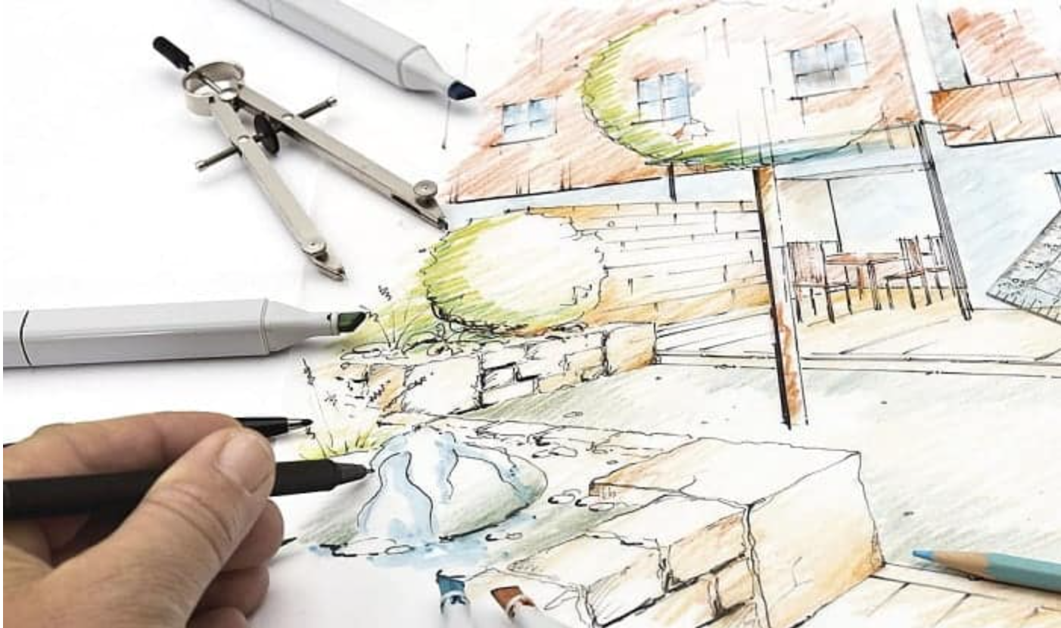

Required Learning Tools & Materials

Physical Tools:
- (1) 18” Roll tracing paper + All drafting tools (from EID 202)
- (2) Sharpie pens (2 different tips: fine & medium)
- (1) Prismacolor Pencil Set (12 or 24 set)
- (1) Prismacolor Premier Double-Ended Art Markers, Fine and Chisel Tip (at least 12-count)/ Copic Sketch Architecture markers/ Chartpak markers
There will be reminders regarding what tools and materials to be ready for each class. Failure to bring the tools will result in unexcused absence for the day.
Digital Tools:
- Revit/ AutoCAD, SketchUp, Adobe Photoshop, Illustrator, InDesign

References
- INTERIOR DESIGN VISUAL PRESENTATION Maureen Mitton
- COLOR DRAWING Design Drawing Skills and Techniques for Architects, Landscape Architects, and Interior Designers Michael E. Doyle

Students are encouraged to search the internet for examples of rendering styles they would like to emulate and bring them into class for analysis.

Technical Assistance for Canvas Users
Search for help on specific topics at help.instructure.com. Chat live with Canvas Support 24/7/365. Watch this video to get you started with online guides and tutorials. Contact the Chaminade IT Helpdesk for technical issues: helpdesk@chaminade.edu, or call (808) 735-4855

Credit Hour Policy
This is a three credit hour course requiring 135 clock hours of student engagement, per the official CUH Credit Hour Policy. Students enrolled in this course are expected:
- In-Class time: 43 hours
- Outside Learning time: 92 hours

- Exercises & Assignments: 57 hrs
- Final Project: 75 hrs
- Reflection Paper: 3 hrs

Connection to the Characteristics of a Marianist Education
The following are characteristics of the approach to education engaged at Marianist schools, including Chaminade University:
- Educate for formation in faith:
  - Trust in yourself and your instructor to do a good job to the best ability.
- Provide an integral quality education
  - Interactive learning between students and an instructor and students and students is a key for the success of digesting the information.
  - Proactive attitude towards learning is important.
- Educate in family spirit
  - Success can be achieved by harnessing everyone’s growth together
- Educate for service, justice and peace
  - Be mindful of how your design may impact users, occupants and the environment
- Educate for adaptation and change
  - As people grow and change, space needs to respond to the changes of people, environment and society.


Code of Conduct

University Academic Conduct Policy
Any community must have a set of rules and standards of conduct by which it operates. At Chaminade, these standards are outlined so as to reflect both the Catholic, Marianist values of the institution and to honor and respect students as responsible adults. All alleged violations of the community standards are handled through an established student conduct process, outlined in the Student Handbook, and operated within the guidelines set to honor both students’ rights and campus values.
Students should conduct themselves in a manner that reflects the ideals of the University. This includes knowing and respecting the intent of rules, regulations, and/or policies presented in the Student Handbook, and realizing that students are subject to the University’s jurisdiction from the time of their admission until their enrollment has been formally terminated. Please refer to the Student Handbook for more details. A copy of the Student Handbook is available on the Chaminade website.
For further information, please refer to the Student Handbook.
Academic Carlendar 2022-23

Late Work Policy
Requests for extensions due to extenuating circumstances (medical problems, for example) will be considered but in general work received after the deadline will not be graded. Computer problems are not an excuse for late work.

Instructor and Student Communication
Questions for this course can be emailed to the instructor at junghwa.suh@chaminade.edu Online, in-person, and phone conferences can be arranged. Response time will take place up to 3 days. The University provides a Chaminade email address for all students. Official Chaminade communications will be sent to the students’ Chaminade email address and instructors will use only this email to communicate with students. It is the responsibility of the student to check their email frequently. Report email-related problems to the Helpdesk at 808-735-4855 or helpdesk@chaminade.edu

Cell phones, tablets, and laptops
Music Devices and Cellular Phones: Unless specifically permitted by your instructor, use of music devices and cell phones is prohibited during classes, as it is discourteous and may lead to suspicion of academic misconduct. Students unable to comply will be asked to leave class. Out of consideration for your classmates, please set your cell phone to silent mode during class. Students are encouraged to bring laptops or tablets to class as the instructor will assign online activities and readings that will require the use of a laptop or tablet. Laptops and tablets should not be misused, such as checking distracting websites. Use your best judgment and respect your classmates and instructor.

Disability Access

If you need individual accommodations to meet course outcomes because of a documented disability, please speak with me to discuss your needs as soon as possible so that we can ensure your full participation in class and fair assessment of your work. Students with special needs who meet criteria for the Americans with Disabilities Act (ADA) provisions must provide written documentation of the need for accommodations from Kōkua ʻIke: Center for Student Learning by the end of week three of the class, in order for instructors to plan accordingly. If a student would like to determine if they meet the criteria for accommodations, they should contact the Kōkua ʻIke Coordinator at (808) 739-8305 for further information (ada@chaminade.edu).

Title IX Compliance
Chaminade University of Honolulu recognizes the inherent dignity of all individuals and promotes respect for all people. Sexual misconduct, physical and/or psychological abuse will NOT be tolerated at CUH. If you have been the victim of sexual misconduct, physical and/or psychological abuse, we encourage you to report this matter promptly. As a faculty member, I am interested in promoting a safe and healthy environment, and should I learn of any sexual misconduct, physical and/or psychological abuse, I must report the matter to the Title IX Coordinator. If you or someone you know has been harassed or assaulted, you can find the appropriate resources by visiting Campus Ministry, the Dean of Students Office, the Counseling Center, or the Office for Compliance and Personnel Services.
Attendance Policy
If you are not feeling well, please do not come to campus! Please email the instructor to let me know that you will not be attending. Repeated unexcused absences without email notification may lead to a grade reduction for the course.

Credit Hour Policy

The unit of semester credit is defined as university-level credit that is awarded for the completion of coursework. One credit hour reflects the amount of work represented in the intended learning outcomes and verified by evidence of student achievement for those learning outcomes. Each credit hour earned at Chaminade University should result in 45 hours of engagement. This equates to one hour of classroom or direct faculty instruction and a minimum of two hours of out-of-class student work each week for approximately fifteen weeks for one semester, 10 week term, or equivalent amount of work over a different amount of time. Direct instructor engagement and out-of-class work result in total student engagement time of 45 hours for one credit.

The minimum 45 hours of engagement per credit hour can be satisfied in fully online, internship, or other specialized courses through several means, including (a) regular online instruction or interaction with the faculty member and fellow students and (b) academic engagement through extensive reading, research, online discussion, online quizzes or exams; instruction, collaborative group work, internships, laboratory work, practica, studio work, and preparation of papers, presentations, or other forms of assessment. This policy is in accordance with federal regulations and regional accrediting agencies.

Grades of "Incomplete"
Students and instructors may negotiate an incomplete grade when there are specific justifying circumstances. An Incomplete Contract (available form the Divisional Secretary and the Portal) must be completed. When submitting a grade the “I” will be accompanied by the alternative grade that will automatically be assigned after 90 days. These include IB, IC, ID, and IF. If only an “I” is submitted the default grade is F. The completion of the work, evaluation, and reporting of the final grade is due within 90 days after the end of the semester or term. This limit may not be extended.

Inclusion Statement
I recognize that I cannot fully understand the lived experience of many minoritized individuals. However, I am dedicated to increasing excellence through inclusion. That includes recognizing as assets the different perspectives students and scholars from diverse backgrounds bring to the classroom and to science. It includes a drive to have the readings and examples used in the classroom be as inclusive and diverse as possible. Furthermore, it is an awareness that biases, both conscious and unconscious, exist in academia and the world, and an aim to reduce the influence of those biases in my decisions and in those around me. Actions that seek to limit the potential of others or perpetuate biases or anti-inclusive sentimentality will not be tolerated.

Syllabus Changes
This syllabus is a guide to the class and will be adhered to as much as possible; however, I reserve the right to make changes as I see fit, so long as they do not create an additional undue burden on the student.

PROFESSIONAL CODE OF CONDUCT
Students of Chaminade University’s Environmental + Interior Design Program (CUH-EID) are expected to maintain professional standards of behavior during their tenure here. As guidelines, CUH-EID has adopted the following protocols: (some terms are particular to current situations for health and safety.)

CLASSROOM BEHAVIOR
▪ Wearing a facemask/covering is voluntary during the class session. If you don’t feel well or you are ill, please stay at home and get well first.
▪ Cell phone use in class (calls, texting, emailing) is prohibited; cell phone ringers must be turned off at all times except in case of emergency. If making a call is absolutely necessary, then please step outside the classroom to do so.
▪ When class is in session, you are expected to show courtesy and respect to your instructor as well as to other students. If your behavior is deemed disruptive, you will be asked to leave the class and consequently receive an unexcused absence for that day.
▪ All assigned work should be completed, presented or submitted before the assigned day and time. Working on homework, presentations, etc. while an instructor or guest speaker is lecturing, or while peers are presenting in class, is disrespectful and will NOT be tolerated.

CLASS ATTENDANCE & ASSIGNMENTS
▪ Three unexcused absences during the course of the semester will result in one letter grade demotion for the course (i.e. if your grade is "B," it can be demoted to "C"). Similarly, six unexcused tardiness will result in one letter grade demotion for the course.
▪ Failure to attend presentations or exams, without informing the instructor in advance, will result in an F for the exam/project; failure to attend a final presentation, final exam or final project submission without informing the instructor in advance will result in an F for the course.
▪ Students should always inform the instructor in 2 days advance (in writing or by email) of any anticipated absences, tardiness, or irregular/unanticipated scheduling conflicts (e.g., jury duty, team sport commitment, etc.) Do not schedule medical or personal appointments during scheduled class time.
▪ Assignments from a missed class must be made up by the next class meeting unless an extension has been arranged with the instructor. Do not expect an instructor to repeat a lecture for you; students must arrange with a fellow student to pick up class materials, lecture notes, homework assignments, exercises, etc.
▪ Assignments handed in late will not be accepted unless arranged in advance with the instructor; 5 points will be deducted from the total number of points for each day the assignment is late beyond the prescribed due date.
▪ If you have any questions or concerns, please contact me via email. I will respond to your email within a day or two. You will receive feedback on your assignments, projects, and exams within one week of submission. I will not be checking the work emails during the weekends starting from 5 pm on Fridays, so please do not expect any email responses during the weekends.

USE OF FACILITIES
▪ Only beverages in sealed containers are allowed in the EID assigned studios/classrooms; in rooms with computers, beverages must be kept on the floor, away from the computer equipment and outlets. Hydration is very important during class. You may step out of the classroom if you need to drink water from your container.
▪ NO Meals (snacks, fruits, any food) allowed in the studio/classroom.
▪ Clean up your work area before & after yourselves in digital studios, classrooms, the materials library, the kitchen area, the resource center, and the print room.
▪ Any damage to workstations or equipment will be charged to the student; if the person cannot be readily determined, the class(es) using the studio/classroom will bear the expense of the repairs collectively.

PERSONAL STANDARDS
▪ Students should dress in a professional manner when attending any public functions on behalf of the school, on field trips/site visits, or when guests visit the class. You are representing the EID Program, Chaminade University, and most importantly, yourself to your future constituents: employers, colleagues, contractors, clients, etc.
▪ Students must be prepared with all materials required for the class; the inability to work during the class will result in an unexcused absence for the day.
▪ Cheating on any exam, exercises, or assignments will result in automatic failure of the course.

I have read, understand, and agree to the terms of the syllabus, course map, and Code of Conduct.
Student Signature:________________________________ Date: ______________________

