 | Course Syllabus  Chaminade University Honolulu  3140 Waialae Avenue, Honolulu, HI 96816  www.chaminade.edu

Course Number: NUR 822
Course Title: Transforming Healthcare Through Health Policy and Advocacy
Department Name: School of Nursing and Health Professions
College/School/Division: School of Nursing and Health Professions
Term: Spring 2023
Course Credits: 3
Class Meeting Days/Hours: Online, asynchronous
Class Location: Online

Instructor Name: Dr. Carolyn Masengale
Email: carolyn.masengale@chaminade.edu
Phone: 317-716-1267
Office Location: Online
Office Hours: By Appointment (zoom, phone)

University Course Catalog Description
This course comprehensively reviews the U.S. healthcare delivery system in the following areas: history, policy, population characteristics, trends in health services access and utilization, structure, financing, organization and delivery of services, civility in healthcare services, advancing medical technology, and the changing policy environment. Students will explore current medical issues such as increased competition, major organizational restructuring and consolidation, a rapidly changing science base, and increased government regulation.

Marianist Values
This class represents one component of your education at Chaminade University of Honolulu. An education in the Marianist Tradition is marked by five principles and you should take every opportunity possible to reflect upon the role of these characteristics in your education and development:
- Education for formation in faith
- Provide an integral, quality education
- Educate in family spirit
- Educate for service, justice, and peace
- Educate for adaptation and change

Native Hawaiian Values
Education is an integral value in both Marianist and Native Hawaiian culture. Both recognize the transformative effect of a well-rounded, value-centered education on society, particularly in seeking justice for the marginalized, the forgotten, and the oppressed, always with an eye toward God (Ke Akua). This is reflected in the 'Olelo No'eau (Hawaiian proverbs) and Marianist core beliefs:
- Educate for Formation in Faith (Mana) E ola au i ke akua (ʻŌlelo Noʻeau 364) May I live by God
- Provide an Integral, Quality Education (Na'auao) Lawe i ka maʻalea a kūʻonoʻono (ʻŌlelo Noʻeau 1957) Acquire skill and make it deep
- Educate in Family Spirit ('Ohana) ʻIke aku, ʻike mai, kōkua aku kōkua mai; pela iho la ka nohana ʻohana ('Ōlelo Noʻeau 1200) Recognize others, be recognized, help others, be helped; such is a family relationship
- Educate for Service, Justice and Peace (Aloha) Ka lama kū o ka noʻeau (ʻŌlelo Noʻeau 1430) Education is the standing torch of wisdom
- Educate for Adaptation and Change (Aina) ʻAʻohe pau ka 'ike i ka hālau hoʻokahi (ʻŌlelo Noʻeau 203) All knowledge is not taught in the same school

DNP Program Learning Outcomes (PLO)
Upon completion of the DNP program:

PLO Concepts | The DNP Graduate Will:
1. Knowledge for Nursing Practice | Integrate nursing science with knowledge from biophysical, psychosocial, analytical, ethics, and organizational sciences as the basis for advanced practice nursing using new approaches to care delivery.
2. Systems-Based Practice, Quality, and Safety | Create and lead high-quality and safe nursing care in a complex global health care environment
3. Scholarship for Nursing Practice | Create and disseminate knowledge in evidence-informed practice.
4. Information Systems and Patient Healthcare Technologies | Evaluate emerging technologies for their ability to improve health care outcomes.
5. Person-Centered Care | Evaluate health policy and advocate for social justice and access to health care, especially for Hawai’ian and Pacific Islanders and other unique populations.
6. Interprofessional Partnerships | Create collaborative interprofessional relationships to improve patient and population health outcomes with an emphasis on select populations, including Hawai’ian and Pacific Islanders.
7. Population Health | Evaluate the social, cultural, and environmental dimensions of population health in practice patterns/systems.
8. Advanced Practice Nursing Professionalism; Personal, Professional, and Leadership Development | Independently assess, diagnose, treat, and manage culturally diverse populations.

Course Learning Outcomes (CLO) and Alignment

NUR 822 Transforming Healthcare through Health Policy and Advocacy
CLOs | Links to PLOs | Method of Measurement
1. Critically analyze health policy proposals, health policies, and related issues from the perspective of consumers, nursing, other health professions, and other stakeholders in policy and public forums. | 1,5 | Discussion boards with the class and team work
2. Demonstrate leadership in the development and implementation of institutional, local, state, federal, and/or international health policy. | 2,5,7 | Discussion boards with the class and team work interview assignment
3. Influence policy makers through active participation on committees, boards, or task forces at the institutional, local, state, regional, national, and/or international levels to improve health care delivery and outcomes. | 6,8 | Group signature assignment policy paper.
4. Educate others, including policy makers at all levels, regarding nursing, health policy, and patient care outcomes. | 3 | Group signature assignment health policy presentation
5. Advocate for the nursing profession within the policy and healthcare communities. | 8 | Synchronous (recorded) class discussions reviewing nursing organizations and their advocacy agendas. Discussion boards with discussions around nursing organizations advocacy that informs their practice.
6. Advocate for social justice, equity, and ethical policies within all healthcare arenas. | 5 | Discussion boards with the class and team work and email policy advocacy assignment

Required Learning Materials
Milstead, J. A. . Short, M.N. (2021). Health Policy and Politics: A Nurse's Guide, Sixth Edition. Burlington, MA: Jones & Bartlett Learning. ISBN: 9781284126372
Recommended Learning Materials
American Psychological Association. (2020). Publication manual of the American Psychological Association (7th ed.). https://doi.org/10.1037/0000165-000

Teaching / Learning Strategies:
Online learning resources, discussion forums, individual and small group work, review and synthesis of articles and pertinent web sites and scholarly papers. and independent study are teaching-learning strategies that may be utilized in this course. Students are expected to take an active role in their learning process through reading, research, online discussions, and sharing enriching experiences.

Attendance and Participation
Regular online attendance and participation/engagement is expected for student success. Therefore, students are expected to attend every class, arrive on time for any scheduled synchronous activities, complete all assigned readings, actively participate in class discussions, complete all class assignments, and always behave appropriately and professionally. Online participation is evident through posting to a discussion board, wiki, virtual office, or classroom meeting, dropbox submissions, attending virtual seminars, completing real-time activities or quizzes, and/or other course-related activities (synchronous or asynchronous). Failure to meet attendance and participation expectations may result in grade reduction, remediation requirements, or administrative withdrawal from the course
Assignments
Students must complete all assignments to achieve a passing grade in this course. Completed assignments are due by the end of the week noted on the schedule unless otherwise stated. Check assignment details in Canvas.

Evaluation Methods and Grading Scale
Students must achieve a final grade of B or higher to pass this course. As per the Chaminade University Graduate Catalog, students who fail a course (i.e., receive a grade of C, F, or NC) must repeat the course within 12 months and receive a CR or a grade of B or higher.

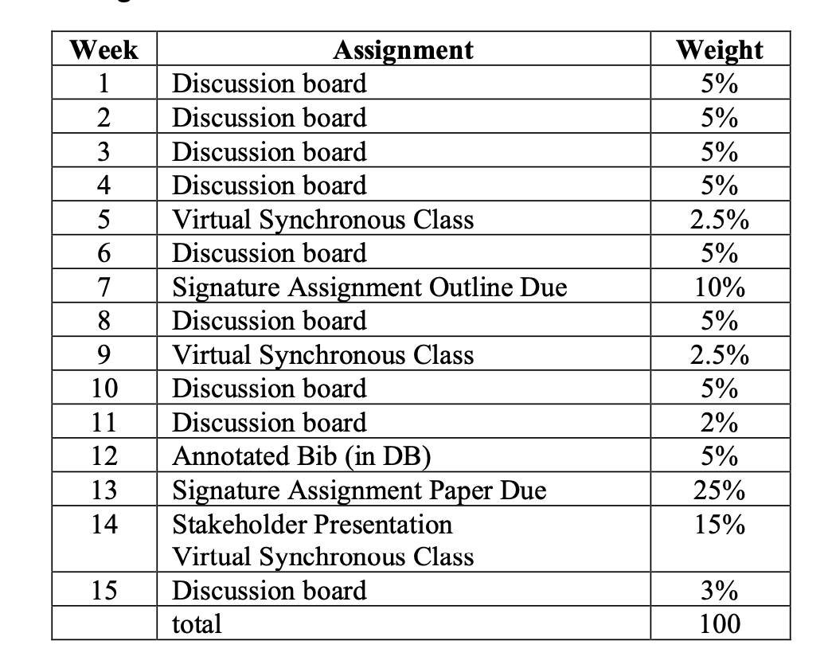
Grading Scale*
A = 90-100 %
B = 80-89%
C = Below 80%
and a failing course grade.

*The College of Nursing and Health Professions does not round grades. For example, a score of 89.7 will be recorded as 89% and a B grade.
Late Work Policy
It is expected that assignments will be submitted on time. Late assignments will be subject to a deduction of 5% per day. No late assignments will be accepted after 48 hours. Extensions on writing assignments are not provided unless prior arrangements have been made with faculty at least a week prior to the assignment due date or unless there are extenuating circumstances. Requests made within the week prior to the due date will not be granted unless there is an emergency.

Grades of "Incomplete"
An Incomplete grade is granted at the discretion of the faculty of record and must be aligned with the University policies. Receiving an "Incomplete" for a nursing course that is a prerequisite for a forthcoming nursing course must be completed prior to the start of the new course.

Writing Policy
All written assignments should be formatted to APA 7th edition standards and must be submitted as MS word documents. No google docs, pdf, pages, or other formats will be accepted. Use the following format for naming your assignments: lastname(s).assignmentname

Instructor and Student Communication
Questions for this course can be emailed to the instructor and must be sent using your Chaminade email. Online and phone conferences can also be arranged. Response time is usually within 24 hours, but weekends and University holidays may extend the response time.

Online Course Guidelines
Chaminade uses Canvas as the online learning management system (LMS) platform. Please review the Student Tutorial located on the Canvas course dashboard regarding instructions on accessing and submitting materials and assignments. If you are unable to find answers using the student tutorial, you may also contact the assigned faculty with questions regarding course navigation.

Students should follow standard Netiquette guidelines, including but not limited to using the same common courtesy, politeness, and appropriate online behaviors as would be used in a face-to-face environment.

Disability Access
If a student needs individual accommodations to meet course outcomes because of a documented disability, please speak with the course instructor to discuss individual needs as soon as possible so that you may have the opportunity for full participation in class and a fair assessment of your work. Students with special needs who meet criteria for the Americans with Disabilities Act (ADA) provisions must provide written documentation of the need for accommodations from the Counseling Center by the end of week three of the class in order for instructors to plan accordingly. If a student would like to determine if they meet the criteria for accommodations, they should contact the Kōkua ʻIke Coordinator at (808) 739-8305 for further information (ada@chaminade.edu).

Failure to provide written documentation through the Counseling Center will prevent instructor(s) from making the necessary accommodations, as instructors cannot provide accommodations unless they have been prescribed by the Counseling Center. Once a student has received an official notice of accommodations from the Counseling Center, it is also very important to discuss these accommodations directly with all instructors so that they can better support student needs. If a student has specific questions regarding individualized accommodations, the student may speak directly with the instructor and/or contact the Counseling Center.

Title IX Compliance
Chaminade University of Honolulu recognizes the inherent dignity of all individuals and promotes respect for all people. Sexual misconduct, physical and/or psychological abuse will not be tolerated at CUH. If a student has been the victim of sexual misconduct, physical and/or psychological abuse, they are encouraged to report this matter promptly. Faculty members promote safe and healthy environments, and any sexual, physical, and/or psychological misconduct or abuse will be reported to the Title IX Coordinator. If you or someone you know has been harassed or assaulted, you can find the appropriate resources by visiting Campus Ministry, the Dean of Students Office, the Counseling Center, or the Office for Compliance and Personnel Services.

Compliance information:
The Compliance website serves as a resource for compliance matters, including Title IX/Nondiscrimination, the Hawaii Post-Secondary Education Authorization Program, and human resource and employment policies. The Executive Director for Compliance and Personnel Services oversees university-wide efforts to meet compliance standards set forth by University policies and Federal and State regulations.
Grievances, violations or suspected violations of these policies may be submitted by the complainant or may be submitted anonymously to the Executive Director of Compliance and Personnel Services. Reports of violations or suspected violations will be kept confidential to the extent possible, consistent with the need to conduct an adequate investigation. Mechanisms in which to file a grievance can be found at the following website link: https://compliance.chaminade.edu/resources

Attendance Policy
Students are expected to regularly attend all courses for which they are registered. Students should notify their instructors when illness or other extenuating circumstances prevent them from attending class, and they should make arrangements to obtain missed information and complete missed assignments. Notification may be done by emailing the instructor’s Chaminade email address, calling the instructor’s campus extension, or by leaving a message with the instructor’s division office. It is the instructor’s prerogative to modify the deadlines of course requirements accordingly. Any student who stops attending a course without officially withdrawing may receive a failing grade. Students may be automatically withdrawn from the class or receive a failing grade if there are three or more absences, or two absences in a row, in a 15-week term.

Students with disabilities who have obtained accommodations from the Chaminade University of Honolulu ADA Coordinator may be considered for an exception when the accommodation does not materially alter the attainment of the learning outcomes. Federal regulations require continued attendance for continuing payment of financial aid.

When illness or personal reasons necessitate continued absence, the student should communicate first with the instructor to review options. Anyone who stops attending a course without official withdrawal may receive a failing grade or be withdrawn by the instructor at the instructor’s discretion.

Academic Conduct Policy
Any community must have a set of rules and standards of conduct by which it operates. At Chaminade, these standards are outlined so as to reflect both the Catholic, Marianist values of the institution and to honor and respect students as responsible adults. All alleged violations of the community standards are handled through an established student conduct process, outlined in the Chaminade University of Honolulu Student Handbook and the DNP Student Handbook, and operated within the guidelines set to honor both students’ rights and campus values.

Students should conduct themselves in a manner that reflects the ideals of the University. This includes knowing and respecting the intent of rules, regulations, and/or policies presented in the Student Handbook and Program Catalog and realizing that students are subject to the University’s jurisdiction from the time of their admission until their enrollment has been formally terminated. Please refer to the Chaminade University of Honolulu Student Handbook and DNP Student Handbook for more details. A copy of the Student Handbook is available on the Chaminade website.

Unless otherwise instructed, all course submissions should follow the formatting of the Publication Manual of the American Psychological Association, 7th Edition format. The faculty of the School of Nursing and Health Professions at Chaminade University of Honolulu is dedicated to providing a learning environment that supports scholarly and ethical writing, free from academic dishonesty and plagiarism. This includes the proper and appropriate referencing of all sources. Students may be asked to submit course assignments through an online authenticity resource (e.g., Turnitin), which helps students and instructors detect potential cases of academic dishonesty.

Technology
A computer with the following technology is required in order to complete courses in the DNP Program: at least Windows 10 (for PCs), at least Mac OS X 10.5.8 (for Macs); a current antivirus program; the current Microsoft Office (PowerPoint and Word) and Adobe Acrobat; a standard web browser; and an internet or broadband connection with speed and connectivity to support internet searches and video conferencing. Installation of proctoring software may be required.

Technical Assistance for Canvas Users:
- Search for help on specific topics or get tips in Canvas Students
- Live chat with Canvas Support for students
- Canvas Support Hotline for students: +1-833-209-6111
- Watch this video to get you started
- Online tutorials: click on “Students” role to access tutorials
- Contact the Chaminade IT Helpdesk for technical issues: helpdesk@chaminade.edu or call (808) 735-4855

Library: The Sullivan Family Library link is available on the CUH website: http://www.chaminade.edu/library Phone: (808) 735-4725. Krystal Kakimoto, dedicated SONHP librarian: krystal.kakimoto@chaminade.edu

Tutoring and Writing Services
Chaminade offers, one-on-one tutoring and writing assistance to all students. Tutoring and writing help is available on campus at Kōkua ʻIke: Center for Student Learning in a variety of subjects (including, but are not limited to: biology, chemistry, math, nursing, English, etc.) from trained Peer and Professional Tutors. Please check Kōkua ʻIke’s website (https://chaminade.edu/advising/kokua-ike/) for the latest times, list of drop-in hours, and information on scheduling an appointment. Free online tutoring is also available via TutorMe. TutorMe can be accessed 24/7 from your Canvas account. Simply click Account – Notifications – TutorMe. For more information, please contact Kōkua ʻIke at tutoring@chaminade.edu or 808-739-8305.

Credit Hour Policy
The unit of semester credit is defined as university-level credit that is awarded for the completion of coursework. One credit hour reflects the amount of work represented in the intended learning outcomes and verified by evidence of student achievement for those learning outcomes. Each credit hour earned at Chaminade University should result in 45 hours of engagement. This equates to one hour of classroom or direct faculty instruction and a minimum of two hours of out-of-class student work each week for approximately fifteen weeks for one semester, 10-week term, or equivalent amount of work over a different amount of time. Direct instructor engagement and out-of-class work result in total student engagement time of 45 hours for one credit.
The minimum 45 hours of engagement per credit hour can be satisfied in fully online, internship, or other specialized courses through several means, including (a) regular online instruction or interaction with the faculty member and fellow students and (b) academic engagement through extensive reading, research, online discussion, online quizzes or exams; instruction, collaborative group work, internships, laboratory work, practica, studio work, and preparation of papers, presentations, or other forms of assessment. This policy is in accordance with federal regulations and regional accrediting agencies.

Course Schedule
The Course Schedule is posted in Canvas.

