COM 310- Intercultural Communication

Chaminade University of Honolulu SYLLABUS

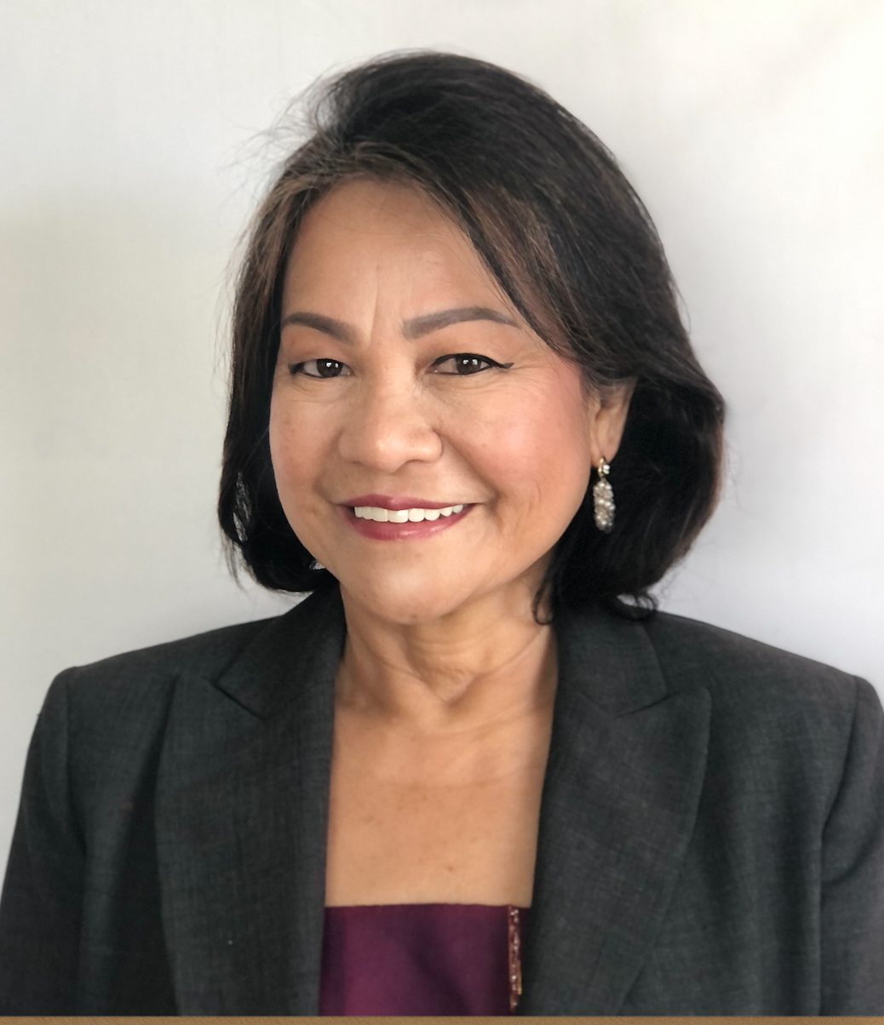

Professor: Dr. Eva Rose B. Washburn-Repollo

BA Speech and Theater Arts
Master of Arts in Literature
Master of Science in Reading
PhD, Education: Curriculum and Pedagogy

Contact: Room Eiben Hall 124 : (808) 735-4874
Email: eva.washburn@chaminade.edu

Class Schedule: COM 310

Email Response: 1-2 days

Texts: Reader taken from…

Samovar, L.A. Porter, R.E. & McDaniel E. R., Roy, C (2017). Communication between Cultures. Belmont, CA: Wadsworth/Thomas Learning. 9th Edition

Other handouts, materials, websites, video and films shared through CANVAS.

COURSE DESCRIPTION

COM 310: Intercultural Communication (3) – Major concepts in the study of communication from various theoretical viewpoints are examined to understand people from different cultural and global backgrounds. Family and community values. Beliefs, expectations. Customs and attitudes of various global and ethnic groups’ communication and symbol systems are studied across cultural boundaries for adaptation, empathy and understanding. Prerequisites COM 101 and EN 102.

GENERAL EDUCATION REQUIREMENTS:

- Education for Integral (Holistic) Education/Global Awareness.

Students will integrate their experience with global awareness in the context of the particular course and field/discipline within a diverse community of learners.

- Education for Adaptation and Change.

Student will evaluate the ways in which adaptation and change are essential to understanding the past, analyzing the present and applying critical thinking to meet future challenges and needs.

COURSE OBJECTIVES

Upon successful completion of COM 310, students should be able to:

1. Understand the meaning of culture through the study of a culture’s values, history, religion, groups and language.
2. Define and analyze cultural practices to understand how people adapt, survive and thrive based on changing gradations of global cultural patterns.
3. Recognize and explain barriers to develop empathy in communicating inter-culturally with others.

Alignment of GEN ED Learning Outcomes

 | Education for Integral (Holistic) Education/Global Awareness. | Education for Adaptation and Change.
Marianist Values | 1,2 & 3 | 2,3

Course Prerequisites: Eng 101, COM 101

Module # | Assignment Title
Module 1 | Course Completion Plan
Module 1 | - Course Schedule Assignment,  - Getting to Know you and  - Open Discussion
Module 2 | - Meaning of Culture, Cultural Elements and Practices Assignment Chapter 1 & 2  - Open discussion
Module 3 & 4 | - Cultural Patterns Chapter 6  - Open Discussion on Project 2 Cultural Immersion
Module 5 | - Chapter 11  - Project 2 Slides 1-3  - Review  - Mid-Term Project Draft
Module 6 & 7 | - Project 2 (Slides 4-8)
Module 8 & 9 | - Project 2 (Slides (9-10 to 12)  - Open Discussion for Final Report  Final Report (Translation)  - Final Exam

COURSE POLICIES

- Technology in the classroom. COM 310 and all related documents/assignments and exams will be delivered through CANVAS found in the Chaminade Portal.

- Schedule meetings and conference to meet virtually or via email.

Contact Information: Dr. Eva Rose B. Washburn-Repollo
Office Phone : 808-735-4874
Email: eva.washburn@chaminade.edu

Email Use and Feedback. Your emails will be responded to within 2 to 3 days from receipt. Exams will be conducted on CANVAS and grades will be uploaded within the week. Feedback on drafts and assignments will be sent through the CANVAS feedback box.

Zoom Meetings/Classes. Invitations will be emailed and announced through the CANVAS modules set ahead of time. Please check your email regularly for announcements. Please respond with a confirmation that you received the invitation.

Technical Assistance for Canvas Users:

- Search for help on specific topics or get tips in Canvas Students
- Live chat with Canvas Support for students
- Canvas Support Hotline for students: +1-833-209-6111
- Watch this video to get you started
- Online tutorials: click on “Students” role to access tutorials
- Contact the Chaminade IT Helpdesk for technical issues: helpdesk@chaminade.edu or call (808) 735-4855

A few reminders when attending class via ZOOM:

- Choose a quiet place in your home/dorm where you have privacy.
- Be ready to attend class 5 minutes before the virtual meeting begins.
- Mute your microphone until the hosts begins the class.
- Have your pens, notebooks, textbooks and study table ready for notetaking.

- Attendance. Regular work based on your proposed schedule in this class is graded. This includes prompt submission of homework, exams and online class discussions. Delayed responses and submissions will adversely affect completion in accordance with your planned schedule. Absences will be noted on CANVAS on the day you are not in class regardless of whether an email has been sent until an official letter from your doctor or the school (or other cases deemed official) has been received. Make up for work
- from excused absences should also be completed within one week from returning to class.

  - Students involved in athletics and/or military deployment should communicate ahead of time through email or a phone call with instructor, if possible, to make alternate arrangements.
  - It is the student’s, not the instructor’s, responsibility to catch up after missed class days within the next week after an excused absence.
  - It is important to respond and submit work for class at the scheduled time to assist you towards your success in the COM 310 program. Please email to eva.washburn@chaminade.edu if you need assistance.

* Participation as Attendance: Your promptness and active participation in class discussion and exercises are expected. I will keep track of your class contributions and keep your participation points. Involvement in class activities, completing your reading assignments and participating in discussions are essential to processing the material and ideas presented in this course. A positive attitude and respect for differences should guide all our interactions.

- Readings and written assignments: Class discussions and activities are based on assigned readings/video/research articles. Assigned material must be read before the module for which it is assigned. Log in with your usual Chaminade password. Find Course List and choose your section in COM 310. All homework should be submitted on time through CANVAS.

- All written assignments should follow the assigned format and MUST be typed. Written work that contains excessive typographical and grammatical errors is subject to grade penalty. Students should keep a copy of all written work submitted.

- NO Late assignments: Students must turn in assignments and take the tests on time. If a student misses an assignment for a documented reason (see item 2 above), the student may be permitted to make up the assignment at a later date (time permitting), within one week after the absence.

- Plagiarism: All assignments should be original work done by the student for this class. Use of work that is not credited to the original source, or use of someone else’s speech or written material is a serious academic offence and will not be tolerated. Communication Department policy requires that, on first offence, plagiarized assignments will be given a grade of zero and one full letter will reduce the student’s final course grade. A second offence will result in automatic failure of the class. Refer to the Chained Student Handbook (p.91) for the complete university policy regarding plagiarism and academic honesty.
- Disability Access

If you need individual accommodations to meet course outcomes because of a documented disability, please speak with me to discuss your needs as soon as possible so that we can ensure your full participation in class and fair assessment of your work. Students with special needs who meet criteria for the Americans with Disabilities Act (ADA) provisions must provide written documentation of the need for accommodations from the Counseling Center by the end of week three of the class, in order for instructors to plan accordingly. If a student would like to determine if they meet the criteria for accommodations, they should contact the Kōkua ʻIke Coordinator at (808) 739-8305 for further information (ada@chaminade.edu).

Title IX Compliance
Chaminade University of Honolulu recognizes the inherent dignity of all individuals and promotes respect for all people. Sexual misconduct, physical and/or psychological abuse will NOT be tolerated at CUH. If you have been the victim of sexual misconduct, physical and/or psychological abuse, we encourage you to report this matter promptly. As a faculty member, I am interested in promoting a safe and healthy environment, and should I learn of any sexual misconduct, physical and/or psychological abuse, I must report the matter to the Title IX Coordinator. If you or someone you know has been harassed or assaulted, you can find the appropriate resources by visiting Campus Ministry, the Dean of Students Office, the Counseling Center, or the Office for Compliance and Personnel Services.

- Marianist and Pacific Hawaiian Values: Native Hawaiian Values

Education is an integral value in both Marianist and Native Hawaiian culture. Both recognize the transformative effect of a well-rounded, value-centered education on society, particularly in seeking justice for the marginalized, the forgotten, and the oppressed, always with an eye toward God (Ke Akua). This is reflected in the ‘Olelo No’eau (Hawaiian proverbs) and Marianist core beliefs:
- Educate for Formation in Faith (Mana) E ola au i ke akua (ʻŌlelo Noʻeau 364) May I live by God
- Provide an Integral, Quality Education (Na’auao) Lawe i ka maʻalea a kūʻonoʻono (ʻŌlelo Noʻeau 1957) Acquire skill and make it deep
- Educate in Family Spirit (‘Ohana) ʻIke aku, ʻike mai, kōkua aku kōkua mai; pela iho la ka nohana ʻohana (‘Ōlelo Noʻeau 1200) Recognize others, be recognized, help others, be helped; such is a family relationship
- Educate for Service, Justice and Peace (Aloha) Ka lama kū o ka noʻeau (ʻŌlelo Noʻeau 1430) Education is the standing torch of wisdom
- Educate for Adaptation and Change (Aina) ʻAʻohe pau ka ‘ike i ka hālau hoʻokahi (ʻŌlelo Noʻeau 203) All knowledge is not taught in the same school

Below is a quick table guide to Project 1 and 2 requirements:

Class Assignments | Cultural Elements | Cultural Practice under each of the five elements | Cultural Patterns | Visual Texts/Pictures or Short Videos
Step 1 towards Project 1 | History, Religion/Worldview, Values, Social Organization and Language | Describe in detail a cultural practice for each cultural element
Completion of Project 1 | History, Religion/Worldview, Values, Social Organization and Language | Describe in detail a cultural practice for each cultural element | Choose a cultural patterns that best explains the cultural practice | Add visuals to enhance the understanding of the cultural practice and its meanings.
PROJECT 2  Cultural Immersion focused on Immigrant Rights: Pacific island Cultures | Know Your Right -Choose the Right you want to translate/study and create a service learning project for. | Choose cultural elements that describe the culture you are studying. | Choose Cultural Patterns that are connected to these behaviors/rights. | Complete a PSA, Radio translation, podcast or or Vlog
Final Presentation

Class Projects: Project 1 & 2 and 1 Final Presentation of Project 2

- Project I: My Cultural Self
(First four modules)

Objective: To better comprehend the world around us requires understanding of our own values and belief systems that we bring to our school and professional group interactions. We will find creative text to present our amazing cultures.
Requirements:
- Readings: Chapter 1, 2 & 6.
- Two pages. Analysis of cultural practices using Cultural patterns (3) interpretation.
speak. Explain the elements found in your experiences using CULTURAL PATTERNS or theoretical concepts from Chapter 2 and 6.

Five Elements of Culture

Submission Format

Cultural Elements textbook Definition (5)  Describe details on these are these learned, practiced and communicated. | Cultural Patterns (5)  Chapter 6 concepts (textbook) Apply and explain your communicated practices. | Describe ideas/Symbols and Images: Creative images/messages that express your culture.
Language
Religion
History
Social Organization
Values

- Project II (Next 4 modules)

Final Project: KNOW YOUR RIGHT TRANSLATION MULTIMEDIA IMMERSION (10-12 Google Slides)
I. The Overview.
The cultural immersion project is focused on translating Immigrant Rights for Pacific Islanders. This is a service learning project in partnership with community organizations like the ACLU and EEH. These cultures include Samoa, Chuuk, Pohnpei, Yap, Kosrae. Developing empathy requires a deeper immersion into other cultures. We approach with an open mind and a respectful viewpoint to understand, adapt and change to achieve cultural competence. Use the cultural theoretical frames we have studied from the text to analyze the cultural practices that you observe. At the end share your experience in order for the class to increase cultural competency.
Establish the Immigrant Right from a Pacific Island culture that you want to study and create a PSA, Vlog, Podcast or PSA for.
1. What is the research reason that you chose this culture? or What makes this culture different from yours? Why are you interested in it? (Since we know that there are five cultural elements that overlap in practice, you may want to focus on something so different from your own to explore and know more about).
2. What is the immigrant right you are translating and creating a multimedia project on?
3. How will you access this culture?
a. When are you going to visit?
b. Who will be your cultural ally (person who can speak the language of the culture that you are studying)? (You can send an email introduction, call or do a pre-visit to ask if there is anyone who might be able to help you with scheduling a time to interview, plan a script and work on the project with.
II. First Set. Slides 1-3.
Slide 1- Overview/PLAN
Slide 2- Timeline
Slide 3- Cultural Ally, Schedule of Visits and Recordings
III. Second Set. Slides 4-8.
Slide 4-8. Upload Multi-Media Product: PSA, Podcast, Radio or Video.
Include: Cultural Elements (History, Language, Values, Social Organization, Religion) and the corresponding cultural practices you gathered from your immersion.
Submit to CANVAS Slides 4-8 and Journal 2. Include date, time and place.
Rubric for Cultural Elements:
III. Presenting your Multi-Media PSA. Final Submission.
CHECKLIST:
I. Overview (You can improve this as you go along.) Why did I choose this culture?
II. Immigrant Right.
III. Cultural Ally and Schedule of Visits
IV-VIII. Multi-Media Product: PSA, Podcast, Radio or Video.
Five Elements. Discuss the practices of this culture based on the 5 elements of culture that we learned throughout the semester. Our textbook is your primary resource. Under language, translate and choose your multi media. list and define 10 words or phrases that are often used in this culture in the context of the research questions. Add pronunciation syllabication or links to audio references if possible. Include only words or phrases that are relevant to your specific study.
IX. What did I Learn that I can share with others? Include Pictures (Pictures can also be inserted according to the cultural element it may belong to.)
X. What did I Learn that I can share with others? How did this develop your ability to adapt and improve your cultural competence? Define and apply at least 3 concepts. Include what you learned that might help other people who do not belong to this culture avoid/prevent cultural conflict. (Use cultural patterns, differences and competencies in your 9th and 10th slide.)

NOTE: Grading on the Overview , Initial Slide submissions and the final submission of the content in 10 Google slides will focus on clarity, definition, data of actual visits, application of concepts used in class and discussion of how your visit enhance cultural competence. Read the articles uploaded here before your visits to understand Ethnography, How to Interview and How to Observe.

@Project II a

Final Report of Project 2 of the Know Your Rights TRANSLATION MULTI-MEDIA PROJECT

Objective: To present a multimedia (radio, psa, podcast etc) recorded video presentation of the Cultural Element of LANGUAGE in translating for Pacific Island Cultural languages.
Use at least 10 new lines from the culture you immersed in other than your own, perform or share the sound of the language (in this case the creative product to disseminate the RIGHT) according to the context of the communicative events these lines are used based on your cultural immersion.

*Final Project will be presented with Service Learning partners ACLU and EEH

- Grading:

Graded Activities | Possible Points | Percentage
Assignments | 100 | 15%
Midterm/Finals | 150 | 20%
Project 1 Who Am I? | 100 | 15%
Project 2 Cultural Immersion | 150 | 25%
Final Presentation Project 2 | 50 | 15%
Attendance/Participation | 50 | 10%
TOTAL | 650 | 100%

