 | Chaminade-Flex Course Syllabus  Chaminade University Honolulu  3140 Waialae Avenue - Honolulu, HI 96816  
Course Number: RE 103
Course Title: World Religions
Department Name: Religious Studies
College/School/Division Name: School of Humanities, Arts, and Design
Term: Flex term begins the first of the month and extends six months.
Course Credits: 3
Class Meeting Days: Asynchronous, at your own pace
Class Meeting Hours: Asynchronous, at your own pace
Course Website Address (Canvas): https://chaminade.instructure.com/

Instructor Name: Dr. Achilles Gacis, Ph.D.
Email: achilles.gacis@chaminade.edu
Phone: 808.539.9376
Office Location: 0nline
Office Hours: Mondays 9-10 am and by appointment

University Course Catalog Description
Within the context of the dialogue between Christianity and the other world religions, the student will explore the diverse historical, philosophical, and spiritual foundations from which the major religious traditions in the world have arisen. The course examines the lives of their founders, their basic teaching, and the historical development of their communities and institutions, while providing an inter-religious survey of ethics.
This course satisfies lower-division religion course for students entering prior to Fall 2020. It satisfies the Critical Thinking Skill General Education for students admitted Fall 2020 and later

Course Overview
The purpose of this class is to assist students in their exploration and understanding of different approaches to the answers of the human quest in existence, morality, and ethical behaviors.

This study is presented in a way where students will examine the major religious traditions, such as Hinduism, Buddhism, Taoism, Judaism, Christianity, and Islam while engaging in a review and comparison of their diverse spiritual, historical, and philosophical foundations. This class will critically analyze their application to current sociopolitical problems and their effect on the harmony of the global community.

Marianist Values
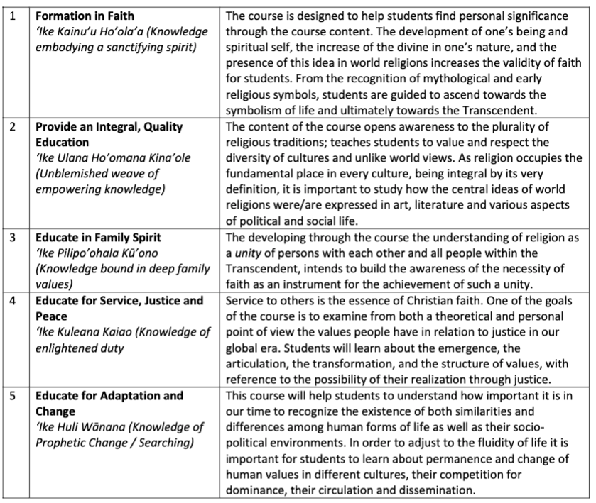

Native Hawaiian Values
Education is an integral value in both Marianist and Native Hawaiian culture. Both recognize the transformative effect of a well-rounded, value-centered education on society, particularly in seeking justice for the marginalized, the forgotten, and the oppressed, always with an eye toward God (Ke Akua). This is reflected in the ‘Olelo No’eau (Hawaiian proverbs) and Marianist core beliefs:
- Educate for Formation in Faith (Mana) E ola au i ke akua (ʻŌlelo Noʻeau 364) May I live by God
- Provide an Integral, Quality Education (Na’auao) Lawe i ka maʻalea a kūʻonoʻono (ʻŌlelo Noʻeau 1957) Acquire skill and make it deep
- Educate in Family Spirit (‘Ohana) ʻIke aku, ʻike mai, kōkua aku kōkua mai; pela iho la ka nohana ʻohana (‘Ōlelo Noʻeau 1200) Recognize others, be recognized, help others, be helped; such is a family relationship
- Educate for Service, Justice and Peace (Aloha) Ka lama kū o ka noʻeau (ʻŌlelo Noʻeau 1430) Education is the standing torch of wisdom
- Educate for Adaptation and Change (Aina) ʻAʻohe pau ka ‘ike i ka hālau hoʻokahi (ʻŌlelo Noʻeau 203) All knowledge is not taught in the same school

Learning Outcomes

By the end of the course, students will be able to:

Discuss the important elements of the major religions – their myths, symbols, rituals, doctrines, moral codes and artistic expression (GELO Critical Thinking and Information Literacy), (PLO 2 );
  - Compare and contrast the commonalities and differences among the religious traditions (GELO Critical Thinking and Information Literacy) (PLO 2);
  - Understand some of the religious responses to global and social justice issues;
  - Express one’s own beliefs, feelings, and attitudes towards different religious perspectives in correlation and contrast with those learned through the course in approaching the human quest for meaning.

Alignment of Learning Outcomes

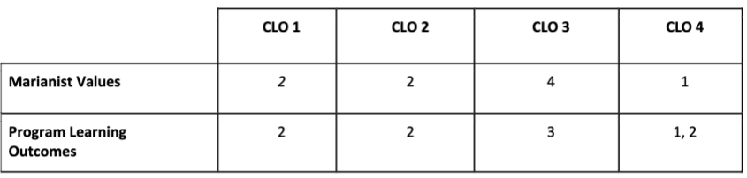

Course Prerequisites

No prerequisite

Required Learning Materials

This course uses McGraw Hill Connect

Experiencing the World’s Religions, 8th edition

Michael Molloy

ISBN-13: 978-1260813760

ISBN-10: 1260813762

Course Website: https://chaminade.instructure.com/

Hardware Requirements: Canvas is accessible from both PC and Mac computers with a reliable internet connection. You will also need to be able to access audio and video files. Subsequently, you should have access to speakers or headphones that allow you to hear the audio.

Software Requirements: You will need to have some ability to listen to audio in an mp3 format, watch videos in mp4 format, stream online videos, and read .pdf files. There are a number of free software online that can be downloaded for free. If you need assistance with locating software please feel free to contact the Chaminade Help Desk at helpdesk@chaminade.edu or (808) 735-4855.

Technical Assistance for Canvas Users:
- Search for help on specific topics or get tips in Canvas Students
- Live chat with Canvas Support for students
- Canvas Support Hotline for students: +1-833-209-6111
- Watch this video to get you started
- Online tutorials: click on “Students” role to access tutorials
- Contact the Chaminade IT Helpdesk for technical issues: helpdesk@chaminade.edu or call (808) 735-4855

Tutoring and Writing Services
Chaminade is proud to offer free, one-on-one tutoring and writing assistance to all students. Tutoring and writing help is available on campus at Kōkua ʻIke: Center for Student Learning in a variety of subjects (including, but are not limited to: biology, chemistry, math, nursing, English, etc.) from trained Peer and Professional Tutors. Please check Kōkua ʻIke’s website (https://chaminade.edu/advising/kokua-ike/) for the latest times, list of drop-in hours, and information on scheduling an appointment. Free online tutoring is also available via TutorMe. Tutor Me can be accessed 24/7 from your Canvas account. Simply click Account – Notifications – TutorMe. For more information, please contact Kōkua ʻIke at tutoring@chaminade.edu or 808-739-8305.

Assessment

Student’s work will be evaluated for:
- Knowledge of the subject matter from textbooks, class presentations, discussions, videos, research, and other activities.
- Ability to apply the knowledge to understand current issues in society.
- Understand the subject matter from different viewpoints.
- Demonstration of the following 5 Core Competencies:
    - Written Communication
    - Oral Communication
    - Quantitative Reasoning
    - Critical Thinking
    - Information Literacy

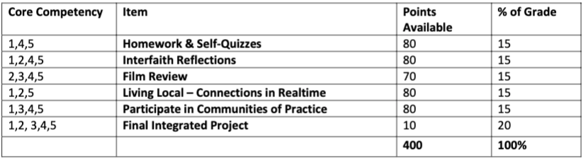

Grading Scale
Letter grades are given in all courses except those conducted on a credit/no credit basis. Grades are calculated from the student’s daily work, class participation, quizzes, tests, term papers, reports and the final examination. They are interpreted as follows:
A Outstanding scholarship and an unusual degree of intellectual initiative
B Superior work done in a consistent and intellectual manner
C Average grade indicating a competent grasp of subject matter
D Inferior work of the lowest passing grade, not satisfactory for fulfillment of prerequisite course work
F Failed to grasp the minimum subject matter; no credit given

Course Policies

Course Approach

This course is utilizing a Flex model, meaning the only due dates you have are 1) your course completion Schedule, which is due by 11:59pm on the Sunday of your first week in this class; and 2) all other assignments must be submitted by 11:59 pm on the last day of class (six months after your initial start date). The Flex model provides you with the convenience and ability to work at your own pace and complete assignments when it is convenient for you. You can work as fast as you want, meaning you can complete the course in as little as six weeks, or up to six months.

Grades of "Incomplete"
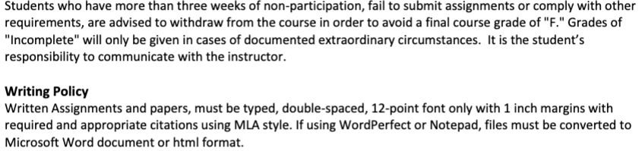
Instructor and Student Communication
Questions for this course can be emailed to the instructor at achilles.gacis@chaminade.edu. Online and phone conferences can be arranged. Response time will take place up to three (3) days.
Disability Access

If you need individual accommodations to meet course outcomes because of a documented disability, please speak with me to discuss your needs as soon as possible so that we can ensure your full participation in class and fair assessment of your work. Students with special needs who meet criteria for the Americans with Disabilities Act (ADA) provisions must provide written documentation of the need for accommodations from Kōkua ʻIke: Center for Student Learning by the end of week three of the class, in order for instructors to plan accordingly. If a student would like to determine if they meet the criteria for accommodations, they should contact the Kōkua ʻIke Coordinator at (808) 739-8305 for further information (ada@chaminade.edu).

Title IX Compliance
Chaminade University of Honolulu recognizes the inherent dignity of all individuals and promotes respect for all people. Sexual misconduct, physical and/or psychological abuse will NOT be tolerated at CUH. If you have been the victim of sexual misconduct, physical and/or psychological abuse, we encourage you to report this matter promptly. As a faculty member, I am interested in promoting a safe and healthy environment, and should I learn of any sexual misconduct, physical and/or psychological abuse, I must report the matter to the Title IX Coordinator. If you or someone you know has been harassed or assaulted, you can find the appropriate resources by visiting Campus Ministry, the Dean of Students Office, the Counseling Center, or the Office for Compliance and Personnel Services.

Attendance Policy
The following attendance policy is from the 2020-2021 Academic Catalog.

Students are expected to attend regularly all courses for which they are registered. Student should notify their instructors when illness or other extenuating circumstances prevents them from attending class and make arrangements to complete missed assignments. Notification may be done by emailing the instructor’s Chaminade email address, calling the instructor’s campus extension, or by leaving a message with the instructor’s division office. It is the instructor’s prerogative to modify deadlines of course requirements accordingly. Any student who stops attending a course without officially withdrawing may receive a failing grade.

Students with disabilities who have obtained accommodations from the Chaminade University of Honolulu ADA Coordinator may be considered for an exception when the accommodation does not materially alter the attainment of the learning outcomes.

Federal regulations require continued attendance for continuing payment of financial aid. When illness or personal reasons necessitate continued absence, the student should communicate first with the instructor to review the options. Anyone who stops attending a course without official withdrawal may receive a failing grade or be withdrawn by the instructor at the instructor’s discretion.

Academic Conduct Policy
From the 2019-2020 Undergraduate Academic Catalog (p. 39):
Any community must have a set of rules and standards of conduct by which it operates. At Chaminade, these standards are outlined so as to reflect both the Catholic, Marianist values of the institution and to honor and respect students as responsible adults. All alleged violations of the community standards are handled through an established student conduct process, outlined in the Student Handbook, and operated within the guidelines set to honor both students’ rights and campus values.

Students should conduct themselves in a manner that reflects the ideals of the University. This includes knowing and respecting the intent of rules, regulations, and/or policies presented in the Student Handbook, and realizing that students are subject to the University’s jurisdiction from the time of their admission until their enrollment has been formally terminated. Please refer to the Student Handbook for more details. A copy of the Student Handbook is available on the Chaminade website.

For further information, please refer to the Student Handbook which is linked annually on the following webpage: https://chaminade.edu/current-students/

Credit Hour Policy
The unit of semester credit is defined as university-level credit that is awarded for the completion of coursework. One credit hour reflects the amount of work represented in the intended learning outcomes and verified by evidence of student achievement for those learning outcomes. Each credit hour earned at Chaminade University should result in 45 hours of engagement. This equates to one hour of classroom or direct faculty instruction and a minimum of two hours of out-of-class student work each week for approximately fifteen weeks for one semester, 10 week term, or equivalent amount of work over a different amount of time. Direct instructor engagement and out-of-class work result in total student engagement time of 45 hours for one credit.

The minimum 45 hours of engagement per credit hour can be satisfied in fully online, internship, or other specialized courses through several means, including (a) regular online instruction or interaction with the faculty member and fellow students and (b) academic engagement through extensive reading, research, online discussion, online quizzes or exams; instruction, collaborative group work, internships, laboratory work, practica, studio work, and preparation of papers, presentations, or other forms of assessment. This policy is in accordance with federal regulations and regional accrediting agencies.

Suggested Course Schedule

