
Course Syllabus
Chaminade University Honolulu
3140 Waialae Avenue, Honolulu, HI 96816
www.chaminade.edu
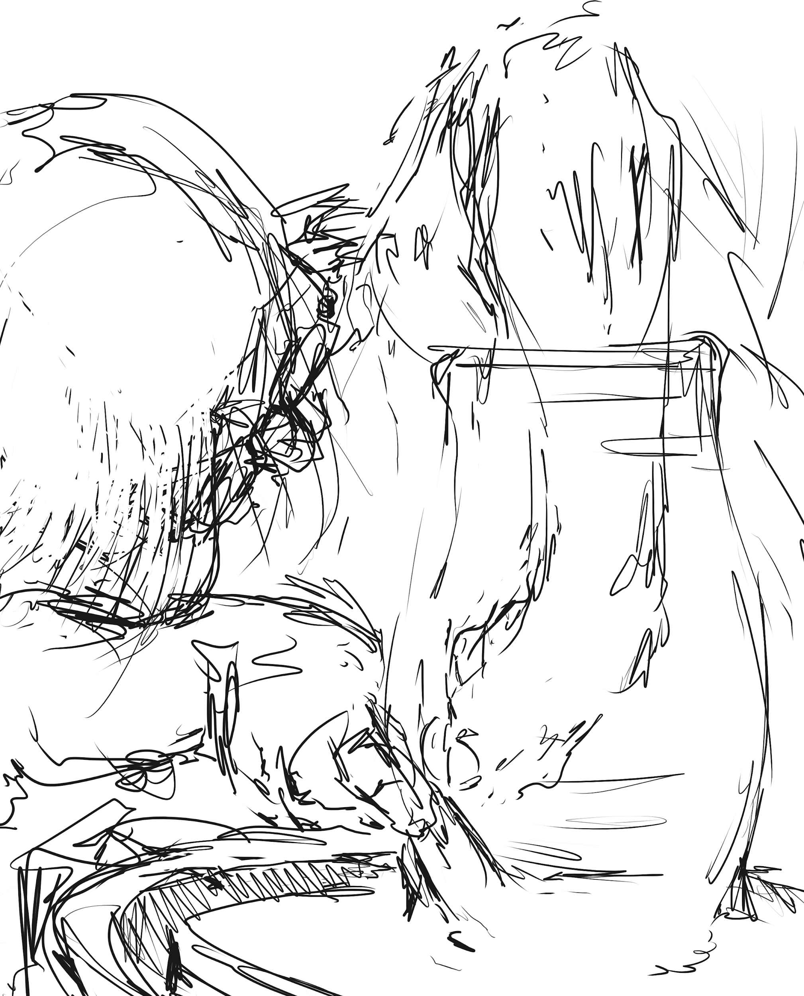

ART 350

Intermediate Ceramics

Humanities, Arts, and Design
Course Credits: 3
Class Meeting Days: MWF
Class Meeting Hours:
E-101

Devin Oishi

devin.oishi@chaminade.edu
Phone:
Office Location:
Office Hours: varies depending on kiln firing, generally before lunch MWF
Instructor’s Art Website: https://devinoishi.wixsite.com/devin-oishi
Other Professional Contact Information (IG): @devinoishi

University Course Catalog Description
Basic studio experience in the creation of clay forms, both functional and nonfunctional, incorporating hand-building techniques. Six hours per week. This course fulfills the Fine Arts general education requirement. Offered every semester.

Course Overview
Ceramics covers aspects of creating art and craft through clay. In addition, we will explore the development of the technology and history of clay through the ages and its impact on society today.

- Overview of the history of clay and art
- Basic techniques of throwing and firing ceramics.
- Technology of clay and its use in society today.
- Critique and appreciation of art.

"Art is the means through which culture and civilization travel across generations." This is the core value I would like to pass on to you. Over the ages humanity has recorded not only its history but its values through the arts. We have seen the erosion of this knowledge as modern society has focused on extrinsic values. During this course I would like you to think about your place in society as makua. How will I use this power to communicate with the next generation?

Marianist Values
This class represents one component of your education at Chaminade University of Honolulu. An education in the Marianist Tradition in marked by five principles and you should take every opportunity possible to reflect upon the role of these characteristics in your education and development:
- Education for formation in faith
- Provide an integral, quality education
- Educate in family spirit
- Educate for service, justice and peace
- Educate for adaptation and change

Native Hawaiian Values
Education is an integral value in both Marianist and Native Hawaiian culture. Both recognize the transformative effect of a well-rounded, value-centered education on society, particularly in seeking justice for the marginalized, the forgotten, and the oppressed, always with an eye toward God (Ke Akua). This is reflected in the ‘Olelo No’eau (Hawaiian proverbs) and Marianist core beliefs:
- Educate for Formation in Faith (Mana) E ola au i ke akua (ʻŌlelo Noʻeau 364) May I live by God
- Provide an Integral, Quality Education (Na’auao) Lawe i ka maʻalea a kūʻonoʻono (ʻŌlelo Noʻeau 1957) Acquire skill and make it deep
- Educate in Family Spirit (‘Ohana) ʻIke aku, ʻike mai, kōkua aku kōkua mai; pela iho la ka nohana ʻohana (‘Ōlelo Noʻeau 1200) Recognize others, be recognized, help others, be helped; such is a family relationship
- Educate for Service, Justice and Peace (Aloha) Ka lama kū o ka noʻeau (ʻŌlelo Noʻeau 1430) Education is the standing torch of wisdom
- Educate for Adaptation and Change (Aina) ʻAʻohe pau ka ‘ike i ka hālau hoʻokahi (ʻŌlelo Noʻeau 203) All knowledge is not taught in the same school

Learning Outcomes
Program Learning Outcomes
- Demonstrate the application of skills related to a particular artistic methodology in order to create a project.
- Articulate steps necessary to the process of creating works of art.
- Describe and define the ways in which fine arts are an essential part of human culture that enriches their lives
Course Learning Outcomes
- Develop the skills required to create arts and crafts from ceramics
- Develop confidence discussing your work through conversations and writing using art terminology.
- Develop an understanding of art through the ages as a conduit for humanity, civilization, culture, and knowledge and how you can interpret and participate in the promulgation of culture.
- Discover how the skills we develop influence and enhance other seemingly unrelated aspects of our lives.

Course Prerequisites
AR 250, EN 102, COM 101

Required Learning Materials

25 pounds
of Cone-10 Stoneware clay to start, $15. Most students will use at least 100LB of clay during the semesterPaper and or sketchbook, pencil, pen, folder or space in binder to store printed materials.
I suggest Soldate 60- it’s white stoneware and in expensive. Easier for throwing is B-Mix which is also more white than Soldate 60. B- Mix is a little pricier. Won’t stain your clothes, works well for handbuilding and throwing, takes glaze well.
https://www.bookstore.hawaii.edu/manoa/shop_product_detail.asp?catalog_group_id=LTQ&catalog_group_name=U2VhcmNoIFJlc3VsdHM&catalog_id=0&catalog_name=U2VhcmNoIFJlc3VsdHM&pf_id=16524&product_name=Q2VyYW1pYyBDbGF5IFNvbGRhdGUgNjA&type=1&search_text=clay&f=

Plastic Bags of various sizes to store clay in.
Newspaper, wood chips, sawdust, dry leaves

Stores:

We have some clay in stock at Chaminade
University of Hawaii Bookstore,
Kapiolani Community College Bookstore (Hand building clay)
Ben Franklin (might be most expensive and often does not have cone 10 clay)
Amazon, Laguna on line

Optional:
Work tool kit (about $30), brush, ruler, towel, work clothes (apron)
https://www.bookstore.hawaii.edu/manoa/shop_product_detail.asp?catalog_group_id=LTQ&catalog_group_name=U2VhcmNoIFJlc3VsdHM&catalog_id=0&catalog_name=U2VhcmNoIFJlc3VsdHM&pf_id=17733&product_name=UG90dGVyeSBUb29sIEtpdCAoOCBQaWVjZXMp&type=1&search_text=clay&f=
We have some tool kits in class for sale. We also have tools and aprons you can share while in class.

Course Website:
Provide the link to your Canvas course site here. All course evaluations will be conducted via Canvas, so even if you are teaching face-to-face courses, your students will have to access the site.

Technical Assistance for Canvas Users:
- Search for help on specific topics at help.instructure.com
- Chat live with Canvas Support 24/7/365
- Watch this video to get you started with online guides and tutorials
- Contact the Chaminade IT Helpdesk for technical issues: helpdesk@chaminade.edu, or call (808) 735-4855

Assessment
Provide a listing of assessments and their weighting. In addition to (or even in lieu of) tests, you may wish to consider creating “authentic” assessments, which are aligned to experiences that students will encounter in their careers. You also may wish to include service learning assignments and connect with the CUH Service Learning Center.

Projects:

Cups
Bowls
Plates
Vase
Pitcher
Teapot set
Sculpture
Make a glaze

Each project will have a rubric by which to quantify grades. Here is a sample:
https://docs.google.com/document/d/14gdqKB5WjZey2LaN_PlU-S20oi6INxqeQCHqXOZVNEo/edit?usp=sharing

Each project has 4 grades 0-100% each:

- Sketches, research, introspection
- Greenware: unfired clay ready to be placed in kiln
- Glazeware: clay that has been bisqued, glazed, and fired and is complete
- Self and class critique

Other grades 0-100% each:

- Portfolio: web &/or social media catalogue of ur work
- Labwork: Maintenance Cleaning Making glaze & clay Firing etc
- Attendance
- Behavior

Grading Scale
Letter grades are given in all courses except those conducted on a credit/no credit basis. Grades are calculated from the student’s daily work, class participation, quizzes, tests, term papers, reports and the final examination. They are interpreted as follows:

A 90-100 Outstanding scholarship and an unusual degree of intellectual initiative
B 80-89 Superior work done in a consistent and intellectual manner
C 70-79 Average grade indicating a competent grasp of subject matter
D 60-69 Inferior work of the lowest passing grade, not satisfactory for fulfillment of prerequisite course work
F 0-59 Failed to grasp the minimum subject matter; no credit given

Sample grade spreadsheet:

https://docs.google.com/spreadsheets/d/13aOPOlT-1AbV19Aq26l9pScy2uqRYg2DXdO3ZUWeitk/edit?usp=sharing

Course Policies

Late Work Policy
Last chance to turn in green ware is one week before final bisque firing 2-3 weeks before the end of semester.
Last chance for glaze firing is the 1-2 weeks before the end of the semester.
Each project will have a critique. Work for each project turned in late will be deducted by 10% unless there are extenuating circumstances.

Writing Policy
I do check for plagiarism. Any format is fine. I have bad eyes. Use 12 pt text.
Instructor and Student Communication
Questions for this course can be emailed to the instructor at devin.oishi@chaminade.edu. Online, in-person and phone conferences can be arranged. Response time will take place up to 3+ days to accommodate weekends and holidays. I check work email MWF, possibly on other days. Do not message or call me via text 10pm-8am if you have my cell or other personal contact unless it is an extreme emergency.
Cell phones, tablets, and laptops

Out of consideration for your classmates, please set your cell phone to silent mode during class. Students are encouraged to bring laptops or tablets to class as the instructor will assign online activities and readings that will require the use of a laptop or tablet. Laptops and tablets should not be misused, such as checking distracting websites. Use your best judgment and respect your classmates and instructor.

WARNING: The ceramics lab can be dusty.

Disability Access
If you need individual accommodations to meet course outcomes because of a documented disability, please speak with me to discuss your needs as soon as possible so that we can ensure your full participation in class and fair assessment of your work. Students with special needs who meet criteria for the Americans with Disabilities Act (ADA) provisions must provide written documentation of the need for accommodations from the Counseling Center by the end of week three of the class, in order for instructors to plan accordingly. If a student would like to determine if they meet the criteria for accommodations, they should contact the Counseling Center at (808) 735-4845 for further information.

Title IX Compliance
Chaminade University of Honolulu recognizes the inherent dignity of all individuals and promotes respect for all people. Sexual misconduct, physical and/or psychological abuse will NOT be tolerated at CUH. If you have been the victim of sexual misconduct, physical and/or psychological abuse, we encourage you to report this matter promptly. As a faculty member, I am interested in promoting a safe and healthy environment, and should I learn of any sexual misconduct, physical and/or psychological abuse, I must report the matter to the Title IX Coordinator. If you or someone you know has been harassed or assaulted, you can find the appropriate resources by visiting Campus Ministry, the Dean of Students Office, the Counseling Center, or the Office for Compliance and Personnel Services.

Attendance Policy
The following attendance policy is from the 2018-2019 Academic Catalog (p. 57-58). Faculty members should also check with their divisions for division-specific guidelines.

Students are expected to attend all courses regularly for which they are registered. Students should notify their instructors when illness or other extenuating circumstances prevents them from attending class and make arrangements to complete missed assignments. Notification may be done by emailing the instructor’s Chaminade email address, calling the instructor’s
campus extension, or by leaving a message with the instructor’s division office. It is the instructor’s prerogative to modify deadlines of course requirements accordingly. Any student who stops attending a course without officially withdrawing may receive a failing grade.
Unexcused absences equivalent to more than a week of classes may lead to a grade reduction for the course. Any unexcused absence of two consecutive weeks or more may result in being withdrawn from the course by the instructor, although the instructor is not required to withdraw students in that scenario. Repeated absences put students at risk of failing grades.

FYI: If you miss class and or come in late and do not make up the time and projects missed I lower your grade. In entry level classes the most important part is practicing and perfecting the making of your art and craft. As an example one student who has excellent work only came in half the classes. All project were A accept that she never trimmed a foot. She got a “C” for the semester. If she had been a BFA or art teacher candidate I would have gone with “D”. Students coming in consistently late or missing a crit or ignoring others during a crit could get one letter reduction of the semester grade.

Students with disabilities who have obtained accommodations from the Chaminade University of Honolulu ADA Coordinator may be considered for an exception when the accommodation does not materially alter the attainment of the learning outcomes. Federal regulations require continued attendance for continuing payment of financial aid. When illness or personal reasons necessitate continued absence, the student should communicate first with the instructor to review the options. Anyone who stops attending a course without official withdrawal may receive a failing grade or be withdrawn by the instructor at the instructor’s discretion.

Academic Conduct Policy
From the 2018-2019 Undergraduate Academic Catalog (p. 42):
Any community must have a set of rules and standards of conduct by which it operates. At Chaminade, these standards are outlined so as to reflect both the Catholic, Marianist values of the institution and to honor and respect students as responsible adults. All alleged violations of the community standards are handled through an established student conduct process, outlined in the Student Handbook, and operated within the guidelines set to honor both students’ rights and campus values.

Students should conduct themselves in a manner that reflects the ideals of the University. This includes knowing and respecting the intent of rules, regulations, and/or policies presented in the Student Handbook, and realizing that students are subject to the University’s jurisdiction from the time of their admission until their enrollment has been formally terminated. Please refer to the Student Handbook for more details. A copy of the Student Handbook is available on the Chaminade website.

For further information, please refer to the Student Handbook: https://studentaffairs.chaminade.edu/wp-content/uploads/sites/28/2018-19-NEW-STUDENT-HANDBOOK.pdf

Schedule
https://docs.google.com/spreadsheets/d/13aOPOlT-1AbV19Aq26l9pScy2uqRYg2DXdO3ZUWeitk/edit?usp=sharing

