 | Course Syllabus  Chaminade University Honolulu  3140 Waialae Avenue - Honolulu, HI 96816  www.chaminade.edu

Course Number: CH203-02
Course Title: General Chemistry
School Name: Natural Sciences and Mathematics
College/School/Division Name: Chaminade University of Honolulu
Term: Fall 2022
Course Credits: 3
Class Meeting Days: MWF
Class Meeting Hours: 11:30 – 12:20 PM
Class Location: Henry Hall 207

Instructor Name: Joel Kawakami, Ph. D.
Email: jkawakam@chaminade.edu (Best method for contact and I will do my best to get back to you within 24 hours of your received email)
Phone: (808) 739-8576
Office Location: Henry 5
Office Hours: Tuesday through Friday 8:30-9:20am
Instructor Website: https://chaminade.edu/academics/nsm/joel-kawakami/
Other Professional Contact Information (Skype, Twitter, Blog, etc.): None

1. University Course Catalog Description
A study of the general concepts and basic principles of chemistry: properties of matter, atomic and molecular structure, theories of bonding, chemical reactions and stoichiometry, equilibria, and ions in aqueous solution. Offered annually. Prerequisites: MA 103. Concurrent registration in CH 203L. An optional 4th hour recitation may be offered in support of development of problem-solving skills in general chemistry. Cross-listed with BC 203.

2. Course Overview
CH 203 is the first half of a two semester, college-level, general chemistry course. The second semester is CH 204. This course will introduce you to the fundamental principles and models of chemistry necessary for an understanding of the composition, structure, and properties of matter and the changes that matter undergoes. CH 203/204 is suitable for students planning careers in science, medicine, engineering or other areas requiring an extensive background in chemistry. The class periods will consist of lecture/discussion with an emphasis on problem solving, and so it is important that you bring a calculator and writing materials to each meeting. 4 credits
Prerequisites: MA 103. Concurrent registration in CH 203L required.

Expectations
I do expect all assignments listed on the module to be done on time (late work is NOT expected). I will assign groups to work together and expect full interaction from everyone within the group. I expect to hear all group assignment communicated to me either on Zoom or Google Doc from all members of the group participating. I expect at all times during one-on-one to large group setting discussions to be civil and respectful to everyone with no vulgar language at any time – that includes my respect to each and every one of you. Thank you all for your dedication to these aspects in advance.

Marianist Values (MV)
This class represents one component of your education at Chaminade University of Honolulu. An education in the Marianist Tradition in marked by five principles and you should take every opportunity possible to reflect upon the role of these characteristics in your education and development:
- Education for formation in faith
- Provide an integral, quality education
- Educate in family spirit
- Educate for service, justice and peace
- Educate for adaptation and change

In this course, we Provide an Integral, Quality Education (MV No. 2) based on ACS (American Chemical Society) National Norms standard. For further information on this standard, please see:
https://uwm.edu/acs-exams/instructors/exam-statistics/national-norms/

Native Hawaiian Values (NHV)
Education is an integral value in both Marianist and Native Hawaiian culture. Both recognize the transformative effect of a well-rounded, value-centered education on society, particularly in seeking justice for the marginalized, the forgotten, and the oppressed, always with an eye toward God (Ke Akua). This is reflected in the ‘Olelo No’eau (Hawaiian proverbs) and Marianist core beliefs:
- Educate for Formation in Faith (Mana) E ola au i ke akua (ʻŌlelo Noʻeau 364) May I live by God
- Provide an Integral, Quality Education (Na’auao) Lawe i ka maʻalea a kūʻonoʻono (ʻŌlelo Noʻeau 1957) Acquire skill and make it deep
- Educate in Family Spirit (‘Ohana) ʻIke aku, ʻike mai, kōkua aku kōkua mai; pela iho la ka nohana ʻohana (‘Ōlelo Noʻeau 1200) Recognize others, be recognized, help others, be helped; such is a family relationship
- Educate for Service, Justice and Peace (Aloha) Ka lama kū o ka noʻeau (ʻŌlelo Noʻeau 1430) Education is the standing torch of wisdom
- Educate for Adaptation and Change (Aina) ʻAʻohe pau ka ‘ike i ka hālau hoʻokahi (ʻŌlelo Noʻeau 203) All knowledge is not taught in the same school.

Program Learning Outcomes
Upon completion of the undergraduate program in Chemistry, students will have demonstrated the ability to:
- Apply the scientific method as it is used in organic chemistry, inorganic chemistry, analytical chemistry, physical chemistry, and molecular sciences
- Recognize and explain chemical theory as it applies to the physical world
- Visualize, evaluate, validate and interpret results of chemical analyses
- Solves problems using analytical reasoning, professional resources, professional conduct, and ethical behavior
- Communicate chemical information effectively in oral and written formats

4. Course Learning Outcomes and Linkage to Program Learning Outcomes
Upon successful completion of CH 203, the student will demonstrate the ability to:

- Determine the number of subatomic particles in a given isotope of any element.
- Write chemical formulas and give the chemical name of ionic and simple molecular compounds.
- Apply the mole concept in a variety of chemical calculations, including the calculation of the number of particles in a given mass of substance, and the quantitative relationship between reactants and products in a chemical reaction.
- Recognize the different types of chemical reactions: acid-base, precipitation, and redox reactions.
- Apply the various models of atomic structure and the basic principles of quantum theory.

 | CLO 1 | CLO 2 | CLO 3 | CLO 4 | CLO 5
Marianist & Native Hawaiian Values | 1, 2 & 3 | 1, 2 & 3 | 1, 2 & 3 | 1, 2 & 3 | 1, 2 & 3
Program Learning  Outcomes | 1, 2 & 3 | 1, 2, 3 & 4 | 1, 2 & 5 | 1, 2 & 3 | 1, 2, 3 & 5

5. Course Prerequisites
Prerequisites: MA 103. Concurrent registration in CH 203L required.

6. Required Learning Materials
- Textbook (eBook with minimum of 2 year access with online CONNECT): Chang & Goldsby, CHEMISTRY, 13e, McGraw Hill,
- Scientific calculator
- Computer and/or smartphone with web/app access to CANVAS (PowerPoint Lecture Files, Worksheets, Example Exams, Example Exam Answers, and Exam Answers)

Course Website:

https://chaminade.instructure.com/courses/11393

Technical Assistance for Canvas Users:
- Search for help on specific topics at help.instructure.com
- Chat live with Canvas Support 24/7/365
- Watch this video to get you started with online guides and tutorials
- Contact the Chaminade IT Helpdesk for technical issues: helpdesk@chaminade.edu, or call (808) 735-4855

Tutoring and Writing Services
Chaminade is proud to offer free, one-on-one tutoring and writing assistance to all students. Tutoring and writing help is available on campus at Kōkua `Ike: Center for Student Learning in a variety of subjects (including, but are not limited to: biology, chemistry, math, nursing, English, etc.) from trained Peer and Professional Tutors. Please check Kōkua `Ike’s website (https://chaminade.edu/advising/kokua-ike/) for the latest times, list of drop-in hours, and information on scheduling an appointment. Free online tutoring is also available via Smarthinking. Smarthinking can be accessed 24/7 from your Canvas account. Simply click Account – Notifications – Smarthinking. For more information, please contact Kōkua `Ike at tutoring@chaminade.edu or 808-739-8305.

Assessment

- Homework: Online Homework problems from each chapter will be assigned in class and online via McGraw’s online module called “CONNECT.” The homework will include preparative work before the lecture as well as problems post lecture. The homework will be added to your overall grade. Using McGraw Connect you will have access to all assigned Homework, my PowerPoint slides used in lecture, worksheets done in-class, electronic access to your eChang Chemistry textbook, and a lot of other resources such as additional problems and example exam questions to help you succeed in CH 203. See below for CONNECT information:

Go to:
- Go to ALEKs on McGraw Hill’s Website (You should then see a link called: ‘NEW-McGraw Hill Connect’)

You will now need to register in ALEKs and need your eBook license number ( Chang - Overby, CHEMISTRY, 13e, McGraw Hill, ISBN 1260161889 ).

Register at: https://www.aleks.com/login

- Look for :
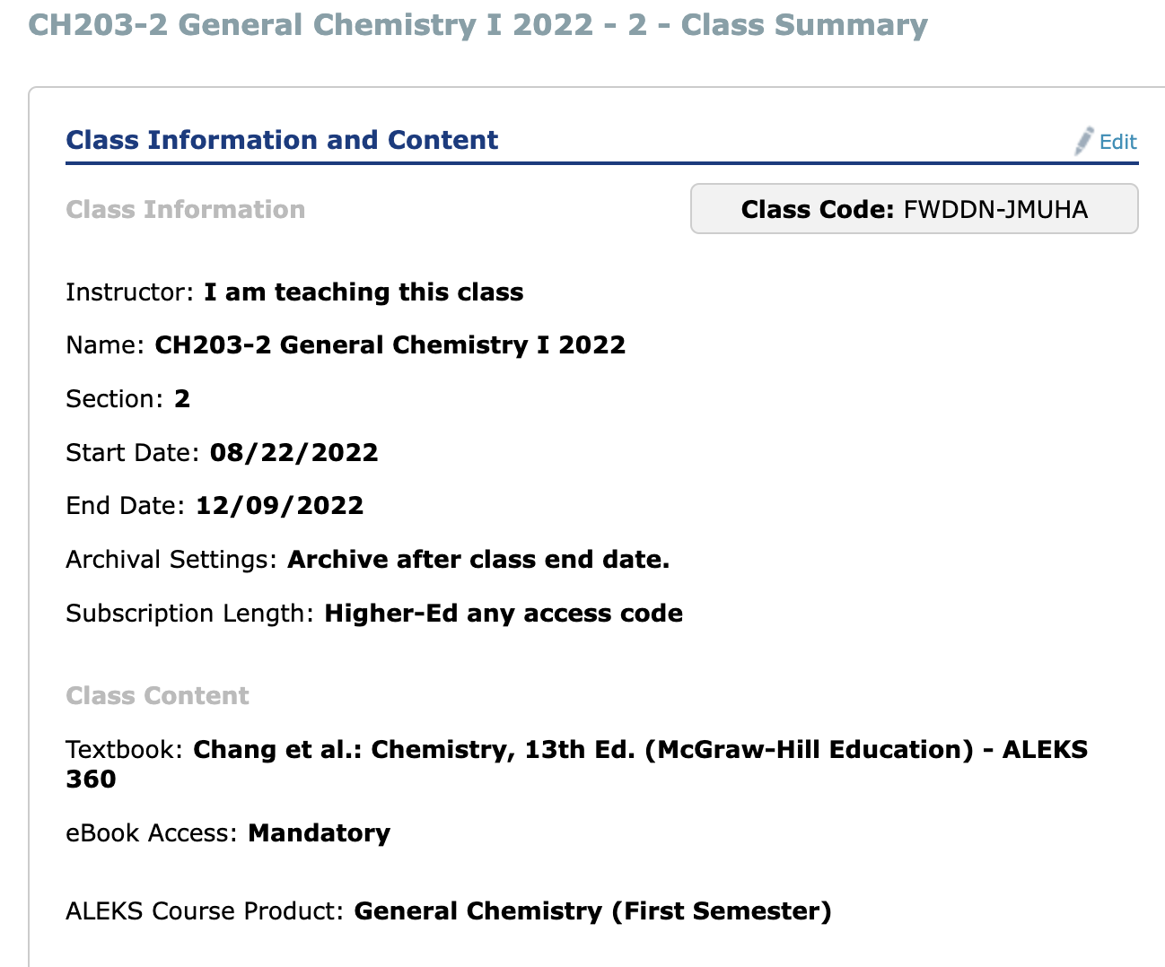

Worksheets: There will be several worksheets handed out this semester. We will work on these worksheets together in class. However, you are encouraged to work in groups or with a tutor to review them well and understand the material covered. Quizzes will be made directly from these questions on the worksheets.
Quizzes: There will be at least one online quiz for every chapter we cover (Chapters 1 through 8). The quizzes will consist of problems directly taken from the worksheets done in-class or similar to the online homework in CONNECT.
Midterm Exams: There will be three midterm exams given this semester. Each will be
worth 100 points and you will be responsible for all lecture material covered up to the exam dates. These exams are tentatively scheduled to be taken on the daters shown in the schedule below. More information about these exams will be given in class.

Cumulative Final Exam:

Thursday December 8th, 2022. Same Room as lecture room. Time: 11AM – 1 PM

7. Course Website:

https://chaminade.instructure.com/courses/11393

Technical Assistance for Canvas Users:
- Search for help on specific topics at help.instructure.com
- Chat live with Canvas Support 24/7/365
- Watch this video to get you started with online guides and tutorials
- Contact the Chaminade IT Helpdesk for technical issues: helpdesk@chaminade.edu, or call (808) 735-4855

8. Tutoring and Writing Services
Chaminade is proud to offer free, one-on-one tutoring and writing assistance to all students. Tutoring and writing help is available on campus at Kōkua `Ike: Center for Student Learning in a variety of subjects (including, but are not limited to: biology, chemistry, math, nursing, English, etc.) from trained Peer and Professional Tutors. Please check Kōkua `Ike’s website (https://chaminade.edu/advising/kokua-ike/) for the latest times, list of drop-in hours, and information on scheduling an appointment. Free online tutoring is also available via Smarthinking. Smarthinking can be accessed 24/7 from your Canvas account. Simply click Account – Notifications – Smarthinking. For more information, please contact Kōkua `Ike at tutoring@chaminade.edu or 808-739-8305.

Assessment

9. Assessment
Extra Credit Online Homework (Ch 1 – 8 via McGraw Hill’s ALEKs. 20pt/ea) 260 Extra Points
Quizzes (10 quizzes, 50 pts each) 500 points
Midterm Exams (3 midterms, 100 pts each) 300 points
Final Exam 140 points
Total 1200 points

10. Grading Scale
Letter grades are given in all courses except those conducted on a credit/no credit basis. Grades are calculated from the student’s daily work, class participation, quizzes, tests, term papers, reports and the final examination. They are interpreted as follows:

GRADE Total Pts PERCENTAGE
A 1080 – 1200 90-100 %
B 960 – 1079 80-89 %
C 780 – 959 65-79 %
D 540 – 779 45-64 %
F below 540 below 45 %

A Outstanding scholarship and an unusual degree of intellectual initiative
B Superior work done in a consistent and intellectual manner
C Average grade indicating a competent grasp of subject matter
D Inferior work of the lowest passing grade, not satisfactory for fulfillment of prerequisite course work
F Failed to grasp the minimum subject matter; no credit given

11. Course Schedule
(The Professor may modify elements of this syllabus according to the operational needs of the class)
DATE | TOPICS AND MODE OF LECTURE
 | Online ALEKs Homework begins on 8/22
8/22 | Course information
8/24 | Pre-Test & Intro to CONNECT (In-Class or Online: Your Choice)
8/26 | Ch. 1: Lecture and Worksheet #1
 | Continue on your own and online the Online ALEKs Homework
8/29 | Ch 1: Working through Problems (In-Class or Online: Your Choice)
8/31 | Quiz #1: Ch 1 (Online in CONNECT)  Ch. 2: Lecture (Online ONLY: No In-Class Session)
9/2 | Ch. 2: Working through Problems (In-Class or Online: Your Choice)
 | Continue on your own and online the Online ALEKs Homework
9/5 | Holiday: Labor Day
9/7 | Quiz #2: Ch 2 (Online in CONNECT)  Ch. 3: Lecture (Online ONLY: No In-Class Session)
9/9 | Ch. 3: Working through Problems (In-Class or Online: Your Choice)
 | Continue on your own and online the Online ALEKs Homework
9/12 | Quiz #3: Ch 3 (Online in CONNECT)  Ch. 4: Lecture (Online ONLY: No In-Class Session)
9/14 | Ch. 4: Working through Problems (In-Class or Online: Your Choice)
9/16 | Ch. 4: Working through Problems (In-Class or Online: Your Choice)
 | Continue on your own and online the Online ALEKs Homework
9/19 | Quiz #4: Ch 4 (Online in CONNECT)
9/21 | Review: Ch 1-4 (In-Class or Online: Your Choice)
9/23 | Review: Ch 1-4 (In-Class or Online: Your Choice)
 | Continue on your own and online the Online ALEKs Homework
9/26 | Midterm Exam I (Chapters 1 – 4) (Online in CONNECT)
9/28 | Ch. 5: Lecture (Online ONLY: No In-Class Session)
9/30 | Ch. 5: Working through Problems (In-Class or Online: Your Choice)
 | Continue on your own and online the Online ALEKs Homework
10/3 | Quiz #5: Ch 5 (Online in CONNECT)
10/5 | Ch. 6 PART 1 OF 2: Lecture (Online ONLY: No In-Class Session)
10/7 | Worksheet #5: Ch 6 Thermo (Part 1 of 2)
 | Continue on your own and online the Online ALEKs Homework
10/10 | Holiday: Discoverers’ Day
10/12 | Quiz #6: Ch 6 (Part 1 of 2) &  Ch. 6: Lecture (Part 2 of 2)
10/14 | Ch. 6: Worksheet (Part 2 of 2)

10/17 | Quiz #7: Ch 6 (Part 2 of 2)
10/19 | Ch. 7 Quantum: Lecture (Part 1 of 2)
10/21 | Ch. 7: Worksheet (Part 1 of 2)
 | Continue on your own and online the Online ALEKs Homework
10/24 | Quiz #8: Chapter 7 (Part 1 of 2)
10/26 | Chapters 5, 6 & 7 (Part 1) Review: Q & A
10/28 | Review Continued: Mock Exam II
 | Continue on your own and online the Online ALEKs Homework
10/31 | Exam II (Chapters 5 – 7 [Part 1])
11/2 | Ch. 7: Lecture (Part 2 of 2)
11/4 | Worksheet (Part 2 of 2)
 | Continue on your own and online the Online ALEKs Homework
11/7 | Quiz #9: Ch 7 (Part 2). Ch 8: Lecture
11/9 | Quiz #9: Ch 7 (Part 2).  Ch 8: Lecture  Worksheet Ch 7 Part 2 (No Worksheet for Ch 8)  Ch. 8: Worksheet.
11/11 | Holiday: Veterans’ Day
 | Continue on your own and online the Online ALEKs Homework
11/14 | Quiz #10: Ch 8
11/16 | Chapters 7 (No need to review Chapter 8): Review: Q & A
11/18 | Chapters 7 (No need to review Chapter 8): Review: Q & A
 | Continue on your own and online the Online ALEKs Homework
11/21 | Exam III (Chapters 7 [Part 2 ONLY. Chapter 8 Omitted)  Nov 23 – Dec 1 (11:59 pm)
11/23 | Exam III Continued online.
11/25 | Holiday: Thanksgiving
 | Continue on your own and online the Online ALEKs Homework
11/28 | Post-Test
11/30 | Course Assessment
12/2 | Open Session: Review for Final Exam
 | Continue on your own and online the Online ALEKs Homework
12/8 | Final Exam 11 AM – 1 PM, Thursday. Location: Lecture Room

12. Alignment of Natural Sciences Courses with Marianist and Hawaiian values of the University.
The Natural Sciences Division provides an integral, quality education: sophisticated integrative course content taught by experienced, dedicated, and well-educated instructors.

- We educate in family spirit – every classroom is an Ohana and you can expect to be respected yet challenged in an environment that is supportive, inclusively by instructors who take the time to personally get to know and care for you.
- We educate for service, justice and peace, since many of the most pressing global issues (climate change, health inequity, poverty, justice) are those which science and technology investigate, establish ethical parameters for, and offer solutions to.
- We educate for adaptation and change. In science and technology, the only constant is change. Data, techniques, technologies, questions, interpretations and ethical landscapes are constantly evolving, and we teach students to thrive on this dynamic uncertainty.

The study of science and technology can be formative, exploring human creativity and potential in the development of technologies and scientific solutions, the opportunity to engage in the stewardship of the natural world, and the opportunity to promote social justice. We provide opportunities to engage with the problems that face Hawai‘i and the Pacific region through the Natural Sciences curriculum, in particular, those centered around severe challenges in health, poverty, environmental resilience, and erosion of traditional culture. The Marianist Educational Values relate to Native Hawaiian ideas of mana, na’auao, ohana, aloha and aina. We intend for our Natural Sciences programs to be culturally-sustaining, rooted in our Hawaiian place, and centered on core values of Maiau, be neat, prepared, careful in all we do; Makawalu, demonstrate foresight and planning; `Ai, sustain mind and body; Pa`a Na`au, learn deeply.

13.1. Late Work Policy
All overdue assignment not completed or anticipated to be late must have approval from the instructor along with a valid excuse.

13.2. Grades of "Incomplete"
Students and instructors may negotiate an incomplete grade when there are specific justifying circumstances. When submitting a grade the “I” will be accompanied by the alternative grade that will automatically be assigned after 90 days. These include IB, IC, ID, and IF. If only an “I” is submitted the default grade is F. The completion of the work, evaluation, and reporting of the final grade is due within 90 days after the end of the semester or term. This limit may not be extended.

13.3. Writing Policy
Plagiarism will not be tolerated and will be checked.
13.4. Instructor and Student Communication
Questions for this course can be emailed to the instructor at jkawakam@chaminade.edu. Online, in-person and phone conferences can be arranged. Response time will take place up to [1-12 hours].
13.5. Cell phones, tablets, and laptops
Music Devices and Cellular Phones: Unless specifically permitted by your instructor, use of music devices and cell phones is prohibited during all Natural Science and Mathematics classes, as it is discourteous and may lead to suspicion of academic misconduct. Students unable to comply will be asked to leave class.

Out of consideration for your classmates, please set your cell phone to silent mode during class. Students are encouraged to bring laptops or tablets to class as the instructor will assign online activities and readings that will require the use of a laptop or tablet. Laptops and tablets should not be misused, such as checking distracting websites. Use your best judgment and respect your classmates and instructor.
Cell phones, tablets, and laptops
Out of consideration for your classmates, please set your cell phone to silent mode during class. Students are encouraged to bring laptops or tablets to class as the instructor will assign online activities and readings that will require the use of a laptop or tablet. Laptops and tablets should not be misused, such as checking distracting websites. Use your best judgment and respect your classmates and instructor.
Disability Access

If you need individual accommodations to meet course outcomes because of a documented disability, please speak with me to discuss your needs as soon as possible so that we can ensure your full participation in class and fair assessment of your work. Students with special needs who meet criteria for the Americans with Disabilities Act (ADA) provisions must provide written documentation of the need for accommodations from the Counseling Center by the end of week three of the class, in order for instructors to plan accordingly. If a student would like to determine if they meet the criteria for accommodations, they should contact the Kōkua ʻIke Coordinator at (808) 739-8305 for further information (ada@chaminade.edu).

Title IX Compliance
Chaminade University of Honolulu recognizes the inherent dignity of all individuals and promotes respect for all people. Sexual misconduct, physical and/or psychological abuse will NOT be tolerated at CUH. If you have been the victim of sexual misconduct, physical and/or psychological abuse, we encourage you to report this matter promptly. As a faculty member, I am interested in promoting a safe and healthy environment, and should I learn of any sexual misconduct, physical and/or psychological abuse, I must report the matter to the Title IX Coordinator. If you or someone you know has been harassed or assaulted, you can find the appropriate resources by visiting Campus Ministry, the Dean of Students Office, the Counseling Center, or the Office for Compliance and Personnel Services.

Attendance Policy
The following attendance policy is from the 2019-2020 Academic Catalog (p. 54-55). Faculty members should also check with their divisions for division-specific guidelines.

Students are expected to attend regularly all courses for which they are registered. Student should notify their instructors when illness or other extenuating circumstances prevents them from attending class and make arrangements to complete missed assignments. Notification may be done by emailing the instructor’s Chaminade email address, calling the instructor’s campus extension, or by leaving a message with the instructor’s division office. It is the instructor’s prerogative to modify deadlines of course requirements accordingly. Any student who stops attending a course without officially withdrawing may receive a failing grade.

Unexcused absences equivalent to more than a week of classes may lead to a grade reduction for the course. Any unexcused absence of two consecutive weeks or more may result in being withdrawn from the course by the instructor, although the instructor is not required to withdraw students in that scenario. Repeated absences put students at risk of failing grades.

Students with disabilities who have obtained accommodations from the Chaminade University of Honolulu ADA Coordinator may be considered for an exception when the accommodation does not materially alter the attainment of the learning outcomes.
Federal regulations require continued attendance for continuing payment of financial aid. When illness or personal reasons necessitate continued absence, the student should communicate first with the instructor to review the options. Anyone who stops attending a course without official withdrawal may receive a failing grade or be withdrawn by the instructor at the instructor’s discretion.

Academic Conduct Policy
From the 2019-2020 Undergraduate Academic Catalog (p. 39):
Any community must have a set of rules and standards of conduct by which it operates. At Chaminade, these standards are outlined so as to reflect both the Catholic, Marianist values of the institution and to honor and respect students as responsible adults. All alleged violations of the community standards are handled through an established student conduct process, outlined in the Student Handbook, and operated within the guidelines set to honor both students’ rights and campus values.

Students should conduct themselves in a manner that reflects the ideals of the University. This includes knowing and respecting the intent of rules, regulations, and/or policies presented in the Student Handbook, and realizing that students are subject to the University’s jurisdiction from the time of their admission until their enrollment has been formally terminated. Please refer to the Student Handbook for more details. A copy of the Student Handbook is available on the Chaminade website.

For further information, please refer to the Student Handbook: https://chaminade.edu/wp-content/uploads/2019/08/NEW-STUDENT-HANDBOOK-19-20-Final-8.20.19.pdf

Credit Hour Policy
The unit of semester credit is defined as university-level credit that is awarded for the completion of coursework. One credit hour reflects the amount of work represented in the intended learning outcomes and verified by evidence of student achievement for those learning outcomes. Each credit hour earned at Chaminade University should result in 37.5 hours of engagement. For example, in a one credit hour traditional face to face course, students spend 50 minutes in class per week for 15 weeks, resulting in a minimum of 12.5 instructional hours for the semester. Students are expected to engage in reading and other assignments outside of class for at least 2 additional hours per week, which equals an additional 25 hours. These two sums result in total student engagement time of 37.5 hours for the course, the total engagement time expected for each one credit course at Chaminade.
The minimum 37.5 hours of engagement per credit hour can be satisfied in fully online, internship, or other specialized courses through several means, including (a) regular online instruction or interaction with the faculty member and fellow students and (b) academic engagement through extensive reading, research, online discussion, online quizzes or exams; instruction, collaborative group work, internships, laboratory work, practica, studio work, and preparation of papers, presentations, or other forms of assessment. This policy is in accordance with federal regulations and regional accrediting agencies.

