COM 310- Intercultural Communication

Chaminade University of Honolulu SYLLABUS

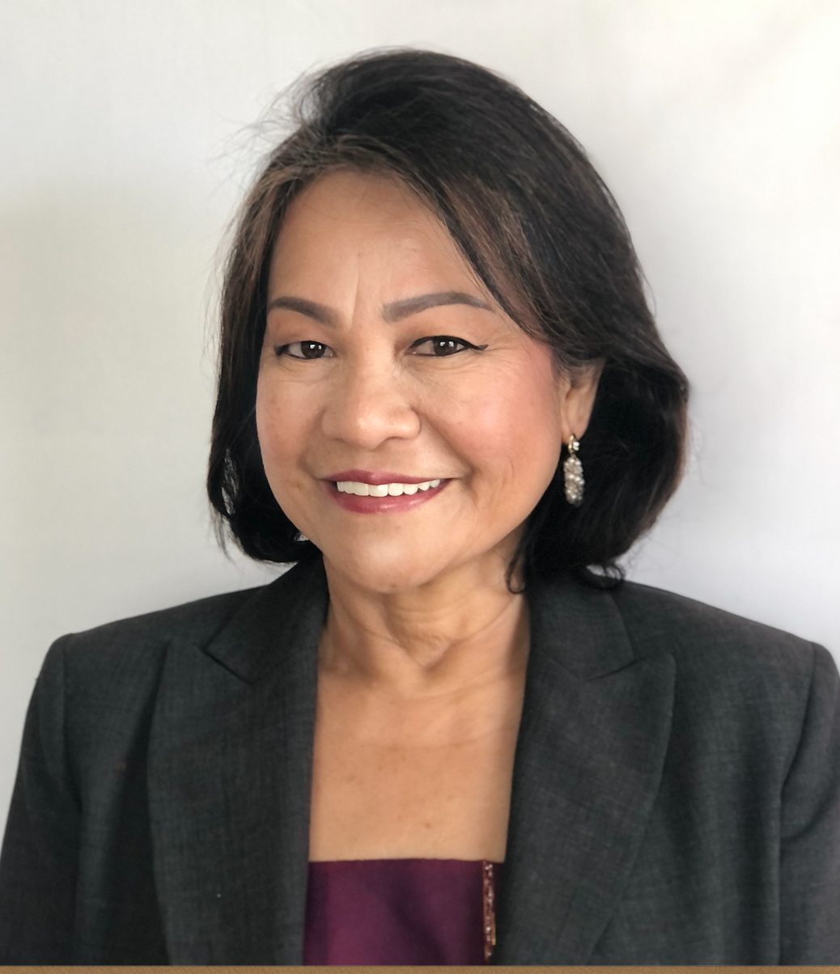

Professor: Dr. Eva Rose B. Washburn-Repollo

BA Speech and Theater Arts
Master of Arts in Literature
Master of Science in Reading
PhD, Education: Curriculum and Pedagogy

Contact: Room Eiben Hall 124 : (808) 735-4874
Email: eva.washburn@chaminade.edu

Class Schedule: COM 310

Email Response: 1-2 days

Texts: Reader taken from…

Samovar, L.A. Porter, R.E. & McDaniel E. R., Roy, C (2017). Communication between Cultures. Belmont, CA: Wadsworth/Thomas Learning. 9th Edition

Other handouts, materials, websites, video and films shared through CANVAS.

COURSE DESCRIPTION

COM 310: Intercultural Communication (3) – Major concepts in the study of communication from various theoretical viewpoints are examined to understand people from different cultural and global backgrounds. Family and community values. Beliefs, expectations. Customs and attitudes of various global and ethnic groups’ communication and symbol systems are studied across cultural boundaries for adaptation, empathy and understanding. Prerequisites COM 101 and EN 102.

GENERAL EDUCATION REQUIREMENTS:

- Education for Integral (Holistic) Education/Global Awareness.

Students will integrate their experience with global awareness in the context of the particular course and field/discipline within a diverse community of learners.

- Education for Adaptation and Change.

Student will evaluate the ways in which adaptation and change are essential to understanding the past, analyzing the present and applying critical thinking to meet future challenges and needs.

COURSE OBJECTIVES

Upon successful completion of COM 310, students should be able to:

1. Understand the meaning of culture through the study of a culture’s values, history, religion, groups and language.
2. Define and analyze cultural practices to understand how people adapt, survive and thrive based on changing gradations of global cultural patterns.
3. Review the basic processes, principles and definitions of basic communication as it relates to culture in different scenarios and events.
4. Understand the dimensions of micro (family, teams, sub-cultures, blended families, digital groups) and macro cultures (patterns of relationships, nonverbal/verbal communication, business, education, health and religious practices and beliefs).
5. Recognize and explain barriers to communicating inter-culturally with others
6. Articulate empathy and other solutions to change and improve intercultural communication competence.

Alignment of GEN ED Learning Outcomes

 | Education for Integral (Holistic) Education/Global Awareness. | Education for Adaptation and Change.
Marianist Values | 1,2 & 3 | 4, 5 & 6

Course Prerequisites: Eng 101, COM 101

Module # | Assignment Title
Module 1 | Course Completion Plan
Module 1 | - Course Schedule Assignment,  - Getting to Know you and  - Open Discussion on Wednesday
Module 2 | - Meaning of Culture, Cultural Elements and Practices Assignment Chapter 1 & 2  - Open discussion on Wednesday
Module 3 & 4 | - Cultural Patterns Chapter 6  - Open Discussion on Wednesday  - Project 2 Submission
Module 5 | - Chapter 11  - Community of Practice  - Slides 1-3  - Review on Wednesday  - Mid-Term
Module 6 & 7 | - Project 2 (Slides 4-8)
Module 8 & 9 | - Project 2 (Slides (9-10 to 12)  - Open Discussion Wednesday for Final Report  Final Report (Just the Language Slide)  - Community of Practice  - Final Exam

COURSE POLICIES

- Technology in the classroom. COM 310 and all related documents/assignments and exams will be delivered through CANVAS found in the Chaminade Portal.

- Schedule meetings and conference to meet virtually or via email.

Contact Information: Dr. Eva Rose B. Washburn-Repollo
Office Phone : 808-735-4874
Email: eva.washburn@chaminade.edu

Email Use and Feedback. Your emails will be responded to within 2 to 3 days from receipt. Exams will be conducted on CANVAS and grades will be uploaded within the week. Feedback on drafts and assignments will be sent through the CANVAS feedback box.

Zoom Meetings/Classes. Invitations will be emailed and announced through the CANVAS modules set ahead of time. Please check your email regularly for announcements. Please respond with a confirmation that you received the invitation.

Technical Assistance for Canvas Users:

- Search for help on specific topics or get tips in Canvas Students
- Live chat with Canvas Support for students
- Canvas Support Hotline for students: +1-833-209-6111
- Watch this video to get you started
- Online tutorials: click on “Students” role to access tutorials
- Contact the Chaminade IT Helpdesk for technical issues: helpdesk@chaminade.edu or call (808) 735-4855

A few reminders when attending class via ZOOM:

- Choose a quiet place in your home/dorm where you have privacy.
- Be ready to attend class 5 minutes before the virtual meeting begins.
- Mute your microphone until the hosts begins the class.
- Have your pens, notebooks, textbooks and study table ready for notetaking.

- Attendance. Regular work based on your proposed schedule in this class is graded. This includes prompt submission of homework, exams and online class discussions. Delayed responses and submissions will adversely affect completion in accordance with your planned schedule.

  - Students involved in athletics and/or military deployment should communicate ahead of time through email or a phone call with instructor, if possible, to make alternate arrangements.
  - It is the student’s, not the instructor’s, responsibility to catch up after missed class days
  - It is important to respond and submit work for class at the scheduled time to assist you towards your success in the FLEX program.

* Participation as Attendance: Your promptness and active participation in class discussion and exercises are expected. I will keep track of your class contributions and keep your participation points. Involvement in class activities, completing your reading assignments and participating in discussions are essential to processing the material and ideas presented in this course. A positive attitude and respect for differences should guide all our interactions.

- Readings and written assignments: Class discussions and activities are based on assigned readings/video/research articles. Assigned material must be read before the module for which it is assigned. Log in with your usual Chaminade password. Find Course List and choose your section in COM 310. All homework should be submitted on time through CANVAS.

- All written assignments should follow the assigned format and MUST be typed. Written work that contains excessive typographical and grammatical errors is subject to grade penalty. Students should keep a copy of all written work submitted.

- NO Late assignments: Students must turn in assignments and take the tests on time. If a student misses an assignment for a documented reason (see item 2 above), the student may be permitted to make up the assignment at a later date (time permitting), within the FLEX guidelines.

- Plagiarism: All assignments should be original work done by the student for this class. Use of work that is not credited to the original source, or use of someone else’s speech or written material is a serious academic offence and will not be tolerated. Communication Department policy requires that, on first offence, plagiarized assignments will be given a grade of zero and one full letter will reduce the student’s final course grade. A second offence will result in automatic failure of the class. Refer to the Chained Student Handbook (p.91) for the complete university policy regarding plagiarism and academic honesty.
- Disability Access

If you need individual accommodations to meet course outcomes because of a documented disability, please speak with me to discuss your needs as soon as possible so that we can ensure your full participation in class and fair assessment of your work. Students with special needs who meet criteria for the Americans with Disabilities Act (ADA) provisions must provide written documentation of the need for accommodations from the Counseling Center by the end of week three of the class, in order for instructors to plan accordingly. If a student would like to determine if they meet the criteria for accommodations, they should contact the Kōkua ʻIke Coordinator at (808) 739-8305 for further information (ada@chaminade.edu).

Title IX Compliance
Chaminade University of Honolulu recognizes the inherent dignity of all individuals and promotes respect for all people. Sexual misconduct, physical and/or psychological abuse will NOT be tolerated at CUH. If you have been the victim of sexual misconduct, physical and/or psychological abuse, we encourage you to report this matter promptly. As a faculty member, I am interested in promoting a safe and healthy environment, and should I learn of any sexual misconduct, physical and/or psychological abuse, I must report the matter to the Title IX Coordinator. If you or someone you know has been harassed or assaulted, you can find the appropriate resources by visiting Campus Ministry, the Dean of Students Office, the Counseling Center, or the Office for Compliance and Personnel Services.

- Marianist and Pacific Hawaiian Values: Native Hawaiian Values

Education is an integral value in both Marianist and Native Hawaiian culture. Both recognize the transformative effect of a well-rounded, value-centered education on society, particularly in seeking justice for the marginalized, the forgotten, and the oppressed, always with an eye toward God (Ke Akua). This is reflected in the ‘Olelo No’eau (Hawaiian proverbs) and Marianist core beliefs:
- Educate for Formation in Faith (Mana) E ola au i ke akua (ʻŌlelo Noʻeau 364) May I live by God
- Provide an Integral, Quality Education (Na’auao) Lawe i ka maʻalea a kūʻonoʻono (ʻŌlelo Noʻeau 1957) Acquire skill and make it deep
- Educate in Family Spirit (‘Ohana) ʻIke aku, ʻike mai, kōkua aku kōkua mai; pela iho la ka nohana ʻohana (‘Ōlelo Noʻeau 1200) Recognize others, be recognized, help others, be helped; such is a family relationship
- Educate for Service, Justice and Peace (Aloha) Ka lama kū o ka noʻeau (ʻŌlelo Noʻeau 1430) Education is the standing torch of wisdom
- Educate for Adaptation and Change (Aina) ʻAʻohe pau ka ‘ike i ka hālau hoʻokahi (ʻŌlelo Noʻeau 203) All knowledge is not taught in the same school

Below is a quick table guide to Project 1 and 2 requirements:

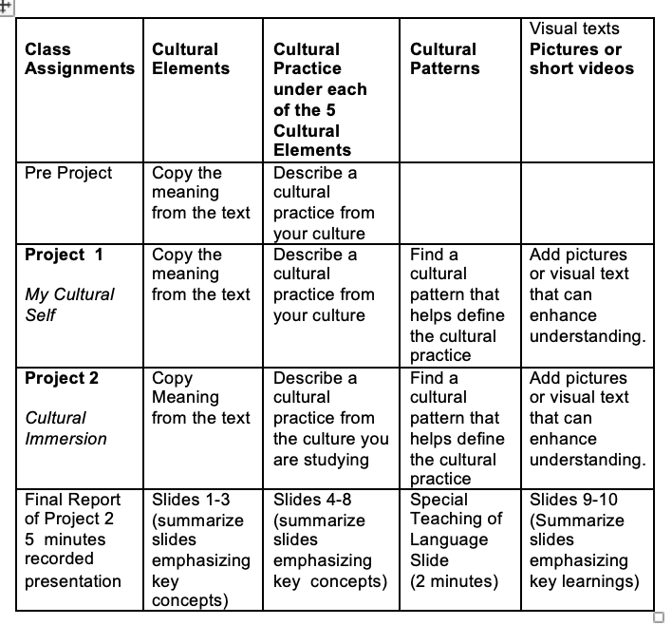

Class Projects: Project 1 & 2 and 1 Final Presentation of Project 2

- Project I: My Cultural Self
(First four modules)

Objective: To better comprehend the world around us requires understanding of our own values and belief systems that we bring to our school and professional group interactions. We will find creative text to present our amazing cultures.
Requirements:
- Readings: Chapter 1, 2 & 6.
- Two pages. Analysis of cultural practices using Cultural patterns (3) interpretation.
speak. Explain the elements found in your experiences using CULTURAL PATTERNS or theoretical concepts from Chapter 2 and 6.

Five Elements of Culture

Submission Format

Cultural Elements textbook Definition (5)  Describe details on these are these learned, practiced and communicated. | Cultural Patterns (5)  Chapter 6 concepts (textbook) Apply and explain your communicated practices. | Describe ideas/Symbols and Images: Creative images/messages that express your culture.
Language
Religion
History
Social Organization
Values

- Project II (Next 4 modules)

Final Project: Cultural Immersion Visits (10-12 Google Slides)
I. The Overview.
Developing empathy requires a deeper immersion into other cultures. We approach with an open mind and a respectful viewpoint to understand, adapt and change to achieve cultural competence. Use the cultural theoretical frames we have studied from the text to analyze the cultural practices that you observe. At the end share your experience in order for the class to increase cultural competency.
Establish the cultural interest (could be an issue, a curiosity, a difference) that you want to observe/interview. One Page. Use these questions as your guide:
1. What is the research reason that you chose this culture? or What makes this culture different from yours? Why are you interested in it? (Since we know that there are five cultural elements that overlap in practice, you may want to focus on something so different from your own to explore and know more about).
2. What is the issue you are researching on?
3. How will you access this culture?
a. When are you going to visit?
b. Who will be your cultural ally? (You can send an email introduction, call or do a pre-visit to ask if there is anyone who might be able to help you with scheduling a time to observe, witness or participate in an event. Check the local Midweek, newspapers and other social media outlets for cultural events that you might be able to visit. Recurrent events occurring in churches, restaurants, museums. art galleries are easy and open to the public.)
II. First Set. Slides 1-3.
Slide 1- Overview
Slide 2- Theoretical Frame
Slide 3- Cultural Ally, Schedule of Visits
III. Second Set. Slides 4-8.
Slide 4-8. Cultural Elements (History, Language, Values, Social Organization, Religion) and the corresponding cultural practices you gathered from your journal.
Submit to CANVAS Slides 4-8 and Journal 2. Include date, time and place.
Rubric for Cultural Elements:
III. Writing it all up. Final Submission. (10 to 12 Slides on Google Slides or Powerpoint)
CHECKLIST:
I. Overview (You can improve this as you go along.) Why did I choose this culture?
II. Theoretical Frame. Use textbook concepts and review and include data different studies, write ups, blogs or documentaries to determine the importance of your study. Use at least 3.
III. Cultural Ally and Schedule of Visits
IV-VIII. Five Elements. Discuss the practices of this culture based on the 5 elements of culture that we learned throughout the semester. Our textbook is your primary resource. Under language, list and define 10 words or phrases that are often used in this culture in the context of the research questions. Add pronunciation syllabication or links to audio references if possible. Include only words or phrases that are relevant to your specific study.
IX. What did I Learn that I can share with others? Include Pictures (Pictures can also be inserted according to the cultural element it may belong to.)
X. What did I Learn that I can share with others? How did this develop your ability to adapt and improve your cultural competence? Define and apply at least 3 concepts. Include what you learned that might help other people who do not belong to this culture avoid/prevent cultural conflict. (Use cultural patterns, differences and competencies in your 9th and 10th slide.)

NOTE: Grading on the Overview , Initial Slide submissions and the final submission of the content in 10 Google slides will focus on clarity, definition, data of actual visits, application of concepts used in class and discussion of how your visit enhance cultural competence. Read the articles uploaded here before your visits to understand Ethnography, How to Interview and How to Observe.

@Project II a

Final Report of Project 2 with a focus on Language

Objective: To create a recorded video presentation of the Cultural Element of LANGUAGE
Use at least 10 new lines from the culture you immersed in other than your own, perform or share the sound of the language according to the context of the communicative events these lines are used on based on your cultural immersion.

- Grading:

Graded Activities | Possible Points | Percentage
Assignments | 100 | 15%
Midterm/Finals | 150 | 20%
Project 1 Who Am I? | 100 | 15%
Project 2 Cultural Immersion | 150 | 25%
Final Presentation Project 2aLanguages and Values Performance | 50 | 15%
Communities of Practice | 50 | 10%
TOTAL | 650 | 100%

