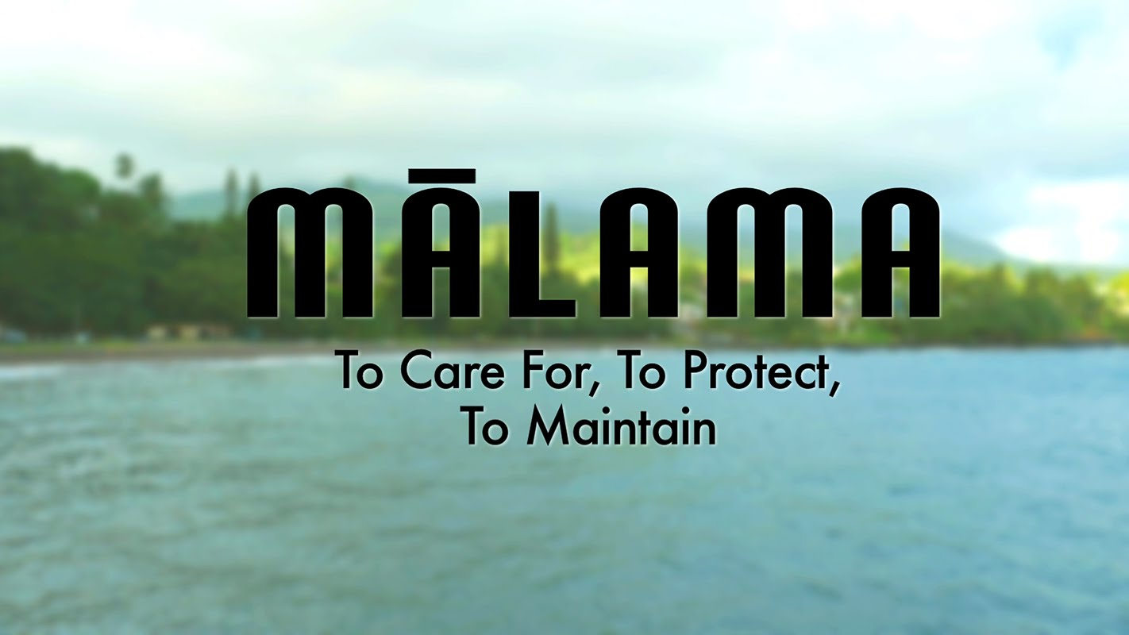
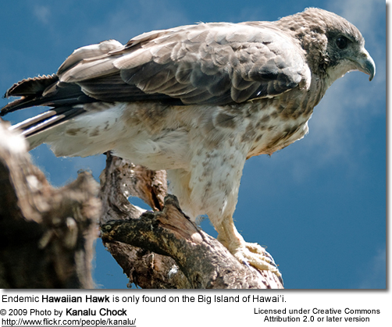
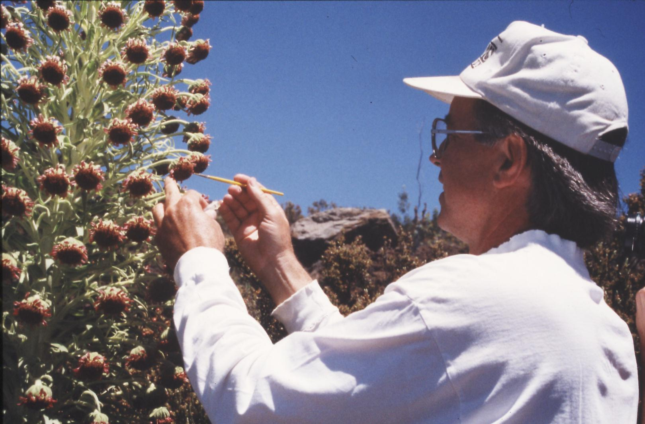

ENV 201 & 201L: Conservation Biology & Ecology Lecture and Laboratory
Fall 2022
Dr. Gail Grabowsky

Syllabus

The Earth’s resources are also being plundered because of short-sighted approaches to the economy, commerce and production. The loss of forests and woodlands entails the loss of species which may constitute extremely important resources in the future, not only for food but also for curing disease and other uses…. It is not enough, however, to think of different species merely as potential “resources” to be exploited, while overlooking the fact that they have value in themselves. Each year sees the disappearance of thousands of plant and animal species which we will never know, which our children will never see, because they have been lost forever.
Pope Francis, Laudato Si 2015

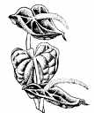
A worldview does not dissolve overnight. Rather, like one of Hutton’s mountain ranges, it erodes through long centuries.
Lorien Eisley

Few will have the greatness to bend history itself; but each of us can work to change a small portion of events, and in the total of all those acts will be written the history of this generation.
Robert F. Kennedy

A thing s right if it tends to preserve the integrity, stability and beauty of the biotic community. It is wrong if it tends to do otherwise.
Aldo Leopold

Change your thoughts and you change the world.
Norman Vincent Peale

The scientific community is no private club. In principle, and in its best and broadest sense of the words, scientific inquiry can be undertaken by anyone on almost any subject matter.
W. Quine and J. Ullian
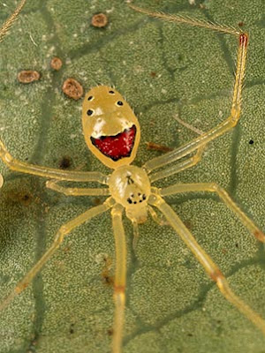

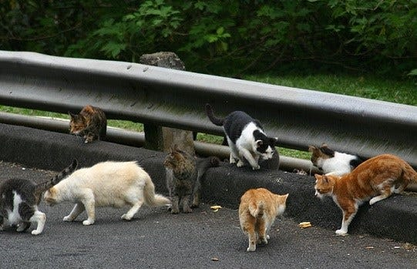
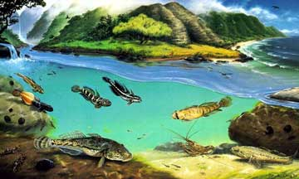
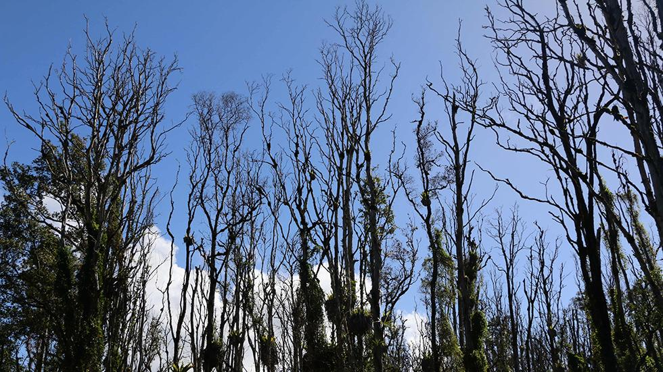
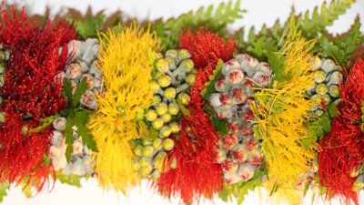

Department Name: Environmental Program
School Name: School of Natural Sciences and Mathematics
Course Credits: 3/1
Class Meeting Days: Lecture: TTh 1:00-2:20 Class Location: Henry Hall 225
Class Meeting Days: Lab: M 2:30-5:20 Class Location: HL4 and OUTSIDE

Instructor: Dr. Gail Grabowsky
E-mail address: ggrabows@chaminade.edu
Phone: 735-4834 (ext. 834); cell 808-387-9319 (you may text anytime!)
Office Location: Wesselkamper Science Center, room 105
Office hours: Tuesday-Friday 4:00-6:00 PM; Or by appointment (Zoom or in person)
Dr Gail’s Zoom Link: https://chaminade.zoom.us/j/2916035174
Course Canvas Website: Lecture and Lab are in the same Canvas folder HERE. (This is because they
compliment one another throughout the course.)
Google Drive Folder: HERE!

University Course Catalog Descriptions:
ENV 201 Conservation Biology & Ecology
An introduction to conservation biology issues and goals and the principles of ecology. The course includes consideration of the impacts of human activity on ecosystems and our efforts to ameliorate destructive impacts and devise sustainable solutions. Major topics include the effects of industrialization, agriculture, pollution, species introduction and human population growth and development on the health and future sustainability of ecosystems and humans alike. Particular emphasis is placed on island ecosystems. Course must be taken concurrently with ENV 201L.

ENV 201L Conservation Biology & Ecology Laboratory
Students perform laboratory and field research techniques used in conducting conservation biology and ecological research and restoration. Analyses are conducted in the laboratory and in the field. Course must be taken concurrently with ENV 201.

Course Overview and Introduction:
Welcome to Conservation Biology & Ecology. I really enjoy teaching/facilitating this class because it comes from the heart (and the mind) as I am, like many of you, concerned for the current and future environment. This course mainly focuses on the condition of earth’s terrestrial (land) ecosystems: what threatens them and why and how to keep them healthy or return them to a healthier state once they are degraded. I feel this class is not simply a course you take in college, it changes the lives of most who take it, as it introduces you to and helps you understand the causes and consequences of the real-world environmental issues we confront every day (or every time we take a sip of water…). If you are an Environmental Studies or Environmental Science major/minor OR a student with another major(s): WELCOME!
One thing I want all of us to realize through this course is that science is NOT a “sacred cow.” It is a very useful tool, but it is not in itself infallible or the only component of solutions to our environmental and ecological challenges. We also must consider the people involved, their values and beliefs, their economics, politics, history, culture, needs, desires, etc in order to solve any environmental problem. Also while the science we do helps us gather information about a phenomenon or determine how to behave in order to change a situation, it does not tell us what is better or worse, right or wrong, what we should or should not do. Because of the complexity of environmental issues and the fact that science is only one of the players involved in learning about and solving environmental issues, we will have to touch on those other factors in this science course as well.

Marianist Values
This class represents one component of your education at Chaminade University of Honolulu. An education in the Marianist Tradition is marked by five principles and you should take every opportunity possible to reflect upon the role of these characteristics in your education and development:
- Education for formation in faith
- Provide an integral, quality education
- Educate in family spirit
- Educate for service, justice and peace
- Educate for adaptation and change

Native Hawaiian Values
Education is an integral value in both Marianist and Native Hawaiian culture. Both recognize the transformative effect of a well-rounded, value-centered education on society, particularly in seeking justice for the marginalized, the forgotten, and the oppressed, always with an eye toward God (Ke Akua). This is reflected in the ‘Olelo No’eau (Hawaiian proverbs) and Marianist core beliefs:
- Educate for Formation in Faith (Mana) E ola au i ke akua (ʻŌlelo Noʻeau 364) May I live by God
- Provide an Integral, Quality Education (Na’auao) Lawe i ka maʻalea a kūʻonoʻono (ʻŌlelo Noʻeau 1957) Acquire skill and make it deep
- Educate in Family Spirit (‘Ohana) ʻIke aku, ʻike mai, kōkua aku kōkua mai; pela iho la ka nohana ʻohana (‘Ōlelo Noʻeau 1200) Recognize others, be recognized, help others, be helped; such is a family relationship
- Educate for Service, Justice and Peace (Aloha) Ka lama kū o ka noʻeau (ʻŌlelo Noʻeau 1430) Education is the standing torch of wisdom
- Educate for Adaptation and Change (Aina) ʻAʻohe pau ka ‘ike i ka hālau hoʻokahi (ʻŌlelo Noʻeau 203) All knowledge is not taught in the same school

What this course counts for:
This course is required for Environmental Studies and Environmental Science majors and minors. It also counts for your Natural Science general education requirement if you are a junior or senior and for your Quantitative Reasoning requirement if you are a sophomore or freshmen and under our new General Education Program. If you are an Environmental major the table below shows you how this course helps you achieve the Program Learning Outcomes for Environmental Studies and Environmental Science and at what level of proficiency. Some of the Learning Outcomes are shared between Programs but not all! NOTE: If you are not an ENV major think about it! Environmental Studies is not a large major and it goes well with many other majors: BU + ENV, COM + ENV, ED + ENV, CJ = ENV, etc!!!!!

Upon completion of the undergraduate B.S. program in Environmental Studies, students will be able to:
Environmental Studies Program Learning Outcomes | ENV 201/L
Authenticate their commitment to service, justice and peace through experiential project-based
activities that enhance the condition of the integral ecology, care for creation and value all voices.
Apply analytical methods and skills from multiple disciplines to environmental problems.
Participate in, plan and execute environmental change-making strategies that employ scientific,
political, socio-cultural, artistic, educational and economic skills and knowledge.
Design and describe new futures and ideas that solve environmental problems and foster
sustainability.
Pursue throughout their education the ever-changing knowledge and skills that prepare them for
the adaptation and change essential to environmental problem solving.

Upon completion of the undergraduate B.S. program in Environmental Science, students will be able to:
Environmental Science Program Learning Outcomes | ENV 201/L
Authenticate their commitment to service, justice and peace through experiential project-based
activities that enhance the condition of the integral ecology, care for creation and value all voices.
Apply scientific reasoning and methodology to environmental problems.
Identify the major physical, chemical and biological components, interactions and cycles of earth
systems and ecosystems.
Propose, design and participate in scientific research projects that document, describe and/or
help solve environmental problems and foster sustainability.
Pursue throughout their education the ever-changing knowledge and skills that prepare them for
the adaptation and change essential to environmental problem solving.
Introduces to the concept or skill
Develops the concept or skill
Gains mastery of the concept or skill

The COURSE Learning outcomes for the lecture and lab are the following:
Lecture: When you complete this course you will be able to:
- Summarize what science is and how scientific research is conducted and shared with others
- Outline the role of science in enabling us to understand and problem-solve environmental phenomena
- Explain the role of ethics in allowing us to define environmental problems and solutions
- Describe the major physical causes of habitat/ecosystem degradation and destruction
- Relate a number of potential solutions for global and Pacific Island habitat/ecosystem degradation and destruction
- Give examples of the basic structure and types of fresh water and terrestrial ecosystems
- Categorize the generalized sorts of interactions between organisms and their environment
- Define what a healthy ecosystem is and what sustainability means in general
- Explain the historic reasons why human population growth occurred and what its future implications are for ourselves and other species
- Show the connections between academic work and real-life situations

Lab: When you complete this course you will be able to:
- Articulate the scientific method and how to apply it to real environmental issues
- Recall what descriptive science is and how it is important in environmental biology
- Memorize the basic units used in making scientific measurements
- Recite the taxonomic hierarchy and describe the systematic biology methodology and the species concept
- Differentiate between species abundance and distribution
- List some of the measures used to determine ecological stress
- Interpret and create graphs, tables and maps
- Express the importance of, and know how to access and read, the primary scientific literature
- Formulate a hypothesis and design a scientific experiment to test it
- Prepare a formal laboratory write-up

Required Texts: An Introduction to Conservation Biology. 2016. [ISBN: 9781605354736]

Supplemental Texts: Many other articles, reports and exercises will come from other sources. All of them will be provided to you in Google Drive in the course folder.

Course Website: We will be using a shared Google Drive folder for this course located here: https://drive.google.com/drive/folders/1fVjlJT7S3IdpS0FkIsCv0TQasPMiHMLk?usp=sharing

Grading & Assessment:
Lecture grading will be quantified as follows:
Exam I and II and Final Exam (20% each) 60% 600 pts

Habitat Type Project - Group Presentation 20% 200 pts
15 hours of Service Learning + Survey, Photo & Discussion 20% 200 pts
100% 1000 pts
Lab grading will be quantified as follows:
Lab assignments, worksheets, info shares 50% 500 pts
Formal Lab Write-Up 20% 200 pts
Hypothetical Experiment Write-Up 20% 200 pts
Attendance 10% 100 pts
100% 1000 pts
Letter grades are interpreted as follows:
A = Outstanding scholarship and an unusual degree of intellectual initiative
B = Superior work done in a consistent and intellectual manner
C = Average grade indicating a competent grasp of subject matter
D = Inferior work of the lowest passing grade, not satisfactory for fulfillment of prerequisite course work
F = Failed to grasp the minimum subject matter; no credit given

Grading procedures and the components of your grade:
Lecture grades will be determined in part by written exams using a curve with the mean score for the class being a B- and the score immediately below the mean being a C+. This will be explained in detail in class. The lecture exams will cover the material from the start of class up until the first exam and the material after the first exam up until the second Exam. These exams will have a variety of types of questions on them. The final exam is cumulative, multiple choice and covers the lecture material for the entire semester. A review sheet will be handed out before every exam.
The details surrounding the lecture presentations and service learning assignment will be explained in class and via handouts. The factors that determine your particular grade for the presentation and your service learning will also be explained in a grading rubric handout.
Lab grades for oral and written lab assignments and worksheets will be determined based on your effort, correctness (when there is a correct response etc.) and your thoughtfulness. Effort in general manifests itself as neatness, completeness, thoroughness, calories expended per unit time(!), timeliness, correct spelling, any extra creative things you do above-and-beyond what is expected, etc. Correctness means do your statements jive with corresponding scientific knowledge, do your conclusions follow from the evidence before you, did you calculate an equation correctly, interpret a graph accurately, make a table that illustrates your data properly, etc. Thoughtfulness can show up in many ways, perhaps you really think things through, trying to consider all the variables or you worked hard to tie pieces of evidence together, maybe you consider something that may be important that everyone else ignores. By being “thoughtful” I don’t mean that you look out for other people (i.e. are kind) I mean that you have done some thinking, really reflected upon a topic, have given it some time, have analyzed it, etc. thoroughly.

Service Learning Requirement:

You will need to participate in 15 hours of service-learning work throughout the semester that aims to help Hawaii and the Pacific islands achieve the United Nations Sustainable Development Goals (SDG) and is officially tied to Chaminade’s new United Nations CIFAL Honolulu training center. This year you have two opportunities to choose from. You may commit to just one of them or participate in both! (NOTE: any other service activities that you participate in that relate to the class will be counted as extra credit and the details are described below). The two UN CIFAL Honolulu SDG service projects are:

- Helping out with Chaminade’s Compassionate Care and Reduction Project. Here is the link to the Project Google Drive folder!
- Help sleuth out what sustainability efforts are going on at a Pacific island of your choice as part of our Spaghetti Diagram Describing Sustainability Efforts in the Pacific project!

Attendance and your grade:
While I dearly hope that you can make every class…, since you are adults now, you are free to miss any lecture class you choose… but KNOW that there may be some consequences should you choose to exercise this option: your grade could (and most likely WILL) suffer. I believe that students who have missed a lot of classes ALWAYS would have done better if they had not missed classes. There simply is no substitute for being in class when it comes to understanding the material. I can give you a fishing pole, but I cannot make you fish.
If you miss a lecture exam or lab your absence must be excused if it is not to formally effect your grade. Excused absences occur when you bring in a doctor’s note, a funeral announcement for a family member, notice of participation in athletic events, etc. Unexcused absences occur when you were working, surfing, sleeping, cramming for an exam in another class, etc. I am a scientist; I require hard evidence if an absence is to be excused. If your car breaks down on the way to an exam or lab take a picture and make SURE I can verify the date and time of the breakdown and it will be an excused absence, ☺, however, no evidence; no excused absence.

Extra Credit Options:
Throughout the course I will make environmental service-learning outings available to you when I am made aware of them. You may also find environmental service opportunities on your own. Once you have finished your 8-hours of mandatory service, any extra service earns you extra credit! For every service-learning activity that you participate in (after you complete your 8-hours) that entails 4-5 hours of work, you will receive +5 extra credit points.
Also, periodically throughout the course there will be livestream talks and webinars you may attend that pertain to the course material. You can earn +2 extra credit points towards a lecture exam for each talk you e-attend with content related to the course content. In order for all talks and service activities to count for extra credit you MUST have them approved by Dr. Gail PRIOR TO the event and you MUST document your presence with a photograph of yourself participating or some other kind of evidence. You may earn up to 30 extra credit points from service activities, testimonies and/or attending talks/presentations.

Classroom Atmosphere:
Specific to Dr. Gail’s classes: Guys, I value a very open, yet courteous class atmosphere. Express your thoughts! Ask your questions! (The only dumb question is the one in which you ask yourself if you should ask your question.) Respect the thoughts and ideas and opinions of others – really think about what others say. Let them express themselves fully, then you do the same. The thing I value most from my college days are all the wonderful, valuable, diverse ways of looking at and understanding the world that I was exposed to by my fellow students and my professors. Be an open vessel – take ideas in! You will learn as much from each other as you do from me.

This syllabus and course schedule are living documents: they are free to change. I try to adhere as closely as possible to them for your convenience, but there will be times in which we will take longer on a particular topic or add or delete a topic to enhance the course. I like to be able to react to you as the course proceeds and go with the flow a bit in order to make the course experience sort of custom fit to you!

You are responsible for all of the information in this document: losing it or not reading it do not make you exempt from knowing what’s in it!

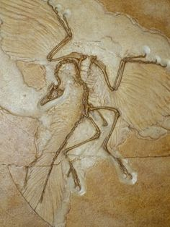
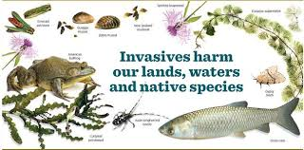
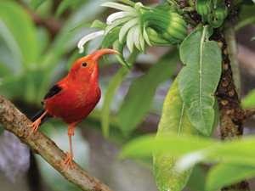

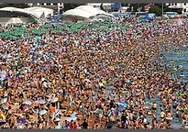

Class Schedule:

Fall 2022

Part I
Knowledge, Ethics & the Environment in General

WEEK TOPIC ACTIVITIES
1 Course intro; Survey; Who we are; Course path; Review course syllabi; questionnaire
Lab 1: Video: “Endangered Planet” and Watch it here & Canvas Discussion after

Your favorite natural places photo upload; Upload a photo of nature you here by 8/29
Important terms & concepts; UN SDG’s Read: “Human Domination…” here
General human effect on the environment intro

2 Lab 2: Survey of issues that concern us Share a terrestrial enviro issue; Review photos
General human effect on the environment: QUIZ on “Human Domination” on 8/30! Land Transformation; Oceans

3 Monday is LABOR DAY!
Lab 3: Indigenous Knowledge Lab (on your own!) Upload completed worksheet to Drive here!
Alteration of biogeochemical cycles
Alteration of biogeochemical cycles (cont’d) Read: “Living Planet Report 2020”

4 Lab 4: Metric Measure & Gathering Data: Handouts and Worksheets
Biotic change and species loss QUIZ on “Living Planet Report 2020”
“Human Domination” paper wrap-up Skim: “A Safe Operating Space for Humanity
Boundaries we may have overstepped already… Read: “The Philosophy of Science”

5 Lab 5: Value Lab Worksheet and bring something to value!
What is science? Underlying philosophy & methods QUIZ on “The Philosophy of Science”
Science, traditional knowledge and ecological ethics Read/Review: Textbook chapter 1
What is Conservation Biology? Hypothetical Experiment Hypothesis explained!

Part II
Pristine Nature: Biodiversity and Ecology

WEEK TOPIC ACTIVITIES
6 Lab 6: Biological Diversity I & Classification Worksheet, Camanicules & Gallery Walk
The history of life on earth Read/Review: Textbook chapter 2
The characteristics and requirements of life History of Life Power Point by Dr. Gail
E X A M I scheduled for 9/27 E X A M I scheduled for 9/27

7 Lab 7: Biological Diversity II Fieldtrip to the Zoo! Zoo Biodiv Photo Contest!
Life: Unity and diversity and their implications... Read/Review: Textbook chapter 3
Evolution: Evidence Evidence of Evolution Power Point by Dr. G.
Evolution: Patterns Hypotheses Due on 10/6!

8 Lab 8: Life Expectancy & Fertility Rate Lab Online Worksheet; Add your family’s data!
Evolution: Mechanisms Read/Review: Textbook chapter 6
Evolution: Speciation & Extinction

9 NO LAB MEETING!
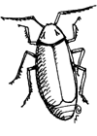
Lab 9: Eco Footprint Calculation (on your own!) Handout; Done online on your own time!
Human historical place in nature; World Pop Clock Habitat Type Presentation Explained
Ecological principles; causal networks Revised Hypotheses due by 10/21!

10 Lab 10: Island species: Native and invasive species St. Louis Hike; Worksheet
Abiotic & Biotic ecological interactions
Ecological productivity; Ecosystems Read/Review: Textbook chapter 4

11 Lab 11: Habitat Presentations Habitat Type Oral Presentations
Formal Lab Description Day! (Don’t miss it!) Your Formal Lab uses Makapu’u or Mask data!
Soil; Earth’s habitats & systems
Ecology wrap-up

Part III

Island Populations and Challenges

WEEK TOPIC ACTIVITIES
12 Lab 12: Quantifying habitat variation in the field Fieldtrip to Makapu’u; Graph worksheet
Pacific peoples and their island homes Read/Review: Textbook chapter 5
Islands: Why each is unique & things they all share… Island Types Power Point by Dr. Gail
Islands: Types, geology, climate and dispersal

13 Lab 13: Formal Lab Help Day! (Don’t miss it!) Bring Makapu’u data in Excel table!
Islands: Endemism and adaptive radiations Adaptive Radiation Power Point
Islands: Invasive species & extinctions Read/Review: Textbook chapter 7
E X A M II scheduled for 11/15 E X A M II scheduled for 11/15

Part IV

Restoring Biodiversity & Living Sustainably on Island Earth

WEEK TOPIC ACTIVITIES
14 Lab 14: IDing Birdsong in a Hawaiian Forest & Worksheet; Awards for those who ID first!
Island Earth: Island vs global threats Read/Review: Textbook chapter 8 & 9
Natural resource management
Protected areas; Ecological restoration Read: “Mind in the Biosphere; Mind of the…”

15 Lab 15: Endangered species/restored sites solutions Worksheet and photo upload!
UN Devel Goals & Conservation: Link here QUIZ on “Mind in the Biosphere;…” on 11/29!
Conservation answers for Hawaii
Your Conservation Fixes Read/Review: Textbook chapter 10

Important Dates You Should Know:
- Our FINAL EXAM will be on Tuesday December 6th^{th} from 1:15-3:15.
- Your Formal Lab Write-up and Part II of the Hypothetical Experiment Project: Designing an Experiment and your service learning assignments (Excel sheet fill-in, discussion and photos) are all due by Friday December 9th^{th} at midnight! Late assignments will not be accepted!


Other general notables not specific to this class…

Grades of "Incomplete”: Students and instructors may negotiate an incomplete grade when there are specific justifying circumstances. When submitting a grade the “I” will be accompanied by the alternative grade that will automatically be assigned after 90 days. These include IB, IC, ID, and IF. If only an “I” is submitted the default grade is F. The completion of the work, evaluation, and reporting of the final grade is due within 90 days after the end of the semester or term. This limit may not be extended.

Instructor and Student Communication: Questions for this course can be emailed to the instructor at [ggrabows@chaminade.edu]. Online, in-person and phone conferences can be arranged. Dr. Gail will get back to you in person or via email or text within two business days and usually faster! Please if you text Dr. Gail include your name in your text!

Cell phones, tablets, and laptops: Out of consideration for your classmates, please set your cell phone to silent mode during class. Students are encouraged to bring laptops or tablets to class as the instructor will assign online activities and readings that will require the use of a laptop or tablet. Laptops and tablets should not be misused, such as checking distracting websites. Use your best judgment and respect your classmates and instructor.
Disability Access: If you need individual accommodations to meet course outcomes because of a documented disability, please speak with me to discuss your needs as soon as possible so that we can ensure your full participation in class and fair assessment of your work. Students with special needs who meet criteria for the Americans with Disabilities Act (ADA) provisions must provide written documentation of the need for accommodations from Kōkua ʻIke: Center for Student Learning by the end of week three of the class, in order for instructors to plan accordingly. If a student would like to determine if they meet the criteria for accommodations, they should contact the Kōkua ʻIke Coordinator at (808) 739-8305 for further information (ada@chaminade.edu).

Title IX Compliance: Chaminade University of Honolulu recognizes the inherent dignity of all individuals and promotes respect for all people. Sexual misconduct, physical and/or psychological abuse will NOT be tolerated at CUH. If you have been the victim of sexual misconduct, physical and/or psychological abuse, we encourage you to report this matter promptly. As a faculty member, I am interested in promoting a safe and healthy environment, and should I learn of any sexual misconduct, physical and/or psychological abuse, I must report the matter to the Title IX Coordinator. If you or someone you know has been harassed or assaulted, you can find the appropriate resources by visiting Campus Ministry, the Dean of Students Office, the Counseling Center, or the Office for Compliance and Personnel Services.

