MBA Program
2021 Spring Semester
April 12 – June 19, 2021
MBA-722-90-2 Information Technology for Managers
Online using myMISlab

Class Schedule:
Quarter: April 12, 2019 – June 19, 2021
Meeting days and times: On myMISlab portal and via email
Class Location: Online

Instructor Contact Info: Dr. Maria Brownlow
Office Hours: Noon – 01:00 PM; MWF at Kieffer Room 28 or by appointment
Contact Office: 808-739-8337

Primary email: mariabrownlow@hawaiiantel.net
CUH email: maria.brownlow@chaminade.edu
Administrative Assistant: 808-440-4280

- Course Orientation
“Digital learning removes limits and gives us the freedom to provide education anytime and anywhere, empowering us to overcome our most difficult challenges.”

I strongly believe that learning is a continuous process, which never ends. My aim is to create an eLearning environment where students succeed. The MBA722 course with its myMISlab portal is a perfect tool to support my goals and objectives for this course. All assignments are published in myMISlab. Students have an opportunity to improve course deliverables by re-doing their work. Only EXAMS cannot be repeated, unless student present a special circumstance prior to exam start date.

A tremendous growth and continuous changes in technology, computers and Internet produce new methods that have been developed for processing everyday business activities. Without the advent of technology, routine tasks would otherwise have taken an enormous amount of time and specialization. Undoubtedly, the computer represents the top technology development in the last century as it relates to businesses today, both large and small.

Advances in the field of technology have created a vast number of business opportunities. The fundamental reasons for the popularity of computers are their efficiency, speed, reasonably low procurement cost and more than anything else, capability to handle multiple tasks. The explosion of the Internet and e-commerce has opened up a plethora of opportunities for all types of business. It is now possible to have many business functions operate on “autopilot.” It is difficult to think of a situation where a business can function without technology. We can easily say that businesses depend on computers and computers create business opportunities.

My own business experience confirms the authors’ statement: “When interviewing potential employees, business firms often look for new hires who know how to use information systems and technologies for achieving bottom-line business results. Regardless of whether a student is an accounting, finance, management, operations management, marketing, or information systems major, the knowledge and information found in this book will be valuable throughout a business career.”

Knowledge of IT in business is a competitive edge for student’s career path or obtaining a desired position. In the 21st century, it is assumed that job seekers have IT knowledge similarly as they have skills how to use Internet or smart phone.

This course presents in-depth how today's business firms use information technologies and systems to achieve corporate objectives. Information systems are one of the major tools available to business managers for achieving operational excellence, developing new products and services, improving decision making and achieving competitive advantage. Students will find the most up-to-date and comprehensive overview of information systems used by corporations today.

It is important to know that when interviewing potential employees, business firms often look for new hires who know how to use information systems and technologies for achieving bottom-line business results. Regardless of whether a student is an accounting, finance, management, operations management, marketing, or information systems major, the knowledge and information found in this course will be valuable throughout a business career.

This course is about increasing student’s knowledge about IT management so that as a manager you can effectively invest in and utilize new and already in-place information technologies through the knowledge of:
- technologies available today and emerging technology trends, for example, cloud computing and social networking
- software applications to support business operations and business intelligence.
- “best practices” for acquiring and implementing new systems and
- planning and managing IS department’s resources effectively.

- Catalog Description
Provides skills for choosing effective strategies and tools for information management. The course uses a “hands-on” approach to define, analyzing, and solving day-to-day management problems using information technology. Topics include hardware, software, system analysis, information systems and databases.

- Course Learning Outcomes
At the conclusion of the MBA722 course, successful students will demonstrate:
- Understand the direct connection between information systems and business performance.
- Gain hands-on experience on working on projects with real-world business scenarios and data that heighten student involvement in interesting subjects.
- Evaluate cases about a real-world company, solving management decision problems that could be used in business scenarios.
- Analyze in-depth how today’s business firms use information technologies and systems to achieve corporate objectives.

Students will be able to eloquently answer questions such as:

- Why has a utilization of IT become pervasive in the recent years?
- What role IT plays in increasingly ‘flat world’ in which IT links businesses across emerging, developing, and mature economies around the world?
- How IT professionals and business managers design, manage and collaborate to wisely invest and effectively utilize information technologies for the benefit of their organizations?

Textbook:
The selected textbook provides a comprehensive coverage of the IS management practices and technology trends for managers. Various support materials accompany the textbook, which enhance students’ learning experience. The authors keep content up to date. Various case studies resulted in a unique set of materials for the audience who seek careers as business managers, IS managers or IS specialists.

Laudon and Laudon continue to define the MIS course with their latest comprehensive text.
Management Information Systems, Sixteens Edition, provides comprehensive and integrative coverage of essential new technologies, information system applications, and their impact on business models and managerial decision making in an exciting and interactive manner.
The sixteens edition focuses on the major changes that have been made in information technology over the past two years, and includes new opening, closing, and Interactive Session cases.

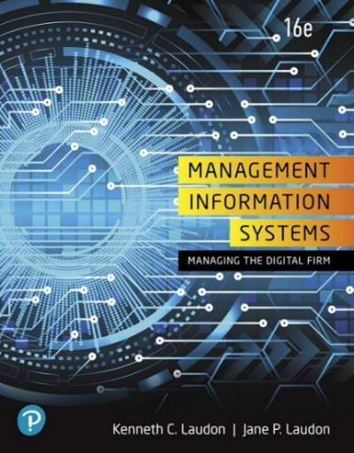
MBA722 IT for Managers (3 Credits)
Textbook: Kenneth C. Laudon, Jane P. Laudon “Management Information Systems, Managing the Digital Firm”, Sixteens Edition, Kenneth C. Laudon, New York University, Jane P. Laudon, New York University, ©2020 |Pearson |Available |MYLAB
ISBN: 978-0-13-519179-8 (textbook only)

Note: MyMISlab portal is used for this class. Portal comes with e-Text (electronic textbook) and access to myMISlab. This is a minimum package which is required for this course, $99.99 ISBN: 978-0-13-520555-6

CUH bookstore have minimum requirements available, particularly if you have book vouchers. You can purchase this textbook from the Pearson Store at $24.99 with free shipping.

- Resources for Assessment and Participation
Information how to set up your PC/MAC, purchase an access code with e-Text and enroll to myMISlab portal will be provided to students prior to start of the course.
The following types of assignments on-line are available for this course:
- Chapter opening cases.
- Interactive Session: Management
- Interactive Session: Technology
- An additional Learning Track Modules (as time permits):
- How much does it matter?
- Information Systems and your career
- The mobile digital platform
- Chapter cases
- Video cases illustrating some of the concepts in each chapter.
- Review summary with key terms
- End of chapter review questions
- Discussion questions
- Hands-on MIS Projects
- Collaboration and teamwork projects dealing with the concepts of the chapter.

- Program Learning Outcomes
Student will be able to:

- Understand how using MIS Decisions-Making Sims and auto-grading Excel and Access Projects will help students succeed in their future careers.

- Demonstrate knowledge of fundamental MIS concepts using an integrated framework for describing and analyzing information systems.

- Evaluate new technologies and explore concepts through Case Studies and instructional videos.

- Experiment how interactivity to learn is accomplished by doing MIS hands-on projects with real-world business scenarios.

- Utilize technology tools for communication, collaboration, information management and decision support.

- Appraise the role of MIS in strengthen organization competitive position against direct competition, and withing industry the company do business.

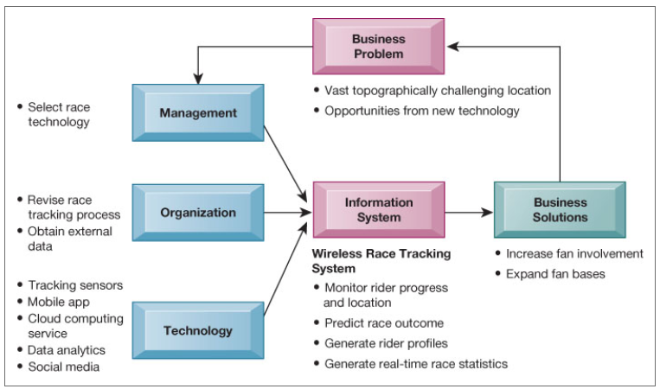

This diagram graphically illustrates how management, organization, and technology elements work together to create an information system solution to the business challenges.

- Institutional Learning Outcome
- Written communication
- Oral communication
- Critical thinking
- Information literacy
- Quantitative reasoning

- Marianist Values

This class represents one component of your education at Chaminade University of Honolulu. An education in the Marianist Tradition in marked by five principles and you should take ever.

opportunity possible to reflect upon the role of these characteristics in your education and development:
- Educate for formation in faith.
“As higher educational institutions, Marianist universities have kept, along with education in the disciplines, a commitment to the development of the whole person, which includes the dimension of religious faith and its personal appropriation and practice.”

- Provide an integral quality education.
“In the Marianist approach to education, “excellence” includes the whole person, not just the technician or rhetorician. It also includes people with their curricular and extra-curricular experiences, their intellectual and spiritual development, understood and supported best in and through community.”

- Educate in family spirit.
“Marianist educational experience fosters the development of a community characterized by a sense of family spirit that accepts each person with loving respect and draws everyone in the university into the challenge of building community. Community support for scholarship, friendship among faculty, staff and students, and participation in university governance characterize the Marianist University.”

- Educate for service, justice, and peace.
“The Marianist approach to higher education is deeply committed to the common good. The intellectual life itself is undertaken as a form of service in the interest of justice and peace, and the university curriculum is designed to connect the classroom with the wider world. In addition, Marianist universities extend a special concern for the poor and marginalized and promote the dignity, rights and responsibilities of all peoples.”

- Educate for adaptation and change.
“In the midst of rapid social and technological change, Marianist universities readily adapt and change their methods and structures so that the wisdom of their educational philosophy and spirituality may be transmitted even more fully.”

- Native Hawaiian Values
Education is an integral value in both Marianist and Native Hawaiian culture. Both recognize the transformative effect of a well-rounded, value-centered education on society, particularly in seeking justice for the marginalized, the forgotten, and the oppressed, always with an eye toward God (Ke Akua). This is reflected in the ‘Olelo No’eau (Hawaiian proverbs) and Marianist core beliefs:
- Educate for Formation in Faith (Mana) E ola au i ke akua (ʻŌlelo Noʻeau 364) May I live by God.
- Provide an Integral, Quality Education (Na’auao) Lawe i ka maʻalea a kūʻonoʻono (ʻŌlelo Noʻeau 1957) Acquire skill and make it deep.
- Educate in Family Spirit (‘Ohana) ʻIke aku, ʻike mai, kōkua aku kōkua mai; pela iho la ka nohana ʻohana (‘Ōlelo Noʻeau 1200) Recognize others, be recognized, help others, be helped; such is a family relationship.
- Educate for Service, Justice and Peace (Aloha) Ka lama kū o ka noʻeau (ʻŌlelo Noʻeau 1430) Education is the standing torch of wisdom.
- Educate for Adaptation and Change (Aina) ʻAʻohe pau ka ‘ike i ka hālau hoʻokahi (ʻŌlelo Noʻeau 203) All knowledge is not taught in the same school.

- Title IX Compliance
Chaminade University of Honolulu recognizes the inherent dignity of all individuals and promotes respect for all people. Sexual misconduct, physical and/or psychological abuse will NOT be tolerated at CUH. If you have been the victim of sexual misconduct, physical and/or psychological abuse, we encourage you to report this matter promptly. As a faculty member, I am interested in promoting a safe and healthy environment, and should I learn of any sexual misconduct, physical and/or psychological abuse, I must report the matter to the Title IX Coordinator. If you or someone you know has been harassed or assaulted, you can find the appropriate resources by visiting Campus Ministry, the Dean of Students Office, the Counseling Center, or the Office for Compliance and Personnel Services.

- Assessment and Grading

Late assignments
Student is responsible to contact instructor for make-up assignments. Student must notify the instructor before any posted due date that is unable to work on the assignment within posted due dates.

Final grade for the MBA722 course will be calculated as a weighted average of all assignments. Assignments will be posted on the myMISlab portal and entered into CUH Grading System. Occasionally homework will be assigned via email attachment. Assignments on myMISlab portal must be completed within the same week as assigned and can be improved with 2 weeks if student desire to obtain better grades. A request to make-up exams will be allowed only with prior approval from the instructor. You must request the make-up date before the scheduled examination date. Contact me, at any time for an estimate of your current grade.
Grading your accomplishments:  Grading is based on the myMISlab formula using weighted averages for various types of assignments. | Grade scale:  A = 90% – 100%  B = 80% – 89%  C = 70% – 79%

Letter grades are given in all courses except those conducted on a credit/no credit basis. Grades are calculated from the student’s assignments, class participation, quizzes, tests, term papers, reports, and exams. They are interpreted as follows:
A → Outstanding scholarship and an unusual degree of intellectual initiative
B → Superior work done in a consistent and intellectual manner.
C → Average grade indicating a competent grasp of subject matter.

My philosophy about learning is that it is never ending process. We learn every day by observing, solving problems, making mistakes and not to repeat them again. Student responsibility is discovering your own style of learning. Educators’ responsibility is to crate learning environment that student can discover, learn, apply, and flourish.

- Course Ground Rules
Attendance policy
Attendance Policy does not apply to online eLearning courses. Students follow schedule developed for the 10 weeks program of this course. Following scheduled assignments on myMISlab calendar is expected. This course resides on Pearson myMISLab portal and follows a cycle which starts on the current Monday through the following Monday, before 11:59 PM HST.
Academic Honesty
Students are responsible for promoting academic honesty at Chaminade by not participating in any act of dishonesty. Academic dishonesty may include theft of records or examinations, alteration of grades, and plagiarism. Questions of academic dishonesty in a particular class are first reviewed by the instructor who must make a report with recommendations to the Business School Dean.

Syllabus Modification
This syllabus is only a plan. The instructor may modify the plan during the course. The requirements of the course may be altered from those appearing in the syllabus. Further, the plan contains criteria by which the student’s progress and performance in the course will be measured. These criteria may also be changed, and students will be notified.

Guidelines for Communication
Email: Use your Chaminade email account or email that you check often.
Always include a subject line.

Remember that without others being able to see your facial expressions or hear your tone, some comments may be taken in a way you did not intend. So be careful in wording your emails. Use of emoticons may be helpful in some cases.

Special formatting such as centering, audio messages, tables, html, etc. should be avoided unless necessary to complete an assignment or other communication.

Discussion Groups:
- Review discussion threads thoroughly before entering the discussion.
- Maintain threads by using the “reply” button rather than starting a new topic.
- Be respectful of others’ ideas.
- Read the comments of others thoroughly before entering your remarks.
- Cooperate with group leaders in completing assigned tasks.
- Be positive and constructive in group discussions.
- Respond in a thoughtful and timely manner.

Chat online:
Introduce yourself to others in the chat session. Be polite. Choose words carefully. Do not use derogatory statements. Be concise in responding to others in the chat session. Be constructive in your comments.

Instructor and Student Communication
Questions for this course can be emailed to instructor at the email provided by instructor. Online, in-person and phone conferences can be arranged. Response time will take place within 24 hours.

Library
Provide a link to the Chaminade library, www.chaminade.edu/library.

Technical Support
For technical questions view the http://www.mymislab.com/Student_Support or call Person Technical support at 1-844-292-7015.

Contact the Chaminade IT Helpdesk for technical issues:
helpdesk@chaminade.edu or call (808) 735-4855

Use of Technology to Harass
No student may, under any circumstances, use technology to harass any other person.

Writing Policy
This course support described recommendation on formatting, e.g., use of MLA or APA. The standard font is Calibri or Arial.

Pearson Higher Ed Research
Characteristics of Marinist Universities: Chaminade University of Honolulu, St. Mary’s University, University of Dayton, A Resource Paper, Published in 1999, Republished in 2006

