MBA Program
2021 Spring Semester
April 12 – June 19, 2021
MBA-762-90-3 Project Management
eLearning Online in CANVAS

Class Schedule:
Quarter: April 12 – June 19, 2021
On-line Cycle: CANVAS, from current Monday through the following Monday, before 11:59 PM HST
Class Location: Online in CANVAS

Instructor Contact Info: Dr. Maria Brownlow, Associate Professor
Office Hours: Noon – 01:00 PM; MWF at Kieffer Room 26 or by appointment
Contact Office: 808-739-8337

Primary email: mariabrownlow@hawaiiantel.net
CUH email: maria.brownlow@chaminade.edu
Administrative Assistant: 808-440-4280

- Course Introduction and Approach
In October 1998, Project Management Institute (PMI) was accredited as a standards developer by the American National Standards Institute (ANSI). The PMBOK® Guide became a standard for project management. Project management is a unique set of activities which became central to the operations of any organization.

Project Management is defined as planning, organizing, directing/managing, and controlling of organizational resources to complete specific project goals and objectives.

Project Management is central to operations in every industry and agriculture. This course uses examples and case studies in every chapter of the textbook. Many organizations spent enormous resources to manage projects who often fail. The answer is complicated because projects are complex endeavor with risks and unknown events.

“One of the principal challenges of effectively teaching project management is to understand that project management duties are broad and diverse; most particularly, they require computational, software, and organizational/behavioral knowledge.”

The “big data”, business analytics and informatics as a part of enterprise Decision Support System (DSS), provide support to executive management on selection projects which support Vision and Mission of the organization.

“The fascinating nature of project management is that it requires students to develop mastery of both “people” and “Numbers” side of the discipline. Short of the CRO’s office, in no other position in an organization are the duties as broad and diverse as those found in the project manager role – developing strategies, financing, budgeting, negotiating, controlling, and monitoring – these are all routine responsibilities of project managers.”

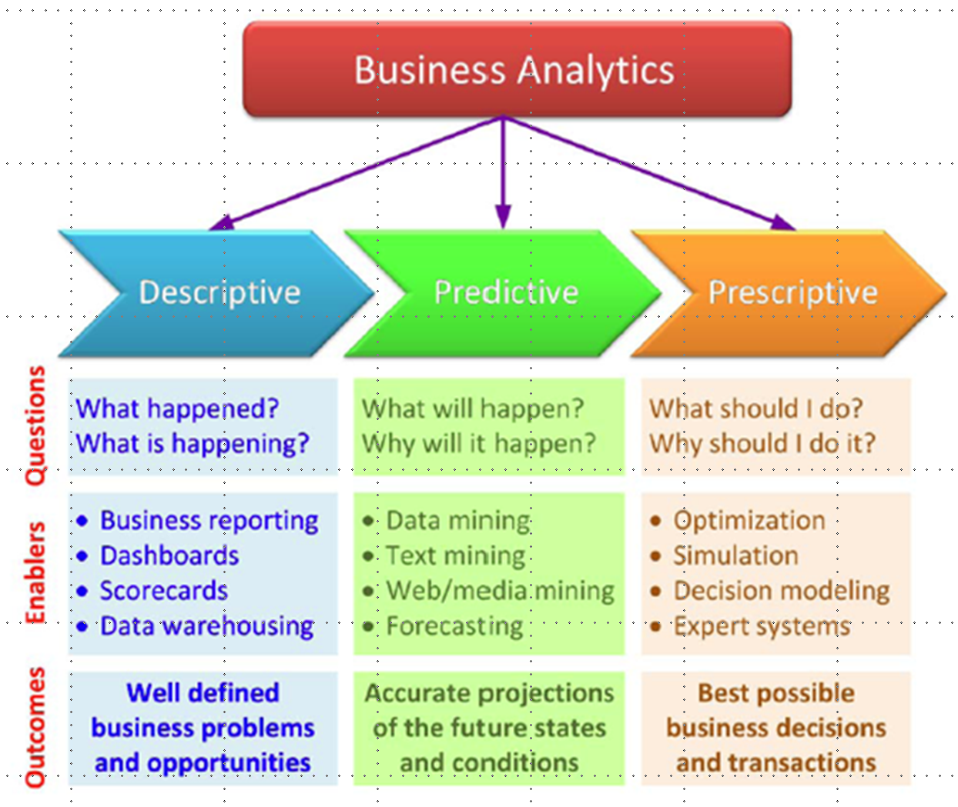

It is a temporary endeavor undertaken to create product or service. The project must indicate start and finish date. The PMI PMBOK® Guide contains a “body of knowledge”, skills, tools, and techniques to define activities meeting project requirements. A project must add value, otherwise why do it?

Why did project management become a center of our professional and private life? Let us say you want to visit Canada. It depends on what you would like to see, it is a project. If you are planning to go with your family or friends – the scope of your project is growing and to be successful, you must develop a plan. In brief, such a plan should have scope, schedule, budget, resources, risks and of course start and end date. Yes, you must define risks. The specific project circumstances will influence the constraints on which a good project manager must focus. It requires an effective use of knowledge and skills to bring this project to successful end. Our personal and professional life consists of many projects.

As the knowledge and practical experience about project management grew through the lessons learned from reviews of the project successes and failures, project management complexity grew exponentially.

Successful project management requires knowledge and selection of technology, people guidance, understanding culture, clearly identifying stakeholders, and other diverse elements necessary to successfully complete a project. It requires leadership, team building, conflict resolution, negotiation, and influence in equal measure with the traditional and technical skill set. Successful project managers are people who have experience in managing projects, technical knowledge of available tools (software) and have all-embracing people skills.

This course presents principals of project management while addressing specific discipline-based examples. Each chapter describes project profiles of successful and failed projects. There is a common belief that we learn more from failures than successes.

At the end of the chapter, students find a Case Study with questions to test student understanding or opinions about the project in the case study. These cases have discussion questions that can be used as short essays. Students will be able to use MS Project 2013 to develop a project plan.

Why I selected “Project Management, Achieving Competitive Advantage” by Jeffrey K. Pinto, from Pennsylvania State University? There are many reasons, the major of which are listed below:
- Dr. Pinto has received the Distinguished Contribution Award from the Project Management Institute
- Dr. Pinto is a practitioner and currently consults many organizations on project management.
- Agile Project Management is the foundation of his textbook.
- This course also provides step-by-step MS Project tutorials
- All Project Management Body of Knowledge (PMBOK) referencing is updated to its 5th edition.
- Textbook includes samples of questions for the PMP Certification Exam, the highest standard of professional qualification for project manager.

Textbook:

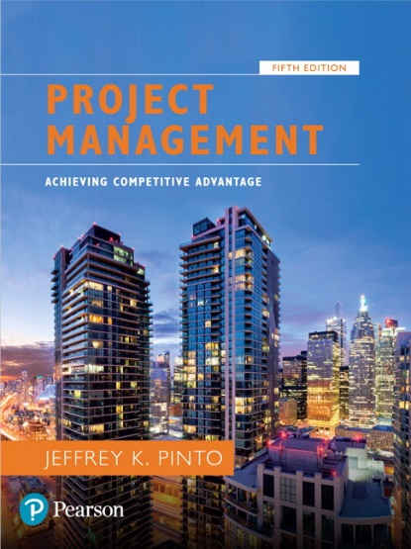
MBA-762-90-3 Project Management (3 Credits)
Textbook: Jeffrey K. Pinto, “Project Management, Achieving Competitive Advantage, Pennsylvania State University “, 5th Edition ©2019 Pearson:
ISBN: 978-013-473033-2

Note: You can find various options on via link:
https://www.vitalsource.com/products/project-management-jeffrey-k-pinto-v9780134730714

Click on the link above for more details.

- Catalog Description
Provides perspectives and processes used in effective project management from conception through evaluation. Employs hands-on learning to prepare students to develop project planning and oversight systems, identify and implement best practices, and establish operational links between project and organizational objectives. Focuses on use of project management in accomplishing strategic organizational goals.

- Course Learning Outcomes for Students
- Understand and articulate why project management became such a powerful and popular practice in business (knowledge and comprehension).

- List and define project life cycle. Apply project life cycle stages to business activities managing them to successful completion (application).

- Recognize the key motivators that are pushing companies to adopt project management practices (analysis).

- Name and describe 3 components of the corporate strategy model: formulation, implementation, and evaluation (comprehension).

- Employ sophisticated scoring models such as the Analytical Hierarchy Process to analyze the value risk/return models (application and analysis).

- Differentiate between the role of a manager and the characteristics of a leader (analysis). Understand the concept of emotional intelligence as it relates to how project managers lead.

- Demonstrate knowledge how to structure a project team from the perspective skills needed, technology deployed and human interactions within a successful project team (comprehension and application).

- Recognize the challenges that arise in maintaining an optimal project portfolio for new project investments (analysis).

- Formulate the characteristics of effective project teams and why teams fail. Examine results and prepare lessons learned to close the project (analysis and evaluation).

- Gain proficiency in both, top-down and bottom-up budgeting procedure for cost management (knowledge and comprehension).

- Program Learning Outcomes
- Manage the scope, cost, timing, and quality of the project always. Focused on project success as defined by project stakeholders.

- Align the project to the organization's strategic plans and business justification throughout its lifecycle.

- Identify project goals, constraints, deliverables, performance criteria, control needs and resource requirements in consultation with stakeholders.

- Implement project management knowledge, processes, lifecycle and the embodied concepts, tools, and techniques in order to achieve project success.

- Utilize technology tools for communication, collaboration, information management and decision support.

- Appraise the role of project management in organization change.

- Institutional Learning Outcome (CUH)
- Written communication
- Oral communication
- Critical thinking
- Information literacy
- Quantitative reasoning

- Marianist Values
An education in the Marianist Tradition in marked by five principles and you should take every opportunity possible to reflect upon the role of these characteristics in your education and development Characteristics of Marinist Universities: Chaminade University of Honolulu, St. Mary’s University, University of Dayton, A Resource Paper, published in 1999, Republished in 2006.

This class represents one component of your education at Chaminade University of Honolulu. An education in the Marianist Tradition in marked by five principles and you should take every opportunity possible to reflect upon the role of these characteristics in your education and development Characteristics of Marinist Universities: Chaminade University of Honolulu, St. Mary’s University, University of Dayton, A Resource Paper, published in 1999, Republished in 2006.

- Educate for formation in faith.
“As higher educational institutions, Marianist universities have kept, along with education in the disciplines, a commitment to the development of the whole person, which includes the dimension of religious faith and its personal appropriation and practice.”

Catholic Universities affirm an intricate relationship between reason and faith. As important as discursive and logical formulations and critical thinking are, they are not able to capture all that can be and ought to be learned. Intellectual rigor coupled with respectful humility provides a more profound preparation for both career and life. Intellectual rigor characterizes the pursuit of all that can be learned. Respectful humility reminds people of faith that they need to learn from those who are of other faiths and culture, as well as from those who may have no religious faith at all.

- Provide an integral quality education.
“In the Marianist approach to education, “excellence” includes the whole person, not just the technician or rhetorician. It also includes people with their curricular and extra-curricular experiences, their intellectual and spiritual development, understood and supported best in and through community.”

In the Marianist approach to education, excellence includes the whole person, not just the technician or rhetorician. Marianist universities educate whole persons, developing their physical, psychological, intellectual, moral, spiritual, and social qualities. Faculty and students attend to fundamental moral attitudes, develop their personal talents, and acquire skills that will help them learn all their lives. The Marianist approach to education links theory and practice, liberal and professional education. Our age has been deeply shaped by science and technology. Most recently, information and educational technologies have changed the way faculty and students research and teach. At Marianist universities, two goals are pursued simultaneously: an appropriate use of information technology for learning, and the enhancement of interaction between students and teachers. As Catholic, Marianist Universities seek to embrace diverse peoples and understand diverse cultures, convinced that ultimately, when such people come together, one of the highest purposes of education is realized: a human community that respects every individual within it.

- Educate in family spirit.
“Marianist educational experience fosters the development of a community characterized by a sense of family spirit that accepts each person with loving respect and draws everyone in the university into the challenge of building community. Community support for scholarship, friendship among faculty, staff and students, and participation in university governance characterize the Marianist University.”

Known for their strong sense of community, Marianists have traditionally spoken of this sense as “family spirit”. Marianist educational experience fosters the development of a community characterized by a sense of family spirit that accepts each person with loving respect and draws everyone in the university into the challenge of community building. Family spirit also enables Marianist universities to challenge their students, faculty and staff to excellence and maturity, because the acceptance and love of a community gives its members the courage to risk failure and the joy of sharing success.

- Educate for service, justice, and peace.
“The Marianist approach to higher education is deeply committed to the common good. The intellectual life itself is undertaken as a form of service in the interest of justice and peace, and the university curriculum is designed to connect the classroom with the wider world. In addition, Marianist universities extend a special concern for the poor and marginalized and promote the dignity, rights and responsibilities of all peoples.”

The Marianist approach to higher education is deeply committed to the common good. The intellectual life itself is undertaken as a form of service in the interest of justice and peace, and the university curriculum is designed to connect the classroom with the wider world. In addition, Marianist universities extend a special concern for the poor and marginalized and promote dignity, rights, and responsibilities of all people.

- Educate for adaptation and change.
“In the midst of rapid social and technological change, Marianist universities readily adapt and change their methods and structures so that the wisdom of their educational philosophy and spirituality may be transmitted even more fully.”

In the midst of rapid social and technological change, Marianist universities readily adapt and change their methods and structures so that the wisdom of their educational philosophy and spirituality may be transmitted even more fully. “New Times call for new methods”, Father Chaminade often repeated. The Marianist University faces the future confidently, on the one hand knowing that it draws on a rich educational philosophy, and on the other fully aware for that philosophy to remain vibrant in changing times, adaptations need to be met. Selected from Characteristics of Marianist Universities: A Resource Paper Published in 1999 by Chaminade University of Honolulu, St. Mary’s University and University of Dayton.

- Native Hawaiian Values
Education is an integral value in both Marianist and Native Hawaiian culture. Both recognize the transformative effect of a well-rounded, value-centered education on society, particularly in seeking justice for the marginalized, the forgotten, and the oppressed, always with an eye toward God (Ke Akua). This is reflected in the ‘Olelo No’eau (Hawaiian proverbs) and Marianist core beliefs:
- Educate for Formation in Faith (Mana) E ola au i ke akua (ʻŌlelo Noʻeau 364) May I live by God.

- Provide an Integral, Quality Education (Na’auao) Lawe i ka maʻalea a kūʻonoʻono (ʻŌlelo Noʻeau 1957) Acquire skills and make it deep.

- Educate in Family Spirit (‘Ohana) ʻIke aku, ʻike mai, kōkua aku kōkua mai; pela iho la ka nohana ʻohana (‘Ōlelo Noʻeau 1200) Recognize others, be recognized, help others, be helped; such is a family relationship.

- Educate for Service, Justice and Peace (Aloha) Ka lama kū o ka noʻeau (ʻŌlelo Noʻeau 1430) Education is the standing torch of wisdom and using it has no boundaries.

- Educate for Adaptation and Change (Aina) ʻAʻohe pau ka ‘ike i ka hālau hoʻokahi (ʻŌlelo Noʻeau 203) All knowledge is not taught in the same school.

- Assessment and Grading
The most common types of assessment used to measure results of learning outcomes:

Performance-Based Activities | These activities assess the learner’s proficiency in meeting the learning objectives based on real-world assignments. For example, a learner can be assessed on his/her ability to create a WBS based on an assigned case study.
Practice Quizzes | Quizzes delivered at regular intervals (i.e., at the conclusion of each module) provide feedback to be used by the instructor and learner to indicate the level of proficiency in meeting the learning objectives.
Exams | Exams measure the level of proficiency obtained at the end of a learning event, by comparing it against a standard or benchmark. An example for a PMP® certification prep course could include a sample PMP® certification exam.

Grading will be based on the following table:

Grading your accomplishments:  Homework assignments 40 points  Exams 60 points  Grading calculations might change based on the overall class performance. | Grade scale:  A = 90% – 100%  B = 80% – 89%  C = 70% – 79%

Letter grades are given in all courses except those conducted on a credit/no credit basis. Grades are calculated from the student’s assignments, class participation, quizzes, tests, term papers, reports, and exams. They are interpreted as follows:
A → Outstanding scholarship and an unusual degree of intellectual initiative
B → Superior work done in a consistent and intellectual manner.
C → Average grade indicating a competent grasp of subject matter.

My philosophy about learning is that it is never ending process. We learn every day by observing, solving problems, making mistakes and not to repeat them again. Student responsibility is discovering your own style of learning. Educators’ responsibility is to crate learning environment that student can discover, learn, apply, and flourish.

- Title IX Compliance
Chaminade University of Honolulu recognizes the inherent dignity of all individuals and promotes respect for all people. Sexual misconduct, physical and/or psychological abuse will NOT be tolerated at CUH. If you have been the victim of sexual misconduct, physical and/or psychological abuse, we encourage you to report this matter promptly. As a faculty member, I am interested in promoting a safe and healthy environment, and should I learn of any sexual misconduct, physical and/or psychological abuse, I must report the matter to the Title IX Coordinator. If you or someone you know has been harassed or assaulted, you can find the appropriate resources by visiting Campus Ministry, the Dean of Students Office, the Counseling Center, or the Office for Compliance and Personnel Services.

- Course Ground Rules
Attendance policy
This class is on-line. CANVAS, course cycle starts from the current Monday through the following Monday, before 11:59 PM HST.
Academic Honesty
Students are responsible for promoting academic honesty at Chaminade by not participating in any act of dishonesty. Academic dishonesty may include theft of records or examinations, alteration of grades, and plagiarism. Questions of academic dishonesty in a class are first reviewed by the instructor who must make a report with recommendations to the Business School Dean.

Syllabus Modification
This syllabus is only a plan. The instructor may modify the plan during the course. The requirements of the course may be altered from those appearing in the syllabus. Further, the plan contains criteria by which the student’s progress and performance in the course will be measured. These criteria may also be changed, and students will be notified.

Guidelines for Communication
Email: Use your Chaminade email account.
Always include a subject line.

Remember that without others being able to see your facial expressions or hear your tone, some comments may be taken in a way you did not intend. So be careful in wording your emails. Use of emoticons may be helpful in some cases.

Special formatting such as centering, audio messages, tables, html, etc. should be avoided unless necessary to complete an assignment or other communication.

Here are a few important items “You Need to Know:"

24-Hour Chaminade University Emergency Information Hotline (808) 739 – 7499.
University Emergency Information webpage: https://chaminade.edu/emergency/

Technical Support:
CANVAS Technical Support is: 1-877-251-6615

Technical Assistance for Canvas Users:
Search for help on specific topics at help.instructure.com
Chat with Canvas Support 24/7/365

Watch this video to get you started with online guides and tutorials.

Contact the Chaminade IT Helpdesk for technical issues:
helpdesk@chaminade.edu or call (808) 735-4855

Use of Technology to Harass
No student may, under any circumstances, use technology to harass any other person.

Writing Policy
This course support described recommendation on formatting, e.g., use of MLA or APA. The standard font is Calibri or Arial.

Project Management, Achieving Competitive Advantage, 5th edition.
Project Management, Achieving Competitive Advantage, 5th edition.
Project Management Institute. A Guide to the Project Management Body of Knowledge (PMBOK® Guide) Sixth Edition
2014 Characteristics of Marianist Universities
Source: Project Management Institute, Dick, W., & Carey, L. (1996). The systematic design of instruction. 4th edition. New York, NY: Harper Collin

