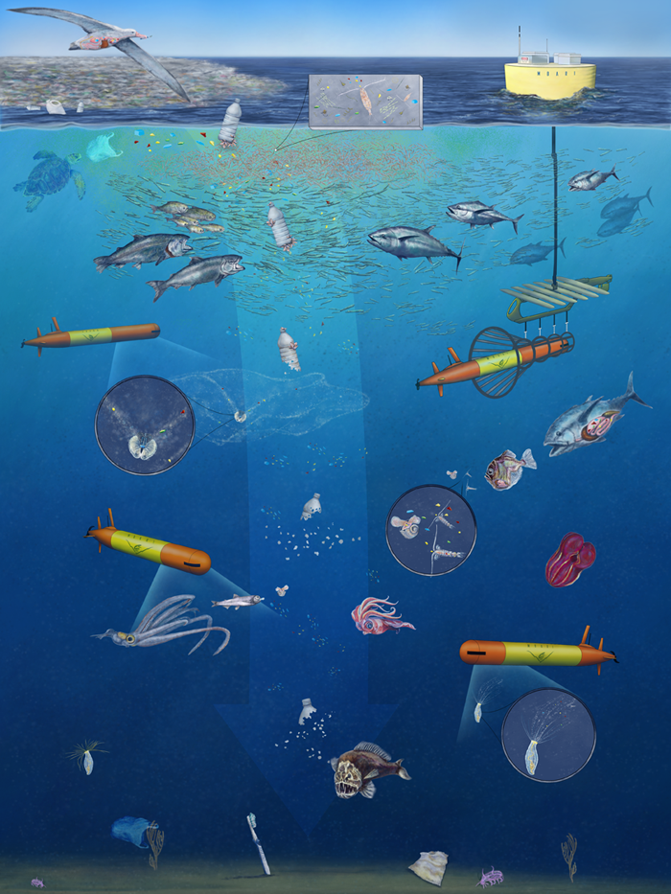


Course Title: Marine Environmental Science (Lab)
Course Number: ENV 115L
Term: Spring 2021
Course Credits: 1
Class Meeting Times: Thur 10:00-12:50
Class Location: Henry Hall Lab 4, in the field & zoom (link in Canvas)

Instructor Name: Dr. Lupita Ruiz-Jones
Email: guadalupe.ruiz-jones@chaminade.edu
Office Location: Wesselkamper 104
Cell Phone (welcome to text): 505.603.1985
Office Hours: Tues 2:30-4:00 / Wed 12:30-1:30 / Thur 2:30-4:00
(via Zoom for now - text me to lmk you want to join zoom)

We will start the semester with Tues lecture being in zoom and Thur lecture being in-person. Labs will either be in zoom, in-person, or in the field.

In-person class: wear your mask and socially distance; no eating or drinking in the classroom.

Zoom class: set yourself up for learning by being in a place you can focus (i.e., not in a car driving or somewhere you will be continuously distracted -- if this is the case, I will ask you to leave class and you will not get credit for the day).

In the field: plan accordingly so that you arrive to the field site on time and with any gear you need. Always bring your mask and water.

Understatement of our time...we are living in a challenging pandemic.
I recognize that all of us are disappointed that this college experience is not what we signed up for. These times are frustrating (sometimes I feel like having a temper tantrum). But it is imperative that we step up and bring our best self forward-our future selves will look back at how we responded. Approach this situation with compassion, empathy, and respect. We will get on the other side of this pandemic and feel different.

Course description from University catalogue

This course introduces students to the scientific methodologies used to determine and study the current major marine environmental issues. Issues studied include: global warming, marine pollution, marine debris, oil spills, fisheries exploitation, fisheries by-catch, marine alien species and coral reef degradation. Laboratory exercises are conducted in the field and on the Chaminade campus. Students taking this course will be engaged in field science activities. Course must be taken concurrently with ENV 115.

Course overview

This lab course parallels the lecture. Due to the COVID-19 pandemic the lab course structure has shifted to focus more on the process of doing research and communicating science. We will have a few field visits to a fishpond in Maunalua Bay that we will contribute to the restoration of. At this field site you will learn more about your local environment and conduct a survey of the reef. You will submit a reflection of your experience and you will have freedom in selecting how you want to present your reflection: poem, short video, slide show, etc.

In addition to diving deeper into some of the lecture concepts, you will think critically about what it means to do research and engage in the process through two endeavours: Hawaiian Critter Project and Oceans & the Pandemic Team Project. For your Hawaiian Critter Project you will dive deeper into the biology and ecology of a Hawaiian marine critter and create an engaging presentation that draws connections to a local marine environmental issue. For your Oceans & the Pandemic Team Project you will examine a marine issue in the context of COVID-19 and think through how the pandemic has been or will influence this issue, in addition to presenting the types of research questions you think scientists will need to address moving forward to understand the full impact of the pandemic. You will present your analysis in one of two ways: photojournalism or podcast style interview. With the photojournalism approach you will create either a photo essay or recorded narrated slideshow. With the podcast approach you will conduct an interview that includes descriptions of data figures analyzed in your project. Teams will present in class during week 13. This course satisfies the General Education Learning Outcome for Quantitative Reasoning: students will analyze and interpret quantitative data.

Classroom etiquette (in the time of the COVID-19 pandemic)

When we are together in the same physical classroom, our primary goal will be to keep each other safe. Wear your masks in the classroom. Drink water before coming into the room. No eating or drinking during class. Keep physical space between you, your peers and me. And if you have any COVID symptoms, be responsible and stay home, and let me know your situation.

Course Learning Outcomes and their evaluation

By the end of the course, you will be able to:
- Identify and describe common marine organisms found in Hawaiian waters.
  - Evaluated via critter quizzes and Hawaiian Critter Project.
- Think like a scientist by developing research questions and analyzing different types of sources.
  - Evaluated via Oceans & the Pandemic Team Project.
- Analyze data figures and draw conclusions founded in evidence.
  - Evaluated via discussions, Hawaiian Critter Project, and Oceans & the Pandemic Team Project.
  - Satisfies General Education Learning Outcome for Quantitative Reasoning.
- Explain the significance of a challenging marine environmental issue.
  - Evaluated via analyses conducted of selected Hawaiian critter and with Oceans & the Pandemic Team Project.

Grading breakdown

20% = Engaged participation with peers, me, and guests (requires arriving to class prepared)
20% = Critter quizzes
10% = Fieldwork reflection
20% = Hawaiian Critter Project
30% = Oceans & the Pandemic Team Project (proposal of ideas, annotated bibliography, final product)

A = Outstanding scholarship and an unusual degree of intellectual initiative
B = Superior work done in a consistent and intellectual manner
C = Average grade indicating a competent grasp of subject matter
D = Inferior work of the lowest passing grade
F = Failed to grasp the minimum subject matter; no credit given

Workload expectations

Students are expected to devote a minimum of 2 hours of focused work out of class for each 1 hour of class time per week.

Attendance and your grade
As an enrolled student in the course, I expect that you will attend every class unless you are sick or have a COVID-related situation. If you have more than two unexcused absences your grade will be negatively impacted. An important aspect of learning is active engagement. There is no substitute for being in class when it comes to understanding and thinking critically about the material. Due to the COVID-19 pandemic, it is essential that you stay home if you have any symptoms -- your absence will be excused. Unexcused absences occur when playing hooky to go surfing, to sleep, to cram for an exam in another class, etc.

Course website
We will use Canvas and google drive.

Course Policies - same as those listed in the lecture syllabus

This syllabus and course schedule are living documents: they are free to change. I try to adhere as closely as possible, but there will be times in which we will take longer on a particular topic or add or delete a topic to enhance the course. I like to be able to react to you as the course proceeds and go with the flow a bit in order to make the course experience sort of custom fit to you!

You are responsible for all of the information in this document: not reading it does not make you exempt from knowing what’s in it!

Use this syllabus to keep you organized and how your grade is determined.

