 | Course Syllabus  Chaminade University Honolulu  3140 Waialae Avenue - Honolulu, HI 96816
Course Number: NUR 406
Course Title: Evidence Based Practice Practicum
College/School/Division Name: Nursing
Term: Spring 2021
Course Credits: 2
Class Meeting Days & Hours: Sec 1 Mondays 1:30pm-3:20pm
Sec 2 Mondays 3:30pm-5:30pm
Class Location: Synchronous Zoom
Sec 1 Zoom ID 97971535851
Sec 2 Zoom ID 93083971797

Group EBP Consultation days and times starting Week 2: sign-up will be available
Thursdays 8:00am-12:00pm
Fridays 8:00am-12:00pm
Saturdays as needed

Instructor Name: Edna Magpantay-Monroe, Ed.D., APRN, CMDCP
Email: edna.magpantay-monroe@chaminade.edu
Office Phone: 808.739.8380
Office Location: Henry Hall 117
Office Hours: Via Zoom Tuesdays 9:00am-11:00am & 4:00pm-6:00pm
Zoom ID 95655342598
Appointments are highly encouraged outside of the above open hours
Main Nursing Office Phone: 808-735-4813

Instructor and Student Communication Including Exam/Assignment Feedback
Questions for this course can be emailed to the instructor at edna.magpantay-monroe@chaminade.edu. Zoom meetings, in-person and phone conferences can be arranged. Response time may take place up to 72 hours on emails. It is best to attend the open office hours above on Tuesdays

All assignment feedback will be provided within 10 days from due date. Faculty will inform students via email if there will be a delay in releasing the completion of assignment grading.

University Course Catalog Description
This is a clinical course and will provide the student the opportunity to apply evidence-based practice theory to the clinical setting. Service-learning will be a required element of the course, in the form of a 10-hour service-learning activity and a written reflection about the experience. Prerequisites: BI 151 and BI 151L, BI 152 and BI 152L, BI 250 and BI 250L, BI 304, BI 305, CH 250, MA 107, NUR 190, NUR 201, NUR 202, NUR 203, NUR 204, NUR 206, NUR 290, NUR 291, NUR 301, NUR 302, NUR 303, NUR 306, NUR 307, NUR 403, NUR 404.

Course Overview

NUR 406 EBP Practice is linked with NUR 404 EBP Theory in fall semester; the EBP problem is identified and evidence appraised in fall and based on the evidence a practice recommendation (may include pilot project) is planned, implemented or presented, and evaluated in spring. The goal of this two course EBP series (NUR 404 and NUR 406) is the creation of a well-designed undergraduate EBP project addressing a nursing or health related problem. Each student will help solve a practice problem related to health, healthcare, nursing education and nursing practice in the community.

Marianist Values
This class represents one component of your education at Chaminade University of Honolulu. An education in the Marianist Tradition is marked by five principles and you should take every opportunity possible to reflect upon the role of these characteristics in your education and development:
- Education for formation in faith
- Provide an integral, quality education
- Educate in family spirit
- Educate for service, justice and peace
- Educate for adaptation and change

Native Hawaiian Values
Education is an integral value in both Marianist and Native Hawaiian culture. Both recognize the transformative effect of a well-rounded, value-centered education on society, particularly in seeking justice for the marginalized, the forgotten, and the oppressed, always with an eye toward God (Ke Akua). This is reflected in the ‘Olelo No’eau (Hawaiian proverbs) and Marianist core beliefs:
- Educate for Formation in Faith (Mana) E ola au i ke akua (ʻŌlelo Noʻeau 364) May I live by God
- Provide an Integral, Quality Education (Na’auao) Lawe i ka maʻalea a kūʻonoʻono (ʻŌlelo Noʻeau 1957) Acquire skill and make it deep
- Educate in Family Spirit (‘Ohana) ʻIke aku, ʻike mai, kōkua aku kōkua mai; pela iho la ka nohana ʻohana (‘Ōlelo Noʻeau 1200) Recognize others, be recognized, help others, be helped; such is a family relationship
- Educate for Service, Justice and Peace (Aloha) Ka lama kū o ka noʻeau (ʻŌlelo Noʻeau 1430) Education is the standing torch of wisdom
- Educate for Adaptation and Change (Aina) ʻAʻohe pau ka ‘ike i ka hālau hoʻokahi (ʻŌlelo Noʻeau 203) All knowledge is not taught in the same school

Learning Outcomes
By the end of our course, students will be able to:
- Critically appraise research and non-research sources of evidence at an advanced beginner level
- Synthesize appraised evidence for use in EBP project
- Collaborate effectively with teammates both face-to face and using technology
- Design an evidence-based policy recommendation or educational project for a community organization
- Present an EBP project in a professional manner to community organizations and the academic community
- Evaluate EBP project process and team/self-contributions
- Display personal value for the role evidence plays in the provision of safe, high quality nursing care
Service Learning Course Outcome
- Demonstrate an understanding of the connections between academic work and real-life situations

Alignment of Learning Outcomes

 | CLO 1 | CLO 2 | CLO 3 | CLO 4 | CLO 5 | CLO 6 | CLO 7 | CLO 8
Native Hawaiian Values | 2, 4 | 2 | 1, 2, 3, 4 | 2,3 | 1,2,3 | 1,2,3,5 | 1,2, 3,  4, 5 | 3,5
Marianist Values | 2,4 | 2 | 1, 2, 3, 4 | 2, 3 | 1, 2, 3, | 1, 2, 3, 5 | 1, 2, 3, 4, 5 | 3,5
Program Learning  Outcomes | 2, 3, 4, 5, 6, 7, 8 | 4, 5, 6 | 1, 2, 3, 4, 5, 6, 7, 8 | 3, 4, 5, 6, 7, 8 | 3, 4, 5, 6, 7,8 | 3, 4, 6 | 4, 6 | 1, 2, 3, 4. 5. 6, 7

Program Learning Outcomes (these PLO’s are from the catalog 2019-2020)
Upon completion of the B.S. Degree in Nursing, the student will demonstrate the ability to:
1. Use the nursing process for comprehensive assessments of health and illness parameters in patients
using developmentally, and culturally, appropriate approaches
2. Provide safe, holistic, patient-centered care, across the health-illness continuum, across the lifespan,
using state-ofthe-art methodologies, and in all healthcare settings
3. Engage in dialogue about contemporary issues in healthcare, effectively advocate in the interest of
patients, and lead others in the professional nursing role
4. Communicate and collaborate effectively with patients and professionals from a variety of disciplines
5. Integrate research and reliable clinical evidence to inform their nursing practice
6. Incorporate informatics and healthcare technologies into the practice of professional nursing
7. Use the determinants of health, tools for measurement, and interventions for health promotion and
disease prevention in populations
8. Describe the elements of health care policy and finance within a regulatory environment

Course Prerequisites
NUR 404 must be completed successfully. An understanding of clinical and nursing education practice is important in completion of the evidence based practice project.

Required Learning Materials

- American Psychological Association. (2020). Publication manual of the American Psychological Association (7th ed.). Washington, DC: Author. ISBN: 978-1-43383216-1

- Nursing Library guide (lib guide) under Evidence Based Practices. Forms that will be used in this class may be available at this site. Here is the direct link https://chaminade.libguides.com/c.php?g=147285&p=7029211

- BSN Essentials Revisions in Progress https://www.aacnnursing.org/Portals/42/Downloads/Essentials/DRAFT-Domains-Descriptors-Competencies-May-2020.pdf

- Quality Safety Education for Nurses(QSEN) competencies https://drive.google.com/file/d/0B5YGF5c2vqn5cHFZcnZ5X09ST2s/edit

Supplementary Materials
Dearholt, S., & Dang, D. (2018). Johns Hopkins Nursing evidence-based practice: Models and guidelines (3rd Ed). Indianapolis, IN: Sigma Theta Tau International. ISBN: 9781940446974. This book can be bought directly from the STTI website if you need additional resource to understanding the concepts. This book will be useful for NUR 404 and NUR 406.

NCLEX current Test Plan: https://www.ncsbn.org/2019_RN_TestPlan-English.pdf. This material will help you understand the use of evidence based practice in your future NCLEX testing.

Hawaii State Center for Nursing: https://www.hawaiicenterfornursing.org/
This site have many current information about evidence based practice in the state especially about advocacy.

Use of Technology Support
The Learning Management System, Canvas, is used extensively. You can reach the log in page by searching canvas.chaminade.edu. Canvas is accessible from most PCs and Macintosh computers with a reliable internet connection. Canvas is accessible on all computers available for use on campus. Technical support is available by clicking the help button on the lower left side of the course screen. If you encounter a problem with Canvas be sure to click the report a problem link to get help for a support agent 24/7. Be sure to get a report incident number if you are working on a graded assignment. Document your incident number with the instructor of record. The Canvas Support Line for students is 1-877-251-6615

Technical Assistance for Canvas Users:
- Search for help on specific topics or get tips in Canvas Students
- Live chat with Canvas Support for students
- Watch this video to get you started
- Online tutorials: click on “Students” role to access tutorials

Assessment Technologies Institute (ATI) is an online educational learning system used
throughout the nursing courses at Chaminade School of Nursing. The cost for the system is taken out of your nursing fees. Your anticipated graduation date is 0521 The website is located at: https://www.atitesting.com Complete system requirements are available on the log on page. For all inquiries during office hours use: 1-800-667-7531. After hours technical support, send an email to helpdesk@atitesting.com. Technical

Contact the Chaminade IT Helpdesk for technical issues: helpdesk@chaminade.edu or call (808) 735-4855

I highly recommend that you put the support numbers above for Canvas, ATI and Chaminade HelpDesk in your cell phone for easy access.

Websites
Course Website:
Here is the direct link to your course:

All course evaluations will be conducted via Canvas. Please wait for your faculty instructions before completing the course evaluations towards the end of the semester.

Tutoring and Writing Services
Chaminade is proud to offer free, one-on-one tutoring and writing assistance to all students. Tutoring and writing help is available on campus at Kōkua ʻIke: Center for Student Learning in a variety of subjects (including, but are not limited to: biology, chemistry, math, nursing, English, etc.) from trained Peer and Professional Tutors. Please check Kōkua ʻIke’s website (https://chaminade.edu/advising/kokua-ike/) for the latest times, list of drop-in hours, and information on scheduling an appointment. Free online tutoring is also available via TutorMe. Tutor Me can be accessed 24/7 from your Canvas account. Simply click Account – Notifications – Tutor Me. For more information, please contact Kōkua ʻIke at tutoring@chaminade.edu or 808-739-8305.

Grading Scale
Letter grades are given in all courses except those conducted on a credit/no credit basis. Grades are calculated from the student’s class participation, exams, papers, service learning project and the infographic project. They are interpreted as follows:
A Outstanding scholarship and an unusual degree of intellectual initiative
(90-100%)
B Superior work done in a consistent and intellectual manner (80-89%)
C Average grade indicating a competent grasp of subject matter (70-79%)
D Inferior work of the lowest passing grade, not satisfactory for fulfillment of
prerequisite course work (60-69%)
F Failed to grasp the minimum subject matter; no credit given (59% and below)

Grades are available on Canvas in each student individual gradebook. Please contact the instructor of record for any issues or concerns immediately after the method of evaluation or when the grades are posted in Canvas. The SON does not round final points for the final grade. For example, If you get a 69.9% as your final grade, this is not considered passing. A 70% or C grade is considered passing.

Course Requirements/Method of Evaluation:
Your grade in this course will be based on the following:
- Attendance and Participation
- EBP Webinars/Conference with Reflections
- Service Learning Activities
- Evidence Based Project

Assignments and Course Grading:
The proportion that each of the above contributes to your grade in this course is as follows:

Assignments: Graded | Points | Weighted % of Total Points
Attendance in Synchronous Class (Feb 8, 22, March 1, 8 15) 2 points each = 10 points & Participation in Weekly one hour EBP Consultation ( Feb 8-April 5) 2 points each = 20 points | 30 | 15%
EBP Webinars & Live Conference with Reflections (total 20 hours) | 100 | 20%
Service Learning Activities (minimum 10 hours) and Reflection Paper | 100 | 15%
Evidence Based Project  - Poster 20 points  - Mini Abstract 15 points  - Video Presentation and Attendance to the EBP project presentation to the community 15 points  - Draft of Project Trajectory (Design and Implement 25 points  - Literature Review 10 points  - Appendix B 5 points  - Peer Review Evaluation 10 points | 100 | 50%
TOTAL | 330 points | 100%
Assignments: Non Graded* | * Must be completed to pass this course
Additional Human Subject Research Training as requested | PASS/FAIL
Timely Submission to IRB of forms for project | PASS/FAIL

IMPORTANT: This is a clinical practicum - attendance is mandatory at synchronous seminars on Mondays and EBP Consultation Days sign-up once a week. Students must track additional hours of work to complete 90 over the semester. Students must complete clinical hours by the end of the semester to pass the course. If a student has concerns or questions about tracking hours he/she should see Dr. Monroe for guidance.

COURSE POLICIES:

All policies stated in the Chaminade University Catalog 2020-2021, CUH Student Handbook 2020-2021, and School of Nursing Student Handbook 2020-2021 are in effect in this course. Students are strongly encouraged to refer to these resources online.

Academic Honesty:
Nursing students are responsible for promoting academic honesty in all educational settings. Nursing students represent Chaminade University and the School of Nursing and as such are expected to demonstrate professional, ethical behavior in the classroom, in laboratory settings, in the clinical setting, and in the community. The Chaminade student nurse shall be committed to the Marianist Values and the core values of the School of Nursing.

Any behavior that impedes assessment will be considered academic dishonesty by the CUHSON. All students are encouraged to clarify all assignments with the course instructor(s) if there are any questions. Students are responsible for promoting academic honesty by not participating in any act of dishonesty and by reporting any incidence of academic dishonesty to an instructor or to a University official. Please refer to the section of Professional Behaviors in the 2020-2021 Nursing Student Handbook for an in-depth explanation. The Chaminade Student Handbook 2020-2021 outlines Student Code of Conduct

Course Atmosphere:
This course is not a lecture course. Active engagement strategies are utilized for student learning. The classroom (Zoom and Canvas) is a teaching and learning environment where there is an exchange of knowledge and experience, so it is essential that students attend class (Zoom synchronous and Canvas) and actively participate in classroom activities to maximize individual learning. Students needs to drive their inquisitiveness to learning through substantial participation in the required activities to complete an evidence based project.

Attendance:
Class attendance via Zoom is regarded as an essential part of the educational process. Synchronous classes are an expectation. Students who are absent from class not only miss a part of the subject matter of the course but also diminish the opportunities for contributing to the learning environment for the entire class. Any absence must be communicated to the course instructor of record in an email. No make-up points for any missed required synchronous or EBP consultation meetings. Each student will be encouraged to develop a professional work ethic that reflects personal responsibility, initiative, and teamwork. Students should notify an instructor by email when illness prevents them from attending class. Any student who stops attending class without officially withdrawing may receive a failing grade. Unexcused absences equivalent to more than a week of class may lead to a grade reduction for the course. Any absence of two weeks or more must be reported to the Associate Provost and the Records Office by the course instructor of record. See Chaminade University Catalog and Nursing Student Handbook for detailed information about attendance.

Academic Conduct:
Any community must have a set of rules and standards of conduct by which it operates. At Chaminade, these standards are outlined so as to reflect both the Catholic, Marianist values of the institution and to honor and respect students as responsible adults. All alleged violations of the community standards are handled through an established student conduct process, outlined in the Student Handbook, and operated within the guidelines set to honor both students’ rights and campus values.

Students should conduct themselves in a manner that reflects the ideals of the University. This includes knowing and respecting the intent of rules, regulations, and/or policies presented in the Student Handbook, and realizing that students are subject to the University’s jurisdiction from the time of their admission until their enrollment has been formally terminated. Please refer to the Student Handbook for more details. A copy of the Student Handbook is available on the Chaminade website.

The Nursing Student Handbook will be provided to you. You will be asked to sign the last pages acknowledging your receipt and understanding of the school of nursing policies.

Assignments:
ALL written assignments must be submitted to Canvas by the due date. If Canvas is down, obtain a ticket incident number. You will need to email the course instructor of record the incident number along with the assignment in an attachment. This is to ensure the correct assignment has been done at the correct time however, you will be expected to post your assignment on Canvas as soon as the Learning Management System is operational before your assignment can be graded. It is the responsibility of the student to ensure that assignments are posted correctly, in proper format, and by the deadline. Only versions posted on Canvas at the submission deadline will be graded. Late assignments are highly discouraged. Late assignments will receive a deduction in points: 10% for every day it is late including the weekends. No late assignments will be accepted after 7 calendar days the assignment is due.

Writing policy:
All papers should demonstrate mastery of grammar, punctuation, spelling and syntax expected of college level students. Use of APA 7th edition is required for all papers. If you need writing assistance, please seek help from Student Support Services. Canvas has online tutoring available through Tutor Me. All papers are to be word processed, proofread, and solely the work of the author. All papers must be submitted on Canvas. Please read information about plagiarism in your student handbook.

Testing policy:
Students are expected to take tests on the designated day. In case of an emergency, please contact the instructor prior to the test so that an alternate plan can be made. Failure to do so will result in a zero. Approval for taking a make-up test must be granted by the course instructor of record on a case by case basis. Make-up exams are highly discouraged. Students will be asked to remove hats, water bottles, phones & other paraphernalia in the front of the testing room during examinations.

Online Proctoring:
The School of Nursing may choose to utilize an online exam proctoring technology at
any time during this course. This technology enables students to take proctored exams at a location that is off-campus. This technology provides a secure test environment that promotes academic integrity and provides data security. The process identifies a student and records video, audio, and screen capture during the student’s exam. This information is communicated to secure servers and reviewed. The video, audio, and screen capture are used solely for the purpose of ensuring academic integrity during the testing process.

Grades of "Incomplete"
Incomplete grade is granted at the discretion of the faculty of record and must be aligned with the University policies. Receiving an “Incomplete” for a nursing course that is a prerequisite for a forthcoming nursing course must be completed prior to the start of the new course.

Cell phones and Laptops:
Out of consideration for your classmates, please set your cell phone to silent mode during class. Students are encouraged to bring laptops or tablets to class as the instructor will assign online activities and readings that will require the use of a laptop or tablet. Laptops and tablets should not be misused, such as checking distracting websites. In addition, use of cell phones and music devices in any class is discourteous and may lead to suspicion of academic misconduct. Students who cannot comply with this rule will be asked to leave class and may receive unsatisfactory performance for that day. Use your best judgment and respect your classmates and instructor.

ADA Accommodations:
Chaminade University of Honolulu is committed to providing reasonable accommodations for all persons with disabilities. If you need individual accommodations to meet course outcomes because of a documented disability, please speak with me to discuss your needs as soon as possible so that we can ensure your full participation in class and fair assessment of your work. Students with special needs who meet criteria for the Americans with Disabilities Act (ADA) provisions must provide written documentation of the need for accommodations from the Counseling Center as soon as possible or no later than the end of week three of the class, in order for instructors to plan accordingly. If a student would like to determine if they meet the criteria for accommodations, they should contact the Kōkua ʻIke Coordinator at (808) 739-8305 for further information (ada@chaminade.edu).

Title IX Compliance
Chaminade University of Honolulu recognizes the inherent dignity of all individuals and promotes respect for all people. Sexual misconduct, physical and/or psychological abuse will NOT be tolerated at CUH. If you have been the victim of sexual misconduct, physical and/or psychological abuse, we encourage you to report this matter promptly. As a faculty member, I am interested in promoting a safe and healthy environment, and should I learn of any sexual misconduct, physical and/or psychological abuse, I must report the matter to the Title IX Coordinator. If you or someone you know has been harassed or assaulted, you can find the appropriate resources by visiting Campus Ministry, the Dean of Students Office, the Counseling Center (808-735-4845), or the Office for Compliance and Personnel Services.

Compliance Information:
The Compliance website serves as a resource for compliance matters, including Title IX/Nondiscrimination, the Hawaii Post-Secondary Education Authorization Program, and human resource and employment policies. The Executive Director for Compliance and Personnel Services oversees university-wide efforts to meet compliance standards set forth by University Policies and Federal and State regulations.

Grievances, violations or suspected violations of these policies may be submitted by the complainant or may be submitted anonymously to the Executive Director of Compliance and Personnel Services. Reports of violations or suspected violations will be kept confidential to the extent possible, consistent with the need to conduct an adequate investigation. Mechanisms in which to file a grievance can be found at the following website URL: https://compliance.chaminade.edu/resources/

Credit Hour Policy
The unit of semester credit is defined as university-level credit that is awarded for the completion of coursework. One credit hour reflects the amount of work represented in the intended learning outcomes and verified by evidence of student achievement for those learning outcomes. Each credit hour earned at Chaminade University should result in 37.5 hours of engagement. For example, in a one credit hour traditional face to face course, students spend 50 minutes in class per week for 15 weeks, resulting in a minimum of 12.5 instructional hours for the semester. Students are expected to engage in reading and other assignments outside of class for at least 2 additional hours per week, which equals an additional 25 hours. These two sums result in total student engagement time of 37.5 hours for the course, the total engagement time expected for each one credit course at Chaminade.
The minimum 37.5 hours of engagement per credit hour can be satisfied in fully online, internship, or other specialized courses through several means, including (a) regular online instruction or interaction with the faculty member and fellow students and (b) academic engagement through extensive reading, research, online discussion, online quizzes or exams; instruction, collaborative group work, internships, laboratory work, practica, studio work, and preparation of papers, presentations, or other forms of assessment. This policy is in accordance with federal regulations and regional accrediting agencies.
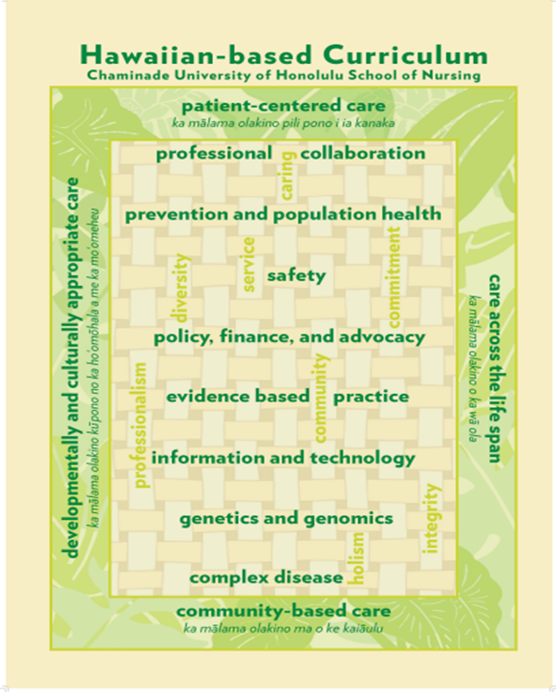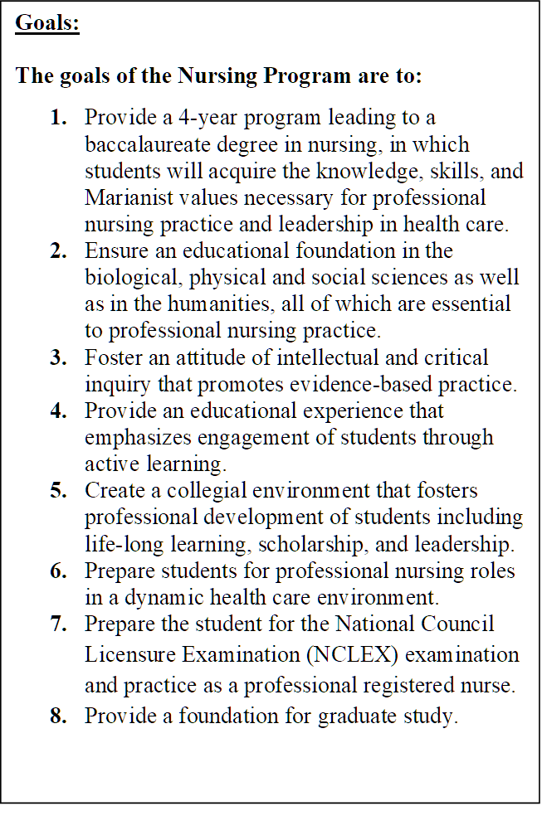

Schedule of Content Readings and Assignment Due Dates
Please see a separate document for ease of planning.

