RE 324 01: Sexuality in Christian Life
Chaminade University of Honolulu
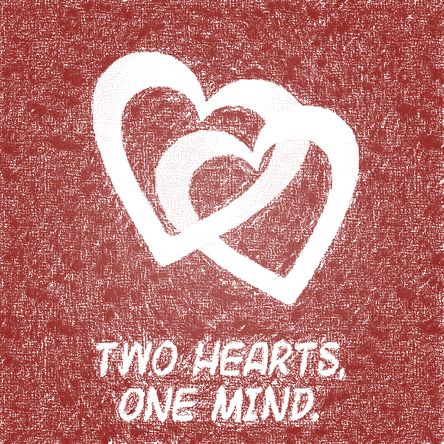
FALL Day 2020

TIME: 2:30-5:20 p.m., Wednesday
CLASSROOM: Henry Hall 225
INSTRUCTOR: Regina Pfeiffer, D. Min.
PHONE: 739-8536
OFFICE: Henry Hall 208D
OFFICE HOURS: MWF 8:30-10:30; and by appointment
E-MAIL: rpfeiffe@chaminade.edu
COURSE
TEXTBOOKS: Grabowski, John S. Sex and Virtue: An Introduction to Sexual Ethics. Washington D. C.: The Catholic University of America Press, 2003.

Lawler, Michael G. Marriage and Sacrament: A Theology of Christian Marriage. Collegeville, MN: Liturgical Press, 1993.

New American Bible or any standard Bible version.

COURSE DESCRIPTION
This course will explore the meaning of adult life as based upon a sacramental perspective. Students will examine the paradigm of Jesus as Sacrament and the human response to that image in adult life. They will determine what the Christian view regarding married and single life in order to make informed choices regarding human sexuality, and moral and social responsibilities. They will evaluate differing views regarding human behavior and lifestyles as consistent with or in opposition to a sacramental understanding of human life.

STUDENT LEARNING OUTCOMES LINKED TO PROGRAM LEARNING OUTCOMES

Upon successful completion of this course, students will:
- Describe the meaning of Jesus as foundational for the Christian perspective and the effect on human choices; (PLO 1, 3)
- Explain the concept of covenant as relevant to and foundational for the Christian understanding of human sexuality; (PLO 3, 5)
- Compare and contrast varying views regarding marriage and human sexuality. (PLO 5)
- Correlate biblical resources and other sources in dialogue using theological reflection to determine potential Christian responses to contemporary issues in sexuality. (PLO 3, 5)
Organizational Theme: Marianist Educational Philosophy

Educate for formation in faith;
Provide for an integral quality education;
Educate for family spirit;
Educate for service, justice and peace; and,
Educate for adaptation and change.

The root of the word educate, educare, means to “lead out from.” To educate means to begin where persons are individually to lead them to a future locus of where they will become. It is a journey that continues throughout one’s life that involves growing in faith through relationship, continuing to learn for better knowledge and understanding, living in the human family, serving others, and being open to change and adaptation.

This course will invite students to explore and understand the Christian perspective of human sexuality based upon a critical analysis of its foundations and bases. Students will study this content in a supportive, familial atmosphere that encourages discussion and tolerance of other views. As part of their study in this field, students will be invited to understand how the Christian perspective both challenges and should be challenged in order to adapt, change and work toward the human dignity of all persons.

Educate for formation in faith;
Sexuality in Christian Life is based on the understanding of humanity created made in the image and likeness of God. In addition, human relationships themselves depend on the ability to have faith that the other has one’s best interests at heart.

Provide for an integral quality education;
In this course, students will study various theories of human relationship from philosophical, psychological and religious points of view.

Educate for family spirit;
Developing healthy human relationships is at the heart of Sexuality in Christian Life.

Educate for service, justice and peace; and,
While many may be under the impression that Sexuality in Christian Life is limited to marriage, its roots exist in the dignity of all human persons and covenantal relationships. Relationships can be lived in many ways, spouses, friends, and family. Service, justice and peace are integral to raising human dignity.

Educate for adaptation and change
Human life itself is about change. From infancy to adulthood, we face changes in our lives. Sexuality in Christian Life explores our life-cycles during which we adapt and change to meet the challenges of living and being.

STUDENT REQUIREMENTS:
This course is organized in weekly online sessions. Students should plan to spend a minimum of three (3) hours per week online. More time may be needed for reading others’ posts, exploring and examining Internet sites or watching assigned videos. Your skills in locating and using online resources may impact on time spent online.

In addition, you should plan to spend time offline for reading the text and reflecting over course concepts.

Students are required to:
- Read any and all assigned materials (texts, discussion board posts, and anything else required);
- Post regularly on CANVAS discussion boards;
- Complete assignments as indicated on CANVAS, including, but not limited to, handouts provided, watching videos, writing essays;
- Complete Course Integration Project as indicated on CANVAS.

Grading Policy
Points are given for various activities, such as but not limited to, discussion boards, assignments (essays and handouts) and quizzes if applicable. The amount of points will depend on the type of activity. Final letter grade will be based on points earned out of the total points possible. The percentage scale below indicates how the points will be converted to letter grade.

Points for discussion boards will depend on the type of discussion board. There are two kinds of discussion boards.

Reading Reflection Boards do not require replying to another classmate and have an assigned number of points, but may have some additional points if additional work is required. Due date for this board will be posted on the board.

Engaged Discussion Boards are graded as follows.
- Your initial reply to one of the questions posed (1-4 points)
  - depth of individual response to posted questions or handout;
  - accuracy of content in terms of replying to the question;
  - a question to ask others to use for reflection and comment;
- Your reply to classmate that includes at least one of the following (1-2 points):
  - why you agree or disagree with what was written;
  - what you learned from that person’s post;
  - how the person’s response has led you to consider something more or different.

Your initial post must be completed by Wednesday of the week it is due. You should respond to another by Friday at the latest. If the instructor posts a question or response to your post, you must respond by Sunday before the next week of work begins.

Other Learning Activities
Points will be assigned to other learning activities, such as essay assignments, collaborative work, presentations and quizzes. The type of learning activities throughout the term depends on what is to be accomplished in this course. Students will receive instructions for and ample time to complete learning activities.

Midterm essay assignment
Students will be required to complete a midterm essay assignment as one of the learning activities and to help assess what each individual has understood and can express.

Integration Project
Students will have a choice of projects as listed on a document and provided on CANVAS. It will be located on Assignments and Files pages. Service Learning, essay questions, film reviews correlated to course concepts and other learning opportunities will be provided to meet students’ interests and needs.

Policy regarding late graded activities:
If the activity (discussion board initial post, assignments, etc.) is late, points may be deducted depending on how late the assignment is and whether the student informed the instructor in regards to reason for delay. The instructor reserves the right to determine whether or not to deduct points for graded activities.

Student Assessment -- GRADES:
Excellence in this course requires not only academic mastery of the course content and meeting the qualitative and quantitative criteria, but also personal reflection upon the academic issues raised in the course.

Grade Calculation –
Grades will be based on percentage of points completed of the total possible points. See above Grading Policy for more information.

Your grade is calculated using the following scale:
A: 90-100% of total points; B: 80-89%; C: 70-70%; D: 63-69%; F: 0-62%

Students who have more than two weeks of non-participation, fail to submit assignments or comply with other requirements, are advised to withdraw from the course in order to avoid a final course grade of "F." Grades of "Incomplete" will only be given in cases of documented extraordinary circumstances.

LEARNING OUTCOME ASSESSMENT:
Student’s work will be evaluated for:
- knowledge of the subject matter from textbooks, class presentations, discussions, videos, research, outside class activities;
- critical application and accuracy of content;
- thoroughness of answers in essay assignments and exams;
- continuing development of understanding.

Important notices:

ADA Accommodations:
ADA Accommodations
If you need individual accommodations to meet course outcomes because of a documented disability, please contact me to discuss your needs as soon as possible so that we can ensure your full participation in class and fair assessment of your work. Students with special needs who meet criteria for the Americans with Disabilities Act (ADA) provisions must provide written documentation of the need for accommodations from Kōkua ʻIke: Center for Student Learning by the end of week three of the class. Once you have received the documentation, share with me as soon as possible via email in order for us to design your learning activities according to your needs. If a student would like to determine if they meet the criteria for accommodations, they should contact the Kōkua ʻIke Coordinator at (808) 739-8305 for further information (ada@chaminade.edu).

Title IX Compliance
Chaminade University recognizes the inherent dignity of all individuals and promotes respect for all people. Sexual misconduct will NOT be tolerated at Chaminade University. If you have been the victim of sexual misconduct, we encourage you to report this matter promptly. As a faculty member, I am interested in promoting a safe and healthy environment, and should I learn of any sexual misconduct, I must report the matter to the Title IX Coordinator.

Academic Conduct – see CANVAS

Plagiarism
Don’t do it! If you can “google” it, so can I. Avoid plagiarism by citing your resources properly. In the case of plagiarism, it is up to the instructor how to handle the incident. I can:
- Report you to the administration which may lead to expulsion;
- Give you a failing grade for the course;
- Give you a failing grade for the assignment;
- Work with you on redoing the assignment (my usual choice).

Course Schedule Subject to Revision
Note that the order of the readings from Marriage and Sacrament are not sequential.
Week of…. | Course activities | Reading assignments to be completed prior to the start of the week
Aug. 24 | Introduction to course and its content  Introduction Discussion Board  Engaged Discussion Board
Aug. 31 | The source of Christian morality, including sexual virtue  Reading Reflection Discussion Board on Leviticus and Deuteronomy  Engaged Discussion Board: Sex in the Bible video | Leviticus in the Old Testament chapters 17-20  and  Deuteronomy chapter 21:10-14; 22:13-23:1; 24:1-5; 25:5-10  http://www.usccb.org/bible  (in case you don’t have a Bible
Sept. 7 | Law, beatitude, which is more relevant to developing sexual virtue? Developing moral codes and behaviors | Read: Virtue – Chapter 1
Sept. 14 and 21 | From Friendship to Commitment:  Covenant and Sacrament  What is the covenant? How is sex covenantal? | Read: Virtue – Chapter 2  Marriage – Chapters 1 and 3
Sept. 28 | Sexual ethics: rooted in the teachings of Jesus | Read: Virtue – Chapter 3
Oct. 5 and 12 | Chastity is more than a belt  Attitudes through the centuries | Virtue – Chapter 4  Marriage – Chapter 4
Oct. 19 | Gender: Male and Female | Virtue – Chapter 5
Oct. 26 | Covenant fidelity and gift of self | Virtue – Chapters 6 and 7  Marriage – Chapter 2
Nov. 2 | What if?  Legal versus sacramental | Marriage – Chapters 5 and 6
Nov. 9 | There’s more to sexuality than sex | TBD
Nov. 16 | And…. What next? | TBD
Nov. 23

