Fall 2020 Semester
August 25 – November 25, 2020
BU-469-01-1 Business Strategy

Dare to Learn. Dare to Change.
“The future is no longer stable; it has become moving target. No single “right” projection can be deducted from the past behavior. The better approach, I believe, is to accept uncertainty, try to understand it, and make it part of our reasoning. Uncertainty today is not just occasional, temporary deviation from a reasonable predictability; it is a basic structural feature of the business environment.”

- Faculty Contact Information
Maria Brownlow, Ph.D.: Management Science, Business Strategy, Computer Information Systems (CIS)
Program Advisor: Maria Brownlow
Division: School of Business & Communication
Email: maria.brownlow@chaminde.edu
Alternative (fast response email): mariabrownlow@hawaiiantel.net
Office Phone #: 808-739-8337
Division Phone #: 808-440-4280, 808-739-4636
Assistant to Dean: 808-739-8369
Class Schedule: 08:30 – 09:50 PM Tu Th at room HENR 121
Office Hours: Noon – 01:00 PM MWF at Kieffer Room 28 or by appointment

- Course Introduction and Overview
One of the most widely used strategic management textbooks in the world. The 17th edition became available on January 2nd, 2019. The mission of the authors and their team is:
“The David Strategic Management textbook offers students the best skills-oriented strategic management product on the market. The text’s chapters unfold as the strategic planning process unfolds, guided by an integrative model; students learn “how to do strategic planning” through fun exercises and excellent cases; a conversational writing style and outstanding ancillaries make this text a true pleasure for students to learn and professors to teach strategic management.”

The current USA Based Universities Adoptions:
http://strategyclub.com/current-usa-based-universities-using-the-textbook/

Top 50 visiting countries to strategy club:
http://strategyclub.com/top-50-hits-to-strategyclub-in-2017-by-country/


MyLab Management -- Print Offer -- Strategic Management: A Competitive Advantage Approach, Concepts and Cases, 17th Edition by Fred R. David, Forest R. David, Meredith E. David
Published by Pearson Copyright © 2020 Published Date: Jan 15, 2019

Discount Price: $24.99 | ISBN-13: 978-0-13-519993-0 Free Ground Shipping. Strongly recommended.

NOTE: The Print Offer, available exclusively to MyLab™ users, features the same content as the traditional bound text in a convenient, three-hole-punched, loose-leaf format.

Minimum requirements for this course are purchasing an access code to myLAB Management with eText from Chaminade bookstore. This is the only way you can use your book vouchers.

You ca also purchase from Person Store: MyLab Management with Pearson eText -- Instant Access -- for Strategic Management: A Competitive Advantage Approach, Concepts and Cases, 17th Edition

Discount Price: $84.99 | ISBN-13: 978-0-13-519995-4
You can purchase immediate access to this online product with a credit card.

The textbook is new, published in January 2019. Authors applied a practical, skills-oriented approach to business strategy. Through the concept of strategic management, authors captured the complexity of the current business environment and presented the latest skills and concepts with unparalleled clarity, helping students develop their own cutting-edge strategy through skill-developing exercises. It offers more coverage than any other textbook on important issues related to business ethics, social responsibility, global operations, and sustainability -- one of the reasons it is adopted at more than 500 colleges and universities worldwide.

A flexible platform, MyLab Management personalizes the learning experience and improves results for each student allowing access course anytime and anywhere. Dare to learn, dare to change is no longer a slogan but modern approached to Higher Education through practice real business problems that managers chasing every day operational challenges.

Solving Teaching and Learning Challenges
Keeping students learning through engagement in the classroom is a challenge of every professor in the fast-changing environment. Concentration is short and knowledge is vast with unbelieve market complexity. Acquiring strategic planning skills is helping students to develop their own cutting-edge strategy through skill-developing exercises.

A brief content of the new 17th edition adopted from the authors’ textbook description what is new?

- New - Comprehensive Cases in each chapter (30 in total) showcase a company that is employing strategic management exceptionally well. These cases have been personally written by the authors, ensuring maximum control and effectiveness in applying strategic management concepts through case analysis.

- New - 11 End-of-Chapter Mini Cases with Questions bring the chapter contents to life and feature companies today’s students care about, such as Tesla, Ford, Walmart, P&G, Facebook, Boston Consulting Group, De Beers, Hasbro, TJX Companies, Chick-fil-A, and Lynk and Co.

- New - A Concepts by Cases Matrix facilitates student learning of 30 key strategic-management concepts applied to 30 cases.

- Updated - All Chapter Capsules have been updated. They include: Strategist Capsules, which demonstrate individuals employing strategic management exceptionally well; Global Capsules, which explain the relevance of material to global operations, issues, and conditions; and Ethics Capsules, which explain how to operate in an ethical manner.

- New - With 62 End-of-Chapter Assurance of Learning Exercises, students apply chapter concepts and prepare for strategic-management case analysis.

- A strategic-planning template, available at strategyclub.com, enables users to more easily apply strategic management concepts while engaging in assurance of learning exercises or case analysis. Students also gain experience using Excel, an important employability skill.

- New - 22 author created video assignments in the MyLab - Eleven new videos introduce the content of each chapter and another 11 discuss a variety of important topics such as mission statement delivery, BCG matrix, corporate evaluation, etc. Each video is associated with multiple-choice questions to help students assess their learning.

Tools to help solve teaching and learning challenges:

  - Chapter-Opening Learning Objectives show students what they should know after reading the chapter.

  - Chapter Warm-up assessment helps instructors hold their students accountable for reading and demonstrating their knowledge of key concepts in each chapter before coming to class.

  - New - Chapter Quizzes, written by the authors, assess students’ understanding of chapter learning objectives. Quizzes contain 471 review questions, many of which are new to this edition.

Proven, hallmark features:

  - New and Updated - 40% of the material in the 17th Edition has been updated, including discussions and examples on company core values, Porter’s Five Forces model, corporate governance, ethics, workplace romance, hiring away rival firms’ employees, wildlife welfare, sustainability, and more.

This text meets all AACSB International guidelines that support a practitioner orientation rather than a theory/research approach. Strategic Management offers a skills-oriented process for developing a vision and mission statement; performing an external audit; conducting an internal assessment; and formulating, implementing, and evaluating strategies.

  - The authors use a concise, conversational, and logical writing style, supported by numerous, current examples.

  - A simple, integrative strategic-management model appears in all chapters and on the inside back cover. This model is widely used by strategic-planning consultants and companies around the world.

  - Color photographs bring this edition to life and illustrate the practice of strategic management.

Reach every student with MyLab:

  - Teach your course your way: Your course is unique. So, whether you’d like to build your own assignments, teach multiple sections, or set prerequisites, MyLab gives you the flexibility to easily create your course to fit your needs.

  - New - Pearson eText is a simple-to-use, mobile-optimized, personalized reading experience available within MyLab. It lets students highlight, take notes, and review key vocabulary all in one place -- even when offline. Seamlessly integrated videos and other rich media engage students and give them access to the help they need, when they need it. Educators can easily share their own notes with students, so they see the connection between their eText and what they learn in class.

  - Empower each learner: Each student learns at a different pace. Personalized learning pinpoints the precise areas where each student needs practice, giving all students the support, they need -- when and where they need it -- to be successful.

  - Deliver trusted content: You deserve teaching materials that meet your own high standards for your course. That’s why we partner with highly respected authors to develop interactive content and course-specific resources that you can trust -- and that keep your students engaged.

  - Improve student results: When you teach with MyLab, student performance often improves. That’s why instructors have chosen MyLab for over 15 years, touching the lives of over 50 million students.

Note: Bullet text was adopted from authors’ various papers describing content of the textbook.

- Catalog Description
https://chaminade.edu/wp-content/uploads/2019/10/2019-2020-UG-Catalog_updated.pdf
Page# 104
This capstone course for business majors provides students the opportunity to integrate the knowledge gained in their business coursework to better understand and engage the work of organizations. Topics include organizational assessment; organizational “visioning” and mission composition; strategy formulation, implementation, and evaluation; and the coordination of resources, core competencies, and processes to achieve competitive advantage and provide social value. Student teams conduct and present rigorous case analyses of exemplar organizations.

- Course Description and Overview
Philosophy Behind the Business Strategy Course
Business Strategy is the capstone course for business administration majors. Students will learn new strategy formulation, implementation, and evaluation concepts and techniques. Students will use this new knowledge, coupled with knowledge acquired from other courses, to map the future direction of different organizations.

Every decision relies on predictions with varying degrees of certainty. That uncertainty cannot simply be analyzed out of existence. It is an incredible property of complex systems within organizations. Students will analyze organizations in different areas, make objective strategic decisions for companies, and justify those decisions through oral or written communication. Students recommend strategies for the organizations studied. They specify how those strategies could best be implemented. Business Strategy is a challenging and exciting course.
Business Strategy students analyze:
- organizations in different industries
- make objective strategic decisions for companies, and
- justify those decisions through oral or written communication

Students recommend strategies for the organizations studied and specify how those strategies could best be implemented. Business Strategy is a challenging and exciting course for students. It is an interesting course to teach because the challenges of strategic management cover a vast spectrum of business, including finance, marketing, management information systems, production operations, economics, statistic, and quantitative methods. Although the features of Business Strategy present an instructional challenge, there is an opportunity to make the study of strategic management the best course in the business curriculum. Most professors use cases to teach Business Strategy courses and for me, coming from business to the higher education, this is a wise choice. The case typically describes the external conditions and internal situation facing a firm and presents sufficient information to develop, analyze, and choose among alternative strategies.

The cases in the selected textbook cover a broad spectrum of business and industry situations. They represent well-known organizations and they are about real people.

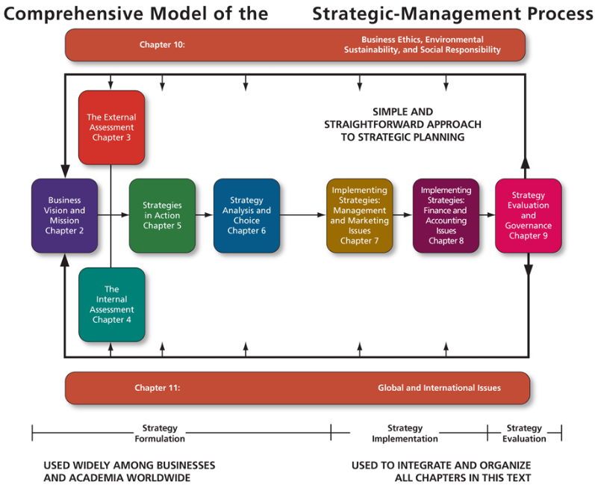

- Program Learning Outcomes (PLO)
- Demonstrate the ability to use integrative and reflective thinking to create business strategy for chosen organization
- Follow a Comprehensive Model of the Strategic-Management Process
- Prepare and present a case analysis of the selected organization business strategy to classmates and faculty

- Course Learning Outcomes (CLO)
- Demonstrate an understanding the purpose and terminology of strategic management
- Explain how to write proper Vision and Mission statement of chosen organization
- Apply your knowledge and conduct Internal Assessment of chosen firm
- Identify opportunities and threats in External Assessment Analysis
- Perform SWOT Matrix and highlight ones that make it as your recommendation
- Create Boston Consulting Group (BCG) Matrix or Internal-External Matrix (IE) focusing on allocation of resources and implications of these tools/resources on your recommendation
- Formulate Recommendation
- Present EPS/EBIT Technique and determine the best alternative to raise the capital to implement strategies
- Explain Projected Financial Statements: start with income statement, net earnings to the balance sheet, highlight several balance sheets such as capital surplus, long-term debt and property/plant/equipment
- Compose Final Conclusion

- Institutional Learning Outcome (ILO)
- Written communication
- Oral communication
- Critical thinking
- Information literacy
- Quantitative reasoning

- Marianist Values
This class represents one component of your education at Chaminade University of Honolulu. An education in the Marianist Tradition in marked by five principles and you should take every opportunity possible to reflect upon the role of these characteristics in your education and development Characteristics of Marinist Universities: Chaminade University of Honolulu, St. Mary’s University, University of Dayton, A Resource Paper, Published in 1999, Republished in 2006

- Educate for formation in faith
“As higher educational institutions, Marianist universities have kept, along with education in the disciplines, a commitment to the development of the whole person, which includes the dimension of religious faith and its personal appropriation and practice.”

Catholic Universities affirm an intricate relationship between reason and faith. As important as discursive and logical formulations and critical thinking are, they are not able to capture all that can be and ought to be learned. Intellectual rigor coupled with respectful humility provides a more profound preparation for both career and life. Intellectual rigor characterizes the pursuit of all that can be learned. Respectful humility reminds people of faith that they need to learn from those who are of other faiths and culture, as well as from those who may have no religious faith at all.

- Provide an integral quality education
“In the Marianist approach to education, “excellence” includes the whole person, not just the technician or rhetorician. It also includes people with their curricular and extra-curricular experiences, their intellectual and spiritual development, understood and supported best in and through community.”

In the Marianist approach to education, excellence includes the whole person, not just the technician or rhetorician. Marianist universities educate whole persons, developing their physical, psychological, intellectual, moral, spiritual, and social qualities. Faculty and students attend to fundamental moral attitudes, develop their personal talents, and acquire skills that will help them learn all their lives. The Marianist approach to education links theory and practice, liberal and professional education. Our age has been deeply shaped by science and technology. Most recently, information and educational technologies have changed the way faculty and students research and teach. At Marianist universities, two goals are pursued simultaneously: an appropriate use of information technology for learning, and the enhancement of interaction between students and teachers. As Catholic, Marianist Universities seek to embrace diverse peoples and understand diverse cultures, convinced that ultimately, when such people come together, one of the highest purposes of education is realized: a human community that respects every individual within it.

- Educate in family spirit
“Marianist educational experience fosters the development of a community characterized by a sense of family spirit that accepts each person with loving respect and draws everyone in the university into the challenge of building community. Community support for scholarship, friendship among faculty, staff and students, and participation in university governance characterize the Marianist University.”

Known for their strong sense of community, Marianists have traditionally spoken of this sense as “family spirit”. Marianist educational experience fosters the development of a community characterized by a sense of family spirit that accepts each person with loving respect and draws everyone in the university into the challenge of community building. Family spirit also enables Marianist universities to challenge their students, faculty and staff to excellence and maturity, because the acceptance and love of a community gives its members the courage to risk failure and the joy of sharing success.

- Educate for service, justice, and peace
“The Marianist approach to higher education is deeply committed to the common good. The intellectual life itself is undertaken as a form of service in the interest of justice and peace, and the university curriculum is designed to connect the classroom with the wider world. In addition, Marianist universities extend a special concern for the poor and marginalized and promote the dignity, rights and responsibilities of all peoples.”

The Marianist approach to higher education is deeply committed to the common good. The intellectual life itself is undertaken as a form of service in the interest of justice and peace, and the university curriculum is designed to connect the classroom with the wider world. In addition, Marianist universities extend a special concern for the poor and marginalized and promote dignity, rights, and responsibilities of all people

- Educate for adaptation and change
“In the midst of rapid social and technological change, Marianist universities readily adapt and change their methods and structures so that the wisdom of their educational philosophy and spirituality may be transmitted even more fully.”

In the midst of rapid social and technological change, Marianist universities readily adapt and change their methods and structures so that the wisdom of their educational philosophy and spirituality may be transmitted even more fully. “New Times call for new methods”, Father Chaminade often repeated. The Marianist University faces the future confidently, on the one hand knowing that it draws on a rich educational philosophy, and on the other fully aware for that philosophy to remain vibrant in changing times, adaptations need to be met. Selected from Characteristics of Marianist Universities: A Resource Paper Published in 1999 by Chaminade University of Honolulu, St. Mary’s University and University of Dayton.

- Native Hawaiian Values
Education is an integral value in both Marianist and Native Hawaiian culture. Both recognize the transformative effect of a well-rounded, value-centered education on society, particularly in seeking justice for the marginalized, the forgotten, and the oppressed, always with an eye toward God (Ke Akua). This is reflected in the ‘Olelo No’eau (Hawaiian proverbs) and Marianist core beliefs:
- Educate for Formation in Faith (Mana) E ola au i ke akua (ʻŌlelo Noʻeau 364) May I live by God.

- Provide an Integral, Quality Education (Na’auao) Lawe i ka maʻalea a kūʻonoʻono (ʻŌlelo Noʻeau 1957) Acquire skills and make it deep.

- Educate in Family Spirit (‘Ohana) ʻIke aku, ʻike mai, kōkua aku kōkua mai; pela iho la ka nohana ʻohana (‘Ōlelo Noʻeau 1200) Recognize others, be recognized, help others, be helped; such is a family relationship.

- Educate for Service, Justice and Peace (Aloha) Ka lama kū o ka noʻeau (ʻŌlelo Noʻeau 1430) Education is the standing torch of wisdom and using it has no boundries.

- Educate for Adaptation and Change (Aina) ʻAʻohe pau ka ‘ike i ka hālau hoʻokahi (ʻŌlelo Noʻeau 203) All knowledge is not taught in the same school.
CHAMINADE UNIVERSITY MISSION STATEMENT
Chaminade University offers its students an education in a collaborative learning environment that prepares them for life, service, and successful careers. Guided by its Catholic, Marianist and liberal arts educational traditions, Chaminade encourages the development of moral character, personal competencies, and a commitment to build a just and peaceful society. The university offers both the civic and church communities of the Pacific region its academic and intellectual resources in the pursuit of common aims.

- Assessment and Grading
Entire course resides in myLAB Management portal. Grades will be based on the following:

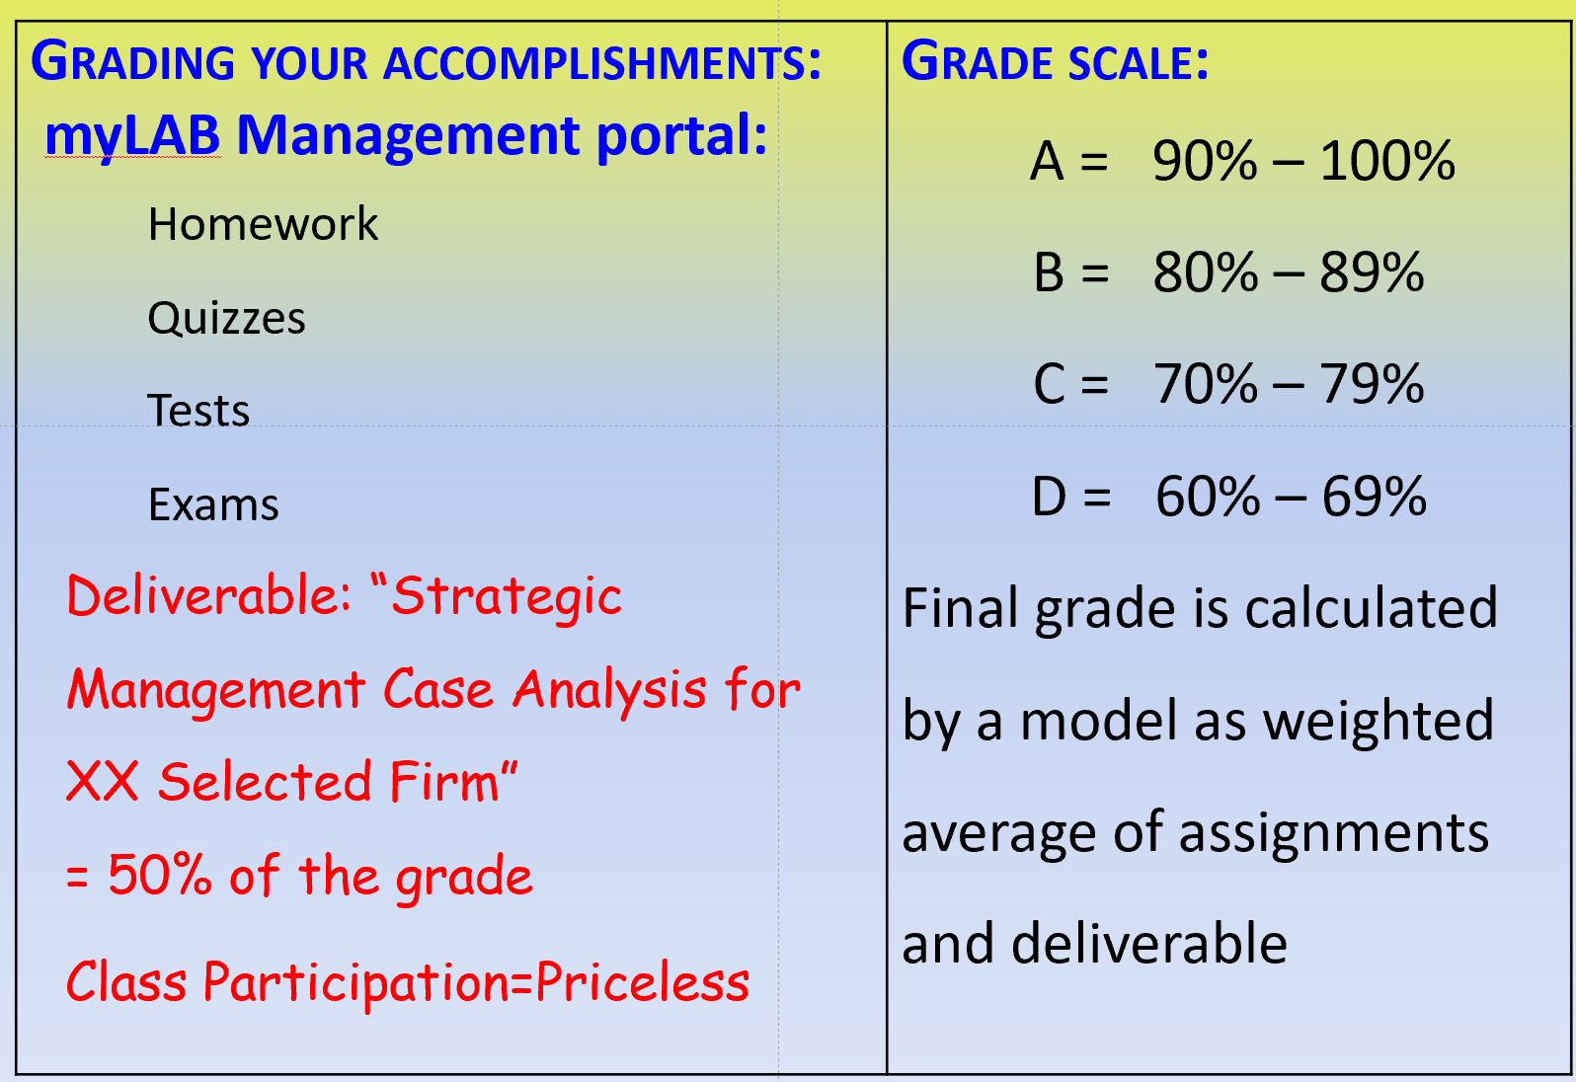
Letter grades are given in all courses except those conducted on a credit/no credit basis. Grades are calculated from the student’s assignments, class participation, quizzes, tests, term papers, reports and exams. They are interpreted as follows:
A Outstanding scholarship and an unusual degree of intellectual initiative
B Superior work done in a consistent and intellectual manner
C Average grade indicating a competent grasp of subject matter
D Inferior work of the lowest passing grade, not satisfactory for fulfillment of prerequisite course work
F Failed to grasp the minimum subject matter; no credit given

My philosophy about learning is that it is never ending process. We learn every day by observing, solving problems, making mistakes and not to repeat them again. Student responsibility is discovering your own style of learning. Educators responsibility is to crate learning environment that student can discover, learn, apply, and flourish.

What students need to know about my pedagogy, how to succeed in such environment?
- Maintain open communication with educator.
- You have an issue, ask me; any question, just ask me.
- Do not be afraid to speak up your mind.
- All my courses are fully online in CANVAS, blended, or web-enhanced, having its own portals for example, Pearson Publisher.
- You grade yourself by doing and submitting assignments (software gradebook).
- If you obtained and grade that you did not expect and you want review incorrect answers and re-do them, you are welcome to do this within next two weeks. Practice is learning. You have to send me email to extended a due date and provided and new due date as your commitment for improvement.
- I do not deduct points; this is a university and you should know why you are here.
- This apply to all types of assignments with exception of EXAMS.
- We do not have final exams. Based on the modern pedagogy literature, they create stress and stress is clutter students critical thinking. We have exams during semester logically scheduled based on covered material.
Exams cannot be repeated and must be complete within assigned dates. If special circumstances had occurred, and you notify me before the date of the exam. Each request to re-do exam will be considered individually.

- University Policies
Academic Conduct Policy
https://chaminade.edu/wp-content/uploads/2019/08/NEW-STUDENT-HANDBOOK-19-20-Final-8.20.19.pdf
See Student Handbook, page# 6

https://chaminade.edu/wp-content/uploads/2019/10/2019-2020-UG-Catalog_updated.pdf
Undergraduate Catalog, 2019-2020 Academic Year
https://portal.chaminade.edu/student/CourseCatalog/2018-2019%20UG%20Catalog.pdf
Undergraduate Catalog, 2018-2019 Academic Year
From the 2018-2019 Undergraduate Academic Catalog (p. 42):
Any community must have a set of rules and standards of conduct by which it operates. At Chaminade, these standards are outlined so as to reflect both the Catholic, Marianist values of the institution and to honor and respect students as responsible adults. All alleged violations of the community standards are handled through an established student conduct process, outlined in the Student Handbook, and operated within the guidelines set to honor both students’ rights and campus values.
Students should conduct themselves in a manner that reflects the ideals of the University. This includes knowing and respecting the intent of rules, regulations, and/or policies presented in the Student Handbook, and realizing that students are subject to the University’s jurisdiction from the time of their admission until their enrollment has been formally terminated. Please refer to the Student Handbook for more details. A copy of the Student Handbook is available on the Chaminade website.
Academic Grievance
Concerns of Academic Issues Questions regarding the conduct of a course, including grading, should be director to the instructor of the course. If the issue cannot be resolved in discussion with the instructor, the student should invoke the additional steps outlines below.

The following three items of an academic nature have specific procedures to address concerns:
- Course content that veers significantly and substantively from the content and requirements as set forth in a course syllabus.
- Demonstrably arbitrary/unfair evaluation of student produced coursework.
- Accusations of plagiarism or other forms of academic dishonesty.

Academic Honesty
Academic honesty is an essential aspect of all learning, scholarship, and research. It is one of the values regarded most highly by academic communities throughout the world. Violations of the principle of academic honesty are extremely serious and will not be tolerated.

Students are responsible for promoting academic honesty at Chaminade by not participating in any act of dishonesty and by reporting any incidence of academic dishonesty to an instructor or to a University official. Academic dishonesty may include theft of records or examinations, alteration of grades, and plagiarism, in addition to more obvious dishonesty.

Questions of academic dishonesty in a particular class are first reviewed by the instructor, who must make a report with recommendations to the Dean of the Academic Division. Punishment for academic dishonesty will be determined by the instructor and the Dean of Academic Division and may include an “F” grade for the work in question, an “F” grade for the course, suspension, or dismissal from the University.

Accusations of Plagiarism or Other Forms of Academic Dishonesty
Plagiarism is the offering of work of another as one’s own. Plagiarism is a serious offense and may include, but is not limited to, the following:
- Complete or partial copying directly from a published or unpublished source without proper acknowledgement to the author. Minor changes in wording or syntax are not sufficient to avoid charges of plagiarism. Proper acknowledgement of the source of a text is always mandatory.
- Paraphrasing the work of another without proper author acknowledgement.
- Submitting as one’s own original work, however freely given or purchased, the original exam, research paper, manuscript, report, computer file, or other assignment that has been prepared by another individual.

In the cases of alleged academic dishonesty, such as plagiarism, cheating, claiming work not done by the student, or lying, where a faculty member observes or discovers the dishonesty, the faculty members may choose to confront the student and handle the matter between the faculty member and the student, or the faculty member may choose to refer the incident to the Dean or Graduate Program Director. If the Dean or Graduate Program Director is the instructor in question, the concern should be directed to the Provost. If the Provost is the instructor in question, the concern should be directed to the President. If the faculty member chooses to confront the situation and it is not satisfactorily resolved between the faculty member and the student, the matter may then be referred or appealed to the Dean or Director.

In either case, the Dean or Graduate Program Director may choose to resolve the matter through a meeting with both the student and the faculty member or refer the matter to the Provost. The findings, in either case, are final.

ADA Policy
https://chaminade.edu/student-life/counseling-services/
email: counselingcenter@chaminade.edu

Counseling Center, Student Support Services Building, Room 101, (808) 735-4845. Pursuant to federal and state laws, including the Americans with Disabilities Act of 1990 as amended by the ADA Amendments Act of 2008 and Section 504 of the Rehabilitation Act of 1973, all qualified students with disabilities are protected from discrimination on the basis of disability and are eligible for reasonable accommodations or modifications in the academic environment to enable them with equal access to academic programs, services, or activities. If a student would like to determine if they meet the criteria for accommodations, they should contact the Counseling Center at (808) 735-4845
or email counselingcenter@chaminade.edu for further information.

Attendance Policy
Class begins on time. Unexcused absence is unacceptable. Chronic tardiness will be viewed as absence from class. Attendance is expected and essential for your progress in this class. The goal of the lecture and discussion is to provide the needed context to remove barriers to students understanding of the material.

The following attendance policy is from the 2018-2019 Academic Catalog (p. 57-58). Faculty members should also check with their divisions for division-specific guidelines.
Students are expected to regularly attend all courses for which they are registered. Student should notify their instructors when illness or other extenuating circumstances prevents them from attending class and plan to complete missed assignments. Notification may be done by emailing the instructor’s Chaminade email address, calling the instructor’s campus extension, or by leaving a message with the instructor’s division office. It is the instructor’s prerogative to modify deadlines of course requirements accordingly. Any student who stops attending a course without officially withdrawing may receive a failing grade.
Unexcused absences equivalent to more than a week of classes may lead to a grade reduction for the course. Any unexcused absence of two consecutive weeks or more may result in being withdrawn from the course by the instructor, although the instructor is not required to withdraw students in that scenario. Repeated absences put students at risk of failing grades.
Campus Security, Henry Hall Annex (808) 735 - 4792
Campus Security at the university is overseen by the Director of Campus Safety, a full-time university employee. Guard services are contracted with Allied Universal. The Campus Security Officers are uniformed, unarmed, and not deputized. Their authority to arrest is the same power as that of any private citizen.

Cell phones, tablets, and laptops
Out of consideration for your classmates, please set your cell phone to silent mode during class. Students are encouraged to bring laptops or tablets to class as the instructor will assign online activities and readings that will require the use of a laptop or tablet. Laptops and tablets should not be misused, such as checking distracting websites. Use your best judgment and respect your classmates and instructor.
Chat online:
Introduce yourself to others in the chat session. Be polite. Choose words carefully. Do not use derogatory statements. Be concise in responding to others in the chat session. Be constructive in your comments.

Classroom Policies
While each instructor has their own policies regarding classroom conduct and requirements, the following University policies apply to all classes:
- Smoking and alcoholic beverages are prohibited in all classrooms, whether or not class is in session.
- No pets are allowed in class. Exceptions will be made in the case of a seeing-eye dog.
- Radio, CD players, headsets, televisions, and other personal audiovisual equipment not pertinent to the class are prohibited during class.
- Cellular telephone use is also prohibited during class except in extenuating circumstances approved in advance by the professor.
- The use of any camera or video devices while in class, restrooms, locker rooms, or in any situation not normally considered public or where users of the facility may reasonably expect privacy is prohibited. Such devices shall include but are not limited to those in mobile telephones, computers, electronic organizers, or other more surreptitious equipment, and which are capable of capturing either still or moving image.
- A dress code requiring footwear and appropriate attire, to be worn in classrooms, as well as in the library, cafeteria, and administrative offices. No beachwear is allowed. Laboratories have additional requirements. Please note that it is the instructor’s sole prerogative to determine whether a student is.
- In a fit condition to perform classroom work (e.g., is not under the influence of alcohol or drugs, and is not sleeping).
- Working on assignments for that particular class (rather than working on projects for other classes or engaging in activity unrelated to schoolwork).
- Distracting other students as to impair the learning environment.

If the instructor finds a student in violation of any of these provisions, or the policies outlines in the course syllabus, he or she may require the student to leave the classroom and may subsequently mark the student absent, which could eventually affect the student’s final grade. Failure on the part of the student to honor the instructor’s request to leave the classroom may result in removal of the student by the University security personnel and initiation of the University disciplinary process.

Communicable Disease Policy
https://www.cdc.gov/
Residence Life: (808) 739-4648
Dean of Students: (808) 735-4710

Discussion Groups:
- Review discussion threads thoroughly before entering the discussion.
- Maintain threads by using the “reply” button rather than starting a new topic.
- Be respectful of others’ ideas.
- Read the comments of others thoroughly before entering your remarks.
- Cooperate with group leaders in completing assigned tasks.
- Be positive and constructive in group discussions.
- Respond in a thoughtful and timely manner.

Drug – Free Workplace & Campus Policy
Student Handbook, on page # 43

Grades of "Incomplete"
Student will be given one more chance to complete assignment within 90 days.

Guidelines for Communication
Email: Use your Chaminade email account.
Always include a subject line.

Remember that without others being able to see your facial expressions or hear your tone, some comments may be taken in a way you did not intend. So be careful in wording your emails. Use of emoticons may be helpful in some cases.

Special formatting such as centering, audio messages, tables, html, etc. should be avoided unless necessary to complete an assignment or other communication.

Information Technology Resources
Computer Labs The public computer lab on campus is located on the central floor of the Sullivan Family Library. This computer lab features PC desktops as well as MACs with a variety of software and provides an ideal environment for students and faculty to reference materials for research, as well as work assignments. For use of specialized computer labs in Environmental + Interior Design and Communications, please seek approval from the respective department. 2029-2020 UG Catalog, page # 24.

Instructor and Student Communication
Questions for this course can be emailed to the instructor at mariabrownlow@hawaiaintel.net online, in-person and phone conferences can be arranged. Response time will take place up to time required for discussion.
Online, in-person and phone conferences can be arranged. Response time will take place within 24 hours.

Late Work Policy
Points are NOT deducted however assignment must be delivered within 2 weeks of assignment date or valid reason is provided.

Library:
Provide a link to the Chaminade library, www.chaminade.edu/library

Privacy and Confidentiality
See Student Handbook, page # 20.

Procedures for Filing a Complaint, Internal Informal Process
See Student Handbook, page # 20 – 23

Students must be familiar with current Student Handbook: https://chaminade.edu/wp-content/uploads/2019/08/NEW-STUDENT-HANDBOOK-19-20-Final-8.20.19.pdf

Here are a few important You Need to Know:
24-Hour Chaminade University Emergency Information Hotline (808) 739 - 7499; (833) 739 - 7499
University Emergency Information webpage: https://chaminade.edu/emergency/

Technical Support:
CANVAS Technical Support is: 1-877-251-6615

Technical Assistance for Canvas Users:
Search for help on specific topics at help.instructure.com
Chat live with Canvas Support 24/7/365
Watch this video to get you started with online guides and tutorials
Contact the Chaminade IT Helpdesk for technical issues: helpdesk@chaminade.edu or call (808) 735-4855

Title IX Compliance
Chaminade University of Honolulu recognizes the inherent dignity of all individuals and promotes respect for all people. Sexual misconduct, physical and/or psychological abuse will NOT be tolerated at CUH. If you have been the victim of sexual misconduct, physical and/or psychological abuse, we encourage you to report this matter promptly. As a faculty member, I am interested in promoting a safe and healthy environment, and should I learn of any sexual misconduct, physical and/or psychological abuse, I must report the matter to the Title IX Coordinator. If you or someone you know has been harassed or assaulted, you can find the appropriate resources by visiting Campus Ministry, the Dean of Students Office, the Counseling Center, or the Office for Compliance and Personnel Services.

Tutoring Services
All Chaminade undergraduate students are eligible to receive free tutoring through Kōkua ʻIke: Center for Student Learning. Kōkua ʻIke. Provides in-person tutoring with student or professional tutors. Appointments are scheduled via an online appointment system. Students seeking more information and wanted to schedule appointments should stop by Kōkua ʻIke, located in the Student Services Building, call the Tutor Coordinator at 808-735-8305 or email tutoring@chaminade.edu. Graduate students are also eligible for tutoring in certain subject areas. Please call 808-735-8305 for further information. All Chaminade students have access to Smarthinking, an online tutoring resource. Students may access Smarthinking through the university’s learning management system. Please call 808-735-8305 for further information.

Undergraduate Catalog 2019-2020 Academic Year
https://chaminade.edu/wp-content/uploads/2019/10/2019-2020-UG-Catalog_updated.pdf

Use of Technology to Harass
No student may, under any circumstances, use technology to harass any other person.
See Student Handbook, page # 24

Writing Policy
This course support described recommendation on formatting, e.g., use of MLA or APA. The standard font is Calibri or Arial.

Farsighted. How We Make the Decisions that Matter the Most” by Steven Johnson, New York Times best- selling author
John Dewey (1859-19520, the founder of the philosophical movement known as pragmatism.
3 From the textbook, Ch1, page 4
2019-20202 UG Catalog

