2020 Summer Semester
July 27th – August 16^{th,} 2020
HCM-701-90-3 Healthcare Informatics, Data and Biostatistics
Online eLearning

Dare to Learn. Dare to Change.
Digital learning removes limits and gives us the freedom to provide education anytime and anywhere, empowering us to overcome our most difficult challenges.

Class Schedule: Online, eLearning using CANVAS
Office Hours: via email or phone
Instructor Information: Dr. Maria Brownlow
Preferred Outlook email: mariabrownlow@hawaiiantel.net

email: maria.brownlow@chaminade.edu
Contact: 808 – 739 – 8337

Catalogue Course Description
Study of the health informatics domain, including emergence of the discipline, health information systems design and implementation, clinical data standards theory and development, and electronic record integration into the healthcare system. Overview of public health data collection and common statistical measures of health and disease.

Textbook:

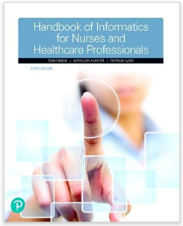
Toni L. Hebda, Toni Lee Hebda, BSN, M.N.Ed., Ph.D., MSIS, Chatham University, Kathleen Hunter, Patricia Czar, RN, St. Francis Medical Center, School of Nursing, Patricia Czar

Handbook of Informatics for Nurses & Healthcare Professionals, 6th edition, ©2019
ISBN – 13: 978-0134711010

See my note below about textbook!

Why ISBN is important?
This bar-code number lets you verify that you are getting exactly the right version or edition of a book. The 13-digit and 10-digit formats both works.

You can rent eBook or textbook for under $30 with free shipping from:
- The CUH bookstore rents the eBook (same as Pearson)

- VitalSource rents textbook, click on https://www.vitalsource.com
Textbook URL: https://www.vitalsource.com/products/handbook-of-informatics-for-nurses-amp-healthcare-toni-l-hebda-v9780134748436
Note: Read aloud is available with Vital Source.

- Amazon.com, search Textbooks and ISBN – 13: 978-0134711010 to rent a textbook

- Course Orientation
Healthcare informatics became a fast-growing profession after 1991. The Accredited Standards Committee (ASN) and X12N Insurance subcommittee was created. The ASN began developing the general standards that would be used for health facilities. These standards were accepted by entire healthcare administration ecosystem allowing an interactive communication with its members. No matter where patients were located, health care providers (with permission because of HIPPA) were able to access confidential medical records to provide higher quality care through:
- Access to electronic medical records to deliver patient-centered care
- Storing and sharing electronic medical records as mandated by the Federal Government by 2018
- Consequently, organization like American Medical Informatics Association (AMIA) improve health through informatics education, science, and practice
- AMIA aims to lead the way in transforming health care through trusted science, education, and the practice of informatics.
Informatics is a science that drives innovation in defining future approaches to information and knowledge management in biomedical research, clinical care, and public health. Informatics researchers develop, introduce, and evaluate new biomedically motivated methods in areas as diverse as:
- data mining
- deriving new knowledge from large databases, big data
- natural language or text processing, Artificial Intelligence
- cognitive science emerged
- human interface design in decision support
- creating large databases and algorithms for analyzing large amounts of data generated in public health, possible due to tremendous technology growth
- conduct various research, such as clinical research, or genomics/proteomics
The science of informatics is inherently interdisciplinary. It draws on and contributes to many other component fields, for example, computer science, decision-making science, information and management science, cognitive science, and organizational theory.

Why informatics? Informatics fast-tracks healthcare’s revolution by collecting, analyzing, and applying data directly to care decisions. Data generated throughout health and healthcare are the driving force of informatics and its ability to innovate critical advancements that directly benefit people.

The American Medical Informatics Board (AMIB) in November 2012 created and published a white paper: definition of biomedical informatics and specification of core competencies for graduate education in the discipline.

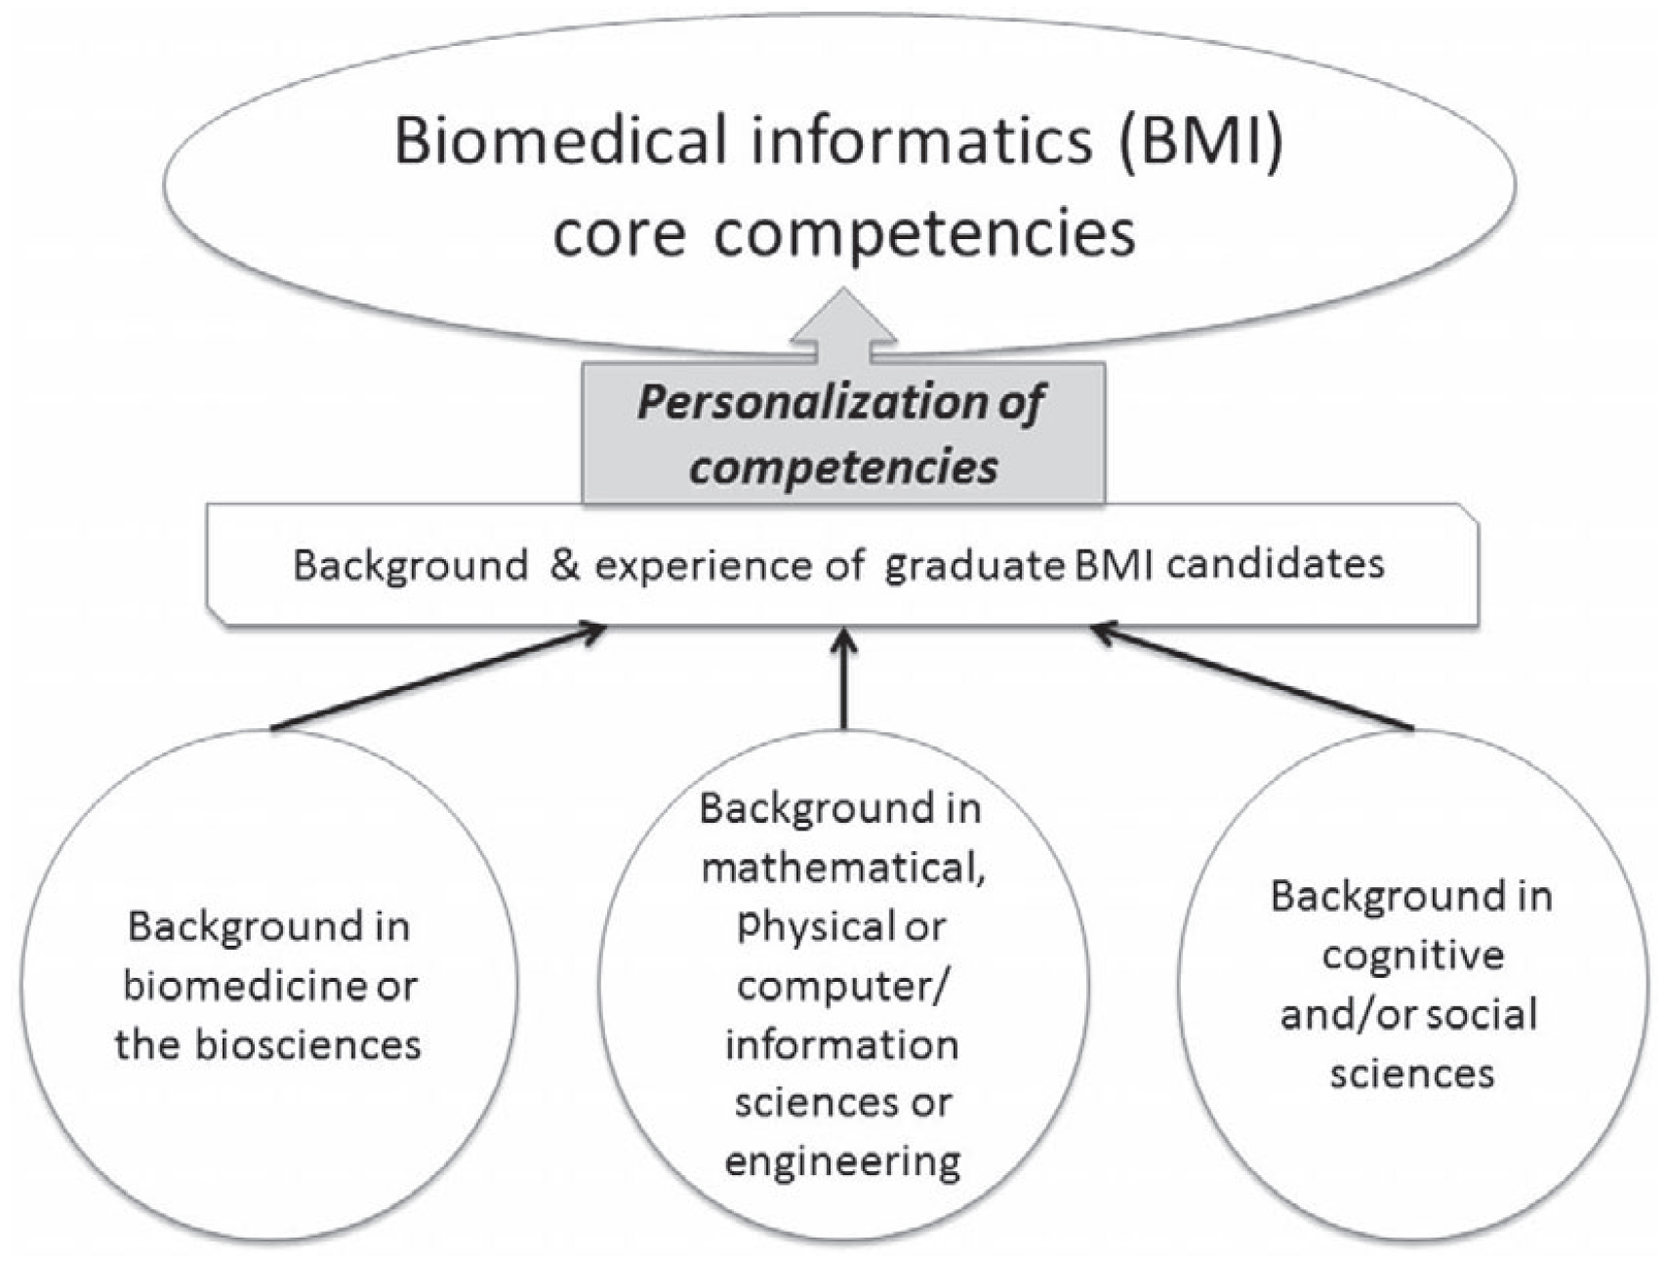
Figure 3. The need to adapt biomedical informatics core competencies to the backgrounds of individual graduate program candidates.

How does informatics, data and biostatistics benefit people? For years, name-drug Lipitor were prescribed to people with high level of cholesterol to prevent heart attacks, even this drug had many side-effects and badly interacted with other medications that patients were taking. Research conducted about heart attacks discovered that there is a relationship between LDL (low-density lipoprotein cholesterol, so called bad cholesterol and HDL (high-density lipoprotein cholesterol, also called good cholesterol.

Researchers found out that people who were given Lipitor had more heart attacks than others who did not. In brief, medical community stop prescribing Lipitor to their patents and replaced it with a generic drug, called Atorvastatin, which is used widely today.

The informatics community typically uses the term health informatics referring it to applied research and practice of informatics across the clinical and public health domains. Medical informatics is an earlier term, no longer routinely used, outdated by the growth of bioinformatics.

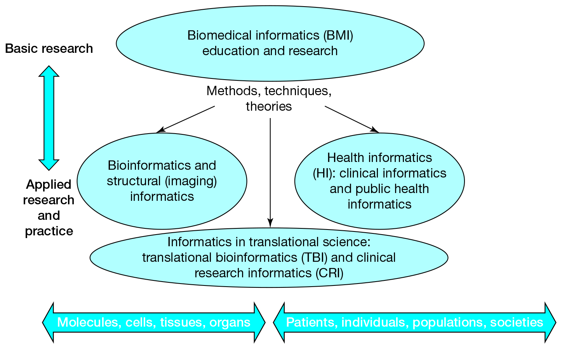
Figure 1. Biomedical informatics and its areas of application and practice, spanning the range from molecules to populations and society (adapted from Shortliffe and Blois3).

Knowledge is power and affects everybody’s life, and you are about to acquire some of this knowledge.

- Program Learning Outcome
In addition to the existing learning outcomes for the MBA Core Program, the Master Business Administration – Healthcare Concentration Administration (MBA-HCA) students will:

Learn about the social, political, physical, and mental determinants of health and the processes that lead to health inequity.

Gather information about local, regional, and national healthcare economic environments to serve and support their need for healthcare and support healthcare-decision making.

Comprehend the legal, ethical, policy and regulatory issues for contemporary healthcare organizations.

Define, analyze, and promote strategies for healthcare advocacy and policy-making that respond to the rapidly changing healthcare environment.

Demonstrate specialized knowledge and an integrated understanding of the healthcare ecosystem and applying this knowledge in a client-directed project related to a contemporary issue in healthcare.

- Course Learning Outcomes
After completion of this short course, students will be able:

- To understand the role that technology plays in healthcare.

- Describe the process required to create an informatics culture.

- Examine the relationship between technology, informatics, and caring.

- Discuss the relevance of theory for informatics research and practice.

- Compare and contrast the different informatics subdisciplines found within healthcare.

- Weigh how the scope of informatics practice determines the types and levels of competencies needed.

- Course Teaching Approach
This course is designed to promote student participation through discussions on CANVAS of current informatics issues as they relate to higher quality care. Students will study and apply process thinking to practical issues and decisions faced by patients coming from out-patient care facilities, clinics, and hospitals. Healthcare informatics, when used properly, can improve safety of care outcomes, patient participation, and public health on a larger scale.

The graduate course will be taught, as follows:

- Power Points lectures presentations to support students’ studies.
- Chapters on informatics theory and practice has been thoroughly revised in the new textbook to reflect the current and evolving practice of healthcare Information Technology (IT) and informatics.
- HCM Multimedia Library was created for selected chapters where appropriate, using YouTube.com and TED.com
- Separate chapters on policy, legislation, regulatory, reimbursement, and accreditation issues are now combined to show the relationship among them and to contextualize information system design and use.
- Assignments: quizzes and exams will be assigned to students on CANVAS to validate learned material.
- Chapter handouts will be made available to students; these handouts will be used by students to follow the lectures, Power Point presentations and for note taking purposes. These handouts can be used for assignments preparation.

Note: All these tools will be used when applicable.

- Assessment and Grading

Recommended Learning Strategies
- Chapter Assignments must be read prior to performing any assignments on CANVAS.

- Review videos library were appropriate to aide understanding presented concepts and its applications.

- Complete quizzes assigned after each chapter to reinforce the learning material.

- Submit assignments on-time.

- Contribute to and participate in team projects (if assigned). You will learn to become a confident working within teams, improving people skills.

Learning Informatics science is designed to promote student participation in online course on CANVAS. Various multimedia resources of current events in the business world will be reviewed as they relate to the health care decision-making processes.

Grading your accomplishments:  Quizzes  Team projects  Exams | Grade scale:  A = 90% – 100%  B = 80% – 89%  C = 70% – 79%

This is online course therefore chapter assignments must be completed within two weeks and NOT to carry an overdue assignment to the end of the course.

All assignments will be posted on CANVAS must be completed within an assigned date.

Quizzes will be given with each chapter. A request to make up exams will be allowed only with prior approval from the instructor. Student must request the make-up date before the scheduled examination date. The final grade will be calculated as an average or weighted grade of all assignments during semester.

Changes to the syllabus will be made, if necessary, and will be communicated to students. Students are responsible for ensuring that they read a current syllabus.

Course Ground Rules

Attendance policy
This class is on-line. Following assignments schedule is expected.

Academic Honesty
Students are responsible for promoting academic honesty at Chaminade by not participating in any act of dishonesty. Academic dishonesty may include theft of records or examinations, alteration of grades, and plagiarism. Questions of academic dishonesty in a class are first reviewed by the instructor who must make a report with recommendations to the Business School Dean. Consequences for academic dishonesty may range from an “F” grade for the work in question to an “F” grade for the course to suspension or dismissal from the University.

Syllabus Modification
This syllabus is only a plan. The instructor may modify the plan during the course. The requirements of the course may be altered from those appearing in the syllabus. Further, the plan contains criteria by which the student’s progress and performance in the course will be measured. These criteria may also be changed, and students will be notified.

Guidelines for Communication
Email: Use your Chaminade email account unless specified otherwise by instructor
Always include a subject line.

Remember that without others being able to see your facial expressions or hear your tone, some comments may be taken in a way you did not intend. So be careful in wording your emails. Use of emoticons may be helpful in some cases.

Special formatting such as centering, audio messages, tables, html, etc. should be avoided unless necessary to complete an assignment or other communication.

Discussion Groups:
- Review discussion threads thoroughly before entering the discussion.
- Maintain threads by using the “reply” button rather than starting a new topic.
- Be respectful of others’ ideas.
- Read the comments of others thoroughly before entering your remarks.
- Cooperate with group leaders in completing assigned tasks.
- Be positive and constructive in group discussions.
- Respond in a thoughtful and timely manner.

Chat online:
Introduce yourself to others in the chat session. Be polite. Choose words carefully. Do not use derogatory statements. Be concise in responding to others in the chat session. Be constructive in your comments.

Instructor and Student Communication
Questions for this course can be emailed to the individual instructor at the email provided by instructor. Online, in-person and phone conferences can be arranged. Response time will take place within 24 hours.

- Institutional Learning Outcome
- Written communication
- Oral communication
- Critical thinking
- Information literacy
- Quantitative reasoning

- Marianist Values

This class represents one component of your education at Chaminade University of Honolulu. An education in the Marianist Tradition in marked by five principles and you should take every opportunity possible to reflect upon the role of these characteristics in your education and development:

- Educate for formation in faith
“As higher educational institutions, Marianist universities have kept, along with education in the disciplines, a commitment to the development of the whole person, which includes the dimension of religious faith and its personal appropriation and practice.”

- Provide an integral quality education
“In the Marianist approach to education, “excellence” includes the whole person, not just the technician or rhetorician. It also includes people with their curricular and extra-curricular experiences, their intellectual and spiritual development, understood and supported best in and through community.”

- Educate in family spirit
“Marianist educational experience fosters the development of a community characterized by a sense of family spirit that accepts each person with loving respect and draws everyone in the university into the challenge of building community. Community support for scholarship, friendship among faculty, staff and students, and participation in university governance characterize the Marianist University.”

- Educate for service, justice, and peace
“The Marianist approach to higher education is deeply committed to the common good. The intellectual life itself is undertaken as a form of service in the interest of justice and peace, and the university curriculum is designed to connect the classroom with the wider world. In addition, Marianist universities extend a special concern for the poor and marginalized and promote the dignity, rights and responsibilities of all peoples.”

- Educate for adaptation and change
“In the midst of rapid social and technological change, Marianist universities readily adapt and change their methods and structures so that the wisdom of their educational philosophy and spirituality may be transmitted even more fully.”

- Hawaiian Values
Education is an integral value in both Marianist and Native Hawaiian culture. Both recognize the transformative effect of a well-rounded, value-centered education on society, particularly in seeking justice for the marginalized, the forgotten, and the oppressed, always with an eye toward God (Ke Akua). This is reflected in the ‘Olelo No’eau (Hawaiian proverbs) and Marianist core beliefs:
- Educate for Formation in Faith (Mana) E ola au i ke akua (ʻŌlelo Noʻeau 364) May I live by God.

- Provide an Integral, Quality Education (Na’auao) Lawe i ka maʻalea a kūʻonoʻono (ʻŌlelo Noʻeau 1957) Acquire skill and make it deep.

- Educate in Family Spirit (‘Ohana) ʻIke aku, ʻike mai, kōkua aku kōkua mai; pela iho la ka nohana ʻohana (‘Ōlelo Noʻeau 1200) Recognize others, be recognized, help others, be helped; such is a family relationship.

- Educate for Service, Justice and Peace (Aloha) Ka lama kū o ka noʻeau (ʻŌlelo Noʻeau 1430) Education is the standing torch of wisdom.

- Educate for Adaptation and Change (Aina) ʻAʻohe pau ka ‘ike i ka hālau hoʻokahi (ʻŌlelo Noʻeau 203) All knowledge is not taught in the same school.

Title IX Compliance
Chaminade University of Honolulu recognizes the inherent dignity of all individuals and promotes respect for all people. Sexual misconduct, physical and/or psychological abuse will NOT be tolerated at CUH.

If you have been the victim of sexual misconduct, physical and/or psychological abuse, we encourage you to report this matter promptly. As a faculty member, I am interested in promoting a safe and healthy environment, and should I learn of any sexual misconduct, physical and/or psychological abuse, I must report the matter to the Title IX Coordinator. If you or someone you know has been harassed or assaulted, you can find the appropriate resources by visiting Campus Ministry, the Dean of Students Office, the Counseling Center, or the Office for Compliance and Personnel Services.

Library
Link to the Chaminade library www.chaminade.edu/library.

Technical Support
For technical questions contact CANVAS Technical Support at: 1-877-251-6615.

Pearson Higher Ed
https://www.hhs.gov/hipaa/for-professionals/privacy/index.html
Characteristics of Marinist Universities: Chaminade University of Honolulu, St. Mary’s University, University of Dayton, A Resource Paper, published in 1999, Republished in 2006

