2019 Fall Evening Semester
October 07 – December 18, 2019
CIS-103-90-2 Computers & Application Software
Online eLearning on myITlab portal

Dare to Learn. Dare to Change.
Digital learning removes limits and gives us the freedom to provide education anytime and anywhere, empowering us to overcome our most difficult challenges.

- Overview

Computers have become an essential part of our life. They are found everywhere. It is difficult to find a business or profession that does not rely on computers. Therefore, it is important to learn basic computing skills and gain knowledge to become computer fluent. During this course, we will look at two different applications which have been used universally in every business and many individuals to track their own business endeavors.

Past years’ experience showed that students already have basic skills of using MS Word and Power Point, therefore this course is focused on teaching advanced Excel and advanced Access Data Base.

Business world expect advanced hands-on knowledge of Excel and Access from the higher education graduates. In the current job market, comprehension of Excel and Access DB is assumed. Students who possess these skills highly increase chances to obtain a job offer and/or increase their chances for promotion.

Class Schedule: Online
Office Hours: Noon – 01:00 PM; MWF at Kieffer Room 28 or by appointment
Contact Office: 808 – 739 – 8337

Instructor Information: Dr. Maria Brownlow
Primary email: mariabrownlow@hawaiiantel.net

Email: maria.brownlow@chaminade.edu

Textbook:

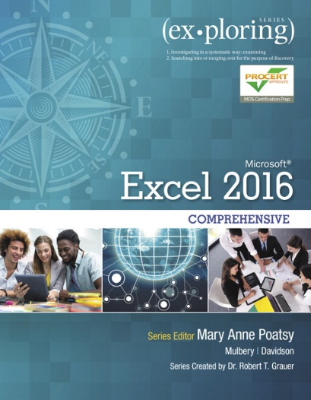
CIS-103-90-2 Computers and Applications Software (3 Credits)
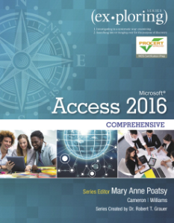

ISBN: 978-0-13-447944-6 ISBN: 978-013-447945-3

NOTE:
This course is not on CANVAS. It has its own portal called myITlab. All assignments will be located on myITlab.

At minimum, an access code to myITlab portal with eText is required for this course.

It is strongly recommended that students, who have never used Excel and Access, purchase or rent these two textbooks from the Chaminade bookstore at very competitive prices. You also MUST buy an access code with eText for this course.

If you have questions, please contact me via email: maria.brownlow@chaminade.edu

- Catalogue Course Description
Computers have become an essential part of our life. It is difficult to find a business or profession that does not rely on computers. Hence, it is imperative to learn computing skills and gain knowledge to become computer fluent. This course focuses on computer concepts such as the operating system, advanced Excel and advanced Access databases. This course also introduces student to basics of project management using MS Project. These three (3) applications are major departmental computing tools in the digital organization. Knowledge of Excel, Access and MS Project is expected from students entering the job market today. No prerequisites. Offered every semester.

- Excel 2016 and Access Data Base 2016 series Exploring … Move students beyond the point-and-click.
The goal of the Exploring series is to open passage for students beyond the point and click, to understanding the why and how behind each skill. So much learning take place outside of the classroom, these series provide learning tools that students can access anywhere and anytime.
Students go to college now with a different set of skills than they did years ago. With this in mind, the Exploring series seeks to move students beyond the basics of the software at a faster pace, without sacrificing coverage of the fundamental skills that everyone needs to know.

MyITLab is an online homework, tutorial and assessment program designed to work with this text to engage students and improve results. Within its structured environment, students practice what they learn, test their understanding and pursue a personalized study plan that helps them absorb course material and understand challenging concepts.

- Excel
Students will learn concepts and uses of spreadsheet software on the personal computer. Business decision-making worksheet models will be created and modified by entering labels, functions and formulas. Various formatting techniques will be applied to enhance the appearance of printed worksheets. Students will also learn to display the worksheet data graphically with the charting capabilities of the software.

Learning Outcomes
- Given a set of business data and analysis/presentation needs, students will design an appropriate workbook.
- Students should be able take existing worksheets and implement required revisions, inspect, assess and revise content and format to reflect changed requirements.
- Given the need to present data to a diverse audience, such as an annual stockholder meeting, students should be able to create a chart/graph using an appropriate chart type for depicting the given data such as trends, proportions, etc.
- Students will take an integrated document, containing text, tables and/or graphs/charts, and create a report with linked and/or embedded objects.
- Students will learn how to use formulas and functions, chart data.
- With specialized functions, performing logical and lookup functions students will learn an advanced Excel that is widely used today in most area of life.

- And finely students will learn:
- How to use multiple-sheets and manage them
- Importing data from external resources
- Collaboration and workbook distribution
- Creating templates, styles and using macros

- Institutional Learning Outcome (CUH)
- Written communication
- Oral communication
- Critical thinking
- Information literacy
- Quantitative reasoning

- Marianist Values

This class represents one component of your education at Chaminade University of Honolulu. An education in the Marianist Tradition in marked by five principles and you should take every opportunity possible to reflect upon the role of these characteristics in your education and development:

- Educate for formation in faith
“As higher educational institutions, Marianist universities have kept, along with education in the disciplines, a commitment to the development of the whole person, which includes the dimension of religious faith and its personal appropriation and practice.”

- Provide an integral quality education
“In the Marianist approach to education, “excellence” includes the whole person, not just the technician or rhetorician. It also includes people with their curricular and extra-curricular experiences, their intellectual and spiritual development, understood and supported best in and through community.”

- Educate in family spirit
“Marianist educational experience fosters the development of a community characterized by a sense of family spirit that accepts each person with loving respect and draws everyone in the university into the challenge of building community. Community support for scholarship, friendship among faculty, staff and students, and participation in university governance characterize the Marianist University.”

- Educate for service, justice and peace
“The Marianist approach to higher education is deeply committed to the common good. The intellectual life itself is undertaken as a form of service in the interest of justice and peace, and the university curriculum is designed to connect the classroom with the wider world. In addition, Marianist universities extend a special concern for the poor and marginalized and promote the dignity, rights and responsibilities of all peoples.”

- Educate for adaptation and change
“In the midst of rapid social and technological change, Marianist universities readily adapt and change their methods and structures so that the wisdom of their educational philosophy and spirituality may be transmitted even more fully.”

Title IX Compliance
Chaminade University of Honolulu recognizes the inherent dignity of all individuals and promotes respect for all people. Sexual misconduct, physical and/or psychological abuse will NOT be tolerated at CUH.

If you have been the victim of sexual misconduct, physical and/or psychological abuse, we encourage you to report this matter promptly. As a faculty member, I am interested in promoting a safe and healthy environment, and should I learn of any sexual misconduct, physical and/or psychological abuse, I must report the matter to the Title IX Coordinator. If you or someone you know has been harassed or assaulted, you can find the appropriate resources by visiting Campus Ministry, the Dean of Students Office, the Counseling Center, or the Office for Compliance and Personnel Services.

- Access Database
Databases are everywhere, every Internet application uses database. This course introduces the concepts and real-world applications that use relational database software.
Organizations relay on databases to store data that is presented as information using reports.
Foundational database competencies, including building tables, defining fields, relating tables, entering and editing data, filtering, and sorting will be covered. Students will query the database to select, calculate and summarize information. Students will build and customize forms and reports.

Learning Outcomes
- Students will navigate a database.
- Perform data manipulation using filters and sorts.
- Use relations window and understand relational power.
- Students will design databases using related data, create a query and use the query wizard.
- Given directions, students will customize, analyze and summarize query data.
- Students will learn to create professional and useful reports.
- Create and use pivot table to discover trends and variances in the organization data sources.
- Establish data validation and input mask.
- Restricts edits in a form.
- Create various queries to display data or missing data.
- Using macros and SQL in Access.

Keys to Success
- Follow instructions and review “how to do this” videos
- Complete and submit your work within the time frame allotted
- Prepare yourself to become a professional in today’s business world
- Get in the game, success is an objective to be achieved and not due to good luck

- Course Teaching Approach
This course is designed to promote student participation in online eLearning through “hands-on” lab exercises. Demonstrations and videos will be used to assist in completing assignments in a form of hands-on exercises and skill-based exams at the end of every chapter. Students are responsible for reading recommended textbook chapters and use “hands-on” exercises on myITlab portal.

Applications, technology and audio-visual tools will make this course highly interactive and experiential. The undergraduate course will be taught, as follows:

- Enhanced Objective Mapping: enables students to follow a directed path through each chapter, from the objectives list at the chapter opener through the exercises in the end of chapter

- Key Terms Matching: a new exercise that requires students to match key terms to their definitions. This requires students to work actively with this important vocabulary and prove conceptual understanding

- Case Study: presents a scenario for the chapter, creating a story that ties the Hands-On Exercises together

- Hands-On Exercise Videos: are tied to each Hands-On Exercise and walk students through the steps of the exercise while weaving in conceptual information related to the Case Study and the objectives as a whole

- End-of-Chapter Exercises: offer several options for self-assessment. Each chapter has approximately 12—15 exercises ranging from multiple choice questions to open-ended projects

- Enhanced Mid-Level Exercises: include Analysis Case which requires students to interpret the data they are using to answer an analytic question, as well as Discover Steps, which encourage students to use Help or to problem-solve to accomplish a task

New Beyond the Classroom Exercise introduce videos on skills like interview etiquette and time management and require students to use the Office applications to explore those skills more deeply.

Application Capstone exercises or simulations are included in the book to allow testing students on the entire contents of a single application. These are also Grader Projects in MyITLab.

More Grader Projects include not only the chapter Capstone Exercise, but also 2-3 Mid-Level Exercises per chapter.

MOS Certification Guide for instructors and students to direct anyone interested in prepping for the MOS exam to the specific locations to find all content required for the test.

Note: Not all the types of assignments mentioned above will be used during semester.

- Recommended Learning Strategies
- Chapter Assignments must be reviewed prior to begin working on exercise (watch videos “how to do this.” Students familiar with chapter materials will be effective in completing assignment on time.

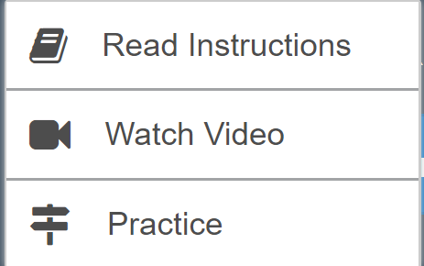

Learning aids provide students with 3-steps process:
- Read Instructions with detailed descriptions in the textbook or eBook
- Watch video showing step-by-step process of doing task
- Practice by doing

- Review examples and solutions within each chapter to reinforce the understanding of presented concepts.

- Complete tests and quizzes after each chapter to reinforce the learning material.

- Submit assigned homework on time.

- Take part in classroom discussions and ask questions via discussion board.

- Complete and submit the exams, as scheduled.

- Grading
Grading will be based on the following table:

Grading your accomplishments:  Assignments  Exercises  Exams | Grade scale:  A = 90% – 100%  B = 80% – 89%  C = 70% – 79%  D = 60% – 69%

Final grade for the CIS103 course will be calculated as a weighted average of the Excel and Access DB grades. All assignments will be posted on the myITlab portal. Assignments on myITlab portal have be completed within the same week as assigned. Under special circumstances, you can complete the exercises the following week. A request to make-up exams will be allowed only with prior approval from the instructor. You must request the make-up date before the scheduled examination date. Contact me, at any time for an estimate of your current grade.

- Policies
Late assignments
Student is responsible to contact instructor for make-up assignments and exams. Student must notify the instructor before any posted due date that is unable to work on the assignment within posted due dates.

Students are also expected to have read and to abide by the “Student Rules of Conduct” which are available in your copy of Chaminade University’s Student Handbook or on Chaminade website.

Pearson Higher Ed
Characteristics of Marinist Universities: Chaminade University of Honolulu, St. Mary’s University, University of Dayton, A Resource Paper, published in 1999, Republished in 2006

