



PAR 205: ACTING I Fall, 2019
Course Number: PAR205-01-1

THR 305: ACTING II
Course Number: PAR305-01-1
3 Academic Credits
Performing Arts Discipline
Division of Humanities and Fine Arts

Bro. Gary E. Morris, S.M. Tu/Th, 2:30-3:50pm
Office: Ching 105A Ching 101—The Loo Theater
Phone: 440-4246
Office Hours: T. Th.1:00-2:30 PM (also by appointment)
MW.F. By appointment
E-mail address: gmorris@chaminade.edu



Course Description
The course aims to develop an appreciation of theater and the acting process. The student will develop a basic understanding of the acting process through improvisation, exercises, various reading and writing assignments—all given practical exploration when applied to scene and monologue work. Acting skills of relaxation and concentration are combined with script analysis, line interpretation and character development to produce short performances that are worthy of the craft of acting.

THR 305—advanced development of the above



Performing Arts Program Learning Outcomes (PLOs)
- Become familiar with the history of the performing arts, particularly the development of art forms, styles and genres
- Demonstrate the skills used in the performing arts in a hands-on, practical experience within a learning community in music and/or theatre.
- Be knowledgeable about major actors, directors, playwrights, composers, musicians and other collaborative artists who have contributed to music and the theatre.
- Be able to critique a performance and apply the rules for criticism in the performing arts.

Marianist Values
This class represents one component of your education at Chaminade University of Honolulu. An education in the Marianist Tradition in marked by five principles and you should take every opportunity possible to reflect upon the role of these characteristics in your education and development:
- Education for formation in faith
- Provide an integral, quality education
- Educate in family spirit
- Educate for service, justice and peace
- Educate for adaptation and change

Native Hawaiian Values
Education is an integral value in both Marianist and Native Hawaiian culture. Both recognize the transformative effect of a well-rounded, value-centered education on society, particularly in seeking justice for the marginalized, the forgotten, and the oppressed, always with an eye toward God (Ke Akua). This is reflected in the ‘Olelo No’eau (Hawaiian proverbs) and Marianist core beliefs:
- Educate for Formation in Faith (Mana) E ola au i ke akua (ʻŌlelo Noʻeau 364) May I live by God
- Provide an Integral, Quality Education (Na’auao) Lawe i ka maʻalea a kūʻonoʻono (ʻŌlelo Noʻeau 1957) Acquire skill and make it deep
- Educate in Family Spirit (‘Ohana) ʻIke aku, ʻike mai, kōkua aku kōkua mai; pela iho la ka nohana ʻohana (‘Ōlelo Noʻeau 1200) Recognize others, be recognized, help others, be helped; such is a family relationship
- Educate for Service, Justice and Peace (Aloha) Ka lama kū o ka noʻeau (ʻŌlelo Noʻeau 1430) Education is the standing torch of wisdom
- Educate for Adaptation and Change (Aina) ʻAʻohe pau ka ‘ike i ka hālau hoʻokahi (ʻŌlelo Noʻeau 203) All knowledge is not taught in the same school

Course Outcomes
The desirable outcomes from this class are that students will:

- Possess fundamental knowledge and practice of the vocal and physical tools required for acting (PLO #2)
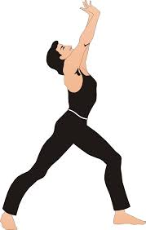
- Demonstrate some of the basic skills used in the creation of character, and the choices that lead characters to action. (PLO #2)

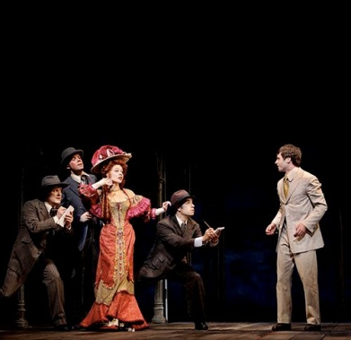
- Through the use of neutral scenes, individual monologues, and scene study students will leave the class with an understanding of objectives, obstacles, character analysis, blocking, movement, and transitions. (PLO #2 and #4)
.

- Recognize connections between life and acting and build acting technique upon those connections. (PLO 1 and #2)


- Understand and competently use the terminology and vocabulary of the art of acting. (PLO #2 and #4)

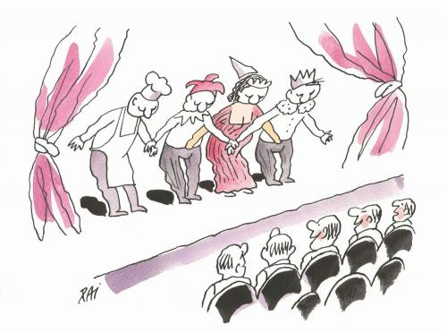

- Become more focused and informed as a theater audience. (PLO #3 and #4)

- Develop the ability to evaluate acting in a theatrical production (PLO #4)



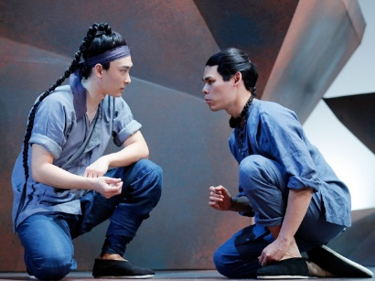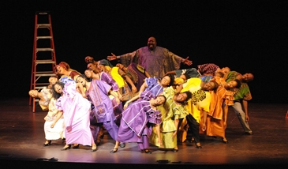
- Read and understand a range of theatrical literature representing different cultures and traditions of acting (PLO #1 and #3)



- Respond actively and imaginatively in classroom by engaging in active participation in exercises and activities, discussion, interpreting, analyzing and critical thinking. (PLO #2)


- Present monologues, readings or scenes/short plays in front of an audience with confidence and evidence of proper preparation and rehearsal. (PLO #2 and #4)

THR 305—advanced development of the above

Texts—No required textbook; use of play scripts, monologues and other published or original material

Supplemental Materials
Play scripts, articles and other materials and resources will be placed in the Sullivan Library on reserve for this class. Specific information will be given out as the materials are available.

Expectations and Policies 
- Attendance ON TIME and participation at all class sessions. This is very important, as group work on scenes and play production demands that all be present and participating.
- Reading all assigned materials and being prepared for classroom activities, in class and scheduled rehearsals and performances.
- Memorizing all selections/scenes by specified dates.
- Writing one acting analysis of a character in a play script.
- Writing one review of a professional acting performance from a play on DVD
- Attend and review two live theatrical productions (the spring CUH production and one community-based production)
- Maintain a detailed and efficient acting journal, with one page minimum reflection on each class session. Some journal entries will have assigned topics for reflection.

Cell phones, tablets, and laptops
Out of consideration for your classmates, please set your cell phone to silent mode during class. Students are encouraged to bring laptops or tablets to class as the instructor will assign online activities and readings that will require the use of a laptop or tablet. Laptops and tablets should not be misused, such as checking distracting websites. Use your best judgment and respect your classmates and instructor.

Disability Access
If you need individual accommodations to meet course outcomes because of a documented disability, please speak with me to discuss your needs as soon as possible so that we can ensure your full participation in class and fair assessment of your work. Students with special needs who meet criteria for the Americans with Disabilities Act (ADA) provisions must provide written documentation of the need for accommodations from the Counseling Center by the end of week three of the class, in order for instructors to plan accordingly. If a student would like to determine if they meet the criteria for accommodations, they should contact the Counseling Center at (808) 735-4845 for further information.

Title IX Compliance
Chaminade University of Honolulu recognizes the inherent dignity of all individuals and promotes respect for all people. Sexual misconduct, physical and/or psychological abuse will NOT be tolerated at CUH. If you have been the victim of sexual misconduct, physical and/or psychological abuse, we encourage you to report this matter promptly. As a faculty member, I am interested in promoting a safe and healthy environment, and should I learn of any sexual misconduct, physical and/or psychological abuse, I must report the matter to the Title IX Coordinator. If you or someone you know has been harassed or assaulted, you can find the appropriate resources by visiting Campus Ministry, the Dean of Students Office, the Counseling Center, or the Office for Compliance and Personnel Services.

Attendance Policy
The following attendance policy is from the 2019-2020 Academic Catalog:

Students are expected to attend regularly all courses for which they are registered. Student should notify their instructors when illness or other extenuating circumstances prevents them from attending class and make arrangements to complete missed assignments. Notification may be done by emailing the instructor’s Chaminade email address, calling the instructor’s campus extension, or by leaving a message with the instructor’s division office. It is the instructor’s prerogative to modify deadlines of course requirements accordingly. Any student who stops attending a course without officially withdrawing may receive a failing grade.

Unexcused absences equivalent to more than a week of classes may lead to a grade reduction for the course. Any unexcused absence of two consecutive weeks or more may result in being withdrawn from the course by the instructor, although the instructor is not required to withdraw students in that scenario. Repeated absences put students at risk of failing grades.

Students with disabilities who have obtained accommodations from the Chaminade University of Honolulu ADA Coordinator may be considered for an exception when the accommodation does not materially alter the attainment of the learning outcomes. Federal regulations require continued attendance for continuing payment of financial aid. When illness or personal reasons necessitate continued absence, the student should communicate first with the instructor to review the options. Anyone who stops attending a course without official withdrawal may receive a failing grade or be withdrawn by the instructor at the instructor’s discretion.

Academic Conduct Policy
From the 2019-2020 Undergraduate Academic Catalog:
Any community must have a set of rules and standards of conduct by which it operates. At Chaminade, these standards are outlined so as to reflect both the Catholic, Marianist values of the institution and to honor and respect students as responsible adults. All alleged violations of the community standards are handled through an established student conduct process, outlined in the Student Handbook, and operated within the guidelines set to honor both students’ rights and campus values.

Students should conduct themselves in a manner that reflects the ideals of the University. This includes knowing and respecting the intent of rules, regulations, and/or policies presented in the Student Handbook, and realizing that students are subject to the University’s jurisdiction from the time of their admission until their enrollment has been formally terminated. Please refer to the Student Handbook for more details. A copy of the Student Handbook is available on the Chaminade website.

For further information, please refer to the Student Handboohttps://studentaffairs.chaminade.edu/wp-content/uploads/sites/28/2019-20-NEW-STUDENT-HANDBOOK.pdf

Extra Credit
The following are extra credit options for the class:
- Seeing and reviewing an additional production/performance; up to 50 points E.C.
- Presenting an additional memorized and staged monologue or scene; up to 25 points E.C.
- Actively participate as a performer or in a running crew (costumes and props, scenery, or sound and lighting) for the CUH Drama Department’s fall production this semester; up to 100 points E.C.. The fall production is The Last Mass at St. Casimir’s, by Tom Dudzick. with performances Nov. 8, 9, 10, 12, 13, 14, 15, 16, 17. Auditions TBA in the Loo Theatre. Information will be provided in class about auditions and signing up for crew positions.



Grading:
The class grade is determined through a point system. Points are earned on the preparation and presentation of selections, monologues and scenes, short quizzes, the writing assignments (play attendance/reviews, short reflection papers and acting journal); classroom attendance and participation; and any extra credit done for this class. The following scale of the total points will be used to determine grades: 90-100% is an A; 80-89% is a B; 70-79% is a C; 60-69% is a D; 59% and below is an F.

Grade Value Assignments: Performances/scene work 50%
Written work 20%
Final Performance/Exam 20%
Class Participation/Attendance 10%



Writing Requirements
All written assignments handed into the professor for this class must meet the following criteria:
- The papers must be word-processed or typed, double-spaced, in black ink, using appropriate paper, fonts and standard margins.
- All written work must meet the standard writing requirements set forth by CUH and will be evaluated using a template designed to meet these requirements.
- All writing assignments must be handed in during the class on the assigned dates unless permission from the professor to hand in a tardy assignment is given in advance.
- Production Reviews (with programs, ticket stubs attached) are due the week following the attendance at the production. Late reviews will not be accepted.

It is the student’s responsibility to notify the professor in writing concerning all excused absences.



Class Structure 

We will approach our learning of basic acting skills in three parts:

Part I: Developing the Actor's Instrument
Observation, Concentration, Sensory Awareness, Emotional Awareness, Imagination, Listening, Relaxation, Voice

Part II: The Actor as Detective
Given Circumstances, Environment, Objectives, Actions, Obstacles, Structure, Characterization.

Part III: Putting It All Together
Applying what we've learned to texts (interpretive readings, monologues, scenes.)
You will be assigned individual and ensemble exercises throughout all three parts. Rehearsal outside of class is mandatory.

A more detailed schedule of assignments and classroom activities will follow soon.

Final Exam Scenes are scheduled for 1:15-3:15pm on Wednesday, Dec. 11 in the Loo Theatre.





