AN 350 Cultures of Oceania
Instructor: Dr. Chris Howard
Contact: christopher.howard@chaminade.edu
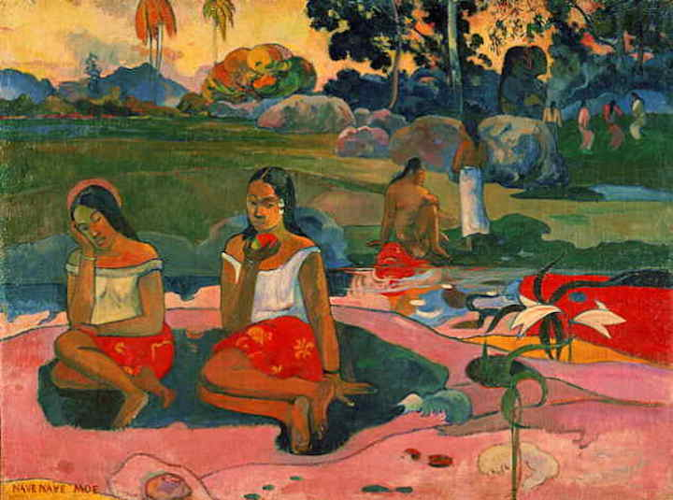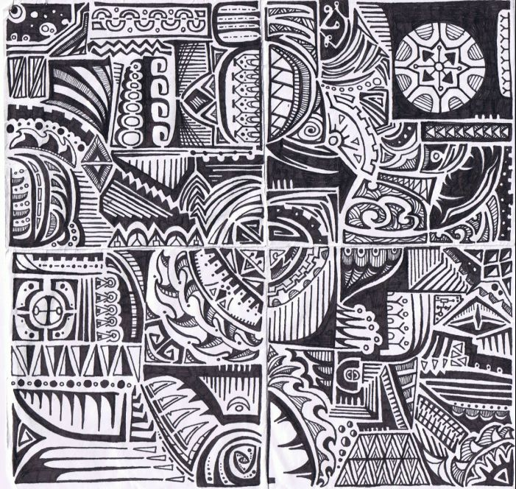
Course Description
This course is designed to provide an introduction to the traditional and contemporary cultures of the island Pacific. The major emphasis will be on the Oceanic regions of Melanesia, Polynesia and Micronesia, though we will also examine trans-Pacific issues, including climate change, migration and sports. Since its European 'discovery', the Pacific has been a contradiction of images to the West and a backwater of important events – a place with beautiful people, palm trees, sparkling sand and water, a veritable Eden, yet also a place of dark, disease-infested jungle and savage cannibals. These stereotypic images tend to clash both with traditional and modern realities, which are that: 1) the Pacific Ocean is the major undeveloped resource base left on the planet, and 2) Oceania contains the majority of the world's remaining colonial possessions. The region has made major moves towards both independence and a developing sense of regional and ethnic identity, yet is plagued by problems of transportation costs, small size, political unrest, economic dependency, ethnic violence and major health care issues. An informed understanding of this area should be a prerequisite for living in Hawai'i or any other area having contact with Oceania.
Required texts
Besnier, Niko (2011). On the Edge of the Global: Modern anxieties in a Pacific Island nation. Palo Alto: Stanford University Press.
Throop, Jason C. (2010). Suffering and Sentiment: Exploring the vicissitudes of experience and pain in Yap. Berkeley: University of California Press.
Other required readings and videos will be posted in the Modules section on Canvas .
AN350 Catalog Description: Introduction to native cultures of Polynesia, Melanesia, Micronesia and Australia. Emphasis on migration, differences in social organization, land tenure, and effects of contact with Western society. Offered annually.
General Course Objectives
- To develop an understanding and awareness of the island Pacific and the peoples that inhabit it.
- To utilize anthropological theories, concepts and research techniques to analyze present situations, and predict future problems and opportunities in the region along with possible solutions.
Specific Course Objectives: During the semester you will develop a general understanding of the following concepts and their application in Oceania:
- Implications of island environments
- Oceanic Prehistory and human settlement
- European impacts and colonialism in Oceania
- National and ethnic identity in Oceania
- Ritual, symbolism and ancestors in Oceania
- Migration and remittances in Oceania
- Patterns of change and affiliation in the Pacific
Course Learning Outcomes
- To develop a basic level of understanding and awareness of the island Pacific and the peoples who inhabit it.
- To develop a basic awareness of issues of cultural/ethnic identity in relation to global change.
Behavioral Science Division Student Learning Outcomes
- Ability to apply the scientific method to the study of human behaviour in various environmental contexts.
- An understanding of human behaviour relative to various environmental contexts.
- An understanding of human behaviour relative to adapting to various changing environmental contexts.
This course meets the following goals for the Behavioral Sciences Program:
- Appreciating the diversity of peoples and cultures – other ways of seeing and being in the world
- Understanding how social forces shape individual perceptions and behaviours
- Understanding the dynamic relationship between the Self and the Group.
The Marianist Values of Chaminade University, which we strive to incorporate into our classes are:
- Educate in the formation of faith
- Provide an integral quality education
- Educate in family spirit
- Educate for service, justice and peace
- Educate for adaptation and change
Course format
The course is divided into 5 modules, each of which lasts three weeks. The modules cover different topics and regions (Melanesia, Polynesia, Micronesia), but are designed to build upon one another, moving towards a comprehensive view of Oceania. You will access readings, maps, videos, web links and other learning materials within the modules section of Canvas. There will also be a ‘module guide’ that provides an overview of the module and specific learning aims.
As this is an entirely online course, there will be an emphasis on self-regulated learning, defined as the conscious planning, monitoring, evaluation, and ultimately control of one’s learning in order to maximize it. The lecturer will post regular announcements, discussion questions and assignment guidelines. You will be responsible for putting 10-12 hours a week of work into AN350. The lecturer will be available for email contact, though not on a 24/7 basis. Please email me directly, rather than within Canvas.
Course grading
- Reading Responses: During each module, there will be a reading response to submit. Thoughtful responses that engage directly with the topics, course and use anthropological concepts will be rewarded full credit. This component will be worth 10% of your course grade, or 2% per module.
- Module quizzes: In the third week of each module there will be a quiz on the material covered (5 in total). These are designed to promote your memory retention and show you the effectiveness of your learning strategies and habits. The format will be a mix of multiple choice, true/false and short answer questions. The quizzes will be worth 15% each, accounting for 75% of your total grade.
- Research Paper: You will write a research paper based on your choice of several topics. In order to write the paper, you will draw upon both course materials and also collect your own. As per scientific writing, you will need to make an argument, and support it using evidence, concepts and theories, sound logic and argumentation. Topics and writing guidelines will be posted by your lecturer. The word count is between 1500-1800. The paper will be worth 15% of your overall grade and will be due on December 3rd.
Grade Breakdown
Reading responses (5) | 10%
Research Paper | 15%
Module quizzes (5) | 75%
A=90-100, B=80-89, C=70-79, D=60-69, F= -60
Course Schedule, Fall 2018
Modules | Dates | Topics and Reading | Assignments
1 |  | Introduction to Oceania
1.1 | Aug 19-25 | Island environments, geology and geography, human migration  Readings  - ‘Island Formation’ (Nunn 2009)  - ‘Oceanic Islands’ (Nunn 2009)  - ‘Ancient DNA and the Pacific’ (Matisoo-Smith, 2014)
1.2 | Aug 26-Sept 1 | Human settlement and ecological impacts in the Pacific  Readings  - Nature-Society Interactions in the Pacific Islands’ (Nunn, 2003)  - ‘Polynesian Voyaging’ (Anderson 2009)  - ‘Human Impacts, Pre-European’ (Kirch, 2009)
1.3 | Sept 2-8 | Cultural identity, tradition, Pacific Studies  Readings  - ‘Geography of Island Creation Myths’ (Nunn 2003)  - ‘Imagining Oceania’ (Jolly, 2007)  - ‘The Ocean in Us’ (Hau’ofa, 1998) | Module 1 quiz,  Reading response
2 |  | Melanesia
2.1 | Sept 9 -15 | Tradition and change in Melanesia I  Readings  - ‘Reconstructing the Concept of Tradition’ (Turner, 1990)  - ‘Social and Cultural Aspects of Land Tenure’ (Bonnemaison 1981)  - ‘Roots and Mobility in Vanuatu’ (Bonnemaison 1985)
2.2 | Sept 16 - 22 | Tradition and change in Melanesia II  Readings  - The Lahir Destiny (introduction only)  - ‘Indigenous Articulations’ (Clifford, chapter 1 in The Worlding Project)  - ‘Indigenous Governance’ (White 2007)
2.3 | Sept 23 - Sept 29 | Tradition and change in Melanesia III  Readings  - ‘Re-presenting Melanesia’ (Kabutaulaka 2015)  - ‘Surfing, Tourism and Modernist Fantasy’ (West 2014) | Module 2 quiz  Reading response
3 |  | Polynesia
3.1 | Sept 30- Oct 6 | Tradition and change in Polynesia I
  Reading
  - On the Edge of the Global chapters 1-3
3.2 | Oct 7 - 13 | Tradition and change in Polynesia II  Reading  - On the Edge of the Global chapters 4-6
3.3 | Oct 14 - 20 | Tradition and change in Polynesia III  Reading  - On the Edge of the Global chapters 7-8, conclusion | Module 3 quiz  Reading response
4 |  | Micronesia
4.1 | Oct 21 - 27 | Tradition and change in Micronesia I  Reading  - Suffering and Sentiment introduction, chapters 1-2
4.2 | Oct 28 - Nov 3 | Tradition and change in Micronesia II  Reading  - Suffering and Sentiment chapters 3-4
4.3 | Nov 4 - 10 | Tradition and change in Micronesia III  Reading  - Suffering and Sentiment chapters 7, 8 | Module 4 quiz  Reading response
5 |  | Contemporary Pacific Issues
5.1 | Nov 11 - 17 | Pacific island futures: climate change and migration  Readings  - ‘Vulnerable Islands’ (Connell, 2015)  - ‘Sea of Warriors’ (Steiner, 2015)
5.2 | Nov 18- 24 | Global mobility and sports  Readings  - ‘Sports, Bodies, Futures’ (Bensier, 2014)  - ‘Tongan Rugby Players in Japan’ (Besnier 2012)  - ‘Migration and Mobility’ (Upresa 2014) | Research Paper
5.3 | Nov 25 - Dec 1 | Pacific identity and transnational frontiers  Readings  - ‘Hawaiian at Heart’ (Hall, 2015)  - ‘Style and Self-Making in P.N.G.’ (Andersen, 2015)  - ‘Pacific Island Identity in Australia’ (McGavin, 2014) | Module 5 quiz  Reading response
Declaration of respect and dignity
Chaminade University recognizes the inherent dignity of all individuals and promotes respect for all people. Sexual misconduct will NOT be tolerated at Chaminade University. If you have been the victim of sexual misconduct, we encourage you to report this matter promptly. As a faculty member, I am interested in promoting a safe and healthy environment, and should I learn of any sexual misconduct, I must report the matter to the Title IX Coordinator. Should you want to report to a confidential source you may contact Dr. June Yasuhara at the Chaminade Counseling Center. Email: jyasuhar@chaminade.edu Tel. (808) 735-4845

