2019 Summer Semester
June 2nd – August 11^{th,} 2019
MBA-617-90-5 Operations Management Macau

Lifelong Learning is a core of the university environment. Learning is the responsibility of students. "Tell me and I forget. Show me and I remember. Involve me and I understand." This Chinese proverb I use in my classroom.

Class Schedule: Online, eLearning using myOMlab portal
Office Hours: via email or phone
Instructor Information: Dr. Maria Brownlow
Preferred Outlook email: mariabrownlow@hawaiiantel.net

email: maria.brownlow@chaminade.edu
Contact: 1+ 808 – 739 – 8337

Catalogue Course Description
The Operations Management course provides students with management skills for planning, coordinating, and controlling the people and technology used to provide goods and services. It studies the production of goods and provision of services by an organization to meet the needs of its customers. We examine operations strategy, quality management, scheduling, supply chain management, project management, and facilities design in a wide variety of industries. Prerequisites: MBA 520 or equivalent.

Textbook:

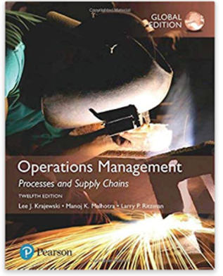
MBA 617 Operations Management Macau (3 Credits)
Operations Management, Processes and Supply Chains
Textbook: Lee J. Krajewski, Manoj K. Malhotra, Larry P. Ritzman; 12th Global Edition, ISBN: 978-1-292-25993-2

Course is using myOMlab portal on Pearson Site via the Internet
Package#1: e-Text (electronic text) with access code
Package#2: e-Text (electronic text) with access code and paper textbook with access code

- Course Orientation
Dare to Learn. Dare to Change. Digital learning removes limits and gives us the freedom to provide education anytime and anywhere, empowering us to overcome our most difficult challenges.

Operations Management is a lively topic in every organization, for non-profit and for profit. Students need to understand it because Operations Management activities are the center of the wealth creation process for businesses and. In recent years, the globalization of the economy, increase in world competition and shorter product and service life cycles has dramatically increased the importance of operations management.

Operations managers are responsible for running all processes within the organization that produce goods and services. With the valid concerns people and world leader about climate warming, operations managers are responsible for the production of services and products in an ethical and environmentally responsible way while being responsive to the markets. These activities include managing purchases, inventory control, quality control, storage, logistics and evaluations. Major focus is directed to efficiency and effectiveness of processes therefore, operations management often includes substantial measurement and analysis of internal and external processes.

With the globalization of markets, organizations are recognizing that the operations function can be used to strengthen the organization’s position in the marketplace. Operations managers play a strategic and tactical role in satisfying customer needs and making their businesses strong international competitors.

Organizations must be efficient and adaptable with respect to internal processes. It is critical for organizations to link those processes to those of their customers and suppliers to create competitive supply chains.

As my quote of the Chinese proverb above, my philosophy is that students will learn by doing. The course based on the 12th Global Edition of the textbook, provides ample opportunities to play a role of the manager with challenging problems, reviewing cases from other organizations, and reviewing videos of solves cases.

This course is designed to address the key challenges that have strategic and tactical implications faced by organizations in the service, business, and manufacturing sectors.

- Program Learning Outcome
Understand the process of value creation by an organization. Gain an ability to use concepts and processes of marketing and management to develop a competitive advantage in specified business environments.

- Course Learning Outcomes
Students will learn to apply the concept of a supply chain to the overall operational goals of the organization starting with analysis of the business processes. They will focus on a scientific approach to develop pragmatic decision-making processes, e.g. how to operate business more efficiently and without wasting valuable resources. Students will actively identify, discuss, and apply concepts that enhance the active business practice that supply chains are only as good as the processes across each organization within the supply chain.

Each supply chain decision will be presented in the classroom to illustrate concepts of process strategy, process analysis, quality, performance, capacity planning, and constraint management. These operations management challenges will develop critical thinking skills and approaches to real-life business issues. The concept of lean systems reveals the methods students can use to improve the systems’ performance. Of greater importance is the ability to communicate these challenges and solutions to others who participate in the supply chain decisions.

- To understand the role of operations management of processes and supply chains in the overall business strategy of the organization. Students will learn how operations managers focus on managing the processes to produce and distribute products and services.

- To determine the capability of a process and continually improve it.

- To gather process information so the management chooses the best alternative when outcomes are uncertain.

- To comprehend the interdependence of operations management with other key functional areas in the organization.

- To evaluate a range of tools suitable for analysis of operations in the organization.

- To identify and evaluate comparative approaches to production and operations management used in the decision-making process in a global economic context.

Developing Employability Skills

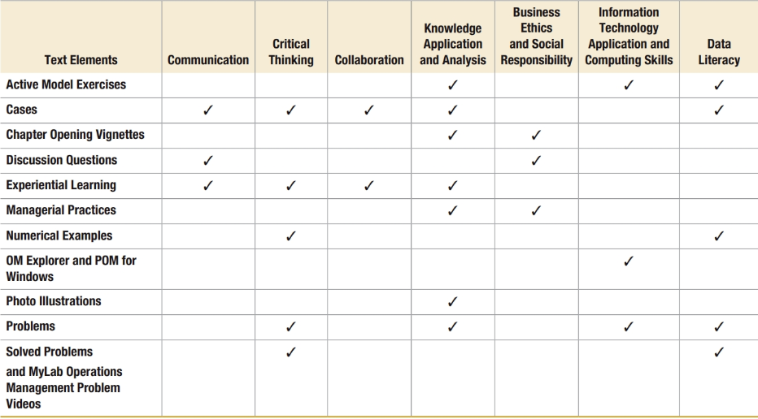

- Course Teaching Approach
This course is designed to promote student participation through discussions of current business issues as they relate to operations management and the supply chains decision-making processes. Students will study and apply process thinking to practical issues and decisions faced by operations management to small and big business environments, locally and internationally. Thus, it is important to know the capability of the process, its limitations and assumptions in order to implement continuous process improvements.

Applications, technology and audio-visual tools will make this course highly interactive and experiential. The graduate course will be taught, as follows:

- Power Points presentations to support students’ studies.

- Chapter Opening Vignettes opens each chapter with a real-world example of a company addressing the topic of that chapter

- Managerial Practices present an important function for the understanding of operations management to provide many examples of best practices.

- Video Cases for fourteen chapters showing actual managers dealing with important operating problems. Each video has an associated case in the text, along with thought-provoking questions to generate discussion.

- New Topics introduce new disruptive technologies, for example, Internet of Things (IoT) in Ch1, Quality and Performance in Ch3, big data in Ch8, addictive manufacturing (AM), to fabricate products using 3-D printing in Ch14.

- Assignments: homework, quizzes, tests and exams will be assigned to students on myOMlab to validate learned material.

- Supplementary materials and handouts will be provided to students to aid in understanding operations management.

- Chapter handouts will be made available to students; these handouts will be used by students to follow the lectures, Power Point presentations and for note taking purposes. These handouts can be used for exam preparation.

- Multimedia Library – will be used, as time permits, to show operations management in action, discuss management challenges, and develop critical thinking skills and approaches to real-life business issues.

Part 1 – Managing Processes
Designing and operating processes in the firm.

Part 2 – Managing Customer Demands
Forecasting demands and developing inventory plans and operating schedules.

Part 3 – Managing Supply Chains
Designing an integrated and sustainable supply chain of connected processes between firm.

Source: Course textbook

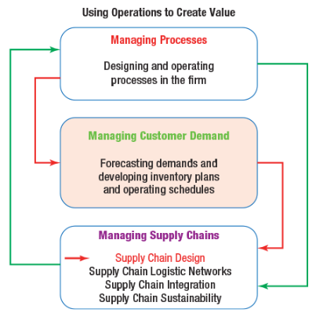

Note: All these tools will be used when applicable.

- Assessment and Grading

Recommended Learning Strategies
- Chapter Assignments must be read prior to performing any assignments on myOMlab.

- Review examples and solutions within each chapter to reinforce the understanding of presented concepts.

- Complete tests and quizzes (when assigned) after each chapter to reinforce the learning material.

- Submit assignments on-time.

- Contribute to and participate in team projects (if assigned). You will learn to become a confident working within teams, improving people skills.

- Complete and submit exams, as scheduled.

Learning operations management science is designed to promote student participation in online course through myOMlab. Various multimedia resources of current events in the business world will be reviewed as they relate to the use of operations management for managerial decision-making processes.

Grading your accomplishments:  Quizzes, tests, and homework  Team projects  Exams | Grade scale:  A = 100% – 90%  B = 89% – 80%

This is online course therefore chapter assignments must be completed within two weeks and NOT to carry an overdue assignment to the end of the course.

All assignments will be posted on the myOMlab portal. All exams will be posted on myOMlab and must be completed within an assigned date.

Tests or quizzes will be given with each chapter. A request to make up exams will be allowed only with prior approval from the instructor. Student must request the make-up date before the scheduled examination date. The final grade will be calculated as an average or weighted grade of all assignments during semester.

Changes to the syllabus will be made, if necessary, and will be communicated to students. Students are responsible for ensuring that they read a current syllabus.

Course Ground Rules

Attendance policy
This class is on-line. Following assignments schedule is expected.

Academic Honesty
Students are responsible for promoting academic honesty at Chaminade by not participating in any act of dishonesty. Academic dishonesty may include theft of records or examinations, alteration of grades, and plagiarism. Questions of academic dishonesty in a class are first reviewed by the instructor who must make a report with recommendations to the Business School Dean. Consequences for academic dishonesty may range from an “F” grade for the work in question to an “F” grade for the course to suspension or dismissal from the University.

Syllabus Modification
This syllabus is only a plan. The instructor may modify the plan during the course. The requirements of the course may be altered from those appearing in the syllabus. Further, the plan contains criteria by which the student’s progress and performance in the course will be measured. These criteria may also be changed, and students will be notified.

Guidelines for Communication
Email: Use your Chaminade email account unless specified otherwise by instructor
Always include a subject line.

Remember that without others being able to see your facial expressions or hear your tone, some comments may be taken in a way you didn’t intend. So be careful in wording your emails. Use of emoticons may be helpful in some cases.

Special formatting such as centering, audio messages, tables, html, etc. should be avoided unless necessary to complete an assignment or other communication.

Discussion Groups:
- Review discussion threads thoroughly before entering the discussion.
- Maintain threads by using the “reply” button rather than starting a new topic.
- Be respectful of others’ ideas.
- Read the comments of others thoroughly before entering your remarks.
- Cooperate with group leaders in completing assigned tasks.
- Be positive and constructive in group discussions.
- Respond in a thoughtful and timely manner.

Chat online:
Introduce yourself to others in the chat session. Be polite. Choose words carefully. Do not use derogatory statements. Be concise in responding to others in the chat session. Be constructive in your comments.

Instructor and Student Communication
Questions for this course can be emailed to the individual instructor at the email provided by instructor. Online, in-person and phone conferences can be arranged. Response time will take place within 24 hours.

- Institutional Learning Outcome
- Written communication
- Oral communication
- Critical thinking
- Information literacy
- Quantitative reasoning

- Marianist Values

This class represents one component of your education at Chaminade University of Honolulu. An education in the Marianist Tradition in marked by five principles and you should take every opportunity possible to reflect upon the role of these characteristics in your education and development:

- Educate for formation in faith
“As higher educational institutions, Marianist universities have kept, along with education in the disciplines, a commitment to the development of the whole person, which includes the dimension of religious faith and its personal appropriation and practice.”

- Provide an integral quality education
“In the Marianist approach to education, “excellence” includes the whole person, not just the technician or rhetorician. It also includes people with their curricular and extra-curricular experiences, their intellectual and spiritual development, understood and supported best in and through community.”

- Educate in family spirit
“Marianist educational experience fosters the development of a community characterized by a sense of family spirit that accepts each person with loving respect and draws everyone in the university into the challenge of building community. Community support for scholarship, friendship among faculty, staff and students, and participation in university governance characterize the Marianist University.”

- Educate for service, justice and peace
“The Marianist approach to higher education is deeply committed to the common good. The intellectual life itself is undertaken as a form of service in the interest of justice and peace, and the university curriculum is designed to connect the classroom with the wider world. In addition, Marianist universities extend a special concern for the poor and marginalized and promote the dignity, rights and responsibilities of all peoples.”

- Educate for adaptation and change
“In the midst of rapid social and technological change, Marianist universities readily adapt and change their methods and structures so that the wisdom of their educational philosophy and spirituality may be transmitted even more fully.”

Title IX Compliance
Chaminade University of Honolulu recognizes the inherent dignity of all individuals and promotes respect for all people. Sexual misconduct, physical and/or psychological abuse will NOT be tolerated at CUH.

If you have been the victim of sexual misconduct, physical and/or psychological abuse, we encourage you to report this matter promptly. As a faculty member, I am interested in promoting a safe and healthy environment, and should I learn of any sexual misconduct, physical and/or psychological abuse, I must report the matter to the Title IX Coordinator. If you or someone you know has been harassed or assaulted, you can find the appropriate resources by visiting Campus Ministry, the Dean of Students Office, the Counseling Center, or the Office for Compliance and Personnel Services.

Link to myOMlab portal
www.pearsonmylabandmastering.com

Library
Provide a link to the Chaminade library www.chaminade.edu/library.

Technical Support
For technical questions view the contact your instructor.

Pearson Higher Ed
Operations Management, Global Addition, Lee J. Krajewski, Manoj Malhotra, Larry P. Ritzman
Characteristics of Marinist Universities: Chaminade University of Honolulu, St. Mary’s University, University of Dayton, A Resource Paper, published in 1999, Republished in 2006

