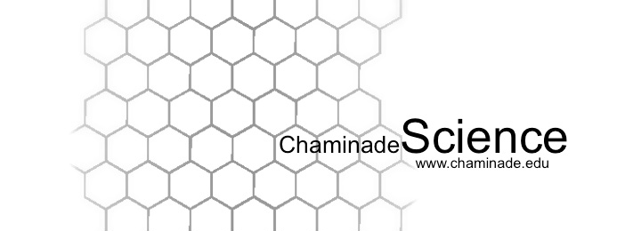
Spring 2019: Biology 215 Cellular and Organismal Biology I Lab

Instructor: Dr. Jolene Cogbill, PhD
Class Meetings: Th 2:30 – 5:20am, Henry Hall Lab 4
Office Hours: WSC 102, M,W,F 10:30-11:30 or by appointment
E-mail: jolene.cogbill@chaminade.edu

Required Text: There is no required text for this lab. All necessary protocols and reading will be

provided to you either as handouts or will be posted on E-college

Course Description:

This laboratory course accompanies the BI215 Cellular and Organismal Biology lecture which is an

introduction to animal and plant diversity, with emphasis on form and function, mechanisms of regulation in biological systems, a d how organisms exchange materials and energy with their environment.

General Course Objectives:
- Prepare the students for further education in advanced biology lab courses, or related fields.
- To be exposed to the culture of doing science.
- To develop the ability to begin scientific investigation and problem solving through observational methodology.
- To study organisms included in the zoological & botanical fields, emphasizing Hawaiian flora.
- Develop an appreciation of working collaboratively in groups.

Specific Student Learning Outcomes:

At the end of the course, you will be able to:
Student Learning Outcomes | Linkage to Biology Program Learning Outcomes
Describe and apply the Scientific Method to observable phenomenon with an emphasis on being able make descriptive and thorough observations, as well as recognize proper scientific questions and hypotheses | #1) An understanding of the scientific method and the  ability to design and test a hypothesis.  #2) ability to visualize, statistically evaluate, validate and  interpret scientific data, and to communicate science  effectively both orally and in writing.  #3) The ability to acquire and comprehend information from  published scientific literature and to employ computational  resources in the resolution of biological problems.  #7) An understanding of the entry requirements, career  pathways and progression for the major post-graduate  fields of research, education and health professions.
Identify representative flora and fauna, and whether it is endemic, invasive or indigenous of Hawaii | #4) An understanding of the chemical and physical principles  that unite all life forms, and of biological organization at the  molecular, cellular, tissue, organ, organism and systems level.  #7) An understanding of the entry requirements, career  pathways and progression for the major post-graduate  fields of research, education and health professions
Perform dissections and observational analysis to compare and contrast representative plants, invertebrate and vertebrate anatomical organs/body systems. | #1) An understanding of the scientific method and the  ability to design and test a hypothesis.  #2) ability to visualize, statistically evaluate, validate and  interpret scientific data, and to communicate science  effectively both orally and in writing  #4) An understanding of the chemical and physical principles  that unite all life forms, and of biological organization at the  molecular, cellular, tissue, organ, organism & systems level.  #7) An understanding of the entry requirements, career  pathways and progression for the major post-graduate  fields of research, education and health professions

Expectations of students: The following are what is expected of students:
- Attend lectures and labs.
- Read assignments BEFORE coming to lab; know assignment and test dates.
- Be prompt, both in attendance and in turning in of assignments.
- Be responsible & proactive. If you miss a class, ask your classmates and/or your instructor for the information missed; and approach another BI215L instructor to inquire about making up the lab in their section. It is YOUR responsibility to pick up any handouts that were distributed.
- Ask the instructor for assistance way in advance. DO NOT WAIT until the day of the exam or the day when an assignment is due to ask questions.
- Respect. It works both ways.
- Remember, the knowledge that you will take away from your courses is directly proportional to what you put into your courses so keep a positive attitude and work hard!

Grading:

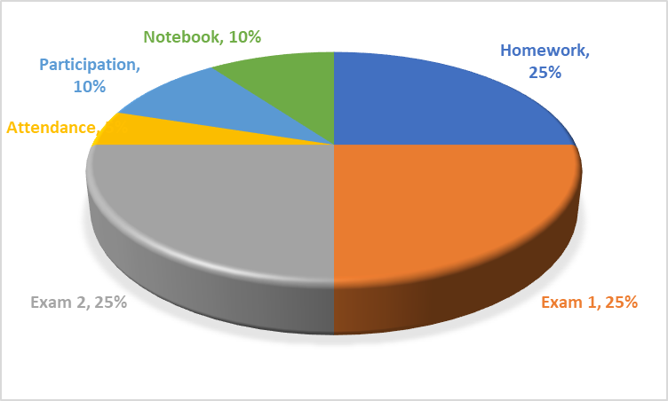

Laboratory notebook:
- All students will be required to maintain a bound laboratory notebook into which ALL laboratory information and data is to be entered. Lab notebooks will be graded twice and are to be handed in on exam days.
- Notebooks must be bound with non-tear out pages. No spiral notebooks, as are three holed folder paper.
- Additional formatting information will be available on Canvas.

Attendance/Participation:
- Presence in class is mandatory & necessary in order for a student to fully grasp concepts. Students are expected to attend regularly all courses for which they are registered. Students should notify their instructors when illness or other extenuating circumstances prevents them from attending class and make arrangements to complete missed assignments. Notification may be done by emailing the instructor’s Chaminade email address, calling the instructor’s campus extension or by leaving a message with the instructor’s division office (Natural Science and Math 1 (808) 440-4204). It is the instructor’s prerogative to modify deadlines of course requirements accordingly. Any student who stops attending a course without officially withdrawing may receive a failing grade.
- Unexcused absences equivalent to more than a week of classes may lead to a grade reduction for the course. Any unexcused absence of two consecutive weeks or more may result in being withdrawn from the course by the instructor, although the instructor is not required to withdraw students in that scenario. Repeated absences put students at risk of failing grades.
- If you miss a class it is YOUR responsibility to ask the instructor or your classmates for the information that you missed and to pick up any handouts that may have been distributed.
- It is highly suggested that students bring their text books with them to class as there may be in class activities that will require the use of the text.

Makeup exams and extra credit:
- Makeup exams and quizzes are generally not given. If there is an insurmountable problem please come talk to me to see what arrangements can be made.

Departmental and University Polices:
- Music Devices and Cellular Phones: Use of music devices and cell phones is prohibited during all Natural Science and Mathematics classes at Chaminade, unless specifically permitted by your instructor. Use of cellphones and music devices in laboratories is a safety issue. In addition, use of cellphones and music devices in any class is discourteous and may lead to suspicion of academic misconduct. Students who cannot comply with this rule will be asked to leave class and may be subject to laboratory safety violation fines. You will be asked to leave class and marked absent if you do not comply. This will negatively affect your grade. Please refer any questions to the Dean of Natural Sciences and Mathematics.
- ADA Accomodations: Pursuant to several federal and state laws, including the Americans with Disabilities Act of 1990, as amended by the ADA Amendments Act of 2008, and Section 504 of the Rehabilitation Act of 1973, all qualified students with disabilities are protected from discrimination on basis of disability and are eligible for reasonable accommodations or modifications in the academic environment to enable them to enjoy equal access to academic programs, services, or activities. If a student would like to determine if they meet the criteria for accommodations, they should contact the Counseling Center at 808-735-4845 for further information Students with special needs who meet criteria for the Americans with Disabilities Act (ADA) provisions must provide written documentation of the need for accommodations from CUH Couseling Center (Dr. June Yasuhara, 735-4845) by the end of the third week of classes. Failure to provide written documentation will prevent your instructor from making necessary accommodations.
- Policy on Communication : The University provides a Chaminade email address for all students. Official Chaminade communications will be sent to the students’ Chaminade email address and instructors will use only this email to communicate with students. It is the responsibility of the student to check their email frequently. Report email-related problems to the Helpdesk at 808-735-4855 or helpdesk@chaminade.edu.
- Title IX Declaration: Chaminade University of Honolulu recognizes the inherent dignity of all individuals and promotes respect for all people. Sexual misconduct, physical and/or psychological abuse will NOT be tolerated at CUH. If you have been the victim of sexual misconduct, physical and/or psychological abuse, we encourage you to report this matter promptly. As a faculty member, I am interested in promoting a safe and healthy environment, and should I learn of any sexual misconduct, physical and/or psychological abuse, I must report the matter to the Title IX Coordinator. Should you want to speak to a confidential source you may contact the following: Chaminade Counseling Center| 808 735-4845;
Any priest serving as a sacramental confessor or any ordained religious leader serving in the sacred confidence role.
- Academic Honesty: Students are expected to have read and to abide by the “Student Rules of Conduct” which are available in your copy of Chaminade University’s Student Handbook. Cheating in the form of plagiarism, collusion, deception and will not be tolerated and will negatively affect your grade.

Because the university is an academic community with high professional standards, its teaching function is seriously disrupted and subverted by academic dishonesty. Such dishonesty includes, but is not limited to, cheating, which includes giving/receiving unauthorized assistance during an examination; obtaining information about an examination before it is given, using inappropriate/unallowed sources of information during an examination; altering answers after an examination has been submitted; and altering the records on any grade. (Refer to the Chaminade University catalog for further information).

Tentative Course Outline (subject to change as instructor sees fit)
Wk | Date | Lab topic | Assignments
1 | Wk of Jan 14 | Lab Safety  The Culture of Science: Protocol & Tools | See Canvas
2 | Wk of Jan 21 | The Culture of Science: Scientific Method | See Canvas
3 | Wk of Jan 28 | The Power of Observation Pt I: Art and Science | See Canvas
4 | Wk of Feb 4 | The Power of Observation Pt II: Field Trip: Native Hawaiian Plant Identification | See Canvas
5 | Wk of Feb 11 | The Power of Observation Pt III | See Canvas
6 | Wk of Feb 18 | Dissections: Flowers and Leaves | See Canvas
7 | Wk of Feb 25 | Dissections: Roots and Shoots | See Canvas
8 | Wk of Mar 4 | EXAM 1
9 | Wk of Mar 11 | The Power of Observation Pt 3 | See Canvas
10 | Wk of Mar 18 | Dissections: Vertebrates & Invertebrates | See Canvas
11 | Wk of Mar 25 | Spring Break
12 | Wk of Apr 1 | Dissections: Vertebrates & Invertebrates | See Canvas
13 | Wk of Apr 8 | Dissections: Vertebrates & Invertebrates | See Canvas
14 | Wk of Apr 15 | Dissections: Vertebrates & Invertebrates | See Canvas
15 | Wk of Apr 22 | Dissections: Vertebrates & Invertebrates | See Canvas
16 | Wk of Apr 29 | EXAM 2

Note: Every effort has been made to insure that the material in this syllabus is accurate and complete. However, occasionally changes must be made in the printed schedule. Thus the instructor reserves the right to make any changes in the contents of this syllabus that she deems necessary or desirable. These changes, if any, will be announced as soon as the need for them becomes apparent.

