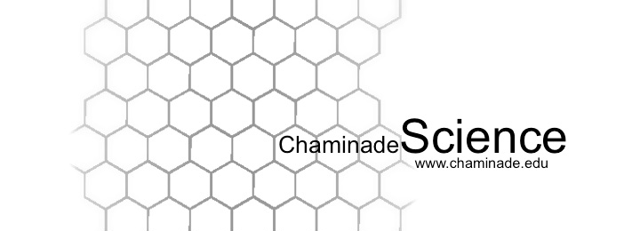
Fall 2017: Biology 215 Cellular and Organismal Biology I

Instructor: Dr. Jolene Cogbill, PhD
Class Meetings: T,TH 1:00 – 2:20am, WSC 120
Office Hours: WSC 102, M, W, F 10:00-11:30 or by appointment
E-mail: jolene.cogbill@chaminade.edu

Required Text:

Reece, Jane and Lisa Urry, Michael Cain, Steven Wasserman, Peter Minorsky & Robert

Jackson. Campbell Biology, 10 edition. Boston: Benjamin Cummings, 2013.

Course Description:

Introduction to animal and plant diversity, with emphasis on form and function, mechanisms

of regulation in biological systems, a d how organisms exchange materials and energy with

their environment.

General Course Objectives:
- Prepare the students for further education in advanced biology courses, or related fields.
- Introduce the student to the cellular biology of prokaryotes and eukaryotes.
- To help the student on their road to becoming a competent and educated professional.
- To examine and analyze specific content areas, such as molecular or cellular biology, evolution, genetics, physiology, and related areas of biochemistry and biophysics.
- To study organisms included in the botanical & zoological fields emphasizing Hawaiian flora & fauna.

Specific Student Learning Outcomes:

At the end of the course, you will be able to:
Student Learning Outcomes | Linkage to Biology Program Learning Outcomes
Identify biological structures and body systems, describe how those body systems relate to each other and be able to explain their general anatomy and physiology | #4) An understanding of the chemical and physical principles  that unite all life forms, and of biological organization  at the molecular, cellular, tissue, organ, organism and  systems level.  #7) An understanding of the entry requirements, career  pathways and progression for the major post-graduate  fields of research, education and health professions.
Use proper anatomy and physiology terminology | #2) ability to visualize, statistically evaluate, validate and  interpret scientific data, and to communicate science  effectively both orally and in writing.  #7) An understanding of the entry requirements, career  pathways and progression for the major post-graduate  fields of research, education and health professions
Describe plant antatomy, organ systems and physiological process as well as identify representative flora and fauna, especially that of Hawaii | #4) An understanding of the chemical and physical principles  that unite all life forms, and of biological organization  at the molecular, cellular, tissue, organ, organism and  systems level.  #7) An understanding of the entry requirements, career  pathways and progression for the major post-graduate  fields of research, education and health professions
Understand and explain ecological relationships between organisms and their environment | #4) An understanding of the chemical and physical principles  that unite all life forms, and of biological organization  at the molecular, cellular, tissue, organ, organism and  systems level.  #7) An understanding of the entry requirements, career  pathways and progression for the major post-graduate  fields of research, education and health professions
Describe how evolutionary relationships between diverse organisms are determined | #2) ability to visualize, statistically evaluate, validate and  interpret scientific data, and to communicate science  effectively both orally and in writing  #4) An understanding of the chemical and physical principles  that unite all life forms, and of biological organization  at the molecular, cellular, tissue, organ, organism and  systems level.  #7) An understanding of the entry requirements, career  pathways and progression for the major post-graduate  fields of research, education and health professions

Expectations of students: The following are what is expected of students:
- Attend lectures and labs.
- Know assignment and test dates.
- Be prompt, both in attendance and in turning in of assignments.
- Read the text. We are going to move at a rapid pace this semester; therefore, it is imperative that you keep up with the reading.
- Be responsible & proactive. If you miss a class, ask your classmates and/or your instructor for the missed information. It is YOUR responsibility to pick up any handouts.
- Ask the instructor for assistance way in advance. DO NOT WAIT until the day of the exam or the day when an assignment is due to ask questions.
- Respect. It works both ways.
- Remember, the knowledge you will take away from your courses is directly proportional to what you put into your courses so keep a positive attitude and work hard!

Reading Assignments
- The required reading assignments are listed in your course outline.
- Exam questions will cover both lecture and reading material.
- You are responsible for all reading material regardless of whether or not the particular topic has been covered in lecture.

Critical Thinking Questions (CTQs)
- CTQs will be assigned weekly and will be due the day following the upcoming exam.
- Feel free to work with your peers however everyone turns in their own work.

Quizzes
- Quizzes will be assigned for each chapter and can be taken in Canvas

Grading

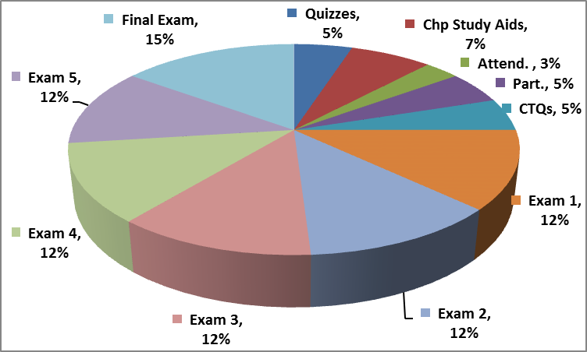

Makeup exams and extra credit:
- Makeup exams and quizzes are not given unless a student is ill and contacts the instructor within 24 hours of missed class period. A doctor’s written excuse should be supplied at the NEXT class attended.
- Extra credit opportunities may be available during the course of regular lectures or may be written into the exams. In addition, you can decide to give a 5 – 15 minute powerpoint, oral presentation of a scientific, research journal article pertaining to the class material for extra credit points.

Attendance/Participation:
- Presence in class is mandatory & necessary in order for a student to fully grasp concepts. Students are expected to attend regularly all courses for which they are registered. Students should notify their instructors when illness or other extenuating circumstances prevents them from attending class and make arrangements to complete missed assignments. Notification may be done by emailing the instructor’s Chaminade email address, calling the instructor’s campus extension or by leaving a message with the instructor’s division office (Natural Science and Math 1 (808) 440-4204). It is the instructor’s prerogative to modify deadlines of course requirements accordingly. Any student who stops attending a course without officially withdrawing may receive a failing grade.
- Unexcused absences equivalent to more than a week of classes may lead to a grade reduction for the course. Any unexcused absence of two consecutive weeks or more may result in being withdrawn from the course by the instructor, although the instructor is not required to withdraw students in that scenario. Repeated absences put students at risk of failing grades.
- If you miss a class it is YOUR responsibility to ask the instructor or your classmates for the information that you missed and to pick up any handouts that may have been distributed.
- It is highly suggested that students bring their text books with them to class as there may be in class activities that will require the use of the text.

Departmental and University Polices:
- Music Devices and Cellular Phones: Use of music devices and cell phones is prohibited during all Natural Science and Mathematics classes at Chaminade, unless specifically permitted by your instructor. Use of cellphones and music devices in laboratories is a safety issue. In addition, use of cellphones and music devices in any class is discourteous and may lead to suspicion of academic misconduct. Students who cannot comply with this rule will be asked to leave class and may be subject to laboratory safety violation fines. You will be asked to leave class and marked absent if you do not comply. This will negatively affect your grade. Please refer any questions to the Dean of Natural Sciences and Mathematics.
- ADA Accomodations: Pursuant to several federal and state laws, including the Americans with Disabilities Act of 1990, as amended by the ADA Amendments Act of 2008, and Section 504 of the Rehabilitation Act of 1973, all qualified students with disabilities are protected from discrimination on basis of disability and are eligible for reasonable accommodations or modifications in the academic environment to enable them to enjoy equal access to academic programs, services, or activities. If a student would like to determine if they meet the criteria for accommodations, they should contact the Counseling Center at 808-735-4845 for further information Students with special needs who meet criteria for the Americans with Disabilities Act (ADA) provisions must provide written documentation of the need for accommodations from CUH Couseling Center (Dr. June Yasuhara, 735-4845) by the end of the third week of classes. Failure to provide written documentation will prevent your instructor from making necessary accommodations.
- Policy on Communication : The University provides a Chaminade email address for all students. Official Chaminade communications will be sent to the students’ Chaminade email address and instructors will use only this email to communicate with students. It is the responsibility of the student to check their email frequently. Report email-related problems to the Helpdesk at 808-735-4855 or helpdesk@chaminade.edu.
- Title IX Declaration: Chaminade University of Honolulu recognizes the inherent dignity of all individuals and promotes respect for all people. Sexual misconduct, physical and/or psychological abuse will NOT be tolerated at CUH. If you have been the victim of sexual misconduct, physical and/or psychological abuse, we encourage you to report this matter promptly. As a faculty member, I am interested in promoting a safe and healthy environment, and should I learn of any sexual misconduct, physical and/or psychological abuse, I must report the matter to the Title IX Coordinator. Should you want to speak to a confidential source you may contact the following:
Chaminade Counseling Center| 808 735-4845.
Any priest serving as a sacramental confessor or any ordained religious leader serving in the sacred confidence role.
- Academic Honesty: Students are expected to have read and to abide by the “Student Rules of Conduct” which are available in your copy of Chaminade University’s Student Handbook. Cheating in the form of plagiarism, collusion, deception and will not be tolerated and will negatively affect your grade.

Because the university is an academic community with high professional standards, its teaching function is seriously disrupted and subverted by academic dishonesty. Such dishonesty includes, but is not limited to, cheating, which includes giving/receiving unauthorized assistance during an examination; obtaining information about an examination before it is given, using inappropriate/unallowed sources of information during an examination; altering answers after an examination has been submitted; and altering the records on any grade. (Refer to the Chaminade University catalog for further information).

Tentative Course Outline (subject to change as instructor sees fit)
*mastering biology assignments and due dates are not included here. Please go to mastering biology course website to view these assignments and due dates.
Week | Date | Lecture topic | Reading
1 | Jan 15 (Tu) | History of Life on Earth/ Phylogeny | Ch. 25 & 26
 | Jan 17(Th) | History of Life on Earth/ Phylogeny  Plant Diversity | Ch. 29 & 30
2 | Jan 22 (Tu) | Plant Diversity con’t  Plant Structure, Growth & Develop. | Ch. 29 & 30
 | Jan 24 (Th) | Plant Diversity | Ch. 35
3 | Jan 29 (Tu) | EXAM 1
 | Jan 31 (Th) | Resource Acquisition & Transport in Vascular Plants | Ch. 36
4 | Feb 5 (Tu) | Soil & Plant Nutrition | Ch. 37
 | Feb 7 (Th) | Angiospoerm Reproduction | Ch. 38
5 | Feb 12 (Tu) | Angiospoerm Reproduction | Ch. 38
 | Feb 14 (Th) | Exam 2
6 | Feb 19 (Tu) | Animal Diversity | Ch. 32
 | Feb 21 (Th) | Animal Diversity Con’t  Invertebrates | Ch. 33
7 | Feb 26 (Tu) | Invertebrates Con’t  Origin & Evolution of Vertebrates | Ch. 34
 | Feb 28 (Th) | Origin & Evolution of Vertebrates | Ch. 34
8 | Mar 5 (Tu) | EXAM 3
 | Mar 7 (Th) | Basic Principles of Animal Form & Function | Ch. 40
9 | Mar 12 (Tu) | Animal Nutrition | Ch. 41
 | Mar 14 (Th) | Circulation & Gas Exchange | Ch. 42
10 | Mar 19 (Tu) | Circulation & Gas Exchange con’t  The Immune System | Ch. 43
 | Mar 21 (Th) | The Immune System Con’t | Ch. 43
11 | Mar 26(Tu) | Spring Break
 | Mar 28(Th) | Spring Break
12 | Apr 2 (Tu) | Osmoregulation & Excretion | Ch. 44
 | Apr 4 (Th) | Hormones & Endocrine System | Ch. 45
13 | Apr 9 (Tu) | Hormones & Endocrine Con’t | Ch. 45
 | Apr 11 (Th) | EXAM 4 | Ch. 46&47
14 | Apr 16 (Tu) | Animal Reproduction & Development | Ch. 46&47
 | Apr 28 (Th) | Animal Reproduction & Development Con’t  Nervous System | Ch. 48-50
15 | Apr 23 (Tu) | Animal Reproduction & Development Con’t  Nervous System | Ch. 48-50
 | Apr 25 (Th) | Protists | Ch. 28
16 | Apr 30 (Tu) | Fungi | Ch. 31
 | May 2 (Th) | Review or overflow from semester delays

Note: Every effort has been made to insure that the material in this syllabus is accurate and complete. However, occasionally changes must be made in the printed schedule. Thus the instructor reserves the right to make any changes in the contents of this syllabus that she deems necessary or desirable. These changes, if any, will be announced as soon as the need for them becomes apparent.

