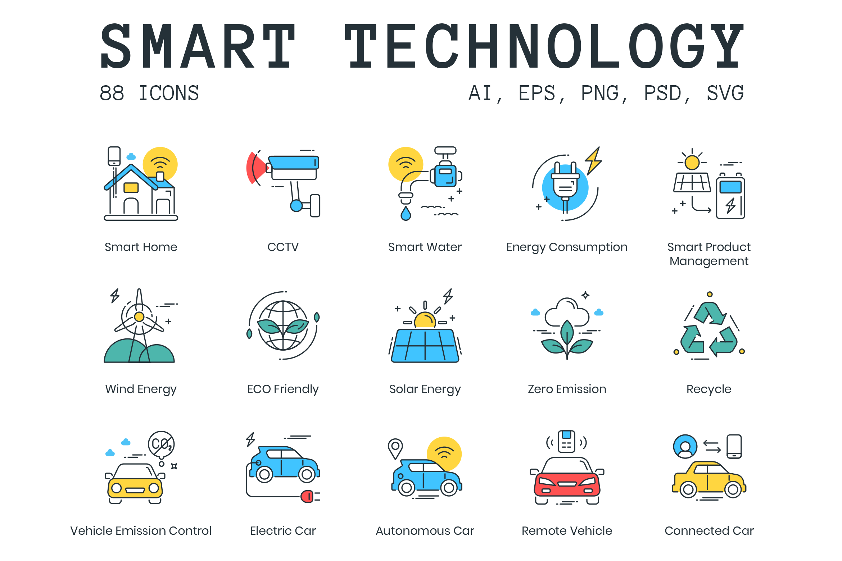



ENV 490: (Principles of) Sustainable Technologies & Ecological Restoration

Course Syllabus
Spring 2019

Instructor: Dr. Gail Grabowsky

Address: Wesselkamper, rm 108
Environmental Studies
Chaminade University
3140 Waialae Ave
Honolulu, HI 96816

Phone: 735-4834 (ext. 834 if calling from on campus)

E-mail address: ggrabows@chaminade.edu

Office hours: MF: 3:00-6:00; Tu 12:30-2:00; Or by appointment
Texts:
Required: The required texts for the course are these (you need to have access to each throughout the course):

Clewell, Andre F., and James Aronson. 2013. Ecological Restoration: Principles, Values and Structure of an Emerging Profession (2nd ed). Island Press. ISBN: 9781610911689

Harrari, Yuval Noah. 2017. Homo Deus: A Brief History of Tomorrow. HarperCollins Publisher. ISBN 9780062464316

Moyer, Ellen. 2017. Our Earth, Our Species, Our Selves. Greenvironment Press. ISBN 9781942936558

Other: Throughout the course there may be readings, handouts, links and videos to view/read that we find ourselves in our search for idea, knowledge and answers! We will share e-copies of all of the additional readings or videos that are mandatory for the course with each other. Sharing will be done via a course file in Google Drive. Make sure you can use Chrome as your search engine as accessing Google Drive etc. works best with it.

Course Description:
Maybe technology is moving faster than our values can keep up with!? Are we letting objects and apps and machines and automation get ahead of the question of why we make them other than for profit? Should we ask ourselves why we make something and maybe say no even if it will make us a lot of money!? And what about ecosystems; as our population grows and less developed countries improve their quality of life ecosystems dwindle in size or experience degradation. The new science of ecological restoration has arisen to provide you all careers restoring the Earth!

This course is about recognizing good and sustainable technologies and developing some principles and guidelines for how to recognize them and how to decide what we should do/make going forward. It is also about learning the new and developing principles and practices of ecological restoration and examining successful case studies so that we can design our own restoration plans.

I am very excited about leading this timely course. Notice I didn’t say “teaching” this course – this is a senior-lever course and we are a learning community teaching each other! I am learning as much from each of you as you from me! Also – I want YOU to help US define just what this course will be about. So on the first day we will be finishing up this syllabus. It is a work-in-progress that I want you each to have a hand in designing.

Student Learning Outcomes:
Students will:
- Become knowledgeable about the existing principles and defining features of sustainable technologies
- Develop their own list of principles and guidelines for recognizing and developing sustainable technologies
- Recognize specific examples of sustainable/good tech and be able to explain why
- Recognize un-sustainable/bad tech and explain why
- Design their own yet-to-be invented good tech devices etc.

- Become knowledgeable about the existing principles and practices of ecological restoration
- Develop their own list principles and guidelines for ecological restoration
- Describe and understand success and/or failure case-studies in ecological restoration
- Plan their own ecological restoration project for a specific place in need of restoration
- Participate in a real ecological monitoring or restoration project

Course Requirements:
Your grade in this course will be based on the following. Each of the items/activities listed below will be described to you below and in writing or orally in class.

- Good/Sustainable Tech Expose (your presentation & participation in others!) 25%
- Bad/Dumb/Fake Tech Presentation 25%
- “A Successful Eco-Restoration Case Study” OR “Restoration Gone Wrong!” 25%
- Your design and purpose for good/sustainable tech we need but don’t have! OR 25%
- Your plan for the ecological restoration of one specific place! 25%

Course Grading:
The proportion that each of the above contributes to your grade in this course is as follows:

- Good/Sustainable Tech Expose (your presentation & participation in others!) 250
- Bad/Dumb/Fake Tech Presentation 250
- “A Successful Eco-Restoration Case Study” OR “Restoration Gone Wrong!” 250
- Your design and purpose for good/sustainable tech we need but don’t have! OR 250
- Your plan for the ecological restoration of one specific place! 250
1000

Assignments:
The details for each of the assignments will be explained orally and with handouts in class prior to the initiation of each. In general for each:

Good/Sustainable Tech Expose: The purpose and outline of this assignment is:
- Find one existing example of a technology that you believe is good and sustainable
- Introduce us to the specific technology: How is it made? What is it made of? What does it do specifically? How does it do it?
- Explain why you believe it is good/sustainable tech: What good and sustainable tech principle(s) does it illustrate? Why? How?
- Examine in detail if you believe it has any downsides? Any potential negative unintended consequences? What are they?
- Engage the class in some kind of activity related to this tech. The activity can occur before, during or after your Expose.

Bad/Fake Tech Presentation: The purpose and outline of this assignment is:
- Find one example of an existing technology that you believe is bad, unsustainable, fake or dumb
- Introduce us to the specific technology: How is it made? What is it made of? What does it do specifically? How does it do it?
- Explain why you believe it is bad, unsustainable, fake, or dumb tech: What good and sustainable tech principle(s) does it violate? Why? How?
- Examine in detail if you believe it has any upsides? Any potential positive unintended consequences? What are they?
- Engage the class in some kind of activity related to this tech. The activity can occur before, during or after your Expose.

“A Successful Eco-Restoration Case Study” OR “Restoration Gone Wrong!”: The purpose of this assignment is to teach us a restoration success story OR a restoration failure story. It may be in-progress or completed. It may cover any type of ecosystem and be rural or urban. For this assignment:
- Tell us about the ecosystem/place and why it is in need of restoration? What happened to it!?
- Explain the effort that was made: What specifically were they trying to accomplish? How?
- Describe as well as is known why it succeeded or failed (is succeeding/failing). If it is not known speculate from what you uncovered about it and from what you believe.
- Explain how it might have been more successful or why you believe it was successful.

Your design and function for a good/sustainable technology we need but don’t have: This assignment happens near the end of the course when you are a tech guru. Your task is to:
- Come up with a kind of tech we need and don’t have.
- Tell us all about it: What does it do? How? How is it made? What does it look like? How is it disposed of?
CHOOSE ONE OF THESE!!!
- Explain why it is good/sustainable tech: What need(s) does it meet? What principle(s) of good sustainable tech does it illustrate?
- Think on if it might have any negative unintended consequences and if so what?

Your plan for the ecological restoration of one specific place!: Now that we have heard a number of success and failure case studies and read the literature on existing principles and practices in eco restoration you will:
- Choose a specific place to restore and describe it and how it is has been degraded
- Develop a set of goals for your ecological restoration of the place
- Explain how you will attempt to accomplish your goals
- Explain how you will document/record your success
Attendance:
Excused absences include: being ill with a doctor’s note, missing for an emergency work-related, or family-related event/obligation and/or missing for an athletic event, religious retreat, friend’s wedding or research paper presentation at a symposium. You’ll need to provide some kind of documentation in order to verify the reason for your absence no matter the reason. I am a scientist; I require hard evidence if an absence is to be excused. A doctor’s note, wedding invitation, airline ticket stub, etc. will do. If your car breaks down on the way to class take a picture of your smoking engine or flat tire and make SURE I can verify the date and time of the breakdown and it will be an excused absence, ☺. No evidence; no excused absence. Otherwise you are all allowed TWO, and only two, unexcused absences, after the second absence you will lose 25 points from your overall grade for each unexcused absence….

Extra Credit Options:
Throughout the course Dr. Gail will be making numerous environmental service-learning outings available to you. You may also find environmental service opportunities on your own. Those that Dr. Gail organizes or brings to your attention will typically be on Saturdays or after school. For every service-learning activity that you participate in, that entails 4-5 hours of work, you will receive +5 extra credit points.
Also, periodically throughout the course there will be talks and presentations you may attend that pertain to the course material. Dr. Gail will let you know when these opportunities arise OR you may discover them and bring them to the class’s attention. You can earn +2 extra credit points towards a lecture exam for each talk you attend with content related to the course content.
In order for all talks and service activities to count for extra credit you MUST have them approved by Dr. Gail PRIOR TO the event and you MUST document your presence (if Dr. Gail is not also in attendance) with a photograph of yourself participating AND give Dr. Gail the name and phone number of the person in charge or speaker/presenter. If there are any handouts from the event bring them as evidence of your attendance as well. You may earn up to 30 extra credit points from service activities and 10 from attending talks/presentations.

Course Atmosphere:
If you are handicapped under the Americans with Disabilities Act:
Chaminade will provide assistance for any student with documented disabilities. Any student who believes he/she may need accommodations in this class must contact Dr. June Yasuhara (735-4845), at the Counseling Center (office is next to security), in order to determine if you meet the requirements for a documented disability in accordance with the Americans with Disabilities Act. Please contact Dr. Yasuhara as soon as possible so that accommodations can be implemented in a timely fashion.

Nothing is Certain but Change Itself Clause…
This syllabus and course schedule are living documents: they are free to change. I try to adhere as closely as possible to each, but there will be times in which we will take longer on a particular topic or add or delete a topic to enhance the course. I like to be able to react to you as the course proceeds and go with the flow a bit in order to make the course experience sort of custom fit to you!

You are responsible for all of the information in this document: losing it or not reading it are not excuses for not knowing what’s in it!

All “TBD’s” will be determined on 1/22!

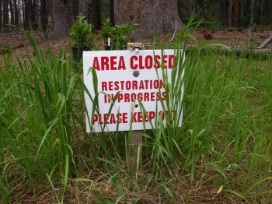
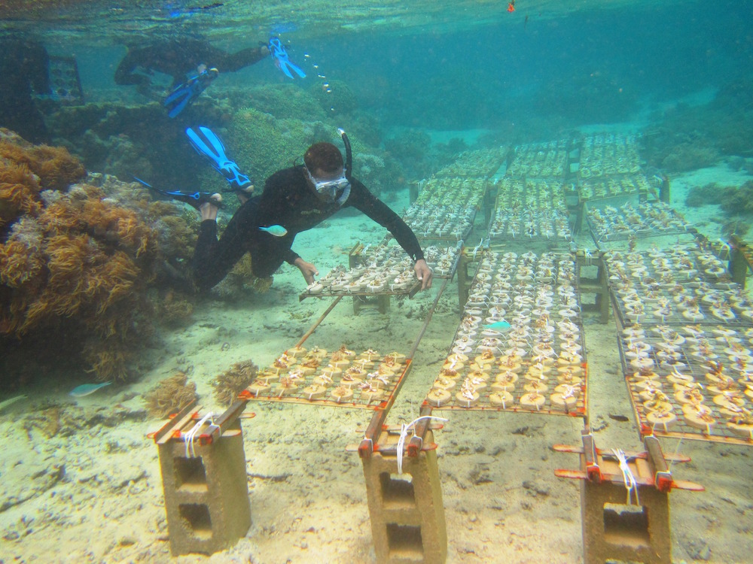
First day of class version!

ENV 490: (Principles of) Sustainable Technologies & Ecological Restoration

Course Schedule: Spring 2019

WEEK TOPIC PRESENTERS ACTIVITIES

Introduction to Sustainable Tech and Ecological Restoration

1/14 – 1/18 Course Intro, Mechanics & Design Dr. Gail Revie Syllabus; Students weigh in!
Intro to Eco Restoration READING! WATCHING! TALKING!

1/22 – 1/25 Intro to Eco Restoration (cont’d) Dr. Gail READING! WATCHING! TALKING!
Principles of Ecological Restoration Dr. Gail READING! WATCHING! TALKING!

1/28 – 2/1 Intro to Technology Dr. Gail READING! WATCHING! TALKING!
Intro to Technology (cont’d) Dr. Gail READING! WATCHING! TALKING!

2/4 – 2/8 Principles of Sustainable Tech Dr. Gail READING! WATCHING! TALKING!
Relevant DVD! Dr. Gail at Coral Reef Meeting WATCHING! TALKING!

Examples of Good Tech!
2/11 – 2/15 Good Tech Exposes ____________________ STUDENTS PRESENT! (2 per day)
Good Tech Exposes ____________________ STUDENTS PRESENT!

2/19 – 2/22 Good Tech Exposes ____________________ STUDENTS PRESENT!
Good Tech Exposes ____________________ STUDENTS PRESENT!

2/25 – 3/1 Good Tech Exposes ____________________ STUDENTS PRESENT!
Good Tech Exposes ____________________ STUDENTS PRESENT!

Examples of Unsustainable, Bad, Fake or Dumb Tech!

3/4 – 3/8 Bad Tech Presentations! ____________________ STUDENTS PRESENT! (3 per day)
Bad Tech Presentations! ____________________ STUDENTS PRESENT!

3/11 – 3/15 Bad Tech Presentations! ____________________ STUDENTS PRESENT!
Bad Tech Presentations! ____________________ STUDENTS PRESENT!

Successful OR Failed Examples of Ecological Restoration

3/18 – 3/22 Restoration Case Studies ____________________ STUDENTS PRESENT! (2 per day)
Restoration Case Studies ____________________ STUDENTS PRESENT!

3/25 – 3/29 SPRING BREAK!

4/1 – 4/5 Restoration Case Studies ____________________ STUDENTS PRESENT!
Restoration Case Studies ____________________ STUDENTS PRESENT!

4/8 – 4/12 Restoration Case Studies ____________________ STUDENTS PRESENT!
Restoration Case Studies ____________________ STUDENTS PRESENT!

YOUR Restoration Plan OR New Sustainable/Good Tech Idea!

4/15 – 4/18 Your Plan OR Your Tech! ____________________ STUDENTS PRESENT! (3 per day)
Your Plan OR Your Tech! ____________________ STUDENTS PRESENT!
4/22 – 4/26 Your Plan OR Your Tech! ____________________ STUDENTS PRESENT!
Your Plan OR Your Tech! ____________________ STUDENTS PRESENT!

4/29 – 5/3 What we learned: Good Tech is… Dr. Gail Leads Roundhouse Discussion & Results!
Eco Restoration Best Practices Dr. Gail Leads Roundhouse Discussion & Results!

Important Dates You Should Know:
Final Exam Day: Wednesday, May 8th, from 1:15-3:15 PM in Wesselkamper room 120!!!.
ON THIS DAY: We celebrate with lunch and take-home useful career-related messages from this course! NOTHING formal is due!



