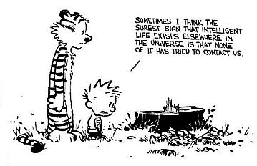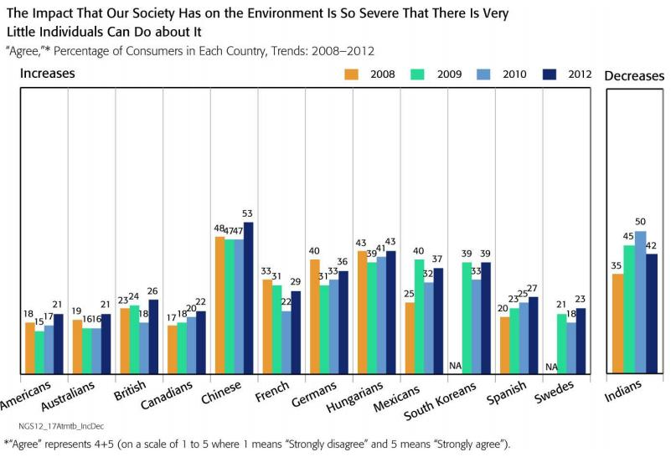

ENV 400: Current Global Environmental Issues

Course Syllabus
Spring 2019

The environment is everything that isn't me.
Albert Einstein

Beyond our genetic coding, we need to go to the earth, as the source whence we came, and ask for its guidance, for the earth carries the psychic structure as well as the physical form of every living being upon the planet. Our confusion is not only with ourselves; it concerns also our role in the planetary community.
Thomas Berry

I think the environment should be put in the category of our national security. Defense of our resources is just as important as defense abroad. Otherwise what is there to defend?
Robert Redford

If we do not permit the earth to produce beauty and joy, it will in the end not produce food, either.
Joseph Wood Krutch

When we try to pick out anything by itself, we find it hitched to everything else in the universe.
John Muir

You may be able to fool the voters, but not the atmosphere.
Donella Meadows
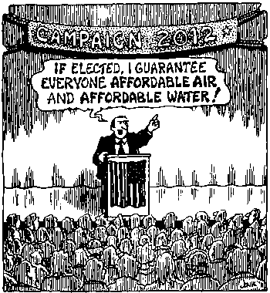

Instructor: Dr. Gail Grabowsky

Address: Wesselkamper, rm 108
Environmental Studies
Chaminade University
3140 Waialae Ave
Honolulu, HI 96816

Phone: Office: 735-4834 (ext. 4834 if calling from on campus); Cell: (808) 387-9319 (no calls after 9:00 PM please; late texts are fine I will respond the next day)

E-mail address: ggrabows@chaminade.edu

Office hours: MF: 3:00-6:00; Tu 12:30-2:00; Or by appointment

Texts:
Required: You should purchase these in the bookstore.
Global Issues. 33nd Edition. McGraw-Hill. 2015.
Myers, Norman & Scott E. Spoolman. Environmental Issues and Solutions: A Modular Approach. Brooks/Cole Cengage Learning. 2014.

Additional Selected Readings List: Many additional readings will be shared with you by Dr. Gail and by YOU with the class for your Issue Exposes! Readings not from the textbooks will be scanned and shared as PDF’s or as links. All will be posted in the course Drive folder!

Course Description:
This course surveys the major environmental challenges facing the planet-at-large and those issues that are particularly poignant to island peoples today. Students will learn, discuss and debate the major proximal cause(s) and potential short-term and long-term consequences of each issue as far as they are currently known. Issues covered will include: population growth, consumerism, climate change, food security, obesity, fresh water consumption & pollution, air pollution, waste management, species extinction, habitat depletion, overharvesting of ocean resources, urban sprawl/development, loss of indigenous knowledge and more.

General Purpose of the Course:
This is an interdisciplinary course with the general goal of having us come to understand and be able to: explain, dialogue, intelligently argue about, problem-solve and see the connections between, the major environmental issues facing the people and ecosystems of planet Earth today. This course does not exist solely in the classroom; it is a course aimed at helping us know, act and better live in our current world. You may take what you learn through this course with you when you graduate. You may share it with your friends and family or take it with you into your workplace to effect change there. You might spread the facts and actions you’ve learned around to those who are interested and lacking in the experience we will have in this course. Who really knows what you might do with what you learn and do in this course but I bet it will change your life and the lives of others through you!

Environmental Studies Learning Outcomes this course helps to meet:
Since this course is required for students seeking a certificate, minor or major in Environmental Studies it has been designed to partly teach some of the Environmental Studies Program Learning Outcomes. Specifically, this course helps the Program to meet these five of its seven Program Learning Outcomes:

A student graduating with a bachelor of science in Environmental Studies will be able to…
- Demonstrate an understanding of the central importance of spirituality, ethics and worldview in the “environmental movement”
- Demonstrate problem-solving skills from diverse disciplines for diverse populations
- Demonstrate an understanding of science and scientific investigation
- Demonstrate and understanding of the roles and importance of laws, politics and economics in environmental issues
- Demonstrate an understanding of the major environmental issues and their potential solutions

Student Learning Outcomes for this particular course:
Students taking this course will demonstrate an understanding of:
- The major global and Pacific Island environmental issues
- The causal sequence of events that is believed to have resulted in/created each of the global issues discussed in class
- The general mechanism(s) by which each of the issues discussed is detrimental to people and/or ecosystems
- One or more potential solutions to each environmental issue and the pros and cons of each from a variety of stakeholder perspectives
- The role of diverse environmental ethics in contributing to the creation of and solutions to global environmental issues
- How to effectively argue for particular solutions to environmental issues
- The connections between environmental issues and real-life situations
- Their hands-on role in issues of public concern
- How service-learning increases student interest in being civically engaged

Course Requirements:
Your grade in this course will be based on the following. Each of the items/activities listed below will be described to you in writing or orally in class. The dates of each activity (or its parts) are indicated on the Schedule portion of this syllabus.

- One midterm and one final exam based on all readings & discussions (multiple choice)
- “Causes, Consequences and Solutions” written portfolios (2)
- Issue Exposés: You lead class (number of times determined by class size)
- Small Group creation of Exhaustive Templates for particular issues

Course Grading: The proportion that each of the above contributes to your grade in this course is as follows:
Midterm & Final Exam 25%
“Causes, Consequences and Solutions” Portfolios 25%
Issue Exposé & Discussion Leading 25%

Small Group Integrative Templates = Mind Maps 25%
100%

The proportion that each of the above contributes to your grade in this course is as follows:
Midterm & Final Exam 250
“Causes, Consequences and Solutions” Portfolios 250
Issue Exposé & Discussion Leading 250
Small Group Intergrative Templates = Mind Maps 250
1000

Midterm & Final Exam: Covers the readings and class discussions. Multiple choice. Date and time of each exam are noted in the Schedule portion of this syllabus. Your highlighted readings, Power Point presentations and discussion notes will be your best study aids for the exams.

“Causes, Consequences and Solutions” Portfolios: For two of the global issues that we cover in class, you will be required to turn in a written explanation of the: (1) Causes, (2) Consequences and (3) potential Solutions for that issue. You may NOT write about one of the topics you gave an expose on. Late papers will not be accepted. Plagiarism within your portfolios will result in you receiving an F for the course. Details describing the portfolios and grading criteria will be shared with you in the form of a grading rubric handout prior to the due date of the first paper.

Global Environmental Issue Exposés: In the early days of this course I led all the discussions for each of the global environmental issues that we covered, but then I learned that it is much more interesting and a better teaching tool if you, too, lead the class ☺. You are juniors and seniors now and up to the task! I’ll explain the grading parameters for this assignment in class. You will choose your issue(s) the first week of class. You will get to critique each other’s exposes. You will decide which article(s)/chapters the class will read. Readings may come from the books you buy for class, or they may come from your own sources. You must have at least ten pages of (text) reading for your expose. If you use an outside source(s) the article(s) must be approved by me first. In either case, you must get the article(s) to the class or let the class know which one(s) it is in their books one week before the date you lead class or you can earn no higher than a C for your expose.

Small Group Integrative Templates: One of the challenges of this class is synthesizing all the information put forth about each particular issue into an integrated understanding of their causes and consequences. In order to facilitate an integrated understanding you are going to work in small groups and diagram what I am calling a “template” for each issue. The template should illustrate all of the causal and consequential components of the issue and their interrelationships. It’s very similar to a technique called Cartesian Cartography or “mind mapping.” You will be creating your issue templates in hard copy on easel paper in class (materials provided to you) so that we will create a portfolio for each group throughout the course. I am hoping that template-making is rigorous and fun and helps reinforce, integrate and clarify your understanding of each of the issues.

Attendance: Excused absences include being ill with a doctor’s note, missing for a work-related emergency, family-related emergency and/or missing for an athletic event/retreat/research paper presentation at a symposium. You’ll need to provide some kind of documentation or a phone number of someone responsible that I may call in order to verify the reason for your absence. Otherwise you are all allowed THREE, and only three, unexcused absences. After the third absence you will lose 20 points from your overall grade for each unexcused absence….

Extra Credit Service Learning Options: Throughout the course Dr. Gail will be making numerous environmental service-learning outings available to you. You may also find environmental service opportunities on your own. Those that Dr. Gail organizes or brings to your attention will typically be on Saturdays or after school. For every service-learning activity that you participate in, that entails 4-5 hours of work, you will receive +5 extra credit points.
Also, periodically throughout the course there will be talks and presentations you may attend that pertain to the course material. Dr. Gail will let you know when these opportunities arise OR you may discover them and bring them to the class’s attention. You can earn +2 extra credit points towards a lecture exam for each talk you attend with content related to the course content.
In order for all talks and service activities to count for extra credit you MUST have them approved by Dr. Gail PRIOR TO the event and you MUST document your presence (if Dr. Gail is not also in attendance) with a photograph of yourself participating AND give Dr. Gail the name and phone number of the person in charge or speaker/presenter. If there are any handouts from the event bring them as evidence of your attendance as well. You may earn up to 30 extra credit points from service activities and 10 from attending talks/presentations.

Assessment: You will be given an assessment survey for this course on the first day of class. The assessment will be administered again on the last day of the course. The results will be analyzed so that I may learn what you think you learned and in so doing learn whether the course is helping to meet the Environmental Studies Program learning outcomes. The assessment has no effect on your course grade.

Course Atmosphere: This course is meant to be a seminar experience; it is not a lecture course. This means we will be discussing issues, the readings, our ideas and opinions, making presentations, videos, debating each other and educating each other almost every day. So if you are shy you’ll have to try and shed that skin and be bold! Fake it if you have to – remember that everyone’s thoughts are valuable and if you don’t share yours the rest of us will be denied that “gold.”

If you are handicapped under the Americans with Disabilities Act:
Chaminade will provide assistance for any student with documented disabilities. Any student who believes he/she may need accommodations in this class must contact Dr. June Yasuhara (735-4845), at the Counseling Center (office is next to security), in order to determine if you meet the requirements for a documented disability in accordance with the Americans with Disabilities Act. Please contact Dr. Yasuhara as soon as possible so that accommodations can be implemented in a timely fashion.

Nothing is Certain but Change Itself Clause…
This syllabus and course schedule are living documents: they are free to change. I try to adhere as closely as possible to each, but there will be times in which we will take longer on a particular topic or add or delete a topic to enhance the course. I like to be able to react to you as the course proceeds and go with the flow a bit in order to make the course experience sort of custom fit to you!

You are responsible for all of the information in this document: losing it or not reading it are not excuses for not knowing what’s in it!


First day of class version

Current Global Environmental Issues

Course Schedule: Spring 2019

WEEK TOPIC PRESENTERS ACTIVITIES
1/14 – 1/18 Course Introduction & Mechanics Dr. Gail Introductions; Choose Topics
Fill out the course assessment Assessment due Friday 1/18 in class.

1/22 – 1/25 Introduction to Global Enviro Issues / Dr. Gail Reading/Discussion/Template
Precautionary Principle

1/28 – 2/1 Pop Growth/Consumerism Dr. Gail/ ________ Reading/Discussion/Template

2/4 – 2/8 Waste: Solid Waste/Wastewater ________________ Reading/Discussion/Template

2/11 – 2/5 Food: Agriculture: Meat/Grains ________________ Reading/Discussion/Template

2/19 – 2/22 Food: Fisheries/Aquaculture ________________ Reading/Discussion/Template

2/25 – 3/1 Water consumption/Pollution ________________ Reading/Discussion/Template
Mid Term 3/1 Mid Term 3/1

3/4 – 3/8 Climate Change: Ocean/Land ________________ Reading/Discussion/Template

3/11 – 3/15 Fossil Fuels/Renewable Energies ________________ Reading/Discussion/Template,

By Friday 3/15: You MUST have at least ONE Portfolio turned in already (and it may NOT be on your presentation topic!)

3/18 – 3/22 Mineral Resources/ Habitat Loss ________________ Reading/Discussion/Template

3/25 – 3/29 S P R I N G B R E A K (Read on the beach!)

4/1 – 4/5 Species Extinction/ Urbanization ________________ Reading/Discussion/Template

4/8 – 4/12 Food Waste/Obesity ________________ Reading/Discussion/Template

4/15 – 4/18 ___________________________ ________________ Reading/Discussion/Template

4/22 – 4/26 ___________________________ ________________ Reading/Discussion/Template

4/29 – 5/3 Summary of Issues; Sustainability ________________ Reading/Discussion
Solutions roundtable

By Tuesday 5/7: Have your SECOND portfolio turned in by 11:05 PM (it cannot be on your presentation topic!)

Important Dates You Should Know:
- Second Exam: Tuesday, May 7th, from 11:00-1:00 PM in our regular classroom.

