Psychology 316: Research Methods in Psychology
Spring 2019

Instructor: Dr. Tracy Trevorrow
Office: Henry Hall 204
Phone: 739-4685 Email: ttrevorr@chaminade.edu
Office Hours: Tuesday & Thursdays 11:30 – 12:20, or by appointment
Required Textbook: Cozby, P.C. & Bates, S. C. (2015). Methods in Behavioral Research. McGraw Hill
Additional Readings: Additional assigned readings from the APA Publication Manual are posted in Canvas
Materials: 1 USB Thumbdrive for saving work & assignments, backing up data, etc.

Course Overview
This course is designed to be “hands on” while providing you with the theoretical and conceptual basis for how research is done in the behavioral sciences. You will be conducting psychological research from forming a research question and designing the study to the final stages of writing and presenting a scientific report. You will be participating in the organization and hosting of an undergraduate psychology research conference held at Chaminade University. The research product that you produce, either a poster or an oral presentation will be presented at this conference.
We will be addressing the features and importance of the scientific method and the strengths and limitations of research designs. You will learn how research questions are best matched to research designs. The nature of different types of data will be reviewed along with how specific tests of the data can be used to answer research questions. You will also learn about the ethical treatment of research participants and data.
There are a number of skills that you will learn as you conduct your research. For example, you will be developing and administering a survey and then “cleaning” entering and analyzing the data you collect in a statistical program. You will be learning how to do a literature review and how to write each section of a scientific report (in APA format), be that a poster, paper, or oral presentation.
Course Format
The lectures and class activities will contribute to your doing the major course assignment (a research project). In this way, the course will be practical and realistic in terms of how research is done. Some weeks our class will be dedicated to data collection, data entry, the preparation of research papers or presentations. You will be divided to work in small research groups and expected to work collaboratively (again, this is how almost all research is done). At times the entire class may be required to help in a specific research group’s data collection.
All class lectures will be reflected in power point presentations and available in Canvas.

Learning Objectives
You will be asked to demonstrate:
- an understanding of the objectives, strengths, and limitations of scientific inquiry including
the differences between scientific versus non-scientific approaches to knowledge
- an understanding of ethical implications of scientific research
- an understanding of different research methods and designs used in the
behavioral and social sciences
- an understanding of measurement, the measurement process, and the related
issues of reliability and validity
- that you can develop a research proposal related to the study of a psychological issue
- that you can conduct a literature review and demonstrate the ability to use online and library sources to obtain research information
- that you can manage data in SPSS and conduct and interpret statistical tests
- that you can communicate clearly in writing and follow guidelines of APA for writing research papers (including the incorporation of feedback)
- that you can work and learn in the spirit of a collaborative and collegial community through participation in group projects
- that you can present your research through oral and written communication.

Course Requirements

Attendance & Participation. I expect you to attend each class meeting and be prepared for informed participation (i.e., come to class having read assigned material and/or completed assignments). You are also expected to contribute to class discussion and small group activities. A pattern of unexplained absences, tardiness, or lack of engagement in class will likely lower your grade.

Individual Assignments. You will be given individual assignments. These will mostly consist of video reviews.

Small Group Assignments. You will be given small group activities that require you to work outside of class with 3 or 4 peers.

Tests. You will take 4 tests in addition to your final exam. Your highest three quiz scores will count.

Literature Review & Proposal. You will conduct on-line and/or library searches for literature on the topic of your research paper. The material you will review will consist largely of research articles from professional literature, i.e., edited books and journals.

Research Paper/Poster/PP. Your research group will generate a paper, poster, and PP that presents your findings. You will receive a group score for all of these products.
- a literature review
- hypothesis/hypotheses
- operational definitions of variables
- assessment devices (e.g., questionnaires)
- research design
- method of data collection
- appropriate statistical analysis and display (e.g., tables, figures)
- reference section.

APA style format is required for all papers. All papers will be double-spaced. Refer to APA Pub. Manual. 6th Edition. No paper will be accepted in other than APA format.
Final Exam
You are required to sit for a final exam taken during finals week. Make your travel plans accordingly. Please take note that your final exam will be on May 8th. This exam will be cumulative.

Grading
Attendance & participation (~2 points per class) 30
Individual assignments (4 X 5) 20
Small group assignments (4 X 5) 20
Tests 3 (best of 4) X 25 75
Literature review & proposal 20
Research paper (final) 30
Research poster 30
Research PP 30
Participation at Research Conference 15

Final exam 30
Total 300

A = 270-300; B = 240-269; C = 210-239; D = 180-209; F = <180

Course Schedule
(Subject to change)

Date | Cl | Topic | Activity | Read | Assignments Due
1/15 | 1 | Introduction  Structure of class  Why study research methods? | Syllabus review  Review of research topics  (sleep, smoking/vaping, screen time) | Syllabus | None
1/17 | 2 | Skepticism  Research methods  Scientific understanding  Science approach  Goals of science | Psychics & Horoscope  How do we approach our projects to maximize credibility? | Ch 1 | None
1/22 | 3 | Research hypotheses  Journal articles, Posters & Oral Presentations  Correlational research designs | Our research hypotheses | Ch 2 | Ind 1: Video Review: Skeptical thinking TED Talks
1/24 | 4 | Librarian visit  Conducting a literature search | Searching the literature for each group. | Ch 2
1/29 | 5 | Ethics  History of problems  Informed consent  Deception  Ethics codes  IRBs | Video: British Soldiers on LSD (1963)  Completing your own CITI IRB certificate | Ch 3 | Grp 1: Research hypotheses & Reference Section
1/31 | 6 | Ethics of our research projects | Video: Tuskegee Study  Evaluation of risk  Informed consent  Example Administrations | Ch 3 | Ind 2: Your IRB CITI Certificate
2/5 | 7 | Test 1.  ------------  Data types & Assessment  Reliability, validity, reactivity, scales of measurement |  | Ch 4
2/7 | 8 | Assessment approach for our projects  Recruitment process | Practice assessments, scoring  Discussion of best match for specific research projects | Ch 5
2/12 | 9 | Writing Introduction section of a paper or poster | Review of example Introduction sections
2/14 | 10 | Review of draft versions of Introduction sections | Review of Draft Introduction sessions (cross project) |  | Grp 2: Bring in draft version of Introduction section
2/19 | 11 | Data collection | Data collection
2/21 | 12 | Data collection | Data collection
2/26 | 13 | Research designs: Observational Quasi-Experimental |  | Ch 6  Ch 7 | Grp 3: Completed data set
2/28 | 14 | Experimental designs |  | Ch 11
3/5 | 15 | Test 2

3/7 | 16 | Data entry using SPSS | Setting up the data matrix  Cleaning of data set
3/12 | 17 | Data analysis: Descriptive statistics  Frequencies, means, standard distributions | Analyzing demographic characteristics of our samples |  | Grp 3: Completed data set
3/14 | 18 | Statistical inference, Type I & II errors, significance level, power  t-tests, F-tests | Apply inferential statistical tests to our research | Ch 13
3/19 | 19 | Inferential statistics, continued  Regression, structural models | Review findings of our analysis |  | Grp 4: Completed descriptive analysis results
3/21 | 20 | Quiz 3
3/26 |  | Spring break
3/28 |  | Spring break
4/2 | 21 | Writing methods, results, conclusion for posters and presentations | Review APA format
4/4 | 22 | Poster format  How to give a conference oral presentation |  |  | Grp 5: Inferential analysis of group data
4/9 | 23 | Rehearsal of presentations | Review and practice presentations
4/11 | 24 | Undergraduate Psychology Research Conference | Afternoon set up conference room.  Evening present research! |  | Ind 3: Contribution to conference preparation
4/16 | 25 | Review of conference experience  Research designs beyond our class projects: qualitative research
4/18 | 26 | Complex factorial designs
4/23 | 27 | Test 4
4/25 | 28 | Writing a research paper |  | App A
4/30 | 29 | Review of paper drafts
4/30 | 20 | Class party! |  |  | Final group research project paper due.
5/8 | 30 | Final Exam |  | Wed | BS 102 @ 9:00
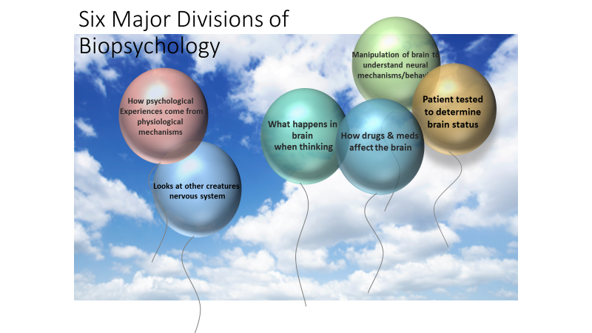
MARIANIST EDUCATIONAL VALUES

The five characteristics of a Marianist Education are:
- Educate for Formation in Faith
Catholic Universities affirm an intricate relationship between reason and faith. As important as discursive and logical formulations and critical thinking are, they are not able to capture all that can be and ought to be learned. Intellectual rigor coupled with respectful humility provide a more profound preparation for both career and life. Intellectual rigor characterizes the pursuit of all that can be learned. Respectful humility reminds people of faith that they need to learn from those who are of other faiths and cultures, as well as from those who may have no religious faith at all.

- Provide an Excellent Education
In the Marianist approach to education, “excellence” includes the whole person, not just the technician or rhetorician. Marianist universities educate whole persons, developing their physical, psychological, intellectual, moral, spiritual and social qualities. Faculty and students attend to fundamental moral attitudes, develop their personal talents and acquire skills that will help them learn all their lives. The Marianist approach to education links theory and practice, liberal and professional education. Our age has been deeply shaped by science and technology. Most recently, information and educational technologies have changed the way faculty and students research and teach. At Marianist Universities, two goals are pursued simultaneously: an appropriate use of information technology for learning, and the enhancement of interaction between students and teachers. As Catholic, Marianist Universities seek to embrace diverse peoples and understand diverse cultures, convinced that ultimately, when such people come together, one of the highest purposes of education is realized: a human community that respects every individual within it.
- Educate in Family Spirit
Known for their strong sense of community, Marianists have traditionally spoken of this sense as “family spirit.” Marianist educational experience fosters the development of a community characterized by a sense of family spirit that accepts each person with loving respect, and draws everyone in the university into the challenge of community building. Family spirit also enables Marianist universities to challenge their students, faculty and staff to excellence and maturity, because the acceptance and love of a community gives its members the courage to risk failure and the joy of sharing success.
- Educate for Service, Justice, and Peace
The Marianist approach to higher education is deeply committed to the common good. The intellectual life itself is undertaken as a form of service in the interest of justice and peace, and the university curriculum is designed to connect the classroom with the wider world. In addition, Marianist universities extend a special concern for the poor and marginalized and promote the dignity, rights and responsibilities of all people.
- Educate for Adaptation to Change
In the midst of rapid social and technological change, Marianist universities readily adapt and change their methods and structures so that the wisdom of their educational philosophy and spirituality may be transmitted even more fully. “New times call for new methods,” Father Chaminade often repeated. The Marianist university faces the future confidently, on the one hand knowing that it draws on a rich educational philosophy, and on the other fully aware for that philosophy to remain vibrant in changing times, adaptations need to be made.
Each of these characteristics is integrated, to varying degrees, in this course.

