CHAMINADE UNIVERSITY
COURSE SYLLABUS, MBA 611



Welcome to the course! Your instructor is Caryn Callahan, Ph.D.

Course Schedule
Quarter: January 14 – March,16, 2019
Course location: Kieffer

Instructor Contact Information
Course Instructor: Caryn Callahan, Ph.D.
Office: Kieffer Room 18
Phone: 395-0541 (Home.)
E-Mail caryncallahan@yahoo.com ccallaha@chaminade.edu
Administrative Assistant Phone: 808-440-4280

Course Description
Covers basic principles of financial valuation and analysis. Topics include financial statement analysis, working capital management, long-term financing decisions, and capital structure and dividend policy. Prerequisites: MBA 510 and MBA 520

Associated Program Learning Outcome
Demonstrate an understanding of issues central to financial management of an organization and the ability to use financial tools and analysis to inform business decisions.

Course Learning Outcomes
At the conclusion of this course, successful students will have demonstrated:

- Knowledge of the fundamental concepts used by financial management in the corporation and of the legal structure of the business organization. (Chapter 1)
- Awareness of the primary goals and objectives of financial management. (Chapter 2)
- Expertise in ratio analysis and in analyzing a firm's financial statements to assess the firm's degree of financial success. (Chapter 4)
- Mastery of the concepts of the time value of money. (Chapter 5)
- Understanding of the relationship between risk and rates of return (Chapter 6)
- Mastery of the fundamentals of bond and stock valuation. (Chapter 7)
- Adeptness in using cash flow estimation for capital budgeting (Chapter 8)
- Mastery of the major capital budgeting techniques (Chapter 9)
- Proficiency in using forecasting techniques used to determine financial needs. (Ch. 10)
- Ability to calculate the cost of capital for a firm. (Chapter 11)
- Understand of the implications of the use of leverage in capital structure (Chapter 12)
- Ability to identify the key determinants of corporate dividend policy (Chapter 13).
- Expertise in the methods used to manage a firm's current assets. (Chapter 14)
- Skills in distinguishing the individual working capital elements. (Chapter 15)
- Understanding of how marketable securities for short-term investment planning. (Ch 16)
- Awareness of the methods used to manage inventories and accounts receivable. (Ch. 17)
- Comprehension of the different sources and uses of derivative securities (Chapter 18)
- Ability to identify the mechanics of mergers, LBOs, divestitures and business failures. (Ch. 19)
- Proficiency in the dynamics of international financial management (Chapter 20)

Course Schedule and Topics
A detailed course schedule starts on page 5 of this syllabus.

Readings and Materials
Principles of Managerial Finance, Lawrence Gitman, Addison Wesley Longman. Fourteenth Edition, 2015.

Assignments and Attendance
You are expected to participate actively in each course session. A description of assignments is below. Due dates are in the Course Schedule section.

Midterm and Final Examinations (25% Each)
The midterm and final examinations will focus on the material covered in the textbook, especially the problems and concepts covered during class.

Weekly Quizzes (42%)
There will be six weekly quizzes, each worth 7 percentage points.

Group Financial Issue Paper and Presentation (7%)
Each team will make a presentation about a financial issue chosen by the group. Your group should choose one issue in contemporary finance and research it in depth. Your research paper should be seven to ten pages in length. Your team will also do an oral presentation about 15 minutes in length regarding your topic. The oral presentation should be professionally prepared and delivered. You will be expected to prepare visual aids and handouts. On the first night of class, students will form teams of three or four students. These teams will work together on their team’s group case presentations. Your topic must be related to Corporate Finance and NOT to macroeconomics or investments. Here are some examples of acceptable topics: mergers and acquisitions, stock splits and dividends, the bond market, the dangers of derivatives, lease financing and the use of preferred stock.

Internet Presentation (1%)
A list if finance-related websites is provided at the end of the syllabus. You may choose any website you wish from the list. You do not have to limit yourself to the finance-related websites listed but please get my permission first if you are not choosing one from the list.

For this assignment, please take the role of a guide and inform the class what they might find useful about the site you chose. You should also evaluate the site, telling the class what is on the pages, how useful it is and any other relevant data. Describe what aspects of the website you found good and what you did not like. Your briefing, which should be about five minutes in length, will count for 1 percentage point. No write-up is required.

Attendance Policy
You are expected to actively attend and participate in each session of the course. Recognizing the professional obligations of our students, one excused absence is allowed in a graduate course. A student with an unexcused absence will lose 10 points off the final grade for each unexcused absence. In other words, if your overall average grade for the semester was 85% or 'B,' the unexcused absence would pull your grade down to 75% for the semester or a 'C" grade. Students with two unexcused absences in place of the missed class (if allowed by the instructor) will not pass the course. Please notify the instructor in advance of an absence if possible.

Assessment and Grading

Midterm Examination 25%
Final Examination 25
Weekly Quizzes (6 quizzes) 42
Group Research Paper and Presentation 7
Internet Presentation 1
Total 100%

Academic Honesty
Students are responsible for promoting academic honesty at Chaminade by not participating in any act of dishonesty and by reporting any incidence of dishonesty to an instructor or to a University official. Academic dishonesty may include theft of records or examinations, alteration of grades, and plagiarism. Questions of academic dishonesty in a particular class are first reviewed by the instructor, who must make a report with recommendation to the Business School Dean. Consequences for academic dishonesty may range from an “F” grade for the work in question to an “F” grade for the course to suspension or dismissal from the University.

Students with Disabilities
Chaminade University provides reasonable accommodations for individuals with a disability in compliance with the Americans with Disabilities Act (ADA) of 1990. If you would like to know if you qualify for ADA accommodations, please contact our Counseling Center at 808-735-4845. Current appropriate documentation will be required for determination of accommodation eligibility.

Characteristics of a Marianist Education
The following are characteristics of the approach to education engaged at Marianist schools, including Chaminade University:
• Educate for formation in faith
• Provide an integral quality education
• Educate in family spirit
• Educate for service, justice and peace
• Educate for adaptation and change

Instructor Background Information
My name is Caryn Callahan, and I am your instructor in this course.
Here’s some information about my background. I have an MBA in Finance/Accounting from UCLA and a Ph.D. in East Asian Languages and Civilizations from Harvard. After I completed my MBA, I worked for W.R. Grace in New York City as a capital budget analyst in their international division for two years. Although analyzing overseas investment projects for Grace was exciting (especially the travel), my real love was Wall Street. As it happened Merrill Lynch was looking for MBAs who were fluent in Asian languages. Since I speak and read Japanese fluently, Merrill Lynch recruited me in New York, and then sent me to Japan for five years.
I acted as Merrill Lynch's worldwide spokesperson and chief analyst for the Japanese consumer electronics industry, covering exciting companies, such as Sony, Fuji Photo, Matsushita, JVC, Pioneer and TDK. My job involved frequent contact with top management at these companies, analysis of financial statements and production of investment recommendations, ranging from short daily updates and recommendations, to quarterly reports of up to 70 pages on each company. My recommendations earned me the honor of being chosen as number one analyst for Japanese consumer electronics industry by Euromoney magazine. My opinions were also frequently quoted in the New York Times, Wall Street Journal, Business Week, Fortune magazine and others. It was very exciting, and I loved the job.
After we started our family, we moved to Hawaii where I began teaching full time at Chaminade University, conducting courses in Finance and International Business. I continue to consult in the finance and international business fields. I also continue to actively participate as an investor in the market.
FINANCIAL CALCULATOR

You may also find a clone of the financial calculator at the following sites; however, these sites are frequently down so you are better off using Excel or a financial calculator. This Website sometimes gives incorrect answers so don’t use it for assignments.

http://www.epx.com.br/ctb/hp12c.php
http://www.vichinsky.com.br/hp12c/hp12c.php
You are required to either purchase (or download) a financial calculator for this course or to use Excel or else you will not be able to solve all the problems easily. If you use Excel, you will not need to purchase a financial calculator; however, it is very handy to have a financial calculator and I recommend it strongly. You can download a financial calculator for $6-to-$20 on your smart phone or iPad or other type of smart phone.
There are many brands of financial calculators available but I strongly recommend the Hewlett Packard 12-C platinum. Hewlett-Packard calculators are the best, followed by Texas Instruments. When you acquire your Hewlett Packard 12-C, be sure to get the “platinum edition” if you are downloading or buying a calculator because the “classic” 12-C uses an input system that is hard to master. The top part of the classic 12-C is colored gold while the top part of the platinum is colored silver. Here’s what it looks like:

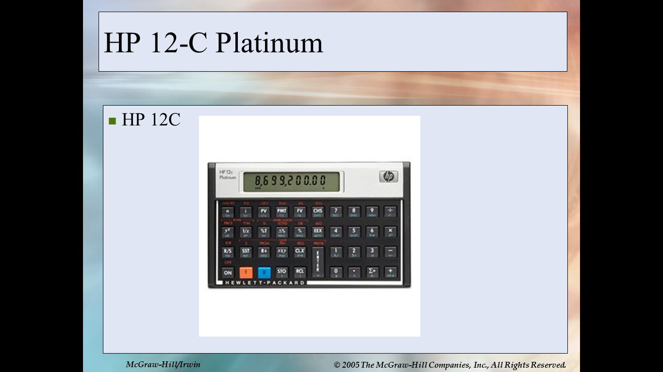

If you already have a calculator but are not sure if it is the correct type of financial calculator, you can be sure that you have the correct type if it has keys for “present value (PV), future value (FV), interest (“I” or “y”) and term (n).

Course Schedule and Topics
Winter 2019, SCHEDULE AND ASSIGNMENTS: MBA 611, FINANCE

MONDAY, JANUARY 14, 2019, Session #1

Reading Assignment due this week: Textbook, Chapters 4 and 5
Chapter 4 “Cash Flow and Financial Planning”
Chapter 5 “Time Value of Money”
Download HP 12C Calculator or prepare to use Excel.
CALCULATOR WEB SITES http://www.epx.com.br/ctb/hp12c.php
http://www.vichinsky.com.br/hp12c/hp12c.php

Quiz 1 is a take-home quiz and is due by 6:00 pm on Saturday. Email your answers to caryncallahan@yahoo.com

MONDAY, JANUARY 21, 2019, Session #2
Despite the Martin Luther King holiday, we will have a class session tonight.

Reading Assignment due this week: Textbook, Chapters 6 and 7
Chapter 6 “Interest Rates and Bond Valuation”
Chapter 7 “Stock Valuation”

Quiz 2 on Chapters 6 and 7 will be a take-home quiz. Email your answers by 6:00 pm on Saturday to caryncallahan@yahoo.com

MONDAY, JANUARY 28, 2019, Session #3

Reading Assignment due this week: Textbook, Chapters 8 and 9
Chapter 8 “Risk and Return”
Chapter 9 “The Cost of Capital “

Quiz 3 is due by 6:00 pm on Sunday. Email your answers by 6:00 pm on Saturday to caryncallahan@yahoo.com

MONDAY, February 4, 2019, Session #4

Reading Assignment due this week: Textbook, Chapters 10 and 11
Chapter 10 “Capital Budgeting Techniques “
Chapter 11 “Capital Budgeting Cash Flow”
Distribution of Take-home Midterm: Chapters 4 through 9. Email your answers by 6:00 pm on Saturday to caryncallahan@yahoo.com

MONDAY, February 11, 2019, Session #5

Reading Assignment due this week: Textbook, Chapters 12 and 13
Chapter 12 “Risk and Refinements in Capital Structure “
Chapter 13 “Leverage and Capital Structure”
Quiz 4: email your answers by 6:00 pm on Saturday to caryncallahan@yahoo.com

MONDAY, February 18, 2019, Session #6
Despite the President’s Day holiday, we will have a class session tonight.
Reading Assignment due this week: Textbook, Chapters 14 and 15
Chapter 14 “Payout Policy”
Chapter 15 “Working Capital and Current Assets Management”
Quiz 5: email your answers by 6:00 pm on Saturday to caryncallahan@yahoo.com

MONDAY, February 25, 2019, Session #7

Reading Assignment due this week: Textbook, Chapter 17
Chapter 17 “Hybrid and Derivative Securities “
Quiz 6: email your answers by 6:00 pm on Saturday to caryncallahan@yahoo.com

MONDAY, March 4, 2019, Session #8

Reading Assignment: Textbook, Ch 16 and 18
Chapter 16 “Current Liabilities Management”
Chapter 18 “Mergers, LBOs, Divestitures, and Business Failures”

MONDAY, March 11, 2019, Session #9

Reading Assignment: Textbook, Ch 19
Chapter 19 “International Managerial Finance”
GROUP PAPER PRESENTATIONS.

MONDAY, March 18, 2019, Session #10
FINAL EXAMINATION, COVERS CHAPTERS 10-19

