CHAMINADE UNIVERSITY
COURSE SYLLABUS, MBA 611



Welcome to the course! Your instructor is Caryn Callahan, Ph.D.

Course Schedule
Quarter: October 1 -December 9, 2018
Course location: Online

Instructor Contact Information
Course Instructor: Caryn Callahan, Ph.D.
Office: Kieffer Room 18
Phone: 395-0541 (Home.)
E-Mail caryncallahan@yahoo.com ccallaha@chaminade.edu
Administrative Assistant Phone: 808-440-4280

Course Description
Covers basic principles of financial valuation and analysis. Topics include financial statement analysis, working capital management, long-term financing decisions, and capital structure and dividend policy. Prerequisites: MBA 510 and MBA 520

Associated Program Learning Outcome
Demonstrate an understanding of issues central to financial management of an organization and the ability to use financial tools and analysis to inform business decisions.

Course Learning Outcomes
At the conclusion of this course, successful students will have demonstrated:

- Knowledge of the fundamental concepts used by financial management in the corporation and of the legal structure of the business organization. (Chapter 1)
- Awareness of the primary goals and objectives of financial management. (Chapter 2)
- Expertise in ratio analysis and in analyzing a firm's financial statements to assess the firm's degree of financial success. (Chapter 4)
- Mastery of the concepts of the time value of money. (Chapter 5)
- Understanding of the relationship between risk and rates of return (Chapter 6)
- Mastery of the fundamentals of bond and stock valuation. (Chapter 7)
- Adeptness in using cash flow estimation for capital budgeting (Chapter 8)
- Mastery of the major capital budgeting techniques (Chapter 9)
- Proficiency in using forecasting techniques used to determine financial needs. (Ch. 10)
- Ability to calculate the cost of capital for a firm. (Chapter 11)
- Understand of the implications of the use of leverage in capital structure (Chapter 12)
- Ability to identify the key determinants of corporate dividend policy (Chapter 13).
- Expertise in the methods used to manage a firm's current assets. (Chapter 14)
- Skills in distinguishing the individual working capital elements. (Chapter 15)
- Understanding of how marketable securities for short-term investment planning. (Ch 16)
- Awareness of the methods used to manage inventories and accounts receivable. (Ch. 17)
- Comprehension of the different sources and uses of derivative securities (Chapter 18)
- Ability to identify the mechanics of mergers, LBOs, divestitures and business failures. (Ch. 19)
- Proficiency in the dynamics of international financial management (Chapter 20)

Course Schedule and Topics
A detailed course schedule starts on page 5 of this syllabus.

Readings and Materials
Principles of Managerial Finance, Lawrence Gitman, Addison Wesley Longman. Fourteenth Edition, 2015. Our publisher’s Website is at this link.
http://www.pearsonhighered.com/educator/product/Principles-of-Managerial-Finance-Plus-NEW-MyFinanceLab-with-Pearson-eText-Access-Card-Package/9780133740929.page
Assignments and Attendance
You are expected to participate actively in each week. A description of assignments is below. Due dates are in the Course Schedule section.

Assessment and Grading

Midterm Examination 13%
Final Examination 14
Weekly Quiz/Homework (8 assignments) 40
Group Case 9
Conference Participation (8 Weeks) 24
Total 100%

MIDTERM (13%) AND FINAL EXAMINATIONS (14%)
The midterm and final examinations will focus on the material covered in the textbook, especially the problems and concepts covered during class. I will upload the exams to the respective Weekly Conferences and you will have a week to answer the questions. Needless to say, they are open-book tests. Please post your answers to Canvas by 6:00 pm on the last day of our online week (Sunday).

WEEKLY HOMEWORK (40%)
There will be 8 weekly homework assignments, each worth 5 percentage points. Homework assignments are posted in the Conferences for each week. Please post your answers to Canvas by 6:00 pm on the last day of our online week (Sunday).

GROUP FINANCIAL ISSUE RESEARCH PAPER (9%)
Each team will research in depth one issue in contemporary finance chosen by the group. Please get my approval of your topic first before starting it. Your research paper should be seven to ten pages in length and is due at the end of Week 9. Your topic must be related to Corporate Finance. Here are some examples of acceptable topics: mergers and acquisitions, stock splits and dividends, the bond market, the dangers of derivatives, lease financing and the use of preferred stock,

CONFERENCE PARTICIPATION (24%)
Participating actively in the Weekly Conferences is an essential part of this class. You cannot pass this course without meeting the participation requirements mentioned below since this part of the class counts for 20 points of your grade. You will have a Conference discussion every week but the midterm and final weeks (Week 5 and 10).

Every week, three Discussion Questions will be presented to facilitate useful discussion among the class members, guided by the professor. The assigned discussion questions can be found posted in the online Discussion Conference for each week. Your responses must be posted by 6:00 pm on Sunday, the last day of the online week. Notes posted after that deadline will not be graded.

To gain full credit for participation (3 points per week), you should provide at least two responses to each one of the three Discussion Questions. That means at least six notes per week. One of the two notes that you post for each discussion question should be your original answer to the question and the other can either be a response to another student’s posting or another original insight on your part. Each one of your notes posted for credit must be at least 200 words long. To give you an idea of the length of a 200-word post, see the blue, italicized section of the syllabus immediately below. It equals exactly 200 words. (Be sure to read the content of the section too since it is a key part of the syllabus.)

The Weekly Discussion Conference is designed to resemble a classroom discussion. You need to actively participate to get credit for participation. You do not get credit if you just log on and read others' comments. Your comments must be significant to count for participation credit. A significant comment is one that contributes a new insight, or which adds useful comments, suggests alternative solutions or gives good reasons for disagreeing with other’s comments in an ongoing discussion. In the course of the ongoing discussion, you may frequently reply with one-phrase comments; however, it does not count towards your participation grade when you just comment, "I agree," or "Good point."
Our online classroom exists only because of active participation by class members. It is entirely created by us. Your comments on one day could generate many responses. The online environment is something like an ongoing conversation.
A Note on Late Postings: Students who post all or most of their notes in the last two days of the week will be penalized and only earn half credit. That is because the class will be discussing the assigned questions throughout the week and building upon each others' insight, Everyone needs to participate in this dialogue. Last minute postings add little value.
If a student posts all of his or her notes on the last day or so, classmates will not have a chance to benefit from the late-poster’s ideas and also have little time to respond to these notes. This contradicts the aim of a “discussion” assignment. The late poster gets a “free ride” on the shoulders of those who have worked through the answers in collaborative discussion throughout the week. Consequently, late-posters who post all their notes to a question on the last two days of the week will only earn half-credit for those responses. I know there are weeks when it is impossible for a student to post earlier. For those weeks, please work ahead. The Conferences are all available in the classroom, so students who plan to be traveling can post before they leave.
The Conference is like any other assignment and students will unfortunately lose points if they cannot do the assignment as directed.
FINANCIAL CALCULATOR
You are required to either purchase (or download) a financial calculator for this course or to use Excel or else you will not be able to solve all the problems easily. If you use Excel, you will not need to purchase a financial calculator; however, it is very handy to have a financial calculator and I recommend it strongly. You can download a financial calculator for $6-to-$20 on your smart phone or iPad or other type of smart phone.
There are many brands of financial calculators available but I strongly recommend the Hewlett Packard 12-C platinum. Hewlett-Packard calculators are the best, followed by Texas Instruments. When you acquire your Hewlett Packard 12-C, be sure to get the “platinum edition” if you are downloading or buying a calculator because the “classic” 12-C uses an input system that is hard to master. The top part of the classic 12-C is colored gold while the top part of the platinum is colored silver. Here’s what it looks like:

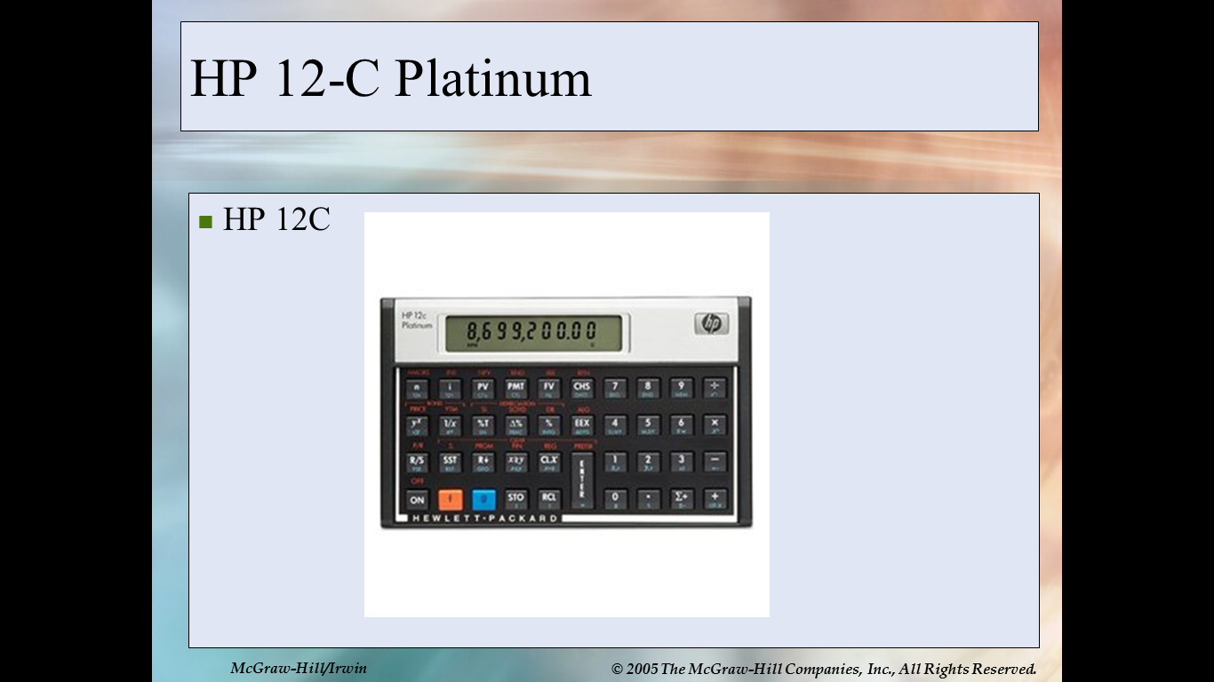

If you already have a calculator but are not sure if it is the correct type of financial calculator, you can be sure that you have the correct type if it has keys for “present value (PV), future value (FV), interest (“I” or “y”) and term (n).

Teams
During the second week of class, teams will be formed to work together on their team’s group case presentations. You may choose your team of three or four students or let me assign you to a team. Students who do not choose a team will be assigned to one.

Questions and Answers:
When you have a question, please post a question in our online classroom or e-mail me at caryncallahan@yahoo.com.

Academic Honesty
Students are responsible for promoting academic honesty at Chaminade by not participating in any act of dishonesty and by reporting any incidence of dishonesty to an instructor or to a University official. Academic dishonesty may include theft of records or examinations, alteration of grades, and plagiarism. Questions of academic dishonesty in a particular class are first reviewed by the instructor, who must make a report with recommendation to the Business School Dean. Consequences for academic dishonesty may range from an “F” grade for the work in question to an “F” grade for the course to suspension or dismissal from the University.

Students with Disabilities
Chaminade University provides reasonable accommodations for individuals with a disability in compliance with the Americans with Disabilities Act (ADA) of 1990. If you would like to know if you qualify for ADA accommodations, please contact our Counseling Center at 808-735-4845. Current appropriate documentation will be required for determination of accommodation eligibility.

Characteristics of a Marianist Education
The following are characteristics of the approach to education engaged at Marianist schools, including Chaminade University:
• Educate for formation in faith
• Provide an integral quality education
• Educate in family spirit
• Educate for service, justice and peace
• Educate for adaptation and change

Instructor Background Information
My name is Caryn Callahan, and I am your instructor in this course.
Here’s some information about my background. I have an MBA in Finance/Accounting from UCLA and a Ph.D. in East Asian Languages and Civilizations from Harvard. After I completed my MBA, I worked for W.R. Grace in New York City as a capital budget analyst in their international division for two years. Although analyzing overseas investment projects for Grace was exciting (especially the travel), my real love was Wall Street. As it happened Merrill Lynch was looking for MBAs who were fluent in Asian languages. Since I speak and read Japanese fluently, Merrill Lynch recruited me in New York, and then sent me to Japan for five years.
I acted as Merrill Lynch's worldwide spokesperson and chief analyst for the Japanese consumer electronics industry, covering exciting companies, such as Sony, Fuji Photo, Matsushita, JVC, Pioneer and TDK. My job involved frequent contact with top management at these companies, analysis of financial statements and production of investment recommendations, ranging from short daily updates and recommendations, to quarterly reports of up to 70 pages on each company. My recommendations earned me the honor of being chosen as number one analyst for Japanese consumer electronics industry by Euromoney magazine. My opinions were also frequently quoted in the New York Times, Wall Street Journal, Business Week, Fortune magazine and others. It was very exciting, and I loved the job.
After we started our family, we moved to Hawaii where I began teaching full time at Chaminade University, conducting courses in Finance and International Business. I continue to consult in the finance and international business fields. I also continue to actively participate as an investor in the market.
CALCULATOR WEB SITE
You may also find a clone of the financial calculator at the following sites; however, these sites are frequently down so you are better off using Excel or a financial calculator.

http://www.epx.com.br/ctb/hp12c.php
http://www.vichinsky.com.br/hp12c/hp12c.php
Course Schedule and Topics
FALL 2018 , SCHEDULE AND ASSIGNMENTS: MBA 611, FINANCE

WEEK 1 (Monday, October 1 to Sunday, October 7)

Reading Assignment due this week: Textbook, Chapters 4 and 5
Chapter 4 “Cash Flow and Financial Planning”
Chapter 5 “Time Value of Money”
Download or bring HP 12C Calculator to class.
CALCULATOR WEB SITES http://www.epx.com.br/ctb/hp12c.php
http://www.vichinsky.com.br/hp12c/hp12c.php

Quiz 1 is due by 6:00 pm on Saturday. Email to caryncallahan@yahoo.com

WEEK 2 (Monday, October 8 to Sunday, October 14)

Reading Assignment due this week: Textbook, Chapters 6 and 7
Chapter 6 “Interest Rates and Bond Valuation”
Chapter 7 “Stock Valuation”
Quiz 2 is due by 6:00 pm on Saturday. Email to caryncallahan@yahoo.com

WEEK 3 (Monday, October 15 to Sunday, October 21)

Reading Assignment due this week: Textbook, Chapters 8 and 9
Chapter 8 “Risk and Return”
Chapter 9 “The Cost of Capital “
Quiz 3 is due by 6:00 pm on Saturday. Email to caryncallahan@yahoo.com

WEEK 4 (Monday, October 22 to Sunday, October 28)

Reading Assignment due this week: Textbook, Chapters 10 and 11
Chapter 10 “Capital Budgeting Techniques “
Chapter 11 “Capital Budgeting Cash Flow”
Distribution of Take-home Midterm: Chapters 1 through 9, excluding Ch. 2. It is due by 6:00 pm on Saturday. Email to caryncallahan@yahoo.com

WEEK 5 (Monday, October 29 to Sunday, November 4)

Reading Assignment due this week: Textbook, Chapters 12 and 13
Chapter 12 “Risk and Refinements in Capital Structure “
Chapter 13 “Leverage and Capital Structure”
Quiz 4 is due by 6:00 pm on Saturday. Email to caryncallahan@yahoo.com

WEEK 6 (Monday, November 5 to Sunday, November 11)

Reading Assignment due this week: Textbook, Chapters 14 and 15
Chapter 14 “Payout Policy”
Chapter 15 “Working Capital and Current Assets Management”
Quiz 5 is due by 6:00 pm on Saturday. Email to caryncallahan@yahoo.com

WEEK 7 (Monday, November 12 to Sunday, November 18)

Reading Assignment due this week: Textbook, Chapter 17
Chapter 17 “Hybrid and Derivative Securities “
Quiz 6 is due by 6:00 pm on Saturday. Email to caryncallahan@yahoo.com

WEEK 8 (Monday, November 19 to Sunday, November 25)

Reading Assignment: Textbook, Ch 16 and 18
Chapter 16 “Current Liabilities Management”
Chapter 18 “Mergers, LBOs, Divestitures, and Business Failures”
Quiz 7 is due by 6:00 pm on Saturday. Email to caryncallahan@yahoo.com

WEEK 9 (Monday, November 26 to Sunday, December 2)

Chapter 19 “International Managerial Finance”
GROUP PRESENTATIONS
Please turn your paper in during class. Include your group name (e.g. "Team A") and the names of the team members on your cover page.

WEEK 10 (Monday, December 3 to Sunday, December 9)

FINAL EXAMINATION, COVERS CHAPTERS 10-18

Some Sample Finance-Related Websites
You may choose any finance-related site you wish and do not have to limit yourself to the ones listed below. These are given in order to give you an idea of what is available. If you would like to do one of the sites below, please go ahead; however, only one student can do each site so grab your site early.

1) Securities and Exchange Commission www.sec.gov/.
2) New York Stock Exchange www.nyse.com
3) Google Finance www.finance.google.com
4) Internal Revenue Service www.irs.gov/index.html
5) Bloomberg www.bloomberg.com/
6) Federal Reserve System www.federalreserve.gov/
7) Yahoo Finance www.finance.yahoo.com
8) Bureau of Labor Statistics www.bls.gov/
9) Investing Answers www.investinganswers.com/
10) Motley Fool www.fool.com
11) CNBC and MSN’s Website moneycentral.msn.com/investor/home.asp,
12) Investopedia www.investopedia.com/default.asp.
13) Bankrate www.bankrate.com/brm/default.asp
14) Study Finance www.studyfinance.com
15) The Online Investor www.theonlineinvestor.com.
16) Chicago Board Options Exchange www.cboe.com.
17) Seeking Alpha http://seekingalpha.com/
18) World Trade Organization www.wto.org/
19) Barrons http://www.barrons.com/?r=1
20) Kiplinger http://www.kiplinger.com/
21) The Military Wallet http://themilitarywallet.com/
22) Banking Sense http://www.bankingsense.com/
23) Realtor.com http://www.realtor.com/news/
24) Real Estate Overview for Honolulu http://www.trulia.com/real_estate/Honolulu-Hawaii/
25) Time: Best Places to Retire http://time.com/money/collection/best-places-to-retire/

