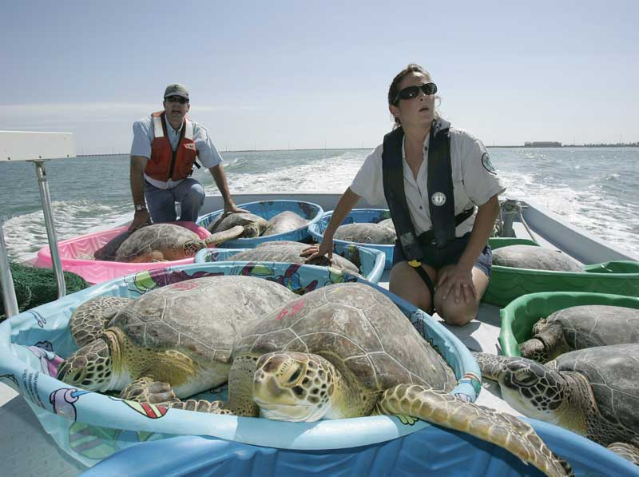

NOTE: Because this class was scheduled at the same time as BU/ENV 313 Dr. Gail is going to establish an alternative meeting time for those of you who cannot make Tuesdays at 2:30 in CH 253.

Senior Environmental Capstone Experience
ENV 485: Fall 2018

Syllabus

Instructor: Dr. Gail Grabowsky
Address: Wesselkamper, rm 108
Chaminade University
Phone: Office: 735-4834 (ext. 4834 if calling from on campus); cell: (808) 387-9319 (no calls after 9:00 PM please, texts are fine after 9:00 PM)
E-mail address: ggrabows@chaminade.edu
Office hours: MF 2:30-6:00, Tu 12:30-2:30; Or by appointment

Course Description:
This capstone course seeks to integrate and assess the experiences and program learning outcomes of the Environmental Studies major around a real environmental issue that the student actively participates in problem-solving through research, service or an innovative project of their own design. Each student is required to demonstrate their interdisciplinary understanding and problem-solving competency pertaining to the particular issue they are involved in.

General Purpose of the Course:
The purposes of this course are threefold.
- The student is required to either (1) participate in real environmental problem solving by working on or researching an environmental issue through an agency outside of Chaminade, or (2) complete an original environmental project on their own. Students must complete at least 30 hours of work on the project-proper over the course of the semester. All students must document the hours they worked towards their project.
- The second purpose of this course is to have students summarize in writing their capstone project and reflect upon all of the components of the environmental issue(s) their project involved as well as the solution strategies they or their agency employed (if your project contains a solution component).
- The final purpose is to assess the Environmental Studies Program Student Learning Outcomes.

Student Learning Outcomes: Students will demonstrate an understanding of:
- The in-depth causes and consequences of the particular issue(s) they studied/worked on.
- Environmental problem-solving field skills specific to their project
- Integrating the many components of environmental problem-solving
- The roles and general job activities of environmental professionals
- Career opportunities in the environment

Course Grading: The proportions that each portion of the course contributes to your grade are:

Field Experience/Project/Internship/Research 40% (300 pts)

Capstone Experience Summary Reflection Paper 40% (500 pts)

Attendance @ 4 mandatory meetings 20% (200 pts)(50 pts each)

The student must complete 30 hours of work in the field or for a single environmental agency, lab, business, etc. All of the student’s work should be related to a single environmental issue. If a student fails to complete all of the necessary hours the student’s grade will be diminished to a degree commensurate with the number of hours completed. (30+ hours = A, 25-29 hours total = B, 20-24 hours total = C, 15-19 hours = D, <10 hours = F).

In addition to the 30 internship hours the student will be required to write a Capstone Experience Summary Reflection Paper. The aim of the paper is for the student to put their work into the greater context of the entire environmental issue they were involved in and to relate their project to the Environmental Studies Student Learning Outcomes. The paper is due on Wednesday 12/13 by 1:15 (the time/date our final is scheduled for); late papers will not be accepted.

Mandatory Course Meetings: There will be FOUR MANDATORY COURSE MEETINGS for ENV 485: two at the beginning of the semester to introduce the course and determine your internship experience, one in the middle of the semester to check on the progress of your research/projects collectively and discuss the Capstone Experience Summary Reflection paper and the Environmental Studies Program Assessment assignment, and a final meeting during finals week (12/4 at 3:30) in which you will: turn in your Reflection Paper, share your project experiences, and eat something ono for lunch – ENV treats you! Because this class was scheduled at the same time as BU/ENV 313 Dr. Gail is going to establish an alternative meeting time for those of you who cannot make Tues at 2:30 in CH 253. You may comer to either of the meeting times: those listed in this syllabus or the ONE alternative time for each meeting. Unexcused absences will result in a loss of 50 points towards your grade.

Our Meeting Dates & Agendas:
First Week of Classes: Tues 8/21 at 2:30 for all who can attend – At this meeting I hear from all of you regarding: (1) If you have already done a project, or (2) If you need to find/invent a project. If you are in the second category we discuss how to get a project/agency etc!,
Fourth Week of Classes: Tues 9/11 at 2:30 for all who can attend – At this meeting ONLY the people who do not yet have a project need to attend! This is your last chance to come up with a project or agency meeting….
Ninth Week of Classes: Tues 10/16 at 2:30 for all who can attend – At this meeting everyone attends to hear how projects are going and to offer help and advice to each other regarding any challenges people are facing. Dr. Gail explains the Reflection Paper components at this meeting as well.
Final Meeting: Tues 12/4 at 3:30 for all (there are no finals except language at this time!) – At this final celebration meeting you turn in both components of your Reflection paper, debrief each other about your projects and Dr. Gail treats you to something healthy to eat!
Throughout the course I will be in touch with you all individually and collectively through e-mail, as well as our group meetings and one-on-one visits, so make sure I have your preferred email address. If you do not respond to an email inquiry I will assume you received it, so make SURE I have your preferred address to which I will send ALL course-related communiqués.

Required Texts: This year I have required you all to buy two helpful books because I think they will help you to get a job! They are:

Fasulo, Mike and Paul Walker. 2007. Careers in the Environment. McGraw-Hill Professional Publishing. ISBN#: 9780071476119

Pollio, Carol. 2013. 12 Months to Launch Your Environmental Career. 2nd Edition. Create Space Publishing. ISBN#: 9781540609472.


