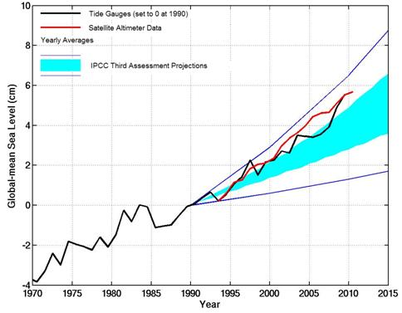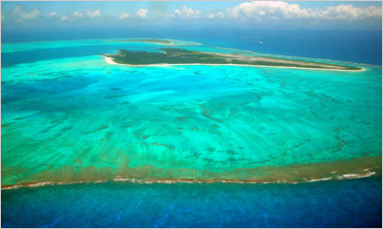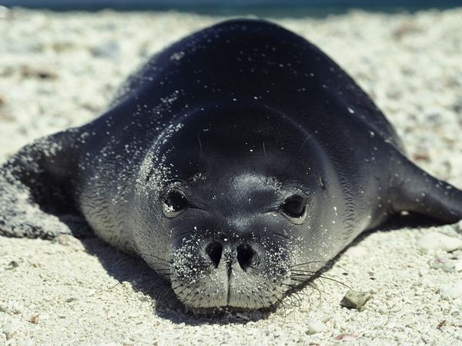
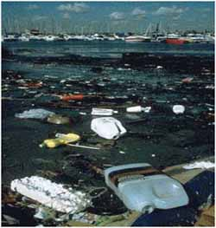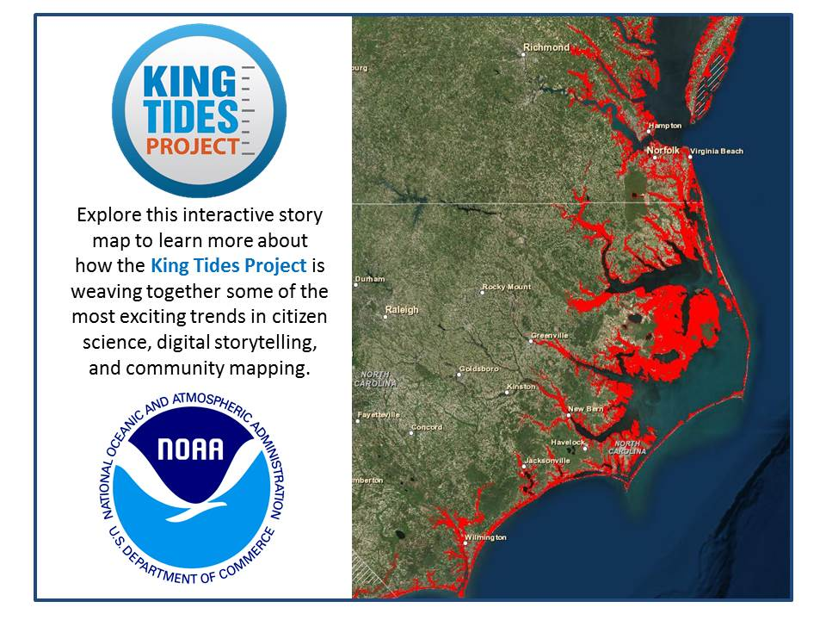

Marine Environmental Science Laboratory: ENV 115L

Laboratory Syllabus
Fall 2018

Human alteration of earth is substantial and growing.
Peter M. Vitousek et al.

Not unlike the lobster, we humans tend not to notice changes in our “water” so long as they happen gradually. For an American, dropping into the “hot pot” of Haiti or Burkina Faso creates a shock of realization: the entire planet is in the same pot, and while there are local spots hotter than others, our “pot” is warming worldwide.
Thom Hartmann

Instructor: Dr. Gail Grabowsky (“Dr. Gail”)

Address: Wesselkamper, rm 108
Environmental Studies
Chaminade University
3140 Waialae Ave
Honolulu, HI 96816

Phone: Office: 735-4834 (ext. 4834 if calling from on campus); cell: (808) 387-9319 (no calls after 9:00 PM please; texts ok at any hour :) I will respond the next day)

E-mail address: ggrabows@chaminade.edu

Office hours: MF: 2:30-6:00; Tu 12:30-2:30; Or by appointment
Course Description: This course introduces students to the scientific methodologies used to determining and studying the current major marine environmental issues. Issues studied include: climate change, marine pollution, marine debris, oil spills, fisheries exploitation, fisheries by-catch, marine alien species, coastal development and coral reef degradation. Laboratory exercises are conducted in the field and on the Chaminade campus. Students taking this course will be engaged in field science activities.

Course Learning Outcomes: When you have completed this course you should:
Know what science is and how scientific research is conducted
Be familiar with and experienced at reading the primary scientific literature
Know the basic units used in making scientific measurements
Be able to competently collect, record, analyze, present and interpret scientific data
Be able to write up a scientific research report
Be able to properly collect, identify and preserve marine biological specimens
Be able to identify particular marine organisms and their behaviors in the field
Be comfortable conducting field measurements in a variety of types of marine habitats
Be able to document the physical effects of a number of the major marine environmental issues
Be able to document some of the detrimental effect(s) marine environmental issues have on marine ecosystems

Course Requirements: Your grade in this course will be based on the following. Each of the items/activities listed below will be described to you in writing or orally in class.

- Laboratory worksheets, quizzes, homework, etc. 40%
- Hawaiian Invertebrate/Vertebrate Organism Exposé 20%
- Marine environmental issue Journal Article Critique 20%
- Attendance 20%

Course Grading: The proportion that each of the above contributes to your grade in this course is as follows:

Lab worksheets, etc. 200 points
Hawaiian Invertebrate/Vertebrate Organism Exposé 100

Journal Article Critique 100
Attendance 100
500 points total

Laboratory worksheets, the Organism Exposé and the Journal Article Critique will be graded on effort, correctness (when there is a correct response etc.) thoughtfulness and organization. Effort in general manifests itself as neatness, completeness, thoroughness, calories expended per unit time(!), timeliness, correct spelling, any extra creative things you do above-and-beyond what is expected, etc. Correctness means do your statements jive with corresponding scientific knowledge, do your conclusions follow from the evidence before you, did you calculate an equation correctly, interpret a graph accurately, make a table that illustrates your data properly, etc. Thoughtfulness can show up in many ways, perhaps you really think things through, trying to consider all the variables or you worked hard to tie pieces of evidence together, maybe you consider something that may be important that everyone else ignores. By being “thoughtful” I don’t mean that you look out for other people (i.e. are kind) I mean that you have done some thinking, really reflected upon a topic, have given it some time, have analyzed it, etc. thoroughly. Organization pertains to the design of your presentation. Did you present the material, answers, ideas, etc. is a way that is understandable, efficient and follows existing protocol (if they exist and/or are explained prior to the assignment).

Texts:
None; Your labs are coming from many sources! Informational handouts will be given in e-copy prior to lab. Worksheets will be given out in hard copy.
Supplemental Texts: We will do a number of laboratory activities that do not come from a specific lab book per se. These have been put together by Dr. Gail and/or her colleagues. You will be given handouts for these labs.

Things You’ll Need for Class:
- Snorkel Gear: The Environmental Studies Program has purchased BRAND NEW, REALLY GOOD masks and snorkels for you to check out for each lab! (Dr. Gail was tired of seeing students – who had purchased cheap masks to save $ - with fully fogged-up equipment seeing nothing underwater!) So borrow Chaminade’s and if you like snorkeling Dr. Gail will help you to know where to go and what to look for in good equipment of your own. It is however NOT a pre-requisite that you be able to snorkel/swim to take this class. ENV has also purchased really nice Oiwi rash guards for you to borrow so that we don’t harm the reef and larval fish by using sunscreen ☺. You will need to buy your own fins however.
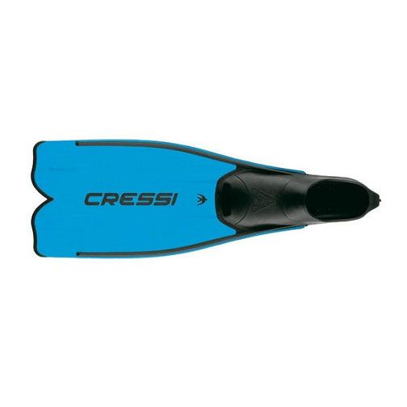
- Lab Coat and Covered Shoes: For when we are in lab. Details will be explained at the first lab meeting.
- Shoes that can get wet: Be sure you have something for your feet that you can cross wet basalt rocks in! These will get wet.
- Water Bottle: Bring this to all labs that occur in the field.
- Hat/etc.: To protect you when we are in the field.
- A love of the field and getting dirty, wet or cold: Guys this is a marine course so you will have/get to go outside! Be ready to be hot/cold, dirty etc. and prepare accordingly. Bring sunscreen if you need it, a towel, a wetsuit, etc. if you’d like and have a mind to be IN nature!

Attendance:
If you miss a lab your absence must be excused if it is not to formally effect your grade. Excused absences occur when you bring in a doctor’s note, a funeral announcement for a family member, notice of participation in athletic events, etc. Unexcused absences occur when you were working, surfing, sleeping, cramming for an exam in another class, etc. Unexcused absences cost you the assignment you missed that day: you receive a zero for it. Excused absences mean that the lab you missed is not counted in determining your lab grade. You may make up a lab (if it is possible to do so for that particular lab) IFF (that means IF and ONLY IF) it was an excused absence. You cannot make up a lab you missed for an unexcused reason.
ClassroomAtmosphere:
I value a very open, yet courteous class atmosphere. Express your ideas! Ask your questions! (The only dumb question is the one in which you ask yourself if you should ask your question.) Respect the thoughts and ideas and opinions of others – really think about what others say. Let them fully express their thoughts and ideas and then you do the same. The thing I value most from my college days are all the wonderful, valuable, diverse ways of looking at and understanding the world that I was exposed to. Be an open vessel – take ideas in! You will learn as much from each other as you do from me.

If you are handicapped under the Americans with Disabilities Act:
Chaminade will provide assistance for any student with documented disabilities. Any student who believes he/she may need accommodations in this class must contact Dr. June Yasuhara (735-4845), at the Counseling Center (office is next to security), in order to determine if you meet the requirements for a documented disability in accordance with the Americans with Disabilities Act. Please contact Dr. Yasuhara as soon as possible so that accommodations can be implemented in a timely fashion.

Reminders of Important University-Wide Policies:
The following policies are summarized from the Student Handbook. Please be sure that you have reviewed these and other policies that your Handbook contains.

Academic Honesty:
Students are responsible for promoting academic honesty at Chaminade by not participating in or facilitating others’ participation in any act of academic dishonesty, and by reporting incidences of academic dishonesty (such as theft of tests, records, and other confidential materials, altering grades, and/or plagiarism) to their instructors.

Freedom of Expression:
Students are free to take reasoned exception to the views offered in a particular course of study. They may be required to know thoroughly the specific bodies of knowledge or interpretations or theories set forth by the professor, but are free to reserve judgment as to the truth or falsity of them.

Students are expected to maintain the standards of academic performance articulated in course syllabi, supplemental readings, assignments and Academic and Student Affairs policies. The instructor is considered the normal and competent judge of academic work. Students have an appeals process in the rare case of unjust grading and evaluation by the procedure detailed in the Academic Grievance section of the Student Handbook.

This syllabus and course schedule are living documents: they are free to change. I try to adhere as closely as possible to them for your convenience, but there will be times when weather or sea states may force me to change our lab plans or there may be times in which we will take longer on a particular topic or add or delete a topic to enhance the course. I like to be able to react to you as the course proceeds and go with the flow a bit in order to make the course experience sort of custom fit to you!

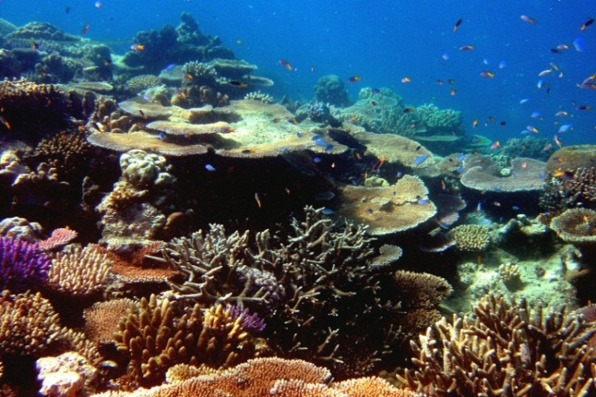

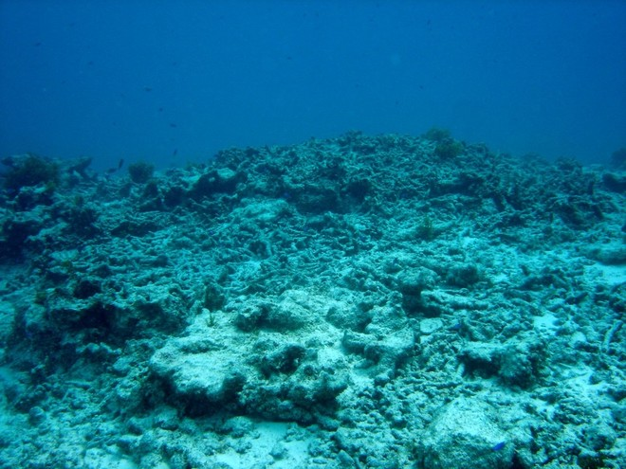
You are responsible for all of the information in this document: losing it or not reading it do not make you exempt from knowing what’s in it!
Use it to keep you organized and aware of important dates and how your grade is determined.
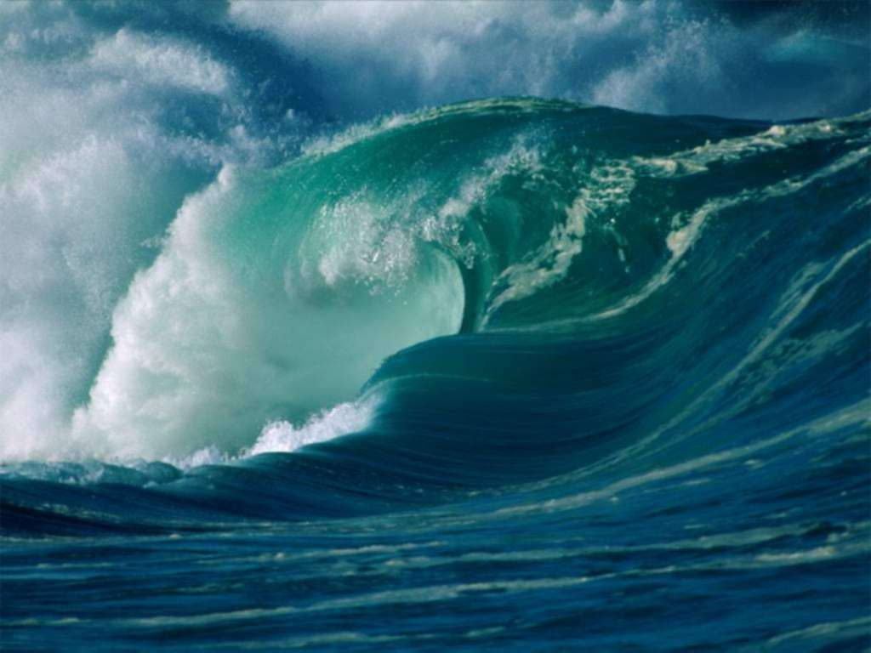

Marine Environmental Science Laboratory

Course Schedule
Fall 2018

DATE LAB TOPIC ACTIVITIES
8/22 Lab Intro; Lab Safety Review lab syllabus; Choose your organisms…

8/29 Introductory DVD & Awareness Lab Blue Planet Opener; Online quizzes and worksheet
Critter Quiz: Coral common & species names
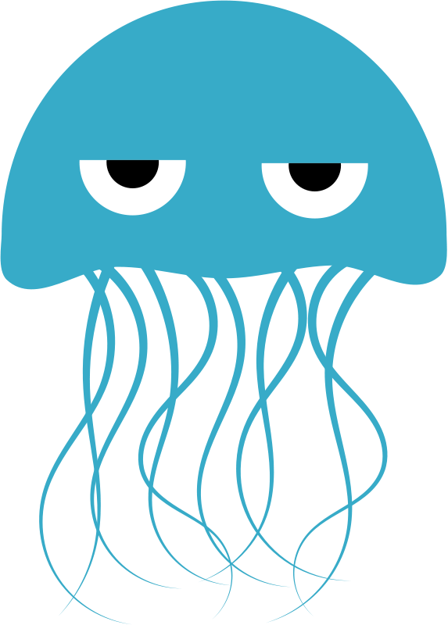
9/5 Ocean Issues You Care about Share a marine issue of concern
Critter Quiz: Invertebrates

9/12 Marine Biodiversity & Taxonomy Lab Biodiversity Power Point
Worksheet: Classification of “Camanicules”
Critter Quiz: Bony Fish

9/19 Marine Animals; Animal Phyla Waikiki Aquarium; Worksheet
Critter Quiz: Remaining Vertebrates & Algae

9/26 Hawaiian Organism Exposés Natural History Organism Exposés
10/3 Ocean Environments & Coastal Development Diamond Head Hike! Worksheet

10/10 Marine Producers: Macroalgae collection Diamond Head; Need Snorkel Gear! Worksheet

10/17 Ocean Ecosystems (we won’t get to!) Blue Planet: Open Ocean and The Deep

10/24 Coral Bleaching Survey Waikiki MLCD; Need Snorkel Gear! Worksheet
Data collected and shared with Eyes of the Reef Read: Coral Survey Information handout

10/31 Ocean Issues and the Role of Science “Changing Seas” series selection
Choose Journal Articles for Critiques “Fieldtrip” to the Library

11/7 Climate Change… OR Skits: Use data to convince a denier!
Fish Counts Ala Moana Beach; Need Snorkel Gear! Worksheet

11/14 Tuna Big Data Lab – Guest Dr. Mark Speck Worksheet
A SATURDAY!
11/17 A Healthy Reef Hanauma Bay; Need Snorkel Gear! Worksheet

11/21 or 28 Journal Article Critiques (the class chooses!) Short presentation of the title, purpose, graphs,
tables and findings that you understand!
12/1 =

