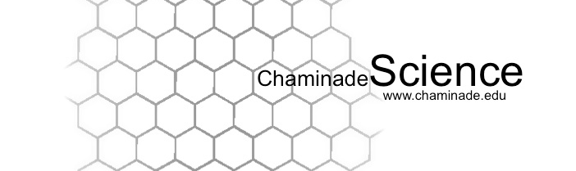

Fall 2018: Biology 210L Biotechniques Lab

Instructors: Dr. Chrystie Naeole, PhD
Class Meetings: F 2:30 – 5:20pm, HL1
Office Hours: WSC 105, by appointment
E-mail: chrystie.naeole@chaminade.edu

Required Text:

There is no required text for this lab. All necessary protocols and reading will be provided to you either as handouts or will be posted on Canvas.

Course Description:

Introduction to biological techniques. Techniques used in the fields of molecular and cellular biology are covered including DNA, RNA and protein purification and manipulation. One three hour period per week.

General Course Objectives:
- To understand basic laboratory safety.
- To learn how to keep a proper laboratory notebook.
- To learn how to operate basic laboratory equipment.
- To be comfortable utilizing basic mathematical calculations necessary in a laboratory setting.

Specific Student Learning Outcomes:

At the end of the course, you will be able to:
Student Learning Outcomes | Linkage to Biology Program Learning Outcomes
Safety lab etiquette:  Demonstrate the capacity to work safely in a laboratory setting and have awareness of common regulatory guidelines for laboratory work. Additionally, students will consistently and proactively behave within accepted norms of lab etiquette. | #7) An understanding of the entry requirements, career  pathways and progression for the major post-graduate  fields of research, education and health professions.
Record keeping:  Understand the principles of good scientific record keeping; demonstrate the keeping of laboratory notebooks and experimental record, and organization of data for accessibility and later understanding and reproducibility | #2) ability to visualize, statistically evaluate, validate and  interpret scientific data, and to communicate science  effectively both orally and in writing  #7) An understanding of the entry requirements, career  pathways and progression for the major post-graduate  fields of research, education and health professions
Mathematics:  Perform basic mathematical calculations including scientific notation and algebraic conversions essential to the preparation of solutions and quantitation of molecules including standard curve analysis and regression analysis. | #1) An understanding of the scientific method and the ability to  design and test a hypothesis  .  #7) An understanding of the entry requirements, career  pathways and progression for the major post-graduate  fields of research, education and health professions
Precise and reproducible manipulations:  Be familiar with basic laboratory equipment operation and theory of its operation as well as be able to demonstrate mechanical and technical operations central to science laboratories; including properly and accurately operating basic biology lab instrumentation such as glassware, pipettes, incubators, balances, centrifuges, pH meters, spectrophotometers, and thermocyclers. | #2) ability to visualize, statistically evaluate, validate and  interpret scientific data, and to communicate science  effectively both orally and in writing  #7) An understanding of the entry requirements, career  pathways and progression for the major post-graduate  fields of research, education and health professions
Precise and reproducible measurements:  Demonstrate understanding of the importance and methods for calibration, repetition of laboratory manipulations, understanding of systematic error. | #2) ability to visualize, statistically evaluate, validate and  interpret scientific data, and to communicate science  effectively both orally and in writing  #7) An understanding of the entry requirements, career  pathways and progression for the major post-graduate  fields of research, education and health professions
Databases:  Familarity with electronic sources of information pertaining to the above | #3) The ability to acquire and comprehend information from  published scientific literature and to employ computational  resources in the resolution of biological problems.  #7) An understanding of the entry requirements, career  pathways and progression for the major post-graduate  fields of research, education and health professions

Expectations of students: The following are what is expected of students:
- Attend labs.
- Know assignment and test dates.
- Be prompt, both in attendance and in turning in of assignments.
- Read assignments BEFORE coming to lab.
- Be responsible & proactive. If you miss a class, ask your classmates and/or your instructor for the information you missed; approach the other BI210L instructor to inquire about making up the lab in their section. It is YOUR responsibility to pick up any handouts that were distributed.
- Ask the instructor for assistance way in advance. DO NOT WAIT until the day of the exam or the day when an assignment is due to ask questions.
- Respect. It works both ways.
- Remember, the knowledge that you will take away from your courses is directly proportional to what you put into your courses so keep a positive attitude and work hard!

Grading

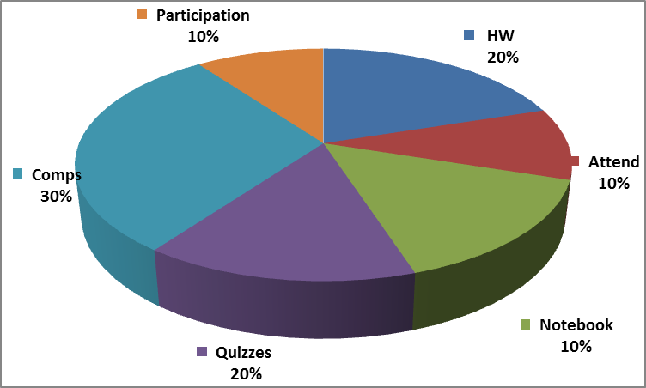

Laboratory notebook:
- We will be piloting the use of electronic notebooks this semester. Additional information will be forthcoming.
- Notebooks will be checked, for grade, randomly throughout the semester.

Attendance & Participation:
- Presence in class is mandatory & necessary in order for a student to fully grasp concepts. Students are expected to attend regularly all courses for which they are registered. Students should notify their instructors when illness or other extenuating circumstances prevents them from attending class and make arrangements to complete missed assignments. Notification may be done by emailing the instructor’s Chaminade email address, calling the instructor’s campus extension or by leaving a message with the instructor’s division office (Natural Science and Math 1 (808) 440-4204). It is the instructor’s prerogative to modify deadlines of course requirements accordingly. Any student who stops attending a course without officially withdrawing may receive a failing grade.
- Unexcused absences equivalent to more than a week of classes may lead to a grade reduction for the course. Any unexcused absence of two consecutive weeks or more may result in being withdrawn from the course by the instructor, although the instructor is not required to withdraw students in that scenario. Repeated absences put students at risk of failing grades.
- If you miss a class it is YOUR responsibility to ask the instructor or your classmates for the information that you missed and to pick up any handouts that may have been distributed.
- You are expected to be an active and contributing member in all group work.

Comps & Quizzes:
- Quizzes will be given at the beginning of class and will cover information from the previous weeks lab
- Competency checks will be performed at the end of each module.

Departmental and University Polices:
- Music Devices and Cellular Phones: Use of music devices and cell phones is prohibited during all Natural Science and Mathematics classes at Chaminade, unless specifically permitted by your instructor. Use of cellphones and music devices in laboratories is a safety issue. In addition, use of cellphones and music devices in any class is discourteous and may lead to suspicion of academic misconduct. Students who cannot comply with this rule will be asked to leave class and may be subject to laboratory safety violation fines. You will be asked to leave class and marked absent if you do not comply. This will negatively affect your grade. Please refer any questions to the Dean of Natural Sciences and Mathematics.
- ADA Accomodations: Pursuant to several federal and state laws, including the Americans with Disabilities Act of 1990, as amended by the ADA Amendments Act of 2008, and Section 504 of the Rehabilitation Act of 1973, all qualified students with disabilities are protected from discrimination on basis of disability and are eligible for reasonable accommodations or modifications in the academic environment to enable them to enjoy equal access to academic programs, services, or activities. If a student would like to determine if they meet the criteria for accommodations, they should contact the Counseling Center at 808-735-4845 for further information Students with special needs who meet criteria for the Americans with Disabilities Act (ADA) provisions must provide written documentation of the need for accommodations from CUH Couseling Center (Dr. June Yasuhara, 735-4845) by the end of the third week of classes. Failure to provide written documentation will prevent your instructor from making necessary accommodations.
- Policy on Communication : The University provides a Chaminade email address for all students. Official Chaminade communications will be sent to the students’ Chaminade email address and instructors will use only this email to communicate with students. It is the responsibility of the student to check their email frequently. Report email-related problems to the Helpdesk at 808-735-4855 or helpdesk@chaminade.edu.
- Title IX Declaration: Chaminade University of Honolulu recognizes the inherent dignity of all individuals and promotes respect for all people. Sexual misconduct, physical and/or psychological abuse will NOT be tolerated at CUH. If you have been the victim of sexual misconduct, physical and/or psychological abuse, we encourage you to report this matter promptly. As a faculty member, I am interested in promoting a safe and healthy environment, and should I learn of any sexual misconduct, physical and/or psychological abuse, I must report the matter to the Title IX Coordinator. Should you want to speak to a confidential source you may contact the following:
Chaminade Counseling Center| 808 735-4845.
Any priest serving as a sacramental confessor or any ordained religious leader serving in the sacred confidence role.
- Academic Honesty: Students are expected to have read and to abide by the “Student Rules of Conduct” which are available in your copy of Chaminade University’s Student Handbook. Cheating in the form of plagiarism, collusion, and deception will not be tolerated and will negatively affect your grade.

Because the university is an academic community with high professional standards, its teaching function is seriously disrupted and subverted by academic dishonesty. Such dishonesty includes, but is not limited to, cheating, which includes giving/receiving unauthorized assistance during an examination; obtaining information about an examination before it is given, using inappropriate/unallowed sources of information during an examination; altering answers after an examination has been submitted; and altering the records on any grade. (Refer to the CUH catalog for further information).

Tentative Course Outline (subject to change as instructor deems necessary)
Week | Date | Lab topic | Assignments
1 | Aug 24 | Lab Safety, Lab Tours, Lab Notebook, Chemicals and MSDS | Prep for next week lab safety quiz
2 | Aug 31 | Introduction to Precision & Accuracy pt 1 | Precision vs Accuracy
3 | Sep 7 | Introduction to Precision & Accuracy pt 2 | Upena Making Discussion  Prep for next week quiz
4 | Sep 14 | Precision & Accuracy: Balances | Intro to Precision & Accuracy Quiz  Prep for next week quiz
5 | Sep 21 | Precision & Accuracy: Pipettes | Balances Quiz  Prep for next week quiz
6 | Sep 28 | Precision & Accuracy: Microscopes | Pipettes Quiz  Prep for next week quiz
7 | Oct 5 | Introduction to Solutions & Dilutions | Microscopes Quiz  Intro to Soln & Dil Discussion  Prep for next week quiz
8 | Oct 12 | Solutions & Dilutions: Molarity, Concentrations, Dilution Factors | Math Worksheet (due next week)  Prep for next week quiz
9 | Oct 19 | Solutions & Dilutions: Buffers & pH | Molarity, Conc and Dil Quiz  Prep for next week quiz
10 | Oct 26 | No Class
11 | Nov 2 | Solutions & Dilutions: Serial Dilutions | Buffers and pH Quiz  Prep for next class quiz
12 | Nov 9 | Technical Application(s): DNA and PCR | Serial Dilutions Quiz  Prep for next week quiz
13 | Nov 16 | Technical Application(s): Gel Electrophoresis | DNA & PCR Quiz  Prep for next week quiz
14 | Nov 23 | No class – Thanksgiving Holiday
15 | Nov 30 | Technical Application(s): TBD | Gel Electrophoresis Quiz

Note: Every effort has been made to insure that the material in this syllabus is accurate and complete. However, occasionally changes must be made in the printed schedule. Thus the instructor reserves the right to make any changes in the contents of this syllabus that she deems necessary or desirable. These changes, if any, will be announced as soon as the need for them becomes apparent.

