PACE Program
2018 Summer Semester
June 9 – September 17, 2018
MTG-305-90-2 Management of Information Resources
Online

Class Schedule: Online
Meeting days and times: On myMISlab portal and via email
Class Location: Online in cyberspace portal is called myMISlab

Instructor Contact Info: Maria Brownlow, Ph.D.
Office Hours: 11:30 – 01:00 PM; MWF at Kieffer Room 26 or by appointment
Contact Office: 808-739-8337

Primary email: mariabrownlow@hawaiiantel.net
CUH email: maria.brownlow@chaminade.edu
Administrative Assistant: 808-440-4280

- Course Introduction
Management of Information Resources is a philosophical and practical approach to managing information which contributes directly to achieving organization’s goals and objective. Management of information and Management of Information Technology are so closely interrelated that often are used interchangeably. They promote interrelationship and organizational integration.

Information resources are defined as the data transformed as information which is used by the organization. The term Information Resource Management means changing the way typical Information Systems/Information Technology is implemented within the organization. It manages the information resources (data, application software and technology) like any other organization resource; the principles of how to properly and effectively manage it are exactly the same.

The organization must establish effective management control of the data resource or it will never fully achieve any benefits such as: faster, cheaper, better business operations and significantly greater business flexibility, innovation and change. Data Resource Management (DRM) is a critical part of the Information Resource Management (IRM) environment.

Kenneth Laudon, an author of our textbook, a Professor of Information Systems at the New York University’s Stern School of Business and Jane Laudon, a management consultant in information systems area – are both well-known experts in management information resources stated in the Preface:
“We wrote this book for business school students who wanted an in-depth look at how today’s business firms use information technologies and systems to achieve corporate objectives. Information systems are one of the major tools available to business managers for achieving operational excellence, developing new products and services, improving decision making, and achieving competitive advantage.”

Organizations today are vitally dependent upon automated information for both daily operation and management control. Today, information is the most important and highest-leveraged resource the organization controls. Information, like all other resource, must be managed. Businesses have begun to exploit the enormous strategic potential of a well-integrated information environment. The main obstacles to exploiting the information resource are internal to the organization and can be easily overcome - it is truly a common sense proposition.

My own business experience confirmed the authors’ statement: “When interviewing potential employees, business firms often look for new hires who know how to use information systems and technologies for achieving bottom-line business results. Regardless of whether a student is an accounting, finance, management, operations management, marketing or information systems major, the knowledge and information found in this book will be valuable throughout a business career.”

Knowledge of IT in business is a competitive edge for student’s career path or obtaining a desired position. In the 21st century, it is assumed that job seekers have IT knowledge similarly as they have skills how to use Internet or smart phone.

This course is about increasing student’s knowledge about IT management so that as a manager you can effectively invest in and utilize new and already in-place information technologies through the knowledge of new topics:
- Big data and the Internet of Things (IoT): In-depth coverage of big data, big data analytics, and the Internet of Things software applications to support business operations and business intelligence
- Cloud computing: Updated and expanded coverage of cloud computing planning and managing IS department’s resources effectively
- Social, mobile, local: New e-commerce content
- Social business: Expanded coverage of social business; discussions of enterprise (internal corporate) social networking as well as social networking in e-commerce

The core of the course provides an overview of fundamental Management Information Systems (MIS) concepts by using an integrated framework for describing and analyzing information systems. This framework shows information systems composed of people, organization and technology elements which are reinforced in student projects and case studies.

The Big Picture

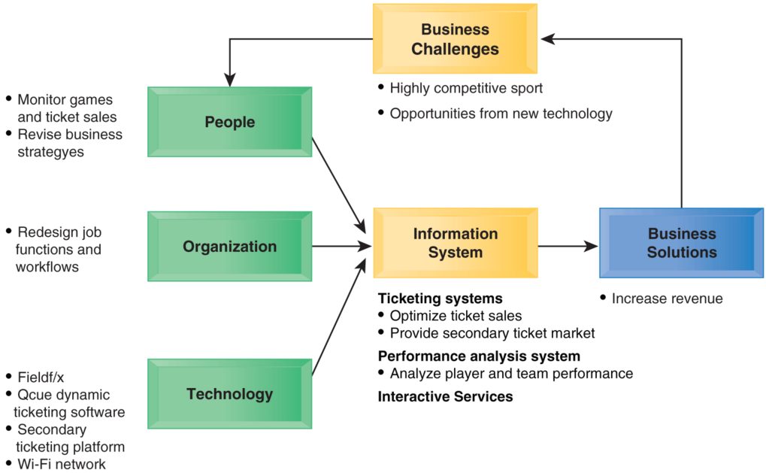

Source: “Essentials of MIS”, 13th edition, K. Laudon

Textbook:
The selected textbook provides a comprehensive coverage of the management of information resources. Various support materials accompany the textbook, which enhance students’ learning experience. The authors keep content up-to-date. Various case studies resulted in a unique set of materials for the audience who seek careers as business managers, IS managers or MIR specialists.

Authors continue to define the MIR course with their latest comprehensive text:
- IT Innovations
- New business models
- Expending e-Commerce
- Management changes
- Changes in organizations

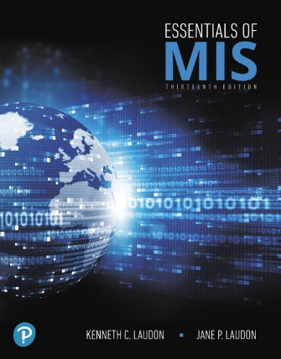
MGT- 305-90-2 Management of Information Resources (3 Credits)
Textbook: Carol V. Kenneth Laudon, Jane Laudon “Essentials of MIS” 13e, Pearson, Prentice Hall, Inc.,
ISBN-13: 9780134803043

A hard copy of the textbook is NOT required. However, myMISLab with Pearson eText and access code to myMISlab 13th Edition is required
ISBN-13: 9780134803081

If you prefer to have a hard copy of this textbook, which comes with access code and eText, you can buy it from the CUH bookstore. Chaminade bookstore has very competitive prices. I believe that you can also rent a textbook. Bookstore accepts student vouchers.

- Catalog Description from CUH Catalog
This course introduces students to the development and use of information resources for organizational decision making. Topics include systems analysis, data communications, internet research, decision support systems, planning and implementing management information systems, and future trends in technology. Students design and operate a functional information system. Offered as scheduled by PACE Administration. Prerequisites: BU 200 and CS 103.

- Course Learning Outcomes
The Association to Advance Collegiate Schools of Business (AACSB) is a not-for-profit corporation of educational institutions, corporations and other organizations that seek to improve business education primarily by accrediting university business programs. As part of its accreditation activities, the AACSB has developed an Assurance of Learning Program designed to ensure that schools do in fact teach students what they promise. Schools are required to state a clear mission, develop a coherent business program, identify student learning objectives, and then prove that students do in fact achieve the objectives.

At the conclusion of the MGT 305 course:
- Students will be able to describe, explain and review how organizations use information technologies and modern systems (Internet) to achieve corporate objectives.
- Students recognize and identify how to utilize the learned knowledge to in their personal career by being an active participant and contributor to the organization they work. This affects affect their business careers.

- Students participate in and even lead in their work place management discussions if MIR through review and analyze a real-world business scenarios.

- Students describe the reasons and present the evidence for implementing management of information systems to serve different management groups in and organization and link to the improved organizational performance.

Students will be able to eloquently answer questions such as:

- Why the utilization of MIR has become pervasive in the recent years (big data, analytics provide evidence to either support or question common believes)?

- What role MIR plays in increasingly ‘flat world’ in which information technology links businesses across emerging, developing and mature economies around the world?

- How IT professionals and business managers design, manage and collaborate to wisely invest and effectively utilize information technologies for the benefit of their organizations?

- Program Learning Outcomes
Program Learning Outcomes Common to the Majors in Business Administration and Accounting In completing one of the business majors, a graduating student will have demonstrated the following competencies:
  - Written and oral communication abilities appropriate to business-related tasks;
  - The ability to select and use appropriate quantitative tools, including statistics and management science, for decision-making;
  - An understanding of tasks associated with career selection, entry, and management;
  - An understanding of the functional areas of business, including central theories, modes of analysis, tasks, and strategies;
  - The ability to use integrative and reflective thinking to assess and create business strategy appropriate for organizations in specified business environments;
  - An understanding of legal obligations of organizations and the ethical dilemmas faced by businesses, along with appropriate frameworks for addressing these dilemmas;
  - An understanding of information technology as it influences organizational processes and system tasks. Demonstrate the ability to use information technology to address functional business tasks;
  - An understanding of domestic and global economic environments and their influence on firm-level organizational decision-making and operations;
  - An understanding of individual and group dynamics in organizations; and
  - An understanding of the connections between academic work and real-life situations as a result of the Service-Learning experiences.

Additional Program Learning Outcomes for Business Administration Majors In completing the major in business administration, a graduating student will have demonstrated the following competencies:

- An understanding of the management of business operations, including product and process design, facilities layout, supply chain management, and quality control and
- An understanding of the distinctive features and challenges of conducting business internationally.

- Institutional Learning Outcome (CUH)
- Written communication
- Oral communication
- Critical thinking
- Information literacy
- Quantitative reasoning

6. Marianist Values
- Educate for formation in faith
- Provide an integral quality education
- Educate in family spirit
- Educate for service, justice and peace
- Educate for adaptation and change

- Keys to Course Success
- Attend the course, poor attendance yields poor results
- Be present in the classroom: listen, pay attention and participate in the conversations
- Learn in the classroom; 50 minutes wasted cannot be ever recovered; it is gone
- Complete and submit your work within the time frame allotted
- Be on time and attend each class; manage your time before entering the classroom because once class is in session late arrivals is disturbance to other students
- Prepare yourself to become a professional in today’s business world; be a contributor
- Get in the game, success is an objective to be achieved through a hard work and not due to good luck
- Be present in the classroom: listen, pay attention and participate in the conversations
- Learn in the classroom; 50 minutes wasted cannot be ever recovered; it is gone
- Complete and submit your work within the time frame allotted
- Be on time and attend each class; manage your time before entering the classroom because once class is in session late arrivals is disturbance to other students
- Prepare yourself to become a professional in today’s business world; be a contributor
- Get in the game, success is an objective to be achieved through a hard work and not due to good luck

- Course Teaching Approach
The following types of assignments on-line will be used during the course:
- Chapter - opening cases
- Interactive Session: Management
- Interactive Session: Technology
- An additional Learning Track Modules (as time permits):
- How much does it matter?
- Information Systems and your career.
- The mobile digital platform
- Case study.
- End of chapter review questions.
- Discussion questions.
- Hands-on MIS Projects.
- Video cases illustrating some of the concepts in the chapter.
- Collaboration and teamwork projects dealing with the concepts of the chapter.

- Recommended Learning Strategies
- Be prepared for each class.

- Review examples and solutions within each chapter to reinforce the understanding of presented concepts.

- Complete and submit assignments to reinforce the learning material.

- Contribute and participate in team projects. You will learn to become a confident public speaker and improve your presentation skills.

- Take part in classroom discussions and ask questions.

- Review supplementary materials in preparation for midterm and final exams.

- Assessment and Grading
Class sessions are designed to promote student participation through the discussion of current events in the business world as they relate to the cyberspace and network systems security.

Grading your accomplishments:  Homework assignments  Quizzes & tests  Exams | Grade scale:  A = 90% – 100%  B = 80% – 90%  C = 70% – 80%  D = 60% – 70%

- Course Ground Rules
Course participation policy in myMISlab portal
This class is on-line. Class participation via emails and in myMISlab portal is priceless. Students are expected to follow assignments schedule published on the myMISlab calendar. Weekly course cycle runs from current Monday to the following Monday. Assignments due date submission is as per assigned schedule before 11:59 PM HST.
Academic Honesty
Students are responsible for promoting academic honesty at Chaminade by not participating in any act of dishonesty. Academic dishonesty may include theft of records or examinations, alteration of grades, and plagiarism. Questions of academic dishonesty in a particular class are first reviewed by the instructor who must make a report with recommendations to the Business School Dean. Consequences for academic dishonesty may range from an “F” grade for the work in question to an “F” grade for the course to suspension or dismissal from the University.

Students with disabilities
ADA Accommodations: Students with special needs who meet criteria for the Americans with Disabilities Act (ADA) provisions must provide written documentation of the need for accommodations from the CUH Counseling Center (Dr. June Yasuhara, 735-4845) by the end of the third week of classes. Failure to provide written documentation will prevent your instructor from making necessary accommodations. Please refer any questions to the Dean of Students and review procedures at www.chaminade.edu/student_life/sss/counseling_services.php

Library
Provide a link to the Chaminade library, www.chaminade.edu/library.

Technical Support
For technical questions view the http://www.mymislab.com/Student_Support or call Pearson Technical Support at 1-800-677-6337.

