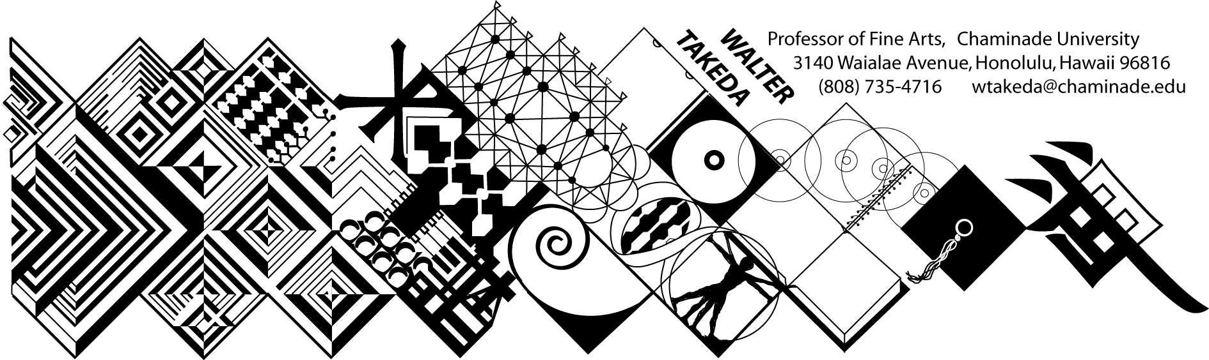
ART 201 – Fall 2018
Survey of Art I
Tues/Thurs 8:30-9:50 H227
Office Hrs: afternoons or appointment: E212

COURSE DESCRIPTION: Art 201 is a general survey course that may be used to fulfill Chaminade's fine arts requirement of the general education core; it is also a requirement for the BFA major. There is no prerequisite for this course.
The material covered in this course includes a survey of Western art from Paleolithic to the Gothic period, as well as Asian art. Art 202, for which this course is not a prerequisite, continues from the Renaissance to contemporary art.
In this age of frequent travel, you will undoubtedly have some opportunity to visit areas where there are considerable works of art. It is hoped that this course would make these trips more meaningful and life-enhancing. Involvement in the rich endowment of human artistic endeavors is a vital part of one's college and life experience.

COURSE OUTCOMES: Student Learning Outcomes linked to Program Learning Outcomes:
Upon successful completion of this course, the student will demonstrate an:
- Understanding of the placement of art within its historical context;
- Ability to recognize important aspects of a style, country, or movement;
- Ability to use this understanding and ability to contextualize a given piece of art or artistic movement.
These outcomes are all linked to Program Learning Outcome #4.

GOAL AND ASSESSMENT: The goal of this course is to acquaint the student with different artistic expressions of many cultures over time. The students’ ability to distinguish to distinguish expressions and styles can be partially assessed as the course progresses. The class will be given a pre-test of slides from different cultures, and during the course of the semester, be tested either separately or with slides imbedded in the exams.

ATTENDANCE will be taken for administrative purposes but will not affect your grade, which is based solely on your graded performances. Attendance is ABSOLUTELY MANDATORY on scheduled exam days. Attendance is particularly crucial in this class; it is categorically impossible to do well just be relying on the text. Additional material will be available on e-college – please download them.

TEXTBOOK: This course will not require a textbook, given the extremely high cost of full-color, comprehensive art history texts, even in paperback. If you want to purchase one as background, Tansey’s Art Through the Ages is recommended, wherever you can get it inexpensively. Just get Part I, available in paperback. I shall place several texts of this and other general art history textbooks in the library for your use.

ELECTRONIC DEVICES: All electronic devices will be turned off during class. If you feel compelled to turn a device on, exit the classroom. As stated, absence will not count against your grade; continued absence will manifest itself on the exams. If you absolutely insist on having a laptop open, see the teacher first and sit on the first row!

HOW TO STUDY FOR THIS COURSE: Each day material will be presented with slides. If time permits at the beginning of each class, the instructor will show accumulating slides from previous lectures for which you will be responsible. From time to time, these slides will be put on Canvas; download them when announced.

Note how the instructor wants the periods broken down. Familiarize yourself with the general characteristics of each style or sub-style; part of the exam will test this knowledge with slides other than from the mandatory pool. If you have difficulty taking notes, bring a recorder to class and place it at the instructor’s table; it is particularly helpful to tape the thorough, full-period review before examinations.

EXAMINATIONS, as stated above, will not be based exclusively on the obligatory pool of slides, but will also test your ability to recognize styles from other examples that you may not have seen before. This section will count for 10% - a full letter grade. In addition to slide questions, there will be other objective questions of a multiple choice, true/false nature.. The following grading criteria will apply to all exams: A = 100-90%, B = 89-80%, C = 79-70%, D = 69-60%, F = 59% or lower.

MAKEUP EXAMS will necessarily be more challenging in fairness to other students. Questions may be restructured in a more difficult way (i.e. fill-in instead of multiple choice), and there may be additional questions increasing the points that could be deducted. Students will notify the instructor BEFORE the scheduled exam if they are to miss a scheduled exam for reasons beyond their control, e.g. flat tire, illness, etc. Leave a message at the instructor's office number above or by e-mail. Subsequently, you must present verifiable evidence to this effect, i.e. service station invoice, doctor's slip, etc., to be eligible for a makeup. IF you qualify for a makeup, the time of the makeup exam will be at the instructor's convenience, not the student's. Failure to appear a second time will result in a zero. Normally this will be at 7:30am when there is no class conflict. There is no other extra credit opportunity in this class. Vacations extending into regularly scheduled exam days will not be considered an excuse for makeups or early exams. All exams, including the final, are equally weighted.

PAPERS: Comparative Analysis: It will be of equal weight to the exams (25%). A handout is supplied on Canvas and will be explained in class. You must write this paper in the prescribed format.

By enrolling in this class, the student understands and agrees to the conditions of this syllabus, and cannot claim ignorance of it as an excuse for noncompliance.

COURSE SCHEDULE: The instructor reserves the right to make adjustments to the following schedule verbally in class to include exam days, for which the student is responsible. This includes verbal notice of exam day changes.

Aug 21 Intro; Paleolithic art
Aug 23 Theories of art
Aug 28 Neolithic art; the beginnings of Chinese art
Aug 30 Bronze age China – Shang and Zhou
Sept 4 Qin, Han, Northern Wei, Tang
Sept 6 Song to Ming (Forbidden City)
Sept 11 Early pre-Buddhist Japan
Sept 13 Nara and Heian Japan; First exam review
Sept 18 FIRST EXAM
Sept 20 India to the Gupta
Sept 25 Hindu Renaissance
Sept 27 Mesopotamian cultures
Oct 2 Egypt: the Old Kingdom
Oct 4 New Kingdom
Oct 9 Aegean arts PAPER SUBJECT DUE if other
than ones suggested on Paper Handout.
Oct 11 Greek archaic and Hellenic
Oct 16 Hellenistic art; architecture
Oct 18 2nd Exam Review
Oct 23 SECOND EXAM
Oct 25 Roman art – Julio-Claudians
Oct 30 Flavian, 5 Good Emperors
Nov 1 Late Roman Empire – optional DRAFT DUE
Nov 6 Late Antique/Early Christian
Nov 8 Byzantine; Dark Ages; Carolingian
Nov 13 Romansque
Nov 15 PAPERS DUE; Romanesque; Gothic
Nov 20 Gothic
Nov 22 THANKSGIVING
Nov 27 Pre-Renaissance
Dec 29 Review of Final Exam

FINAL EXAM: Tuesday on Exam Week, at 8:30am – same classroom
Nov 2: withdrawal deadline. Nothing will help you if you are not mindful of this absolute deadline. If you are still on the roster at semester’s end, I am compelled to give you an F. Do not come to see me because there is nothing I can do about it.

