Spring 2018: Biology 320L Genetic Control & Patterning Lab
Instructors:
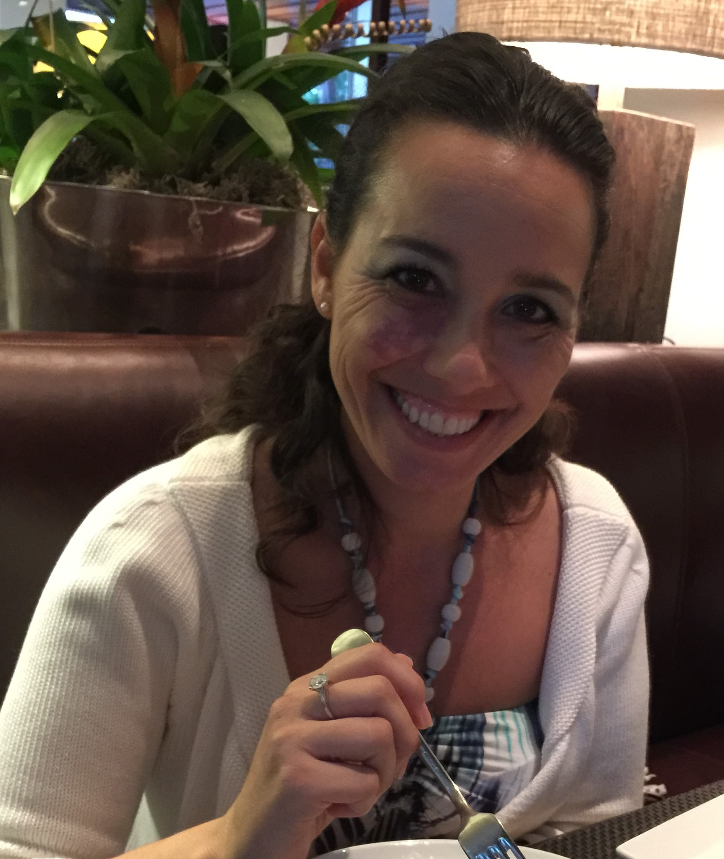
Dr. Henry Trapido-Rosenthal,PhD (henry.trapidorosenthal@chaminade.edu)
Dr. Jolene Tarnay Cogbill, PhD (jolene.cogbill@chaminade.edu)

Office Hours:
Cogbill - WSC 102, M,W,F 10:30qm – 11:30am or by appointment.
Trapido-Rosenthal - WSC 101 when the door is open or by appointment.

Class Meeting:
Mon 2:30pm – 5:20pm in Henry Hall Lab 2 (HL2).

General Course Objectives:
This laboratory course accompanies BI320 Genetic Control and Patterning. This laboratory will encompass an inquiry based student driven project centered around the development of the sea urchin, Tripneustes gratilla.

Learning Objectives:
- Become familiar with the sea urchin T. gratilla as a model organism.
- Prepare students for further education in advanced biology lab courses, or related fields.
- To present principal methods and techniques coupled with appropriate instruments utilized in the study of developmental biology.
- To allow investigation and problem solving through experimental methodology.
- Learn how to critically read scientific journal articles.
- Develop an appreciation of working collaboratively in groups

Specific Student Learning Outcomes:
- At the end of the course, students will be able to:
Student Learning Outcomes | Linkage to Biology Program Learning Outcomes
Apply the Scientific Method to the study genes responsible for the development of the sea urchin T. gratilla, including being able to synthesize an original scientific question and hypothesis in regards to a specific gene of their choosing. | #1) An understanding of the scientific method and the  ability to design and test a hypothesis.  #2) ability to visualize, statistically evaluate, validate and  interpret scientific data, and to communicate science  effectively both orally and in writing.  #3) The ability to acquire and comprehend information from  published scientific literature and to employ computational  resources in the resolution of biological problems.  #7) An understanding of the entry requirements, career  pathways and progression for the major post-graduate  fields of research, education and health professions.
Design and perform an experimental protocol utilizing PCR, RT-PCR and gel electrophoresis to test their hypothesis, and analyze the resulting scientific data appropriately. | #1) An understanding of the scientific method and the  ability to design and test a hypothesis.  #2) ability to visualize, statistically evaluate, validate and  interpret scientific data, and to communicate science  effectively both orally and in writing.  #3) The ability to acquire and comprehend information from  published scientific literature and to employ computational  resources in the resolution of biological problems.  #7) An understanding of the entry requirements, career  pathways and progression for the major post-graduate  fields of research, education and health professions
Write a scientific paper on their research | #2) ability to visualize, statistically evaluate, validate and  interpret scientific data, and to communicate science  effectively both orally and in writing.  #3) The ability to acquire and comprehend information from  published scientific literature and to employ computational  resources in the resolution of biological problems.  #7) An understanding of the entry requirements, career  pathways and progression for the major post-graduate  fields of research, education and health professions

Grading

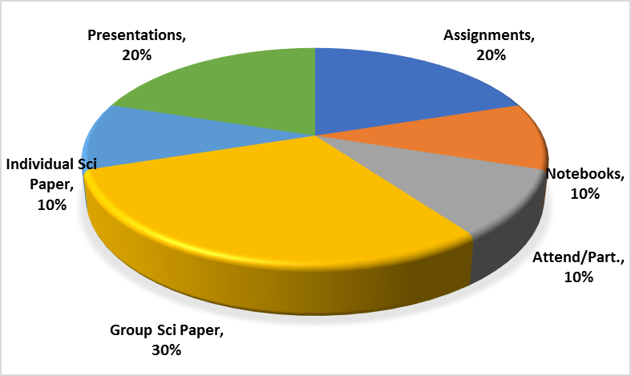

Attendance/Participation:
- Presence in class is mandatory & necessary in order for a student to fully grasp concepts. Students are expected to attend regularly all courses for which they are registered. Students should notify their instructors when illness or other extenuating circumstances prevents them from attending class and make arrangements to complete missed assignments. Notification may be done by emailing the instructor’s Chaminade email address, calling the instructor’s campus extension or by leaving a message with the instructor’s division office (Natural Science and Math 1 (808) 440-4204). It is the instructor’s prerogative to modify deadlines of course requirements accordingly. Any student who stops attending a course without officially withdrawing may receive a failing grade.
- Unexcused absences equivalent to more than a week of classes may lead to a grade reduction for the course. Any unexcused absence of two consecutive weeks or more may result in being withdrawn from the course by the instructor, although the instructor is not required to withdraw students in that scenario. Repeated absences put students at risk of failing grades.
- There will no making up a missed laboratory exercise. If you miss a class it is YOUR responsibility to ask the instructor or your classmates for the information that you missed and to pick up any handouts that may have been distributed.

Lab Notebook:
- You will be engaging in original research in this laboratory and addressing scientific questions that have not yet been asked for this particular species of sea urchin. As such you MUST keep a proper research lab notebook to record what you did, why you did it and the data that you generate throughout the course of the semester. This notebook will be integral to the writing of your scientific paper.
- Notebooks will be checked randomly throughout the semester
- Notebooks will be checked for the following:
  - Table of contents
  - Legibility
  - Experiments must be titled and dated
  - Detailed methods
  - All generated data and observations (properly labeled & annotated)

Scientific Paper:
- The semester’s research will culminate in a comprehensive scientific paper written in the style of a research journal article.
- Departmental and University Polices:
- Music Devices and Cellular Phones: Use of music devices and cell phones is prohibited during all Natural Science and Mathematics classes at Chaminade, unless specifically permitted by your instructor. Use of cellphones and music devices in laboratories is a safety issue. In addition, use of cellphones and music devices in any class is discourteous and may lead to suspicion of academic misconduct. Students who cannot comply with this rule will be asked to leave class and may be subject to laboratory safety violation fines. You will be asked to leave class and marked absent if you do not comply. This will negatively affect your grade. Please refer any questions to the Dean of Natural Sciences and Mathematics.
- ADA Accomodations: Pursuant to several federal and state laws, including the Americans with Disabilities Act of 1990, as amended by the ADA Amendments Act of 2008, and Section 504 of the Rehabilitation Act of 1973, all qualified students with disabilities are protected from discrimination on basis of disability and are eligible for reasonable accommodations or modifications in the academic environment to enable them to enjoy equal access to academic programs, services, or activities. If a student would like to determine if they meet the criteria for accommodations, they should contact the Counseling Center at 808-735-4845 for further information Students with special needs who meet criteria for the Americans with Disabilities Act (ADA) provisions must provide written documentation of the need for accommodations from CUH Couseling Center (Dr. June Yasuhara, 735-4845) by the end of the third week of classes. Failure to provide written documentation will prevent your instructor from making necessary accommodations.
- Policy on Communication : The University provides a Chaminade email address for all students. Official Chaminade communications will be sent to the students’ Chaminade email address and instructors will use only this email to communicate with students. It is the responsibility of the student to check their email frequently. Report email-related problems to the Helpdesk at 808-735-4855 or helpdesk@chaminade.edu.
- Title IX Declaration: Chaminade University of Honolulu recognizes the inherent dignity of all individuals and promotes respect for all people. Sexual misconduct, physical and/or psychological abuse will NOT be tolerated at CUH. If you have been the victim of sexual misconduct, physical and/or psychological abuse, we encourage you to report this matter promptly. As a faculty member, I am interested in promoting a safe and healthy environment, and should I learn of any sexual misconduct, physical and/or psychological abuse, I must report the matter to the Title IX Coordinator. Should you want to speak to a confidential source you may contact the following: Chaminade Counseling Center| 808 735-4845;
Any priest serving as a sacramental confessor or any ordained religious leader serving in the sacred confidence role.
- Academic Honesty: Students are expected to have read and to abide by the “Student Rules of Conduct” which are available in your copy of Chaminade University’s Student Handbook. Cheating in the form of plagiarism, collusion, deception and will not be tolerated and will negatively affect your grade.

The university is an academic community with high professional standards. Its teaching function is seriously disrupted and subverted by academic dishonesty. Such dishonesty includes, but is not limited to, cheating, which includes giving/receiving unauthorized assistance during an examination; obtaining information about an examination before it is given, using inappropriate/unallowed sources during an examination; altering answers after an examination has been submitted; and altering the records on any grade. (Refer to the Chaminade University catalog for further information).

Tentative Course Outline: Every effort has been made to insure that the material in this syllabus is accurate and complete. The instructor reserves the right to make any changes in the contents of this syllabus that he/she deems necessary or desirable.

Week Dates Topic Assignments
1 Jan 17 No Class
2 22 Introduction, group assignments, Research your assigned gene & write summary PCR (review), Assign taxonomy gene Design your PCR protocol including controls, PCR
parameters, etc.
By 5pm Tues EACH GROUP emails their proposed PCR
protocol that will be performed next week.

3 29 Taxonomy gene PCR & gel Each GROUP picks their developmental research gene
Research Developmental Genes Each INDIVIDUAL pick & read one research article on
your gene; write a summary of the article due next wk.

4 Feb 5 Taxonomy gene sequence Each INDIVIDUAL read and prepare a summary of another research article.
Research RT-PCR.

5 12 Primer Design & RT-PCR Each GROUP generate research hypothesis.
(guest speaker) Prepare Group Presentations for next week.
Each GROUP design your developmental gene primers

6 19 No Class, Presidents’ Day Each GROUP continue developing experimental protocol.
Each INDIVIDUAL read and prepare a summary of another research article.

7 26 Group Presentations Each GROUP develop your experimental protocol. TURN IN PRIMER SEQUENCES!

8 Mar 5 Student Directed Research Each GROUP put together an outline for your 5
paragraph introduction.

9 12 Student Directed Research Each GROUP write the 1st and 2nd paragraph of intro.

10 19 Student Directed Research Each GROUP write the 3rd and 4th paragraph of intro.

11 26-30 Spring Break – No Classes Each GROUP complete the introduction.

12 Apr 2 Student Directed Research Each GROUP write a draft of the methods section.

13 9 Student Directed Research Each GROUP write rough draft of a results section.
Data should be coming in by now, so begin data analysis.

14 16 Student Directed Research Each GROUP write rough draft discussion
Data Analysis!

15 23 Student Directed Research Prepare presentation for next week

16 30 Student Research Ppt Presentations Scientific paper due Thursday of finals week

