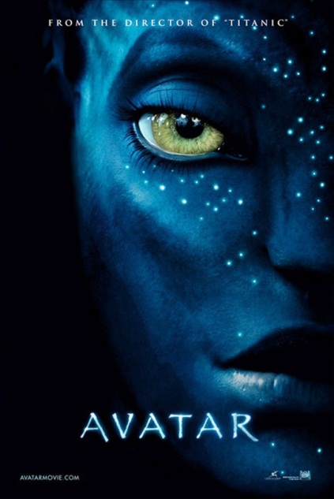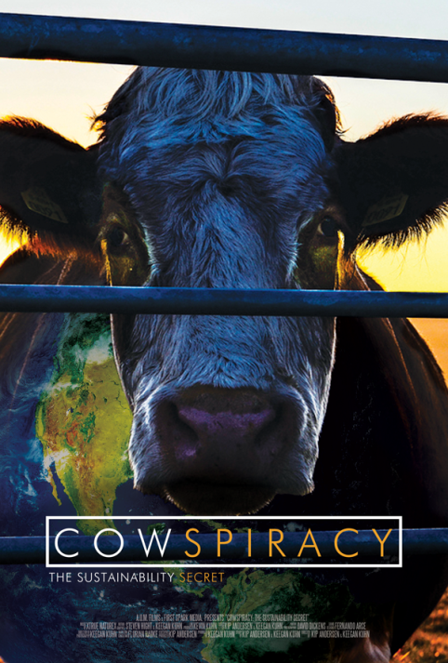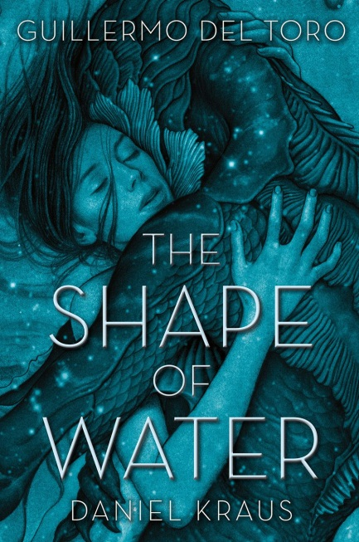

ENV 380: The Environment in Fiction & Film

Course Syllabus
Spring 2018
The good Earth—we could have saved it, but we were too damn cheap and lazy.
Kurt Vonnegut, from the book A Man Without a Country
That's human nature. Nobody does anything until it's too late.
Michael Crichton, from the novel Prey
You must be the change you wish to see in the world.
Mahatma Gandhi
It's a job that's never started that takes the longest to finish.
J.R.R. Tolkien
I am a great eater of beef, and I believe that does harm to my wit.
Shakespeare, (Sir Andrew Aguecheek, in Twelfth Night)
Audacious at trying out everything, men rush
headlong into the things that have been forbidden.
Virgil
True wisdom consists in not departing from nature and in molding our conduct according to her laws and model.
Seneca, ancient Roman writer
I wish they would remember that the charge to Peter was 'Feed my sheep,' not 'Try experiments on my rats,' or even 'Teach my performing dogs new tricks.
C.S. Lewis

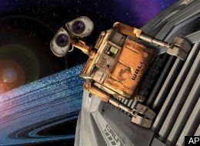

Instructor: Dr. Gail Grabowsky (“Dr. Gail”)

Address: Wesselkamper, rm 108
Environmental Studies
Chaminade University
3140 Waialae Ave
Honolulu, HI 96816

Phone: Office: 735-4834 (ext. 4834 if calling from on campus); cell: (808) 387-9319 (no calls after 9:00 PM please; late texts are fine I will respond the next day)

E-mail address: ggrabows@chaminade.edu

Office hours: MF: 2:30-5:00; Tu 11:30-1:00; Or by appointment

Texts:
Required:
Diamond, Jared. 2012. The World until Yesterday. (ISBN: 978-0-14-312440-5)
Harrari, Yuval Noah. 2015. Sapiens: A Brief History of Humankind. (ISBN: 978-0-06-231609-7)

Course Description:
This one-time only course focuses on the role of storytelling through fiction, film and video in the environmental movement. The course focuses on the apparent goals and aims of authors and movie makers whose stories focus on or contain strong reference(s) to environmental issues. Students in this course will seek to understand those goals and aims and comment on the success of each story at achieving those aims. In addition students will hypothesize how each story impacts society and human behavior.

Student Learning Outcomes:
Students will demonstrate an understanding of:
- Those environmental issues portrayed in the books, films and videos we read/see
- The accuracy of the scientific facts surrounding each issue portrayed
- The likely intentions of each author/producer as they pertain to the environment
- The desired and potential effects of each book and film
- The commentary each story makes about our society and the environment
- How to story board a film or produce an environmental video
- The general types of environmental novels, films and videos produced in the United States in the twentieth and early twenty-first century

Course Requirements:
Your grade in this course will be based on the following. Each of the items/activities listed below will be described to you in writing or orally in class. The dates of each activity (or its parts) are indicated on the Course Schedule portion of this syllabus.

- Film & Book Response and Reflection Pages 33%
- Film & Book Quizzes 33%
- Film-Book Comparison Paper & Presentation OR 33% OR
- Story Board or video produce your own environmental short film 33%

Course Grading:
The proportion that each of the above contributes to your grade in this course is as follows:

Film & Book Response and Reflection Pages 333
Film & Book Quizzes 333
Film- Book Comparison Paper & Presentation OR 333 OR
Story Board of your own environmental short film 333
1000

Grading:
The details for each of the assignments will be explained orally and with handouts in class prior to the initiation of each. In general for each:

Film & Book Response and Reflection Pages:
For every film/video and most chapters of the books we read I will give you a handout to complete with a set of questions on it. These will be due the following week in class.

Film & Book Quizzes:
There will be no exams in this course but there will be lots of quizzes. Quiz questions will be multiple choice or short answer. If you do the reading and pay attention during the films you will be able to do well on these. They are not meant to be picayune detailed quizzes, they are meant to (2) ensure you read and pay attention, and more importantly (2) initiate discussions on the most important and relevant topics of each chapter and film.

Film/Book Comparison Paper & Presentation:
You have the option to write one 10 page paper and give a (solo) presentation comparing a portion of one of the books to one of the films. The details of this assignment will be defined better by us all early in the class and turned into a handout for you.

Story Board or creation of your own Environmental Short Video:
You also have the opportunity design your own film. The story board and video technique will be described by a media specialist and co-graded by Dr. Gail and this expert. The details of this assignment will be defined better by us all early in the class and turned into a handout for you.

Assessment:
Beginning on the first day and throughout class, there may be a number of course assessment assignments. These are all non-graded. They are undertaken for the sole purpose of assessing your baseline knowledge about environmental issues, movies, works of fiction, course outcomes and your satisfaction with the course.

Attendance:
Excused absences include being ill with a doctor’s note, missing for a work-related, family-related emergency and/or missing for an athletic event/retreat/research paper presentation at a symposium. You’ll need to provide some kind of documentation or a phone number of someone responsible that I may call in order to verify the urgency of the reason for your absence if it is to be an excused absence. Otherwise you are all allowed ONE, and only one, unexcused absence, after the first unexcused absence you will lose 10 points from your overall quiz scores for each further unexcused absence….

Extra Credit Options:
Throughout the course Dr. Gail will be making numerous environmental service-learning outings available to you. You may also find environmental service opportunities on your own. Those that Dr. Gail organizes or brings to your attention will typically be on Saturdays or after school. For every service-learning activity that you participate in, that entails 4-5 hours of work, will receive +5 extra credit points.
Also, periodically throughout the course there will be talks and presentations you may attend that pertain to the course material. Dr. Gail will let you know when these opportunities arise OR you may discover them and bring them to the class’s attention. You can earn +2 extra credit points towards a lecture exam for each talk you attend with content related to the course content.
In order for all talks and service activities to count for extra credit you MUST have them approved by Dr. Gail PRIOR TO the event and you MUST document your presence (if Dr. Gail is not also in attendance) with a photograph of yourself participating AND give Dr. Gail the name and phone number of the person in charge or speaker/presenter. If there are any handouts from the event bring them as evidence of your attendance as well. You may earn up to 30 extra credit points from service activities and 10 from attending talks/presentations.

Course Atmosphere:

If you are handicapped under the Americans with Disabilities Act:
Chaminade will provide assistance for any student with documented disabilities. Any student who believes he/she may need accommodations in this class must contact Dr. June Yasuhara (735-4845), at the Counseling Center (office is next to security), in order to determine if you meet the requirements for a documented disability in accordance with the Americans with Disabilities Act. Please contact Dr. Yasuhara as soon as possible so that accommodations can be implemented in a timely fashion.

Nothing is Certain but Change Itself Clause…
This syllabus and course schedule are living documents: they are free to change. I try to adhere as closely as possible to each, but there will be times in which we will take longer on a particular topic or add or delete a topic to enhance the course. I like to be able to react to you as the course proceeds and go with the flow a bit in order to make the course experience sort of custom fit to you!

You are responsible for all of the information in this document: losing it or not reading it are not excuses for not knowing what’s in it!


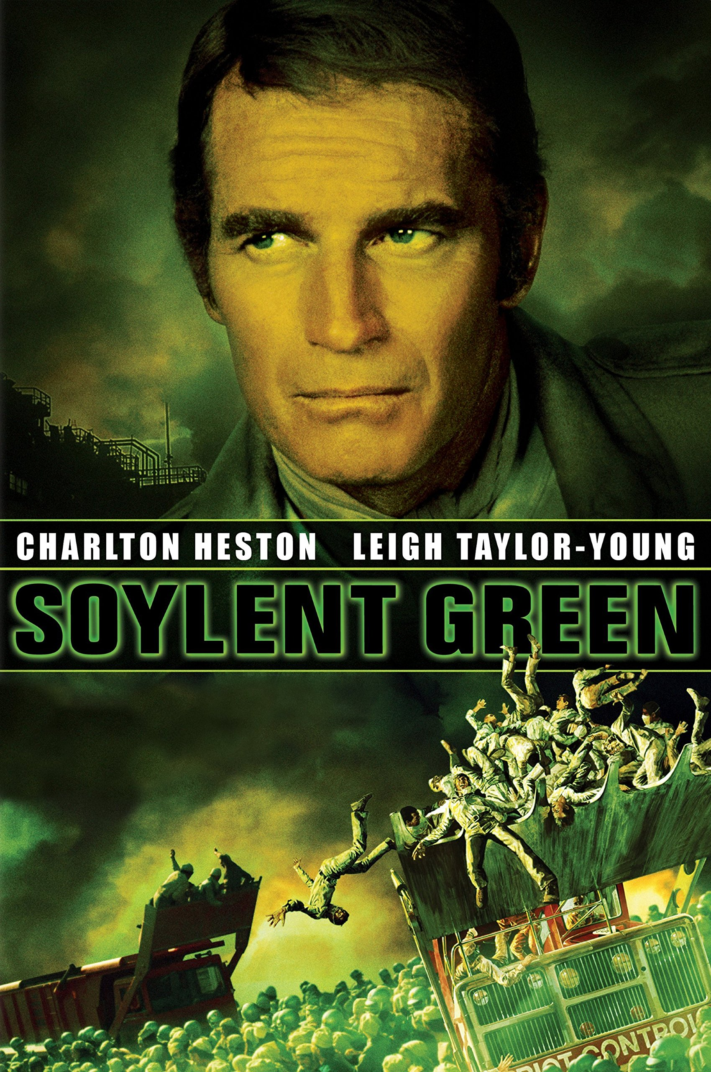
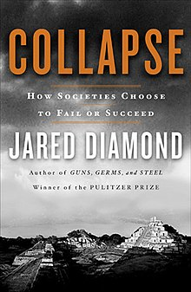

The Environment in Fiction & Film
First day of class version

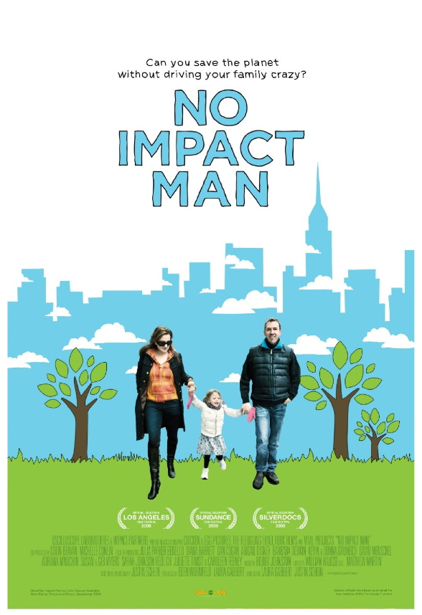

Course Schedule
Spring 2018

WEEK TOPIC ACTIVITIES
1/18 Course Outline, Intro & Assessment Buy your books!
Select the rest of the movies together

1/25 Sapiens Reflection Due: Sapiens Chapters 5 & 6
Soylent Green Watch: Soylent Green
Quizzes: Sapiens Chapters 5& 6; Soylent Green (after we watch!)

2/1 Sapiens Reflections Due: Sapiens Chapters 7 & 8; Soylent Green
Logan’s Run Read: Sapiens Chapters 7 & 8
Quizzes: Sapiens Chapters 7 & 8; Logan’s Run

2/8 Sapiens Reflections Due: Sapiens Chapters 9 & 10; Logan’s Run;
Avatar Read: Sapiens Chapters 9 & 10
Quizzes: Sapiens Chapters 9 & 10; Avatar

2/15 Sapiens Reflections Due: Sapiens Chapters 12-13; Avatar
Wall·e Read: Sapiens Chapters 12 & 13
Quizzes: Sapiens Chapters 12 & 13; Wall·e

2/22 Sapiens Reflections Due: Sapiens Chapters 14 & 15; Wall·e;
An Inconvenient Truth:Truth to Power Read: Sapiens Chapters 14 & 15
Quizzes: Sapiens Chapters 14 & 15; An Inconvenient…

3/1 Sapiens Reflections Due: Sapiens Chapters 16 & 17; An Inconvenient…
You bring in shorts to share! Read: Sapiens Chapters 16 & 17
Quizzes: Sapiens Chapters 16 & 17; Ask one question of your own!

3/8 Sapiens Reflections Due: Sapiens Chapters 18 & 19; One of the shorts
Star Trek: The Voyage Home Read: Sapiens Chapters 18 & 19
Quizzes: Sapiens Chapters 18 & 19; Star Trek: The Voyage Home

3/15 Sapiens Reflections Due: Sapiens Chapter 20 ; Star Trek: The Voyage Home
Koyaanisqatsi Read: Sapiens Chapter 20
Quizzes: Sapiens Chapter 20; Koyaanisqatsi

3/22 The World… Reflections Due: The World… Prologue & Chapter 1; Koyaanisqatsi
Carbon Nation Read: The World… Prologue & Chapter 1
Quizzes: The World… Prologue & Chapter 1; Carbon Nation

3/29 S P R I N G B R E A K (BIG CHANCE TO READ!!!!!) (Read on the beach)
Player One opens on 3/30. I will take the entire class to see it (paid for by Environmental Studies)

4/5 The World… Reflections Due: The World… Chapter 5; Carbon Nation
_______________ Read: The World… Chapter 5
Quizzes: The World… Chapter 5; _______________

4/12 The World… Reflections Due: The World… Chapter 6; _______________
_______________ Read: The World… Chapter 6
Quizzes: The World… Chapter 6; _______________

4/19 The World… Reflections Due: _______________
_______________ Read: The World… Chapter 7
Quizzes: The World… Chapter 7; _______________

4/26 The World… Reflections Due: _______________
_______________ Read: The World… Chapter 8
Quizzes: The World… Chapter 8; _______________

5/3 The World… Reflections Due: The World… Chapter 8; _______________
Considering it all; Synthesis Read: The World… Chapter 9 & Epilogue
Quiz: The World… Chapter 9 & Epilogue

By Wednesday 5/9 @ 1:15: You MUST turn in your Comparison Paper, Story Board or Video production AND present them to the class ☺



